Experiment No.: 1
Title: Demonstrate inline, internal, and external JavaScript; use console methods; create a webpage showing user info and a welcome message.
Software/Tools Required: HTML5, CSS3, JavaScript, Visual Studio Code, Google Chrome
Code:
Index.html:
<!DOCTYPE html>
<html lang="en">
<head>
<meta charset="UTF-8">
<title>Experiment 1</title>
<!-- Internal JavaScript -->
<script>
function showWelcome() {
console.info("Welcome button clicked.");
var name = "Shruti Bawankar";
document.getElementById("welcome").innerHTML =
"Welcome, " + name + "!";
document.getElementById("name").innerHTML = name;
document.getElementById("prn").innerHTML = "24070521148";
document.getElementById("course").innerHTML = "B.Tech CSE";
document.getElementById("college").innerHTML =
"Symbiosis Institute of Technology";
}
</script>
<!-- External JavaScript -->
<script src="script.js"></script>
<style>
body{
font-family:Arial,sans-serif;
background:#e8f4ff;
display:flex;
justify-content:center;
align-items:center;
height:100vh;
}
.card{
width:400px;
background:white;
padding:25px;
border-radius:12px;
text-align:center;
box-shadow:0 5px 15px rgba(0,0,0,.2);
}
button{
padding:10px 18px;
margin:8px;
border:none;
border-radius:6px;
cursor:pointer;
background:#007BFF;
color:white;
font-size:15px;
}
button:hover{
background:#0056b3;
}
h2{
color:#007BFF;
}
</style>
</head>
<body>
<div class="card">
<h2 id="welcome">Welcome!</h2>
<p><b>Name:</b> <span id="name">-</span></p>
<p><b>PRN:</b> <span id="prn">-</span></p>
<p><b>Course:</b> <span id="course">-</span></p>
<p><b>College:</b> <span id="college">-</span></p>
<br>
<!-- Inline JavaScript -->
<button onclick="console.log('Inline JavaScript executed'); alert('Welcome, Shruti
Bawankar! Inline JavaScript executed');">
Inline JS
</button>
<!-- Internal JavaScript -->
<button onclick="showWelcome()">
Internal JS
</button>
<!-- External JavaScript -->
<button onclick="externalDemo()">
External JS
</button>
</div>
</body>
</html>
Script.js:
function externalDemo(){
console.warn("Warning Message");
console.error("Sample Error Message");
console.table([
{Name:"Shruti", PRN: 24070521148}
]);
console.time("Execution");
for(let i=1;i<=1000000;i++){}
console.timeEnd("Execution");
alert("Welcome, Shruti Bawankar! External JavaScript Executed");
}

Output:
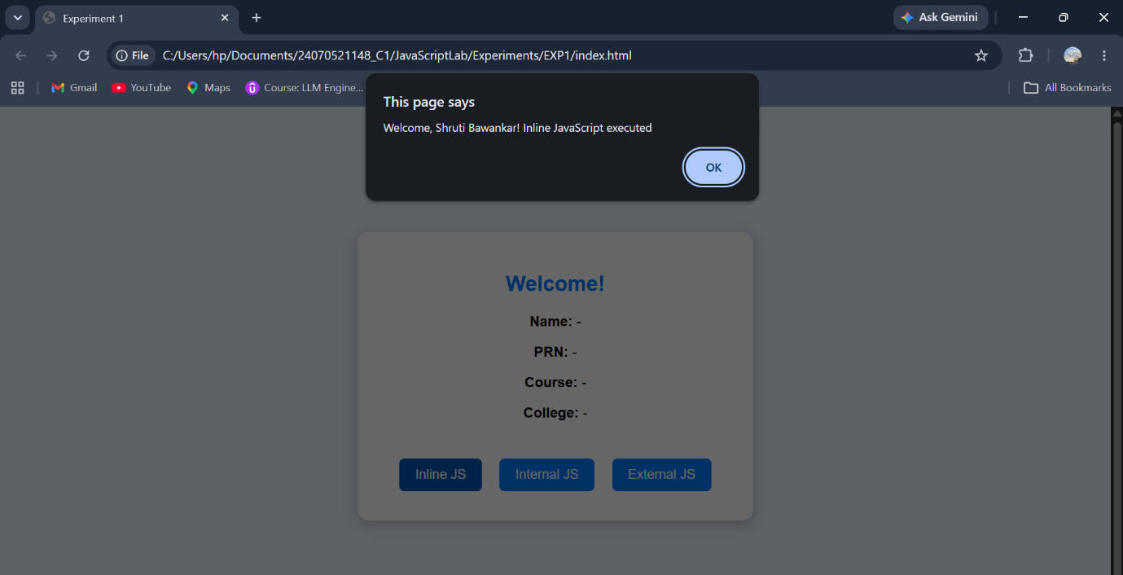

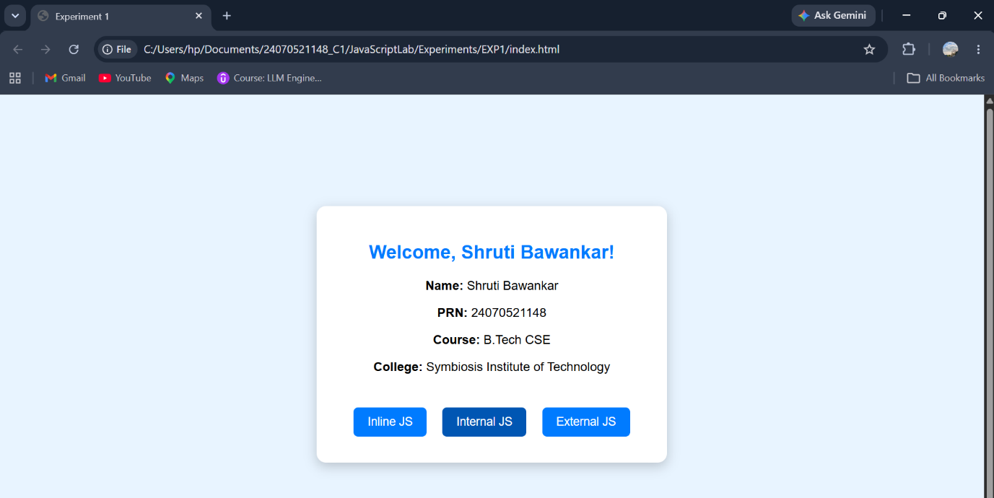
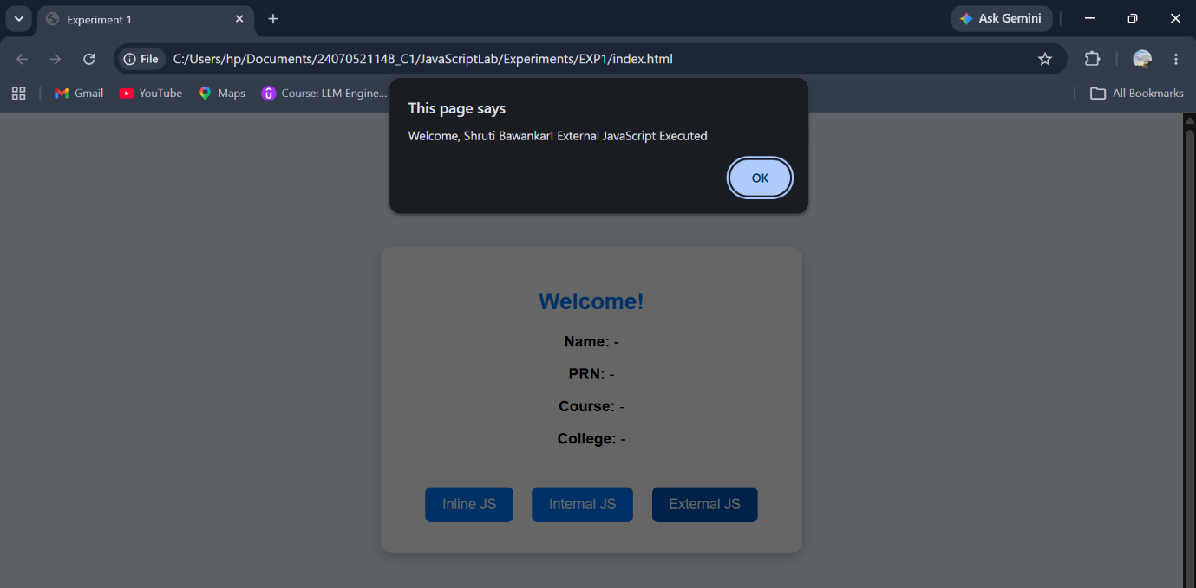
Result: The webpage was successfully created using HTML, CSS, and JavaScript. It demonstrated inline, internal, and external JavaScript, displayed user information with a welcome message, and showed various console methods in the browser console.
Conclusion: The experiment helped in understanding the different ways of including JavaScript in a webpage and how it interacts with HTML elements. It also demonstrated the use of console methods for debugging and basic DOM manipulation.
Case Study No.: 1
Title: Create a webpage for college department and link the student information page with it and write a javascript program to display "Welcome to SIT Nagpur" in an alert box.
Software/Tools Required: HTML5 , CSS3 , JavaScript , Visual Studio Code , Google Chrome
department.html:
<!DOCTYPE html>
<html lang="en">
<head>
<meta charset="UTF-8">
<meta name="viewport" content="width=device-width, initial-scale=1.0">
<title>SIT Nagpur - Computer Science Department</title>
<link rel="stylesheet" href="style.css">
</head>
<body>
<div class="overlay">
<div class="card">
<!-- College Logo -->
<img src="images/sit-logo.png" alt="SIT Nagpur Logo" class="logo">

<h1>Symbiosis Institute of Technology</h1>
<h3>Nagpur</h3>
<div class="line"></div>
<h2>Department of Computer Science & Engineering</h2>
<p>
The Department of Computer Science & Engineering provides
quality education in Artificial Intelligence, Data Science,
Cybersecurity, Cloud Computing, Software Engineering and
Full Stack Development. The department focuses on innovation,
research, and industry-oriented learning.
</p>
<div class="features">
<div class="box">
💻
<h4>Modern Labs</h4>
</div>
<div class="box">
👨‍🏫
<h4>Expert Faculty</h4>
</div>

<div class="box">
🚀
<h4>Excellent Placements</h4>
</div>

<div class="box">
📚
<h4>Research & Innovation</h4>
</div>
</div>
<a href="student.html" class="btn">
View Student Information →
</a>
</div>
</div>
<script src="script.js"></script>
</body>
</html>
student.html:
<!DOCTYPE html>
<html lang="en">
<head>
<meta charset="UTF-8">
<meta name="viewport" content="width=device-width, initial-scale=1.0">
<title>Student Information</title>
<link rel="stylesheet" href="style.css">
</head>
<body>
<div class="overlay">
<div class="student-card">
<img src="images/sit-logo.png" alt="SIT Nagpur Logo" class="logo">
<h1>🎓 Student Information</h1>
<img src="https://cdn-icons-png.flaticon.com/512/3135/3135715.png"
class="profile">
<table>
<tr>
<th>Name</th>
<td>Shruti Bawankar</td>
</tr>
<tr>
<th>Roll Number</th>
<td>24070521148</td>
</tr>
<tr>
<th>Branch</th>
<td>Computer Science Engineering</td>
</tr>
<tr>
<th>Semester</th>
<td>5th Semester</td>
</tr>
<tr>
<th>Division</th>
<td>C</td>
</tr>
<tr>
<th>College</th>
<td>Symbiosis Institute of Technology, Nagpur</td>
</tr>
<tr>
<th>Email</th>
<td>shruti.bawankar.batch2024@sitnagpur.siu.edu.in</td>
</tr>
</table>
<a href="department.html" class="btn">
← Back to Department
</a>
</div>
</div>
</body>
</html>
Style.css :
*{
margin:0;
padding:0;
box-sizing:border-box;
font-family:Segoe UI, sans-serif;
}
body{
background:linear-gradient(135deg, #a2bfe8 0%, #dceeff 100%);;
min-height:100vh;
}
.overlay{
width:100%;
min-height:100vh;
display:flex;
justify-content:center;
align-items:center;
padding:40px;
}
.card,
.student-card{
width:900px;
background:white;
border-radius:20px;
padding:40px;
box-shadow:0 15px 40px rgba(0,0,0,.35);

animation:fade 1s;
}
@keyframes fade{
from{
opacity:0;
transform:translateY(40px);
}
to{
opacity:1;
transform:translateY(0);
}
}
.logo{
display:block;
width:800px;
height:200px;
object-fit:fill;
margin:auto;
margin-bottom:20px;
padding:10px;
background:white;
box-shadow:0 8px 20px rgba(0,0,0,.25);
transition:.4s;
}
.logo:hover{
transform:scale(1.08);
}
h1{
text-align:center;
color:#e72600;
}
h2{
text-align:center;
margin-top:15px;
color:#1565C0;
}
h3{
text-align:center;
color:#666;
margin-top:5px;
}
.line{
width:120px;
height:4px;
background:#1565C0;
margin:20px auto;
border-radius:20px;
}
p{
text-align:center;
color:#555;
margin:20px 0;
font-size:18px;
line-height:1.8;
}
.features{
display:grid;
grid-template-columns:repeat(2,1fr);
gap:20px;
margin-top:30px;
}
.box{
background:#F4F7FF;
border-radius:15px;
text-align:center;
padding:25px;
font-size:40px;
transition:.4s;
cursor:pointer;
}
.box h4{
margin-top:10px;
color:#0D47A1;
font-size:18px;
}
.box:hover{
background:#1565C0;
color:white;
transform:translateY(-8px);
}
.box:hover h4{
color:white;
}
.btn{
display:block;
width:280px;
margin:35px auto 0;
text-align:center;
text-decoration:none;
background:#1565C0;

color:white;
padding:15px;
border-radius:40px;
font-size:18px;
font-weight:bold;
transition:.3s;
}
.btn:hover{
background:#0D47A1;
transform:scale(1.05);
}
.profile{
width:150px;
display:block;
margin:20px auto;
}
table{
width:100%;
border-collapse:collapse;
margin-top:20px;
}
th{
background:#1565C0;
color:white;
padding:15px;
width:30%;
}
td{
padding:15px;
background:#F4F7FF;
}
table,
th,
td{
border:1px solid #ddd;
}
tr:hover td{
background:#D8EFFF;
}
@media(max-width:768px){
.features{
grid-template-columns:1fr;
}
.card,
.student-card{
width:100%;
} }
Script.js :
alert("Welcome to SIT Nagpur");

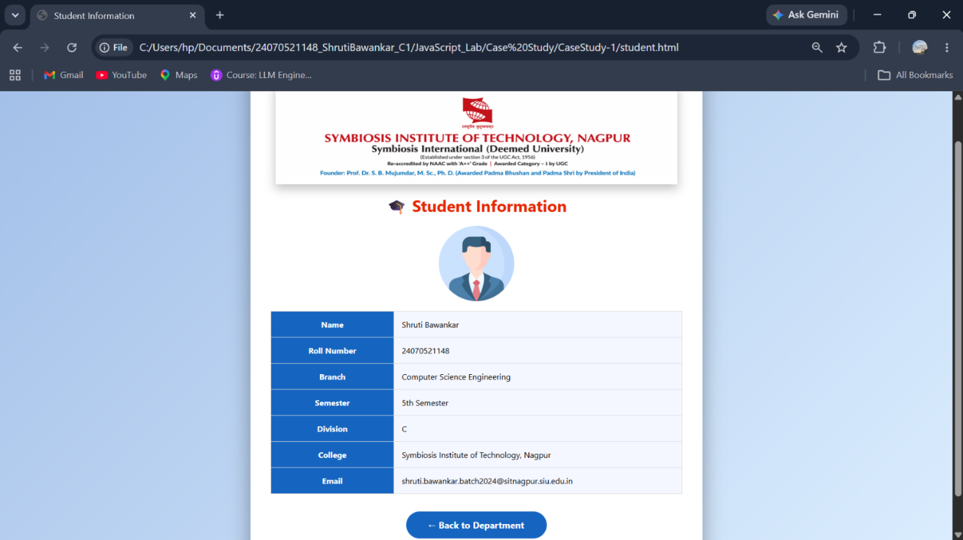

Result: The webpage was successfully created using HTML, CSS, and JavaScript. It demonstrated inline, internal, and external JavaScript, displayed user information with a welcome message, and showed various console methods in the browser console.
Conclusion: The experiment helped in understanding the different ways of including JavaScript in a webpage and how it interacts with HTML elements. It also demonstrated the use of console methods for debugging and basic DOM manipulation.

Experiment No.: 2
Title: Use var, let, const, and demonstrate basic features like template literals and destructuring; build a billing calculator with user input.
Software/Tools Required: HTML5, CSS3, JavaScript, VS Code , Google Chrome
Code:
Index.html:
<!DOCTYPE html>
<html lang="en">
<head>
<meta charset="UTF-8">
<meta name="viewport" content="width=device-width, initial-scale=1.0">
<title>Cafe Billing Receipt</title>
<link rel="stylesheet" href="style.css">
</head>
<body>
<div class="receipt">
<div class="logo">

</div>
<h1>CAFE AROMA</h1>
<p class="subtitle">
Fresh Coffee • Fresh Food
</p>
<div id="bill"></div>
<div class="footer">
<strong>Thank You!</strong>
<br>
Visit Again
</div>
</div>
<script src="script.js"></script>
</body>
</html>
Script.js:
// Using var
var customerName = prompt("Enter Your Name");
// Using let
let productName = prompt("Enter Product Name");
let price = Number(prompt("Enter Price Per Product"));
let quantity = Number(prompt("Enter Quantity"));
// Using const
const GST_RATE = 0.18;
// Calculations
let subtotal = price * quantity;
let gst = subtotal * GST_RATE;
let total = subtotal + gst;
// Create Object
const receipt = {
customerName,
productName,
price,
quantity,
subtotal,
gst,
total
};
// Object Destructuring
const {
customerName: cname,
productName: pname,
price: pprice,
quantity: qty,
subtotal: sub,
gst: gstAmount,
total: grandTotal
} = receipt;
// Display Receipt using Template Literals
document.getElementById("bill").innerHTML = `
<div class="row">
<span>Customer</span>
<span>${cname}</span>
</div>
<div class="row">
<span>Product</span>
<span>${pname}</span>
</div>
<div class="row">
<span>Price</span>
<span>₹${pprice.toFixed(2)}</span>
</div>
<div class="row">
<span>Quantity</span>
<span>${qty}</span>
</div>
<hr>
<div class="row">
<span>Subtotal</span>
<span>₹${sub.toFixed(2)}</span>
</div>
<div class="row">
<span>GST (18%)</span>
<span>₹${gstAmount.toFixed(2)}</span>
</div>
<hr>
<div class="total">
<span>TOTAL</span>
<span>₹${grandTotal.toFixed(2)}</span>
</div>
`;
Style.css:
*{
margin:0;
padding:0;
box-sizing:border-box;
font-family:"Courier New", monospace;
}
body{
min-height:100vh;
display:flex;
justify-content:center;
align-items:center;
background:
linear-gradient(rgba(0,0,0,.15),rgba(0,0,0,.15)),
url("https://encrypted-tbn0.gstatic.com/images?q=tbn:ANd9GcT5qZ22xW3517kfMJRCK
s7_Jul0AzmZ-IZyH4FU5ozLAOv5fwEfpjXiZo&s=10");
background-size:cover;
background-position:center;
}
.receipt{
width:420px;
background:white;
padding:30px;
border-radius:12px;
box-shadow:0 15px 35px rgba(0,0,0,.35);
position:relative;
}
.receipt::after{
content:"";
position:absolute;
left:0;
bottom:-12px;
width:100%;
height:20px;
background:
repeating-linear-gradient(
-45deg,
white 0px,
white 10px,
transparent 10px,
transparent 20px
);
}
.logo{
text-align:center;
font-size:55px;
}
h1{
text-align:center;
color:#5d4037;
margin-top:10px;
}
.subtitle{
text-align:center;
color:#777;
margin-bottom:25px;
}
.row{
display:flex;
justify-content:space-between;
margin:15px 0;
font-size:17px;
}
hr{
border:none;
border-top:2px dashed #999;
margin:18px 0;
}
.total{
background:#6f4e37;
color:white;
padding:15px;
border-radius:8px;
display:flex;
justify-content:space-between;
font-size:22px;
font-weight:bold;
}
.footer{
text-align:center;
margin-top:30px;
color:#777;
font-size:15px;
}
.footer strong{
color:#5d4037;
}
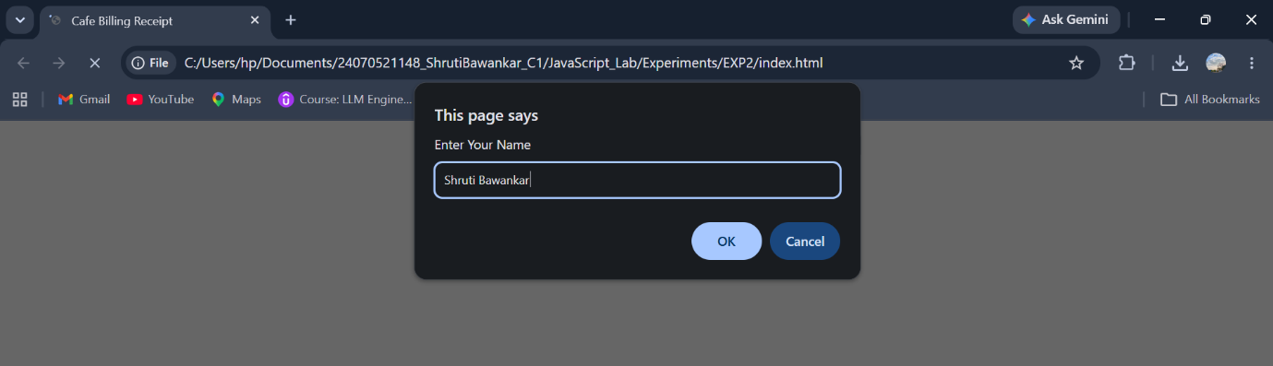
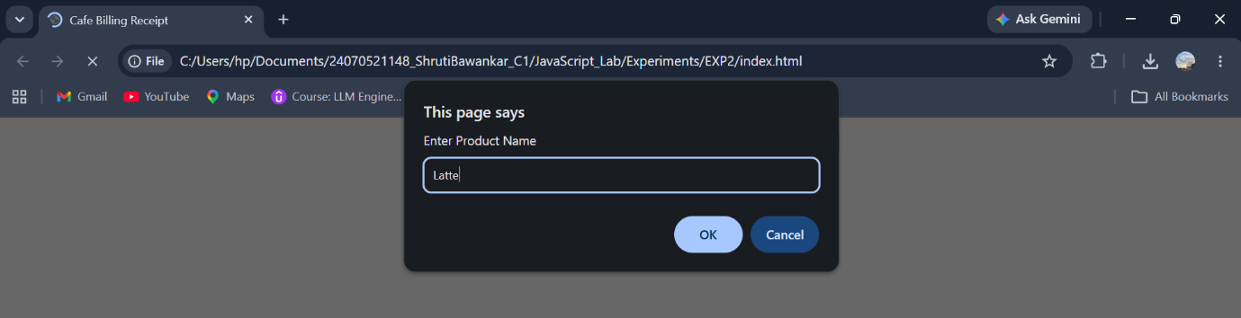
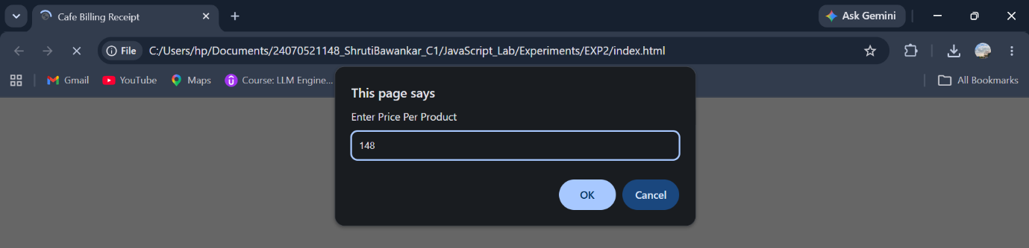
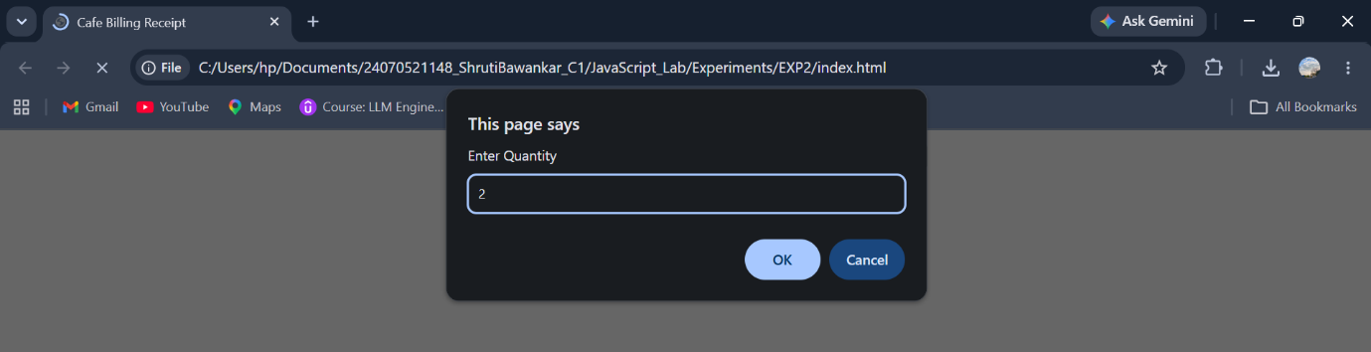
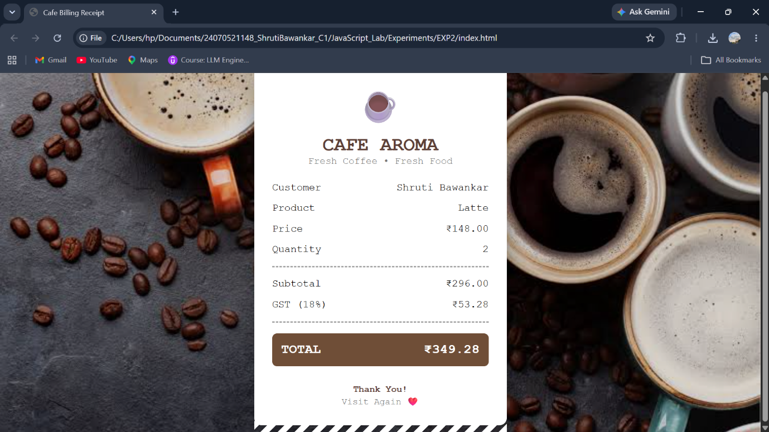

Result: A billing calculator was successfully developed using JavaScript. It accepted user input, calculated the subtotal, GST (18%), and total amount, and displayed a formatted billing receipt on the web page.
Conclusion: The experiment demonstrated the use of var, let, const, prompt(), template literals, and object destructuring to create an interactive and user-friendly billing application.

Case Study No.: 2
Title: Develop the webpage for an online shopping website with using HTML,CSS and HTML5 tags and calculate the bill using Customer Name, Mobile number, Invoice Number, Product Name, Quality (in Kgs), Rate per Kg(Rs), Discount(%), GST(%), Packing Charges(Rs), Payment Mode (Cash/Card/UPI).
Software/Tools Required: HTML5 , CSS3 , JavaScript , Visual Studio Code , Google Chrome
index.html:
<!DOCTYPE html>
<html lang="en">
<head>
<meta charset="UTF-8">
<meta name="viewport" content="width=device-width, initial-scale=1.0">
<title>FreshMart - Smart Billing</title>
<link rel="stylesheet" href="style.css">
<link href="https://fonts.googleapis.com/css2?family=Roboto+Mono:wght@400;500;700&display=swap" rel="stylesheet">
<link rel="stylesheet"
href="https://cdnjs.cloudflare.com/ajax/libs/font-awesome/6.5.2/css/all.min.css">
</head>
<body>
<div class="container">
<header>
<div class="logo">
<h1>
<i class="fa-solid fa-cart-shopping"></i>
FreshMart
</h1>
<p>Fresh Fruits • Vegetables • Grocery</p>
</div>
<div class="title">
<h2>
<i class="fa-solid fa-receipt"></i>
Smart Billing
</h2>
</div>
</header>
<hr>
<main>
<section class="left-panel">
<h2>
🍎 Product Details
</h2>
<form id="billingForm">
<div class="input-group">
<label>
<i class="fa-solid fa-user"></i>
Customer Name
</label>
<input
type="text"
id="customerName"
placeholder="Enter customer name">
</div>
<div class="input-group">
<label>
<i class="fa-solid fa-mobile-screen-button"></i>
Mobile Number
</label>
<input
type="tel"
id="mobile"
maxlength="10"
placeholder="10 digit mobile number">
</div>
<div class="input-group">
<label>
<i class="fa-solid fa-cart-shopping"></i>
Product Name
</label>
<select id="product">
<option value="">Select Product</option>
<option value="Apple"
data-rate="250">
Apple
</option>
<option value="Banana"
data-rate="80">
Banana
</option>
<option value="Mango"
data-rate="180">
Mango
</option>
</select>
</div>
<div class="input-group">
<label>
<i class="fa-solid fa-weight-hanging"></i>
Quantity (Kg)
</label>
<input
type="number"
id="quantity"
min="1"
placeholder="Enter quantity">
</div>
<div class="input-group">
<label>
<i class="fa-solid fa-sack-dollar"></i>
Rate / Kg
</label>
<input
type="number"
id="rate"
readonly>
</div>
<div class="input-group">
<label>
<i class="fa-solid fa-star"></i>
Membership
</label>
<select id="member">
<option value="No">No</option>
<option value="Yes">Yes</option>
</select>
</div>
<div class="input-group">
<label>
<i class="fa-solid fa-credit-card"></i>
Payment Mode
</label>
<select id="payment">
<option>Cash</option>
<option>Card</option>
<option>UPI</option>
</select>
</div>
<div class="button-group">
<button
type="button"
id="calculateBtn">
Calculate Bill
</button>
<button
type="reset"
id="resetBtn">
Reset
</button>
</div>
</form>
</section>
<section class="right-panel">
<h2>
<i class="fa-solid fa-file-invoice"></i>
Invoice Summary
</h2>
<div class="invoice">
<p>
Invoice #
<span id="invoiceNo">
INV-1001
</span>
</p>
<p>
Date
<span id="currentDate"></span>
</p>
<p>
Customer
<span id="outCustomer">-</span>
</p>
<p>
Product
<span id="outProduct">-</span>
</p>
<hr>
<p>
Quantity
<span id="outQty">0 Kg</span>
</p>
<p>
Rate
<span id="outRate">₹0</span>
</p>
<hr>
<p>
Subtotal
<span id="subtotal">₹0</span>
</p>
<p>
Discount
<span id="discount">₹0</span>
</p>
<p>
GST (5%)
<span id="gst">₹0</span>
</p>
<p>
Packing
<span id="packing">₹50</span>
</p>
<hr>
<h3>
TOTAL
<span id="total">
₹0
</span>
</h3>
</div>
</section>
</main>
</div>
<script src="script.js"></script>
</body>
</html>
script.html:
const invoiceNo = document.getElementById("invoiceNo");
const currentDate = document.getElementById("currentDate");
const customerName = document.getElementById("customerName");
const mobile = document.getElementById("mobile");
const product = document.getElementById("product");
const quantity = document.getElementById("quantity");
const rate = document.getElementById("rate");
const member = document.getElementById("member");
const payment = document.getElementById("payment");
const calculateBtn = document.getElementById("calculateBtn");
const resetBtn = document.getElementById("resetBtn");
const outCustomer = document.getElementById("outCustomer");
const outProduct = document.getElementById("outProduct");
const outQty = document.getElementById("outQty");
const outRate = document.getElementById("outRate");
const subtotal = document.getElementById("subtotal");
const discount = document.getElementById("discount");
const gst = document.getElementById("gst");
const packing = document.getElementById("packing");
const total = document.getElementById("total");
invoiceNo.textContent =
"INV-" + Math.floor(1000 + Math.random() * 9000);
const today = new Date();
currentDate.textContent =
today.toLocaleDateString("en-GB", {
day: "numeric",
month: "long",
year: "numeric"
});
product.addEventListener("change", () => {
const selected =
product.options[product.selectedIndex];
const price =
selected.getAttribute("data-rate");
rate.value = price ? price : "";
});
calculateBtn.addEventListener("click", () => {
if (customerName.value.trim() === "") {
alert("Enter Customer Name");
customerName.focus();
return;
}
if (!/^[0-9]{10}$/.test(mobile.value)) {
alert("Enter Valid Mobile Number");
mobile.focus();
return;
}
if (product.value === "") {
alert("Select Product");
return;
}
if (quantity.value === "" || quantity.value <= 0) {
alert("Enter Quantity");
quantity.focus();
return;
}
const qty = Number(quantity.value);
const price = Number(rate.value);
const sub = qty * price;
let discountAmount = 0;
if (member.value === "Yes") {
discountAmount = sub * 0.10;
}
const afterDiscount =
sub - discountAmount;
const gstAmount =
afterDiscount * 0.05;
const packingCharge = 50;
const finalTotal =
afterDiscount + gstAmount + packingCharge;
outCustomer.textContent =
customerName.value;
outProduct.textContent =
product.value;
outQty.textContent =
qty + " Kg";
outRate.textContent =
"₹" + price.toFixed(2);
subtotal.textContent =
"₹" + sub.toFixed(2);
discount.textContent =
"₹" + discountAmount.toFixed(2);
gst.textContent =
"₹" + gstAmount.toFixed(2);
packing.textContent =
"₹" + packingCharge.toFixed(2);
total.textContent =
"₹" + finalTotal.toFixed(2);
});
resetBtn.addEventListener("click", () => {
rate.value = "";
outCustomer.textContent = "-";
outProduct.textContent = "-";
outQty.textContent = "0 Kg";
outRate.textContent = "₹0";
subtotal.textContent = "₹0";
discount.textContent = "₹0";
gst.textContent = "₹0";
packing.textContent = "₹50";
total.textContent = "₹0";
invoiceNo.textContent =
"INV-" + Math.floor(1000 + Math.random() * 9000);
currentDate.textContent =
new Date().toLocaleDateString("en-GB", {
day: "numeric",
month: "long",
year: "numeric"
});
});
Style.css :
*{
margin:0;
padding:0;
box-sizing:border-box;
font-family:'Roboto Mono', monospace;
}
body{
margin: 0;
padding: 40px 20px;
font-family: 'Roboto Mono', monospace;
background: url("images/background.jpg") no-repeat center center fixed;
background-size: cover;
display: flex;
justify-content: center;
align-items: center;
min-height: 100vh;
color: white;
}
.container{
width: 1200px;
max-width: 100%;
background: rgba(0, 0, 0, 0.65);
backdrop-filter: blur(12px);
-webkit-backdrop-filter: blur(12px);
border: 1px solid rgba(255,255,255,0.2);
border-radius: 15px;
padding: 35px;
box-shadow: 0 10px 30px rgba(0,0,0,0.5);
}
header{
display:flex;
justify-content:space-between;
align-items:flex-start;
margin-bottom:25px;
}
.logo h1{
font-size:32px;
margin-bottom:12px;
color:#ffffff;
}
.logo p{
font-size:18px;
color:#dddddd;
font-weight:500;
}
.title h2{
font-size:30px;
color:#ffffff;
}
hr{
border:none;
border-top:2px solid #8a8a8a;
margin:25px 0;
}
main{
display:grid;
grid-template-columns:1fr 1fr;
gap:70px;
}
.left-panel h2,
.right-panel h2{
margin-bottom:25px;
font-size:28px;
}
#billingForm,
.invoice{
background: rgba(255,255,255,0.05);
border: 1px solid rgba(255,255,255,0.2);
border-radius: 12px;
padding: 30px;
backdrop-filter: blur(8px);
}
.input-group{
margin-bottom:22px;
}
.input-group label{
display:block;
font-size:20px;
margin-bottom:8px;
font-weight:bold;
}
.input-group label i{
width:28px;
}
.input-group input,
.input-group select{
width:100%;
padding:13px;
font-size:18px;
color:rgb(0, 0, 0);
background:rgba(255,255,255,0.08);
border:1px solid rgba(255,255,255,0.25);
border-radius:8px;
outline:none;
transition:.3s;
}
.input-group input:focus,
.input-group select:focus{
border-color:#4CAF50;
box-shadow:0 0 12px rgba(76,175,80,.4);
}
.button-group{
margin-top:35px;
display:flex;
gap:18px;
}
.button-group button{
flex:1;
padding:15px;
font-size:18px;
color:white;
background:#4CAF50;
border:none;
border-radius:8px;
cursor:pointer;
transition:.3s;
}
.button-group button:hover{
transform:translateY(-3px);
background:#2E7D32;
box-shadow:0 8px 20px rgba(76,175,80,.4);
}
#billingForm:hover,
.invoice:hover{
transform:translateY(-5px);
transition:.3s;
box-shadow:0 10px 25px rgba(0,0,0,.4);
}
.invoice{
border:2px solid #d9d9d9;
padding:30px;
}
.invoice p{
display:flex;
justify-content:space-between;
margin:18px 0;
font-size:20px;
}
.invoice h3{
display:flex;
justify-content:space-between;
margin-top:25px;
font-size:30px;
color:#FFD54F;
}
.invoice hr{
margin:20px 0;
border-top:1px dashed #999;
}
footer{
margin-top:45px;
text-align:center;
font-size:22px;
font-weight:bold;
}
::placeholder{
color:#b8b8b8;
}
::-webkit-scrollbar{
width:10px;
}
::-webkit-scrollbar-track{
background:#222;
}
::-webkit-scrollbar-thumb{
background:#555;
}
::-webkit-scrollbar-thumb:hover{
background:#777;
}
@media(max-width:900px){
header{
flex-direction:column;
gap:20px;
}
main{
grid-template-columns:1fr;
}
.button-group{
flex-direction:column;
}
.logo h1{
font-size:28px;
}
.title h2{
font-size:26px;
}
.left-panel h2,
.right-panel h2{
font-size:24px;
}
.invoice p{
font-size:18px;
}
.invoice h3{
font-size:26px;
}
}
@media(max-width:600px){
body{
padding:20px 10px;
}
#billingForm,
.invoice{
padding:20px;
}
.input-group label{
font-size:18px;
}
.input-group input,
.input-group select{
font-size:16px;
}
footer{
font-size:18px;
}
}

Output :

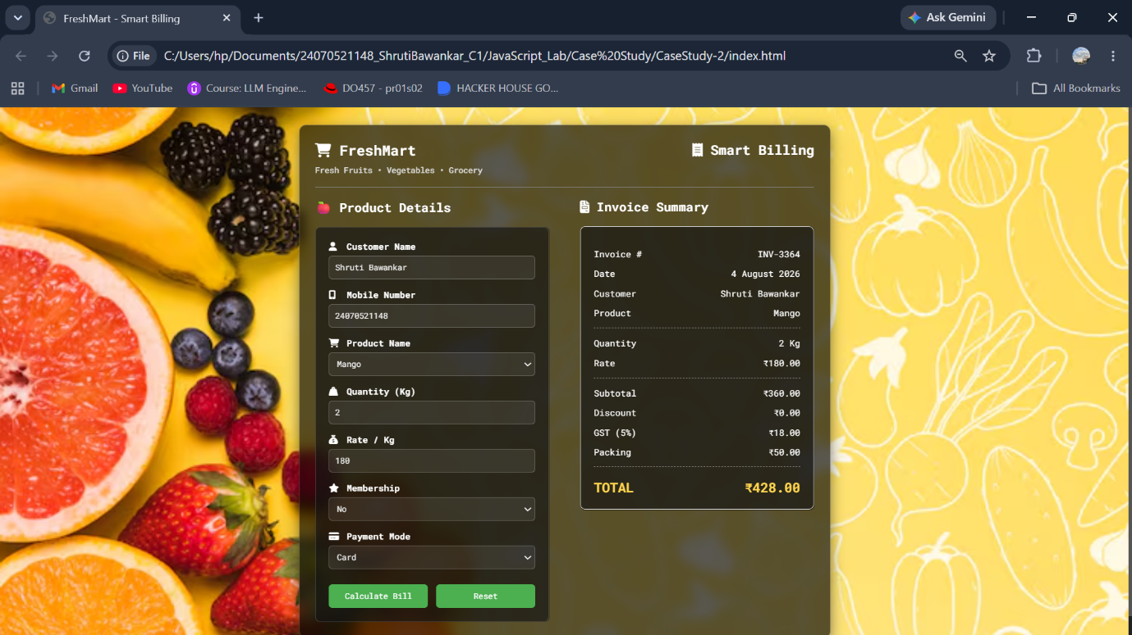

Result: The FreshMart Smart Billing System was successfully developed with a responsive user interface that accurately calculates the bill, applies discounts, GST, and packing charges, and generates a printable invoice.
Conclusion: The experiment demonstrated the use of HTML, CSS, and JavaScript to create an interactive and user-friendly e-commerce billing application with real-time calculations and form validation.

Experiment No.: 3
Title: Implement control structures and form validation; create a grading system based on user-entered marks.
Software/Tools Required: HTML5, CSS3, JavaScript, VS Code, Google Chrome
Index.html:
<!DOCTYPE html>
<html lang="en">
<head>
<meta charset="UTF-8">
<meta name="viewport" content="width=device-width, initial-scale=1.0">
<title>Student Grading System</title>
<link rel="stylesheet" href="style.css">
</head>
<body>
<div class="container">
<h1>Student Grading System</h1>
<form id="gradeForm">
<div class="input-group">
<label>Student Name</label>
<input type="text" id="studentName" placeholder="Enter Student Name">
</div>
<div class="input-group">
<label>Roll Number</label>
<input type="text" id="rollNumber" placeholder="Enter Roll Number">
</div>
<div class="input-group">
<label>Javascript</label>
<input type="number" id="javascript" min="0" max="100">
</div>
<div class="input-group">
<label>Computer Networks</label>
<input type="number" id="computer-networks" min="0" max="100">
</div>
<div class="input-group">
<label>Compiler Construction</label>
<input type="number" id="compiler-construction" min="0" max="100">
</div>
<div class="input-group">
<label>Data Compression</label>
<input type="number" id="data-compression" min="0" max="100">
</div>
<div class="input-group">
<label>Specialization(Data Science/AI/ML)</label>
<input type="number" id="specialization" min="0" max="100">
</div>
<button type="submit">Calculate Result</button>
</form>
<div id="result"></div>
</div>
<script src="script.js"></script>
</body>
</html>
Style.css:
*{
margin:0;
padding:0;
box-sizing:border-box;
font-family: Ballance;
}
body{
background:linear-gradient(135deg,#99c6ee,#a4e5f0);
display:flex;
justify-content:center;
align-items:center;
min-height:100vh;
}
.container{
width: 1000px;
background:#c7e0f4;
padding:30px;
border-radius:15px;
box-shadow:0 10px 25px rgba(0,0,0,.2);
}
h1{
text-align:center;
margin-bottom:25px;
color:#0e0e0f;
}
.input-group{
margin-bottom:15px;
}
label{
display:block;
margin-bottom:6px;
font-weight:bold;
}
input{
width:100%;
padding:10px;
border:1px solid #d2e4fd;
border-radius:8px;
font-size:15px;
}
input:focus{
outline:none;
border-color:#0d6efd;
}
button{
width:100%;
padding:12px;
background:#0c48a1;
color:white;
border:none;
border-radius:8px;
font-size:16px;
cursor:pointer;
}
button:hover{
background:#084298;
}
#result{
margin-top:20px;
display:none;
padding:15px;
background:#f5f8ff;
border-radius:10px;
}
table{
width:100%;
border-collapse:collapse;
}
td{
padding:10px;
border-bottom:1px solid #ddd;
}
.success{
color:green;
font-weight:bold;
}
.fail{
color:red;
font-weight:bold;
}
Script.js:
const gradeForm = document.getElementById("gradeForm");
gradeForm.addEventListener("submit", function (event) {
event.preventDefault();
const name = document.getElementById("studentName").value.trim();
const rollNumber = document.getElementById("rollNumber").value.trim();
const javascript = Number(document.getElementById("javascript").value);
const computerNetworks = Number(document.getElementById("computer
networks").value);
const compilerConstruction = Number(document.getElementById("compiler
construction").value);
const dataCompression = Number(document.getElementById("data-compression").value);
const specialization = Number(document.getElementById("specialization").value);
const marks = [
javascript,
computerNetworks,
compilerConstruction,
dataCompression,
specialization
];
if (name === "") {
alert("Please enter Student Name.");
return;
}
if (rollNumber === "") {
alert("Please enter Roll Number.");
return;
}
for (let mark of marks) {
if (isNaN(mark)) {
alert("Please enter all subject marks.");
return;
}
if (mark < 0 || mark > 100) {
alert("Marks should be between 0 and 100.");
return;
}
}
const total = marks.reduce((sum, mark) => sum + mark, 0);
const percentage = (total / 500) * 100;
let status = "Pass";
for (let mark of marks) {
if (mark < 35) {
status = "Fail";
break;
}
}
let grade;
if (status === "Fail") {
grade = "F";
} else if (percentage >= 90) {
grade = "A+";
} else if (percentage >= 80) {
grade = "A";
} else if (percentage >= 70) {
grade = "B";
} else if (percentage >= 60) {
grade = "C";
} else if (percentage >= 50) {
grade = "D";
} else {
grade = "F";
}
let remarks;
switch (grade) {
case "A+":
remarks = "Outstanding";
break;
case "A":
remarks = "Excellent";
break;
case "B":
remarks = "Very Good";
break;
case "C":
remarks = "Good";
break;
case "D":
remarks = "Needs Improvement";
break;
default:
remarks = "Better Luck Next Time";
}
const studentResult = {
name,
rollNumber,
total,
percentage: percentage.toFixed(2),
grade,
status,
remarks
};
localStorage.setItem("studentResult", JSON.stringify(studentResult));
displayResult(studentResult);
});
function displayResult(data) {
const result = document.getElementById("result");
result.style.display = "block";
result.innerHTML = `
<h2 style="text-align:center; margin-bottom:15px;">
Student Result
</h2>
<table>
<tr>
<td><strong>Student Name</strong></td>
<td>${data.name}</td>
</tr>
<tr>
<td><strong>Roll Number</strong></td>
<td>${data.rollNumber}</td>
</tr>
<tr>
<td><strong>Total Marks</strong></td>
<td>${data.total} / 500</td>
</tr>
<tr>
<td><strong>Percentage</strong></td>
<td>${data.percentage}%</td>
</tr>
<tr>
<td><strong>Grade</strong></td>
<td>${data.grade}</td>
</tr>
<tr>
<td><strong>Status</strong></td>
<td class="${data.status === "Pass" ? "success" : "fail"}">
${data.status}
</td>
</tr>
<tr>
<td><strong>Remarks</strong></td>
<td>${data.remarks}</td>
</tr>
</table>
`; }
window.onload = function () {
const savedData = localStorage.getItem("studentResult");
if (savedData) {
displayResult(JSON.parse(savedData));
} };
Output:
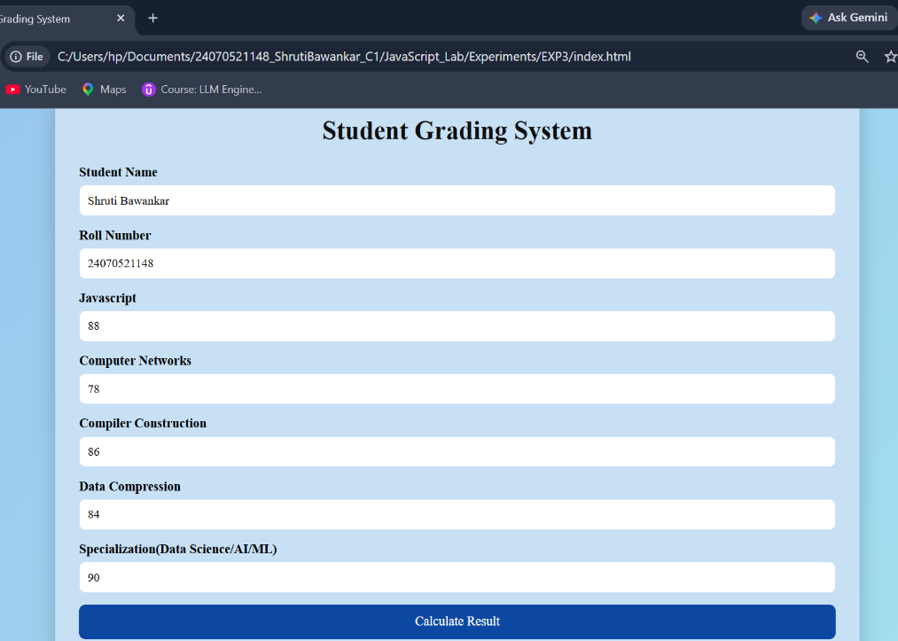
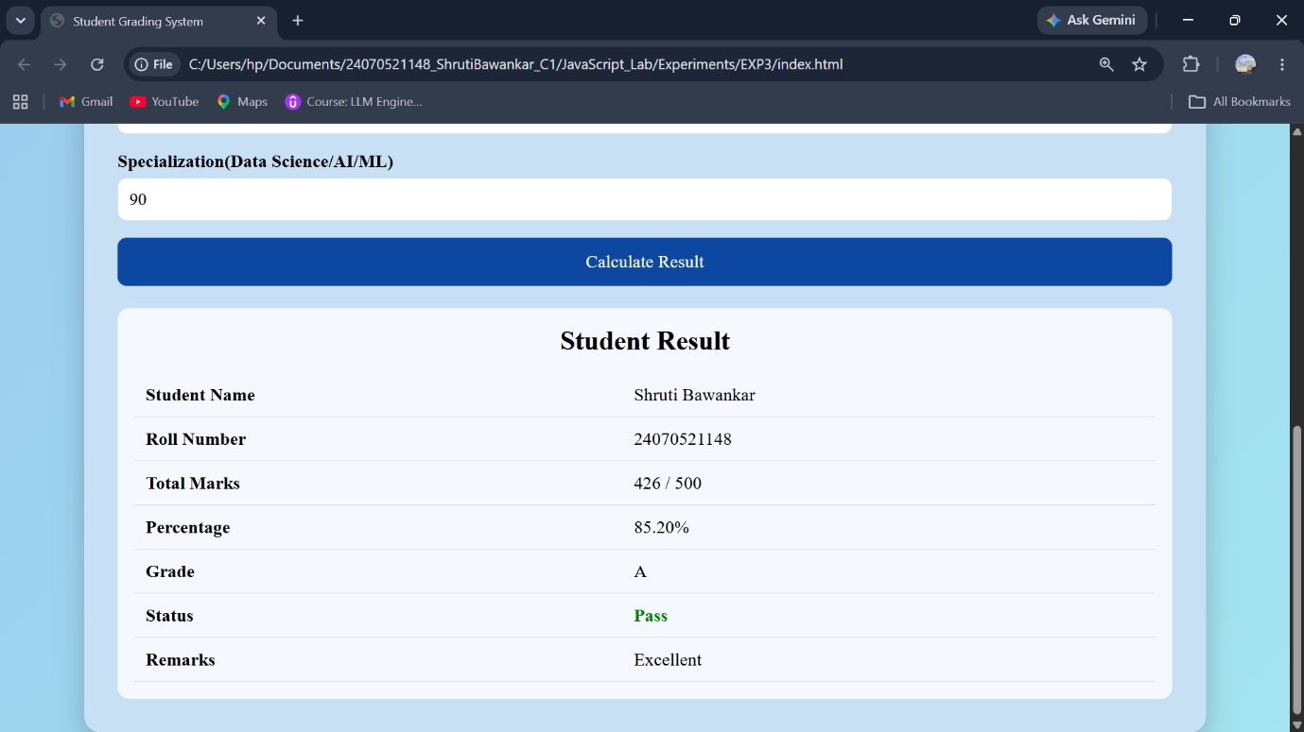

Result: The Student Grading System was successfully implemented using HTML, CSS, and JavaScript. It validates user input, calculates the percentage, assigns grades using control structures, and displays the result accurately on a separate result page.
Conclusion: The Student Grading System successfully demonstrates the use of HTML, CSS, and JavaScript to create an interactive web application. It implements form validation, control structures, loops, and Local Storage to process user input and generate an accurate student result. The project provides a professional and user-friendly interface while reinforcing fundamental concepts of client-side web development.

Case Study No.: 3
Title: Student Grading System with Login Authentication and Form Validation using HTML, CSS, and JavaScript
Software/Tools Required: HTML5 , CSS3 , JavaScript , Visual Studio Code , Google Chrome
Index.html:
<!DOCTYPE html>
<html lang="en">
<head>
<meta charset="UTF-8">
<meta name="viewport" content="width=device-width, initial-scale=1.0">
<title>Student Grading System</title>
<link rel="stylesheet" href="style.css">
</head>
<body>
<div class="container">
<h1>Enter Subject Marks</h1>
<form id="gradeForm">
<div class="input-group">
<label>JavaScript</label>
<input
type="number"
id="javascript"
placeholder="Enter Marks"
min="0"
max="100"
required
>
</div>
<div class="input-group">
<label>Computer Networks</label>
<input
type="number"
id="computer-networks"
placeholder="Enter Marks"
min="0"
max="100"
required
>
</div>
<div class="input-group">
<label>Compiler Construction</label>
<input
type="number"
id="compiler-construction"
placeholder="Enter Marks"
min="0"
max="100"
required
>
</div>
<div class="input-group">
<label>Data Compression</label>
<input
type="number"
id="data-compression"
placeholder="Enter Marks"
min="0"
max="100"
required
>
</div>
<div class="input-group">
<label>Specialization (AI / ML / Data Science)</label>
<input
type="number"
id="specialization"
placeholder="Enter Marks"
min="0"
max="100"
required
>
</div>
<button type="submit">
Generate Result
</button>
<button type="reset" class="reset-btn">
Reset
</button>
</form>
</div>
<script src="script.js"></script>
</body>
</html>
Login.html:
<!DOCTYPE html>
<html lang="en">
<head>
<meta charset="UTF-8">
<meta name="viewport" content="width=device-width, initial-scale=1.0">
<title>Student Login</title>
<link rel="stylesheet" href="style.css">
</head>
<body>
<div class="container">
<h1>Student Login</h1>
<form id="loginForm">
<div class="input-group">
<label>Student Name</label>
<input
type="text"
id="studentName"
placeholder="Enter Student Name"
required
>
</div>
<div class="input-group">
<label>PRN Number</label>
<input
type="text"
id="prn"
placeholder="Enter PRN Number"
required
>
</div>
<div class="input-group">
<label>Password</label>
<input
type="password"
id="password"
placeholder="Enter Password"
required
>
</div>
<button type="submit">
Login
</button>
</form>
<p
id="message"
style="
text-align:center;
margin-top:20px;
color:red;
font-weight:bold;">
</p>
</div>
<script src="login.js"></script>
</body>
</html>

Login.js:
const loginForm = document.getElementById("loginForm");
loginForm.addEventListener("submit", function(event){
event.preventDefault();
const studentName = document.getElementById("studentName").value.trim();
const prn = document.getElementById("prn").value.trim();
const password = document.getElementById("password").value;
const message = document.getElementById("message");
message.innerHTML = "";

if(studentName === ""){
message.innerHTML = "Please enter Student Name.";
return;
}
if(prn === ""){
message.innerHTML = "Please enter PRN Number.";
return;
}

if(!/^[0-9]+$/.test(prn)){
message.innerHTML = "PRN should contain only digits.";
return;
}
if(password.length < 8){
message.innerHTML =
"Password must contain at least 8 characters.";
return;
}
if(!/[A-Z]/.test(password)){
message.innerHTML =
"Password must contain at least one uppercase letter.";
return;
}
if(!/[a-z]/.test(password)){
message.innerHTML =
"Password must contain at least one lowercase letter.";
return;
}
if(!/[0-9]/.test(password)){
message.innerHTML =
"Password must contain at least one number.";
return;
}
if(!/[!@#$%^&*(),.?":{}|<>]/.test(password)){
message.innerHTML =
"Password must contain at least one special character.";
return;
}
const student = {
name: studentName,
prn: prn
};
localStorage.setItem(
"loggedInStudent",
JSON.stringify(student)
);
window.location.href = "index.html";
});

Result.html:
<!DOCTYPE html>
<html lang="en">
<head>
<meta charset="UTF-8">
<meta name="viewport"
content="width=device-width, initial-scale=1.0">
<title>Student Result</title>
<link rel="stylesheet" href="style.css">
</head>
<body>
<div class="container result-container">
<h1>Student Grade Report</h1>
<div id="resultCard">
<!-- Result will be loaded here -->
</div>
<div class="button-group">
<button onclick="goBack()">
Back
</button>
</div>
</div>
<script src="result.js"></script>
</body>
</html>

Result.js:
const student = JSON.parse(localStorage.getItem("studentResult"));
const resultCard = document.getElementById("resultCard");
if (student === null) {
resultCard.innerHTML = `
<h2 style="color:red;text-align:center;">
No Student Data Found
</h2>
<p style="text-align:center;">
Please enter student details first.
</p>
`;
}
else {
resultCard.innerHTML = `
<table>
<tr>
<th colspan="2">
Student Information
</th>
</tr>
<tr>
<td><strong>Student Name</strong></td>
<td>${student.studentName}</td>
</tr>
<tr>
<td><strong>Roll Number</strong></td>
<td>${student.rollNumber}</td>
</tr>
</table>
<br>
<table>
<tr>
<th>Subject</th>
<th>Marks</th>
</tr>
<tr>
<td>JavaScript</td>
<td>${student.javascript}</td>
</tr>
<tr>
<td>Computer Networks</td>
<td>${student.computerNetworks}</td>
</tr>
<tr>
<td>Compiler Construction</td>
<td>${student.compilerConstruction}</td>
</tr>
<tr>
<td>Data Compression</td>
<td>${student.dataCompression}</td>
</tr>
<tr>
<td>Specialization</td>
<td>${student.specialization}</td>
</tr>
</table>
<br>
<table>
<tr>
<th colspan="2">
Result Summary
</th>
</tr>
<tr>
<td><strong>Total Marks</strong></td>
<td>${student.total} / 500</td>
</tr>
<tr>
<td><strong>Percentage</strong></td>
<td>${student.percentage}%</td>
</tr>
<tr>
<td><strong>Grade</strong></td>
<td class="grade">${student.grade}</td>
</tr>
<tr>
<td><strong>Status</strong></td>
<td class="${student.status === "Pass" ? "success" : "fail"}">
${student.status}
</td>
</tr>
<tr>
<td><strong>Remarks</strong></td>
<td>${student.remarks}</td>
</tr>
</table>
`;
}
function goBack() {
window.location.href = "index.html";
}

Script.js:
const loginStudent = JSON.parse(localStorage.getItem("loggedInStudent"));
if (!loginStudent) {
window.location.href = "login.html";
}
const gradeForm = document.getElementById("gradeForm");
gradeForm.addEventListener("submit", function (event) {
event.preventDefault();
const studentName = loginStudent.name;
const rollNumber = loginStudent.prn;
const javascript = Number(document.getElementById("javascript").value);
const computerNetworks = Number(document.getElementById("computer-networks").value);
const compilerConstruction = Number(document.getElementById("compiler-construction").value);
const dataCompression = Number(document.getElementById("data-compression").value);
const specialization = Number(document.getElementById("specialization").value);
const marks = [
javascript,
computerNetworks,
compilerConstruction,
dataCompression,
specialization
];
const subjectNames = [
"JavaScript",
"Computer Networks",
"Compiler Construction",
"Data Compression",
"Specialization"
];
for (let i = 0; i < marks.length; i++) {
if (isNaN(marks[i])) {
alert("Please enter " + subjectNames[i] + " marks.");
return;
}
if (marks[i] < 0 || marks[i] > 100) {
alert(subjectNames[i] + " marks should be between 0 and 100.");
return;
}
}
let total = 0;
for (let mark of marks) {
total += mark;
}
const percentage = (total / 500) * 100;
let status = "Pass";
for (let mark of marks) {
if (mark < 35) {
status = "Fail";
break;
}
}
let grade = "";
if (status === "Fail") {
grade = "F";
}
else if (percentage >= 90) {
grade = "A+";
}
else if (percentage >= 80) {
grade = "A";
}
else if (percentage >= 70) {
grade = "B";
}
else if (percentage >= 60) {
grade = "C";
}
else if (percentage >= 50) {
grade = "D";
}
else {
grade = "F";
}
let remarks = "";
switch (grade) {
case "A+":
remarks = "Outstanding";
break;
case "A":
remarks = "Excellent";
break;
case "B":
remarks = "Very Good";
break;
case "C":
remarks = "Good";
break;
case "D":
remarks = "Needs Improvement";
break;
default:
remarks = "Better Luck Next Time";
}
const studentResult = {
studentName,
rollNumber,
javascript,
computerNetworks,
compilerConstruction,
dataCompression,
specialization,
total,
percentage: percentage.toFixed(2),
grade,
status,
remarks
};
localStorage.setItem(
"studentResult",
JSON.stringify(studentResult)
);
window.location.href = "result.html";
});

Style.css:
*{
margin:0;
padding:0;
box-sizing:border-box;
font-family: Ballance;
}

body{
background:linear-gradient(135deg,#99c6ee,#a4e5f0);
display:flex;
justify-content:center;
align-items:center;
min-height:100vh;
}

.container{
width: 1000px;
background:#c7e0f4;
padding:30px;
border-radius:15px;
box-shadow:0 10px 25px rgba(0,0,0,.2);
}

h1{
text-align:center;
margin-bottom:25px;
color:#0e0e0f;
}

.input-group{
margin-bottom:15px;
}

label{
display:block;
margin-bottom:6px;
font-weight:bold;
}

input{
width:100%;
padding:10px;
border:1px solid #d2e4fd;
border-radius:8px;
font-size:15px;
}

input:focus{
outline:none;
border-color:#0d6efd;
}

button{
width:100%;
padding:12px;
background:#0c48a1;
color:white;
border:none;
border-radius:8px;
font-size:16px;
cursor:pointer;
}

button:hover{
background:#084298;
}

#result{
margin-top:20px;
display:none;
padding:15px;
background:#f5f8ff;
border-radius:10px;
}

table{
width:100%;
border-collapse:collapse;
}

td{
padding:10px;
border-bottom:1px solid #ddd;
}

.success{
color:green;
font-weight:bold;
}
.fail{
color:red;
font-weight:bold;
}

Output:
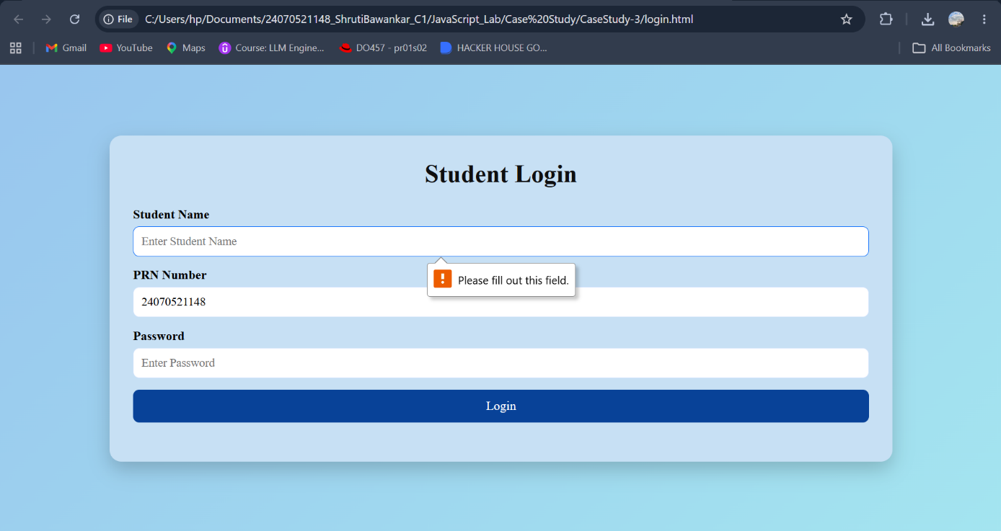
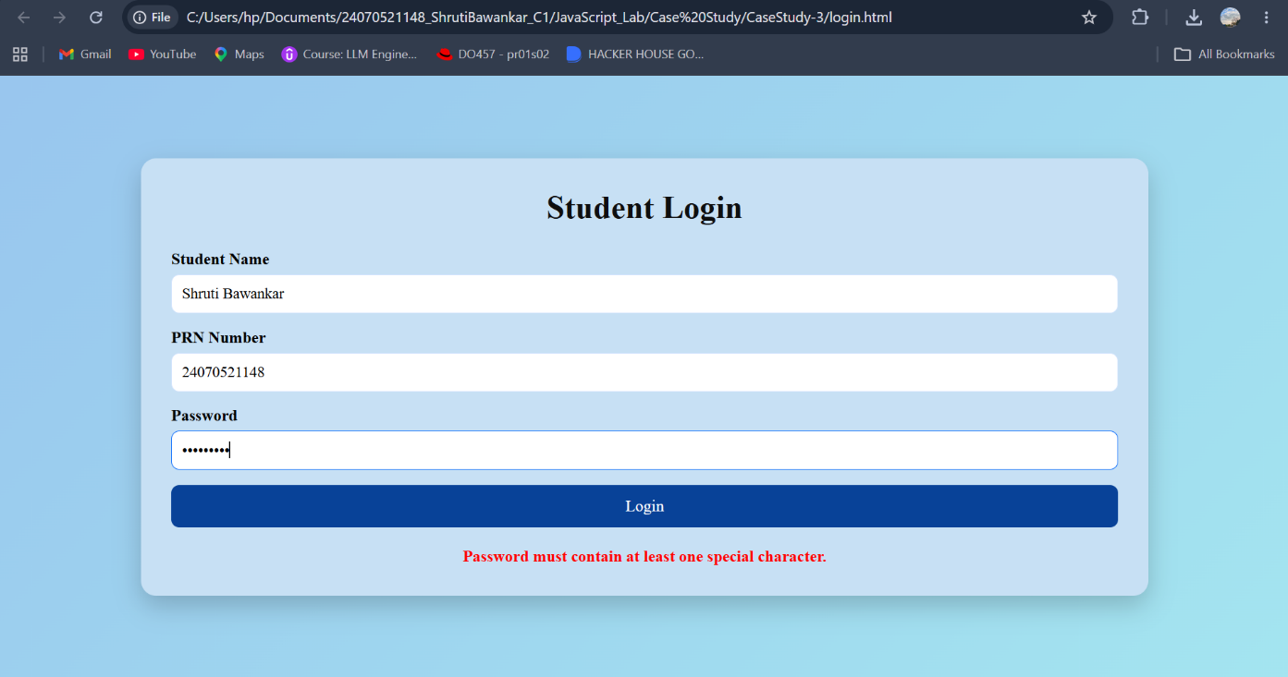
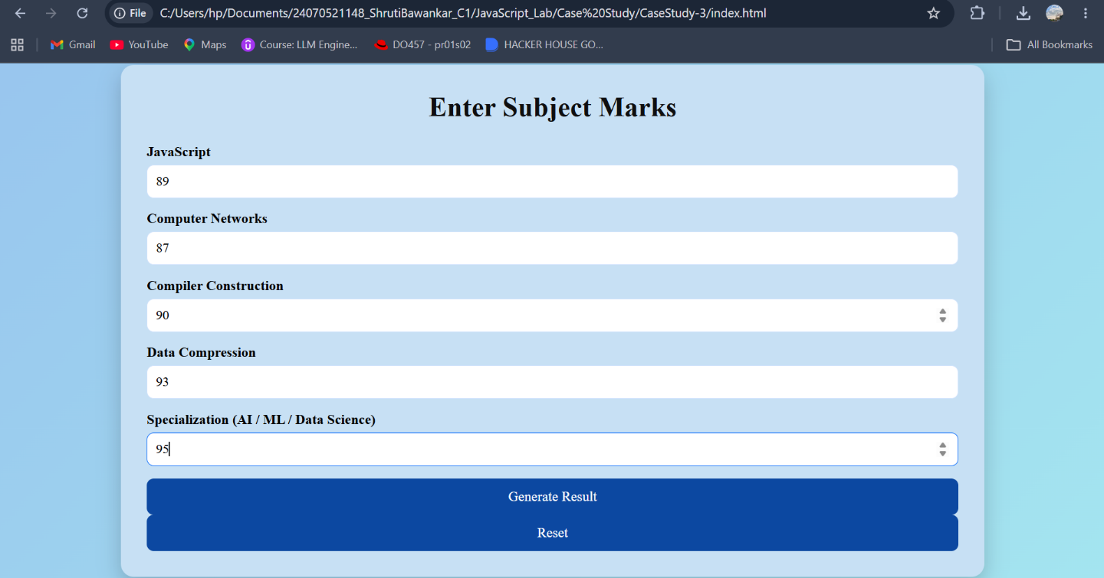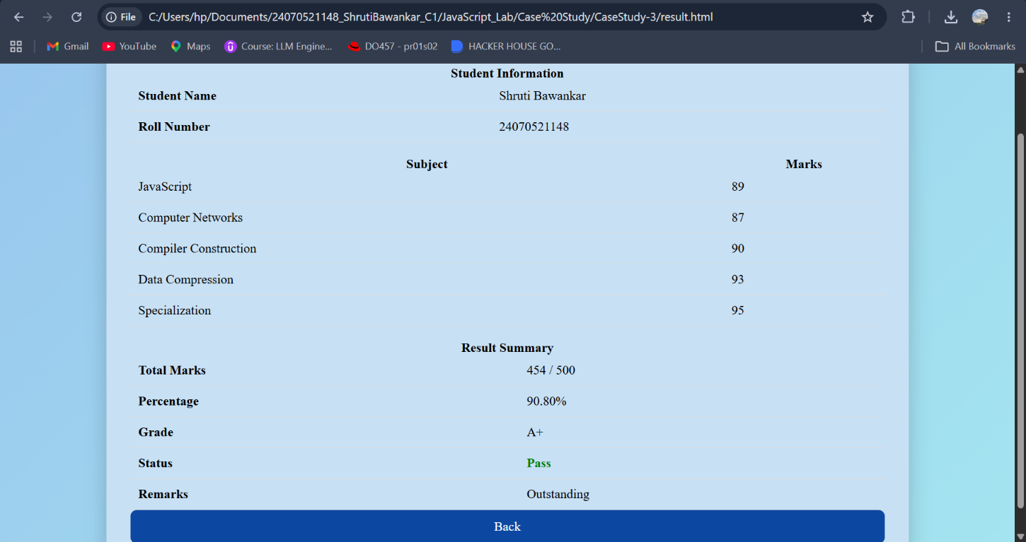
Result: The Student Grading System was successfully developed to validate user credentials, process student marks, calculate grades, and display the results accurately on a separate result page.
Conclusion: This project successfully demonstrates the implementation of JavaScript form validation and control structures, providing a simple, secure, and user-friendly web application for student result management.
Experiment No.: 4
Title: Use function types, scope, and closures; apply try-catch; build a palindrome checker.
Software/Tools Required: HTML5, CSS3, JavaScript, VS Code, Google Chrome
Index.html:
<!DOCTYPE html>
<html lang="en">
<head>
<meta charset="UTF-8">
<meta name="viewport" content="width=device-width, initial-scale=1.0">
<title>Palindrome Checker</title>
<style>
body {
font-family: Georgia, sans-serif;
background: #f8f2d9;
display: flex;
justify-content: center;
align-items: center;
height: 100vh;
}
.container {
background: white;
padding: 25px;
border-radius: 10px;
width: 350px;
box-shadow: 0px 0px 10px rgb(27, 21, 21);
text-align: center;
}
input {
width: 90%;
padding: 10px;
margin: 10px 0;
font-size: 16px;
}
button {
padding: 10px 20px;
background: royalblue;
color: white;
border: none;
border-radius: 5px;
cursor: pointer;
}
button:hover {
background: darkblue;
}
#result {
margin-top: 20px;
font-size: 18px;
font-weight: bold;
}
#counter {
color: green;
margin-top: 10px;
}
</style>
</head>
<body>
<div class="container">
<h2>Palindrome Checker</h2>
<input type="text" id="word" placeholder="Enter a word">
<br>
<button onclick="checkPalindrome()">Check</button>
<p id="result"></p>
<p id="counter"></p>
</div>
<script src="script.js"></script>
</body>
</html>

Script.js:
let appName = "Palindrome Checker";
function visitCounter() {
let count = 0;
return function () {
count++;
return count;
};
}
const counter = visitCounter();
function isPalindrome(text) {
let cleaned = text.toLowerCase().replace(/[^a-z0-9]/g, "");
let reversed = cleaned.split("").reverse().join("");
return cleaned === reversed;
}
const displayMessage = function(message, color) {
const result = document.getElementById("result");
result.innerHTML = message;
result.style.color = color;

};
const updateCounter = () => {
document.getElementById("counter").innerHTML =
"Checked " + counter() + " time(s)";
};
function checkPalindrome() {
try {
let input = document.getElementById("word").value;
if (input.trim() === "") {
throw "Input cannot be empty.";
}
if (isPalindrome(input)) {
displayMessage(
`"${input}" is a Palindrome`,
"green"
);
} else {
displayMessage(
`"${input}" is NOT a Palindrome`,
"red"
);
}
updateCounter();
}
catch(error) {
displayMessage(error, "orange");
}
}

Output:
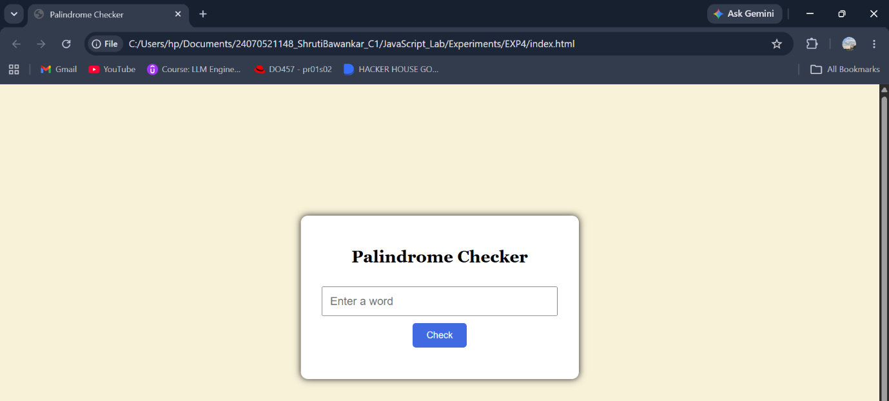
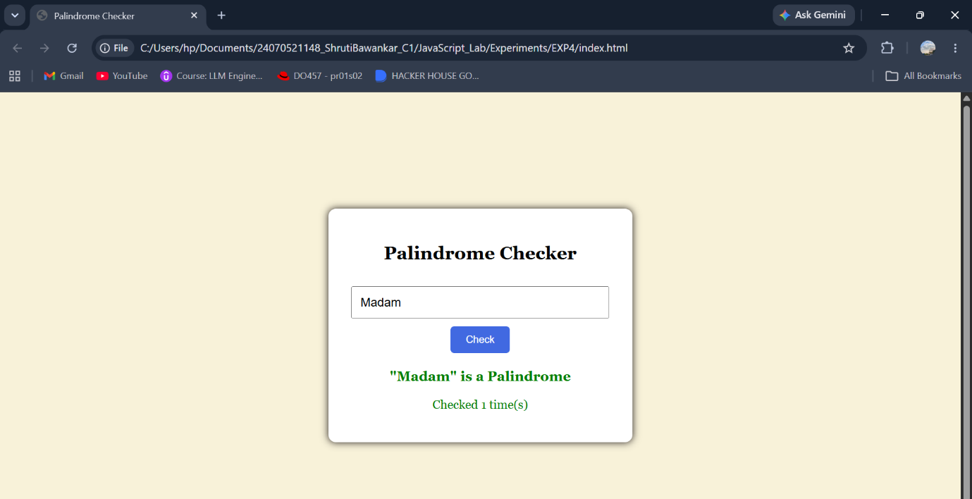
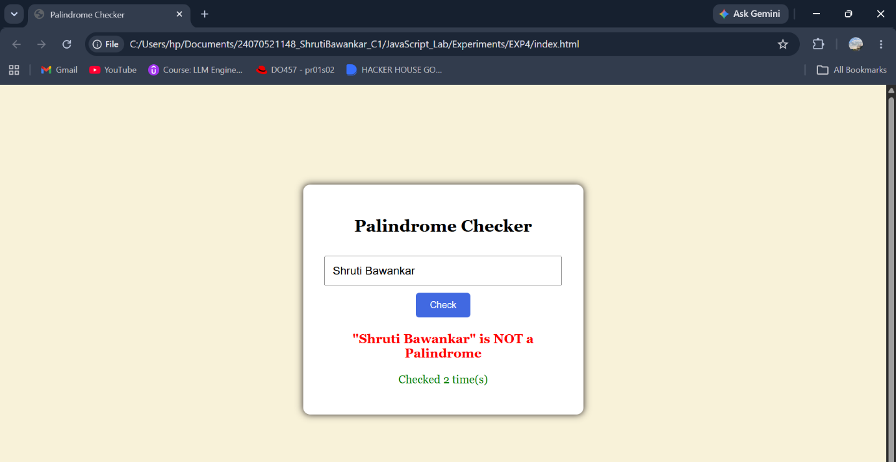
Result: The palindrome checker successfully identifies whether the entered text is a palindrome or not and displays the result while handling invalid input using try...catch.
Conclusion: The program effectively demonstrates JavaScript function types, scope, closures, and exception handling through a simple and user-friendly palindrome checking application.

Experiment No.: 4
Title: Use function types, scope, and closures; apply try-catch; build a password strength checker using palindrome then display strong or weak password and generate a html and js code.
Software/Tools Required: HTML5, CSS3, JavaScript, VS Code, Google Chrome
Index.html:
<!DOCTYPE html>
<html lang="en">
<head>
<meta charset="UTF-8">
<meta name="viewport" content="width=device-width, initial-scale=1.0">
<title>Password Strength Checker</title>
<style>
*{
margin:0;
padding:0;
box-sizing:border-box;
font-family:'Lucida Console', 'Monaco', monospace;
}
body{
height:100vh;
display:flex;
justify-content:center;
align-items:center;
background:linear-gradient(135deg,#89949810,#84b2da);
}
.container{
width:400px;
background:white;
border-radius:18px;
padding:35px;
text-align:center;
box-shadow:
0 15px 35px rgba(0,0,0,0.2);
}
.icon{
font-size:55px;
margin-bottom:10px;
}
h2{
color:#333;
margin-bottom:8px;
}
p.subtitle{
color:#777;
margin-bottom:25px;
font-size:14px;
}
.input-box{
position:relative;
}
input{
width:100%;
padding:14px 16px;
border:2px solid #ddd;
border-radius:10px;
outline:none;
font-size:16px;
transition:.3s;
}
input:focus{
border-color:#33a060;
}
button{
width:100%;
margin-top:18px;
padding:14px;
border:none;
border-radius:10px;
background:#667eea;
color:white;
font-size:16px;
font-weight:600;
cursor:pointer;
transition:.3s;
}
button:hover{
background:#4f61d8;
transform:translateY(-2px);
}
#result{
margin-top:22px;
padding:14px;
border-radius:10px;
background:#f7f7f7;
font-size:17px;
font-weight:600;
min-height:55px;
display:flex;
justify-content:center;
align-items:center;
}
#count{
margin-top:15px;
color:#555;
font-size:14px;
}
.footer{
margin-top:20px;
font-size:12px;
color:#999;
}
</style>
</head>
<body>
<div class="container">
<div class="icon">🔐</div>
<h2>Password Strength Checker</h2>
<p class="subtitle">
A palindrome password is considered <b>Weak</b>.
Any other password is considered <b>Strong</b>.
</p>
<div class="input-box">
<input
type="password"
id="password"
placeholder="Enter your password">
</div>
<button onclick="checkPassword()">
Check Password
</button>
<div id="result">
Result will appear here...
</div>
<div id="count">
</div>
</div>
<script src="script.js"></script>
</body>
</html>
Script.js:
let appName = "Password Strength Checker";
function passwordCounter(){
let count = 0;
return function(){
count++;
return count;
};
}
const counter = passwordCounter();
function isPalindrome(password){
let reverse = password.split("").reverse().join("");
return password === reverse;
}
const displayResult = function(message, color){
const result = document.getElementById("result");
result.innerHTML = message;
result.style.color = color;
if(color === "green"){
result.style.background = "#e8f9ee";
result.style.border = "2px solid #28a745";
}
else if(color === "red"){
result.style.background = "#ffe8e8";
result.style.border = "2px solid #dc3545";
}
else{
result.style.background = "#fff4d6";
result.style.border = "2px solid #ff9800";
}
};
const updateCount = ()=>{
document.getElementById("count").innerHTML =
"Passwords Checked : " + counter();
};
function checkPassword(){
try{
let password = document.getElementById("password").value;
if(password.trim()==""){
throw "Password cannot be empty.";
}
if(password.length < 4){
throw "Password must contain at least 4 characters.";
}
if(isPalindrome(password)){
displayResult(
"Weak Password (Palindrome Password)",
"red"
);
}
else{
displayResult(
"Strong Password (Not a Palindrome)",
"green"
);
}
updateCount();
}
catch(error){
displayResult(error,"orange");
}
}

Output:

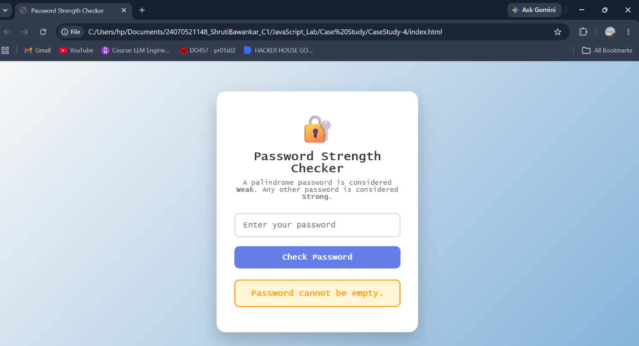
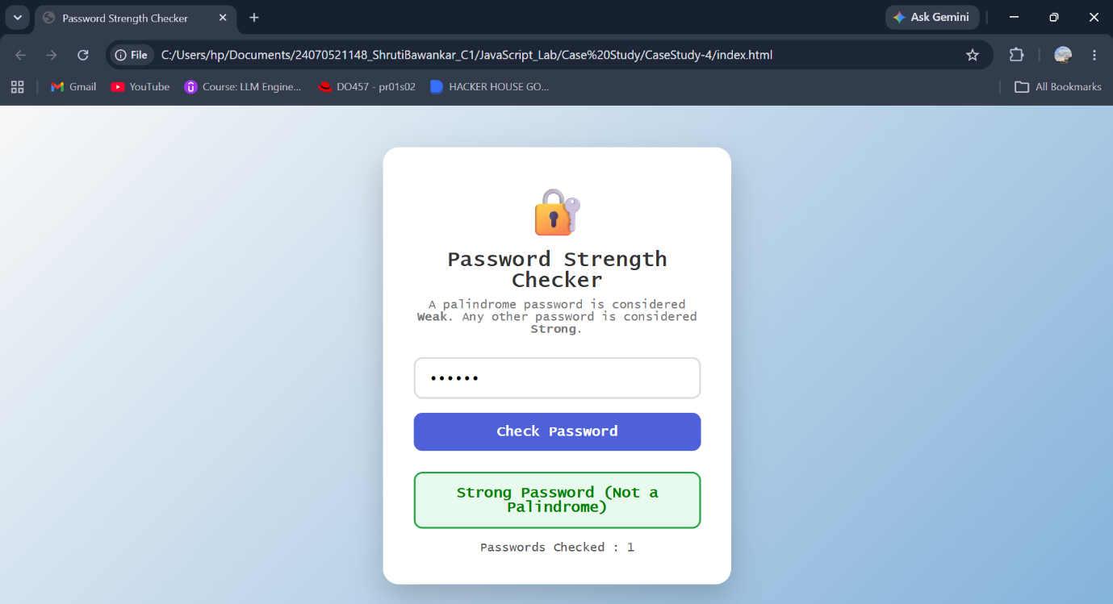
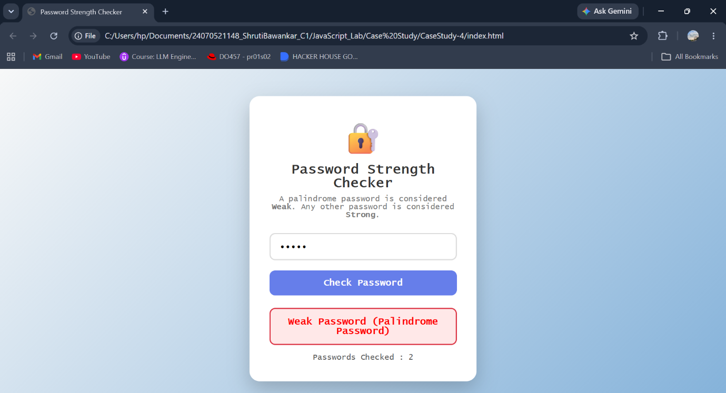

Result: The password checker successfully identifies whether a password is a palindrome and classifies it as Weak or Strong while handling invalid inputs using try...catch.
Conclusion: The program effectively demonstrates JavaScript function types, scope, closures, and exception handling through a simple and interactive password validation application.
Experiment No.: 5

Title
Interactive Arrays and Loops using JavaScript

Software/Tools Required
- HTML5 – To create the structure of the web page.
- CSS3 – To design and style the web page.
- JavaScript – To implement array manipulation and iteration methods.
- Visual Studio Code – For writing and editing the code.
- Web Browser – Google Chrome / Microsoft Edge for execution.

Codes

1. index.html
<!DOCTYPE html>
<html lang="en">
<head>
<meta charset="UTF-8">
<meta name="viewport" content="width=device-width, initial-scale=1.0">
<title>Interactive Arrays & Loops</title>
<link rel="stylesheet" href="style.css">
</head>

<body>

<header>
<h1>📊 Interactive Arrays & Loops</h1>
<p>Explore JavaScript Array Methods in Real Time</p>
</header>

<main class="container">

<section class="section">
<h2>1. Interactive Array</h2>
<p>Add numbers and experiment with different JavaScript array manipulation methods.</p>

<div id="mainArray" class="array-display"></div>

<input type="number" id="numberInput" placeholder="Enter a number">

<button onclick="addNumber()">Add Number</button>
<button onclick="removeLast()" class="danger">pop()</button>
<button onclick="removeFirst()" class="danger">shift()</button>
<button onclick="addBeginning()" class="green">unshift()</button>
<button onclick="clearArray()" class="danger">Clear Array</button>
</section>

<section class="section">
<h2>2. Array Manipulation Methods</h2>

<div class="operation-box">
<h3>splice()</h3>
<p>Replace an element at a selected position.</p>

<input type="number" id="spliceIndex" placeholder="Index" min="0">
<input type="number" id="spliceValue" placeholder="New Value">

<button onclick="spliceArray()">Apply splice()</button>
</div>

<div class="operation-box">
<h3>slice()</h3>
<p>Extract a portion of the array without modifying the original array.</p>

<input type="number" id="sliceStart" placeholder="Start" min="0">
<input type="number" id="sliceEnd" placeholder="End" min="0">

<button onclick="sliceArray()">Apply slice()</button>
</div>

<div id="manipulationOutput" class="output">
Select an operation to see its result.
</div>
</section>

<section class="section">
<h2>3. Array Iteration Methods</h2>
<p>Choose an operation to process the current array.</p>

<div class="method-buttons">
<button onclick="runMap()">map()</button>
<button onclick="runFilter()">filter()</button>
<button onclick="runReduce()">reduce()</button>
<button onclick="runForEach()">forEach()</button>
</div>

<div id="iterationOutput" class="output">
Click a method to see how it works.
</div>
</section>

<section class="section case-study">
<h2>4. Case Study: Maximum & Minimum</h2>

<p>Find the maximum and minimum values from:</p>

<div class="array-display">
[25, 10, 45, 5, 30, 15]
</div>

<button onclick="runCaseStudy()">
🔍 Find Maximum & Minimum
</button>

<div class="result-grid">
<div class="result-card">
<h3>Maximum Value</h3>
<strong id="maximum">-</strong>
</div>

<div class="result-card">
<h3>Minimum Value</h3>
<strong id="minimum">-</strong>
</div>
</div>

<div id="caseStudyOutput" class="output">
Click the button to calculate the result.
</div>
</section>

</main>

<footer>
<p>JavaScript Practical — Arrays and Loops</p>
</footer>

<script src="script.js"></script>

</body>
</html>

2. script.js
let numbers = [25, 10, 45, 5, 30, 15];

function displayArray() {
document.getElementById("mainArray").textContent =
"[" + numbers.join(", ") + "]";
}

function addNumber() {
let input = document.getElementById("numberInput");
let value = Number(input.value);

if (input.value === "") {
alert("Please enter a number.");
return;
}

numbers.push(value);
input.value = "";
displayArray();
}

function removeLast() {
if (numbers.length === 0) {
alert("Array is empty.");
return;
}

numbers.pop();
displayArray();
}

function removeFirst() {
if (numbers.length === 0) {
alert("Array is empty.");
return;
}

numbers.shift();
displayArray();
}

function addBeginning() {
let input = document.getElementById("numberInput");
let value = Number(input.value);

if (input.value === "") {
alert("Enter a number.");
return;
}

numbers.unshift(value);
input.value = "";
displayArray();
}

function spliceArray() {
let index = Number(document.getElementById("spliceIndex").value);
let value = Number(document.getElementById("spliceValue").value);

if (
index < 0 ||
index >= numbers.length ||
document.getElementById("spliceValue").value === ""
) {
alert("Enter a valid index and value.");
return;
}

let before = [...numbers];

numbers.splice(index, 1, value);

document.getElementById("manipulationOutput").textContent =
"splice(" + index + ", 1, " + value + ")\n\n" +
"Before: [" + before.join(", ") + "]\n\n" +
"After: [" + numbers.join(", ") + "]";

displayArray();
}

function sliceArray() {
let start = Number(document.getElementById("sliceStart").value);
let end = Number(document.getElementById("sliceEnd").value);

if (
start < 0 ||
end <= start ||
end > numbers.length
) {
alert("Enter valid start and end values.");
return;
}

let result = numbers.slice(start, end);

document.getElementById("manipulationOutput").textContent =
"slice(" + start + ", " + end + ")\n\n" +
"Original Array: [" + numbers.join(", ") + "]\n\n" +
"Extracted Array: [" + result.join(", ") + "]";
}

function runMap() {
let result = numbers.map(function(value) {
return value * 2;
});

document.getElementById("iterationOutput").textContent =
"map() → Doubles every number\n\n" +
"Original:\n[" + numbers.join(", ") + "]\n\n" +
"Result:\n[" + result.join(", ") + "]";
}

function runFilter() {
let result = numbers.filter(function(value) {
return value > 25;
});

document.getElementById("iterationOutput").textContent =
"filter() → Numbers greater than 25\n\n" +
"Original:\n[" + numbers.join(", ") + "]\n\n" +
"Result:\n[" + result.join(", ") + "]";
}

function runReduce() {
let sum = numbers.reduce(function(total, value) {
return total + value;
}, 0);

document.getElementById("iterationOutput").textContent =
"reduce() → Calculates the sum\n\n" +
"Array:\n[" + numbers.join(", ") + "]\n\n" +
"Sum = " + sum;
}

function runForEach() {
let result = "";

numbers.forEach(function(value, index) {
result += "Index " + index + " → " + value + "\n";
});

document.getElementById("iterationOutput").textContent =
"forEach() → Iterates through every element\n\n" +
result;
}

function clearArray() {
numbers = [];

displayArray();

document.getElementById("manipulationOutput").textContent =
"Array cleared successfully.";
}

function runCaseStudy() {
let caseStudyArray = [25, 10, 45, 5, 30, 15];

let maximum = caseStudyArray.reduce(function(max, value) {
return value > max ? value : max;
});

let minimum = caseStudyArray.reduce(function(min, value) {
return value < min ? value : min;
});

document.getElementById("maximum").textContent = maximum;
document.getElementById("minimum").textContent = minimum;

document.getElementById("caseStudyOutput").textContent =
"Array: [" + caseStudyArray.join(", ") + "]\n\n" +
"Using reduce() to compare each element:\n\n" +
"Maximum Value: " + maximum + "\n" +
"Minimum Value: " + minimum;
}

displayArray();

3. style.css
* {
box-sizing: border-box;
}

body {
font-family: Arial, sans-serif;
margin: 0;
background: #f4f6f8;
color: #222;
}

header {
background: #1f4e79;
color: white;
padding: 30px;
text-align: center;
}

header h1 {
margin: 0;
font-size: 32px;
}

header p {
margin-bottom: 0;
color: #dbe9f4;
}

.container {
width: 90%;
max-width: 1100px;
margin: 25px auto;
}

.section {
background: white;
padding: 25px;
margin-bottom: 25px;
border-radius: 12px;
box-shadow: 0 3px 12px rgba(0, 0, 0, 0.08);
}

.section h2 {
color: #1f4e79;
margin-top: 0;
}

.array-display {
background: #17202a;
color: #58d68d;
padding: 18px;
border-radius: 8px;
font-family: monospace;
font-size: 18px;
margin: 15px 0;
text-align: center;
}

input {
padding: 11px;
border: 1px solid #ccc;
border-radius: 6px;
font-size: 15px;
margin: 5px;
outline: none;
}

input:focus {
border-color: #1f4e79;
}

button {
padding: 11px 16px;
margin: 5px;
border: none;
border-radius: 6px;
background: #1f4e79;
color: white;
cursor: pointer;
font-weight: bold;
}

button:hover {
background: #163a5c;
}

.danger {
background: #c0392b;
}

.green {
background: #278b57;
}

.operation-box {
margin-top: 20px;
padding: 18px;
background: #eef4f8;
border-radius: 8px;
}

.operation-box h3 {
color: #1f4e79;
margin-top: 0;
}

.output {
background: #f0f0f0;
padding: 18px;
border-radius: 8px;
margin-top: 15px;
white-space: pre-line;
font-family: monospace;
line-height: 1.6;
min-height: 50px;
}

.method-buttons {
display: flex;
flex-wrap: wrap;
gap: 5px;
}

.case-study {
border-left: 6px solid #1f4e79;
}

.result-grid {
display: grid;
grid-template-columns: 1fr 1fr;
gap: 15px;
margin-top: 20px;
}

.result-card {
padding: 20px;
border-radius: 10px;
text-align: center;
background: #eef4f8;
}

.result-card h3 {
margin: 0 0 10px;
}

.result-card strong {
font-size: 30px;
color: #1f4e79;
}

footer {
text-align: center;
background: #1f4e79;
color: white;
padding: 18px;
margin-top: 40px;
}

@media (max-width: 700px) {
.result-grid {
grid-template-columns: 1fr;
}

.container {
width: 94%;
}

input {
width: 90%;
}
}

Output
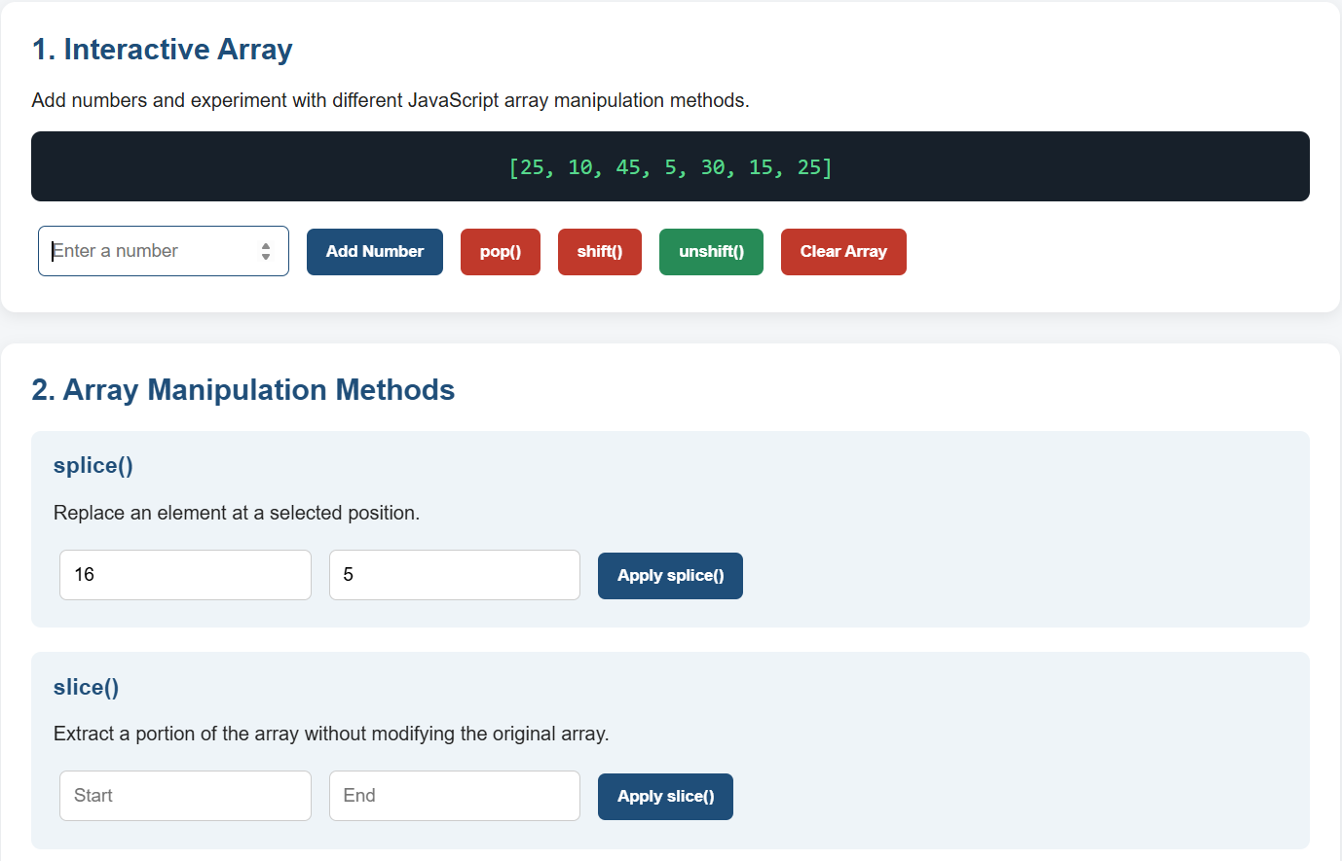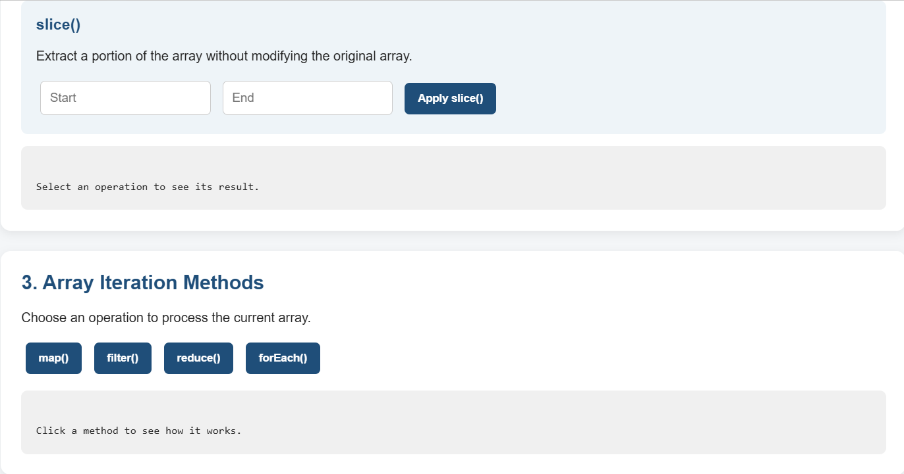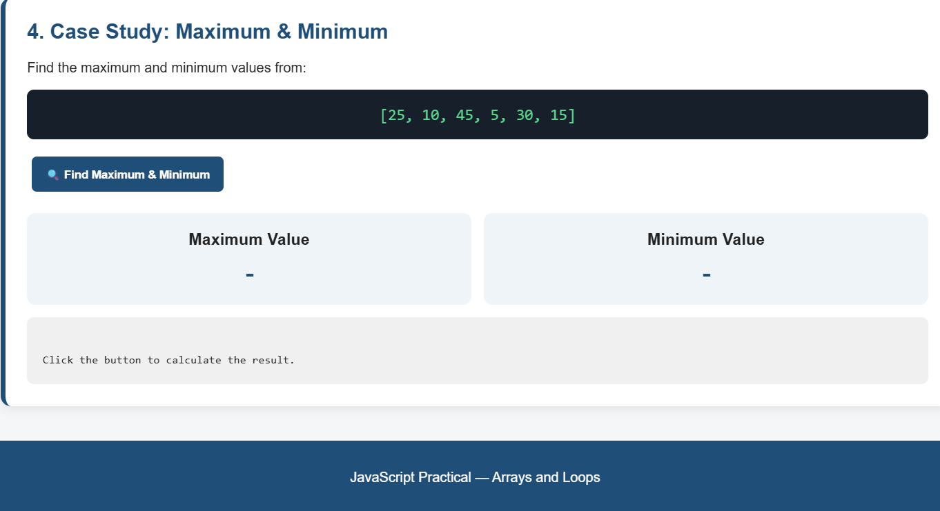

Result
The Interactive Arrays & Loops web application was successfully developed using HTML, CSS, and JavaScript. The application allows the user to dynamically manipulate arrays using push(), pop(), shift(), unshift(), splice(), and slice() methods. It also demonstrates iteration methods such as map(), filter(), reduce(), and forEach(). The maximum and minimum values of an array are calculated using reduce().

Conclusion
Thus, the JavaScript practical successfully demonstrates the use of arrays, array manipulation methods, iteration methods, and loops through an interactive web application. The practical provides a clear understanding of how JavaScript arrays can be modified, processed, and displayed dynamically on a web page.

Case Study 6

Title
Smart Location Tracker using JavaScript Geolocation API

Software/Tools Required
- HTML5 – To create the structure of the location tracking web application.
- CSS3 – To design and style the dashboard, map, buttons, and information cards.
- JavaScript – To implement GPS tracking, distance calculation, geofencing, location history, and alerts.
- Leaflet.js – To display the interactive map and location markers.
- OpenStreetMap – To provide map tiles.
- Nominatim Reverse Geocoding API – To convert GPS coordinates into a readable address.
- Visual Studio Code – For writing and editing the code.
- Google Chrome / Microsoft Edge – For running the web application.
- HTTPS / Localhost – Required for browser geolocation access.

Codes

1. index.html
The HTML file creates the user interface containing the Start Tracking, Stop Tracking, live map, GPS information, detected address, movement status, distance travelled, institute distance, geofencing, location history, and emergency location sections.
<!DOCTYPE html>
<html lang="en">

<head>
<meta charset="UTF-8">

<meta name="viewport"
content="width=device-width, initial-scale=1.0">

<title>Smart Location Tracker</title>

<link
rel="stylesheet"
href="https://unpkg.com/leaflet@1.9.4/dist/leaflet.css"
>

<link rel="stylesheet" href="style.css">
</head>

<body>

<div class="container">

<header>
<h1>Smart Location Tracker</h1>

<p>
Real-Time GPS Location Monitoring System
</p>
</header>

<div class="buttons">

<button
id="startBtn"
class="start-btn">

Start Tracking

</button>

<button
id="stopBtn"
class="stop-btn">

Stop Tracking

</button>

</div>

<section class="map-card">

<h2>🗺️ Live Location Map</h2>

<div id="map"></div>

</section>

<div class="dashboard">

<div class="card">

<h2>📍 GPS Location</h2>

<p>
Latitude:
<span id="latitude" class="value">--</span>
</p>

<p>
Longitude:
<span id="longitude" class="value">--</span>
</p>

<p>
Accuracy:
<span id="accuracy" class="value">--</span>
</p>

</div>

<div class="card">

<h2>🏠 Detected Address</h2>

<p id="locationName" class="address">
Waiting for location...
</p>

</div>

<div class="card">

<h2>🚶 Movement</h2>

<div id="movementStatus" class="status">
Not Tracking
</div>

<p>
Speed:
<span id="speed" class="value">--</span>
</p>

</div>

<div class="card">

<h2>📏 Distance</h2>

<p>
Travelled:
<span id="distance" class="value">0 m</span>
</p>

<p>
Tracking:
<span id="trackingMode" class="value">
Normal
</span>
</p>

</div>

<div class="card">

<h2>🏫 Institute</h2>

<p>
Symbiosis Institute of Technology
</p>

<p>
Distance:
<span id="instituteDistance" class="value">
--
</span>
</p>

<div id="instituteStatus" class="status">
Waiting for location
</div>

</div>

<div class="card">

<h2>⚠️ Location Alert</h2>

<div id="alertMessage" class="alert">
No location changes detected.
</div>

</div>

</div>

<section class="card">

<h2>🏠 Geofencing</h2>

<p>
Create a safe area around your current location.
</p>

<label for="radius">
Radius in meters:
</label>

<input
type="number"
id="radius"
value="100"
min="10"
>

<button
id="setGeofenceBtn"
class="blue-btn">

Set Geofence

</button>

<div id="geofenceStatus" class="status">
Geofence not set
</div>

</section>

<section class="history">

<h2>🕐 Location History</h2>

<div id="historyList" class="history-list">

<p>
No location history yet.
</p>

</div>

</section>

<section class="emergency">

<h2>🆘 Emergency Location</h2>

<p>
Generate a Google Maps link
containing your current location.
</p>

<button
id="emergencyBtn"
class="emergency-btn">

Get Emergency Location

</button>

<p id="emergencyResult"></p>

</section>

<footer>
Smart Location Tracker
</footer>

</div>

<script
src="https://unpkg.com/leaflet@1.9.4/dist/leaflet.js">
</script>

<script src="script.js"></script>

</body>
</html>

2. style.css
* {
box-sizing: border-box;
margin: 0;
padding: 0;
}

body {
font-family: Arial, sans-serif;
background: #f1f5f9;
color: #333;
padding: 20px;
}

.container {
max-width: 1100px;
margin: auto;
}

header {
text-align: center;
margin-bottom: 25px;
}

header h1 {
font-size: 32px;
margin-bottom: 8px;
color: #1e293b;
}

header p {
color: #64748b;
}

.buttons {
text-align: center;
margin-bottom: 25px;
}

button {
border: none;
padding: 12px 20px;
margin: 5px;
border-radius: 6px;
color: white;
font-size: 15px;
cursor: pointer;
transition: 0.3s;
}

.start-btn {
background: #16a34a;
}

.start-btn:hover {
background: #15803d;
}

.stop-btn {
background: #dc2626;
}

.stop-btn:hover {
background: #b91c1c;
}

.blue-btn {
background: #2563eb;
}

.blue-btn:hover {
background: #1d4ed8;
}

.emergency-btn {
background: #991b1b;
width: 100%;
}

.emergency-btn:hover {
background: #7f1d1d;
}

.map-card {
background: white;
padding: 20px;
border-radius: 12px;
box-shadow: 0 4px 15px rgba(0, 0, 0, 0.08);
margin-bottom: 20px;
}

.map-card h2 {
margin-bottom: 15px;
}

#map {
width: 100%;
height: 450px;
border-radius: 8px;
}

.dashboard {
display: grid;
grid-template-columns: repeat(3, 1fr);
gap: 20px;
}

.card {
background: white;
padding: 20px;
border-radius: 12px;
box-shadow: 0 4px 15px rgba(0, 0, 0, 0.08);
margin-top: 20px;
}

.card h2 {
font-size: 18px;
margin-bottom: 15px;
color: #1e293b;
}

.card p {
margin: 9px 0;
line-height: 1.5;
}

.value {
color: #2563eb;
font-weight: bold;
}

.address {
color: #475569;
font-size: 14px;
}

.status {
padding: 10px;
border-radius: 6px;
background: #f1f5f9;
text-align: center;
font-weight: bold;
margin-top: 10px;
}

.alert {
background: #fff7ed;
border: 1px solid #fed7aa;
padding: 12px;
border-radius: 6px;
color: #9a3412;
}

input {
width: 100%;
padding: 11px;
margin-top: 10px;
margin-bottom: 10px;
border: 1px solid #cbd5e1;
border-radius: 6px;
font-size: 15px;
}

.history {
margin-top: 25px;
}

.history h2 {
margin-bottom: 10px;
}

.history-list {
background: white;
padding: 15px;
border-radius: 12px;
box-shadow: 0 4px 15px rgba(0, 0, 0, 0.08);
max-height: 300px;
overflow-y: auto;
}

.history-item {
padding: 10px;
border-bottom: 1px solid #e2e8f0;
font-size: 14px;
}

.history-item:last-child {
border-bottom: none;
}

.emergency {
background: white;
padding: 20px;
border-radius: 12px;
box-shadow: 0 4px 15px rgba(0, 0, 0, 0.08);
margin-top: 25px;
}

#emergencyResult {
margin-top: 15px;
line-height: 1.7;
}

#emergencyResult a {
color: #2563eb;
font-weight: bold;
}

footer {
text-align: center;
color: #64748b;
margin-top: 30px;
padding: 20px;
}

@media (max-width: 800px) {

body {
padding: 12px;
}

header h1 {
font-size: 25px;
}

.dashboard {
grid-template-columns: 1fr;
}

#map {
height: 350px;
}

button {
width: 100%;
margin: 5px 0;
}
}

3. script.js
The JavaScript uses the browser's Geolocation API with watchPosition() for continuous location updates and clearWatch() to stop tracking. It also maintains GPS coordinates, accuracy, speed, distance, history, geofencing, and map markers.
let watchID = null;
let currentPosition = null;
let previousPosition = null;

let totalDistance = 0;
let bestAccuracy = Infinity;

let lastApiCallPosition = null;

let geofence = null;
let geofenceCircle = null;

let locationMarker = null;
let accuracyCircle = null;
let instituteMarker = null;

const instituteLatitude = 21.1702;
const instituteLongitude = 79.0849;

const latitudeElement =
document.getElementById("latitude");

const longitudeElement =
document.getElementById("longitude");

const accuracyElement =
document.getElementById("accuracy");

const locationNameElement =
document.getElementById("locationName");

const movementStatusElement =
document.getElementById("movementStatus");

const speedElement =
document.getElementById("speed");

const distanceElement =
document.getElementById("distance");

const trackingModeElement =
document.getElementById("trackingMode");

const alertMessageElement =
document.getElementById("alertMessage");

const historyListElement =
document.getElementById("historyList");

const geofenceStatusElement =
document.getElementById("geofenceStatus");

const radiusElement =
document.getElementById("radius");

const emergencyResultElement =
document.getElementById("emergencyResult");

const instituteDistanceElement =
document.getElementById("instituteDistance");

const instituteStatusElement =
document.getElementById("instituteStatus");

const map = L.map("map").setView(
[21.1702, 79.0849],
14
);

L.tileLayer(
"https://{s}.tile.openstreetmap.org/{z}/{x}/{y}.png",
{
maxZoom: 19,
attribution:
"&copy; OpenStreetMap contributors"
}
).addTo(map);

instituteMarker = L.marker([
instituteLatitude,
instituteLongitude
]).addTo(map);

instituteMarker.bindPopup(
"🏫 Symbiosis Institute of Technology"
);

document
.getElementById("startBtn")
.addEventListener(
"click",
startTracking
);

function startTracking() {

if (!navigator.geolocation) {

alert(
"Your browser does not support Geolocation."
);

alertMessageElement.innerText =
"❌ Geolocation is not supported.";

return;
}

if (
location.protocol !== "https:" &&
location.hostname !== "localhost" &&
location.hostname !== "127.0.0.1"
) {

alertMessageElement.innerText =
"⚠️ Open this project using localhost or HTTPS.";

return;
}

if (watchID !== null) {

alert(
"Tracking is already running."
);

return;
}

previousPosition = null;
bestAccuracy = Infinity;
lastApiCallPosition = null;

movementStatusElement.innerText =
"🔄 Requesting GPS...";

trackingModeElement.innerText =
"High Accuracy";

alertMessageElement.innerText =
"📡 Requesting your location...";

watchID =
navigator.geolocation.watchPosition(
updateLocation,
locationError,
{
enableHighAccuracy: true,
maximumAge: 0,
timeout: 30000
}
);
}

document
.getElementById("stopBtn")
.addEventListener(
"click",
stopTracking
);

function stopTracking() {

if (watchID !== null) {

navigator.geolocation.clearWatch(
watchID
);

watchID = null;

movementStatusElement.innerText =
"⛔ Not Tracking";

trackingModeElement.innerText =
"Stopped";

alertMessageElement.innerText =
"Location tracking stopped.";

} else {

alert(
"Tracking is not currently running."
);
}
}

function updateLocation(position) {

currentPosition = position;

const latitude =
position.coords.latitude;

const longitude =
position.coords.longitude;

const accuracy =
position.coords.accuracy;

latitudeElement.innerText =
latitude.toFixed(6);

longitudeElement.innerText =
longitude.toFixed(6);

accuracyElement.innerText =
accuracy.toFixed(2) +
" meters";

if (accuracy < bestAccuracy) {
bestAccuracy = accuracy;
}

if (accuracy <= 20) {

alertMessageElement.innerText =
"🟢 Excellent GPS accuracy: " +
accuracy.toFixed(0) +
" meters.";

} else if (accuracy <= 50) {

alertMessageElement.innerText =
"🟢 Good GPS accuracy: " +
accuracy.toFixed(0) +
" meters.";

} else if (accuracy <= 100) {

alertMessageElement.innerText =
"🟡 GPS accuracy is moderate: " +
accuracy.toFixed(0) +
" meters.";

} else {

alertMessageElement.innerText =
"🟠 GPS accuracy is low: " +
accuracy.toFixed(0) +
" meters.";
}

let speed =
position.coords.speed;

if (
speed !== null &&
!isNaN(speed)
) {

speed = speed * 3.6;

} else {

speed = 0;
}

speedElement.innerText =
speed.toFixed(2) +
" km/h";

if (speed > 1) {

movementStatusElement.innerText =
"🟢 Moving";

} else {

movementStatusElement.innerText =
"🔵 Stationary";
}

updateMap(
latitude,
longitude,
accuracy
);

if (previousPosition !== null) {

const previousLatitude =
previousPosition.coords.latitude;

const previousLongitude =
previousPosition.coords.longitude;

const distance =
calculateDistance(
previousLatitude,
previousLongitude,
latitude,
longitude
);

if (distance > 5) {

totalDistance += distance;

distanceElement.innerText =
formatDistance(totalDistance);

if (distance > 50) {

alertMessageElement.innerText =
"⚠️ Location changed by " +
distance.toFixed(0) +
" meters.";
}
}
}

addLocationHistory(
latitude,
longitude,
accuracy
);

smartTracking(position);

checkGeofence(
latitude,
longitude
);

calculateInstituteDistance(
latitude,
longitude
);

getLocationName(
latitude,
longitude
);

previousPosition = position;
}

function updateMap(
latitude,
longitude,
accuracy
) {

if (locationMarker === null) {

locationMarker =
L.marker([
latitude,
longitude
]).addTo(map);

locationMarker.bindPopup(
"📍 Your Current Location"
);

locationMarker.openPopup();

} else {

locationMarker.setLatLng([
latitude,
longitude
]);
}

if (accuracyCircle === null) {

accuracyCircle =
L.circle(
[
latitude,
longitude
],
{
radius: accuracy
}
).addTo(map);

} else {

accuracyCircle.setLatLng([
latitude,
longitude
]);

accuracyCircle.setRadius(
accuracy
);
}

map.setView(
[
latitude,
longitude
],
17
);
}

function calculateDistance(
lat1,
lon1,
lat2,
lon2
) {

const earthRadius = 6371000;

const latitudeDifference =
(lat2 - lat1) *
Math.PI / 180;

const longitudeDifference =
(lon2 - lon1) *
Math.PI / 180;

const latitude1 =
lat1 * Math.PI / 180;

const latitude2 =
lat2 * Math.PI / 180;

const a =
Math.sin(
latitudeDifference / 2
) ** 2
+
Math.cos(latitude1) *
Math.cos(latitude2) *
Math.sin(
longitudeDifference / 2
) ** 2;

const c =
2 *
Math.atan2(
Math.sqrt(a),
Math.sqrt(1 - a)
);

return earthRadius * c;
}

function formatDistance(distance) {

if (distance < 1000) {

return (
distance.toFixed(0) +
" m"
);
}

return (
(distance / 1000).toFixed(2) +
" km"
);
}

function addLocationHistory(
latitude,
longitude,
accuracy
) {

if (
historyListElement.innerText ===
"No location history yet."
) {

historyListElement.innerHTML = "";
}

const item =
document.createElement("div");

item.className =
"history-item";

const time =
new Date()
.toLocaleTimeString();

item.innerText =
time +
" → " +
latitude.toFixed(6) +
", " +
longitude.toFixed(6) +
" | Accuracy: " +
accuracy.toFixed(0) +
"m";

historyListElement.prepend(item);

while (
historyListElement.children.length > 20
) {

historyListElement.removeChild(
historyListElement.lastChild
);
}
}

function smartTracking(position) {

const speed =
position.coords.speed;

if (
speed !== null &&
speed > 1
) {

trackingModeElement.innerText =
"High Accuracy";

} else {

trackingModeElement.innerText =
"Normal";
}
}

async function getLocationName(
latitude,
longitude
) {

if (lastApiCallPosition !== null) {

const distance =
calculateDistance(
lastApiCallPosition.latitude,
lastApiCallPosition.longitude,
latitude,
longitude
);

if (distance < 100) {
return;
}
}

lastApiCallPosition = {
latitude: latitude,
longitude: longitude
};

try {

locationNameElement.innerText =
"Getting address from API...";

const apiURL =
"https://nominatim.openstreetmap.org/reverse" +
"?format=json" +
"&lat=" + latitude +
"&lon=" + longitude;

const response =
await fetch(apiURL);

if (!response.ok) {

throw new Error(
"API request failed"
);
}

const data =
await response.json();

if (data.display_name) {

locationNameElement.innerText =
data.display_name;

} else {

locationNameElement.innerText =
"Address not found";
}

} catch (error) {

console.error(
"Reverse Geocoding API Error:",
error
);

locationNameElement.innerText =
"Address API unavailable";
}
}

function calculateInstituteDistance(
latitude,
longitude
) {

const distance =
calculateDistance(
latitude,
longitude,
instituteLatitude,
instituteLongitude
);

instituteDistanceElement.innerText =
formatDistance(distance);

if (distance <= 200) {

instituteStatusElement.innerText =
"🟢 You are near the institute.";

} else {

instituteStatusElement.innerText =
"🔵 You are away from the institute.";
}
}

document
.getElementById("setGeofenceBtn")
.addEventListener(
"click",
setGeofence
);

function setGeofence() {

if (currentPosition === null) {

alert(
"Start tracking first."
);

return;
}

const radius =
Number(
radiusElement.value
);

if (radius < 10) {

alert(
"Radius must be at least 10 meters."
);

return;
}

const latitude =
currentPosition.coords.latitude;

const longitude =
currentPosition.coords.longitude;

geofence = {
latitude: latitude,
longitude: longitude,
radius: radius
};

if (geofenceCircle !== null) {

map.removeLayer(
geofenceCircle
);
}

geofenceCircle =
L.circle(
[
latitude,
longitude
],
{
radius: radius
}
).addTo(map);

geofenceStatusElement.innerText =
"🟢 Geofence set for " +
radius +
" meters.";
}

function checkGeofence(
latitude,
longitude
) {

if (geofence === null) {
return;
}

const distance =
calculateDistance(
geofence.latitude,
geofence.longitude,
latitude,
longitude
);

if (
distance <= geofence.radius
) {

geofenceStatusElement.innerText =
"🟢 You are inside the geofence.";

} else {

geofenceStatusElement.innerText =
"🔴 You left the geofence!";
}
}

document
.getElementById("emergencyBtn")
.addEventListener(
"click",
emergencyLocation
);

function emergencyLocation() {

if (currentPosition === null) {

alert(
"Start tracking first."
);

return;
}

const latitude =
currentPosition.coords.latitude;

const longitude =
currentPosition.coords.longitude;

const mapLink =
"https://www.google.com/maps?q=" +
latitude +
"," +
longitude;

emergencyResultElement.innerHTML =
"Latitude: " +
latitude.toFixed(6) +
"<br>" +
"Longitude: " +
longitude.toFixed(6) +
"<br><br>" +
"<a href='" +
mapLink +
"' target='_blank'>" +
"📍 Open Current Location in Google Maps" +
"</a>";
}

function locationError(error) {

console.error(
"Geolocation error:",
error
);

if (
error.code ===
error.PERMISSION_DENIED
) {

movementStatusElement.innerText =
"❌ Permission Denied";

alertMessageElement.innerText =
"❌ Location permission was denied.";

} else if (
error.code ===
error.POSITION_UNAVAILABLE
) {

movementStatusElement.innerText =
"❌ GPS Unavailable";

alertMessageElement.innerText =
"❌ GPS location is unavailable.";

} else if (
error.code ===
error.TIMEOUT
) {

movementStatusElement.innerText =
"⏳ GPS Timeout";

alertMessageElement.innerText =
"⏳ GPS took too long. Trying again...";

} else {

movementStatusElement.innerText =
"❌ Location Error";

alertMessageElement.innerText =
"❌ Unable to get your location.";
}
}

Result
The Smart Location Tracker web application was successfully developed using HTML, CSS, and JavaScript. The application obtains the user's GPS coordinates through the browser Geolocation API and displays the current position on an interactive Leaflet map. It also displays latitude, longitude, GPS accuracy, speed, movement status, travelled distance, and location history.
The application additionally provides geofencing, calculates the distance from the specified institute location, retrieves a readable address using reverse geocoding, and generates a Google Maps link for the current location during an emergency.

Conclusion
Thus, the Smart Location Tracker successfully demonstrates the practical implementation of the JavaScript Geolocation API, real-time GPS tracking, Leaflet maps, distance calculation, reverse geocoding, geofencing, location history, and emergency location sharing. The project provides an interactive way to monitor and display real-time geographical information through a web browser.

Case Study 7

Title
Registration Form with JavaScript Validation

Software/Tools Required
- HTML5
- CSS3
- JavaScript
- Visual Studio Code
- Web Browser (Google Chrome / Microsoft Edge)

Code

1. index.html
<!DOCTYPE html>
<html lang="en">
<head>
<meta charset="UTF-8">
<meta name="viewport" content="width=device-width, initial-scale=1.0">
<title>Registration Form</title>
<link rel="stylesheet" href="style.css">
</head>

<body>
<div class="form-container">
<h2>Registration Form</h2>

<form id="registrationForm">

<div class="form-group">
<label for="firstName">First Name</label>
<input type="text" id="firstName" placeholder="Enter first name">
<span class="error" id="firstNameError"></span>
</div>

<div class="form-group">
<label for="lastName">Last Name</label>
<input type="text" id="lastName" placeholder="Enter last name">
<span class="error" id="lastNameError"></span>
</div>

<div class="form-group">
<label for="email">Email</label>
<input type="text" id="email" placeholder="example@gmail.com">
<span class="error" id="emailError"></span>
</div>

<div class="form-group">
<label for="birthday">Birthday</label>
<input type="date" id="birthday">
<span class="error" id="birthdayError"></span>
</div>

<div class="form-group">
<label for="password">Password</label>
<input type="password" id="password" placeholder="Enter password">
<span class="error" id="passwordError"></span>
</div>

<div class="form-group">
<label for="rePassword">Re-enter Password</label>
<input type="password" id="rePassword" placeholder="Re-enter password">
<span class="error" id="rePasswordError"></span>
</div>

<div class="terms">
<input type="checkbox" id="terms">
<label for="terms">
I agree to the Terms and Conditions
</label>
</div>

<span class="error" id="termsError"></span>

<button type="submit">Register</button>

<p id="successMessage"></p>
</form>
</div>

<script src="script.js"></script>
</body>
</html>

2. script.js
const form = document.getElementById("registrationForm");

const firstName = document.getElementById("firstName");
const lastName = document.getElementById("lastName");
const email = document.getElementById("email");
const birthday = document.getElementById("birthday");
const password = document.getElementById("password");
const rePassword = document.getElementById("rePassword");
const terms = document.getElementById("terms");

const firstNameError = document.getElementById("firstNameError");
const lastNameError = document.getElementById("lastNameError");
const emailError = document.getElementById("emailError");
const birthdayError = document.getElementById("birthdayError");
const passwordError = document.getElementById("passwordError");
const rePasswordError = document.getElementById("rePasswordError");
const termsError = document.getElementById("termsError");

const successMessage = document.getElementById("successMessage");

// Focus events
firstName.addEventListener("focus", function () {
firstName.style.backgroundColor = "#eef7ff";
});

lastName.addEventListener("focus", function () {
lastName.style.backgroundColor = "#eef7ff";
});

email.addEventListener("focus", function () {
email.style.backgroundColor = "#eef7ff";
});

password.addEventListener("focus", function () {
password.style.backgroundColor = "#eef7ff";
});

rePassword.addEventListener("focus", function () {
rePassword.style.backgroundColor = "#eef7ff";
});

// Email validation
email.addEventListener("change", function () {

const emailValue = email.value.trim();
const emailPattern = /^[^\s@]+@[^\s@]+\.[^\s@]+$/;

if (emailValue === "") {
emailError.textContent = "Email is required.";
emailError.style.color = "red";
}
else if (!emailPattern.test(emailValue)) {
emailError.textContent = "Please enter a valid email address.";
emailError.style.color = "red";
}
else {
emailError.textContent = "Valid email address.";
emailError.style.color = "green";
}
});

// Password validation
password.addEventListener("change", function () {

if (password.value.length < 6) {
passwordError.textContent =
"Password must contain at least 6 characters.";
}
else {
passwordError.textContent = "";
}
});

// Re-enter password validation
rePassword.addEventListener("change", function () {

if (rePassword.value !== password.value) {
rePasswordError.textContent =
"Passwords do not match.";
}
else {
rePasswordError.textContent = "";
}
});

// Form submission validation
form.addEventListener("submit", function (event) {

event.preventDefault();

firstNameError.textContent = "";
lastNameError.textContent = "";
emailError.textContent = "";
birthdayError.textContent = "";
passwordError.textContent = "";
rePasswordError.textContent = "";
termsError.textContent = "";
successMessage.textContent = "";

let isValid = true;

// First name
if (firstName.value.trim() === "") {
firstNameError.textContent =
"First name is required.";
isValid = false;
}

// Last name
if (lastName.value.trim() === "") {
lastNameError.textContent =
"Last name is required.";
isValid = false;
}

// Email
const emailValue = email.value.trim();
const emailPattern = /^[^\s@]+@[^\s@]+\.[^\s@]+$/;

if (emailValue === "") {
emailError.textContent =
"Email is required.";
isValid = false;
}
else if (!emailPattern.test(emailValue)) {
emailError.textContent =
"Please enter a valid email address.";
isValid = false;
}

// Birthday
if (birthday.value === "") {
birthdayError.textContent =
"Birthday is required.";
isValid = false;
}

// Password
if (password.value === "") {
passwordError.textContent =
"Password is required.";
isValid = false;
}
else if (password.value.length < 6) {
passwordError.textContent =
"Password must contain at least 6 characters.";
isValid = false;
}

// Re-enter password
if (rePassword.value === "") {
rePasswordError.textContent =
"Please re-enter your password.";
isValid = false;
}
else if (password.value !== rePassword.value) {
rePasswordError.textContent =
"Passwords do not match.";
isValid = false;
}

// Terms and conditions
if (!terms.checked) {
termsError.textContent =
"You must agree to the Terms and Conditions.";
isValid = false;
}

// Successful registration
if (isValid) {
successMessage.textContent =
"Registration successful!";

form.reset();
}
});

3. style.css
* {
box-sizing: border-box;
font-family: Arial, sans-serif;
}

body {
margin: 0;
background-color: #f9d5d5;
display: flex;
justify-content: center;
align-items: center;
min-height: 100vh;
}

.form-container {
width: 900px;
background-color: white;
padding: 30px;
border-radius: 10px;
box-shadow: 0 0 15px rgba(0, 0, 0, 0.15);
}

h2 {
text-align: center;
margin-bottom: 25px;
}

.form-group {
margin-bottom: 18px;
}

label {
display: block;
margin-bottom: 6px;
font-weight: bold;
}

input[type="text"],
input[type="password"],
input[type="date"] {
width: 100%;
padding: 10px;
border: 1px solid #aaa;
border-radius: 5px;
font-size: 14px;
}

input:focus {
outline: none;
border: 2px solid #007bff;
background-color: #f5faff;
}

.error {
display: block;
color: red;
font-size: 13px;
margin-top: 5px;
}

.terms {
display: flex;
align-items: center;
gap: 8px;
margin-bottom: 5px;
}

.terms input {
width: auto;
}

.terms label {
margin: 0;
font-weight: normal;
}

button {
width: 100%;
padding: 11px;
margin-top: 20px;
background-color: #007bff;
color: white;
border: none;
border-radius: 5px;
font-size: 16px;
cursor: pointer;
}

button:hover {
background-color: #0056b3;
}

#successMessage {
text-align: center;
color: green;
font-weight: bold;
margin-top: 15px;
}

Result
The registration form successfully validates First Name, Last Name, Email, Birthday, Password, Re-enter Password, and Terms & Conditions using JavaScript events. Error messages are displayed for invalid or missing inputs, and “Registration successful!” is displayed when all fields are valid.

Conclusion
Thus, a Registration Form with JavaScript validation was successfully created. The practical demonstrates the use of DOM manipulation, event listeners, regular expressions, form validation, and dynamic error messages in JavaScript.
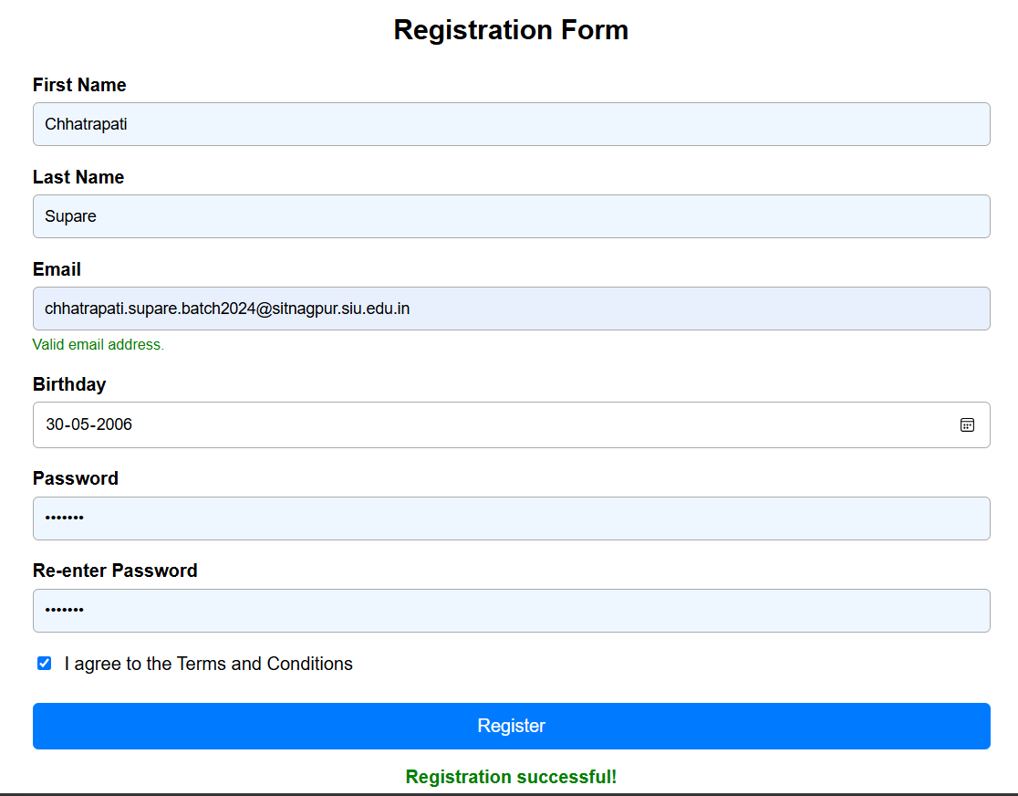
Case Study 8

Title
Online Job Application Form with JavaScript Validation

Software/Tools Required
- HTML5
- CSS3
- JavaScript
- Visual Studio Code
- Google Chrome / Microsoft Edge
- Web Browser

Code

1. index.html
<!DOCTYPE html>
<html lang="en">
<head>
<meta charset="UTF-8">
<meta name="viewport" content="width=device-width, initial-scale=1.0">
<meta name="description" content="Online job application form with live input validation.">
<title>Apply | Northstar Careers</title>

<link rel="preconnect" href="https://fonts.googleapis.com">
<link rel="preconnect" href="https://fonts.gstatic.com" crossorigin>
<link href="https://fonts.googleapis.com/css2?family=DM+Sans:wght@400;500;600;700&family=Manrope:wght@600;700;800&display=swap" rel="stylesheet">

<link rel="stylesheet" href="styles.css">
<script defer src="script.js"></script>
</head>

<body>

<main class="page-shell">

<section class="intro-panel">
<div class="brand-mark">N</div>

<p class="eyebrow">
Northstar Careers <span></span> 2026 intake
</p>

<h1>Build what moves<br><em>people forward.</em></h1>

<p class="intro-copy">
Tell us about yourself and the work you want to do next.
Your application takes about 8 minutes.
</p>

<div class="process-note">
<span class="process-dot"></span>
<div>
<strong>One thoughtful application</strong>
<small>Reviewed by a real member of our hiring team.</small>
</div>
</div>

<div class="intro-footer">
<span>Questions?</span>
<a href="mailto:careers@northstar.example">
careers@northstar.example
</a>
</div>
</section>

<section class="form-panel">

<div class="form-heading">
<div>
<p class="section-kicker">Candidate profile</p>
<h2>Online job application</h2>
</div>

<p class="required-note">
<span>*</span> Required fields
</p>
</div>

<form id="applicationForm" novalidate>

<!-- Personal Information -->

<fieldset>
<legend>
<span class="legend-number">01</span>
Personal information
</legend>

<div class="form-grid two-columns">

<div class="field wide-field">
<label for="fullName">
Full name <span>*</span>
</label>

<input id="fullName"
name="fullName"
type="text"
placeholder="e.g. Aisha Kulkarni"
required>

<p class="field-hint">
Use the name that appears on your official documents.
</p>

<p class="error-message" id="fullNameError"></p>
</div>

<div class="field">
<label for="dateOfBirth">
Date of birth <span>*</span>
</label>

<input id="dateOfBirth"
name="dateOfBirth"
type="date"
required>

<p class="error-message" id="dateOfBirthError"></p>
</div>

<div class="field">
<label for="gender">
Gender <span>*</span>
</label>

<select id="gender" name="gender" required>
<option value="">Select an option</option>
<option>Female</option>
<option>Male</option>
<option>Non-binary</option>
<option>Prefer not to say</option>
</select>

<p class="error-message" id="genderError"></p>
</div>

<div class="field">
<label for="email">
Email address <span>*</span>
</label>

<input id="email"
name="email"
type="email"
placeholder="you@example.com"
required>

<p class="error-message" id="emailError"></p>
</div>

<div class="field">
<label for="mobile">
Mobile number <span>*</span>
</label>

<input id="mobile"
name="mobile"
type="tel"
placeholder="+91 98765 43210"
required>

<p class="error-message" id="mobileError"></p>
</div>

<div class="field wide-field">
<label for="address">
Address <span>*</span>
</label>

<textarea id="address"
name="address"
rows="2"
placeholder="House number, street, area"
required></textarea>

<p class="error-message" id="addressError"></p>
</div>

<div class="field">
<label for="city">
City <span>*</span>
</label>

<input id="city"
name="city"
type="text"
placeholder="Pune"
required>

<p class="error-message" id="cityError"></p>
</div>

<div class="field compact-fields">

<div>
<label for="state">
State <span>*</span>
</label>

<input id="state"
name="state"
type="text"
placeholder="Maharashtra"
required>

<p class="error-message" id="stateError"></p>
</div>

<div>
<label for="pinCode">
PIN code <span>*</span>
</label>

<input id="pinCode"
name="pinCode"
type="text"
placeholder="411001"
required>

<p class="error-message" id="pinCodeError"></p>
</div>

</div>

</div>
</fieldset>

<!-- Educational Qualification -->

<fieldset>

<legend>
<span class="legend-number">02</span>
Educational qualification
</legend>

<div class="form-grid two-columns">

<div class="field">
<label for="qualification">
Highest qualification <span>*</span>
</label>

<select id="qualification"
name="qualification"
required>

<option value="">
Select qualification
</option>

<option>Higher secondary</option>
<option>Diploma</option>
<option>Bachelor's degree</option>
<option>Master's degree</option>
<option>Doctorate</option>
<option>Other</option>

</select>

<p class="error-message"
id="qualificationError"></p>
</div>

<div class="field">
<label for="institute">
University / Institute <span>*</span>
</label>

<input id="institute"
name="institute"
type="text"
placeholder="Institute name"
required>

<p class="error-message"
id="instituteError"></p>
</div>

<div class="field">
<label for="passingYear">
Passing year <span>*</span>
</label>

<input id="passingYear"
name="passingYear"
type="number"
placeholder="2024"
required>

<p class="error-message"
id="passingYearError"></p>
</div>

<div class="field">
<label for="score">
Percentage / CGPA <span>*</span>
</label>

<input id="score"
name="score"
type="text"
placeholder="8.6 CGPA"
required>

<p class="error-message"
id="scoreError"></p>
</div>

</div>

</fieldset>

<!-- Professional Information -->

<fieldset>

<legend>
<span class="legend-number">03</span>
Professional information
</legend>

<div class="form-grid two-columns">

<div class="field">
<label for="jobPosition">
Applying for / Job position <span>*</span>
</label>

<input id="jobPosition"
name="jobPosition"
type="text"
placeholder="Frontend Developer"
required>

<p class="error-message"
id="jobPositionError"></p>
</div>

<div class="field">
<label for="experience">
Total work experience <span>*</span>
</label>

<select id="experience"
name="experience"
required>

<option value="">
Select experience
</option>

<option>Fresher</option>
<option>Less than 1 year</option>
<option>1–3 years</option>
<option>3–5 years</option>
<option>5–8 years</option>
<option>8+ years</option>

</select>

<p class="error-message"
id="experienceError"></p>
</div>

<div class="field">
<label for="organization">
Current / previous organization <span>*</span>
</label>

<input id="organization"
name="organization"
type="text"
placeholder="Company name"
required>

<p class="error-message"
id="organizationError"></p>
</div>

<div class="field">
<label for="designation">
Current designation
</label>

<input id="designation"
name="designation"
type="text"
placeholder="Product Designer">

<p class="error-message"
id="designationError"></p>
</div>

<div class="field">
<label for="salary">
Expected salary <span>*</span>
</label>

<input id="salary"
name="salary"
type="number"
min="0"
placeholder="8,00,000"
required>

<p class="field-hint">
Annual expected CTC in INR.
</p>

<p class="error-message"
id="salaryError"></p>
</div>

</div>

</fieldset>

<!-- Technical Skills -->

<fieldset>

<legend>
<span class="legend-number">04</span>
Technical skills
</legend>

<div class="form-grid two-columns">

<div class="field wide-field">
<label for="languages">
Programming languages <span>*</span>
</label>

<input id="languages"
name="languages"
type="text"
placeholder="JavaScript, Python, Java"
required>

<p class="field-hint">
Separate multiple languages with commas.
</p>

<p class="error-message"
id="languagesError"></p>
</div>

<div class="field wide-field">
<label for="technicalSkills">
Technical skills <span>*</span>
</label>

<textarea id="technicalSkills"
name="technicalSkills"
rows="3"
placeholder="React, Node.js, SQL, Git..."
required></textarea>

<p class="field-hint">
Mention tools, frameworks, platforms, or methods.
</p>

<p class="error-message"
id="technicalSkillsError"></p>
</div>

<div class="field wide-field">
<label for="certifications">
Certifications
</label>

<textarea id="certifications"
name="certifications"
rows="2"
placeholder="Certification name and issuing body (optional)">
</textarea>

<p class="error-message"
id="certificationsError"></p>
</div>

</div>

</fieldset>

<!-- Form Actions -->

<div class="form-actions">

<label class="consent-check">

<input id="consent"
name="consent"
type="checkbox"
required>

<span class="custom-check"></span>

<span>
I confirm that the information shared is accurate.
<b>*</b>
</span>

</label>

<p class="error-message consent-error"
id="consentError"></p>

<button type="submit">
<span>Submit application</span>
<span class="button-arrow">↗</span>
</button>

<p class="secure-note">
◆ Your information is handled securely and only used
for recruitment.
</p>

</div>

<div class="success-message"
id="successMessage"
hidden>

<span class="success-icon">✓</span>

<div>
<strong>Application ready to send</strong>

<p>
Everything looks good. Thank you for taking
the time to apply.
</p>
</div>

</div>

</form>

</section>

</main>

</body>
</html>

2. script.js
const form = document.querySelector("#applicationForm");
const successMessage = document.querySelector("#successMessage");
const currentYear = new Date().getFullYear();

const rules = {

fullName: {
message: "Please enter your full name.",
validate: (value) =>
value.trim().length >= 2 &&
/^[\p{L}][\p{L} .'-]*$/u.test(value.trim())
},

dateOfBirth: {
message: "Please enter a valid date of birth.",
validate: (value) => {

if (!value) return false;

const birthDate = new Date(`${value}T00:00:00`);
const today = new Date();

const oldest = new Date(
today.getFullYear() - 100,
today.getMonth(),
today.getDate()
);

return birthDate <= today && birthDate >= oldest;
}
},

gender: {
message: "Please select an option.",
validate: (value) => Boolean(value)
},

email: {
message: "Enter a valid email address.",
validate: (value) =>
/^[^\s@]+@[^\s@]+\.[^\s@]{2,}$/.test(value.trim())
},

mobile: {
message: "Enter a valid 10-digit mobile number.",
validate: (value) =>
value.replace(/\D/g, "").length === 10
},

address: {
message: "Please enter your complete address.",
validate: (value) =>
value.trim().length >= 8
},

city: {
message: "Please enter your city.",
validate: (value) =>
value.trim().length >= 2
},

state: {
message: "Please enter your state.",
validate: (value) =>
value.trim().length >= 2
},

pinCode: {
message: "Enter a valid 6-digit PIN code.",
validate: (value) =>
/^\d{6}$/.test(value.trim())
},

qualification: {
message: "Please select your highest qualification.",
validate: (value) => Boolean(value)
},

institute: {
message: "Please enter your university or institute.",
validate: (value) =>
value.trim().length >= 2
},

passingYear: {
message: `Enter a year between 1950 and ${currentYear}.`,
validate: (value) =>
Number.isInteger(Number(value)) &&
Number(value) >= 1950 &&
Number(value) <= 2030
},

score: {
message: "Please enter your percentage or CGPA.",
validate: (value) =>
/\d/.test(value.trim())
},

jobPosition: {
message: "Please enter the position you are applying for.",
validate: (value) =>
value.trim().length >= 2
},

experience: {
message: "Please select your work experience.",
validate: (value) => Boolean(value)
},

organization: {
message: "Please enter your current or previous organization.",
validate: (value) =>
value.trim().length >= 2
},

salary: {
message: "Please enter your expected annual salary.",
validate: (value) =>
Number(value) >= 0 && value !== ""
},

languages: {
message: "Please list at least one programming language.",
validate: (value) =>
value.trim().length >= 2
},

technicalSkills: {
message: "Please list your technical skills.",
validate: (value) =>
value.trim().length >= 2
}
};

function getErrorElement(field) {
return document.querySelector(`#${field.id}Error`);
}

function getValue(field) {
return field.type === "checkbox"
? field.checked
: field.value;
}

function validateField(field, showSuccessState = true) {

const rule = rules[field.name];
const errorElement = getErrorElement(field);

if (!rule || !errorElement)
return true;

const isValid = rule.validate(getValue(field));

field.classList.toggle("invalid", !isValid);

field.classList.toggle(
"valid",
isValid && showSuccessState
);

field.setAttribute(
"aria-invalid",
String(!isValid)
);

errorElement.textContent =
isValid ? "" : rule.message;

return isValid;
}

function validateConsent() {

const consent = document.querySelector("#consent");
const errorElement =
document.querySelector("#consentError");

const isValid = consent.checked;

consent.setAttribute(
"aria-invalid",
String(!isValid)
);

errorElement.textContent =
isValid
? ""
: "Please confirm that the information is accurate.";

return isValid;
}

function markFieldAsTouched(event) {

validateField(event.target);

successMessage.hidden = true;
}

Object.keys(rules).forEach((fieldName) => {

const field =
document.querySelector(`#${fieldName}`);

field.addEventListener(
"input",
markFieldAsTouched
);

field.addEventListener(
"change",
markFieldAsTouched
);

field.addEventListener(
"blur",
(event) => validateField(event.target)
);
});

document.querySelector("#consent")
.addEventListener("change", () => {

validateConsent();

successMessage.hidden = true;
});

form.addEventListener("submit", (event) => {

event.preventDefault();

const fieldsAreValid =
Object.keys(rules).every((fieldName) => {

const field =
document.querySelector(`#${fieldName}`);

return validateField(field);
});

const consentIsValid =
validateConsent();

if (!fieldsAreValid || !consentIsValid) {

successMessage.hidden = true;

const firstInvalidField =
form.querySelector(
".invalid, [aria-invalid='true']"
);

firstInvalidField?.focus();

return;
}

successMessage.hidden = false;

successMessage.scrollIntoView({
behavior: "smooth",
block: "nearest"
});
});

document.querySelector("#passingYear")
.setAttribute("max", currentYear);

document.querySelector("#dateOfBirth")
.setAttribute(
"max",
new Date().toISOString().split("T")[0]
);

3. styles.css
:root {
--ink: #182526;
--muted: #6d7e7e;
--line: #dce6e2;
--paper: #fbfcf9;
--mint: #dcefe8;
--mint-dark: #1c6b5c;
--coral: #ef755d;
--coral-dark: #c55442;
--error: #c84f45;
--shadow: 0 22px 70px rgba(36, 74, 66, 0.12);

font-family: "DM Sans", sans-serif;
color: var(--ink);
background: #e6f0ea;
}

* {
box-sizing: border-box;
}

body {
min-width: 320px;
margin: 0;
background: #e6f0ea;
}

.page-shell {
display: grid;
grid-template-columns:
minmax(280px, 0.72fr)
minmax(600px, 1.28fr);

max-width: 1440px;
min-height: 100vh;
margin: 0 auto;
background: var(--paper);
box-shadow: var(--shadow);
}

.intro-panel {
position: sticky;
top: 0;
display: flex;
flex-direction: column;
min-height: 100vh;

padding: clamp(2rem, 5vw, 5.3rem)
clamp(2rem, 5vw, 5.5rem);

color: #f4fbf6;
background: #164d45;
overflow: hidden;
}

.intro-panel::after {
position: absolute;
right: -125px;
bottom: -130px;
width: 360px;
height: 360px;

border: 1px solid rgba(224, 247, 235, 0.2);
border-radius: 50%;

box-shadow:
0 0 0 35px rgba(224, 247, 235, 0.03),
0 0 0 70px rgba(224, 247, 235, 0.03);

content: "";
}

.brand-mark {
display: grid;
place-items: center;

width: 42px;
height: 42px;

margin-bottom: clamp(3rem, 10vh, 8rem);

border: 1px solid rgba(243, 255, 249, 0.6);
border-radius: 50%;

font-family: Manrope, sans-serif;
font-weight: 800;
font-size: 1.15rem;
}

.eyebrow,
.section-kicker {
margin: 0 0 1.35rem;

color: #91d2be;
font-size: 0.72rem;
font-weight: 700;

letter-spacing: 0.13em;
text-transform: uppercase;
}

.eyebrow span {
display: inline-block;

width: 5px;
height: 5px;

margin: 0 0.6rem 2px;

border-radius: 50%;
background: var(--coral);
}

h1,
h2,
legend {
font-family: Manrope, sans-serif;
}

h1 {
max-width: 520px;
margin: 0;

font-size: clamp(2.5rem, 4.7vw, 5rem);
line-height: 1.02;
letter-spacing: -0.035em;
}

h1 em {
color: #a4e4ce;
font-style: normal;
}

.intro-copy {
max-width: 390px;
margin: 2rem 0 0;

color: #c3ddd2;
font-size: 1rem;
line-height: 1.7;
}

.process-note {
display: flex;
gap: 0.8rem;
align-items: flex-start;

max-width: 300px;
margin-top: auto;
padding-top: 3rem;
}

.process-dot {
flex: 0 0 auto;

width: 11px;
height: 11px;
margin-top: 0.25rem;

border: 3px solid #164d45;
border-radius: 50%;

background: var(--coral);
box-shadow: 0 0 0 2px var(--coral);
}

.process-note strong,
.process-note small {
display: block;
}

.process-note strong {
font-size: 0.88rem;
}

.process-note small {
margin-top: 0.35rem;
color: #a9cbbf;
line-height: 1.5;
}

.intro-footer {
position: relative;
z-index: 1;

display: flex;
gap: 0.65rem;

margin-top: 4rem;
padding-top: 1.2rem;

border-top: 1px solid rgba(220, 239, 232, 0.2);

color: #a9cbbf;
font-size: 0.78rem;
}

.intro-footer a {
color: #f4fbf6;
text-decoration: none;
}

.form-panel {
padding: clamp(2rem, 5vw, 5.3rem)
clamp(1.5rem, 5vw, 6.5rem);

background: var(--paper);
}

.form-heading {
display: flex;
align-items: flex-end;
justify-content: space-between;
gap: 1rem;

margin-bottom: 3.2rem;
}

.form-heading .section-kicker {
margin-bottom: 0.65rem;
color: var(--coral-dark);
}

h2 {
margin: 0;
font-size: clamp(1.65rem, 3vw, 2.3rem);
letter-spacing: -0.03em;
}

.required-note {
margin: 0 0 0.25rem;
color: var(--muted);
font-size: 0.75rem;
}

.required-note span,
label span,
.consent-check b {
color: var(--coral-dark);
}

fieldset {
min-width: 0;
margin: 0 0 3.25rem;
padding: 0;
border: 0;
}

legend {
display: flex;
gap: 0.85rem;
align-items: center;

width: 100%;

margin-bottom: 1.5rem;
padding: 0 0 0.9rem;

border-bottom: 1px solid var(--line);

font-size: 1.05rem;
font-weight: 700;
}

.legend-number {
color: var(--coral);

font-family: "DM Sans", sans-serif;
font-size: 0.74rem;
letter-spacing: 0.08em;
}

.form-grid {
display: grid;
gap: 1.2rem 1rem;
}

.two-columns {
grid-template-columns:
repeat(2, minmax(0, 1fr));
}

.wide-field {
grid-column: 1 / -1;
}

.field {
min-width: 0;
}

.field label,
.compact-fields label {
display: block;

margin-bottom: 0.45rem;

font-size: 0.78rem;
font-weight: 700;
}

input,
select,
textarea {
width: 100%;

border: 1px solid var(--line);
border-radius: 3px;

outline: none;

color: var(--ink);
background: #fff;

font: inherit;
font-size: 0.88rem;

transition:
border-color 160ms ease,
box-shadow 160ms ease,
background 160ms ease;
}

input,
select {
height: 46px;
padding: 0 0.9rem;
}

textarea {
min-height: 74px;
padding: 0.75rem 0.9rem;
resize: vertical;
}

select {
cursor: pointer;
}

input::placeholder,
textarea::placeholder {
color: #a6b4b0;
}

input:focus,
select:focus,
textarea:focus {
border-color: var(--mint-dark);
box-shadow:
0 0 0 3px rgba(28, 107, 92, 0.12);
}

input.valid,
select.valid,
textarea.valid {
border-color: #8abdad;
background: #fbfffd;
}

input.invalid,
select.invalid,
textarea.invalid {
border-color: var(--error);
background: #fffafa;
}

.field-hint {
margin: 0.4rem 0 0;

color: var(--muted);
font-size: 0.7rem;
line-height: 1.45;
}

.error-message {
min-height: 0;

margin: 0.32rem 0 0;

color: var(--error);
font-size: 0.7rem;
line-height: 1.3;
}

.error-message:empty {
display: none;
}

.compact-fields {
display: grid;
grid-template-columns: 1.3fr 1fr;
gap: 0.75rem;
}

.form-actions {
margin-top: -0.6rem;
}

.consent-check {
position: relative;

display: flex;
gap: 0.7rem;
align-items: flex-start;

color: var(--muted);
font-size: 0.76rem;
line-height: 1.4;

cursor: pointer;
}

.consent-check input {
position: absolute;

width: 1px;
height: 1px;

opacity: 0;
}

.custom-check {
flex: 0 0 auto;

width: 19px;
height: 19px;

margin-top: -1px;

border: 1px solid #b8c9c3;
border-radius: 3px;

background: #fff;
}

.consent-check input:checked + .custom-check {
border-color: var(--mint-dark);
background: var(--mint-dark);

box-shadow:
inset 0 0 0 4px #fff;
}

button {
display: inline-flex;
gap: 1.2rem;
align-items: center;
justify-content: space-between;

min-width: 220px;

margin-top: 1.4rem;
padding: 0.92rem 1.05rem 0.92rem 1.3rem;

border: 0;
border-radius: 3px;

color: #fff;
background: var(--coral);

font: inherit;
font-size: 0.84rem;
font-weight: 700;

cursor: pointer;
}

button:hover {
background: var(--coral-dark);
transform: translateY(-2px);
}

.button-arrow {
display: grid;
place-items: center;

width: 25px;
height: 25px;

border-radius: 50%;
background: rgba(255, 255, 255, 0.2);

font-size: 1rem;
}

.secure-note {
color: var(--muted);
font-size: 0.68rem;
}

.success-message {
display: flex;
gap: 0.75rem;
align-items: center;

margin-top: 1.5rem;
padding: 0.9rem 1rem;

border: 1px solid #add4c5;
border-radius: 3px;

color: #225f51;
background: #effaf4;
}

.success-icon {
display: grid;
place-items: center;

width: 24px;
height: 24px;

border-radius: 50%;

color: #fff;
background: var(--mint-dark);

font-weight: 700;
}

.success-message strong {
font-size: 0.82rem;
}

.success-message p {
margin: 0.15rem 0 0;

color: #5d7f74;
font-size: 0.73rem;
}

@media (max-width: 900px) {

.page-shell {
grid-template-columns: 1fr;
}

.intro-panel {
position: relative;
min-height: 460px;
}

.brand-mark {
margin-bottom: 4rem;
}

.process-note {
margin-top: 4rem;
}
}

@media (max-width: 560px) {

.intro-panel {
min-height: 430px;
padding: 2rem 1.4rem;
}

.form-panel {
padding: 2.4rem 1.25rem 3rem;
}

.form-heading {
display: block;
margin-bottom: 2.6rem;
}

.two-columns {
grid-template-columns: 1fr;
}

.wide-field {
grid-column: auto;
}

button {
width: 100%;
}
}

Result
The Online Job Application Form is successfully created with live JavaScript validation. It validates personal information, educational qualifications, professional details, technical skills, mobile number, email, PIN code, passing year, salary, and consent before allowing the application to be submitted. The form also displays appropriate error messages and a success message when all required information is valid. The supplied HTML organizes these details into four sections: Personal Information, Educational Qualification, Professional Information, and Technical Skills.

Conclusion
Thus, an Online Job Application Form using HTML, CSS, and JavaScript was successfully implemented. The practical demonstrates DOM manipulation, event handling, form validation, regular expressions, dynamic error messages, CSS validation states, and user-friendly form interaction.
