Experiment No.: 1
Title: Demonstrate inline, internal, and external JavaScript; use console methods; create a webpage showing user info and a welcome message.
Software/Tools Required: HTML5, CSS3, JavaScript, Visual Studio Code, Google Chrome
Code:
HTML Code:
<!doctype html>
<html lang="en">
<head>
<meta charset="UTF-8" />
<meta name="viewport" content="width=device-width, initial-scale=1.0" />
<title>Simple JavaScript Demo</title>
<link rel="stylesheet" href="style.css?v=2" />
</head>
<body>
<!-- Toast Container -->
<div id="toast-container" class="toast-container"></div>
<div class="container">
<h1>Welcome to JavaScript Demo</h1>
<!-- User Info Section -->
<div class="profile-card">
<h2>Welcome Message</h2>
<p id="welcome-text">Hello! Welcome to the website prototype.</p>

<h3>User Information</h3>
<div id="user-info">
<p><strong>Name:</strong> <span id="user-name">Anubhav</span></p>
<p>
<strong>Email:</strong>
<span id="user-email">anubhav@example.com</span>
</p>
<p><strong>Age:</strong> <span id="user-age">25</span></p>
</div>
</div>

<!-- Buttons demonstrating JS styles -->
<div class="button-section">
<!-- 1. Inline JavaScript -->
<button
onclick="
console.warn('Inline JS: Warning logged on button click!');
showToast('Inline JS: Welcome, Anubhav! ✨', 'warning');
"
>
Trigger Inline JS
</button>

<!-- 2. Internal JavaScript -->
<button id="btn-internal">Trigger Internal JS</button>

<!-- 3. External JavaScript -->
<button id="btn-external">Trigger External JS</button>
</div>

<p class="footer-note">
*Note: Open your browser Console (Press F12) to see logs, warnings, and
tables.
</p>
</div>

<!-- Link to External JavaScript -->
<script src="script.js"></script>

<!-- INTERNAL JAVASCRIPT -->
<script>
// Console log when internal script runs
console.log("Internal JS script tag loaded.");
console.info(
"Internal JS can update page content and respond to user actions.",
);

// Fill the welcome text and user info from the shared userData object
const welcomeText = document.getElementById("welcome-text");
const nameField = document.getElementById("user-name");
const emailField = document.getElementById("user-email");
const ageField = document.getElementById("user-age");

if (
welcomeText &&
nameField &&
emailField &&
ageField &&
typeof userData !== "undefined"
) {
welcomeText.textContent = `Hello ${userData.name}! Welcome to your JavaScript demo page.`;
nameField.textContent = userData.name;
emailField.textContent = userData.email;
ageField.textContent = userData.age;
console.log("Internal JS: User info updated on the page.");
}

// Handle Internal Button Click
document
.getElementById("btn-internal")
.addEventListener("click", function () {
// Use console.error (Console Method 3)
console.error("Internal JS: Error simulation logged on click!");
showToast("Hello from Internal JS! 🚀", "info");
});
</script>
</body>
</html>

CSS Code:
/* Simple & Clean Styling Matching the Reference Image */
body {
font-family: -apple-system, BlinkMacSystemFont, "Segoe UI", Roboto, Helvetica, Arial, sans-serif;
background-color: #f0f2f5;
color: #333333;
margin: 0;
padding: 40px 20px;
display: flex;
justify-content: center;
align-items: center;
min-height: 100vh;
box-sizing: border-box;
}
.container {
width: 100%;
max-width: 600px;
background-color: #ffffff;
padding: 30px;
border-radius: 8px;
border: 1px solid #dee2e6;
box-shadow: 0 4px 6px rgba(0, 0, 0, 0.05);
}
h1 {
color: #212529;
font-size: 26px;
font-weight: 700;
margin-top: 0;
margin-bottom: 20px;
border-bottom: 2px solid #007bff;
padding-bottom: 12px;
}
.profile-card {
background-color: #f8f9fa;
border: 1px solid #dee2e6;
padding: 20px;
border-radius: 4px;
margin-bottom: 24px;
}
.profile-card h2 {
font-size: 19px;
font-weight: 700;
color: #212529;
margin-top: 0;
margin-bottom: 8px;
}
.profile-card p {
margin: 8px 0;
font-size: 15px;
color: #333333;
}
.profile-card h3 {
font-size: 16px;
font-weight: 700;
color: #495057;
margin-top: 20px;
margin-bottom: 12px;
}
.profile-card strong {
color: #212529;
}
.button-section {
display: flex;
flex-direction: column;
gap: 12px;
}
button {
font-family: inherit;
font-size: 15px;
font-weight: 500;
padding: 12px 20px;
cursor: pointer;
background-color: #0d6efd;
color: white;
border: none;
border-radius: 6px;
transition: background-color 0.15s ease-in-out;
text-align: center;
display: block;
width: 100%;
}
button:hover {
background-color: #0b5ed7;
}
#btn-internal {
background-color: #6c757d;
}
#btn-internal:hover {
background-color: #5c636a;
}
#btn-external {
background-color: #198754;
}
#btn-external:hover {
background-color: #157347;
}
.footer-note {
margin-top: 24px;
font-size: 13px;
color: #6c757d;
text-align: center;
}
.toast-container {
position: fixed;
top: 20px;
right: 20px;
z-index: 9999;
display: flex;
flex-direction: column;
gap: 10px;
}
.toast {
min-width: 280px;
background-color: #ffffff;
border: 1px solid #dee2e6;
border-radius: 6px;
box-shadow: 0 4px 12px rgba(0, 0, 0, 0.15);
overflow: hidden;
position: relative;
opacity: 0;
transform: translateX(120%);
transition: transform 0.3s ease, opacity 0.3s ease;
}
.toast.show {
transform: translateX(0);
opacity: 1;
}
.toast.hide {
transform: translateX(120%);
opacity: 0;
}
.toast-content-wrapper {
padding: 14px 18px;
display: flex;
align-items: center;
gap: 12px;
}
.toast-icon {
font-size: 16px;
}
.toast-message {
font-size: 14px;
color: #212529;
font-weight: 500;
line-height: 1.4;
}
.toast-progress {
position: absolute;
bottom: 0;
left: 0;
height: 3px;
width: 100%;
transform-origin: left;
animation: toast-timer 4s linear forwards;
}
.toast.success {
border-left: 4px solid #198754;
}
.toast.success .toast-progress {
background-color: #198754;
}
.toast.info {
border-left: 4px solid #0d6efd;
}
.toast.info .toast-progress {
background-color: #0d6efd;
}
.toast.warning {
border-left: 4px solid #ffc107;
}
.toast.warning .toast-progress {
background-color: #ffc107;
}
.toast.error {
border-left: 4px solid #dc3545;
}
.toast.error .toast-progress {
background-color: #dc3545;
}
@keyframes toast-timer {
from { transform: scaleX(1); }
to { transform: scaleX(0); }
}
@media (max-width: 480px) {
.toast-container {
top: auto;
bottom: 20px;
right: 20px;
left: 20px;
}
.toast {
transform: translateY(120%);
}
.toast.show {
transform: translateY(0);
}
.toast.hide {
transform: translateY(120%);
}
}

JavaScript Code:
console.log("External JS file has successfully loaded!");

const userData = {
name: "Anubhav",
email: "aanubhav@123gmail.com",
age: 22,
};
// Toast Notification Function
function showToast(message, type = "success") {
const container = document.getElementById("toast-container");
if (!container) return;
const toast = document.createElement("div");
toast.className = `toast ${type}`;
let icon = "🔔";
if (type === "success") icon = "✨";
if (type === "error") icon = "❌";
if (type === "warning") icon = "⚠️";
if (type === "info") icon = "ℹ️";
toast.innerHTML = `
<div class="toast-content-wrapper">
<span class="toast-icon">${icon}</span>
<span class="toast-message">${message.replace(/\n/g, "<br>")}</span>
</div>
<div class="toast-progress"></div>
`;
container.appendChild(toast);
// Trigger CSS animations
setTimeout(() => {
toast.classList.add("show");
}, 10);
// Automatically remove toast
setTimeout(() => {
toast.classList.remove("show");
toast.classList.add("hide");
toast.addEventListener("transitionend", () => {
toast.remove();
});
}, 4000);
}
// When the page finishes loading, display the user info table in the console and trigger a toast
window.onload = function () {
console.log("User Information Table:");
// Display data as a table in the browser console (Console Method 2)
console.table(userData);
// Pop up toast welcome message
showToast("Welcome back, Anubhav! 🌟", "success");
};
// Handle External Button Click
document.getElementById("btn-external").addEventListener("click", function () {
console.log("External JS: Button clicked!");
showToast("Hello from External JS!\nUser Name: " + userData.name, "success");
});

Output:
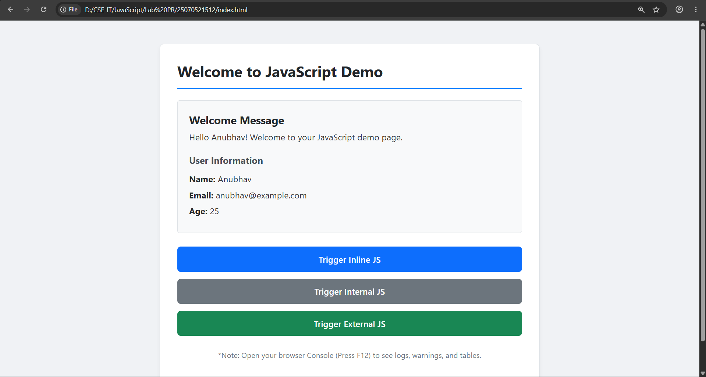

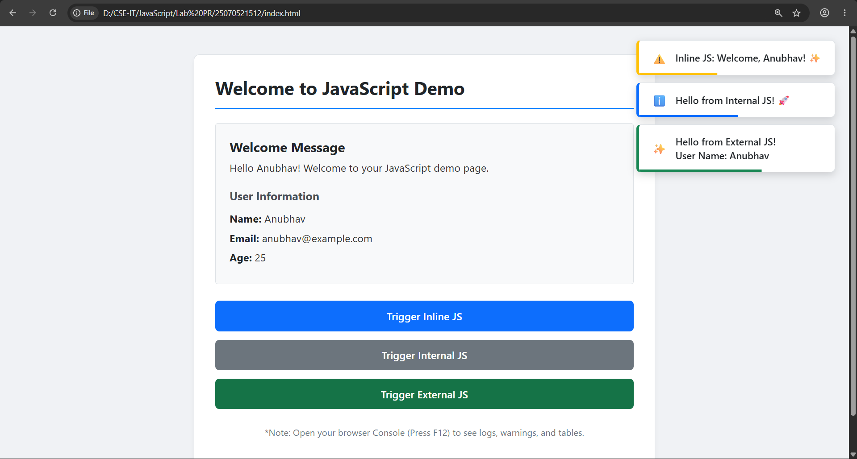
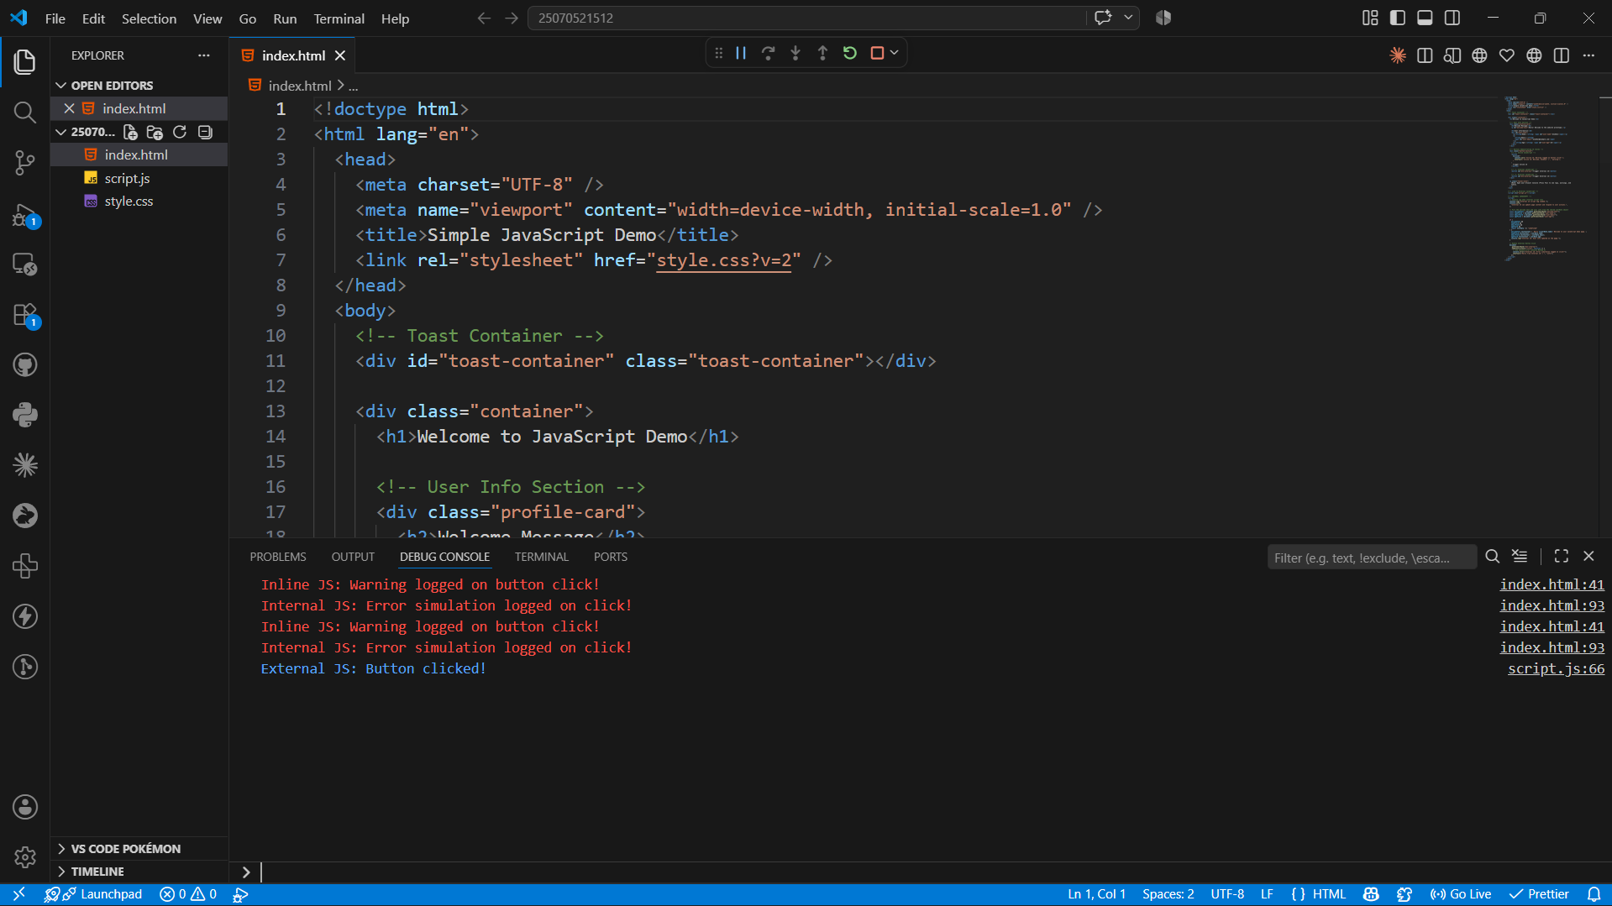
Result: The webpage was successfully created using HTML, CSS, and JavaScript. It demonstrated inline, internal, and external JavaScript, displayed user information with a welcome message, and showed various console methods in the browser console.
Conclusion: The experiment helped in understanding the different ways of including JavaScript in a webpage and how it interacts with HTML elements. It also demonstrated the use of console methods for debugging and basic DOM manipulation.
Case Study No.: 1
Title: Create a webpage for college department and link the student information page with it and write a JavaScript program to display "Welcome to SIT Nagpur" in an alert box.
Software/Tools Required: HTML5 , CSS3 , JavaScript , Visual Studio Code , Google Chrome
Code:
HTML Code:
<!doctype html>
<html lang="en">
<head>
<meta charset="UTF-8" />
<meta name="viewport" content="width=device-width, initial-scale=1.0" />
<title>SIT Nagpur IT Department</title>
<link rel="preconnect" href="https://fonts.googleapis.com" />
<link rel="preconnect" href="https://fonts.gstatic.com" crossorigin />
<link
href="https://fonts.googleapis.com/css2?family=Outfit:wght@400;500;600;700&display=swap"
rel="stylesheet"
/>
<link rel="stylesheet" href="style.css" />
</head>
<body>
<header class="site-header">
<div class="brand-group">
<span class="brand-mark">SIT</span>
<div>
<p class="brand-label">Information Technology</p>
<p class="brand-subtitle">
Symbiosis Institute of Technology, Nagpur
</p>
</div>
</div>
<nav class="top-nav" aria-label="Primary navigation">
<a href="index.html" class="nav-link active">Home</a>
<a href="student_info.html" class="nav-link">Student Records</a>
</nav>
</header>
<main>
<section class="hero-card">
<div class="hero-copy">
<p class="eyebrow">Department Portal</p>
<h1>Information Technology Department</h1>
<p>
Welcome to the official IT department portal for students and
faculty. Access student records, academic announcements, and
department information in a clean, responsive interface.
</p>
<div class="btn-container">
<a href="student_info.html" class="btn">View Student Information</a>
</div>
</div>
<div class="hero-panel">
<article class="stat-card">
<p class="stat-label">Active students</p>
<p class="stat-value">320+</p>
</article>
<article class="stat-card">
<p class="stat-label">Programs</p>
<p class="stat-value">B.Tech • MBA</p>
</article>
<article class="stat-card">
<p class="stat-label">Academic year</p>
<p class="stat-value">2026–2027</p>
</article>
</div>
</section>
<section class="card overview-card">
<h2>About the Department</h2>
<p>
The Information Technology department at SIT Nagpur supports
innovation, industry-aligned learning, and academic excellence. Our
portal provides a polished, accessible view of student data and
department updates for campus stakeholders.
</p>
</section>
</main>
<footer class="page-footer">
<p>Symbiosis Institute of Technology, Nagpur • © 2026</p>
</footer>
<script src="js.js"></script>
</body>
</html>

CSS Code:
:root {
color-scheme: light;
font-family:
"Outfit",
-apple-system,
BlinkMacSystemFont,
"Segoe UI",
Roboto,
sans-serif;
background: #f4f7fb;
color: #1f2937;
--bg: #f4f7fb;
--surface: #ffffff;
--surface-soft: #f8fafc;
--border: #d1d9e6;
--primary: #164e9d;
--primary-strong: #0f3b7d;
--accent: #0ea5e9;
--text: #1f2937;
--muted: #64748b;
--card-shadow: 0 24px 60px rgba(15, 23, 42, 0.08);
}

* {
box-sizing: border-box;
}
html,
body {
margin: 0;
min-height: 100%;
}
body {
background:
radial-gradient(
circle at top left,
rgba(14, 165, 233, 0.12),
transparent 32%
),
radial-gradient(
circle at bottom right,
rgba(22, 78, 157, 0.16),
transparent 28%
),
var(--bg);
color: var(--text);
margin: 0 auto;
max-width: 1100px;
padding: 24px;
}
body::before {
content: "";
position: fixed;
inset: 0;
pointer-events: none;
}
.site-header {
display: flex;
justify-content: space-between;
align-items: center;
padding: 22px 0;
gap: 24px;
}
.brand-group {
display: flex;
align-items: center;
gap: 16px;
}
.brand-mark {
display: inline-flex;
align-items: center;
justify-content: center;
width: 52px;
height: 52px;
border-radius: 14px;
background: linear-gradient(135deg, #2563eb 0%, #1d4ed8 100%);
color: white;
font-weight: 700;
font-size: 1.15rem;
letter-spacing: 0.02em;
}
.brand-label {
margin: 0;
font-size: 1rem;
font-weight: 700;
}
.brand-subtitle {
margin: 4px 0 0;
color: var(--muted);
font-size: 0.92rem;
}
.top-nav {
display: flex;
gap: 18px;
flex-wrap: wrap;
}
.nav-link {
color: var(--muted);
text-decoration: none;
font-size: 0.95rem;
font-weight: 600;
padding: 10px 12px;
border-radius: 10px;
transition: all 0.2s ease;
}
.nav-link:hover,
.nav-link.active {
color: var(--primary-strong);
background: rgba(37, 99, 235, 0.08);
}
main {
display: grid;
gap: 24px;
}
.card {
background: var(--surface);
border: 1px solid rgba(226, 232, 240, 0.9);
border-radius: 24px;
box-shadow: var(--card-shadow);
padding: 32px;
}
.hero-card {
display: grid;
grid-template-columns: minmax(0, 1.4fr) minmax(240px, 1fr);
gap: 24px;
align-items: center;
}
.hero-copy {
max-width: 620px;
}
.eyebrow {
margin: 0 0 16px;
font-size: 0.92rem;
font-weight: 700;
letter-spacing: 0.08em;
text-transform: uppercase;
color: var(--accent);
}
h1,
h2 {
margin: 0;
color: var(--text);
line-height: 1.1;
}
h1 {
font-size: clamp(2rem, 2.4vw, 3rem);
margin-bottom: 18px;
}
h2 {
font-size: 1.55rem;
margin-bottom: 14px;
}
p {
margin: 0 0 18px;
line-height: 1.75;
color: var(--muted);
font-size: 1rem;
}
.hero-panel {
display: grid;
gap: 16px;
}
.stat-card {
background: var(--surface-soft);
border: 1px solid rgba(226, 232, 240, 0.95);
border-radius: 18px;
padding: 22px;
}
.stat-label {
margin: 0 0 8px;
font-size: 0.95rem;
color: var(--muted);
font-weight: 600;
}
.stat-value {
margin: 0;
font-size: 1.45rem;
font-weight: 700;
color: var(--text);
}
.overview-card {
padding: 32px;
}
.btn-container {
margin-top: 16px;
}
.btn {
display: inline-flex;
align-items: center;
justify-content: center;
padding: 14px 26px;
border-radius: 999px;
background: linear-gradient(135deg, var(--primary), #2563eb);
color: #ffffff;
text-decoration: none;
font-weight: 700;
font-size: 0.98rem;
transition:
transform 0.2s ease,
box-shadow 0.2s ease,
background-color 0.2s ease;
box-shadow: 0 18px 32px rgba(37, 99, 235, 0.18);
}
.btn:hover {
transform: translateY(-2px);
box-shadow: 0 24px 40px rgba(37, 99, 235, 0.18);
}
.btn-secondary {
background: var(--surface-soft);
color: var(--text);
box-shadow: none;
border: 1px solid rgba(226, 232, 240, 0.95);
}
.btn-secondary:hover {
background: #eef2ff;
}
.table-container {
overflow-x: auto;
border-radius: 18px;
border: 1px solid rgba(226, 232, 240, 0.95);
box-shadow: inset 0 0 0 1px rgba(255, 255, 255, 0.5);
}
table {
width: 100%;
border-collapse: collapse;
min-width: 520px;
}
th,
td {
padding: 18px 20px;
text-align: left;
border-bottom: 1px solid rgba(226, 232, 240, 1);
}
th {
background: var(--surface-soft);
color: var(--text);
font-weight: 700;
letter-spacing: 0.01em;
}
tbody tr {
transition: background-color 0.2s ease;
}
tbody tr:hover {
background: #f8fafc;
}
tbody tr:last-child td {
border-bottom: none;
}
.page-footer {
text-align: center;
color: var(--muted);
padding: 18px 0 8px;
font-size: 0.95rem;
}
@media (max-width: 860px) {
.hero-card {
grid-template-columns: 1fr;
}
}
@media (max-width: 640px) {
body {
padding: 18px;
}
.site-header {
flex-direction: column;
align-items: flex-start;
}
.top-nav {
width: 100%;
justify-content: flex-start;
}
.btn,
.nav-link {
width: fit-content;
}
}

JavaScript Code:
window.addEventListener("load", function () {
alert("Welcome to SIT Nagpur");
});
console.log("Welcome to SIT Nagpur IT Department Portal");

Student Report:
<!doctype html>
<html lang="en">
<head>
<meta charset="UTF-8" />
<meta name="viewport" content="width=device-width, initial-scale=1.0" />
<title>Student Information | SIT IT Department</title>
<link rel="preconnect" href="https://fonts.googleapis.com" />
<link rel="preconnect" href="https://fonts.gstatic.com" crossorigin />
<link
href="https://fonts.googleapis.com/css2?family=Outfit:wght@400;500;600;700&display=swap"
rel="stylesheet"
/>
<link rel="stylesheet" href="style.css" />
</head>
<body>
<header class="site-header">
<div class="brand-group">
<span class="brand-mark">SIT</span>
<div>
<p class="brand-label">Student Information</p>
<p class="brand-subtitle">
Department of Information Technology, Nagpur
</p>
</div>
</div>
<nav class="top-nav" aria-label="Primary navigation">
<a href="index.html" class="nav-link">Department Home</a>
<a href="student_info.html" class="nav-link active">Student Records</a>
</nav>
</header>
<main>
<section class="card content-card">
<h2>Registered Students</h2>
<p>
This table shows the current student records maintained by the IT
department.
</p>
<div class="table-container">
<table>
<thead>
<tr>
<th>Roll No</th>
<th>Name</th>
<th>Email</th>
</tr>
</thead>
<tbody>
<tr>
<td>101</td>
<td>Chhatrapati Supare</td>
<td>anubhav@email.com</td>
</tr>
<tr>
<td>102</td>
<td>Saksham Kathale</td>
<td>saksham@email.com</td>
</tr>
<tr>
<td>103</td>
<td>Nil Dhoke</td>
<td>nil@email.com</td>
</tr>
</tbody>
</table>
</div>
<div class="btn-container">
<a href="index.html" class="btn btn-secondary">&larr; Back to Home</a>
</div>
</section>
</main>
<footer class="page-footer">
<p>Symbiosis Institute of Technology, Nagpur • © 2026</p>
</footer>
<script src="js.js"></script>
</body>
</html>

Output:

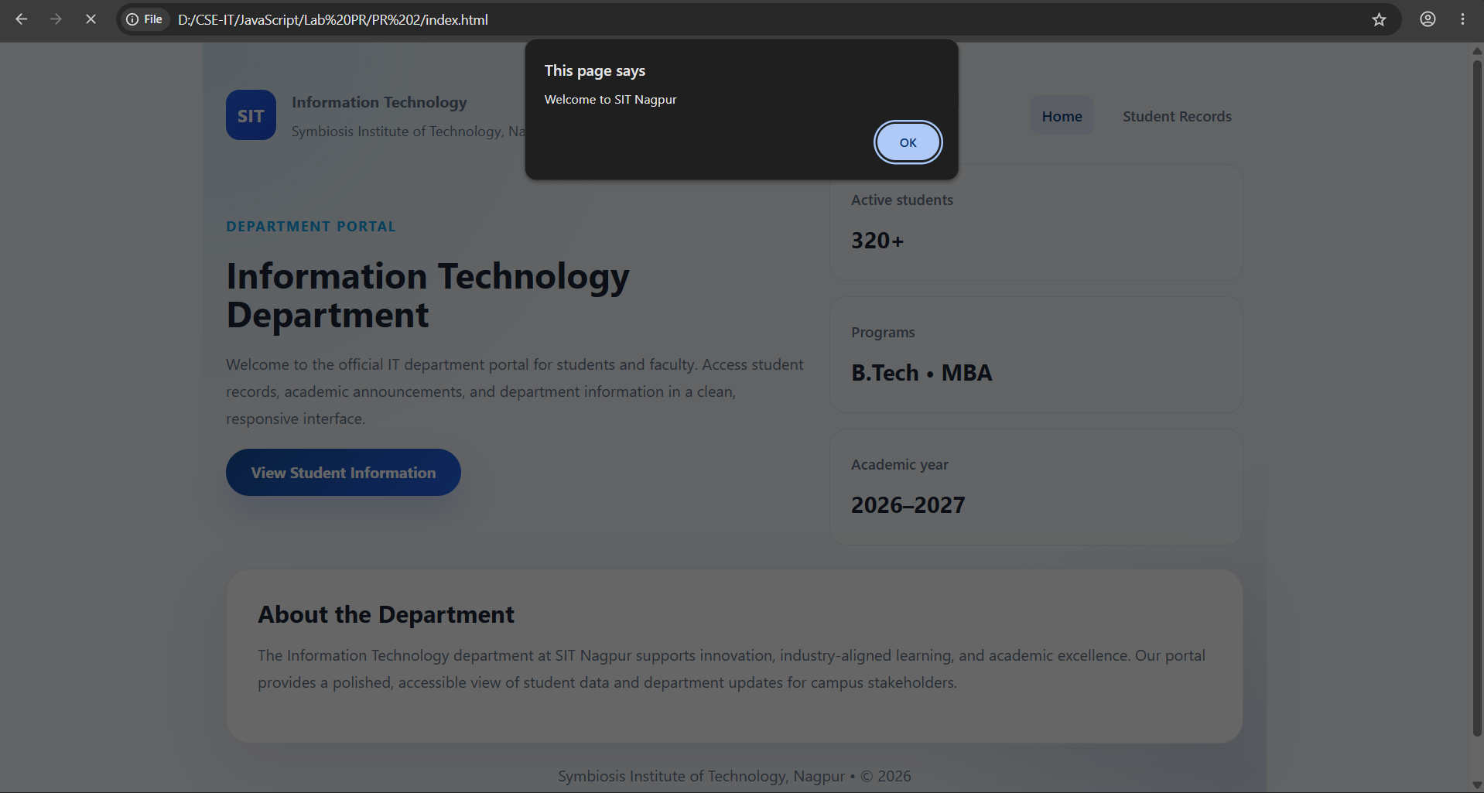

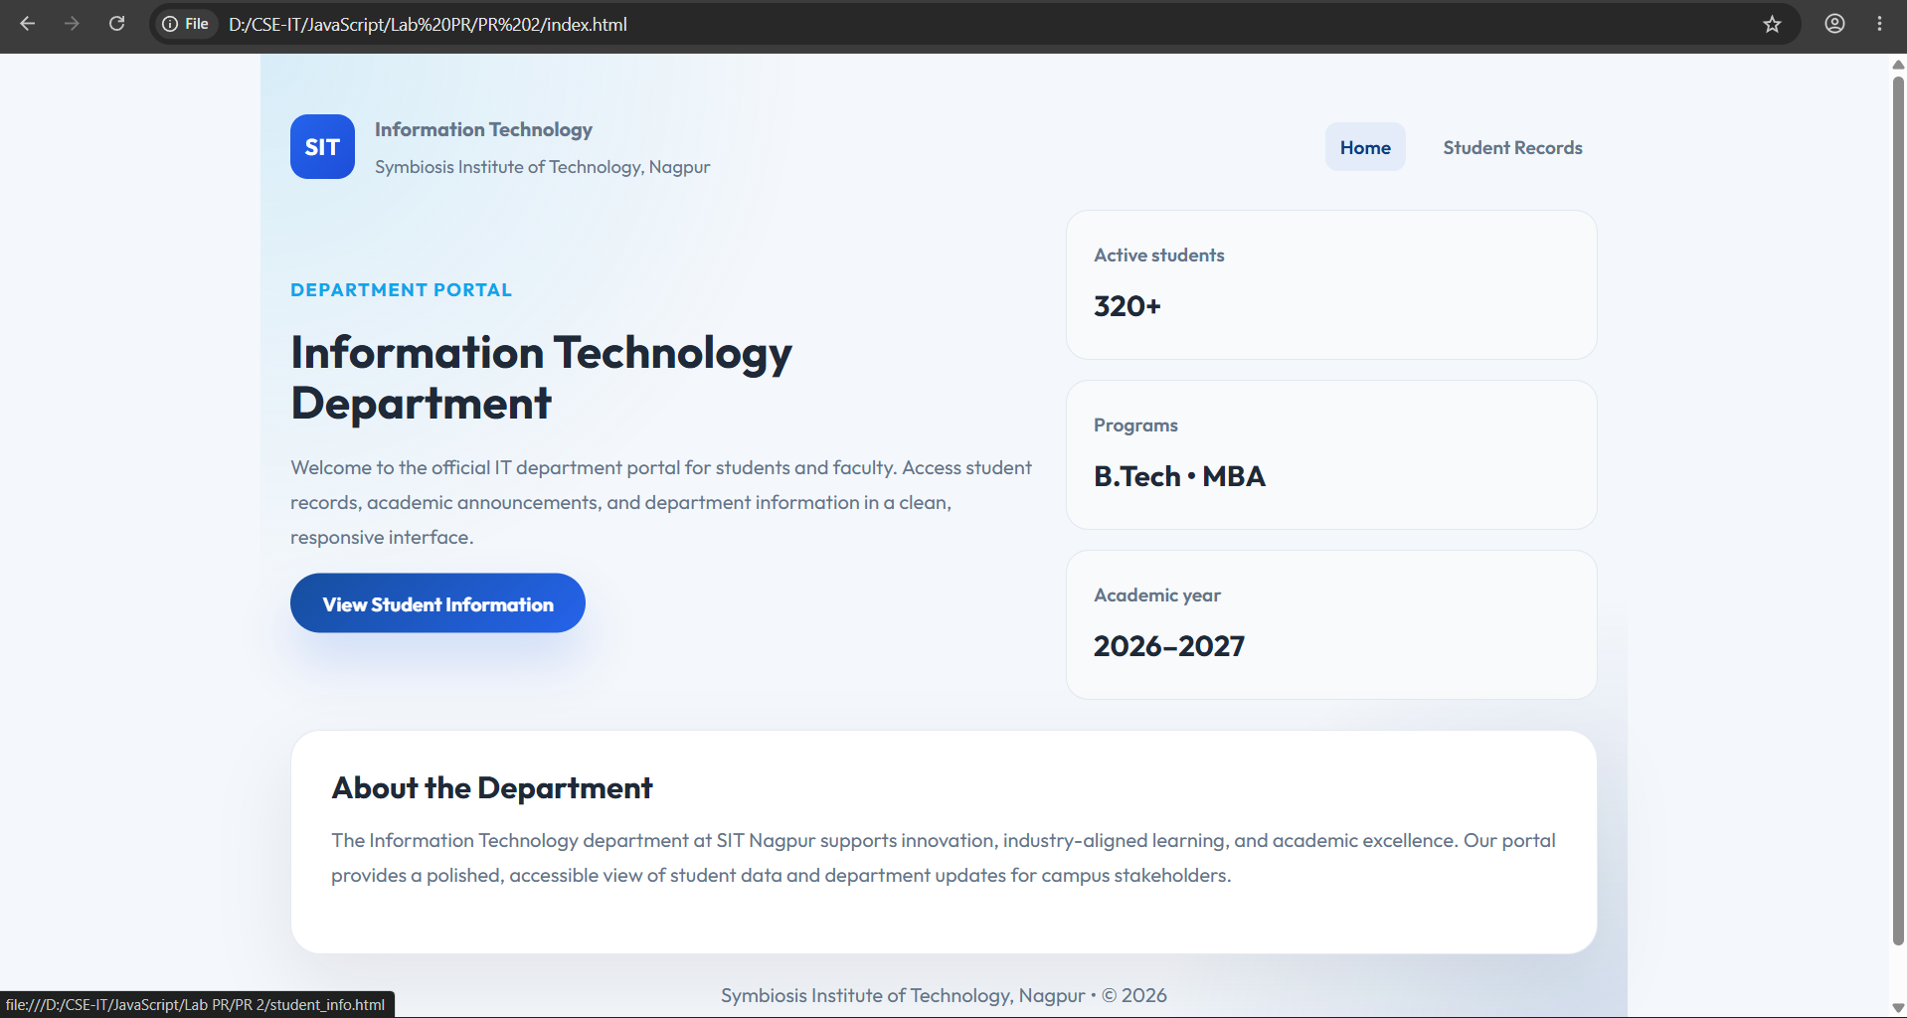
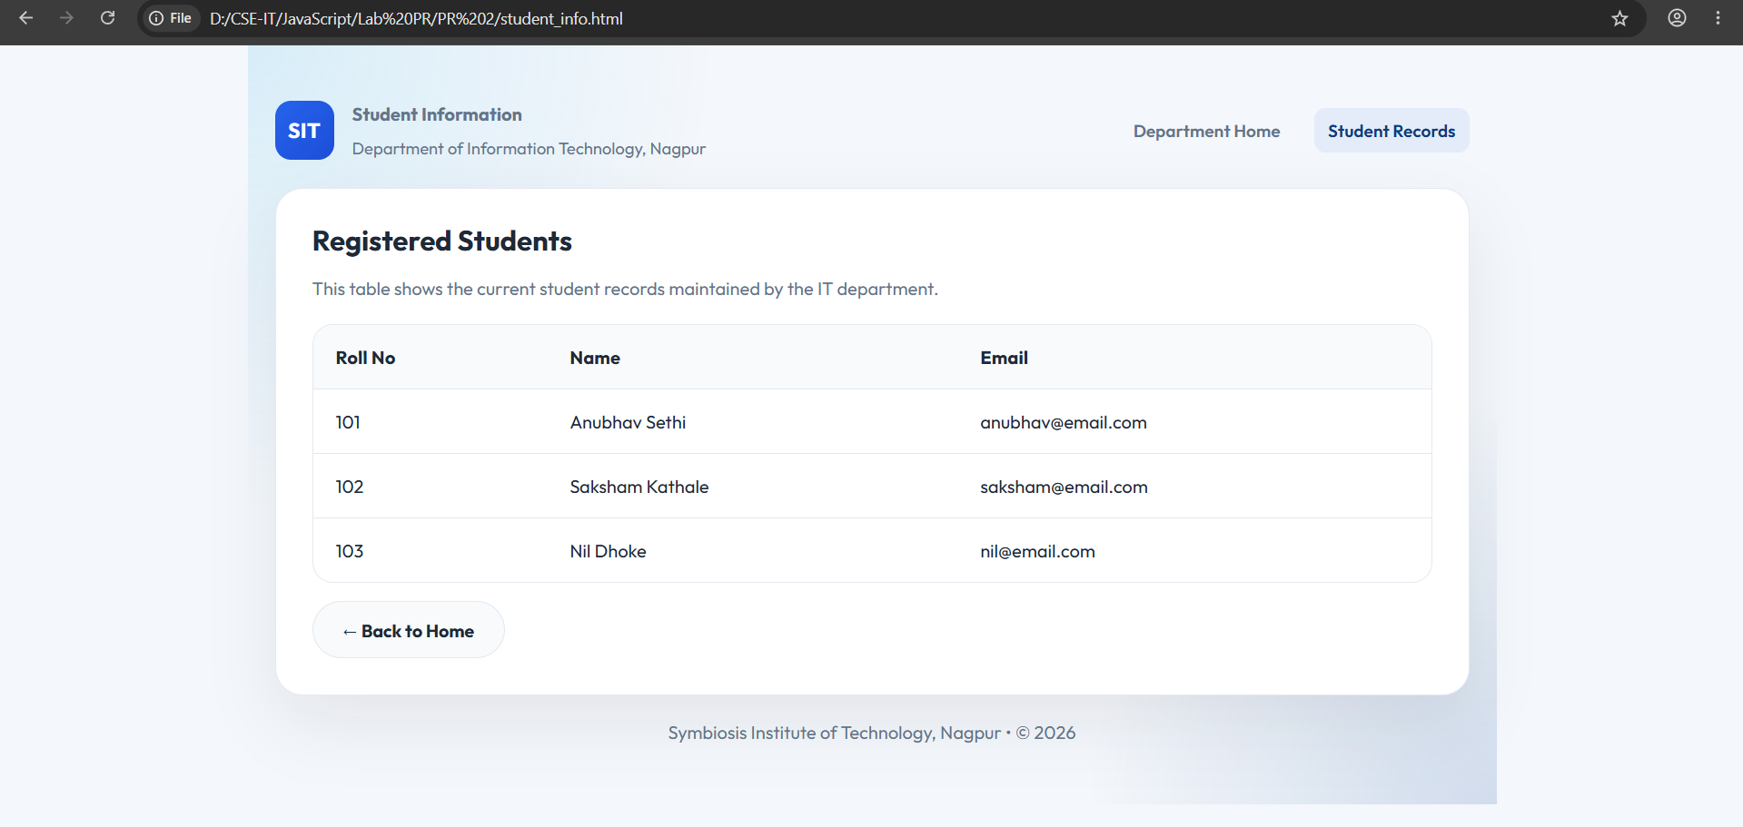
Result: The webpage was successfully created using HTML, CSS, and JavaScript. It demonstrated inline, internal, and external JavaScript, displayed user information with a welcome message, and showed various console methods in the browser console.
Conclusion: The experiment helped in understanding the different ways of including JavaScript in a webpage and how it interacts with HTML elements. It also demonstrated the use of console methods for debugging and basic DOM manipulation.

Experiment No.: 2
Title: Use var, let, const, and demonstrate basic features like template literals and destructuring; build a billing calculator with user input.
Software/Tools Required: HTML5, CSS3, JavaScript, VS Code , Google Chrome
Code:
Index.html:
<!DOCTYPE html>
<html lang="en">
<head>
<meta charset="UTF-8">
<meta name="viewport" content="width=device-width, initial-scale=1.0">
<title>Cafe Billing Receipt</title>
<link rel="stylesheet" href="style.css">
</head>
<body>
<div class="receipt">
<div class="logo">

</div>
<h1>CAFE AROMA</h1>
<p class="subtitle">
Fresh Coffee • Fresh Food
</p>
<div id="bill"></div>
<div class="footer">
<strong>Thank You!</strong>
<br>
Visit Again
</div>
</div>
<script src="script.js"></script>
</body>
</html>
Script.js:
// Using var
var customerName = prompt("Enter Your Name");
// Using let
let productName = prompt("Enter Product Name");
let price = Number(prompt("Enter Price Per Product"));
let quantity = Number(prompt("Enter Quantity"));
// Using const
const GST_RATE = 0.18;
// Calculations
let subtotal = price * quantity;
let gst = subtotal * GST_RATE;
let total = subtotal + gst;
// Create Object
const receipt = {
customerName,
productName,
price,
quantity,
subtotal,
gst,
total
};
// Object Destructuring
const {
customerName: cname,
productName: pname,
price: pprice,
quantity: qty,
subtotal: sub,
gst: gstAmount,
total: grandTotal
} = receipt;
// Display Receipt using Template Literals
document.getElementById("bill").innerHTML = `
<div class="row">
<span>Customer</span>
<span>${cname}</span>
</div>
<div class="row">
<span>Product</span>
<span>${pname}</span>
</div>
<div class="row">
<span>Price</span>
<span>₹${pprice.toFixed(2)}</span>
</div>
<div class="row">
<span>Quantity</span>
<span>${qty}</span>
</div>
<hr>
<div class="row">
<span>Subtotal</span>
<span>₹${sub.toFixed(2)}</span>
</div>
<div class="row">
<span>GST (18%)</span>
<span>₹${gstAmount.toFixed(2)}</span>
</div>
<hr>
<div class="total">
<span>TOTAL</span>
<span>₹${grandTotal.toFixed(2)}</span>
</div>
`;
Style.css:
*{
margin:0;
padding:0;
box-sizing:border-box;
font-family:"Courier New", monospace;
}
body{
min-height:100vh;
display:flex;
justify-content:center;
align-items:center;
background:
linear-gradient(rgba(0,0,0,.15),rgba(0,0,0,.15)),
url("https://encrypted-tbn0.gstatic.com/images?q=tbn:ANd9GcT5qZ22xW3517kfMJRCK
s7_Jul0AzmZ-IZyH4FU5ozLAOv5fwEfpjXiZo&s=10");
background-size:cover;
background-position:center;
}
.receipt{
width:420px;
background:white;
padding:30px;
border-radius:12px;
box-shadow:0 15px 35px rgba(0,0,0,.35);
position:relative;
}
.receipt::after{
content:"";
position:absolute;
left:0;
bottom:-12px;
width:100%;
height:20px;
background:
repeating-linear-gradient(
-45deg,
white 0px,
white 10px,
transparent 10px,
transparent 20px
);
}
.logo{
text-align:center;
font-size:55px;
}
h1{
text-align:center;
color:#5d4037;
margin-top:10px;
}
.subtitle{
text-align:center;
color:#777;
margin-bottom:25px;
}
.row{
display:flex;
justify-content:space-between;
margin:15px 0;
font-size:17px;
}
hr{
border:none;
border-top:2px dashed #999;
margin:18px 0;
}
.total{
background:#6f4e37;
color:white;
padding:15px;
border-radius:8px;
display:flex;
justify-content:space-between;
font-size:22px;
font-weight:bold;
}
.footer{
text-align:center;
margin-top:30px;
color:#777;
font-size:15px;
}
.footer strong{
color:#5d4037;
}
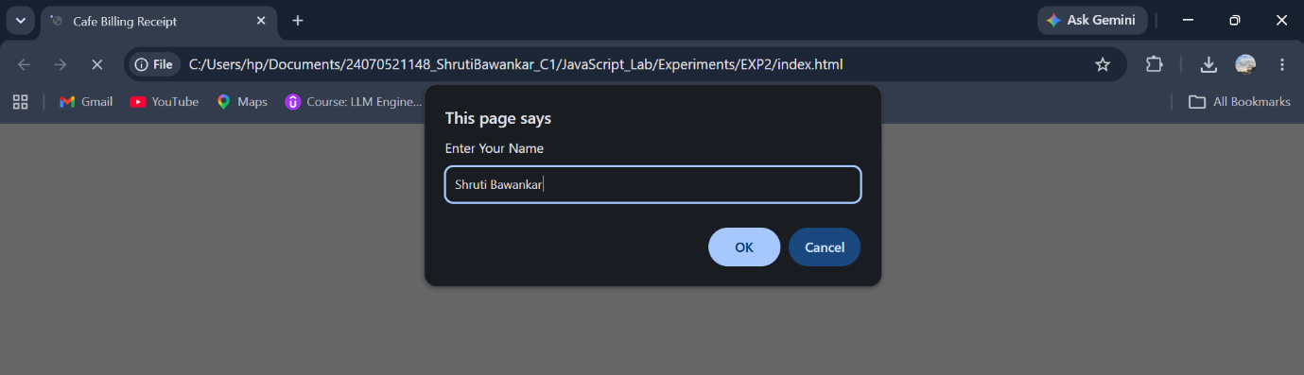
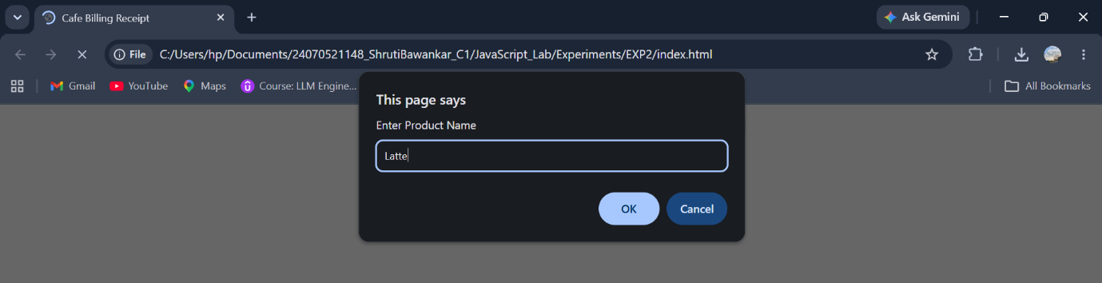
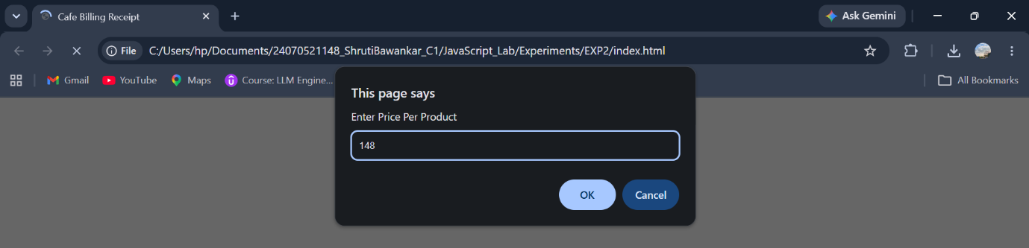
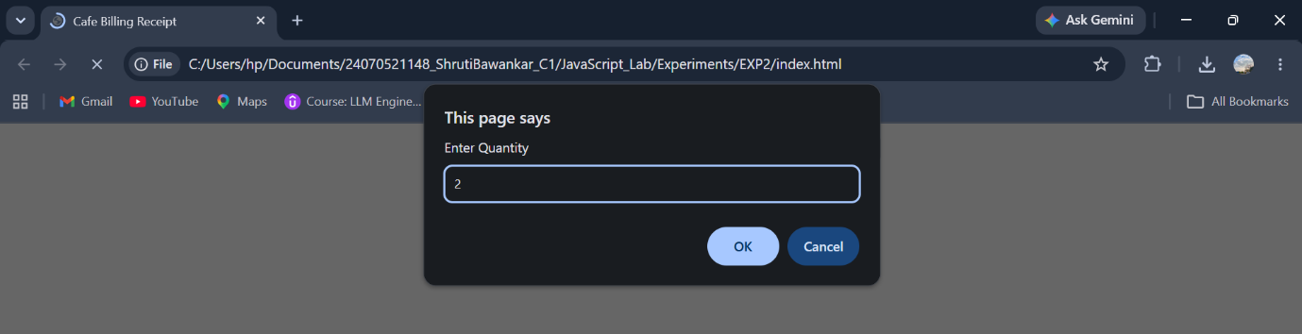
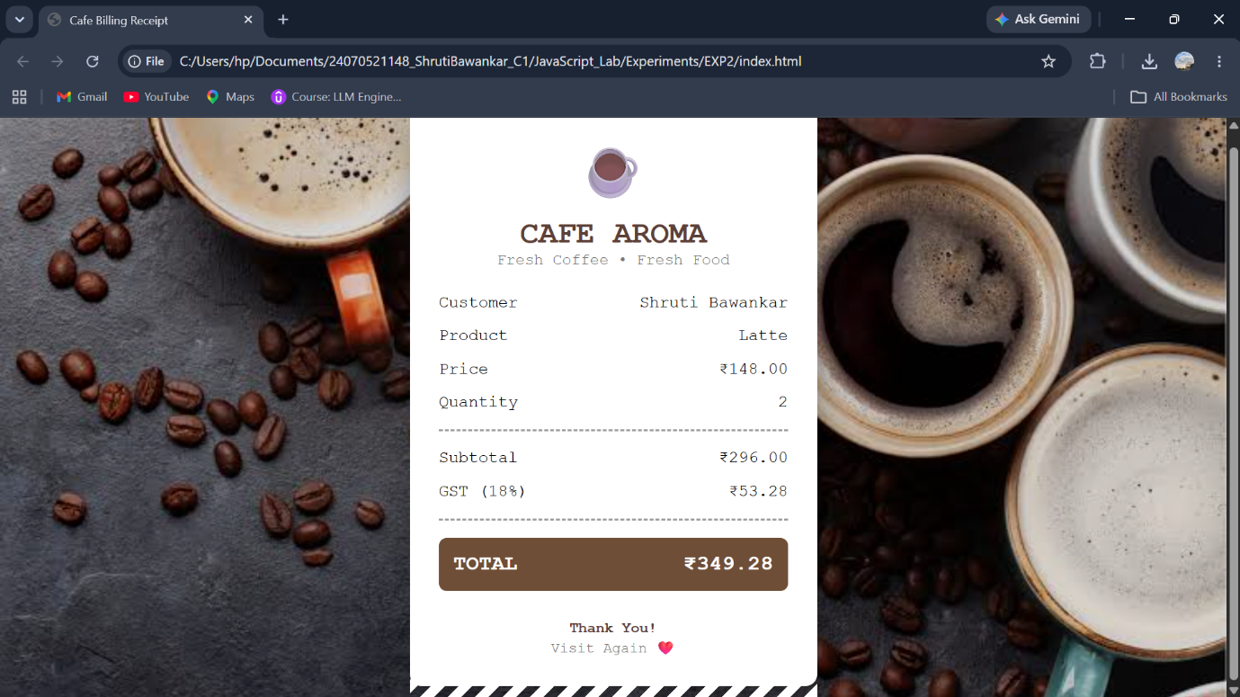

Result: A billing calculator was successfully developed using JavaScript. It accepted user input, calculated the subtotal, GST (18%), and total amount, and displayed a formatted billing receipt on the web page.
Conclusion: The experiment demonstrated the use of var, let, const, prompt(), template literals, and object destructuring to create an interactive and user-friendly billing application.

Case Study No.: 2
Title: Develop the webpage for an online shopping website with using HTML,CSS and HTML5 tags and calculate the bill using Customer Name, Mobile number, Invoice Number, Product Name, Quality (in Kgs), Rate per Kg(Rs), Discount(%), GST(%), Packing Charges(Rs), Payment Mode (Cash/Card/UPI).
Software/Tools Required: HTML5 , CSS3 , JavaScript , Visual Studio Code , Google Chrome
index.html:
<!DOCTYPE html>
<html lang="en">
<head>
<meta charset="UTF-8">
<meta name="viewport" content="width=device-width, initial-scale=1.0">
<title>FreshMart - Smart Billing</title>
<link rel="stylesheet" href="style.css">
<link href="https://fonts.googleapis.com/css2?family=Roboto+Mono:wght@400;500;700&display=swap" rel="stylesheet">
<link rel="stylesheet"
href="https://cdnjs.cloudflare.com/ajax/libs/font-awesome/6.5.2/css/all.min.css">
</head>
<body>
<div class="container">
<header>
<div class="logo">
<h1>
<i class="fa-solid fa-cart-shopping"></i>
FreshMart
</h1>
<p>Fresh Fruits • Vegetables • Grocery</p>
</div>
<div class="title">
<h2>
<i class="fa-solid fa-receipt"></i>
Smart Billing
</h2>
</div>
</header>
<hr>
<main>
<section class="left-panel">
<h2>
🍎 Product Details
</h2>
<form id="billingForm">
<div class="input-group">
<label>
<i class="fa-solid fa-user"></i>
Customer Name
</label>
<input
type="text"
id="customerName"
placeholder="Enter customer name">
</div>
<div class="input-group">
<label>
<i class="fa-solid fa-mobile-screen-button"></i>
Mobile Number
</label>
<input
type="tel"
id="mobile"
maxlength="10"
placeholder="10 digit mobile number">
</div>
<div class="input-group">
<label>
<i class="fa-solid fa-cart-shopping"></i>
Product Name
</label>
<select id="product">
<option value="">Select Product</option>
<option value="Apple"
data-rate="250">
Apple
</option>
<option value="Banana"
data-rate="80">
Banana
</option>
<option value="Mango"
data-rate="180">
Mango
</option>
</select>
</div>
<div class="input-group">
<label>
<i class="fa-solid fa-weight-hanging"></i>
Quantity (Kg)
</label>
<input
type="number"
id="quantity"
min="1"
placeholder="Enter quantity">
</div>
<div class="input-group">
<label>
<i class="fa-solid fa-sack-dollar"></i>
Rate / Kg
</label>
<input
type="number"
id="rate"
readonly>
</div>
<div class="input-group">
<label>
<i class="fa-solid fa-star"></i>
Membership
</label>
<select id="member">
<option value="No">No</option>
<option value="Yes">Yes</option>
</select>
</div>
<div class="input-group">
<label>
<i class="fa-solid fa-credit-card"></i>
Payment Mode
</label>
<select id="payment">
<option>Cash</option>
<option>Card</option>
<option>UPI</option>
</select>
</div>
<div class="button-group">
<button
type="button"
id="calculateBtn">
Calculate Bill
</button>
<button
type="reset"
id="resetBtn">
Reset
</button>
</div>
</form>
</section>
<section class="right-panel">
<h2>
<i class="fa-solid fa-file-invoice"></i>
Invoice Summary
</h2>
<div class="invoice">
<p>
Invoice #
<span id="invoiceNo">
INV-1001
</span>
</p>
<p>
Date
<span id="currentDate"></span>
</p>
<p>
Customer
<span id="outCustomer">-</span>
</p>
<p>
Product
<span id="outProduct">-</span>
</p>
<hr>
<p>
Quantity
<span id="outQty">0 Kg</span>
</p>
<p>
Rate
<span id="outRate">₹0</span>
</p>
<hr>
<p>
Subtotal
<span id="subtotal">₹0</span>
</p>
<p>
Discount
<span id="discount">₹0</span>
</p>
<p>
GST (5%)
<span id="gst">₹0</span>
</p>
<p>
Packing
<span id="packing">₹50</span>
</p>
<hr>
<h3>
TOTAL
<span id="total">
₹0
</span>
</h3>
</div>
</section>
</main>
</div>
<script src="script.js"></script>
</body>
</html>
script.html:
const invoiceNo = document.getElementById("invoiceNo");
const currentDate = document.getElementById("currentDate");
const customerName = document.getElementById("customerName");
const mobile = document.getElementById("mobile");
const product = document.getElementById("product");
const quantity = document.getElementById("quantity");
const rate = document.getElementById("rate");
const member = document.getElementById("member");
const payment = document.getElementById("payment");
const calculateBtn = document.getElementById("calculateBtn");
const resetBtn = document.getElementById("resetBtn");
const outCustomer = document.getElementById("outCustomer");
const outProduct = document.getElementById("outProduct");
const outQty = document.getElementById("outQty");
const outRate = document.getElementById("outRate");
const subtotal = document.getElementById("subtotal");
const discount = document.getElementById("discount");
const gst = document.getElementById("gst");
const packing = document.getElementById("packing");
const total = document.getElementById("total");
invoiceNo.textContent =
"INV-" + Math.floor(1000 + Math.random() * 9000);
const today = new Date();
currentDate.textContent =
today.toLocaleDateString("en-GB", {
day: "numeric",
month: "long",
year: "numeric"
});
product.addEventListener("change", () => {
const selected =
product.options[product.selectedIndex];
const price =
selected.getAttribute("data-rate");
rate.value = price ? price : "";
});
calculateBtn.addEventListener("click", () => {
if (customerName.value.trim() === "") {
alert("Enter Customer Name");
customerName.focus();
return;
}
if (!/^[0-9]{10}$/.test(mobile.value)) {
alert("Enter Valid Mobile Number");
mobile.focus();
return;
}
if (product.value === "") {
alert("Select Product");
return;
}
if (quantity.value === "" || quantity.value <= 0) {
alert("Enter Quantity");
quantity.focus();
return;
}
const qty = Number(quantity.value);
const price = Number(rate.value);
const sub = qty * price;
let discountAmount = 0;
if (member.value === "Yes") {
discountAmount = sub * 0.10;
}
const afterDiscount =
sub - discountAmount;
const gstAmount =
afterDiscount * 0.05;
const packingCharge = 50;
const finalTotal =
afterDiscount + gstAmount + packingCharge;
outCustomer.textContent =
customerName.value;
outProduct.textContent =
product.value;
outQty.textContent =
qty + " Kg";
outRate.textContent =
"₹" + price.toFixed(2);
subtotal.textContent =
"₹" + sub.toFixed(2);
discount.textContent =
"₹" + discountAmount.toFixed(2);
gst.textContent =
"₹" + gstAmount.toFixed(2);
packing.textContent =
"₹" + packingCharge.toFixed(2);
total.textContent =
"₹" + finalTotal.toFixed(2);
});
resetBtn.addEventListener("click", () => {
rate.value = "";
outCustomer.textContent = "-";
outProduct.textContent = "-";
outQty.textContent = "0 Kg";
outRate.textContent = "₹0";
subtotal.textContent = "₹0";
discount.textContent = "₹0";
gst.textContent = "₹0";
packing.textContent = "₹50";
total.textContent = "₹0";
invoiceNo.textContent =
"INV-" + Math.floor(1000 + Math.random() * 9000);
currentDate.textContent =
new Date().toLocaleDateString("en-GB", {
day: "numeric",
month: "long",
year: "numeric"
});
});
Style.css :
*{
margin:0;
padding:0;
box-sizing:border-box;
font-family:'Roboto Mono', monospace;
}
body{
margin: 0;
padding: 40px 20px;
font-family: 'Roboto Mono', monospace;
background: url("images/background.jpg") no-repeat center center fixed;
background-size: cover;
display: flex;
justify-content: center;
align-items: center;
min-height: 100vh;
color: white;
}
.container{
width: 1200px;
max-width: 100%;
background: rgba(0, 0, 0, 0.65);
backdrop-filter: blur(12px);
-webkit-backdrop-filter: blur(12px);
border: 1px solid rgba(255,255,255,0.2);
border-radius: 15px;
padding: 35px;
box-shadow: 0 10px 30px rgba(0,0,0,0.5);
}
header{
display:flex;
justify-content:space-between;
align-items:flex-start;
margin-bottom:25px;
}
.logo h1{
font-size:32px;
margin-bottom:12px;
color:#ffffff;
}
.logo p{
font-size:18px;
color:#dddddd;
font-weight:500;
}
.title h2{
font-size:30px;
color:#ffffff;
}
hr{
border:none;
border-top:2px solid #8a8a8a;
margin:25px 0;
}
main{
display:grid;
grid-template-columns:1fr 1fr;
gap:70px;
}
.left-panel h2,
.right-panel h2{
margin-bottom:25px;
font-size:28px;
}
#billingForm,
.invoice{
background: rgba(255,255,255,0.05);
border: 1px solid rgba(255,255,255,0.2);
border-radius: 12px;
padding: 30px;
backdrop-filter: blur(8px);
}
.input-group{
margin-bottom:22px;
}
.input-group label{
display:block;
font-size:20px;
margin-bottom:8px;
font-weight:bold;
}
.input-group label i{
width:28px;
}
.input-group input,
.input-group select{
width:100%;
padding:13px;
font-size:18px;
color:rgb(0, 0, 0);
background:rgba(255,255,255,0.08);
border:1px solid rgba(255,255,255,0.25);
border-radius:8px;
outline:none;
transition:.3s;
}
.input-group input:focus,
.input-group select:focus{
border-color:#4CAF50;
box-shadow:0 0 12px rgba(76,175,80,.4);
}
.button-group{
margin-top:35px;
display:flex;
gap:18px;
}
.button-group button{
flex:1;
padding:15px;
font-size:18px;
color:white;
background:#4CAF50;
border:none;
border-radius:8px;
cursor:pointer;
transition:.3s;
}
.button-group button:hover{
transform:translateY(-3px);
background:#2E7D32;
box-shadow:0 8px 20px rgba(76,175,80,.4);
}
#billingForm:hover,
.invoice:hover{
transform:translateY(-5px);
transition:.3s;
box-shadow:0 10px 25px rgba(0,0,0,.4);
}
.invoice{
border:2px solid #d9d9d9;
padding:30px;
}
.invoice p{
display:flex;
justify-content:space-between;
margin:18px 0;
font-size:20px;
}
.invoice h3{
display:flex;
justify-content:space-between;
margin-top:25px;
font-size:30px;
color:#FFD54F;
}
.invoice hr{
margin:20px 0;
border-top:1px dashed #999;
}
footer{
margin-top:45px;
text-align:center;
font-size:22px;
font-weight:bold;
}
::placeholder{
color:#b8b8b8;
}
::-webkit-scrollbar{
width:10px;
}
::-webkit-scrollbar-track{
background:#222;
}
::-webkit-scrollbar-thumb{
background:#555;
}
::-webkit-scrollbar-thumb:hover{
background:#777;
}
@media(max-width:900px){
header{
flex-direction:column;
gap:20px;
}
main{
grid-template-columns:1fr;
}
.button-group{
flex-direction:column;
}
.logo h1{
font-size:28px;
}
.title h2{
font-size:26px;
}
.left-panel h2,
.right-panel h2{
font-size:24px;
}
.invoice p{
font-size:18px;
}
.invoice h3{
font-size:26px;
}
}
@media(max-width:600px){
body{
padding:20px 10px;
}
#billingForm,
.invoice{
padding:20px;
}
.input-group label{
font-size:18px;
}
.input-group input,
.input-group select{
font-size:16px;
}
footer{
font-size:18px;
}
}

Output :

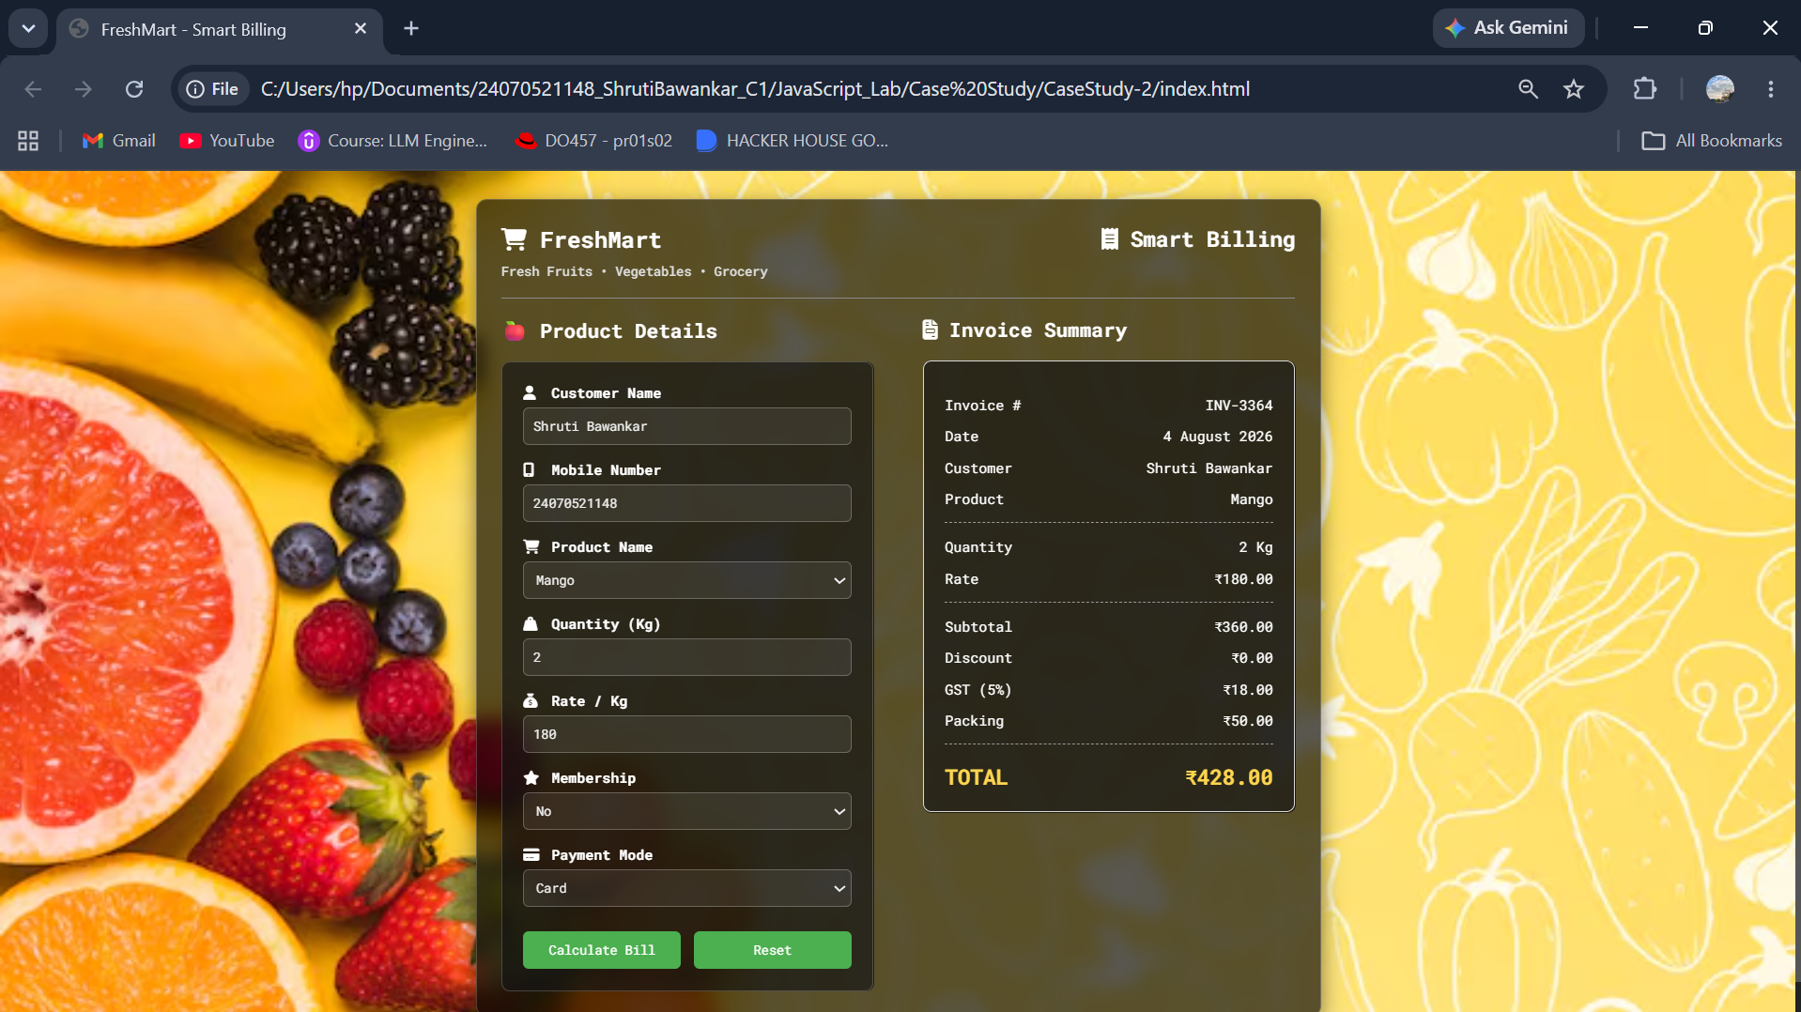

Result: The FreshMart Smart Billing System was successfully developed with a responsive user interface that accurately calculates the bill, applies discounts, GST, and packing charges, and generates a printable invoice.
Conclusion: The experiment demonstrated the use of HTML, CSS, and JavaScript to create an interactive and user-friendly e-commerce billing application with real-time calculations and form validation.

Experiment No.: 3
Title: Implement control structures and form validation; create a grading system based on user-entered marks.
Software/Tools Required: HTML5, CSS3, JavaScript, VS Code, Google Chrome
Index.html:
<!DOCTYPE html>
<html lang="en">
<head>
<meta charset="UTF-8">
<meta name="viewport" content="width=device-width, initial-scale=1.0">
<title>Student Grading System</title>
<link rel="stylesheet" href="style.css">
</head>
<body>
<div class="container">
<h1>Student Grading System</h1>
<form id="gradeForm">
<div class="input-group">
<label>Student Name</label>
<input type="text" id="studentName" placeholder="Enter Student Name">
</div>
<div class="input-group">
<label>Roll Number</label>
<input type="text" id="rollNumber" placeholder="Enter Roll Number">
</div>
<div class="input-group">
<label>Javascript</label>
<input type="number" id="javascript" min="0" max="100">
</div>
<div class="input-group">
<label>Computer Networks</label>
<input type="number" id="computer-networks" min="0" max="100">
</div>
<div class="input-group">
<label>Compiler Construction</label>
<input type="number" id="compiler-construction" min="0" max="100">
</div>
<div class="input-group">
<label>Data Compression</label>
<input type="number" id="data-compression" min="0" max="100">
</div>
<div class="input-group">
<label>Specialization(Data Science/AI/ML)</label>
<input type="number" id="specialization" min="0" max="100">
</div>
<button type="submit">Calculate Result</button>
</form>
<div id="result"></div>
</div>
<script src="script.js"></script>
</body>
</html>
Style.css:
*{
margin:0;
padding:0;
box-sizing:border-box;
font-family: Ballance;
}
body{
background:linear-gradient(135deg,#99c6ee,#a4e5f0);
display:flex;
justify-content:center;
align-items:center;
min-height:100vh;
}
.container{
width: 1000px;
background:#c7e0f4;
padding:30px;
border-radius:15px;
box-shadow:0 10px 25px rgba(0,0,0,.2);
}
h1{
text-align:center;
margin-bottom:25px;
color:#0e0e0f;
}
.input-group{
margin-bottom:15px;
}
label{
display:block;
margin-bottom:6px;
font-weight:bold;
}
input{
width:100%;
padding:10px;
border:1px solid #d2e4fd;
border-radius:8px;
font-size:15px;
}
input:focus{
outline:none;
border-color:#0d6efd;
}
button{
width:100%;
padding:12px;
background:#0c48a1;
color:white;
border:none;
border-radius:8px;
font-size:16px;
cursor:pointer;
}
button:hover{
background:#084298;
}
#result{
margin-top:20px;
display:none;
padding:15px;
background:#f5f8ff;
border-radius:10px;
}
table{
width:100%;
border-collapse:collapse;
}
td{
padding:10px;
border-bottom:1px solid #ddd;
}
.success{
color:green;
font-weight:bold;
}
.fail{
color:red;
font-weight:bold;
}
Script.js:
const gradeForm = document.getElementById("gradeForm");
gradeForm.addEventListener("submit", function (event) {
event.preventDefault();
const name = document.getElementById("studentName").value.trim();
const rollNumber = document.getElementById("rollNumber").value.trim();
const javascript = Number(document.getElementById("javascript").value);
const computerNetworks = Number(document.getElementById("computer
networks").value);
const compilerConstruction = Number(document.getElementById("compiler
construction").value);
const dataCompression = Number(document.getElementById("data-compression").value);
const specialization = Number(document.getElementById("specialization").value);
const marks = [
javascript,
computerNetworks,
compilerConstruction,
dataCompression,
specialization
];
if (name === "") {
alert("Please enter Student Name.");
return;
}
if (rollNumber === "") {
alert("Please enter Roll Number.");
return;
}
for (let mark of marks) {
if (isNaN(mark)) {
alert("Please enter all subject marks.");
return;
}
if (mark < 0 || mark > 100) {
alert("Marks should be between 0 and 100.");
return;
}
}
const total = marks.reduce((sum, mark) => sum + mark, 0);
const percentage = (total / 500) * 100;
let status = "Pass";
for (let mark of marks) {
if (mark < 35) {
status = "Fail";
break;
}
}
let grade;
if (status === "Fail") {
grade = "F";
} else if (percentage >= 90) {
grade = "A+";
} else if (percentage >= 80) {
grade = "A";
} else if (percentage >= 70) {
grade = "B";
} else if (percentage >= 60) {
grade = "C";
} else if (percentage >= 50) {
grade = "D";
} else {
grade = "F";
}
let remarks;
switch (grade) {
case "A+":
remarks = "Outstanding";
break;
case "A":
remarks = "Excellent";
break;
case "B":
remarks = "Very Good";
break;
case "C":
remarks = "Good";
break;
case "D":
remarks = "Needs Improvement";
break;
default:
remarks = "Better Luck Next Time";
}
const studentResult = {
name,
rollNumber,
total,
percentage: percentage.toFixed(2),
grade,
status,
remarks
};
localStorage.setItem("studentResult", JSON.stringify(studentResult));
displayResult(studentResult);
});
function displayResult(data) {
const result = document.getElementById("result");
result.style.display = "block";
result.innerHTML = `
<h2 style="text-align:center; margin-bottom:15px;">
Student Result
</h2>
<table>
<tr>
<td><strong>Student Name</strong></td>
<td>${data.name}</td>
</tr>
<tr>
<td><strong>Roll Number</strong></td>
<td>${data.rollNumber}</td>
</tr>
<tr>
<td><strong>Total Marks</strong></td>
<td>${data.total} / 500</td>
</tr>
<tr>
<td><strong>Percentage</strong></td>
<td>${data.percentage}%</td>
</tr>
<tr>
<td><strong>Grade</strong></td>
<td>${data.grade}</td>
</tr>
<tr>
<td><strong>Status</strong></td>
<td class="${data.status === "Pass" ? "success" : "fail"}">
${data.status}
</td>
</tr>
<tr>
<td><strong>Remarks</strong></td>
<td>${data.remarks}</td>
</tr>
</table>
`; }
window.onload = function () {
const savedData = localStorage.getItem("studentResult");
if (savedData) {
displayResult(JSON.parse(savedData));
} };
Output:
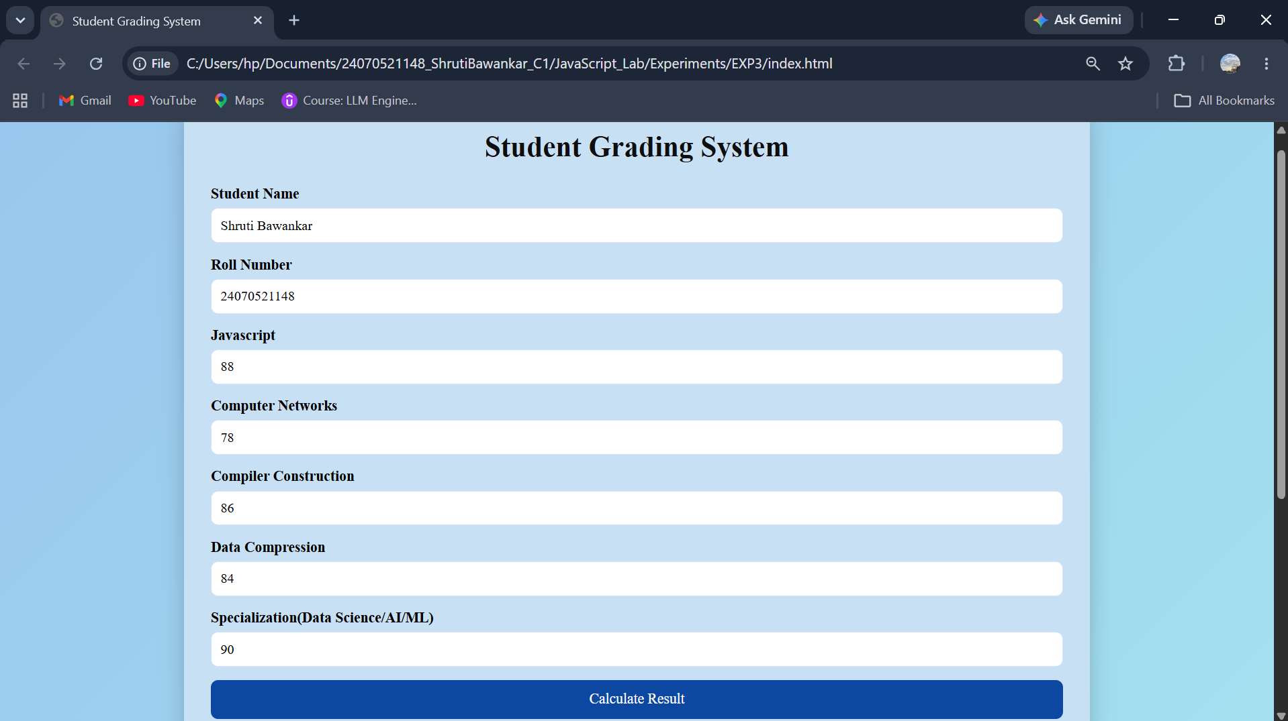
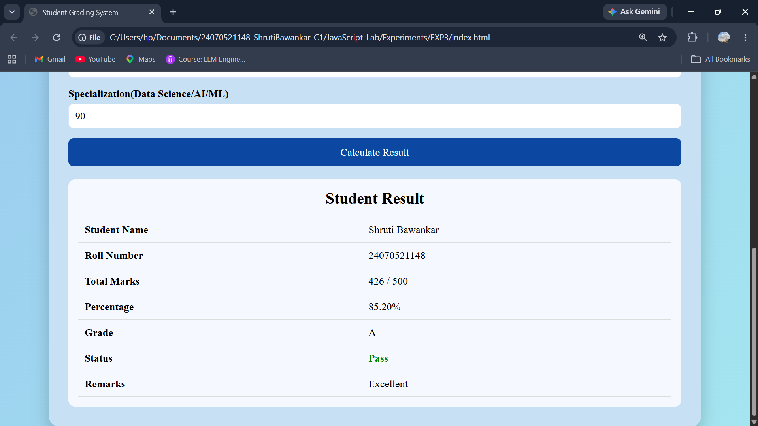

Result: The Student Grading System was successfully implemented using HTML, CSS, and JavaScript. It validates user input, calculates the percentage, assigns grades using control structures, and displays the result accurately on a separate result page.
Conclusion: The Student Grading System successfully demonstrates the use of HTML, CSS, and JavaScript to create an interactive web application. It implements form validation, control structures, loops, and Local Storage to process user input and generate an accurate student result. The project provides a professional and user-friendly interface while reinforcing fundamental concepts of client-side web development.

Case Study No.: 3
Title: Student Grading System with Login Authentication and Form Validation using HTML, CSS, and JavaScript
Software/Tools Required: HTML5 , CSS3 , JavaScript , Visual Studio Code , Google Chrome
Index.html:
<!DOCTYPE html>
<html lang="en">
<head>
<meta charset="UTF-8">
<meta name="viewport" content="width=device-width, initial-scale=1.0">
<title>Student Grading System</title>
<link rel="stylesheet" href="style.css">
</head>
<body>
<div class="container">
<h1>Enter Subject Marks</h1>
<form id="gradeForm">
<div class="input-group">
<label>JavaScript</label>
<input
type="number"
id="javascript"
placeholder="Enter Marks"
min="0"
max="100"
required
>
</div>
<div class="input-group">
<label>Computer Networks</label>
<input
type="number"
id="computer-networks"
placeholder="Enter Marks"
min="0"
max="100"
required
>
</div>
<div class="input-group">
<label>Compiler Construction</label>
<input
type="number"
id="compiler-construction"
placeholder="Enter Marks"
min="0"
max="100"
required
>
</div>
<div class="input-group">
<label>Data Compression</label>
<input
type="number"
id="data-compression"
placeholder="Enter Marks"
min="0"
max="100"
required
>
</div>
<div class="input-group">
<label>Specialization (AI / ML / Data Science)</label>
<input
type="number"
id="specialization"
placeholder="Enter Marks"
min="0"
max="100"
required
>
</div>
<button type="submit">
Generate Result
</button>
<button type="reset" class="reset-btn">
Reset
</button>
</form>
</div>
<script src="script.js"></script>
</body>
</html>
Login.html:
<!DOCTYPE html>
<html lang="en">
<head>
<meta charset="UTF-8">
<meta name="viewport" content="width=device-width, initial-scale=1.0">
<title>Student Login</title>
<link rel="stylesheet" href="style.css">
</head>
<body>
<div class="container">
<h1>Student Login</h1>
<form id="loginForm">
<div class="input-group">
<label>Student Name</label>
<input
type="text"
id="studentName"
placeholder="Enter Student Name"
required
>
</div>
<div class="input-group">
<label>PRN Number</label>
<input
type="text"
id="prn"
placeholder="Enter PRN Number"
required
>
</div>
<div class="input-group">
<label>Password</label>
<input
type="password"
id="password"
placeholder="Enter Password"
required
>
</div>
<button type="submit">
Login
</button>
</form>
<p
id="message"
style="
text-align:center;
margin-top:20px;
color:red;
font-weight:bold;">
</p>
</div>
<script src="login.js"></script>
</body>
</html>

Login.js:
const loginForm = document.getElementById("loginForm");
loginForm.addEventListener("submit", function(event){
event.preventDefault();
const studentName = document.getElementById("studentName").value.trim();
const prn = document.getElementById("prn").value.trim();
const password = document.getElementById("password").value;
const message = document.getElementById("message");
message.innerHTML = "";

if(studentName === ""){
message.innerHTML = "Please enter Student Name.";
return;
}
if(prn === ""){
message.innerHTML = "Please enter PRN Number.";
return;
}

if(!/^[0-9]+$/.test(prn)){
message.innerHTML = "PRN should contain only digits.";
return;
}
if(password.length < 8){
message.innerHTML =
"Password must contain at least 8 characters.";
return;
}
if(!/[A-Z]/.test(password)){
message.innerHTML =
"Password must contain at least one uppercase letter.";
return;
}
if(!/[a-z]/.test(password)){
message.innerHTML =
"Password must contain at least one lowercase letter.";
return;
}
if(!/[0-9]/.test(password)){
message.innerHTML =
"Password must contain at least one number.";
return;
}
if(!/[!@#$%^&*(),.?":{}|<>]/.test(password)){
message.innerHTML =
"Password must contain at least one special character.";
return;
}
const student = {
name: studentName,
prn: prn
};
localStorage.setItem(
"loggedInStudent",
JSON.stringify(student)
);
window.location.href = "index.html";
});

Result.html:
<!DOCTYPE html>
<html lang="en">
<head>
<meta charset="UTF-8">
<meta name="viewport"
content="width=device-width, initial-scale=1.0">
<title>Student Result</title>
<link rel="stylesheet" href="style.css">
</head>
<body>
<div class="container result-container">
<h1>Student Grade Report</h1>
<div id="resultCard">
<!-- Result will be loaded here -->
</div>
<div class="button-group">
<button onclick="goBack()">
Back
</button>
</div>
</div>
<script src="result.js"></script>
</body>
</html>

Result.js:
const student = JSON.parse(localStorage.getItem("studentResult"));
const resultCard = document.getElementById("resultCard");
if (student === null) {
resultCard.innerHTML = `
<h2 style="color:red;text-align:center;">
No Student Data Found
</h2>
<p style="text-align:center;">
Please enter student details first.
</p>
`;
}
else {
resultCard.innerHTML = `
<table>
<tr>
<th colspan="2">
Student Information
</th>
</tr>
<tr>
<td><strong>Student Name</strong></td>
<td>${student.studentName}</td>
</tr>
<tr>
<td><strong>Roll Number</strong></td>
<td>${student.rollNumber}</td>
</tr>
</table>
<br>
<table>
<tr>
<th>Subject</th>
<th>Marks</th>
</tr>
<tr>
<td>JavaScript</td>
<td>${student.javascript}</td>
</tr>
<tr>
<td>Computer Networks</td>
<td>${student.computerNetworks}</td>
</tr>
<tr>
<td>Compiler Construction</td>
<td>${student.compilerConstruction}</td>
</tr>
<tr>
<td>Data Compression</td>
<td>${student.dataCompression}</td>
</tr>
<tr>
<td>Specialization</td>
<td>${student.specialization}</td>
</tr>
</table>
<br>
<table>
<tr>
<th colspan="2">
Result Summary
</th>
</tr>
<tr>
<td><strong>Total Marks</strong></td>
<td>${student.total} / 500</td>
</tr>
<tr>
<td><strong>Percentage</strong></td>
<td>${student.percentage}%</td>
</tr>
<tr>
<td><strong>Grade</strong></td>
<td class="grade">${student.grade}</td>
</tr>
<tr>
<td><strong>Status</strong></td>
<td class="${student.status === "Pass" ? "success" : "fail"}">
${student.status}
</td>
</tr>
<tr>
<td><strong>Remarks</strong></td>
<td>${student.remarks}</td>
</tr>
</table>
`;
}
function goBack() {
window.location.href = "index.html";
}

Script.js:
const loginStudent = JSON.parse(localStorage.getItem("loggedInStudent"));
if (!loginStudent) {
window.location.href = "login.html";
}
const gradeForm = document.getElementById("gradeForm");
gradeForm.addEventListener("submit", function (event) {
event.preventDefault();
const studentName = loginStudent.name;
const rollNumber = loginStudent.prn;
const javascript = Number(document.getElementById("javascript").value);
const computerNetworks = Number(document.getElementById("computer-networks").value);
const compilerConstruction = Number(document.getElementById("compiler-construction").value);
const dataCompression = Number(document.getElementById("data-compression").value);
const specialization = Number(document.getElementById("specialization").value);
const marks = [
javascript,
computerNetworks,
compilerConstruction,
dataCompression,
specialization
];
const subjectNames = [
"JavaScript",
"Computer Networks",
"Compiler Construction",
"Data Compression",
"Specialization"
];
for (let i = 0; i < marks.length; i++) {
if (isNaN(marks[i])) {
alert("Please enter " + subjectNames[i] + " marks.");
return;
}
if (marks[i] < 0 || marks[i] > 100) {
alert(subjectNames[i] + " marks should be between 0 and 100.");
return;
}
}
let total = 0;
for (let mark of marks) {
total += mark;
}
const percentage = (total / 500) * 100;
let status = "Pass";
for (let mark of marks) {
if (mark < 35) {
status = "Fail";
break;
}
}
let grade = "";
if (status === "Fail") {
grade = "F";
}
else if (percentage >= 90) {
grade = "A+";
}
else if (percentage >= 80) {
grade = "A";
}
else if (percentage >= 70) {
grade = "B";
}
else if (percentage >= 60) {
grade = "C";
}
else if (percentage >= 50) {
grade = "D";
}
else {
grade = "F";
}
let remarks = "";
switch (grade) {
case "A+":
remarks = "Outstanding";
break;
case "A":
remarks = "Excellent";
break;
case "B":
remarks = "Very Good";
break;
case "C":
remarks = "Good";
break;
case "D":
remarks = "Needs Improvement";
break;
default:
remarks = "Better Luck Next Time";
}
const studentResult = {
studentName,
rollNumber,
javascript,
computerNetworks,
compilerConstruction,
dataCompression,
specialization,
total,
percentage: percentage.toFixed(2),
grade,
status,
remarks
};
localStorage.setItem(
"studentResult",
JSON.stringify(studentResult)
);
window.location.href = "result.html";
});

Style.css:
*{
margin:0;
padding:0;
box-sizing:border-box;
font-family: Ballance;
}

body{
background:linear-gradient(135deg,#99c6ee,#a4e5f0);
display:flex;
justify-content:center;
align-items:center;
min-height:100vh;
}

.container{
width: 1000px;
background:#c7e0f4;
padding:30px;
border-radius:15px;
box-shadow:0 10px 25px rgba(0,0,0,.2);
}

h1{
text-align:center;
margin-bottom:25px;
color:#0e0e0f;
}

.input-group{
margin-bottom:15px;
}

label{
display:block;
margin-bottom:6px;
font-weight:bold;
}

input{
width:100%;
padding:10px;
border:1px solid #d2e4fd;
border-radius:8px;
font-size:15px;
}

input:focus{
outline:none;
border-color:#0d6efd;
}

button{
width:100%;
padding:12px;
background:#0c48a1;
color:white;
border:none;
border-radius:8px;
font-size:16px;
cursor:pointer;
}

button:hover{
background:#084298;
}

#result{
margin-top:20px;
display:none;
padding:15px;
background:#f5f8ff;
border-radius:10px;
}

table{
width:100%;
border-collapse:collapse;
}

td{
padding:10px;
border-bottom:1px solid #ddd;
}

.success{
color:green;
font-weight:bold;
}
.fail{
color:red;
font-weight:bold;
}

Output:
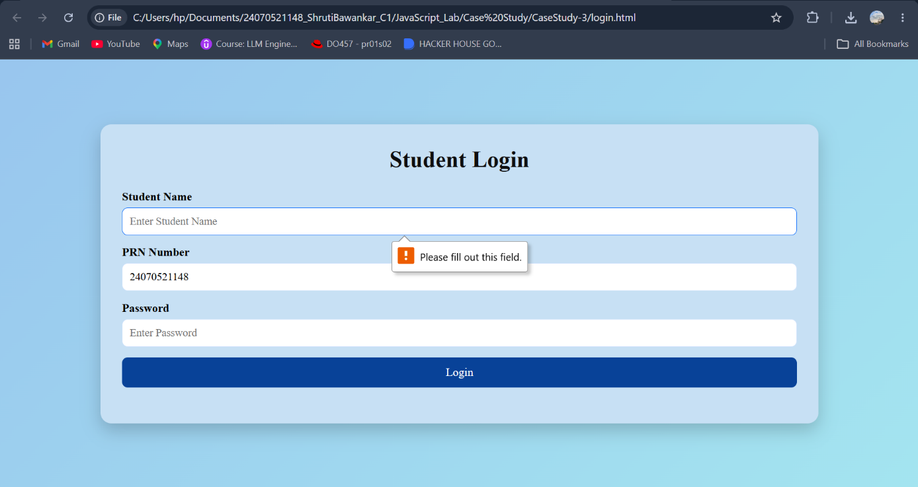
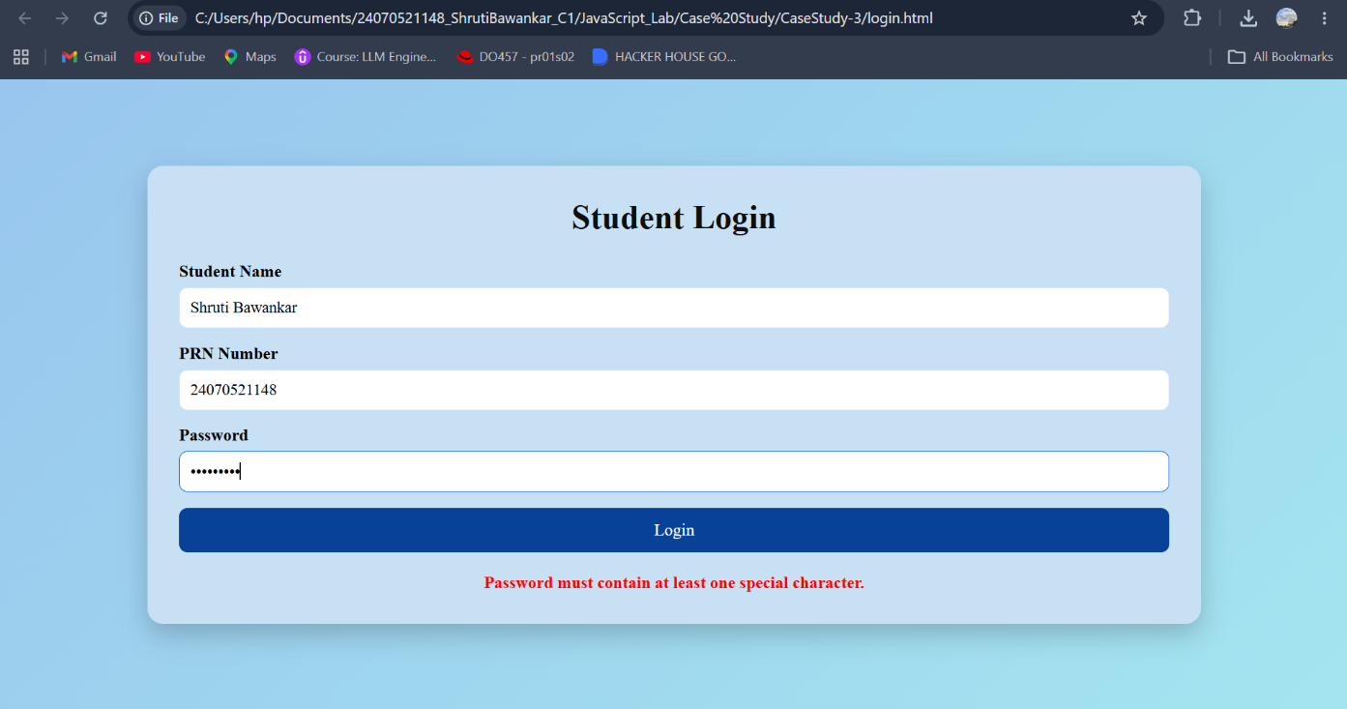
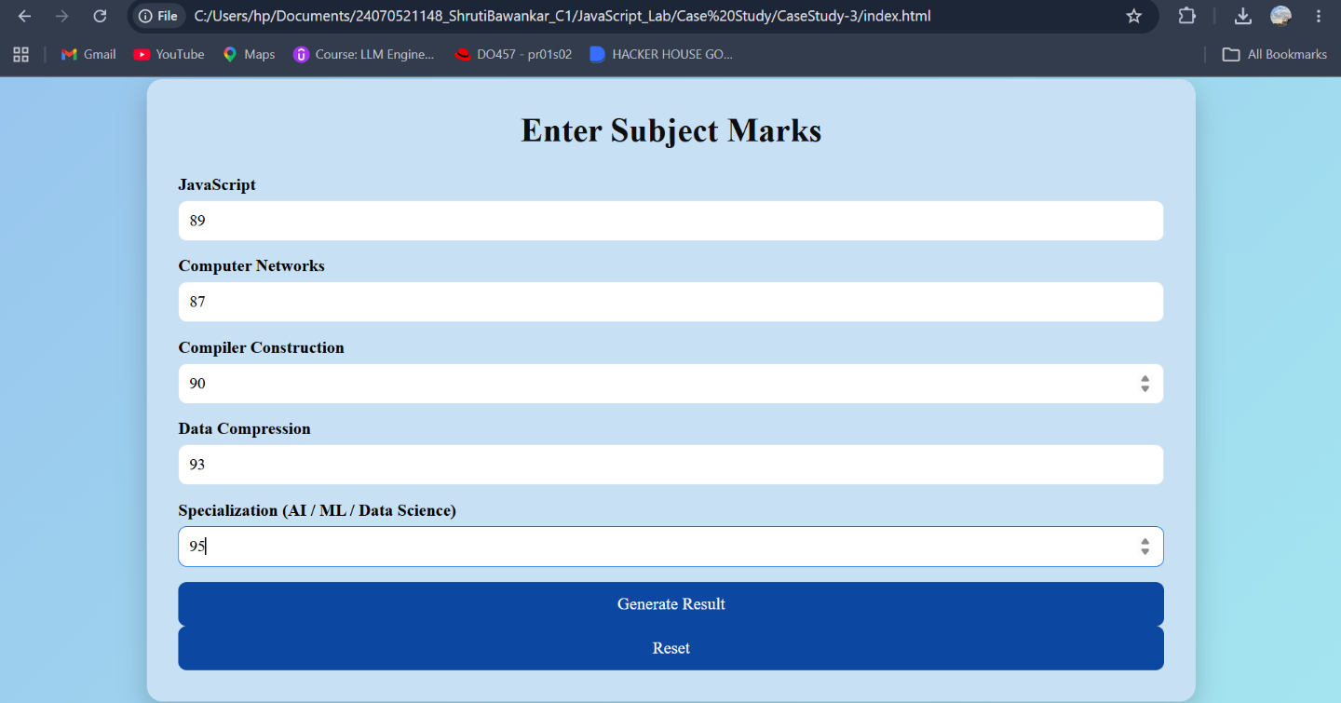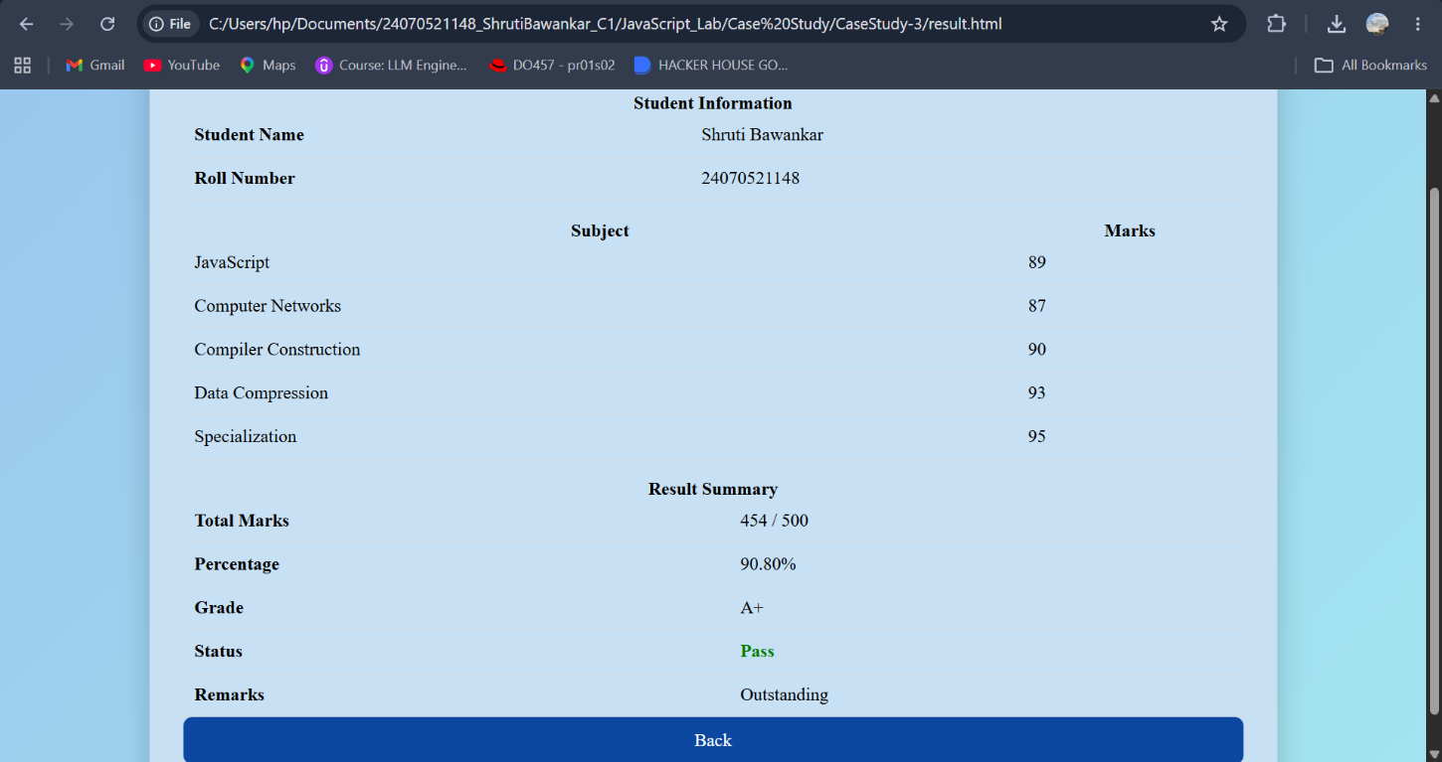
Result: The Student Grading System was successfully developed to validate user credentials, process student marks, calculate grades, and display the results accurately on a separate result page.
Conclusion: This project successfully demonstrates the implementation of JavaScript form validation and control structures, providing a simple, secure, and user-friendly web application for student result management.
Experiment No.: 4
Title: Use function types, scope, and closures; apply try-catch; build a palindrome checker.
Software/Tools Required: HTML5, CSS3, JavaScript, VS Code, Google Chrome
Index.html:
<!DOCTYPE html>
<html lang="en">
<head>
<meta charset="UTF-8">
<meta name="viewport" content="width=device-width, initial-scale=1.0">
<title>Palindrome Checker</title>
<style>
body {
font-family: Georgia, sans-serif;
background: #f8f2d9;
display: flex;
justify-content: center;
align-items: center;
height: 100vh;
}
.container {
background: white;
padding: 25px;
border-radius: 10px;
width: 350px;
box-shadow: 0px 0px 10px rgb(27, 21, 21);
text-align: center;
}
input {
width: 90%;
padding: 10px;
margin: 10px 0;
font-size: 16px;
}
button {
padding: 10px 20px;
background: royalblue;
color: white;
border: none;
border-radius: 5px;
cursor: pointer;
}
button:hover {
background: darkblue;
}
#result {
margin-top: 20px;
font-size: 18px;
font-weight: bold;
}
#counter {
color: green;
margin-top: 10px;
}
</style>
</head>
<body>
<div class="container">
<h2>Palindrome Checker</h2>
<input type="text" id="word" placeholder="Enter a word">
<br>
<button onclick="checkPalindrome()">Check</button>
<p id="result"></p>
<p id="counter"></p>
</div>
<script src="script.js"></script>
</body>
</html>

Script.js:
let appName = "Palindrome Checker";
function visitCounter() {
let count = 0;
return function () {
count++;
return count;
};
}
const counter = visitCounter();
function isPalindrome(text) {
let cleaned = text.toLowerCase().replace(/[^a-z0-9]/g, "");
let reversed = cleaned.split("").reverse().join("");
return cleaned === reversed;
}
const displayMessage = function(message, color) {
const result = document.getElementById("result");
result.innerHTML = message;
result.style.color = color;

};
const updateCounter = () => {
document.getElementById("counter").innerHTML =
"Checked " + counter() + " time(s)";
};
function checkPalindrome() {
try {
let input = document.getElementById("word").value;
if (input.trim() === "") {
throw "Input cannot be empty.";
}
if (isPalindrome(input)) {
displayMessage(
`"${input}" is a Palindrome`,
"green"
);
} else {
displayMessage(
`"${input}" is NOT a Palindrome`,
"red"
);
}
updateCounter();
}
catch(error) {
displayMessage(error, "orange");
}
}

Output:
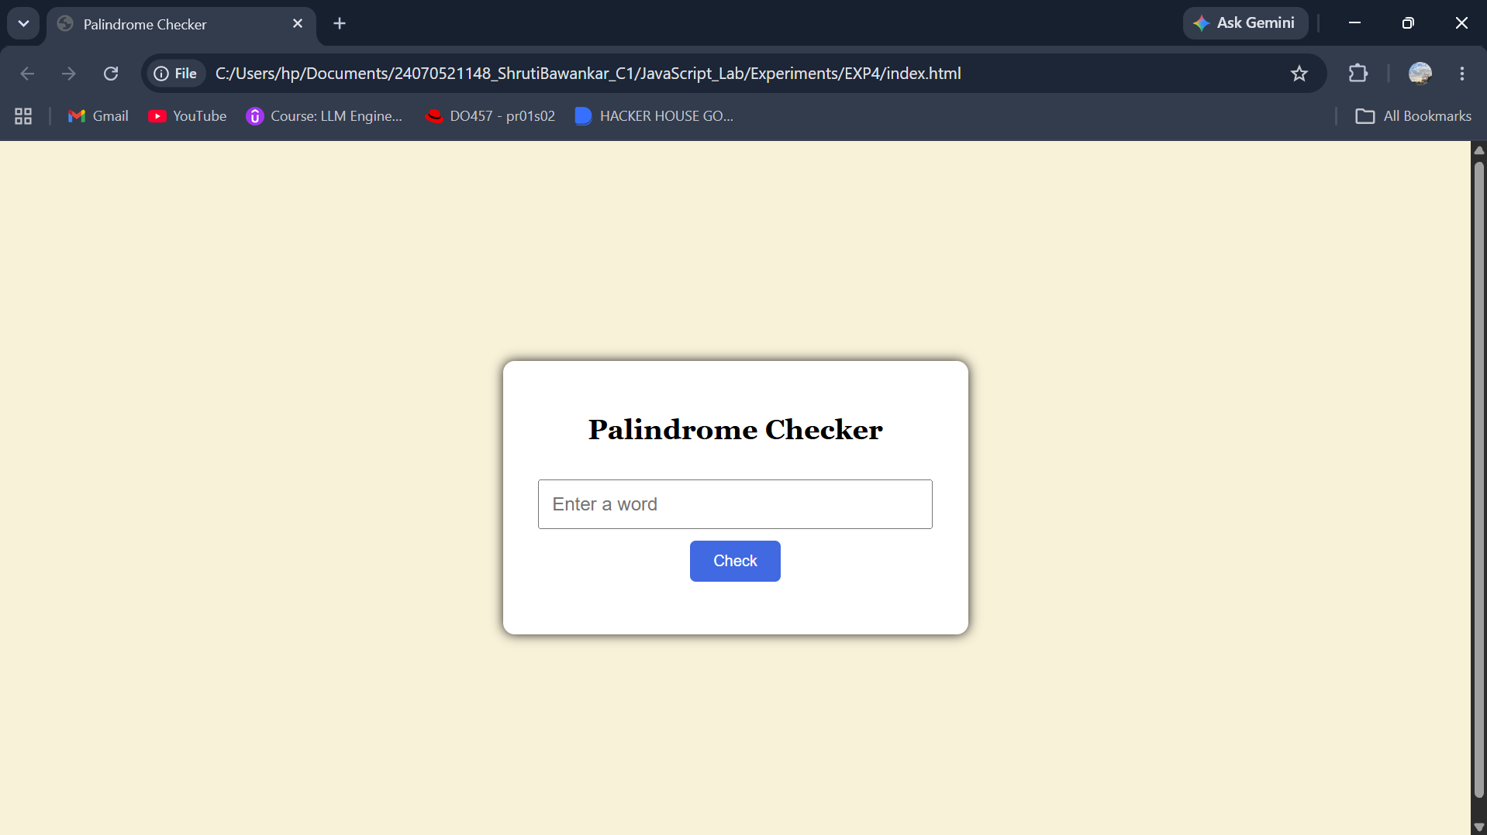
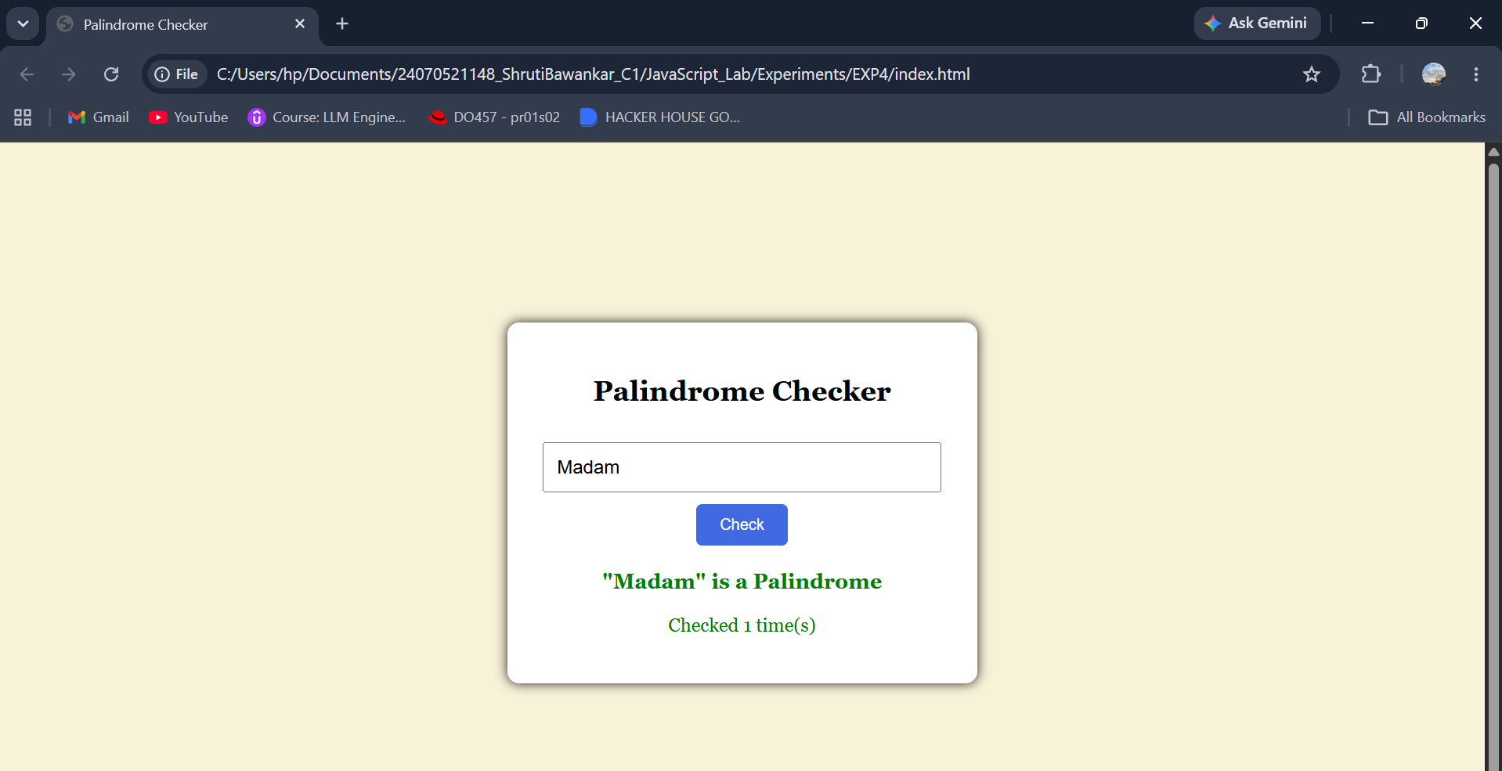
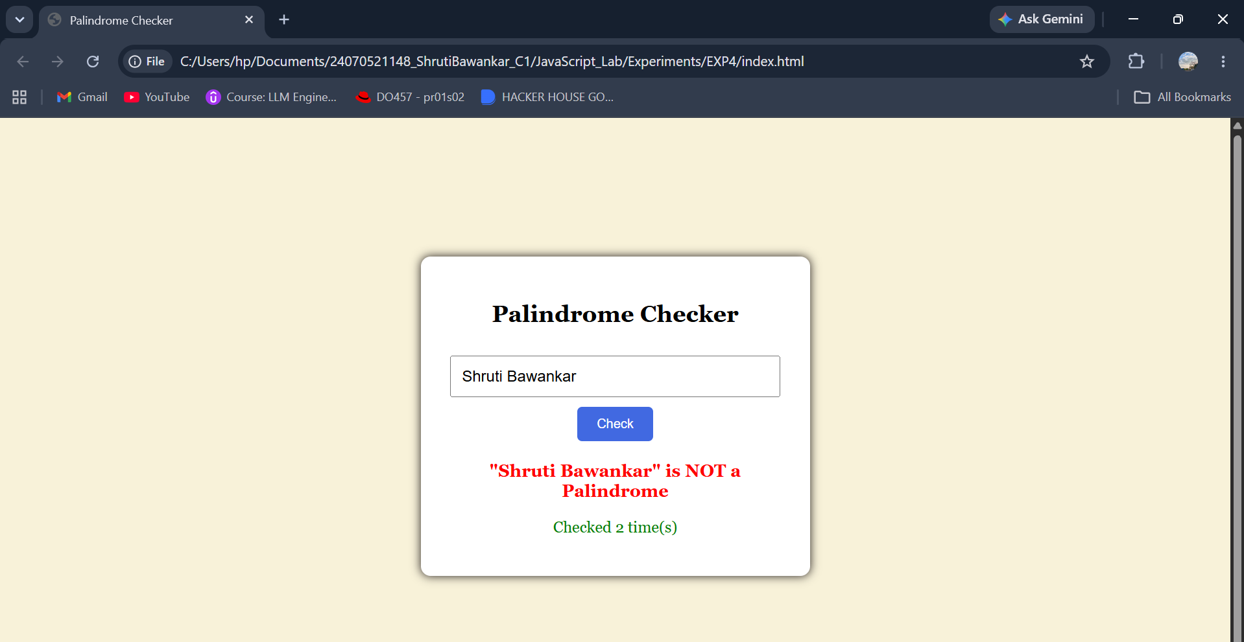
Result: The palindrome checker successfully identifies whether the entered text is a palindrome or not and displays the result while handling invalid input using try...catch.
Conclusion: The program effectively demonstrates JavaScript function types, scope, closures, and exception handling through a simple and user-friendly palindrome checking application.

Experiment No.: 4
Title: Use function types, scope, and closures; apply try-catch; build a password strength checker using palindrome then display strong or weak password and generate a html and js code.
Software/Tools Required: HTML5, CSS3, JavaScript, VS Code, Google Chrome
Index.html:
<!DOCTYPE html>
<html lang="en">
<head>
<meta charset="UTF-8">
<meta name="viewport" content="width=device-width, initial-scale=1.0">
<title>Password Strength Checker</title>
<style>
*{
margin:0;
padding:0;
box-sizing:border-box;
font-family:'Lucida Console', 'Monaco', monospace;
}
body{
height:100vh;
display:flex;
justify-content:center;
align-items:center;
background:linear-gradient(135deg,#89949810,#84b2da);
}
.container{
width:400px;
background:white;
border-radius:18px;
padding:35px;
text-align:center;
box-shadow:
0 15px 35px rgba(0,0,0,0.2);
}
.icon{
font-size:55px;
margin-bottom:10px;
}
h2{
color:#333;
margin-bottom:8px;
}
p.subtitle{
color:#777;
margin-bottom:25px;
font-size:14px;
}
.input-box{
position:relative;
}
input{
width:100%;
padding:14px 16px;
border:2px solid #ddd;
border-radius:10px;
outline:none;
font-size:16px;
transition:.3s;
}
input:focus{
border-color:#33a060;
}
button{
width:100%;
margin-top:18px;
padding:14px;
border:none;
border-radius:10px;
background:#667eea;
color:white;
font-size:16px;
font-weight:600;
cursor:pointer;
transition:.3s;
}
button:hover{
background:#4f61d8;
transform:translateY(-2px);
}
#result{
margin-top:22px;
padding:14px;
border-radius:10px;
background:#f7f7f7;
font-size:17px;
font-weight:600;
min-height:55px;
display:flex;
justify-content:center;
align-items:center;
}
#count{
margin-top:15px;
color:#555;
font-size:14px;
}
.footer{
margin-top:20px;
font-size:12px;
color:#999;
}
</style>
</head>
<body>
<div class="container">
<div class="icon">🔐</div>
<h2>Password Strength Checker</h2>
<p class="subtitle">
A palindrome password is considered <b>Weak</b>.
Any other password is considered <b>Strong</b>.
</p>
<div class="input-box">
<input
type="password"
id="password"
placeholder="Enter your password">
</div>
<button onclick="checkPassword()">
Check Password
</button>
<div id="result">
Result will appear here...
</div>
<div id="count">
</div>
</div>
<script src="script.js"></script>
</body>
</html>
Script.js:
let appName = "Password Strength Checker";
function passwordCounter(){
let count = 0;
return function(){
count++;
return count;
};
}
const counter = passwordCounter();
function isPalindrome(password){
let reverse = password.split("").reverse().join("");
return password === reverse;
}
const displayResult = function(message, color){
const result = document.getElementById("result");
result.innerHTML = message;
result.style.color = color;
if(color === "green"){
result.style.background = "#e8f9ee";
result.style.border = "2px solid #28a745";
}
else if(color === "red"){
result.style.background = "#ffe8e8";
result.style.border = "2px solid #dc3545";
}
else{
result.style.background = "#fff4d6";
result.style.border = "2px solid #ff9800";
}
};
const updateCount = ()=>{
document.getElementById("count").innerHTML =
"Passwords Checked : " + counter();
};
function checkPassword(){
try{
let password = document.getElementById("password").value;
if(password.trim()==""){
throw "Password cannot be empty.";
}
if(password.length < 4){
throw "Password must contain at least 4 characters.";
}
if(isPalindrome(password)){
displayResult(
"Weak Password (Palindrome Password)",
"red"
);
}
else{
displayResult(
"Strong Password (Not a Palindrome)",
"green"
);
}
updateCount();
}
catch(error){
displayResult(error,"orange");
}
}

Output:

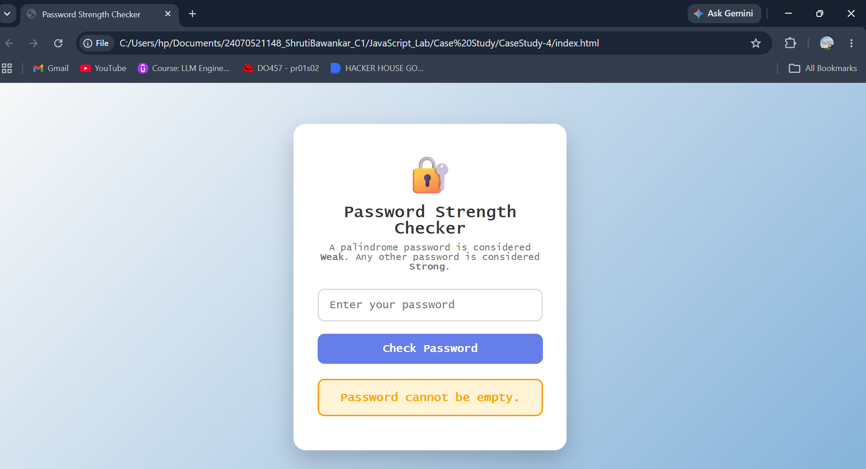
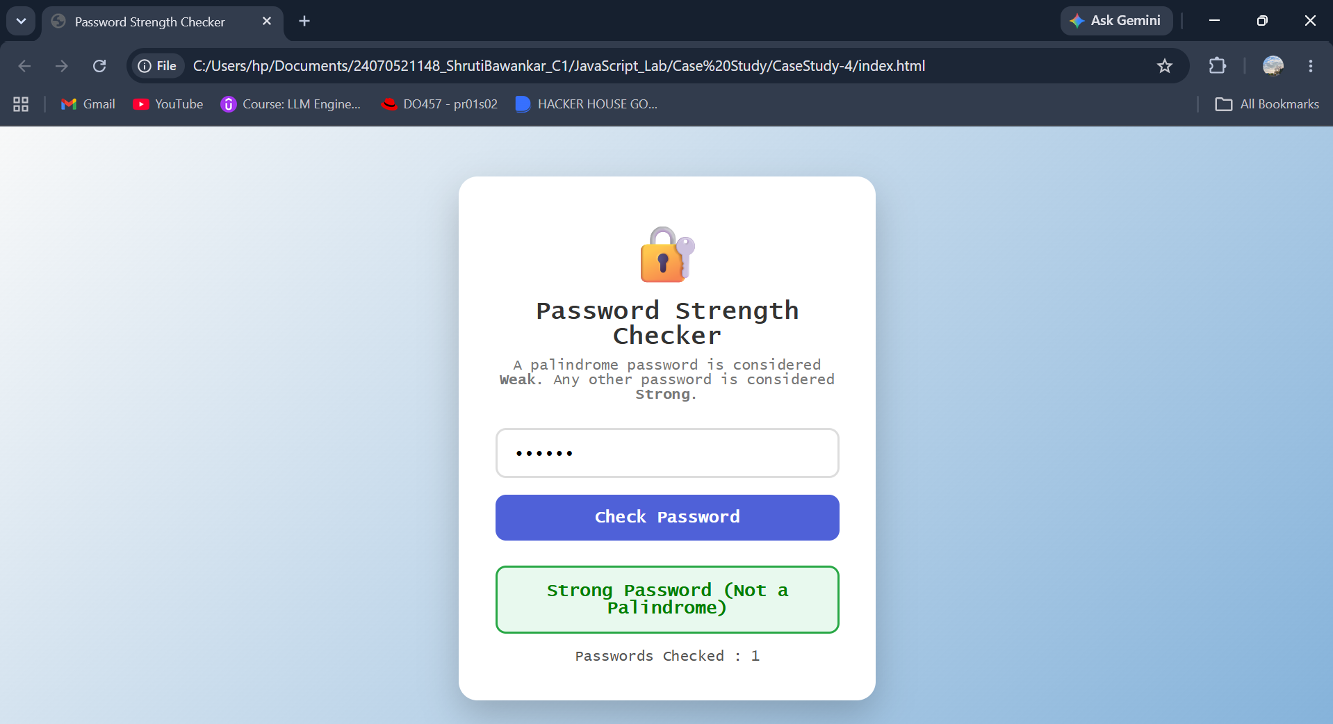
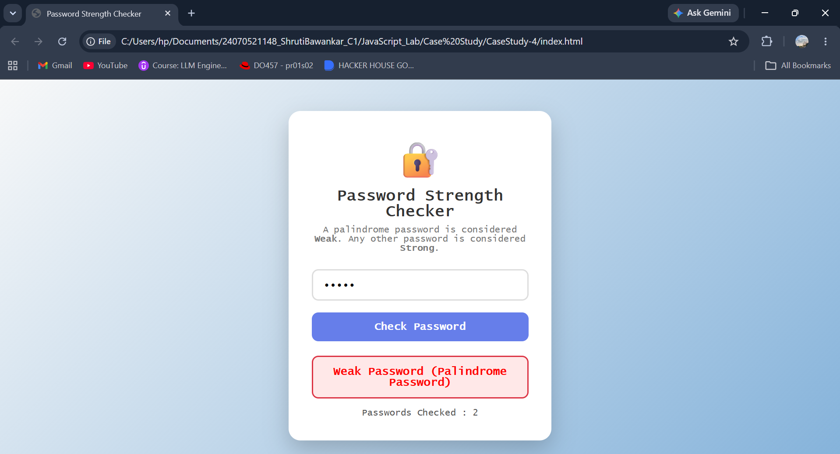

Result: The password checker successfully identifies whether a password is a palindrome and classifies it as Weak or Strong while handling invalid inputs using try...catch.
Conclusion: The program effectively demonstrates JavaScript function types, scope, closures, and exception handling through a simple and interactive password validation application.

