IILM UNIVERSITY


Sentiment-Aware Music Recommendation System

Name of students:
Vaachi Goel
Jeevika Khanna
Shafaq Ahmad
Sanya Malhotra
Roll No.:
CS-23411291
CS-2341286
CS-2341293
CS-23411361

Department: BTech CSE (AI ML)
Date of submission:
Name of the supervisor: Dr. Sumit Chaudhary

1.Introduction
Music has always been closely connected to human emotions, often serving as a medium of self-expression, relaxation, and mood regulation. With the growth of digital platforms and streaming services, recommendation systems have become a crucial component in helping users discover new songs. However, most existing music recommendation engines primarily rely on factors such as popularity, user ratings, or collaborative filtering, and often fail to capture the emotional state of the listener. This limitation reduces the personalization and emotional engagement that music can provide.
Our project, Sentiment-Aware Music Recommendation System, aims to bridge this gap by integrating sentiment analysis into the recommendation process. By analysing users past listening history, the system detects the underlying sentiments and maps them to music features such as genre, tempo, and mood. The objective is to recommend songs that resonate with the listener’s emotions, thereby enhancing personalization and user satisfaction. This sentiment-driven approach is expected to provide a more engaging and human-cantered music discovery experience compared to conventional recommendation systems.

Table of Contents

INTRODUCTION

1. LITERATURE REVIEW

2. LIMITATIONS OF CURRENT APPROACHES
3. METHODOLOGY

4. ALGORITHMS AND TECHNIQUES

5. EXPECTED RESULTS

6. CONCLUSIONS AND FUTURE GOALS

7. REFERENCES

2.Literature Review
Music recommendation systems have gained significant attention in recent years due to the growth of digital music platforms. Traditional recommendation models rely on collaborative filtering, content-based filtering, or hybrid techniques to suggest songs to users. While these methods have been effective, they often focus only on listening patterns, popularity, or similarity of tracks. Recent studies have shown that emotions and sentiments play a critical role in music consumption, as listeners tend to choose songs that match or influence their current mood [1], [3]. Integrating sentiment analysis into recommendation systems has therefore emerged as a promising approach to improve personalization and user satisfaction.
2.1 Problem Statement
Listeners often choose music that reflects or influences their emotions, but existing recommendation systems mostly focus on popularity or user ratings rather than mood. The problem is to design a Machine Learning–based system that analyses user’s past music preferences to detect underlying sentiments and then recommends songs that better align with their emotional state [4].
2.2 Objectives
- To analyse user’s past music preferences to detect underlying sentiments.
- To map user emotions with music features such as genre, tempo, and mood.
- To enhance personalization by combining sentiment detection with traditional recommendation methods.
- To build a user-friendly interface that facilitates interactive music discovery.
2.3 Scope and limitations
The project is focused on creating a sentiment-aware music recommendation system that can be applied to online streaming platforms and personal music libraries. Its scope extends to improving user engagement, emotional well-being, and personalization in music discovery [2]. However, the system’s effectiveness depends on the availability and quality of datasets. Additionally, emotions are subjective and complex, making sentiment detection challenging. The system will primarily focus on sentiment derived from past listening history and may not capture real-time mood variations or physiological signals.
3. Limitations of Current Approaches
Despite considerable research into emotion-based music recommendation systems, existing approaches continue to face significant limitations. Initial works such as [1] and [2] emphasize personalized recommendations through emotion detection but lack integration of long-term user preferences and contextual feedback. Systems relying on wearable sensors [2] show promise for real-time emotion capture but present practical concerns, such as cost, comfort, and scalability, making them unsuitable for widespread adoption. Likewise, facial expression–based systems [3] provide a natural interface but are sensitive to environmental factors like lighting, occlusion, and privacy constraints. These shortcomings reveal that while emotion recognition has advanced, its deployment in music recommendation remains constrained by technological and usability challenges.
Subsequent research has sought to address these issues by proposing lightweight and hybrid architectures. The MobileNet-based approach in [4] improves feasibility for mobile applications but does not extend to multimodal fusion. Similarly, the hybrid CNN–RNN system in [5] advances the integration of facial, textual, and vocal inputs, showing higher accuracy in emotion detection. However, such models still face barriers in real-time scalability, require high computational resources, and do not adequately safeguard user privacy. Studies like [6] focus on CNN-driven facial recognition for improved detection accuracy, yet they overlook cross-modal personalization and fail to account for the dynamic evolution of user preferences. This indicates that while algorithmic sophistication has improved, adaptability and context-awareness remain largely unresolved.
More recent contributions highlight the potential of multimodal and multi-input systems. The framework in [7] combines textual sentiment analysis with CNN-driven facial recognition, supported by deep learning models such as LSTM, CNN-LSTM, and LSTM-CNN. While this enhances flexibility by supporting different input modalities, the system does not provide mechanisms for continuous learning or adaptation to long-term listening habits. Similarly, the OpenCV-based prototype in [8] integrates facial detection with machine learning but remains restricted to single-modality inputs. Approaches like [9] attempt playlist generation based solely on facial expressions, yet they overlook the synergistic benefits of combining multimodal signals such as voice tone, physiological data, and behavioural cues. These limitations suggest that the integration of multiple emotion recognition channels into a unified recommendation engine is still an underexplored area.
Finally, the broader application potential of emotion-based recommendation is emphasized in [10], where the system is envisioned not only as a personalized entertainment tool but also as a medium for therapy, workplace engagement, and cultural exchange. While this study significantly expands the scope of emotion-aware music recommendation, it does not provide a concrete computational framework for scalable, adaptive, and multimodal personalization. Collectively, these gaps highlight the need for a holistic approach that addresses technical, contextual, and ethical challenges. Future systems must move beyond single-modality detection toward multimodal, privacy-conscious, and adaptive solutions that align more closely with real-world user needs.

4.Methodology
The proposed system integrates Natural Language Processing (NLP) and Machine Learning (ML) techniques to recommend songs based on the user’s emotional state derived from their listening history. The approach moves beyond traditional popularity-based methods by embedding sentiment analysis into the recommendation pipeline.
4.1 Methods and Techniques
1. Data Collection and Preprocessing
- User listening history, metadata (artist, genre, tempo, mood tags), and optionally lyrics are collected.
- Textual inputs (song reviews, lyrics, or tags) are pre-processed using tokenization, stop-word removal, and word.
- The dataset is annotated with sentiment labels such as positive, negative, neutral or happy, sad, angry, love.
2. Sentiment Analysis
- Deep learning models are employed for emotion classification:
  - LSTM: Captures sequential dependencies in text.
  - CNN: Extracts local features from word embeddings.
  - Hybrid CNN-LSTM: Leverages both spatial and temporal features.
- The model with the best performance is selected after evaluation.
3. Feature Mapping
- Sentiments are mapped to song attributes (tempo, rhythm, genre, valence, arousal).
- Example: Happy → high-tempo, pop/EDM; Sad → low-tempo, acoustic, soft instrumental.
4. Recommendation Engine
- A hybrid recommender system combines:
  - Collaborative filtering: Learns from user–user or user–item similarities.
  - Sentiment-aware filtering: Matches detected emotion with mood-based playlists.
- Final recommendation = weighted fusion of both approaches.
5. System Interface
- A user-friendly interface allows:
  - Logging in and retrieving past listening history.
  - Generating playlists dynamically based on current emotional state.
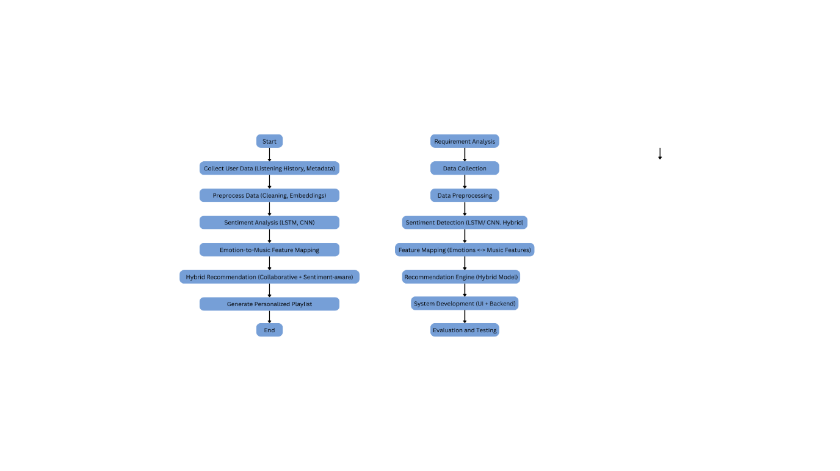
  - Manual playlist selection as a fallback.

4.2 Software and Hardware Requirements
Software Requirements
- Programming Language: Python
- Frameworks/Libraries: TensorFlow / Keras, Scikit-learn, NLTK / SpaCy, Pandas, NumPy
- Database: MySQL / Firebase (for storing user data and playlists)
- Frontend: Flask / Django or simple GUI interface
- OS: Windows/Linux
Hardware Requirements
- Processor: Intel i5 or higher
- RAM: Minimum 8 GB
- Storage: 500 GB HDD / 256 GB SSD
4.3 Workflow
1. Input Layer: User listening history and song metadata.
2. Preprocessing Layer: Clean and convert textual data into embeddings.
3. Sentiment Analysis Module: LSTM/CNN-based classifier detects emotional categories.
4. Feature Mapping Module: Matches emotion with music features.
5. Recommendation Engine: Combines collaborative filtering with sentiment-aware filtering.
6. Output Layer: Personalized playlist suggestion displayed in the user interface.

5. Algorithms and Techniques
5.1 Project Implementation Pipeline
1. Requirement Analysis
- Identified the need for a sentiment-aware music recommendation system.
- Defined objectives: emotion detection from listening history + hybrid recommendation.
2. Data Collection
- Gathered datasets containing user listening history, song metadata, and lyrics.
- Sources include open music datasets (e.g., Million Song Dataset, Last.fm tags).
3. Data Preprocessing
- Cleaned and normalized metadata.
- Pre-processed text data (tokenization, stop-word removal, lemmatization).
- Converted text into embeddings.
4. Sentiment Detection
- Applied NLP-based models to classify user sentiment (happy, sad, angry, love, neutral).
- Models trained and evaluated:
  - LSTM (Long Short-Term Memory): for sequential text features.
  - CNN (Convolutional Neural Network): for extracting local word patterns.
  - Hybrid CNN-LSTM: to combine temporal + spatial text features.
5. Feature Mapping
- Mapped detected sentiments to music features (genre, tempo, mood).
- Example: Happy → Pop/EDM, Sad → Acoustic/Soft, Angry → Rock/Metal.
6. Recommendation Engine
- Implemented a Hybrid Recommender System:
  - Collaborative Filtering: Recommends based on similar users’ preferences.
  - Content-Based Filtering: Uses song features and metadata.
  - Sentiment-Aware Filtering: Incorporates detected emotion for personalization.
- Final recommendation score = weighted fusion of all three approaches.
7. System Development
- Built user interface for input and playlist recommendations.
- Integrated frontend (Flask/Django) with backend (ML models + database).
8. Evaluation and Testing
- Evaluated sentiment detection accuracy using metrics (Precision, Recall, F1-score).
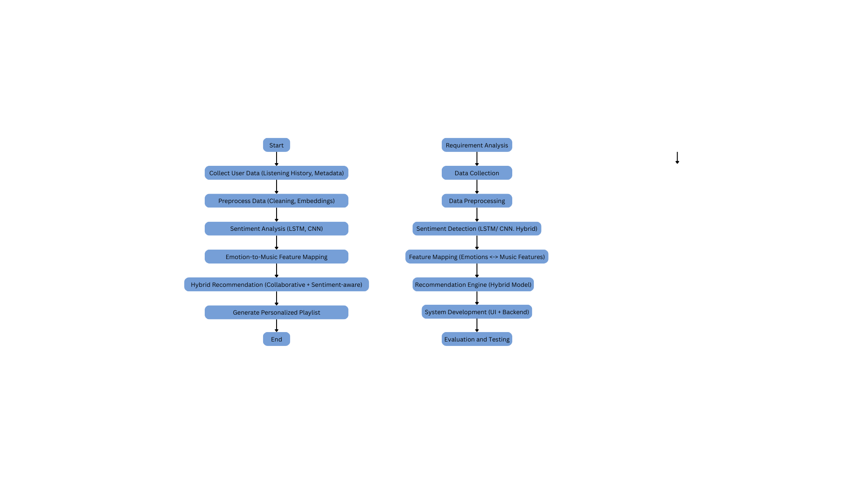
- Assessed recommendation performance using MAE, RMSE, and user satisfaction surveys.
5.2 Programming Languages, Tools, and Frameworks
1. Programming Languages: Python
2. Frameworks & Libraries:
- ML/DL: TensorFlow / Keras, PyTorch, Scikit-learn
- NLP: NLTK, SpaCy, HuggingFace Transformers
- Data Processing: Pandas, NumPy
- Database: MySQL / Firebase / MongoDB
- Backend: Flask / Django
- Frontend: HTML, CSS, JavaScript (basic UI)
5.3 Algorithms and Models Implemented
1. NLP Models for Sentiment Detection
- LSTM
- CNN
- Hybrid CNN-LSTM
2. Recommendation Algorithms
- Collaborative Filtering (User-User / Item-Item)
- Content-Based Filtering
- Hybrid Model (weighted fusion with sentiment analysis)
3. Evaluation Metrics
- Sentiment Classification: Accuracy, Precision, Recall, F1-score
- Recommendation Quality: RMSE, MAE, Top-N accuracy

6. Expected Results
The proposed sentiment-aware music recommendation system is expected to demonstrate improved accuracy and personalization in comparison with traditional recommendation approaches. By incorporating sentiment analysis into the recommendation pipeline, the system aims to capture the emotional context of the user and thereby suggest music that is more closely aligned with their mood.
The anticipated outcomes include:
- Enhanced precision and relevance of music recommendations.
- Higher user satisfaction and engagement due to mood-aligned playlists.
- Reduction in the limitations of purely collaborative or content-based filtering by integrating sentiment-driven features.
- Promising evaluation performance in terms of precision, recall, F1-score, and user satisfaction metrics when benchmarked against conventional models.
Although the model has not yet been implemented, these expected results are based on findings from prior research in sentiment-aware recommendation systems, indicating strong potential for improved personalization and user experience.

7. Conclusion and Future Goals
This project proposes the design of a sentiment-aware music recommendation framework that integrates Natural Language Processing (NLP) and machine learning with conventional recommendation techniques. Unlike existing systems that rely predominantly on listening history, popularity, or explicit ratings, the proposed approach emphasizes emotional context, thereby offering a more human-centric and adaptive recommendation process.
The expected contribution of this system lies in its ability to enhance music discovery by considering user sentiment, potentially improving emotional well-being while increasing engagement on digital music platforms.
Future work will involve:
- Training and fine-tuning models on large-scale sentiment-labelled datasets.
- Comprehensive evaluation against benchmark datasets and algorithms.
- Expanding the system to handle multi-modal sentiment detection (e.g., combining text, speech, or contextual cues).
- Exploring opportunities for integration with commercial streaming platforms to validate performance in real-world environments.
In summary, the proposed framework has the potential to deliver a more personalized, emotionally intelligent, and user-centric music recommendation system, advancing the current state of recommendation technologies.

8. References
1. Rumiantcev, Mikhail, and Oleksiy Khriyenko. Emotion Based Music Recommendation System. 2020.
2. D. Ayata, Y. Yaslan and M. E. Kamasak, "Emotion Based Music Recommendation System Using Wearable Physiological Sensors," in IEEE Transactions on Consumer Electronics, vol. 64, no. 2, pp. 196-203, May 2018, doi: 10.1109/TCE.2018.2844736.
3. V. P. Sharma, A. S. Gaded, D. Chaudhary, S. Kumar and S. Sharma, "Emotion-Based Music Recommendation System," 2021 9th International Conference on Reliability, Infocom Technologies and Optimization (Trends and Future Directions) (ICRITO), Noida, India, 2021, pp. 1-5, doi: 10.1109/ICRITO51393.2021.9596276.
4. Mahadik, Ankita, et al. "Mood based music recommendation system." International Journal of Engineering research & Technology (IJERT) 10.06 (2021).
5. Faye, Pranali, et al. “Emotion Based Music Recommendation System”. International Journal on Advanced Electrical and Computer Engineering, vol. 14, no. 1, May 2025, pp. 156-60, https://journals.mriindia.com/index.php/ijaece/article/view/405.
6. V. Tejaswini Priyanka, Y. Reshma Reddy, D. Vajja, G. Ramesh and S. Gomathy, "A Novel Emotion based Music Recommendation System using CNN," 2023 7th International Conference on Intelligent Computing and Control Systems (ICICCS), Madurai, India, 2023, pp. 592-596, doi: 10.1109/ICICCS56967.2023.10142330.
7. S. Joshi, T. Jain and N. Nair, "Emotion Based Music Recommendation System Using LSTM - CNN Architecture," 2021 12th International Conference on Computing Communication and Networking Technologies (ICCCNT), Kharagpur, India, 2021, pp. 01-06, doi: 10.1109/ICCCNT51525.2021.9579813.
8. Shalini, Shantha K., et al. "Facial Emotion Based Music Recommendation System using computer vision and machine learning techiniques." Turkish journal of computer and mathematics education 12.2 (2021): 912-917.
9. J. S. Joel, B. Ernest Thompson, S. R. Thomas, T. Revanth Kumar, S. Prince and D. Bini, "Emotion based Music Recommendation System using Deep Learning Model," 2023 International Conference on Inventive Computation Technologies (ICICT), Lalitpur, Nepal, 2023, pp. 227-232, doi: 10.1109/ICICT57646.2023.10134389
10. S. Saranya, M. Varshana Devi, M. Colin Powell, D. Dhanya Bharathy and K. Devatharshini, "Emotion Based Music Recommendation System," 2024 International Conference on Smart Systems for Electrical, Electronics, Communication and Computer Engineering (ICSSEECC), Coimbatore, India, 2024, pp. 255-260, doi: 10.1109/ICSSEECC61126.2024.10649404.

