**PROJECT-NAME: MYNTRA**

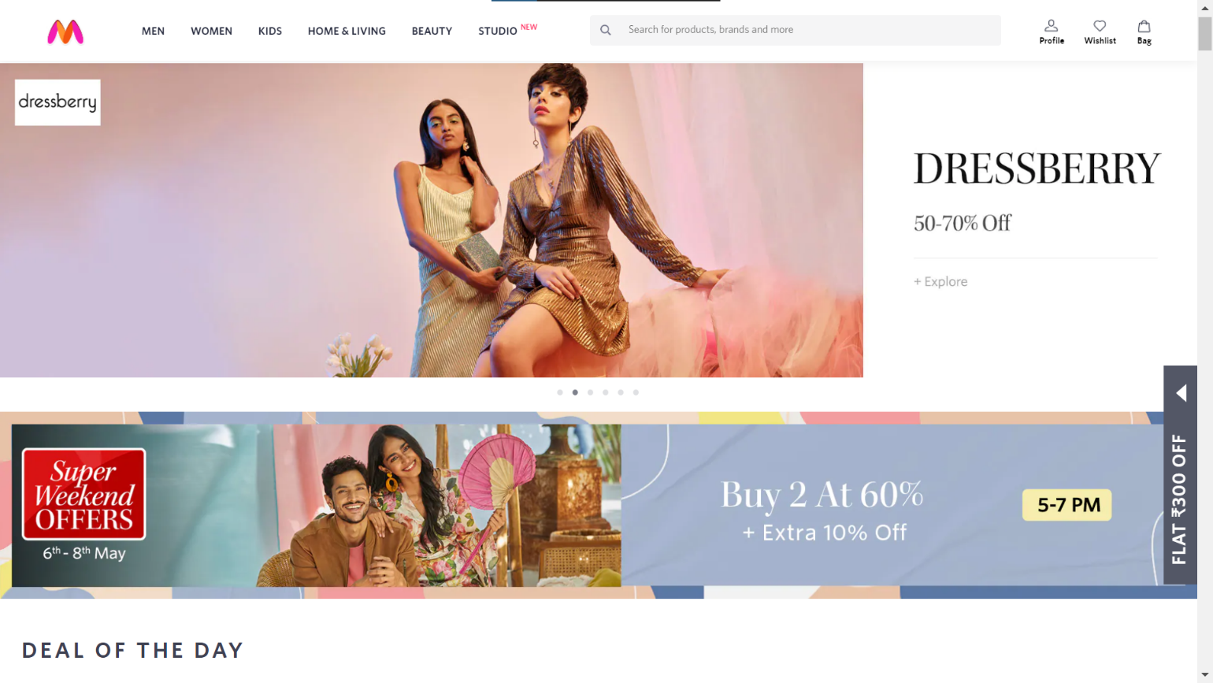

**\*OVERVIEW:** It’s an fashion e-commerce website for women’s , men’s, and kids supplying fashion, beauty, home decore under on single platform.

1. **HOME PAGE:**
   * + - Logo
       - Icons – wishlist, bag, profile
       - Search Bar
       - Sliders with arrows (Images)
       - Deals (Images)
       - Feautured Images
       - Trending Images
       - Footer – ( Contact Us , Helplines , Brief description about company , Social-Media handles)
2. **REGISTRATION FORM:**

* Email Address
* Date Of Birth
* Contact Number
* Gender
* Shopping Preferences

**3. MAIN PAGE:**

* FILTERS - ( brands , color , discount range , price country of origin , material , features , fit , occasion , pattern , rating , size , type , sort by )
* IMAGES OF THE CHOSEN PRODUCT WITH DETAILS LIKE -( brand , product name , price , discount% ( if any ) )
* ON CLICKING THE IMAGE - (multiple images of the product will appear from different angles ,zoom in , zoom out)
* PRODUCT DESCRIPTION - brand , product name ,price , discount% (if any) , size chart ,delivery options , product details , size & fit , material & care , specifications , ratings , customer reviews with images (if any )
* LOWER HALF OF THE PAGE - related products

1. **PAYMENT PAGE:**

* ADDRESS SELECTION
* PAYMENT METHOD - (phonepe , google pay , bhim upi , cod , credit/debit card , net banking , emi , paytm)

1. **OUTLINE :** created using Figma

