Kingdom of Cambodia

Nation Religion King

Institute of Technology of Cambodia
Department of Applied Mathematics and statistics

Final project
Topic: Student Housing Cost
Course: Statistics
Group 2

Members ID POINT
Chhay Lyveng e20230135 ………….
Davath Pechlika e20230643 ………….
LOY KIMLONG e20230483 ………….

Course Teacher: Dr. PHAUK Sokhey
TD Teacher: Dr. HAS Sothea

Submission date: 21/Jan/2026

Academic year 2025 - 2026

Contents
I. Introduction 1
II. Data Description 2
III. Descriptive Statistic 4
Range 8
Third Quartile (Q3) 9
IV. Point Estimation 10
1. Parameters and Estimators 10
2. Unbiasedness and Consistency (Conceptual Explanation) 10
3. Standard Error of the Mean 10
V. Confidence Intervals 11
1. 95% Confidence Interval for the Population Mean 11
2. Interpretation of the Confidence Interval 11
3. Required Sample Size (Theoretical Calculation) 11
VI. Hypothesis Testing 12
1 Stating the Hypotheses 12
2 Test Statistic 13
3 p-Value 13
4 Decision 14
5 Conclusion (in Context) 14
VII. Conclusion 14
What We Learned from the Analysis 14
Was the Research Question Answered? 15
Limitations of the Dataset 15
Suggestions for Future Study 15
VIII. Appendix (Python Code) 15

Introduction
Why did we choose this topic?
Our team chose to investigate student housing cost because it is a common and important aspect of university life that directly affects students’ financial well-being. Housing expenses such as rent or dormitory fees are unavoidable for many students and often represent one of their highest monthly costs. Unlike more abstract economic data, housing cost is a real-life issue that students experience personally and understand clearly.
By focusing on student housing cost, we selected a topic that is both easy to measure and highly relevant to students’ daily lives.
The Real-Life Question and Motivation
The motivation for this study comes from the fact that housing costs can vary widely among university students depending on their living arrangements. Many students often wonder whether the amount they spend on housing is typical compared to other students. Understanding the average housing cost and how much it varies can help students better manage their finances and plan their budgets.
Our real-life question is:
“Is the average monthly housing cost of university students significantly different from a commonly assumed or expected cost?”
This question allows us to examine student housing expenses using statistical evidence rather than assumptions.
What We Hope to Learn
Through the analysis of student housing cost data collected from a sample of 30 students, we aim to achieve the following learning objectives:
- Understand the distribution:
Use descriptive statistics and graphical methods to examine the central tendency, variability, and shape of the housing cost distribution, including:
  - what a typical housing cost looks like (mean, median),
  - how spread out the costs are (standard deviation, IQR),
  - and whether the data are symmetric or skewed.
- Quantify uncertainty:
Construct a 95% confidence interval to estimate the true average housing cost of the student population.
- Evaluate statistical claims:
Apply hypothesis testing to assess whether the population mean housing cost differs from a proposed or expected value.

- Develop statistical reasoning:
Strengthen our ability to interpret statistical results and communicate findings clearly in a real-world context.

Data Description
Source of Data
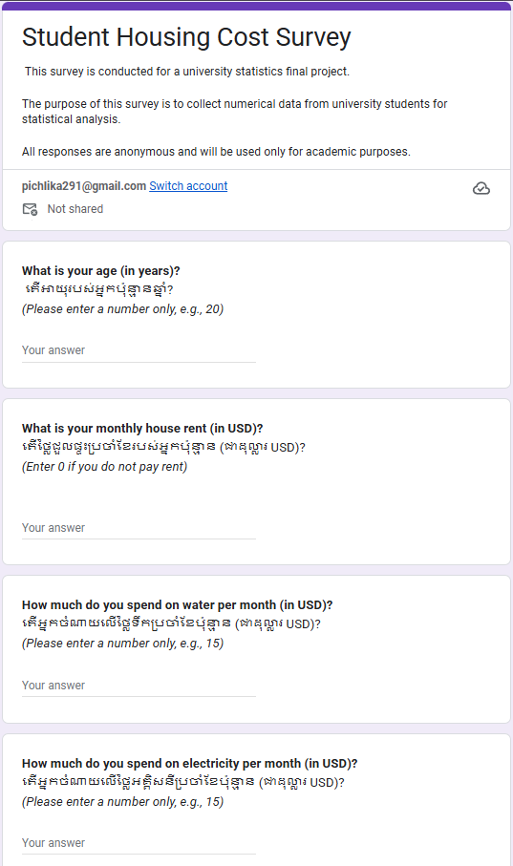
The data used in this study were self-collected by our team using a primary data collection method. An anonymous online survey was designed and distributed by the research team using Google Forms to collect numerical data related to student housing costs. The survey was shared with university students who voluntarily participated in the study. All responses were collected anonymously and used solely for academic purposes.

Google form Survey for Monthly Student house cost

Variables Included
The study focuses on one main quantitative (numerical) variable, supported by several related numerical variables:
Main Variable (X): Monthly Student Housing Cost
- Unit of Measurement: US dollars (USD) per month
- Type: This is a continuous numerical variable, which allows for the calculation of measures of center and spread such as the mean, median, standard deviation, and interquartile range (IQR).
- Description: This variable represents the total monthly housing-related expenses paid by a student.

Supporting Variables (Components of Housing Cost):
- Monthly House Rent Cost (USD):
The amount a student pays per month for rent or dormitory accommodation. This is a continuous numerical variable and a major component of the total housing cost.
- Monthly Water Expense (USD):
The monthly cost of water usage. This is a continuous numerical variable contributing to housing-related expenses.
- Monthly Electricity Expense (USD):
The monthly cost of electricity usage. This is a continuous numerical variable included as part of utility expenses.

Age (years):
Age is a quantitative numerical variable measured in years. It is included to provide background information about the sample but is not the primary focus of the housing cost analysis.
Sample Size (n)
The final sample size used in this study is n = 30, representing monthly housing cost data collected from 30 university students.
The dataset:
The dataset below presents the complete list of 30 observations collected from the survey respondents.

No. | AGE | monthly house rent | water per month | electricity per month | Housing_ Cost
1 | 20 | 60 | 3 | 5 | 68
2 | 19 | 0 | 4 | 20 | 24
3 | 20 | 50 | 3 | 3 | 56
4 | 20 | 100 | 20 | 30 | 150
5 | 20 | 50 | 2 | 1.5 | 53.5
6 | 21 | 120 | 2.5 | 30 | 152.5
7 | 20 | 75 | 5 | 7 | 87
8 | 19 | 100 | 2 | 12.5 | 114.5
9 | 20 | 90 | 5 | 3 | 98
10 | 20 | 50 | 3 | 2.5 | 55.5
11 | 20 | 30 | 15 | 15 | 60
12 | 20 | 60 | 3 | 5 | 68
13 | 20 | 50 | 6 | 5 | 61
14 | 20 | 85 | 5 | 5 | 95
15 | 19 | 0 | 15 | 10 | 25
16 | 20 | 30 | 30 | 30 | 90
17 | 20 | 0 | 0 | 0 | 0
18 | 19 | 250 | 10 | 30 | 290
19 | 19 | 100 | 5 | 10 | 115
20 | 20 | 50 | 2.5 | 10.75 | 63.25
21 | 19 | 200 | 20 | 2.5 | 222.5
22 | 20 | 60 | 30 | 5 | 95
23 | 20 | 80 | 5 | 10 | 95
24 | 19 | 120 | 10 | 50 | 180
25 | 18 | 80 | 5 | 20 | 105
26 | 19 | 75 | 5 | 10 | 90
27 | 20 | 70 | 1.5 | 13 | 84.5
28 | 18 | 25 | 2.5 | 3 | 30.5
29 | 18 | 80 | 10 | 5 | 95
30 | 19 | 50 | 15 | 20 | 85
Table 1 shows the raw housing-related variables collected from the survey

Descriptive Statistic
Graphs
To gain a clearer understanding of the distribution of total monthly student housing cost in our sample, the raw survey data were converted into graphical representations.

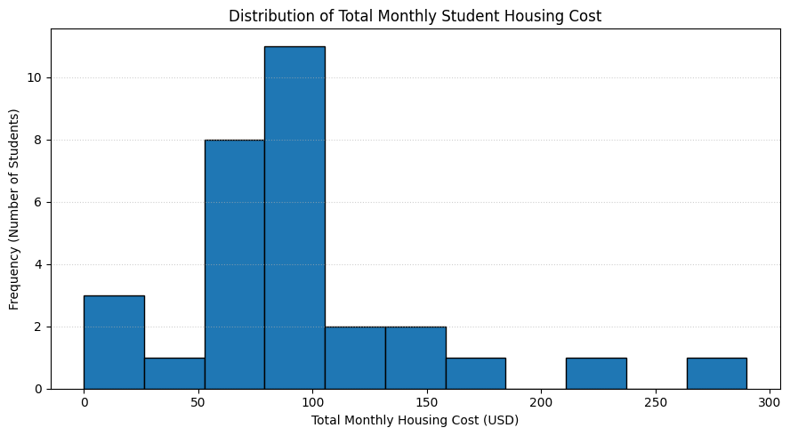
- Histogram

Histogram Interpretation:
Figure X presents the histogram of total monthly student housing cost. The distribution is right-skewed, with most observations concentrated between approximately 50 USD and 120 USD. A small number of students report relatively high housing costs, which extend the right tail of the distribution.

- Boxplot
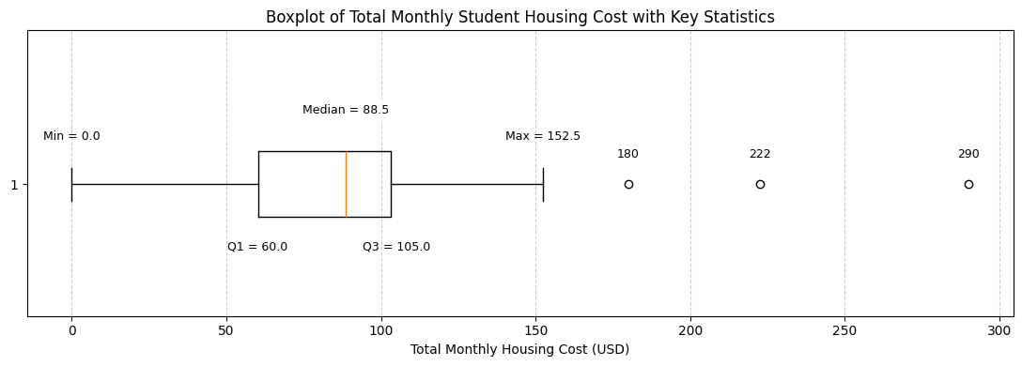

Boxplot Interpretation:
The boxplot summarizes the distribution of total monthly student housing cost. The median housing cost is approximately 88.5 USD, while the middle 50% of observations range between 60.00 USD (Q1) and 105.0 USD (Q3). Several observations lie beyond the upper whisker, indicating the presence of high-cost outliers. This suggests that while most students have similar housing expenses, a small number incur substantially higher monthly housing costs.

Summary Statistic
- Measures of Central Tendency
Measures of central tendency describe the typical or central value of a dataset. In this study, they are used to summarize the total monthly student housing cost.

Add All Numbers from the Survey
From Table 1, the total monthly housing costs (in USD) for the 30 students are:
$$68, 24, 56, 150, 53.5, 152.5, 87, 114.5, 98, 55.5, 60, 68, 61, 95, 25, 90, 0, 290, 115,$$
$$63.25, 222.5, 95, 95, 180, 105, 90, 84.5, 30.5, 95, 85$$
The sum of all 30 observations is:
$$\sum_{i=1}^{30}{x_{i}}=2919.25$$
Mean (Average)
The mean monthly housing cost is calculated using the formula:
$$\overset{ˉ}{x}=\frac{\sum_{i=1}^{n}{x_{i}}}{n}$$Substituting the values:
$$\overset{ˉ}{x}=\frac{\sum_{i=1}^{30}{x_{i}}}{30}=\frac{2919.25}{30}=93.62$$Interpretation:
This means that, on average, students in this sample spend approximately 93.62 USD per month on housing costs.
Median
First, the data are arranged in ascending order:
$$0, 24, 25, 30.5, 53.5, 55.5, 56, 60, 61, 63.25,68, 68, 84.5, 85, 87, 90, 90, 95, 95, 95,95,$$
$$98, 105, 114.5, 115, 150, 152.5, 180, 222.5, 290$$
Since there are 30 observations, there is no single middle value. The median is the average of the 15th and 16th values.
This means the median lies between the 15th and 16th values.
- 15th value = 87
- 16th value = 90
Therefore, the median is:
$$\text{Median}=\frac{87+90}{2}=88.5$$

Interpretation:
Half of the students spend less than or equal to 88.5 USD, and half spend more than or equal to 88.5 USD on monthly housing costs.
Mode
The mode of the data is:
$$\text{Mode}=\text{most frequent value}=95\text{ USD}$$
This value appears most frequently in the dataset, indicating that 95 USD is the most common total monthly housing cost among the students surveyed.
Interpretation of Central Tendency
- The mean monthly housing cost is 93.62 USD, indicating the average amount students spend on housing each month.
- The median monthly housing cost is 88.5 USD, which means that half of the students spend less than or equal to 88.5 USD, and half spend more than or equal to 88.5 USD.
- The mode of the dataset is 95 USD, showing that this is the most common total monthly housing cost among the students surveyed.
- The mean, median, and mode are relatively close in value, suggesting that most students have similar monthly housing expenses.
- The mean is slightly higher than the median, indicating a right-skewed distribution caused by a small number of students with high housing costs.
- The median is particularly useful in this analysis because it is not affected by extreme values, making it a reliable measure of the typical monthly housing cost.
Overall, the measures of central tendency show that while most students spend around 90–100 USD per month on housing, a few students incur significantly higher costs
- Measures of Dispersion (Spread)
Measures of dispersion describe how spread out the housing cost values are.
Minimum and Maximum
- Minimum value: 0 USD
→ This represents a student who reported no monthly housing cost.

- Maximum value: 290 USD
→ This represents the highest monthly housing cost reported by a student.

Range
The range of the data is calculated as:
$$\text{Range}=\text{Maximum}-\text{Minimum}=290-0=290\text{ USD}$$

This wide range shows that housing expenses vary substantially among students, from those who pay no housing cost to those who pay very high monthly amounts.
Variance
The variance of the data is:
$$s^{2}=\frac{∑(x_{i}-\overset{ˉ}{x})^{2}}{n-1}≈3509.35{\text{ USD}}^{2}$$
- The variance of 3509.35 USD² indicates that students’ monthly housing costs vary considerably around the mean.
- Because variance is expressed in squared units (USD²), it is not easy to interpret directly in practical terms.
- The relatively large variance suggests that housing costs are not tightly clustered around the average and that there is noticeable variability among students.
- This variability is influenced by the presence of high-cost housing values, which increase the overall spread of the data.
Standard Deviation
The standard deviation of the data is:
$$s=\sqrt{s^{2}}≈59.24\text{ USD}$$
- The standard deviation of 59.24 USD indicates that students’ monthly housing costs typically differ from the mean by about 59 USD.
- This suggests a moderate level of variability in housing expenses among students.
- Most students’ housing costs are relatively close to the average, but there are some higher-cost values that increase the overall spread.
Interquartile Range (IQR)
Divide the Data into Halves
Since the sample size is n = 30, the median (88.5 USD) divides the data into two equal groups of 15 observations each:

- Lower half: observations 1 through 15

- Upper half: observations 16 through 30
First Quartile (Q1)
The first quartile (Q1) is the median of the lower half of the data.
- The middle position of 15 observations is the 8th value
- From the sorted data, the 8th value is 60.00 USD
$$Q_{1}=60.00\text{ USD}$$

Third Quartile (Q3)
The third quartile (Q3) is the median of the upper half of the data.
- The middle position of the upper half corresponds to the 23rd observation
- From the sorted data, the 23rd value is 105 USD
$$Q_{3}=105.00 \text{USD}$$
Calculate the IQR
The interquartile range is calculated as:
$$\text{IQR}=Q_{3}-Q_{1}=105.00-60.00=45.00\text{ USD}$$
This indicates that the middle 50% of students have monthly housing costs within a 45.00 USD range of each other.
The IQR provides a robust measure of variability and will be used in the next section to identify potential outliers.
General Observations
- Most students spend between 60 USD and 110 USD per month on housing.
- Several values, such as 180 USD, 222.5 USD, and 290 USD, are considerably higher than the majority of the data.
- These high-cost values increase the range, variance, and standard deviation, indicating greater variability in student housing expenses.
- While the mean, median, and mode suggest a typical monthly housing cost of approximately 90–100 USD, a small number of students experience significantly higher housing costs.
- These differences likely reflect variations in housing type, location, and living arrangements among students.

Point Estimation

Parameters and Estimators
In this study, we assume the total monthly student housing cost is drawn from a population with an unknown mean $μ$ and unknown variance $σ^{2}$.
- Population mean ($μ$):
The true average monthly housing cost for all university students in the population.
- Population variance ($σ^{2}$):
The true variance of monthly housing costs in the population.
- Sample mean ($\overset{ˉ}{X}$) as an estimator of $μ$:
$\overset{ˉ}{X}=\frac{1}{n}\sum_{i=1}^{n}{X_{i}}$ is used to estimate $μ$.
From our data:
$$\overset{ˉ}{X}=93.62\text{ USD}$$
- Sample variance ($S^{2}$) as an estimator of $σ^{2}$:
$S^{2}=\frac{1}{n-1}\sum_{i=1}^{n}{(}X_{i}-\overset{ˉ}{X})^{2}$ is used to estimate $σ^{2}$.
From our data:
$$S^{2}≈3509.35{\text{ USD}}^{2}$$

Unbiasedness and Consistency (Conceptual Explanation)
- Unbiasedness of $\overset{ˉ}{X}$:
$\overset{ˉ}{X}$ is an unbiased estimator of $μ$ if its expected value equals $μ$, i.e.,
$E(\overset{ˉ}{X})=μ$.
This means that, on average, the sample mean does not systematically overestimate or underestimate the true population mean.
- Consistency of $\overset{ˉ}{X}$:
$\overset{ˉ}{X}$ is a consistent estimator of $μ$ if, as the sample size $n$ increases, $\overset{ˉ}{X}$ converges to $μ$.
In practical terms: the larger the sample, the closer $\overset{ˉ}{X}$ tends to be to $μ$.

Standard Error of the Mean
The standard error of the sample mean is calculated as:
$$SE(\overset{ˉ}{X})=\frac{s}{\sqrt{n}}$$
where:
- $s=59.24\text{ USD}$ (sample standard deviation)
- $n=30$
$$SE(\overset{ˉ}{X})=\frac{59.24}{\sqrt{30}}≈\frac{59.24}{5.477}≈10.82\text{ USD}$$

Interpretation:
The standard error of 10.82 USD measures the variability of the sample mean as an estimate of the population mean. A smaller standard error indicates that the sample mean is a more precise estimate of $μ$.

Confidence Intervals

1. 95% Confidence Interval for the Population Mean

Since $σ^{2}$ is unknown, we use the t-interval formula:
$$\overset{ˉ}{x}±t_{α/2, n-1}⋅\frac{s}{\sqrt{n}}$$
Where:
- $\overset{ˉ}{x}=93.62$
- $s=59.24$
- $n=30$
- $t_{0.025, 29}≈2.045$ (from t-table)
$$\text{Margin of Error}=2.045×10.82≈22.14$$
Thus:
$$93.62-22.14<μ<93.62+22.14 \\ 71.48<μ<115.76$$
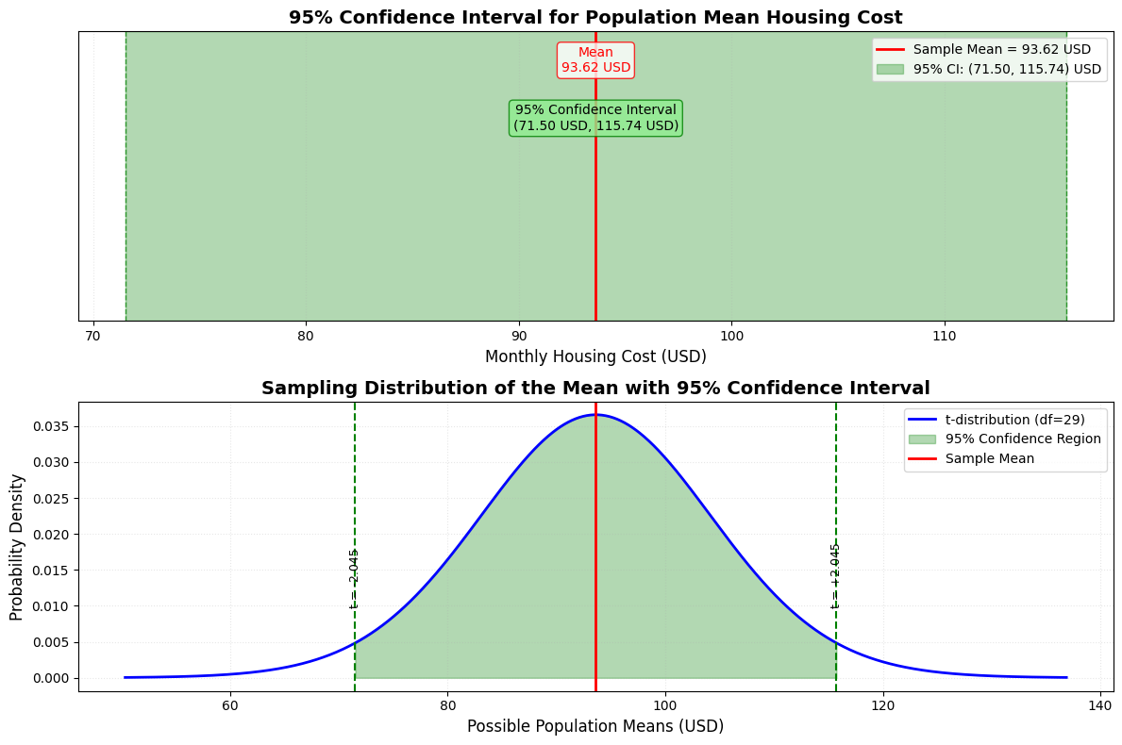
95% Confidence Interval:
$$\left(71.48\text{ USD } , 115.76\text{ USD}\right)$$

2. Interpretation of the Confidence Interval

We are 95% confident that the true average monthly student housing cost for the population lies between 71.48 USD and 115.76 USD.
This means that if we were to take many random samples and construct a 95% confidence interval for each sample, approximately 95% of those intervals would contain the true population mean 𝜇.

3. Required Sample Size (Theoretical Calculation)
Given:
- Desired margin of error $E=0.5\text{ USD}$
- Confidence level $95\%$ → $z_{0.025}≈1.96$
- Estimate of $σ≈s=59.24 \text{USD}$
Formula:
$$n={\left(\frac{z_{α/2}⋅σ}{E}\right)}^{2} \\ n={\left(\frac{1.96×59.24}{0.5}\right)}^{2} \\ n={\left(\frac{116.1104}{0.5}\right)}^{2} \\ n=(232.2208)^{2}≈53,926.49$$
Minimum required sample size: $n≈53,927$
Comment:
Our current sample size ($n=30$) is much smaller than the required $n≈53,927$ to achieve a margin of error of 0.5 USD.
This reflects the large variability in housing costs ($s≈59.24$) relative to the desired precision ($E=0.5$).

Hypothesis Testing

1 Stating the Hypotheses
Housing cost is an important factor affecting students’ living conditions and financial stability. A commonly assumed reference value for student housing is that the average monthly housing cost is 80 USD. The value of 80 USD was chosen as a commonly assumed benchmark based on informal student expectations and prior discussion among students. In this section, we use statistical hypothesis testing to determine whether the actual average monthly house rent in our sample is significantly different from this assumed value.
Let $μ$represent the true population mean total monthly housing cost (USD).
The hypotheses are defined as follows:
- Null Hypothesis (H₀):
$$H_{0}:μ=80\text{ USD}$$
This hypothesis states that the average monthly housing cost is equal to 80 USD.
- Alternative Hypothesis (Hₐ):
$$H_{a}:μ≠80\text{ USD}$$
This hypothesis states that the average monthly housing cost is different from 80 USD.
Because we are interested in detecting any difference, whether higher or lower, this is a two-tailed hypothesis test.

2 Test Statistic
Since the population standard deviation is unknown and the sample size is relatively small ($n=30$), the appropriate test is a one-sample t-test, as introduced in Chapter 4.
The test statistics for a one-sample t-test are given by:
$$t=\frac{\overset{ˉ}{x}-μ_{0}}{s/\sqrt{n}}$$
Where:
- $\overset{ˉ}{x}$is the sample mean,
- $μ_{0}$is the hypothesized population mean,
- $s$is the sample standard deviation,
- $n$is the sample size.
From the dataset:
- Sample mean: $\overset{ˉ}{x}=93.62$USD
- Hypothesized mean: $μ_{0}=80$USD
- Sample standard deviation: $s=59.24$USD
- Sample size: $n=30$
Substituting these values into the formula:
$$t=\frac{93.62-80}{59.24/\sqrt{30}}=\frac{13.62}{10.81}=1.25$$
This calculated t-value measures how far the sample mean is from the hypothesized mean in units of the standard error.

3 p-Value
The p-value represents the probability of obtaining test statistics at least as extreme as the observed value, assuming that the null hypothesis is true.
- Degrees of freedom:
$$df=n-1=29$$
Using a t-distribution table or statistical software for a two-tailed test with:
- $t=1.25$
- $df=29$

Then
$$p=2P\left(T≥\left|1.25\right|\right)$$
$$p≈2(0.11)=0.22 \\ \boxed{p≈0.22 }$$
The p-value is approximately 0.22.
A large p-value indicates that the observed difference between the sample mean, and the hypothesized mean is very likely due to random sampling variation.

4 Decision
We compare the p-value to the significance level:
$$α=0.05$$
- Since $0.22>0.05$,
we fail to reject the null hypothesis $H_{0}$.
This means that the sample does not provide sufficient statistical evidence to support the alternative hypothesis.

5 Conclusion (in Context)
At the 5% significance level, there is no statistically significant evidence to conclude that the average monthly housing cost differs from 80 USD. Although the observed sample mean (93.62 USD) is slightly higher than the hypothesized value (80 USD), this difference is not statistically significant due to the large variability in housing cost.

Conclusion

What We Learned from the Analysis
This project investigated student’s total monthly housing cost, defined as the sum of monthly rent, water, and electricity expenses. Using a dataset of 30 observations, we applied descriptive statistics, point estimation, confidence intervals, and hypothesis testing to analyze the central tendency and variability of housing costs.
The sample mean of the total monthly housing cost was 93.62 USD, with a relatively large standard deviation, indicating substantial variation in housing expenses among students housing costs.

Was the Research Question Answered?
Yes.
The primary research question was whether the average monthly housing cost significantly differs from 80 USD. The hypothesis test produced a p-value of approximately 0.22, which is far greater than the 0.05 significance level. This result clearly indicates that there is no significant difference between the observed average student housing cost and the assumed value. Therefore, the data does not provide evidence against 80 USD is a reasonable estimate of the average monthly housing cost for this sample.

Limitations of the Dataset
While the analysis was conducted correctly, several limitations should be noted:
- Sample Size: With only 30 observations, the results may not fully represent the broader student population.
- Geographic Scope: Housing costs may vary significantly depending on location, housing type, and living arrangements.
- Self-Reported Data: The data were self-reported, which may introduce measurements or reporting errors.

Suggestions for Future Study
To improve future analyses, the following steps are recommended:
- Increase the sample size to obtain more precise estimates of the population mean.
- Analyze housing cost components separately (rent, water, and electricity) to identify their individual impacts.
- Compare different student housing groups using two-sample hypothesis tests (e.g., shared housing vs. private housing).

Appendix (Python Code)
Import Library, load data csv, and rename columns
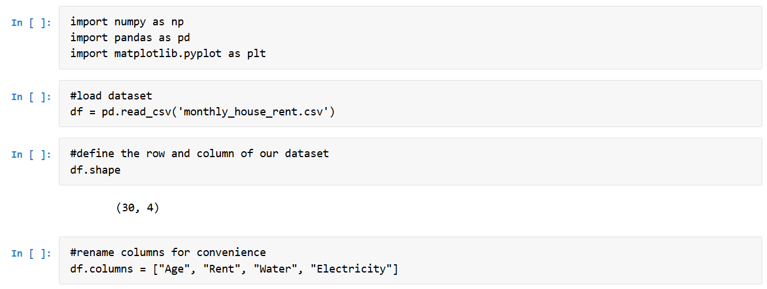
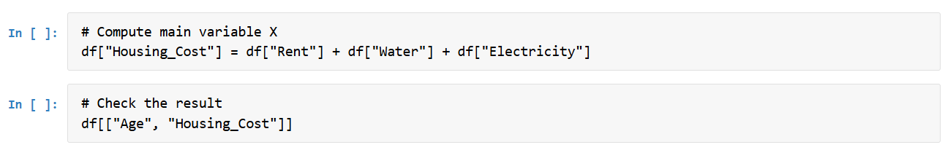

Descriptive Statistics and Detect outliers
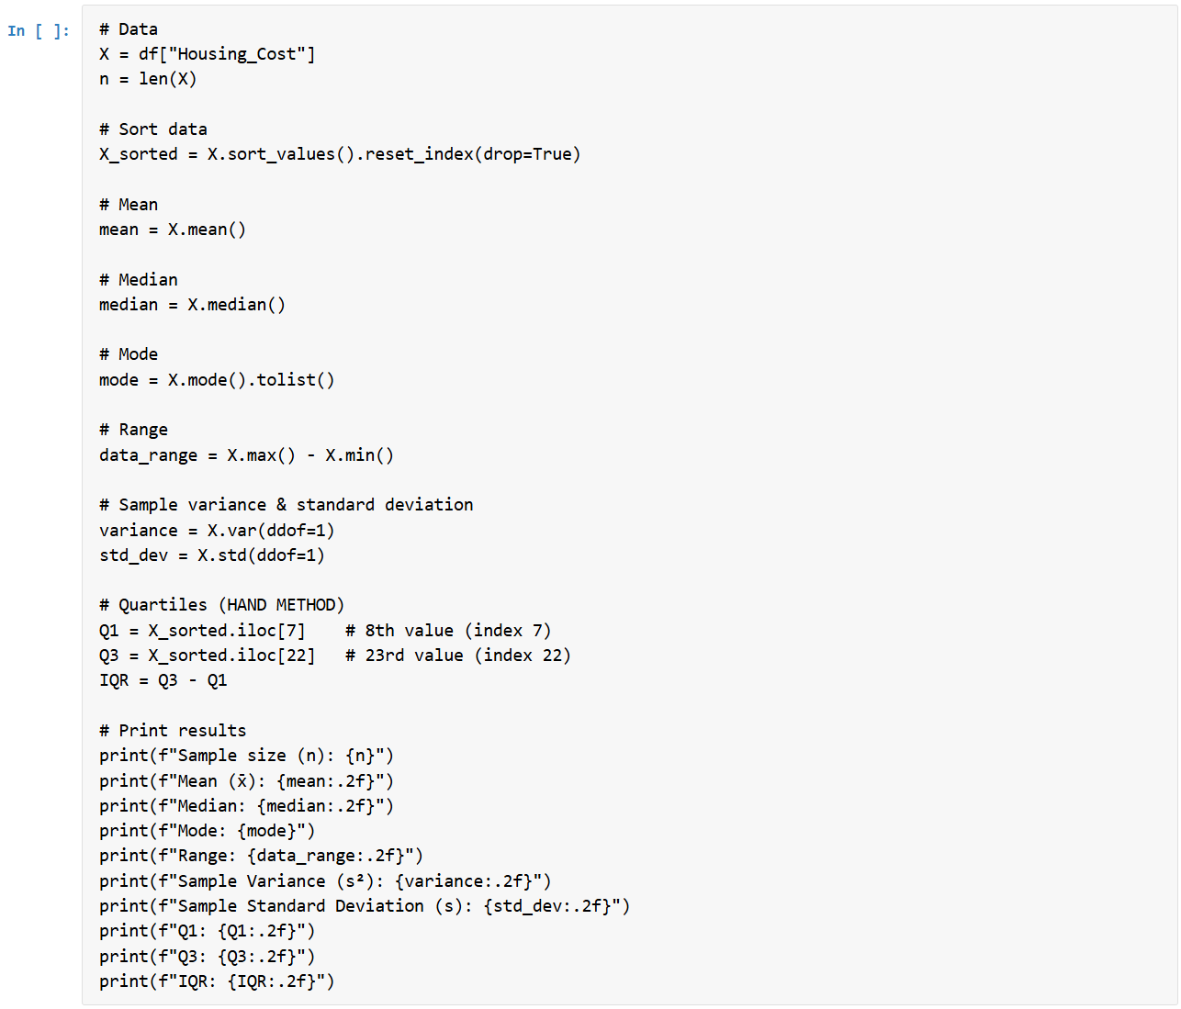
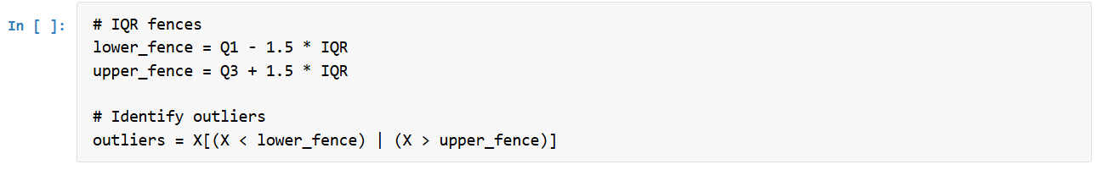
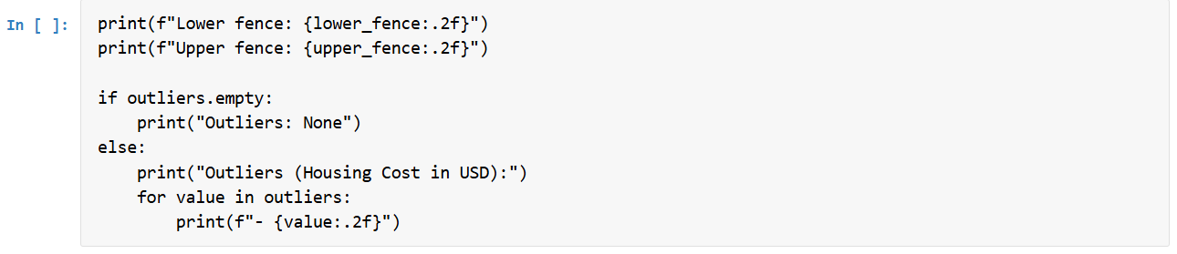
Histogram and Boxplot
