**Q1: Find the pair of the professors living in same city.**

**Query**:

SQL> select p.pname, p1.pname

2 FROM prof p, prof p1

3 where p.pcity=p1.pcity and

4 p.pno!=p1.pno and p.pno<p1.pno;

**Output**:



Table Created

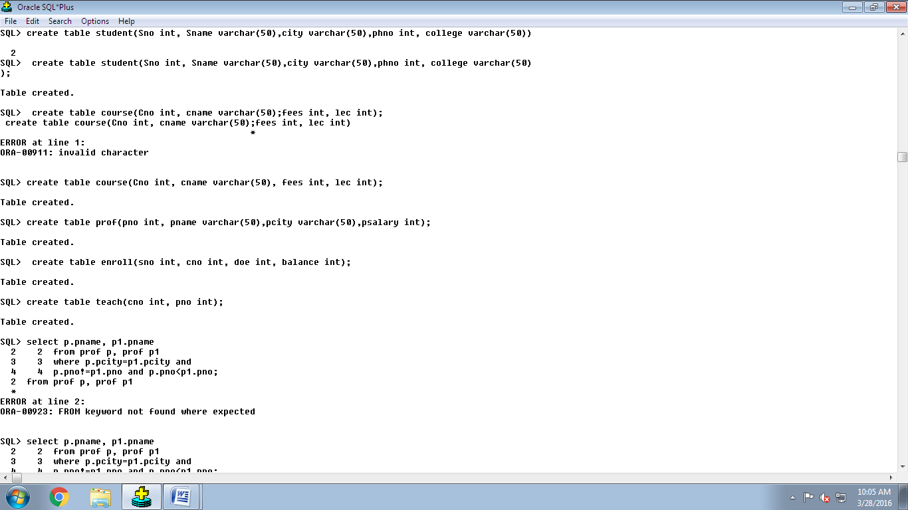

**Q3: Find the list of all the students who have enrolled but not enrolled with student no. 1**

**Query:**

SQL> select distinct sno

2 from enroll

3 minus

4 (select distinct sno

5 from enroll

6 where cno IN

7 (select cno

8 from enroll

9 where sno=6));













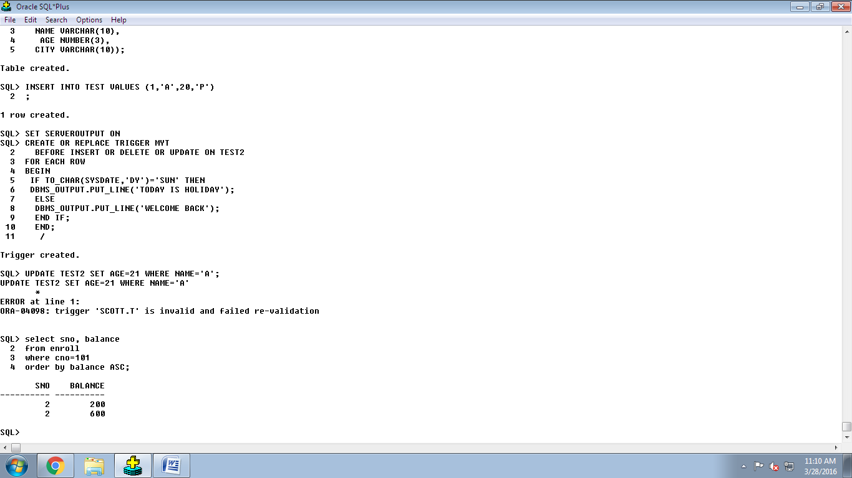

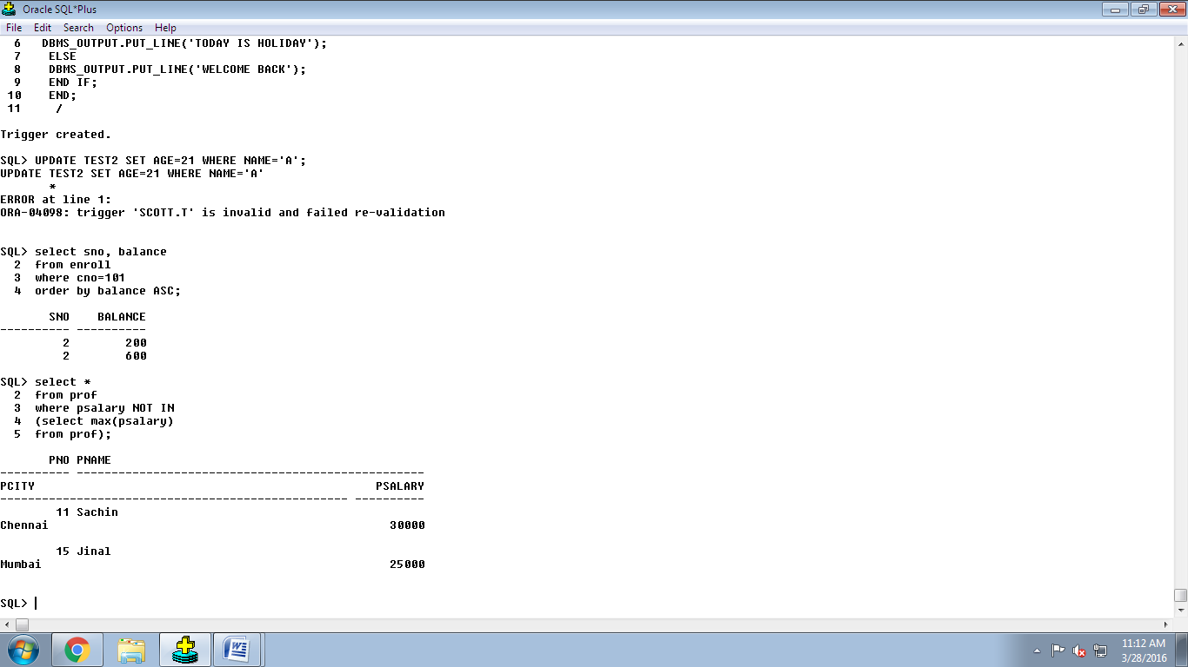

MID Identifier

