Practical No 9:-Write down SQL by using i.Where clause ii.Group By iii.Having Clause

Name:-Gayatri Ishwar Kale Batch NO:-2

Div:-A Roll No:-54 Date:-1-3-2024

-----------------------------------------------------------------------------------------------------------------------

select saleid,productid,amount,salesdate

from sales

where amount>150.00;

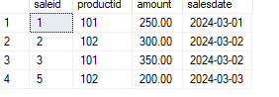

select productid,sum (amount) as totalsales

from sales

group by productid;

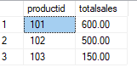

select productid,sum (amount) as totalsales

from sales

group by productid

having sum (amount) > 200.00;

