**Project Specification Document**

1. **Project and Developer details:**
   1. **Project details:**

* It is a multi-role application project Admin and User, where Admin will have the main control over the system. Admin is the main role that will handle the overall application. It has multiple modules like Movies, Tickets, Shows, Details of User, etc. Whereas users can register on the system and View & book movies online. Users can make payments online and book seats online.
* Admin:
* Manage Movies
* Manage Tickets
* Manage Shows
* Manage Users
* Manage Movies: Admin manage Movies using following option
* Add Movies: adding movie into the portal
* Update Movies: updating movie like name, image, or price etc
* Delete Movies: deleting movie
* Manage Tickets: Admin manage Movie tickets using following option
* Add Tickets: adding tickets into the portal
* Update Tickets: updating tickets like price, number of tickets, or etc
* Delete Tickets: deleting ticket
* Manage User: Admin manage User using following option
* Delete User: deleting User
* User:
* Register
* View Movie
* View all upcoming movies
* Book the Movies
* Once user visited website you can search your movies. But for adding movie into the cart, you need to login
* User Login page gives you two options if you are existing user login with your username and password
* If you are new User please register first for your username and password one your registration successful please login with given username and password.
* after Login Your visited to portal and book ticket for movie and add into the cart.
* In the portal user can view all available movies and add favourite movies into the cart.
* You can add number of movie tickets into the cart
* Cart page show all added item with price of all medicine.
* Once you try to buy it asked you billing details.
* Once done you successfully booked your movie
  1. **Developer Details:**

We have developed **My Movie Plan** in spring boot rest Api and Angular JS. It is allowed Users to book movie tickets online. Here, there are multiple users’ user this system. Admin will add, remove, manage movies tickets and movies based on Admin choice. This is a web application to allow admin to manage movies ticket system online.

**2.Sprint Planning:**

**Task1: Admin Module**: This module will allow Admin to log in and log out of the system and manage the system and its functions.

* **Manage Movies**
* **Manage Tickets**
* **Manage Users**

**Task 2: Movie Module:**

* Add movie
* Update movie
* Delete movie

**Task 3: Ticket Module:**

* Add ticket
* Update ticket
* Delete ticket

**Task 3: User module:** This module will allow the user to manage all the operations related to the user like user details,

* Manager user by Admin
* User can visit the after login
* View movies and book movie tickets

**Task 4: Cart module:**

* Movie Added into the cart by user
* Cart show count number tickets book by user
* Cart show total price of all tickets added into cart
* Show checkout option and ask billing details

**3.FlowChart:** 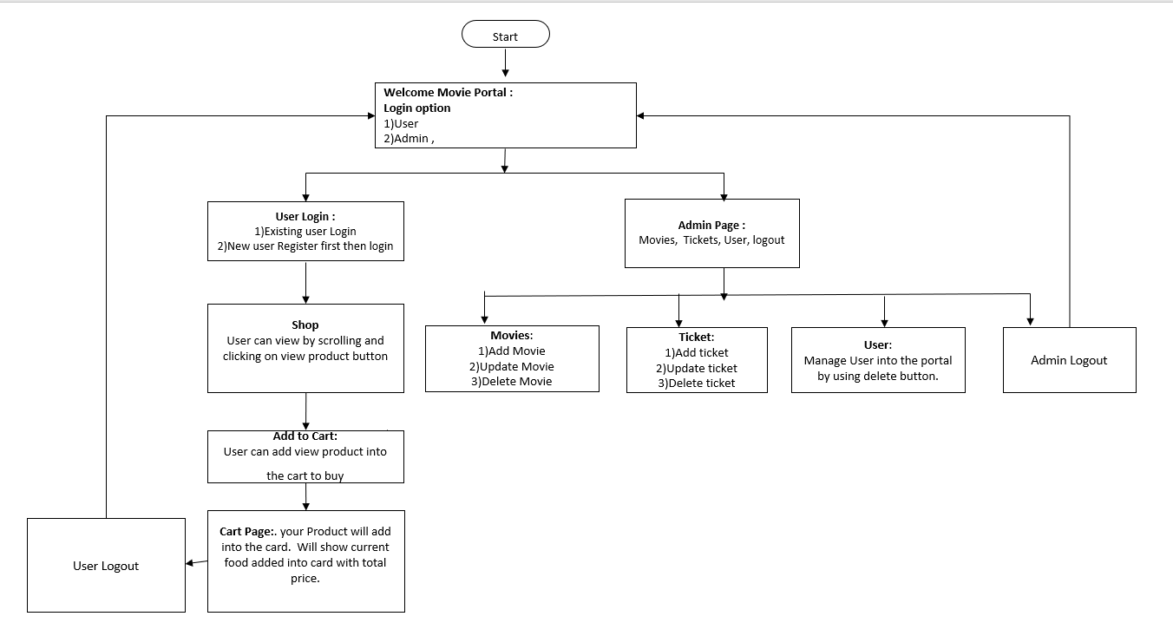

**4. Core concepts used in the project Concepts used in developing the application are**

**Front-End:** HTML, CSS, Angular JS, Bootstrap, JavaScript  
**Server-side:** Spring Boot Rest API  
**Back-end:** MYSQL, Hibernate.

**IDE**: Spring tool suite 4, Node JS

**5**. **Links to the GitHub repository to verify the project completion**