**Home Page of Medicine Shop**

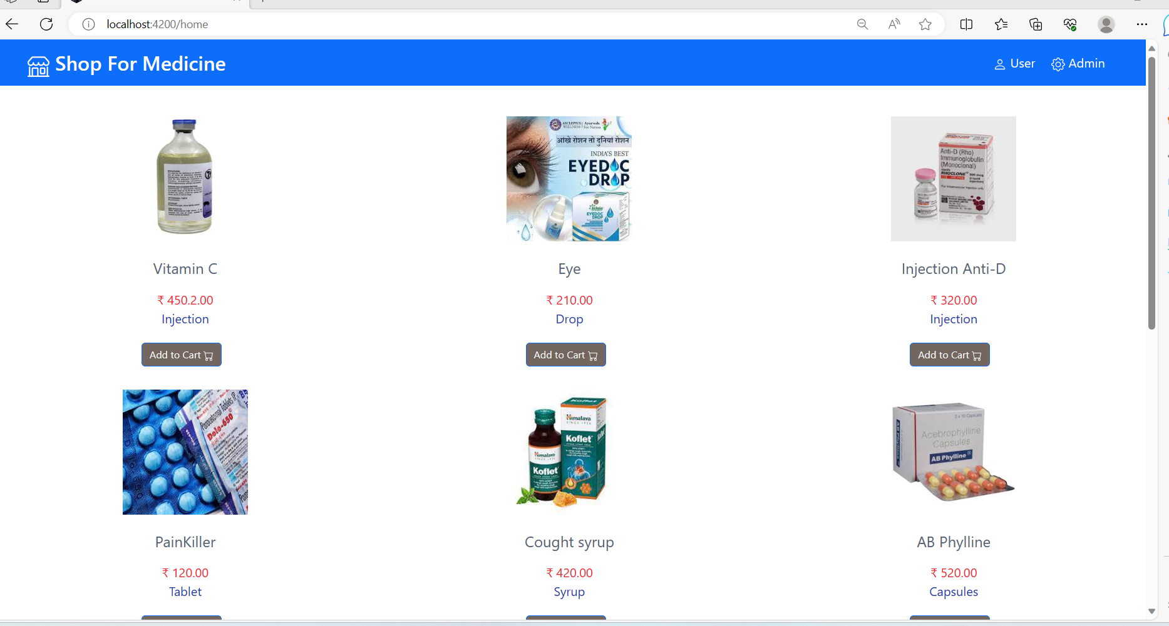

**\*\*\*\*\*\*\*\*\*\*\*\*\*\*\*Admin Interaction Operations\*\*\*\*\*\*\*\*\*\*\*\*\*\*\*\*\*\***

* Admin Login page

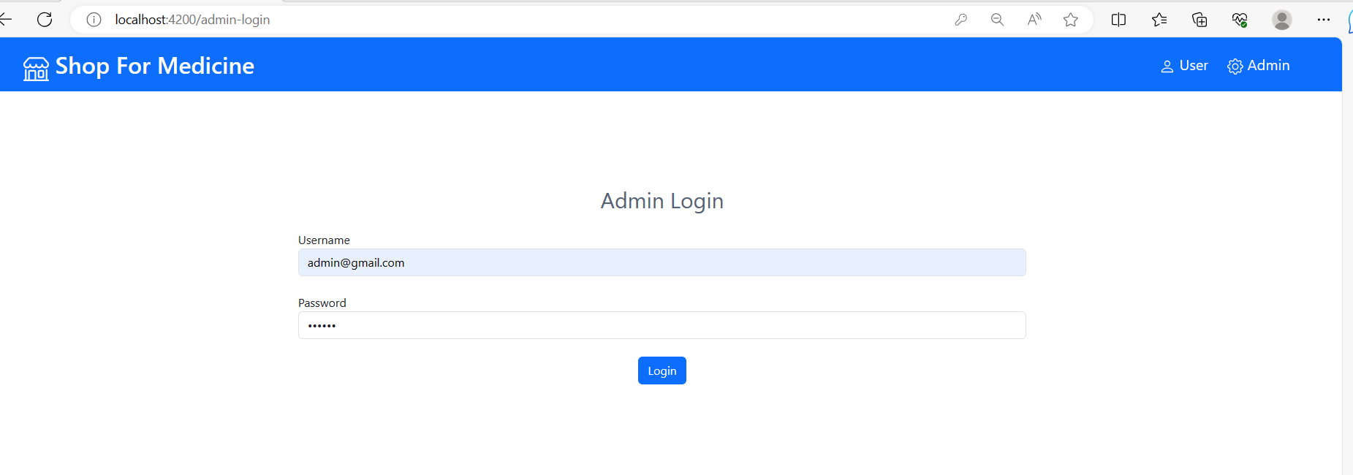

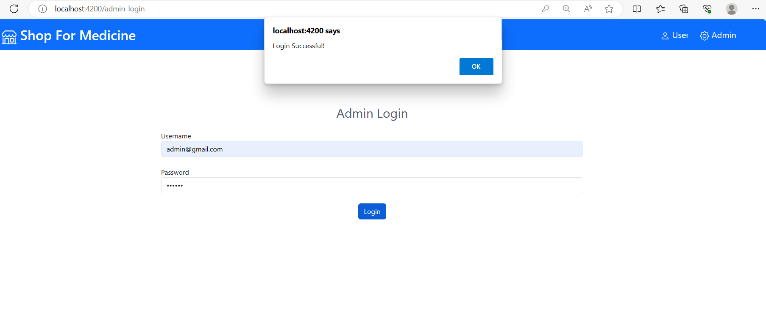

* One Admin Login Successfully, it will show admin operation page:

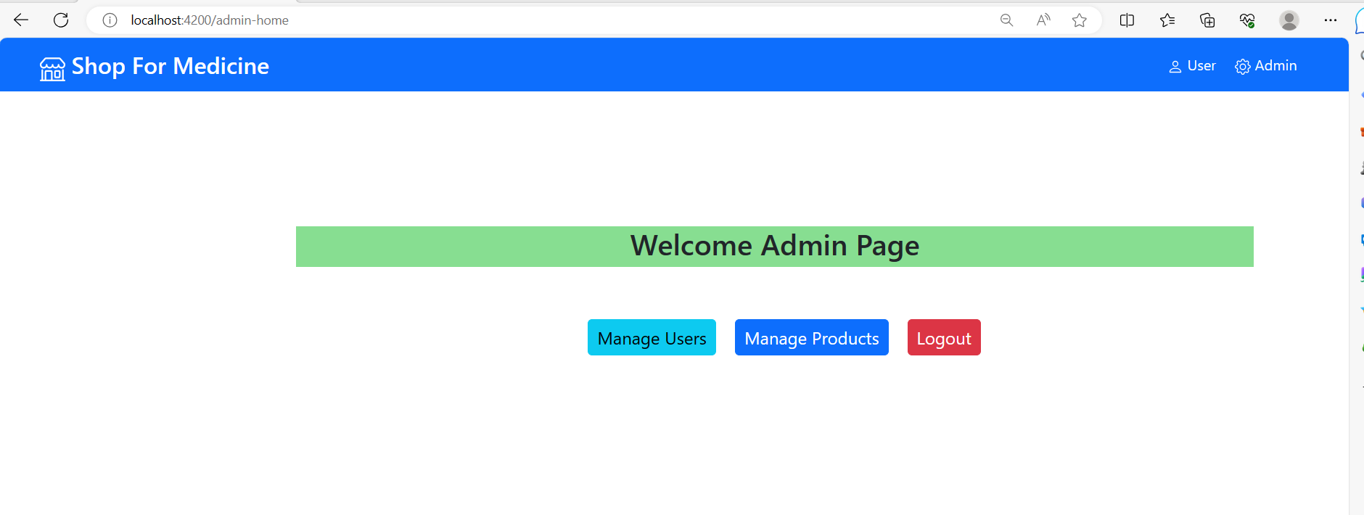

* Let’s Go with User Page: Where admin can manage user data by using delete option,

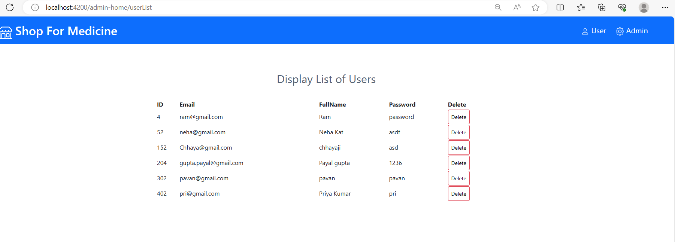

* Admin can delete any user from list: lets delete record for Priya Kumar

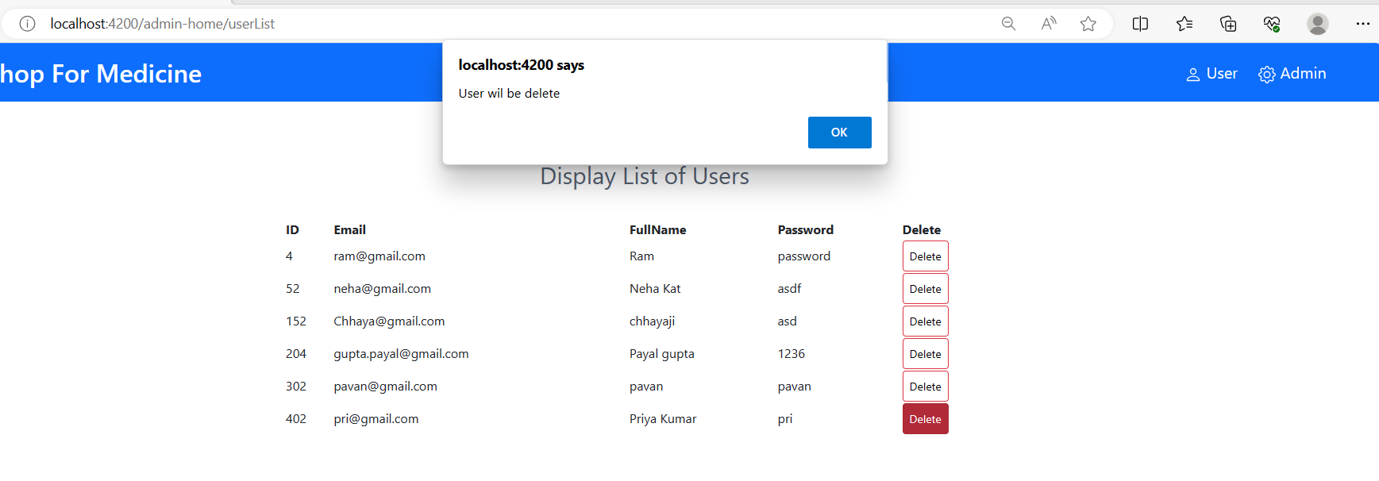

* Once admin click on ok it is deleted from Admin record:

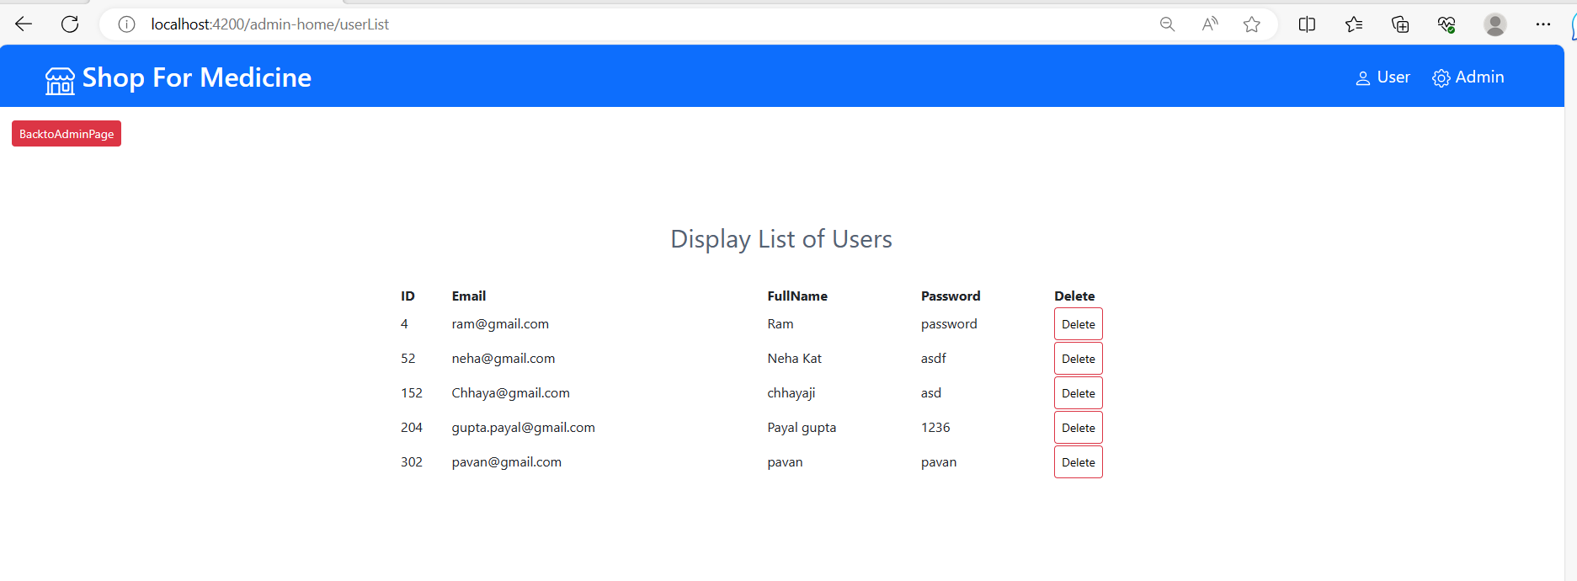

* Now let us go back again admin page to see other operations:

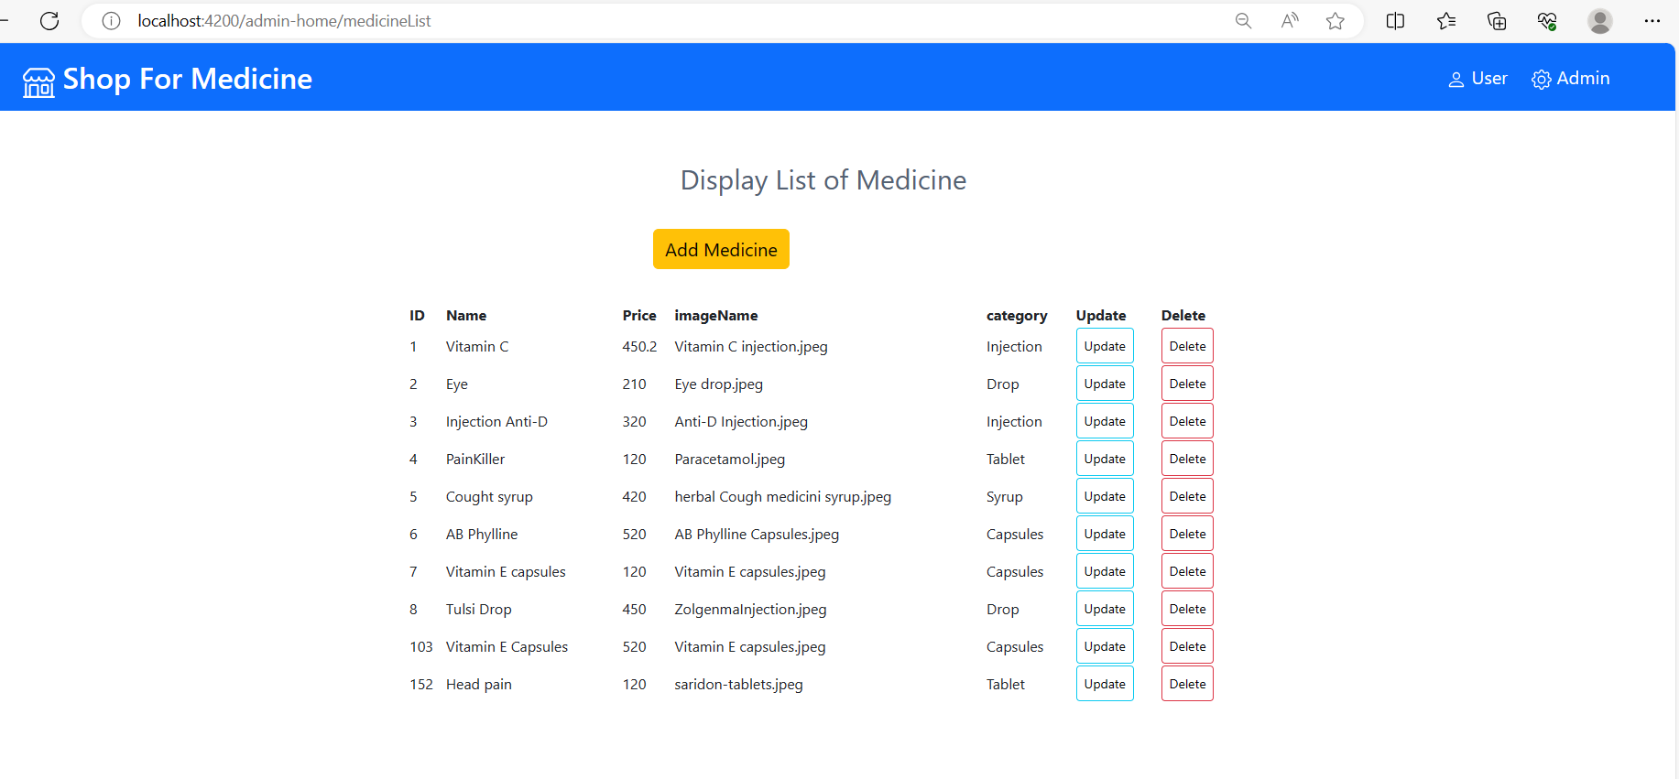

* Let’s Add medicine in our application as Admin:

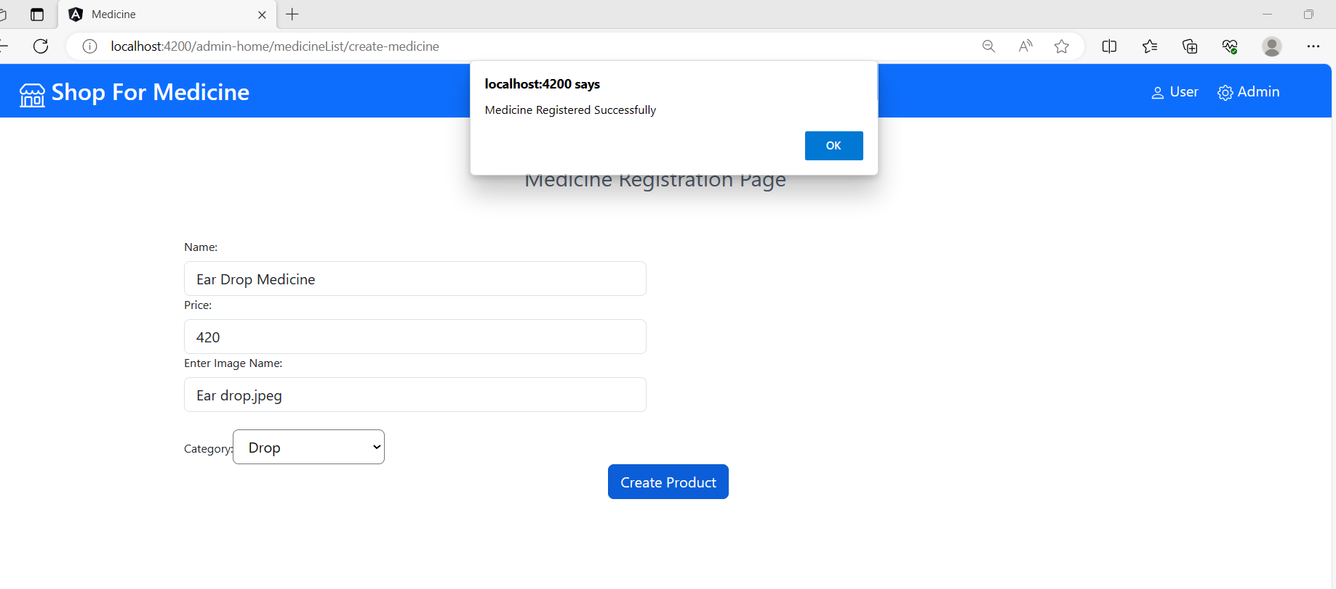

* One you click on Create Product Medicine will add in application. Medicine Successfully Added .

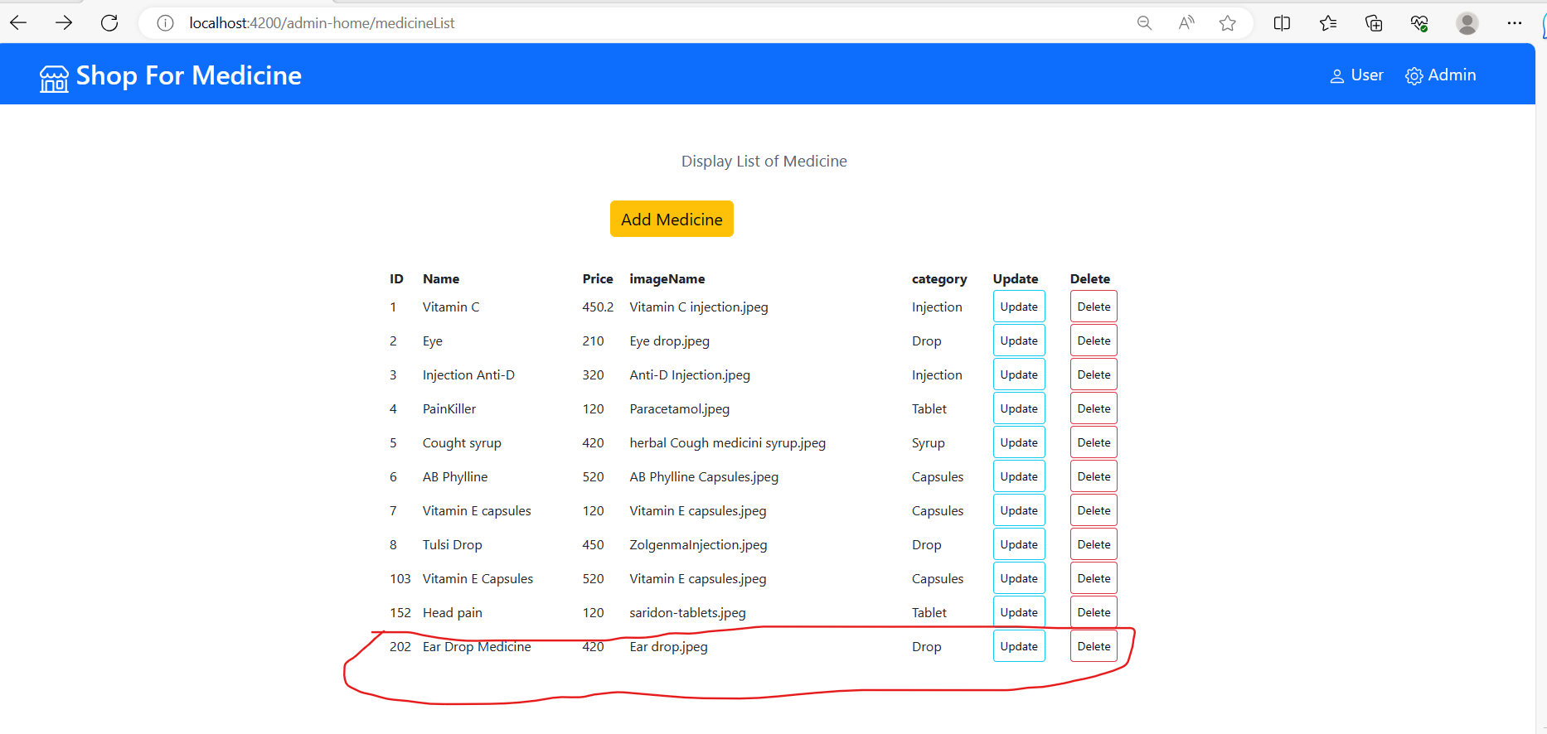

* Admin Can Update or delete the Medicine data. Let’s update the data for Eye medicine.

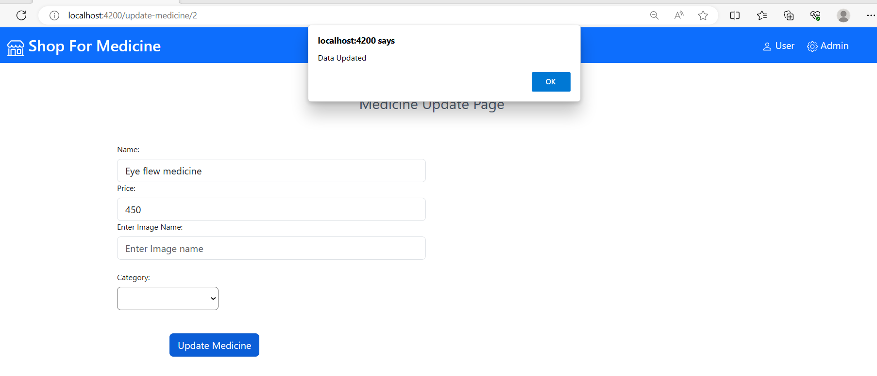

* Data Updated Successfully,

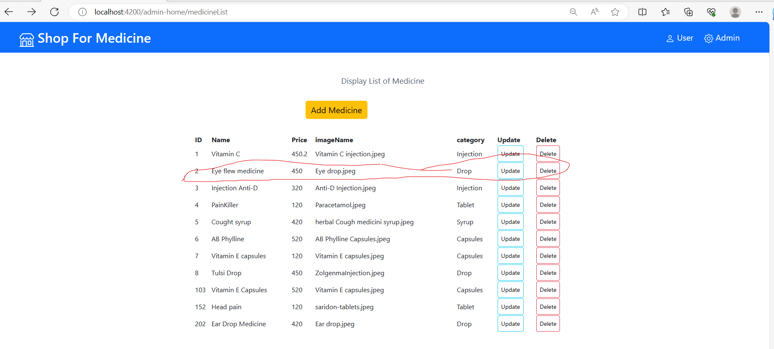

* Admin Can Delete and Record of medicine, let’s delete record 202

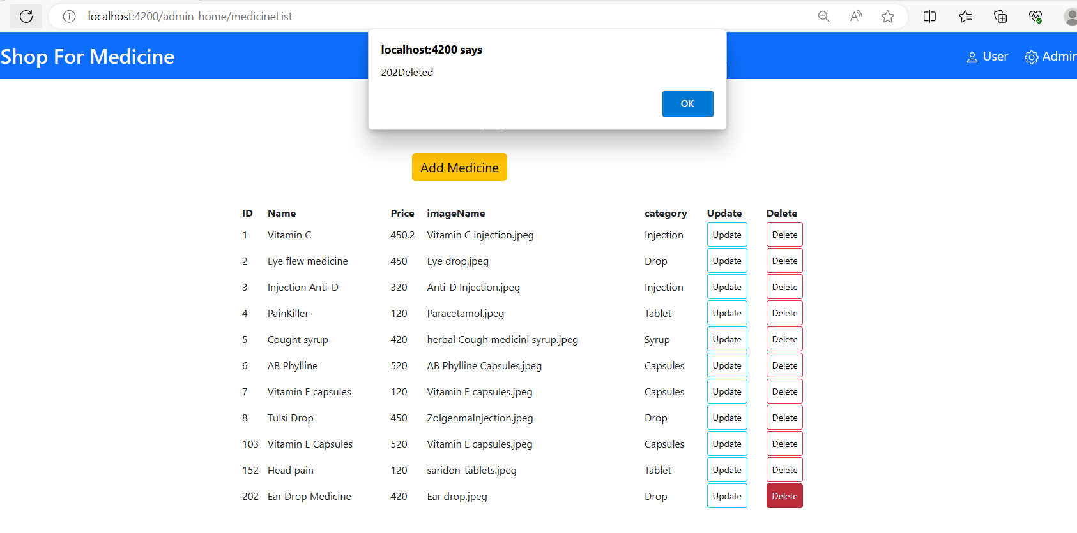

* Record deleted Successfully.

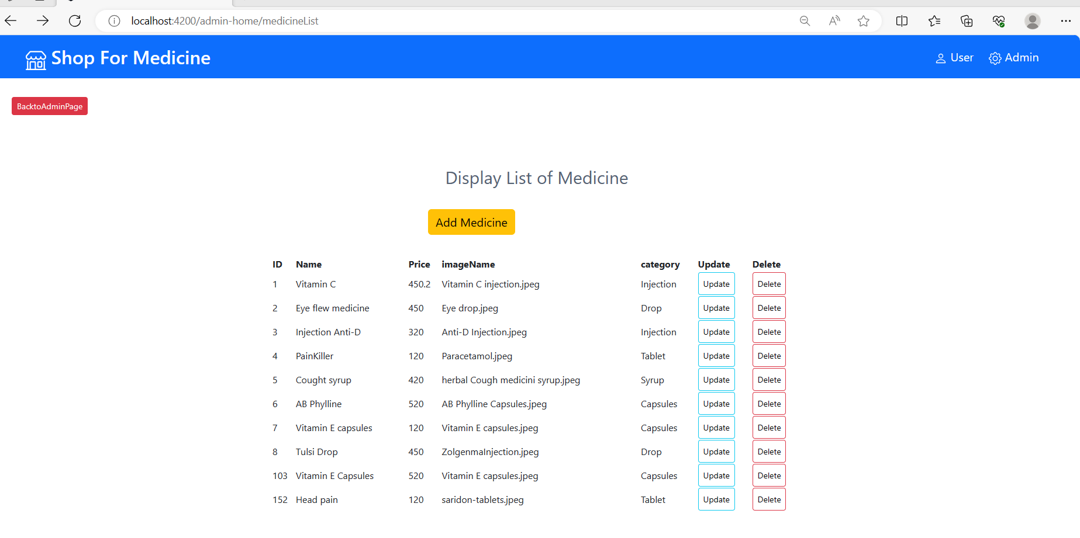

* Let us go back to admin home page to see rest of operations,

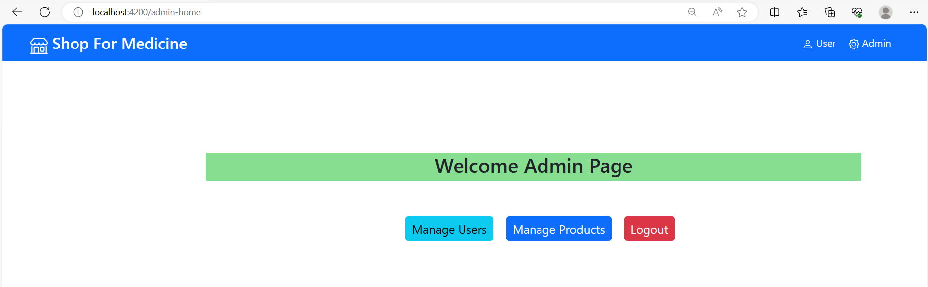

* Its Time to logout as Admin from application. Will see you in Medicine Application as user.

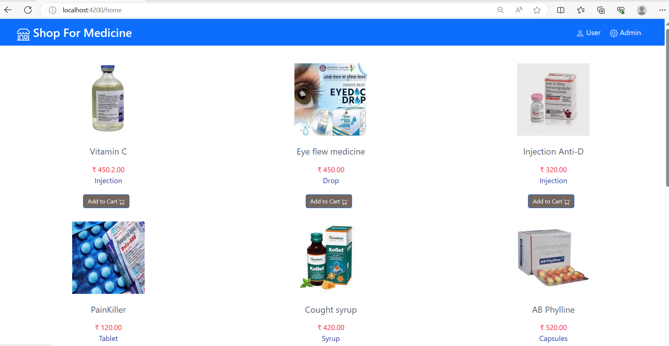

**\*\*\*\*\*\*\*\*\*\*\*\*\*\*\*\*\*\*\*\*\*\*\*\*\*\*\*User Interaction Operation\*\*\*\*\*\*\*\*\*\*\*\*\*\*\*\*\*\*\*\*\*\*\***

* As user you search project by scrolling the application and try to add product to your cart. Let’s add Vitamin E capsule.

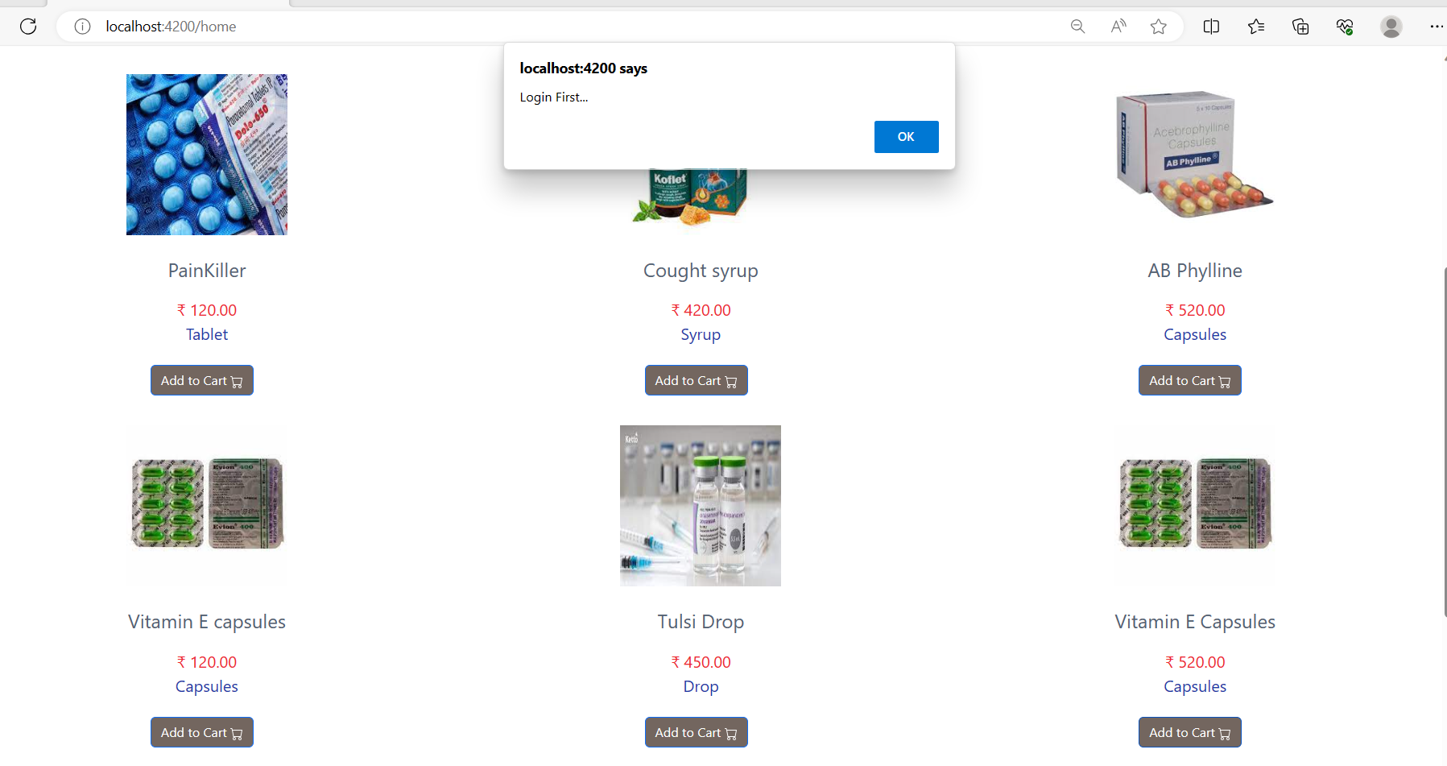

* Let’s go to user login page. it will show you 2 options if you have user id and password then login or if you are new user then register first.

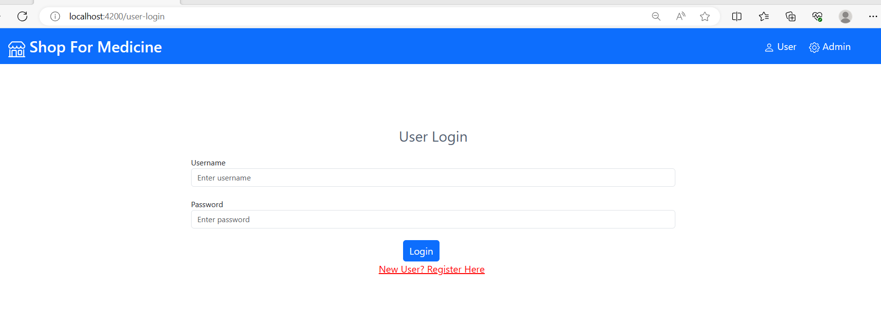

* Let’s Register first for your username and password.

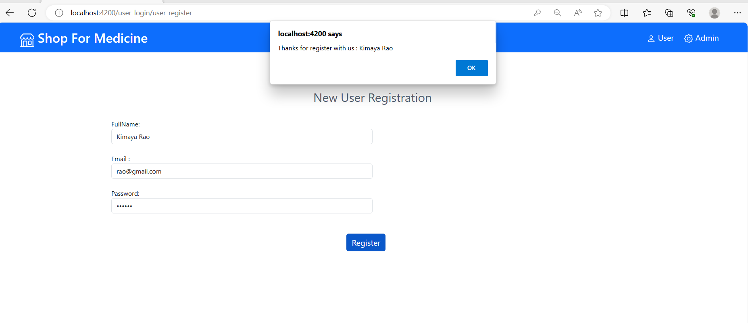

* Now Try to login with given username and password, login successful.

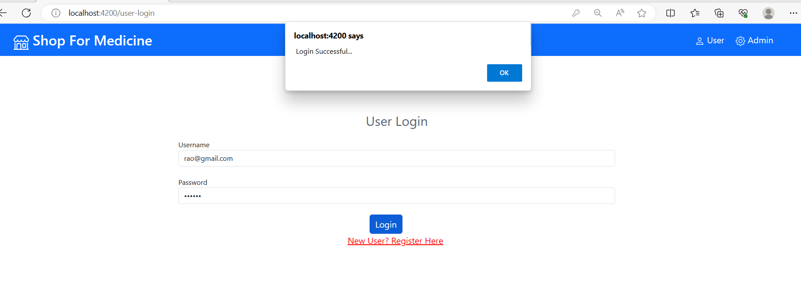

* Once you login you can add you required medicine into the cart for buy. Now let’s try to add medicine.

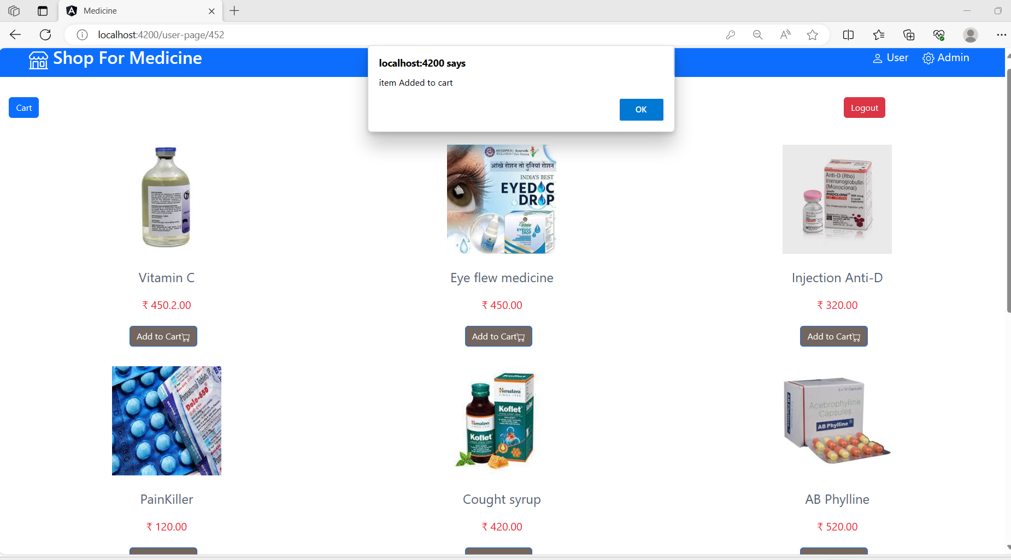

* Let’s go to cart add check and correct item added into the cart.

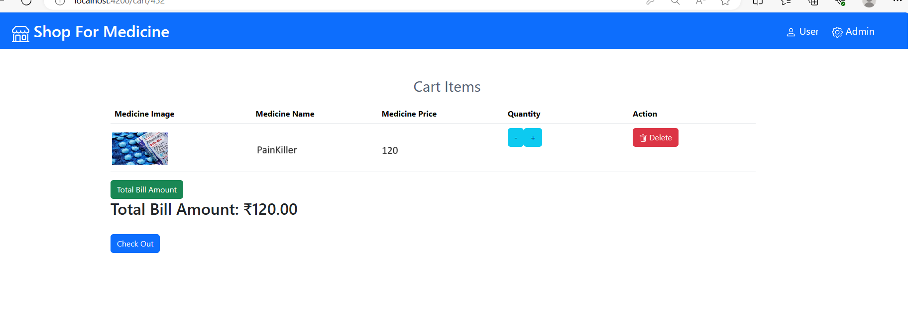

* One you click on check out button you need add back details,

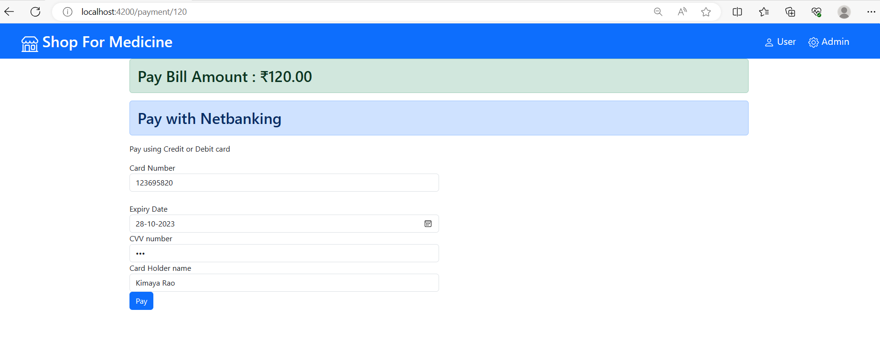

* Once you click on Pay button your order will successfully book .

