**Project Specification Document**

1. **Project and Developer details:**
   1. **Project details:**

* It is a multi-role application project Admin and User, where Admin will have the main control over the system. Admin is the main role that will handle the overall application. It has multiple modules like Categories, Product, Records, Details of User, etc. Whereas users can register on the system and shop for the Medicine online. Users can make payments online and get the products home-delivered.
* Admin:
* Manage Medicine
* Manage User
* Manage Medicine: Admin manage Medicine using following option
* Add Medicine: adding medicine into the application
* Update Medicine: updating medicine like name, image, or price etc
* Delete Medicine: deleting medicine
* Manage User: Admin manage User using following option
* Delete User: deleting User
* User:
* Register
* Shop
* View Product
* Buy Product
* Once user visited website you can search your medicine. But for adding medicine into the cart, you need to login
* User Login page gives you two options if you are existing user login with your username and password
* If you are new User please register first for your username and password one your registration successful please login with given username and password.
* after Login Your visited to shop and add medicine into the cart.
* In the Shop user can view medicine and add favourite medicine into the cart.
* You can add number of medicines into the cart
* Cart page show all added item with price of all medicine.
* Once you try to buy it asked you billing details.
* Once done you successfully buy your product.
  1. **Developer Details:**

We have developed **Online Medicine Shop System Project** in spring boot rest Api and Angular JS. It’s allowed Users to order Medicine online. Here, there are multiple users’ user this system. Admin will add, remove, manage medicine based on Admin choice. This is a web application to allow shop owners to manage Medicine.

**2.Sprint Planning:**

**Task1: Admin Module**: This module will allow Admin to log in and log out of the system and manage the system and its functions.

* **Manage Product**
* **Manage Users**

**Task 2: Product Module:**

* Add product
* Update product
* Delete Product

**Task 3: User module:** This module will allow the user to manage all the operations related to the user like user details,

* Manager user by Admin
* User can visit the after login
* View Product and Buy product

**Task 4: Cart module:**

* Medicine Added into the cart by user
* Cart show count number product added by user
* Cart show total price of all product added into cart
* Show checkout option and ask billing details

**3.FlowChart:**

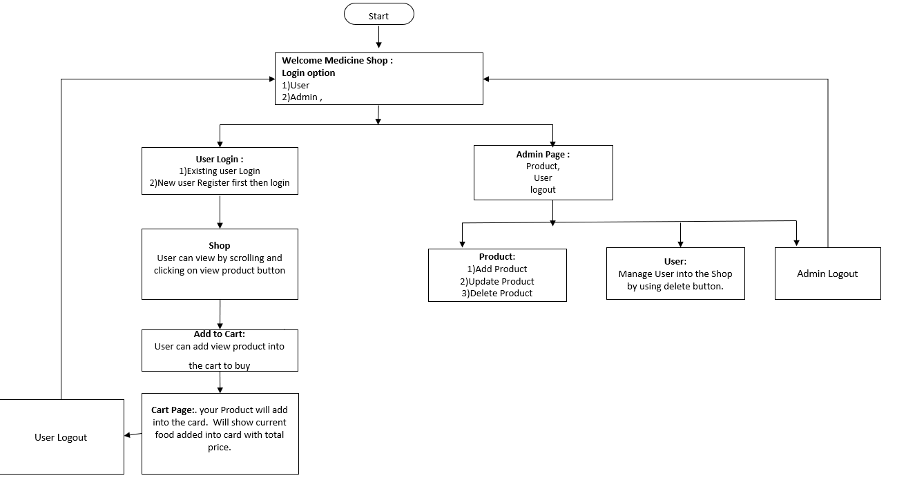

**4. Core concepts used in the project Concepts used in developing the application are**

**Front-End:** HTML, CSS, Angular JS, Bootstrap, JavaScript  
**Server-side:** Spring Boot Rest API  
**Back-end:** MYSQL, Hibernate.

**IDE**: Spring tool suite 4, Node JS

**5**. **Links to the GitHub repository to verify the project completion**