**Project Specification Document**

**1.Project and Developer details:**

**1.1 Project details:**

* Welcome page “Online Food order Application”. Page having search button to search your favourite food as well have all available food button option.
* My application has 8 button of food and having 7 categories:
* All food
* Fast Food
* Pizza
* Lunch
* Slow Food
* Hamburger
* Fry
* Shop
* If you clicked on Fast food, it will show you option
* All available items under the categories
* If you clicked on pizza, it will show you below option
* All available items under the categories
* If you clicked on Lunch, it will show you below option
* All available items under the categories
* If you clicked on slow Food, it will show you below option
* All available items under the categories
* If you clicked on Hamburger, it will show you below option
* All available items under the categories
* If you clicked on fry, it will show you below option
* All available items under the categories
* If you clicked on shop, it will show you below option
* All available items under the categories.
* Search option available to search the food by typing the name.
* You can select food by clicking on picture of your favourite food.
* food name
* food price shown
* button for add your food into the card.
* If you clicked on add to card button,
* your food will add into the card.
* total price of your food
* checkout button

**1.2 Developer Details:**

Application is developed by Chhaya Askar and As a Full Stack Developer, I have designed and developed Kitchen Story is an e-commerce portal having option for user search food and order food, all food is available with their prices. The name of my application is “**My Food Application**”

**2. Sprint Planning**

**task:1** Create angular Project FoodApplication

Generate Header Component

* app.component.CSS:
* app.component.HTML:
* app.component.ts:
* app-routing.module.ts:
* {path:'search/:searchTerm',component:HomeComponent}
* {path:'food/:id',component:FoodPageComponent}
* {path:'tag/:tag',component:HomeComponent}
* {path:'cart-page',component:CartPageComponent}
* app.module.ts : import HttpClientModule
* assets: keep your all images
* index.html
* data.ts :Add sample food

**task :2** Generated shared folder model

* Cart.ts : define food Properties
* cartItem.ts
* food.ts
* tag.ts:

**task :3** Generated services

* food.service.ts: to get all the data using
* getAll() method
* getAllFoodSearchTerm(searchTerm :string){}
* getFoodById(foodId:string):any()
* getAllFoodByTag(tag:string):any{}
* cart.services.ts
* addToCart(food:Food):void{}
* removeFromCart(foodId:String):void{}
* changeQuentity(foodId:String,quentity:number){}
* clearCart(){}
* private setCartToLocalStorage():void{}

**task :4** Create Home component

1.Change ts

2.Change html

3.change CS

**task :5** Generate Search component

2. Add ts //ActivatedRoute

3. Add html

4. Add css

**task** :**6** Generate food page component

1. Add ts

2. Add html

3. Add css

**task** :**7** Generate tags component

1. add to home component

2. Add ts

3. Add html

4. Add css

**3.Flowchart**

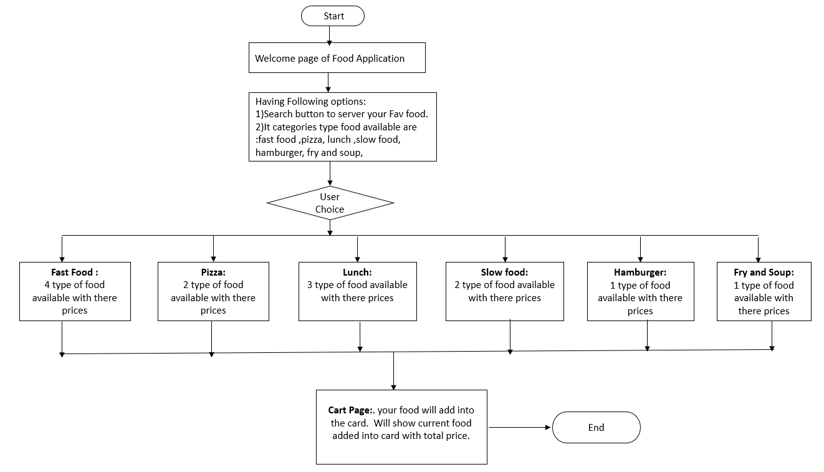

**4. Core concepts used in the project Concepts used in developing the application are**

1. Visual Studio Code IDE
2. HTML
3. CSS
4. Bootstrap
5. Angular JS
6. Type Scripting

**5. Links to the GitHub repository to verify the project completion**