**Quiz Application**

* Welcome Page with quiz name and rules as well showing option for enter your name and button for start the quiz.

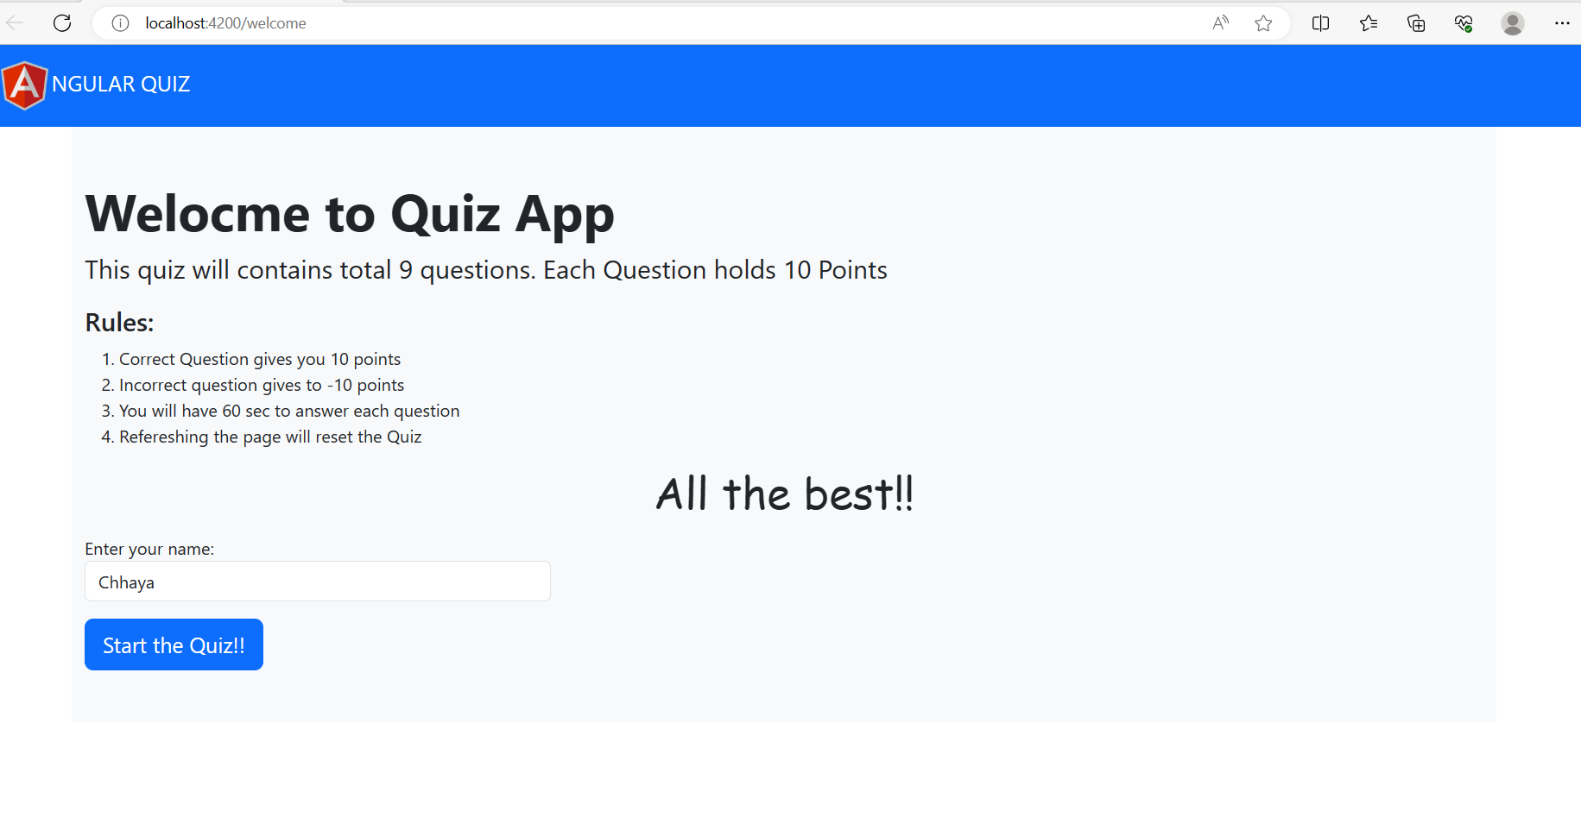

* Once you enter your name and start the quiz it will direct to question page.

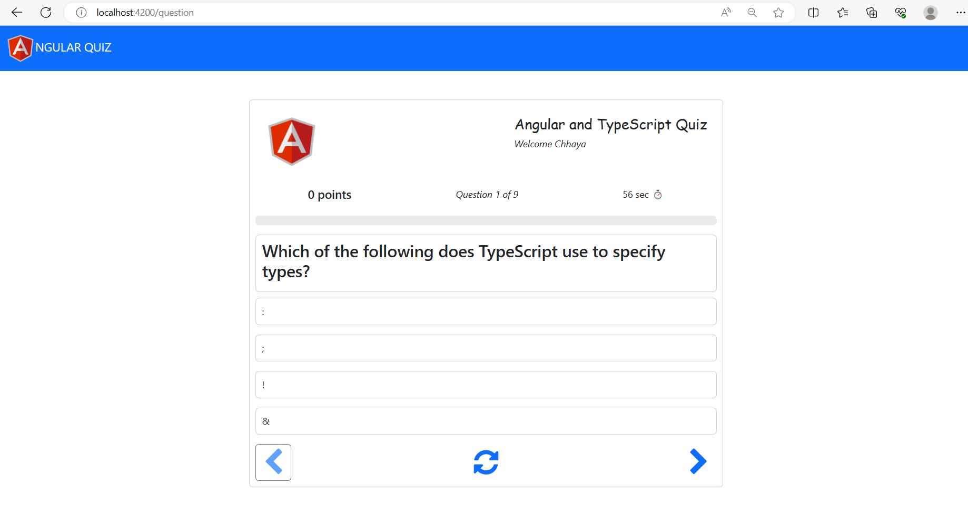

* Its actual Quiz page where all the option are available like username, point, count for all question time, question and answer ,Previous question ,refresh and next question.

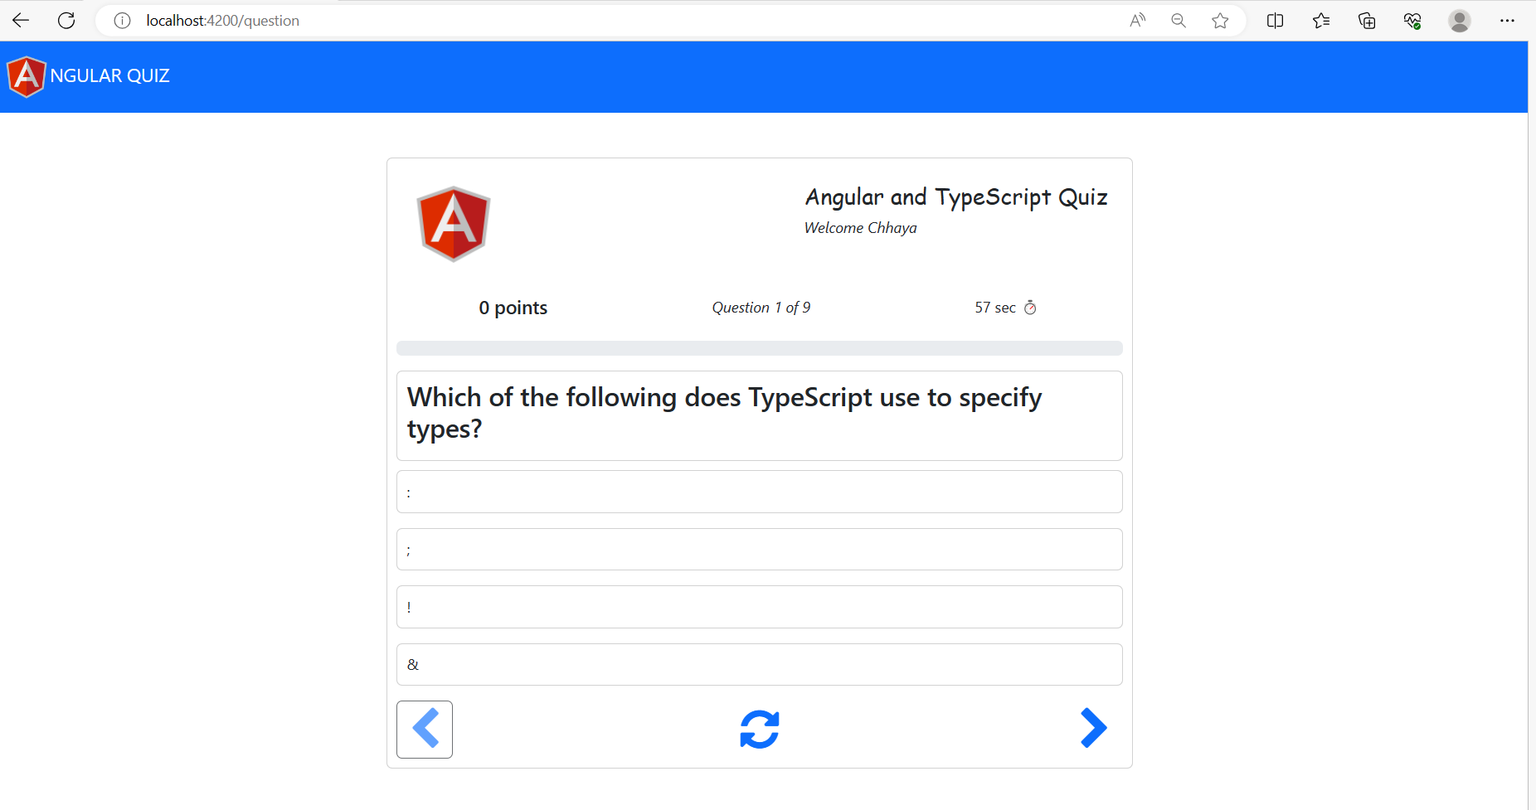

* Each question having 60 sec time to answer the question. If you not answer then it moves to next question after 60 sec and gives you point -10. for wrong answer as well having -10 point and for right answer having +10 point.



* For wrong question gives you -10 points and shows in red colour.

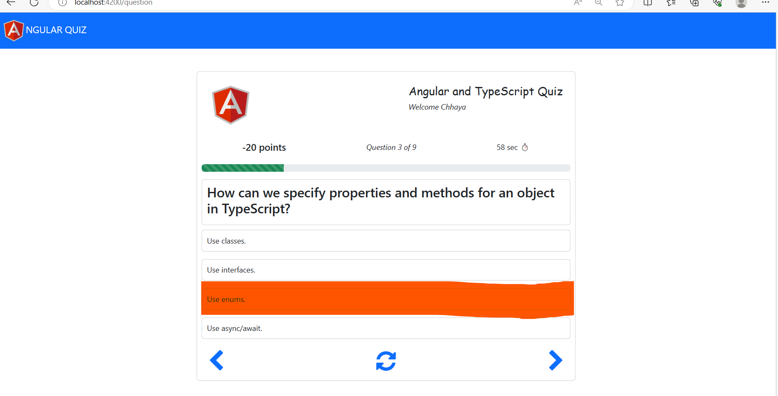

* For right question gives you +10 points and showing in green colour.

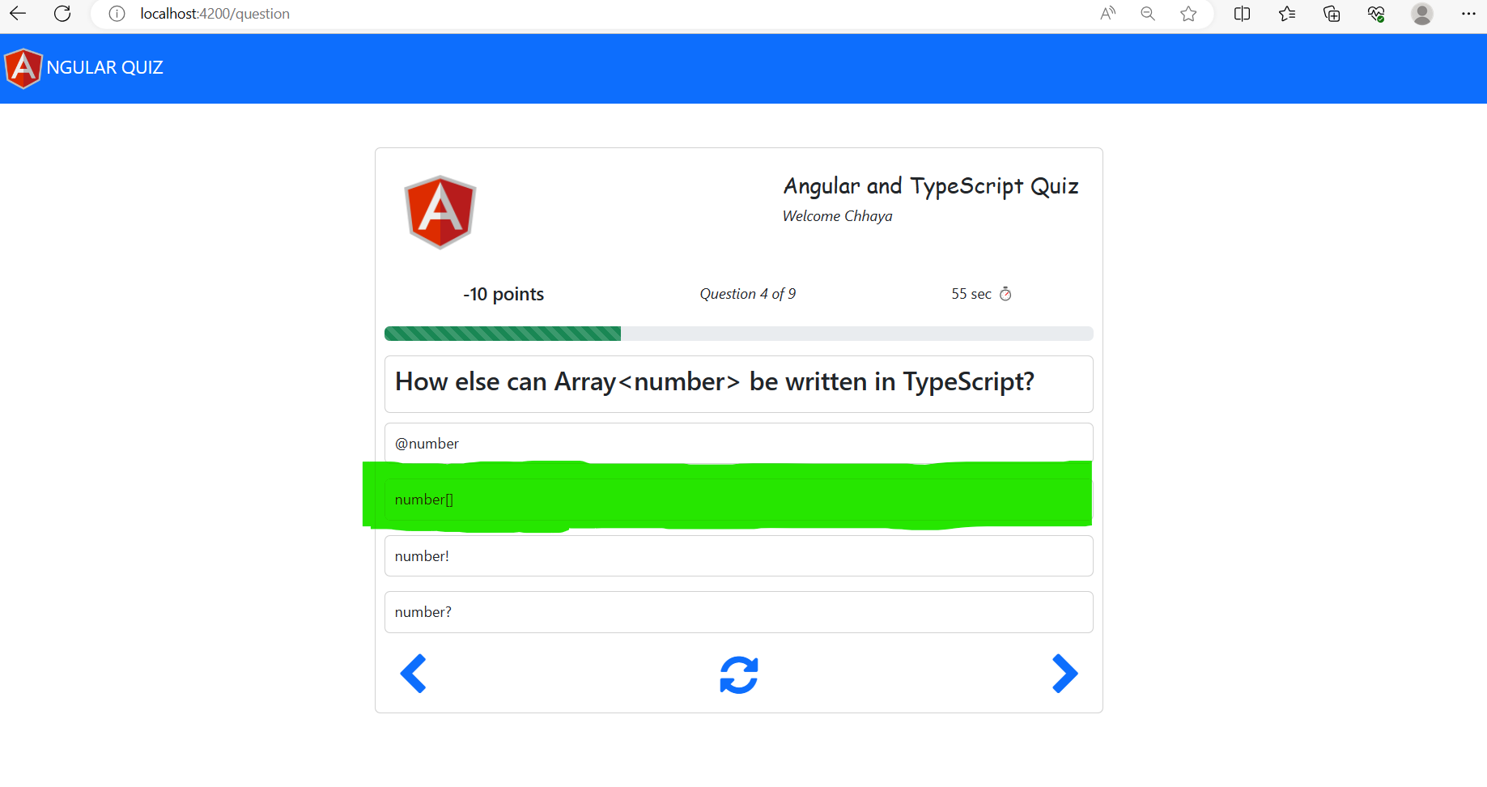

* Refresh button refresh the quiz and started from 1st question as well reset your points and timer.

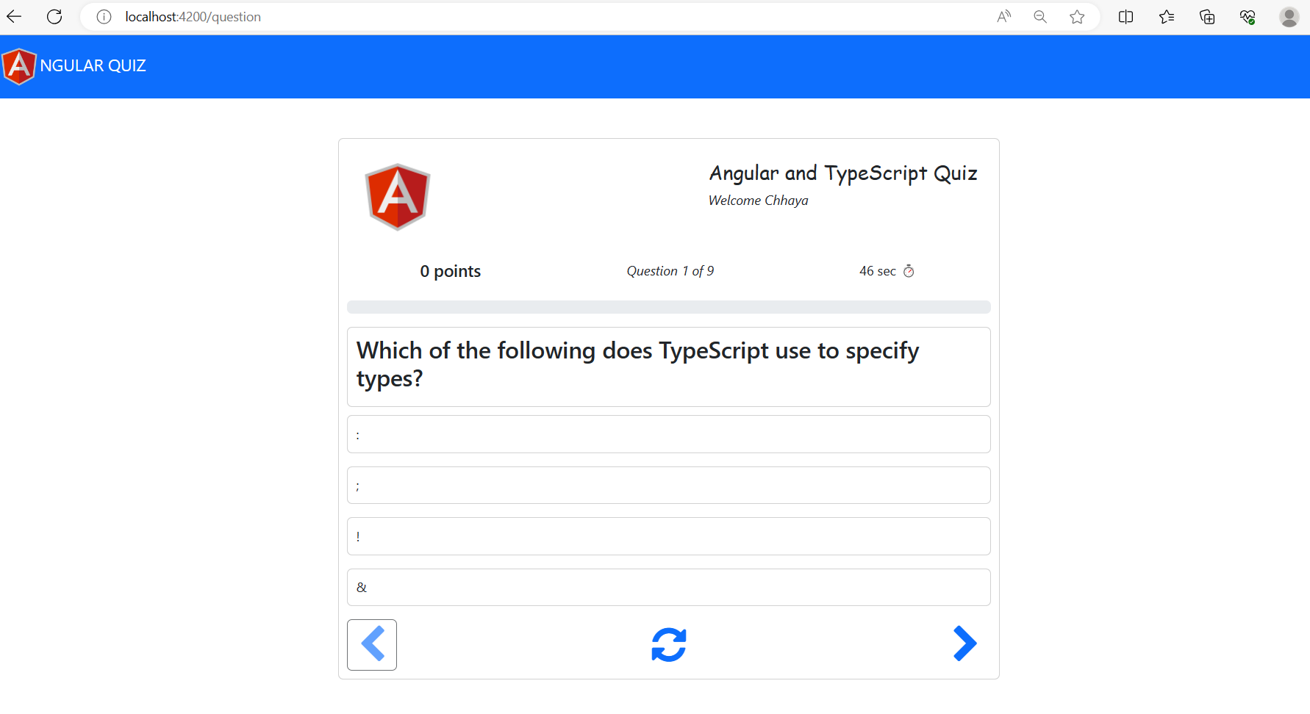

* Once you completed your Quiz at the end it showing you Congrats message and your result.
* Total question attempted.
* Total correction and wrong answer
* Your final score.

