**Project Specification Document**

1. **Project and Developer details:**
   1. **Project details:**

* It is a multi-role application project Admin and User, where Admin will have the main control over the system. Admin is the main role that will handle the overall application. It has multiple modules like Categories, Product, Records, Details of User, etc.Whereas users can register on the system and shop for the shoes online. Users can make payments online and get the products home-delivered.
* Admin:
* Manage Product
* Manage Category
* Manage User
* Manage Product: Admin manage product using following option
* Add Product: adding product into the application
* Update Product: updating product like name, image, or price etc
* Delete Product: deleting product
* Manage Category: Admin manage category using following option
* Add Category: adding Category into the application
* Update Category: updating Category like name, id etc
* Delete Category: deleting Category
* Manage User: Admin manage User using following option
* Delete Category: deleting User
* User:
* Register
* Shop
* View Product
* Buy Product
* Once user visited website must register. after registration he visited to shop
* In the Shop user can view product by category and add favourite project into the cart.
* You can add number of products into the cart
* Cart page show all added item with price of all product.
* Once you try to buy it asked you billing details.
* Once done you successfully buy your product.
  1. **Developer Details:**

We have developed **Online Shoes Shop System Project** in spring boot & hibernate to allow Users to order Shoes online. Here, there are multiple users in this system. Admin will add Shoes, remove, manage, etc. This is a web application to allow shop owners to manage product.”

**2.Sprint Planning:**

**Task1: Admin Module**: This module will allow Admin to log in and log out of the system and manage the system and its functions.

* **Manage Product**
* **Manage Category**
* **Manage Users**

**Task 2: Product Module:**

* Add product
* Update product
* Delete Product

**Task 3:Product Module :**

* Add category
* Update category
* Delete category

**Task 4: User module:** This module will allow the user to manage all the operations related to the user like user name, contact details,

* Manager user by Admin
* User can visite the after registration
* View Product and Buy product

**Task 4: Cart module:**

* Product Added into the cart by user
* Cart show count number product added by user
* Cart show total price of all product added into cart
* Show checkout option and ask billing details

**3.FlowChart:**

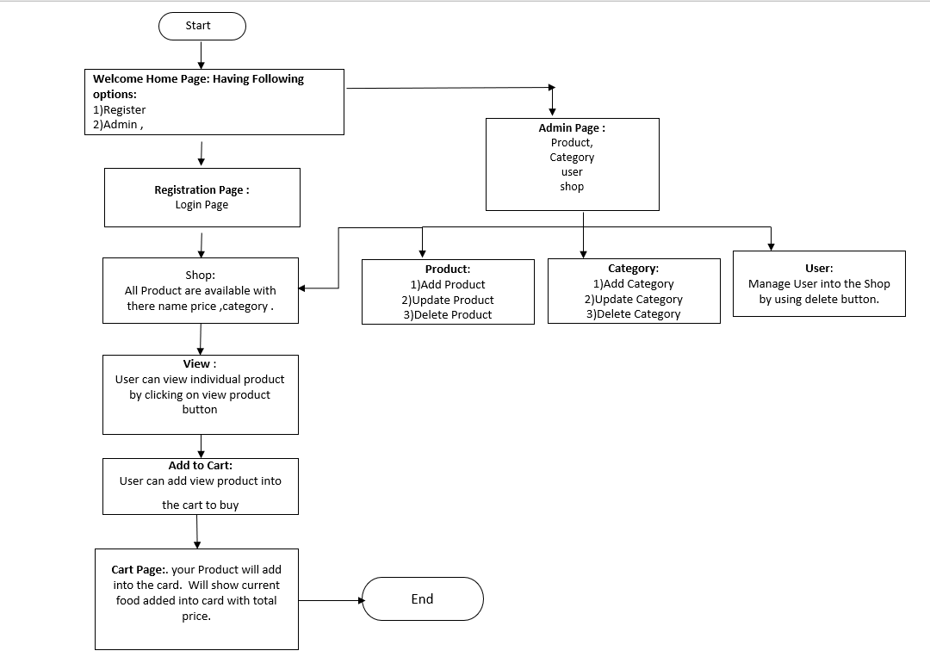

**4. Core concepts used in the project Concepts used in developing the application are**

**Front-End:** Html, CSS, JS, Thymeleaf.   
**Server-side:** Spring Boot MVC, Spring Security  
**Back-end:** MYSQL, Hibernate.

**IDE**: Spring tool suite 4

**5**. **Links to the GitHub repository to verify the project completion**