**FORM A1**

**STUDENT PLAGIARISM DISCLAIMER FORM**

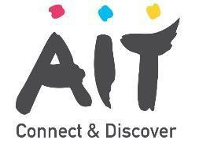

**PLAGIARISM DISCLAIMER**

STUDENT NAME: Chhaya Sharma

STUDENT NUMBER: A00268860

PROGRAMME: Bachelor of Engineering (honours) Software Engineering

YEAR: 4

MODULE: Agile Methodologies

LECTURER: Michael Russel

ASSIGNMENT TITLE: Final CA

DUE DATE: 01/05/2020

DATE SUBMITTED: 01/05/2020

ADDITIONAL INFORMATION:

I understand that plagiarism is a serious academic offence, and that AIT deals with it according to the AIT Policy on Plagiarism.

I have read and understand the AIT Policy on Plagiarism and I agree to the requirements set out therein in relation to plagiarism and referencing. I confirm that I have referenced and acknowledged properly all sources used in preparation of this assignment. I understand that if I plagiarise, or if I assist others in doing so, that I will be subject to investigation as outlined in the AIT Policy on Plagiarism.

I understand and agree that plagiarism detection software may be used on my assignment. I declare that, except where appropriately referenced, this assignment is entirely my own work based on my personal study/or research. I further declare that I have not engaged the services of another to either assist in, or complete this assignment.

**Signed:** Chhaya Sharma

**Dated:** 01/05/2020

**Question1:**

**Answer 1(a)** Two test techniques that can be used for given situation are following:

1. **Equivalence Partition Testing:** In equivalence portioning possible values are divided into equal partitions such that any value in that range shows similar results. So, in this case only one value from each partition is tested.
2. **Boundary Value Analysis:** In boundary value analysis, the testing is done for boundary values that is one possible greater and one lesser than the boundary value. If a condition holds true for these boundary values, it means it will true for all other values.

For the Drug Refund Program, the range of cost for Class A Drug is € 0.00 to € 100.00. Whenever a customer pays a minimum amount of Euro 5, the company refunds 95% of the cost. So, we will first implement equivalence partitioning where there will be 2 invalid classes and one valid range. The first invalid will be the cost greater than 100 and the second one will be less than 5. Whenever we perform equivalence partitioning, the boundary value analysis also comes into place.

For Class B Drug the cost for any drug is greater than 100 and there is no higher limit for the cost of any drug. So, any value greater than 100 will fall into the valid range and value equal to or less than 100 will become invalid. Though it will be valid for Class A Drug.

The company also ensures that the cost will be refunded within 45 days, so the valid range lies between 0 to 45.

**Answer 2** Following are the test cases for given situation

Test Number : 1

Test Objective : Verify the cost does not belong to any group

Input(s) : -20

Expected Output : Cost can not be negative

Output : Cost can not be negative

Test Number : 2

Test Objective : Verify that the cost of the Class A drug belong to valid range

Input(s) : 42

Expected Output : It is a Class A Drug.

Output : It is a Class A Drug.

Test Number : 3

Test Objective : Verify the cost drug is in invalid range.

Input(s) : 3

Expected Output : Value cannot be less than 5

Output : Value cannot be less than 5

Test Number : 4

Test Objective : Verify the cost is valid for Class B drug

Input(s) : 123

Expected Output : Valid for Class B drug

Output : Valid for Class B drug

Test Number : 5

Test Objective : Verify the cost is valid for lower boundary of Class B

Input(s) : 101

Expected Output : Valid for Class B drug

Output : Valid for Class B drug

Test Number : 6

Test Objective : Verify the cost is valid for lower boundary of Class A

Input(s) : 5

Expected Output : Valid for Class A drug

Output : Valid for Class A drug

Test Number : 7

Test Objective : Verify the cost is valid for higher boundary of Class A

Input(s) : 100

Expected Output : Valid for Class B drug

Output : Valid for Class B drug

Test Number : 8

Test Objective : Verify the cost to be calculated and refunded in 45 days

Input(s) : 32

Expected Output : Your amount will be reimbursed

Output : Your amount will be reimbursed

**Question2 How is Kanban different from other Agile methodologies, specifically Scrum?**

Answer:Kanban is visual process-management system that tells teams what to produce, when & how much to produce.

Scrum is an agile process which helps to deliver business value is shortest time. Dew major difference between Kanban ang Scrum are:

|  |  |  |
| --- | --- | --- |
|  | Kanban | Scrum |
| Roles and Responsibilities | There are *no pre-defined roles* for any team.  Everyone in the organization is encouraged to act ad leader even from entry level employee to execute team. | Each team has its own roles and responsibilities where  **scrum master** defines timelines  **Product Owner** defines gaols  **Team** **members** execute work |
| Due Dates/ Delivery Timelines | Products and processes are delivered continuously on need basis | Delivery date are fixed & determined by sprints |
| Delegation & Prioritization | Uses a pull system which allows team members to pull new tasks as previous is completed. | Uses a “Pull system” but entire batch is pulled. |
| Measurement of Productivity | Measures production using “Cycle time” or time it takes to complete one project from start to end. | This approach uses velocity through sprints.  Each sprint lies Back-to-back. |
| Best Suited for Applications | When priorities keeping changing | Best with stable priority. |

Kanban works well along with any Agile methodology like Scrum & can us used to visualize the workflow & process. Kanban system can be customized to fit the process and work system.

When team has started following or adopted any Agile Methodology, with the help of Kanban boards and project forecasting this can be managed easily afterwards.

**Question 2 (b) What do the columns on a typical Kanban board represent?**

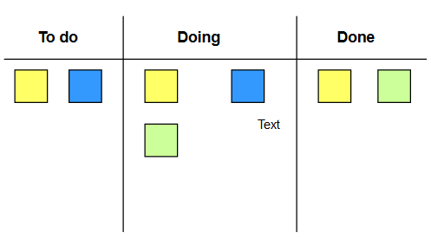Ans: Any Kanban workflow or board has following three columns as To Do, In Progress, Done. These columns can be divided into sub-columns depending upon complexity of work process. Nevertheless, three main stages remain same: Requested, in progress and Done.

**Requested:**

After the backlog part is done, next comes Requested area. Now, items (user story) are pull form the backlog and placed in Requested area column. This is next work to plan. This is like a To-do list.

**In Progress:**

Once the project is pulled from Requested stage and has not been finished yet falls in this category. This is part where everyone is working.

A project is considered in this phase, till the time it is marked as complete, it does not depend upon things like work is paused for a while.

**Done:**

After completion of the task what stage comes is Done where development part is done & project is no longer in progress or doing phase.

**Question 2 (c) What is the difference between a burn-up chart and a burn-down chart? How do you know from a burn-down chart if you are behind schedule?**

Answer: In Agile methodologies, Project managers uses Burn up and burn down to keep a track and communicate the progress of their project with team and different stakeholders.

**Burn Down chart** shows how much work is remaining to be done in the project

While, **burn up chart** traces how much work has completed and total amount of work.

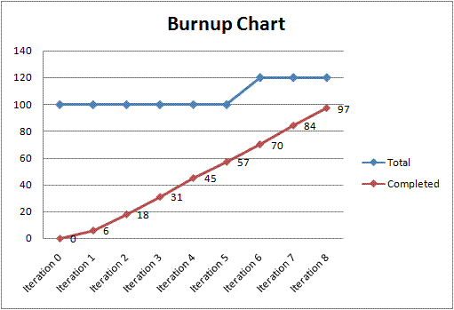Burn down chart are quite simple to understand as a single line approaches towards zero as the project is completed. But burn down chart does not show all important features of the project as with this chart one cannot show how change of scope might affect the progress. Scope is when some work is added or removed from the project which

While a Burn Up chart tracks completed work along with total work completed by two different lines, this makes it easier to understand these chart as compare to burn down chart where both were represented by single line. Total work line signifies important information project is incomplete may be due to slow work done or lots of work has been added, which are crucial factor in identifying and rectifying problems with a project.

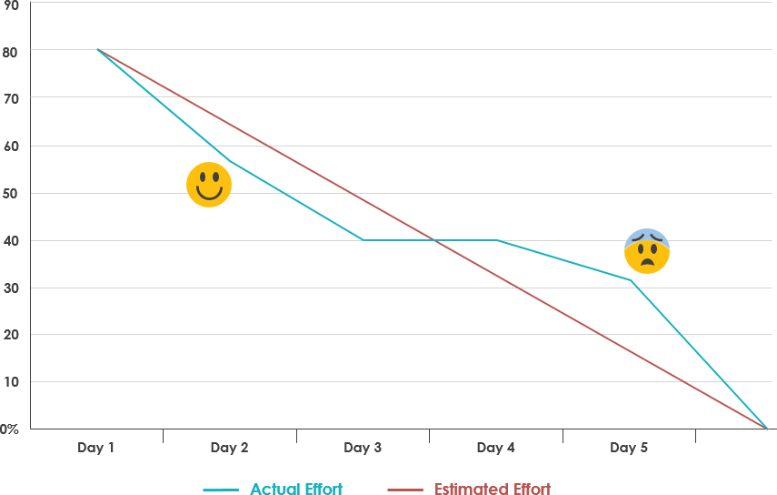Example of burn down chart

As in above diagram expected line was red for 80 story points but it did not show the expected result. As before day 3 work was ahead schedule that is a greater number of story points were completed which shows good performance, but after day 3 fall in performance can be observe which simply shows that work is behind the expected deadline. This is how using Burn down chart one can determine whether they are behind or ahead schedule.

**Question 2. (d) What is the purpose of the stand-up meeting? What three key questions are answered by team members during a daily stand-up meeting? Who typically gets assigned action items during a daily stand-up meeting?**

Answer: Development teams uses the daily-standup meeting for a quick status check & to prepare for the day.

* These meetings take less than 15minutes and provide opportunity to understand the team’s progress in the iteration.
* Each team member answers three question

1. **What did I do yesterday?**

This provides developer an opportunity to share their tasks which were completed yesterday or if something that did not went as per plan.

1. **What I am planning to do?**

This information helps team members to set focus for the day and it makes other team member aware of availability of someone for a slot depending upon their meetings. Also, depending upon other team members work teammate can align his/her task if needed.

1. **Is there anything blocking my progress?**

This can be about any type of technical issue or other work problem faced. The key behind this is to share the challenge to keep things moving in the iteration.

Output from this sets action to be taken for the scrum master.

* Daily Stand-up provides a great opportunity for team calibration and supporting each other.
* These meetings can be a great help in siting together to solve problem or offering teammate help to continue working on troublesome task.
* In Agile, team succeeds or fail together. To ensure that commitments are kept team needs to band together.
* These meetings are open to everyone, but it allows only pigs to talk not the chickens (to someone team report to) in stand ups.
* Scrum master controls the meeting and push certain discussions “offline” which means they will be discussed after the meeting.
* If daily meetings are run well it can really help a team towards meeting is goal.

**Question 2 (e) Product backlogs vary in their depth, breadth, and quality. Explain how the DEEP acronym may be employed to improve product backlog quality?**

Answer: A product backlog stores, organizes and manages all work items so that it can be easily planned. A good product backlog has characteristics like DEEP, INVEST and DIVE. A product backlog can have any number of items (user story, defects and test sets). DEEP has following essence in the structure of a product backlog:

* **Detailed Appropriately**: User stories should have enough details about all the acceptance criteria, inputs etc. There should be no ambiguity. Also, the upcoming user stories should be well understood so that they easily complete in next sprint. It is okay to give less details about story that are not going to be covered in next sprint.
* **Estimated**: Each user story should be able to easily estimate.
* **Emergent**: A product backlog is non-static. It can change depending upon requirements over the time. As work progresses user stories can be added, removed and reprioritize.
* 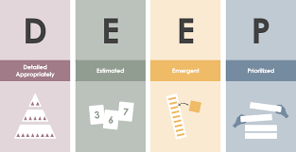**Prioritized**: Priority in a Product backlog is an important feature. The product backlog should be shorted in a way that high priority items goes on the top followed by less prioritize work. By always following priority order team is more likely to maximize the value of product or system being developed.