ASSIGNMENT 1

Client Side Technology


Chhaya Sharma

A00268860
Introduction

A climate website dependent on Ajax API call and chart.js library for information portrayal. Embodies fundamental JavaScript Ajax to make an API call to openweather.org which responds with an XML information. The XML information contains information for 5 days with a 3 hours’ time interval. The XML information is used to make line graph from the chart.js library
The website aims to provide information about climate to the user. User can enter the city name and API call will be made to openweathermaps to fetch the city data. The data will be shown in interactive cards using grid layout. The graph will also be generated using weather data.

Scope

The purpose of this task is to show climate information from a dependable source i.e. openweathermaps to get weather information like temperature, pressure, wind speed etc. The application gives the climate information to user within seconds in an interactive manner. Real time data for several cities all over the world can be retrieved with a single click and their climate charts can be noted down.

Technologies

OpenWeather API

OpenWeatherMap [1] is an online service that provides weather data, including
current weather data, forecasts, and historical data to the developers of web services and mobile applications.
We will use this API to fetch data as per user requirements. It returns data in the from of XML and JSON which can be used by other third party application to show weather information.

Chart.js

Chart.js[2] is a JavaScript library that enables you to draw various kinds of ch expressions by utilizing the HTML5 canvas component. Since it utilizes canvas , you need to incorporate a polyfill to help more seasoned programs.

Javascript
JavaScript is most commonly used as a client side scripting language. This means that JavaScript code is written into an HTML page.

AJAX

AJAX stands for Asynchronous JavaScript and XML.AJAX is a new technique for creating better, faster, and more interactive web applications with the help of XML, HTML, CSS, and Java Script.
Ajax uses XHTML for content, CSS for presentation, along with Document Object Model and JavaScript for dynamic content display.
Response XML
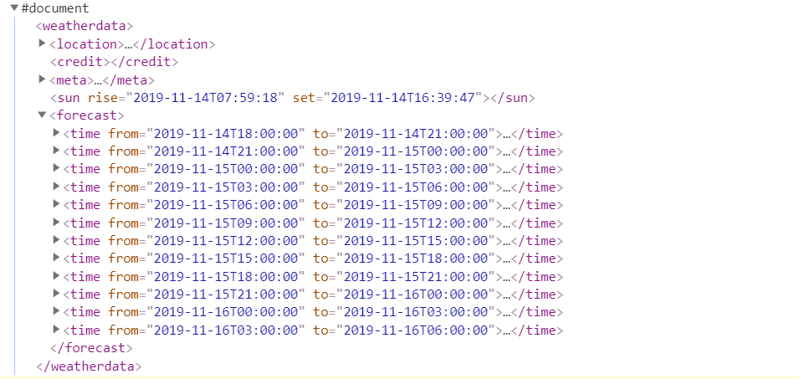

Date Format is Odd. We need to format date

Temperature

40 such time

elements

Code

API Call

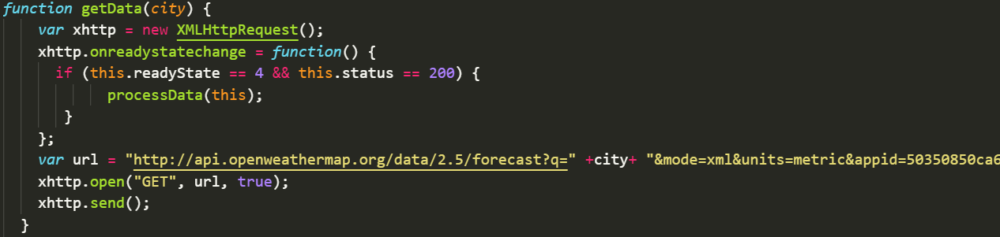

Fetching Node Values
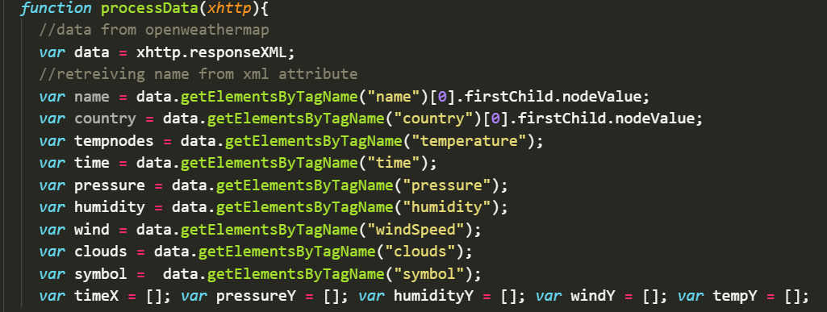
Features

- Reliable and accurate weather data of every 3 hours.
- Data for any city entered by user
- Different weather card for different weather condition
- Implemented Grid layout in css
- Line graph to show variation in temperature, pressure, humidity and windspeed.
- Weather icon based on cloud condition.
- Formatted XML data.
- Gif images to show climate condition

Limitations

Maximum 60 calls per minute to OenWeather API due to free subscription limitation. Data accuracy is limited to every 3 hours.

Future Scope

Integration of google world to display Weather Details on a globe. Formatting data to show data for next 7 days.

Maintaining history of searched cities to give automatic recommendations. Displaying data for multiple cities.
Searching unique cities.
Screenshots

Header

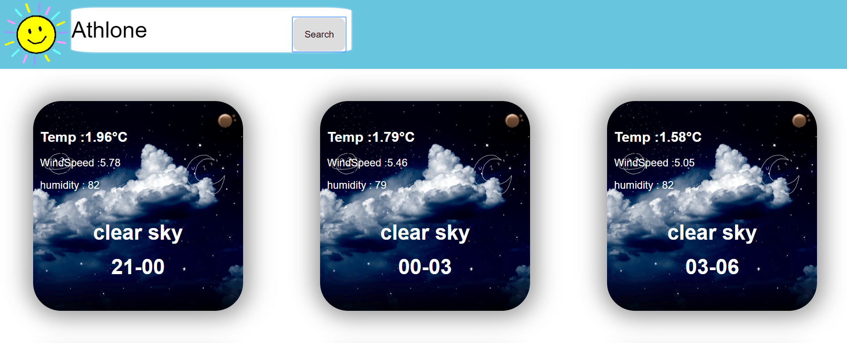

Charts

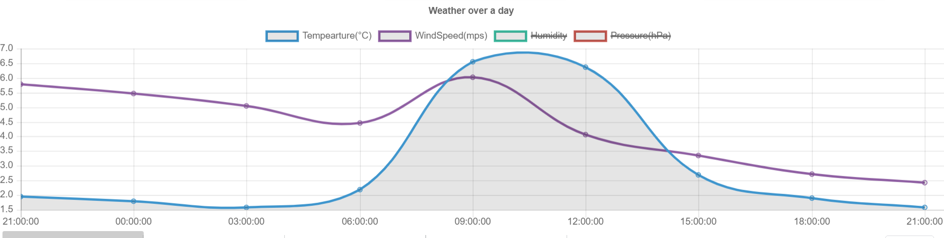

Conclusion

The weather application proves reliable in terms of data and accurate climate values. The data visualization shows required and useful information. The website is ready to deploy and run on desktop as well as mobile devices. Various improvements can be done but the current website itself seems well formatted and ready for implementing on a live server.

References

1. OpenWeather : https://openweathermap.org/api

2. Chart.js: http://www.chartjs.org/

3. jQuery: https://jquery.com/

