**Database Final Assignment**

**Question 1: Briefly describe your proposed concept. What is the aim of your proposed system?**

**Answer:** “RFID Student Attendance System” helps in managing attendance in any college/ school more conveniently and effectively. RFID stands for Radio Frequency Identification which is integrated with database. This system stores data in form of **Tags** which is a unique number associated with cards.

Main aim of the System is to ease the process of management of attendance at any school. As in manual recording of attendance there are chances of mistake. Also, it is very time consuming for both teacher and student however this process can be automated provided every student has unique card with unique RFID code.

RFID system mainly depends upon technology where data encoded in tags or smart labels is captured by a device which are captured by a **reader via radio waves** which is like barcoding. *One remarkable feature of RFID tag data is that it can read outside the line-of-sight while for bar codes system, it must be aligned with an optical scanner.*

**How does RFID work?**

RFID technique is based on Automatic Identification and Data Capture (AIDC). AIDC automatically identifies objects, collect data about it, and it will directly add that data into database (computer system) with no or some human intervention. RFID uses radio waves to achieve this. Basically, RFID contains basic three components as: RFID Tags, RFID reader and an antenna. RFID circuit contains an integrated circuit and an antenna which are used to transmit the data to RFID reader (Interrogator). Then reader converts data into radio waves to a more usable form of data. Information collected from the tags is transferred to computer system through a communication interface, where data can be stored in form of tags and analysed.

**RFID Tags:**

* RFID tags consist of a protective material which holds pieces and shields them from any environmental condition.
* RFID tags comes in variety of shapes and sizes and are either passive or active.
* Passive RFID tags are less expansive to implement and of small size. These tags must be powered up by the card reader before they can transfer the data.
* While, Active tags can onboard transfer the data, which enables them to transfer the data all the times.
* **Smart labels** incorporate both RFID tags and barcode technologies. They are made of an adhesive label along with an RFID tag pattern with a barcode.
* Smart labels can be encoded and printed on-demand using desktop labels-printers.

Hardwar require for RFID Based student Management System are mainly Nodemcu, LCD Module, I2C Module, Zero PCB and RFID Reader Module.

In this system, following are privileges provided to admin:

1. Admin can add new student.
2. Admin can see list of details of all the student.
3. Admin can delet-e a student record.
4. Admin can edit and update any student’s record.

But student will only be able to see their attendance after they log in to system.

**Question2 Draw an ERD for your concept. Normalize the data stating any assumptions.**

Answer: This system can be well described using following describe

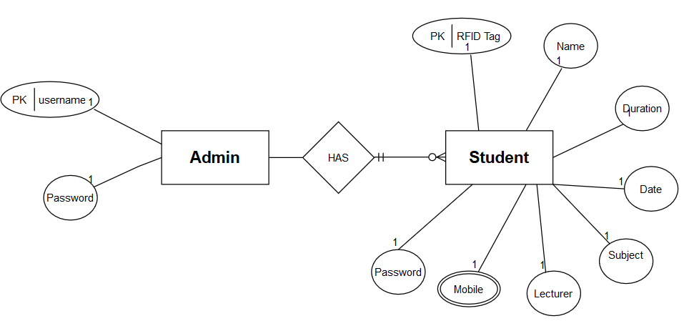

Few major components of ER diagram shown above are:

1. Entity: Two Strong entities as Admin, Student
2. Relationship: Both entities have a strong relation where admin shows one-to-many relationship with student.
3. Attributes: Student has 7 attributes out of which Mobile is multivalued
4. Primary Key: Admin has username as its primary key while Student has RFID Tag as its primary key.

**Normalization** is technique of organizing data into multiple related tables to reduce data redundancy (repetition) and insertion, updating and deletion anomalies.

* Eliminating redundancy is important as it increase the database size also it will make it difficult to insert, update and delete data into database.
* Normalization involves multi-step process which put data into tabular form, removing duplicate data from tables.
* It involves basic two steps:

1. Eliminating redundant (useless) data &
2. Eliminating data dependencies

Four Normalization forms are possible as 1NF, 2NF, 3NF and BCNF.

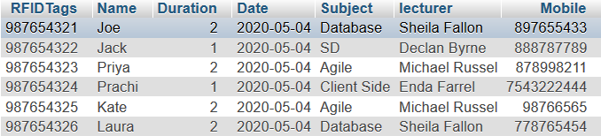

From above table we can see that data contains redundancy (repetition) because for any subject, teacher name is same for every student due to which every time a new student marks himself data is getting repeated which will create problems while deleting or modifying and record further. To avoid this, we will break these tables into two tables as student and subject

|  |  |  |  |
| --- | --- | --- | --- |
| RFID Tags | Name | Mobile | Subject |
| 987654321 | Joe | 898877866 | Database |
| 987654322 | Jack | 876893789 | SD |
| 987654323 | Priya | 767980088 | Agile |
| 987654324 | Prachi | 56567788 | Client Side |
| 987654325 | Kate | 7687899089 | Agile |
| 987654326 | Laura | 8789789989 | Database |

**Student Table:**

**Subject Table:**

|  |  |  |  |
| --- | --- | --- | --- |
| Subject | Lectures | Date | Duration |
| Database | Sheila Fallon | 2020-05-04 | **2** |
| Agile | Michael Russel | 2020-05-04 | **2** |
| SD | Declan Byrne | 2020-05-04 | **1** |
| Client Side | Enda Farrell | 2020-05-04 | **1** |

Although Normalization does not eliminate data redundancy completely, but it reduces repetition to extent also makes it easier to further insert, update and delete data into tables.

**Question 3: Database Script has been submitted separately.**

**Question 4: Write 10 SQL queries to extract information from your database tables. Show both the SQL statement and the output, e.g. using the snipping tool.**

**Code & Output Snippets**

