**UML (Unified Modeling Language)**

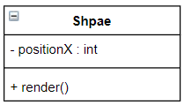

**Public class Shape{**

**private int position;**

**public void render();**

**}**

**______________________________________Inhertiance_____________________________________**

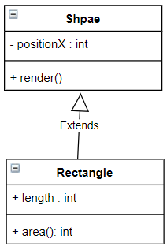

**Public class Rectangle extends Shape{**

**}**

**___________________________________Aggregation_______________________________**

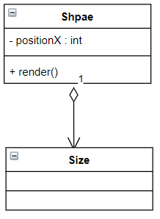

Public class Shape {

Private Size size;

}

Car class is composed of Wheel Class

________________________________________Dependency___________________________________

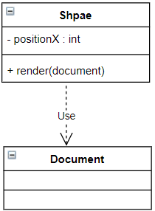

Public class Shape{

Public void render (Document doc)

//Some dependency

}