**How to start doing these exercises?**

1. You should create the file following the exercise name. ✓ *example: index_practice1.html*

2. Open with **VS Code editor**

3. Write HTML code to display the result as an existing exercise

**Practice 1**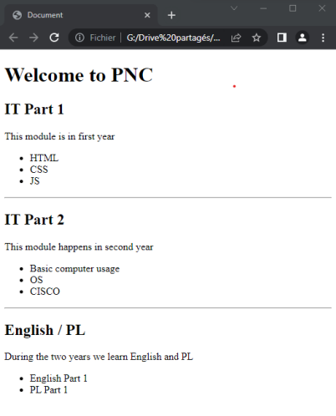

**Practice 2**

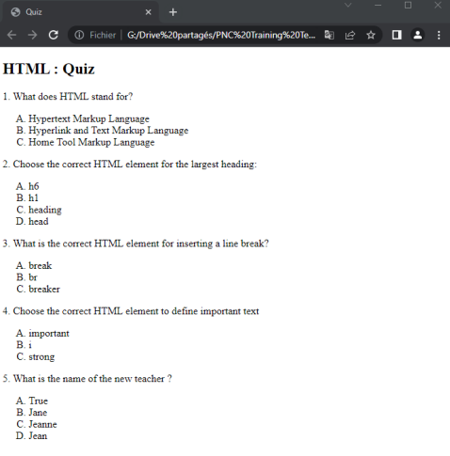

**Practice 3**

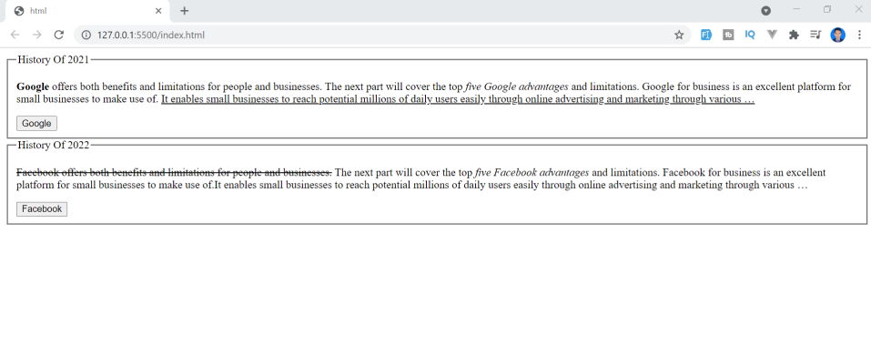

Help?

<legend><fieldset>

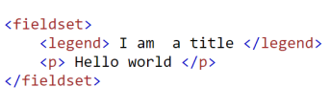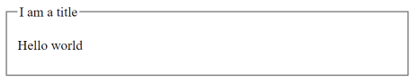<p>

**Practice 3**

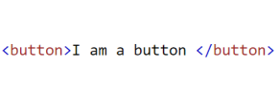

**Practice 4**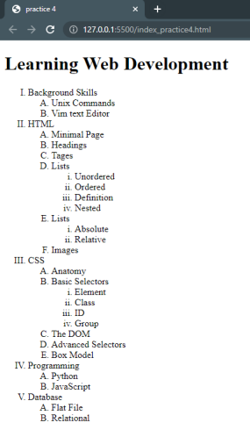

**Practice 5**

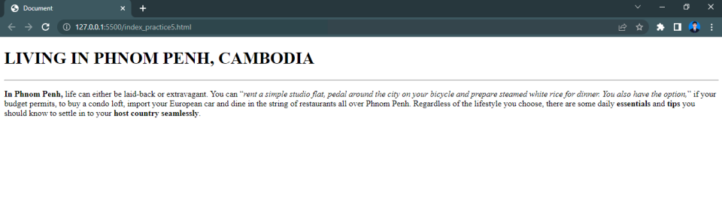

****Click Here Button Images – Browse 24,665 Stock Photos, Vectors, and Video | Adobe Stock

**Practice 5**

html

head body

title h1 hr p b x 3 q

i