Name: Chheng Sophin

ID: e20180110

Group: I4 GIC A

TP3

EX1: Book shop CRUD with Local storage​

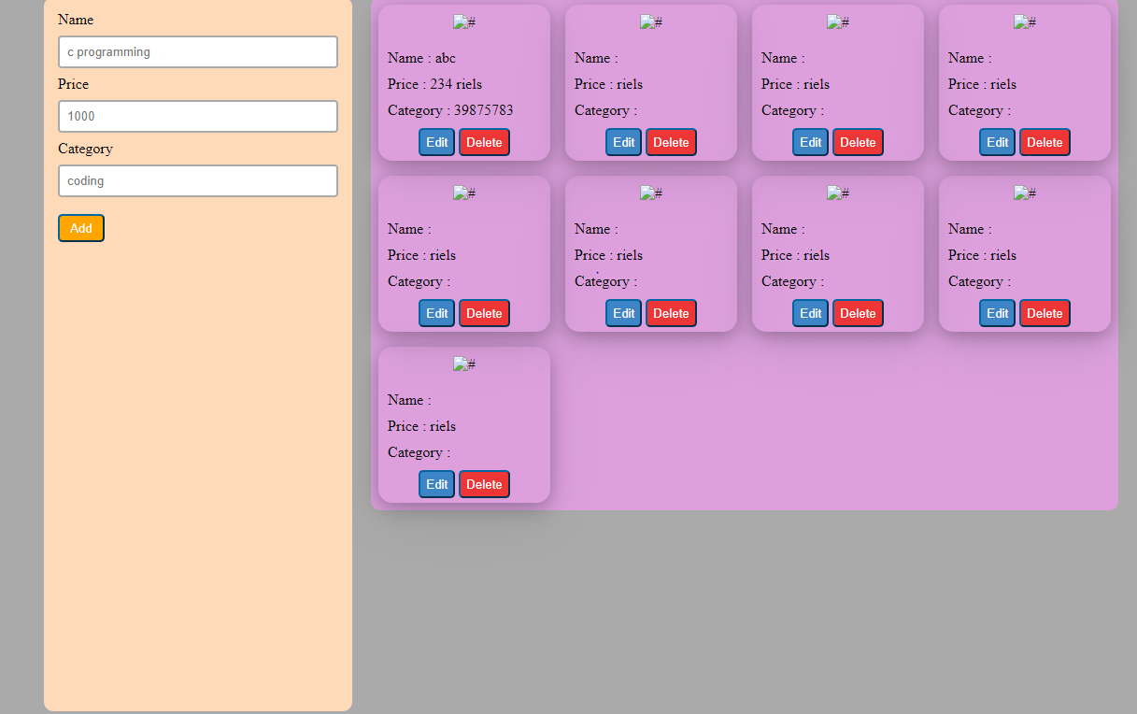

EX2: Login Form with Cookie​

