Simple document

Chhiring Lama

2024-09-10

Table of Contents

### this on the top is the YAML header

I’m an R Markdown document!

# Section 1

Here’s a **code chunk** that samples from a *normal distribution*:

samp = rnorm(100)  
length(samp)

Here eval = false keeps the code but does not run it

## [1] 100

Here echo = false runs it but doesn’t give the code that produced it

# Section 2

I can take the mean of the sample, too! The mean is -0.1082935. ###this is inline R code

## Learning Assessment:

Write a named code chunk that creates a dataframe comprised of: a numeric variable containing a random sample of size 500 from a normal variable with mean 1; a logical vector indicating whether each sampled value is greater than zero; and a numeric vector containing the absolute value of each element. Then, produce a histogram of the absolute value variable just created. Add an inline summary giving the median value rounded to two decimal places. What happens if you set eval = FALSE to the code chunk? What about echo = FALSE?

### Solution:

set.seed(1)  
  
## create a dataframe  
example_df <- tibble(  
 sample = rnorm(500, mean = 1),  
 log_val = sample > 0,   
 abs_val = abs(sample)  
 )

Here is the preview of first few rows of the dataframe:

knitr::kable(head(example_df), format = "markdown")

| sample | log_val | abs_val |
| --- | --- | --- |
| 0.3735462 | TRUE | 0.3735462 |
| 1.1836433 | TRUE | 1.1836433 |
| 0.1643714 | TRUE | 0.1643714 |
| 2.5952808 | TRUE | 2.5952808 |
| 1.3295078 | TRUE | 1.3295078 |
| 0.1795316 | TRUE | 0.1795316 |

Plot showing the histogram of the absolute value:

##produce histogram for absolute value  
ggplot(example_df, aes(x = abs_val)) +  
 geom_histogram()

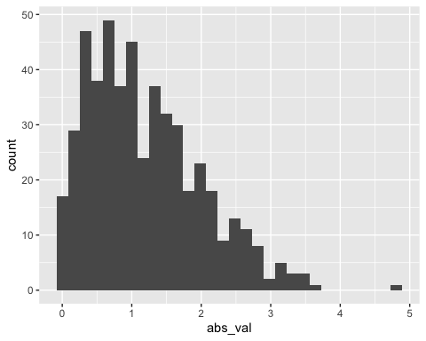

The median value of the absolute value variable is 1.00.

# Formatting Text

## Text formatting

*italic* or *italic* **bold** or **bold** code superscript2 and subscript2

## Headings

# 1st Level Header

## 2nd Level Header

### 3rd Level Header

## Lists

* Bulleted list item 1
* Item 2
  + Item 2a
  + Item 2b

1. Numbered list item 1
2. Item 2. The numbers are incremented automatically in the output.

## Tables

| First Header | Second Header |
| --- | --- |
| Content Cell | Content Cell |
| Content Cell | Content Cell |

## Learning assessment:

After the previous code chunk, write a bullet list given the mean, median, and standard deviation of the original random sample.

## Solution:

* The mean of the random sample is **1.0226441**.
* The median of the random sample is **0.9632217**.
* The standard deviation of the random sample is **1.0119283**.