github : <https://github.com/ChhornKakada/IntenetProgramming/tree/tp6>

# ex1. Pagination (infinite scroll)

* [Index.html](https://github.com/ChhornKakada/IntenetProgramming/blob/tp6/ex1.%20Pagination%20(Infinite%20scroll)/index.html) (ex1. Pagination (infinite scroll))

<!DOCTYPE *html*>

<html *lang*="en">

<head>

  <meta *charset*="UTF-8">

  <meta *http-equiv*="X-UA-Compatible" *content*="IE=edge">

  <meta *name*="viewport" *content*="width=device-width, initial-scale=1.0">

  <title>Pagination</title>

  <script *src*="./assets/tailwindcss.js"></script>

  <link *rel*="stylesheet" *href*="./assets/styles.css">

</head>

<body>

  <div *class*="w-[500px] h-[80vh] p-6 absolute top-[50%] left-[50%] border-2

  translate-x-[-50%] translate-y-[-50%] rounded-lg">

    <div *class*="h-full rounded-lg overflow-y-scroll" *id*="scroller">

    </div>

  </div>

  <script *src*="./assets/app.js"></script>

</body>

</html>

* [assets/app.js](https://github.com/ChhornKakada/IntenetProgramming/blob/tp6/ex1.%20Pagination%20(Infinite%20scroll)/assets/app.js) (ex1. Pagination (infinite scroll))

let scrollerEle = document.getElementById("scroller");

let pageNum = 0;

let isDataLoading = false;

var toShow = "";

function fetchAPI(pageNumber) {

  isDataLoading = true;

  fetch(`https://api.instantwebtools.net/v1/passenger?page=${pageNumber}&size=15`)

    .then(async (res) => {

      let dataInfors = *await* res.json();

      toShow += `

          <div class="font-bold text-[1.5rem] px-2">${pageNumber + 1}</div>

      `;

      dataInfors.data.forEach(element => {

        toShow += `

          <div class="w-full border-2 rounded-lg px-5 py-2 mb-2 bg-[#F4F4F4]">

            <div class="font-bold">✈️ : ${element.airline[0].name} - ${element.airline[0].country}</div>

            <div>😊 : ${element.name}</div>

          </div>

        `

      });

      scrollerEle.innerHTML = toShow;

      pageNum++;

      isDataLoading = false;

    })

    .then(() => {

      scrollerEle.addEventListener("scroll", () => {

        const { scrollTop, clientHeight, scrollHeight } = scrollerEle;

*if* ((clientHeight + scrollTop) >= (scrollHeight * 0.95)) {

*if* (!isDataLoading) {

            fetchAPI(pageNum);

          }

        }

      });

    })

    .catch((err) => {

      alert(err);

    });

}

fetchAPI(pageNum);

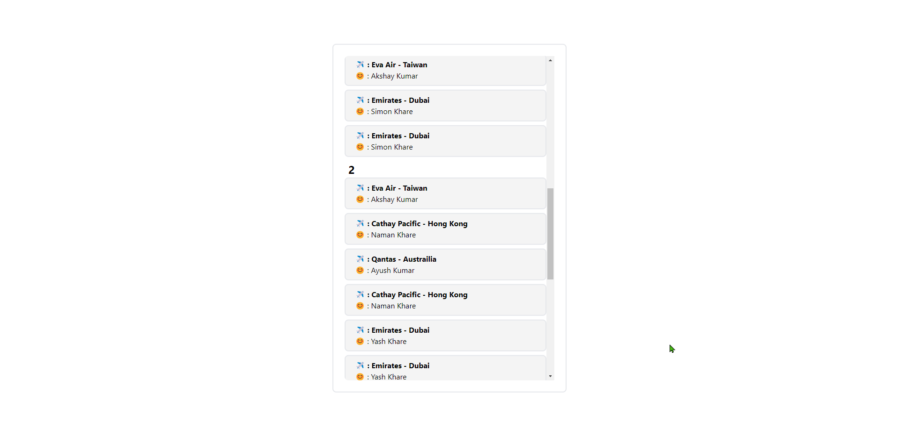

# ex2. Local data sync

* [index.html](https://github.com/ChhornKakada/IntenetProgramming/blob/tp6/ex2.%20Local%20data%20sync/index.html) (ex2. Local data sync)

<!DOCTYPE *html*>

<html *lang*="en">

<head>

  <meta *charset*="UTF-8">

  <meta *http-equiv*="X-UA-Compatible" *content*="IE=edge">

  <meta *name*="viewport" *content*="width=device-width, initial-scale=1.0">

  <title>Local data sync</title>

  <script *src*="./assets/tailwindcss.js"></script>

  <link *rel*="stylesheet" *href*="./assets/styles.css">

</head>

<body>

  <div *class*="w-[500px] h-[80vh] p-6 absolute top-[50%] left-[50%] border-2

  translate-x-[-50%] translate-y-[-50%] rounded-lg">

    <div *class*="h-full rounded-lg overflow-y-scroll" *id*="scroller">

    </div>

  </div>

  <script *src*="./assets/app.js"></script>

</body>

</html>

* [assets/app.js](https://github.com/ChhornKakada/IntenetProgramming/blob/tp6/ex2.%20Local%20data%20sync/assets/app.js) (ex2. Local data sync)

let scrollerEle = document.getElementById("scroller");

let pageNum = 0;

let isDataLoading = false;

var passengers = localStorage.getItem("passengers") != null ? JSON.parse(localStorage.getItem("passengers")) : [];

*// input as array*

function displayAPage(dataAPage) {

  dataAPage.forEach(element => {

    scrollerEle.innerHTML += `

      <div class="w-full border-2 rounded-lg px-5 py-2 mb-2 bg-[#F4F4F4]">

        <div class="font-bold">✈️ : ${element.airline[0].name} - ${element.airline[0].country}</div>

        <div>😊 : ${element.name}</div>

      </div>

    `

  });

}

function fetchDataFromLocal(pageNumber) {

  displayAPage(passengers[pageNumber]);

}

function fetchData(pageNumber) {

  scrollerEle.innerHTML += ` <div class="font-bold text-[1.5rem] px-2">${pageNumber + 1}</div>`;

  pageNum >= passengers.length ? fetchAPI(pageNum) : fetchDataFromLocal(pageNumber);

  pageNum++;

}

function fetchAPI(pageNumber) {

  isDataLoading = true;

  fetch(`https://api.instantwebtools.net/v1/passenger?page=${pageNumber}&size=15`)

    .then(async (res) => {

      let dataInfors = *await* res.json();

      passengers.push(dataInfors.data);

      saveToLocalstorage(passengers);

      displayAPage(dataInfors.data);

      isDataLoading = false;

    })

    .catch((err) => {

      alert(err);

    });

}

const saveToLocalstorage = (data) => {

  localStorage.setItem("passengers", JSON.stringify(data));

}

fetchData(pageNum);

scrollerEle.addEventListener("scroll", () => {

  const { scrollTop, clientHeight, scrollHeight } = scrollerEle;

*if* ((clientHeight + scrollTop) >= (scrollHeight * 0.95)) {

*if* (!isDataLoading) {

      fetchData(pageNum);

    }

  }

});

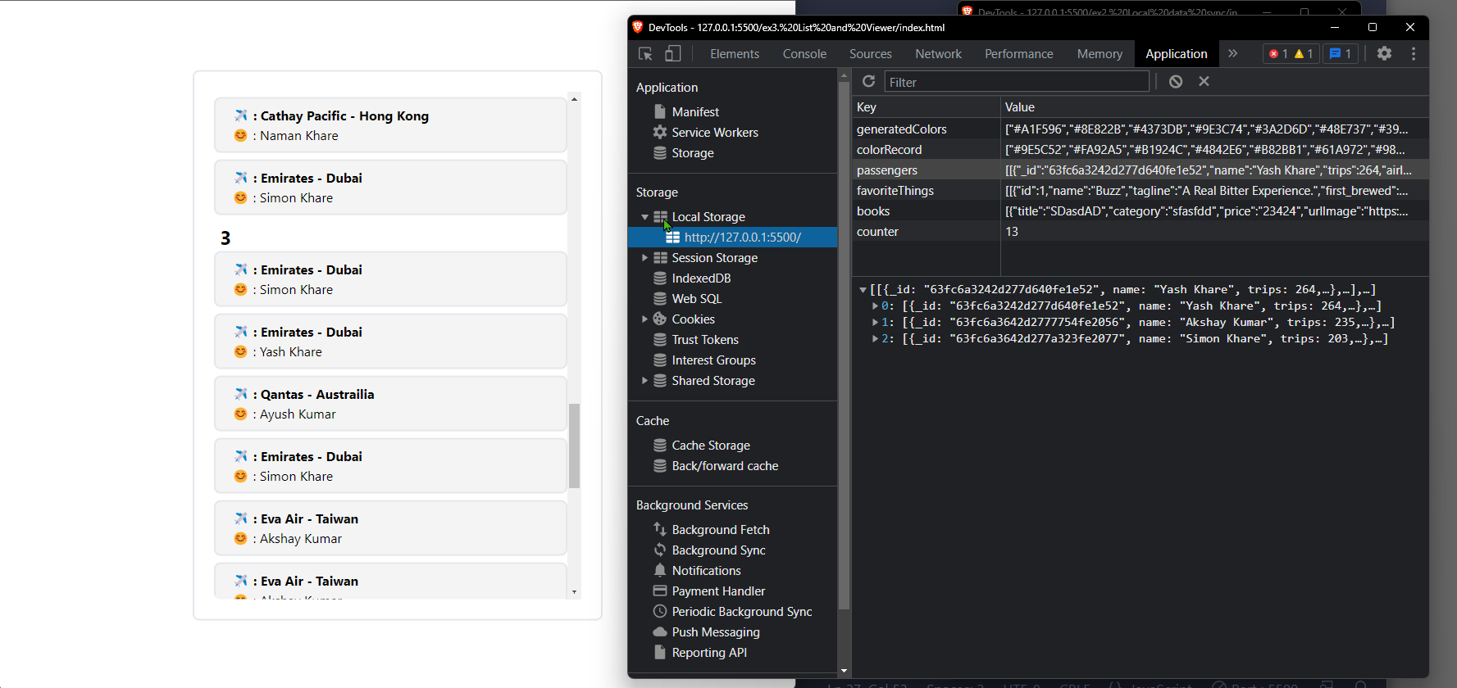

# ex3. List and Viewer

* [index.html](https://github.com/ChhornKakada/IntenetProgramming/blob/tp6/ex3.%20List%20and%20Viewer/index.html) (ex3. List and Viewer)

<!DOCTYPE *html*>

<html *lang*="en">

<head>

  <meta *charset*="UTF-8">

  <meta *http-equiv*="X-UA-Compatible" *content*="IE=edge">

  <meta *name*="viewport" *content*="width=device-width, initial-scale=1.0">

  <title>List and Viewer</title>

  <script *src*="./assets/tailwindcss.js"></script>

  <link *rel*="stylesheet" *href*="./assets/styles.css">

</head>

<body>

  <div *class*=" absolute left-[50%] translate-x-[-50%] py-10">

    <h1 *class*="juleeFont text-[4rem] text-center font-bold mb-6">Find your favorite 🥂?</h1>

    <div *class*="flex gap-2 mx-auto">

*<!-- data list -->*

      <div *class*="w-[400px] h-[700px] p-2 border-2 rounded-lg">

        <div *class*="h-full rounded-lg overflow-y-scroll" *id*="scroller">

        </div>

      </div>

*<!-- view data -->*

      <div *class*="w-[400px] h-[700px] border-2 rounded-lg overflow-y-auto p-6"

*id*="view">

          <center>

            <p *class*="text-[2rem] font-bold">Click on thing you want to view a detail</p>

          </center>

      </div>

    </div>

  </div>

  <script *src*="./assets/app.js"></script>

</body>

</html>

* [assets/app.js](https://github.com/ChhornKakada/IntenetProgramming/blob/tp6/ex3.%20List%20and%20Viewer/assets/app.js) (ex3. List and Viewer)

let scrollerEle = document.getElementById("scroller");

let view = document.getElementById("view");

let pageNum = 1;

let isDataLoading = false;

var favoriteThings = localStorage.getItem("favoriteThings") != null ? JSON.parse(localStorage.getItem("favoriteThings")) : [];

*// input as array*

function displayAPage(dataAPage) {

  dataAPage.forEach(element => {

    scrollerEle.innerHTML += `

    <button class="w-[97%] flex gap-2 items-center border-2 p-2 rounded-lg bg-[#F4F4F4] mr-2 mb-2 something"

      onclick="viewDetail(${element.id})">

      <p class="text-[2rem]">🍻</p>

      <div class="shorten text-left">

        <h3 class="font-bold">${element.name}</h3>

        <p class="shorten">${element.description}</p>

      </div>

    </button>

    `

  });

}

function viewDetail(id) {

*for* (let pNum of favoriteThings) {

*for* (let ele of pNum) {

*if* (ele.id == id) {

        view.innerHTML = `

          <center>

            <img src="${ele.image_url}" class="my-6" alt="">

            <h3 class="font-bold">${ele.name}</h3>

            <p class="mb-4">${ele.first_brewed}</p>

            <p class="font-[500] mb-4">${ele.description}</p>

            <hr>

            <p class="font-medium mt-4">Contributor</p>

            <p class="mb-4 font-medium text-[1.2rem]">Sam Mason</p>

          </center>

        `

*break*;

      }

    }

  }

}

function fetchDataFromLocal(pageNumber) {

  displayAPage(favoriteThings[pageNumber]);

}

function fetchData(pageNumber) {

  scrollerEle.innerHTML += ` <div class="font-bold text-[1.5rem] px-2">${pageNumber}</div>`;

  pageNum > favoriteThings.length ? fetchAPI(pageNumber) : fetchDataFromLocal(pageNumber-1);

  pageNum++;

}

function fetchAPI(pageNumber) {

  isDataLoading = true;

  fetch(`https://api.punkapi.com/v2/beers?page=${pageNumber}&per_page=15`)

    .then(async (res) => {

      let datas = *await* res.json();

      favoriteThings.push(datas);

      saveToLocalstorage(favoriteThings);

      displayAPage(datas);

      isDataLoading = false;

    })

    .catch((err) => {

      alert(err);

    });

}

const saveToLocalstorage = (data) => {

  localStorage.setItem("favoriteThings", JSON.stringify(data));

}

fetchData(pageNum);

scrollerEle.addEventListener("scroll", () => {

  const { scrollTop, clientHeight, scrollHeight } = scrollerEle;

*if* ((clientHeight + scrollTop) >= (scrollHeight * 0.95)) {

*if* (!isDataLoading) {

      fetchData(pageNum);

    }

  }

});

