Github Account:

<https://github.com/ChhornKakada/Intenet_Programming/tree/tp12>

**Noted**: in this tp12, I only done with API. Sorry teacher, I will implement it later.

# CRUD for price

## Create

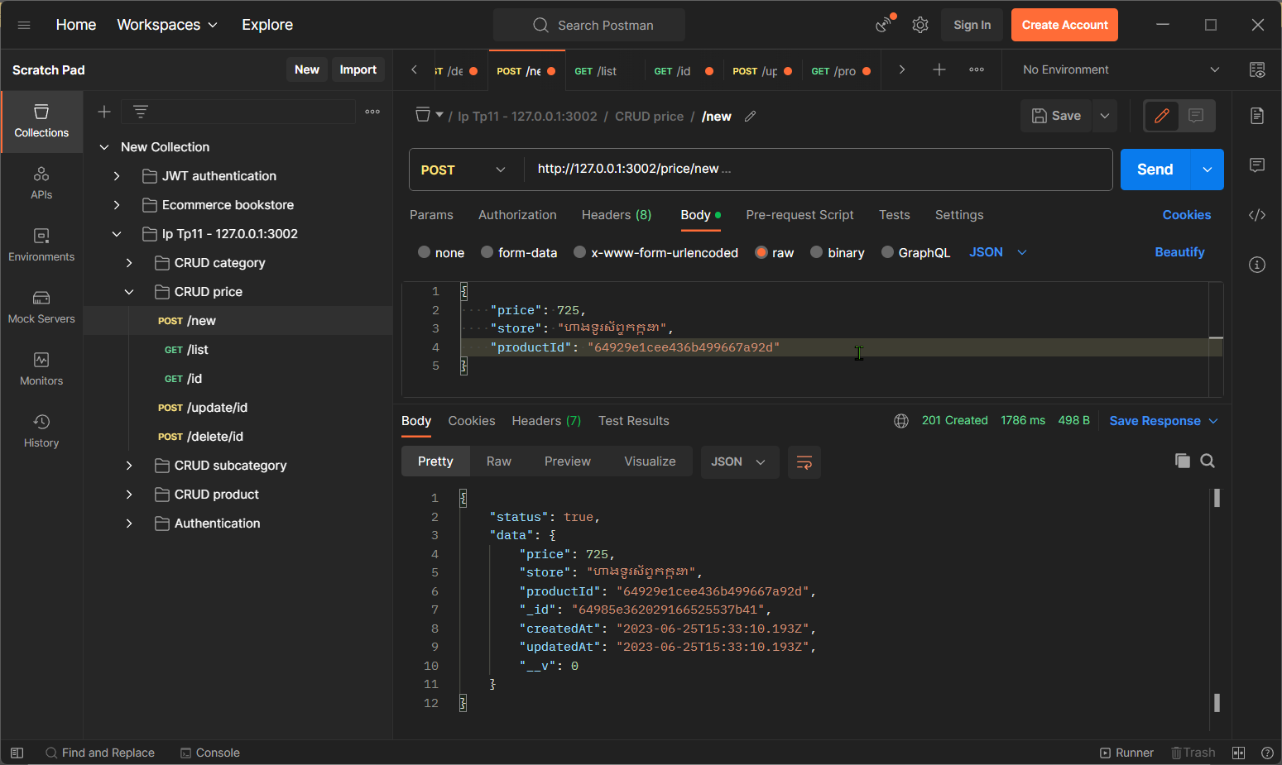Add new price for a product.

## List

List all the prices that has recorded in the DB.

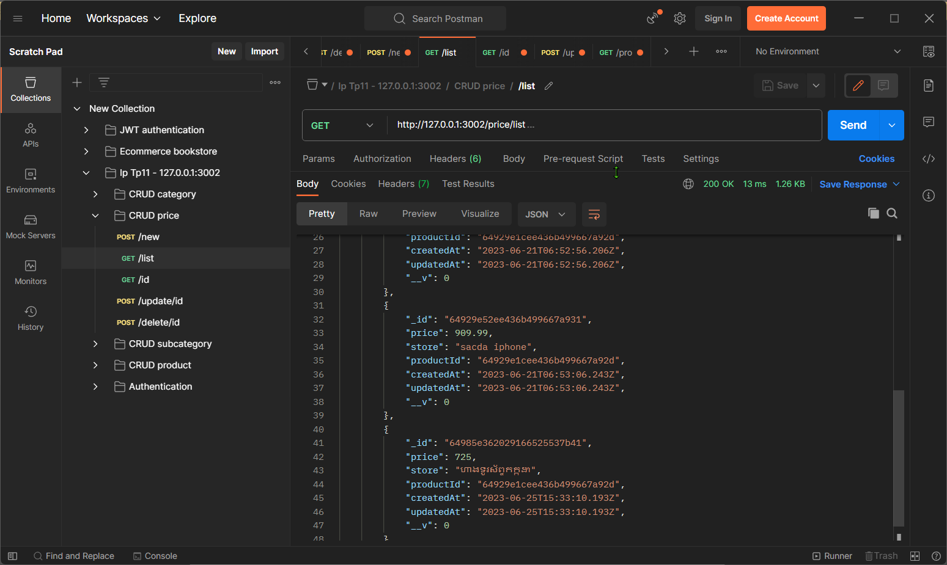

## Get by Id

Get the price by its ID.

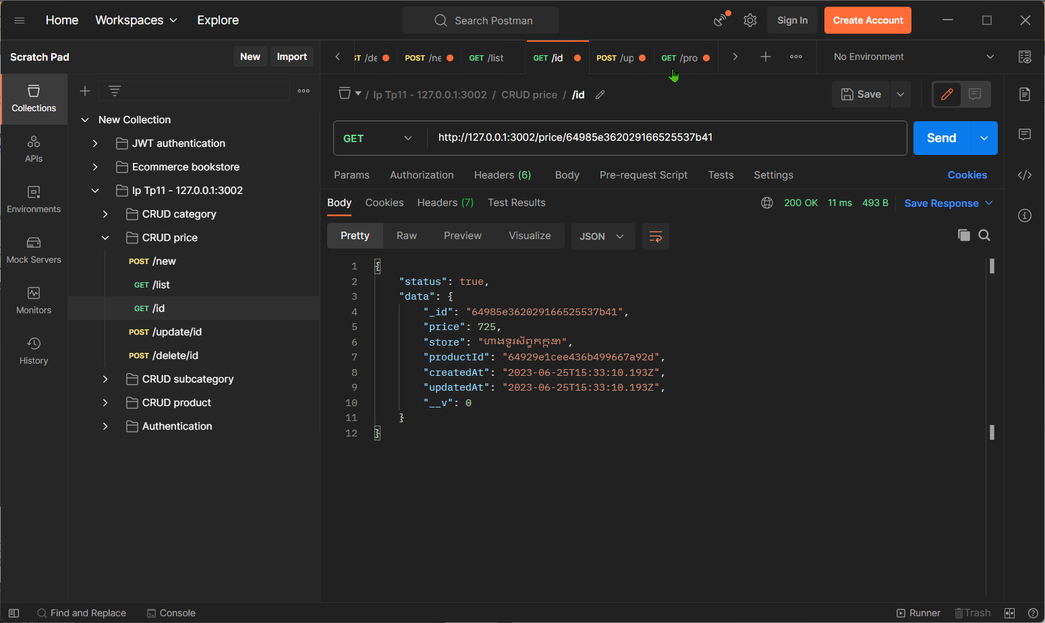

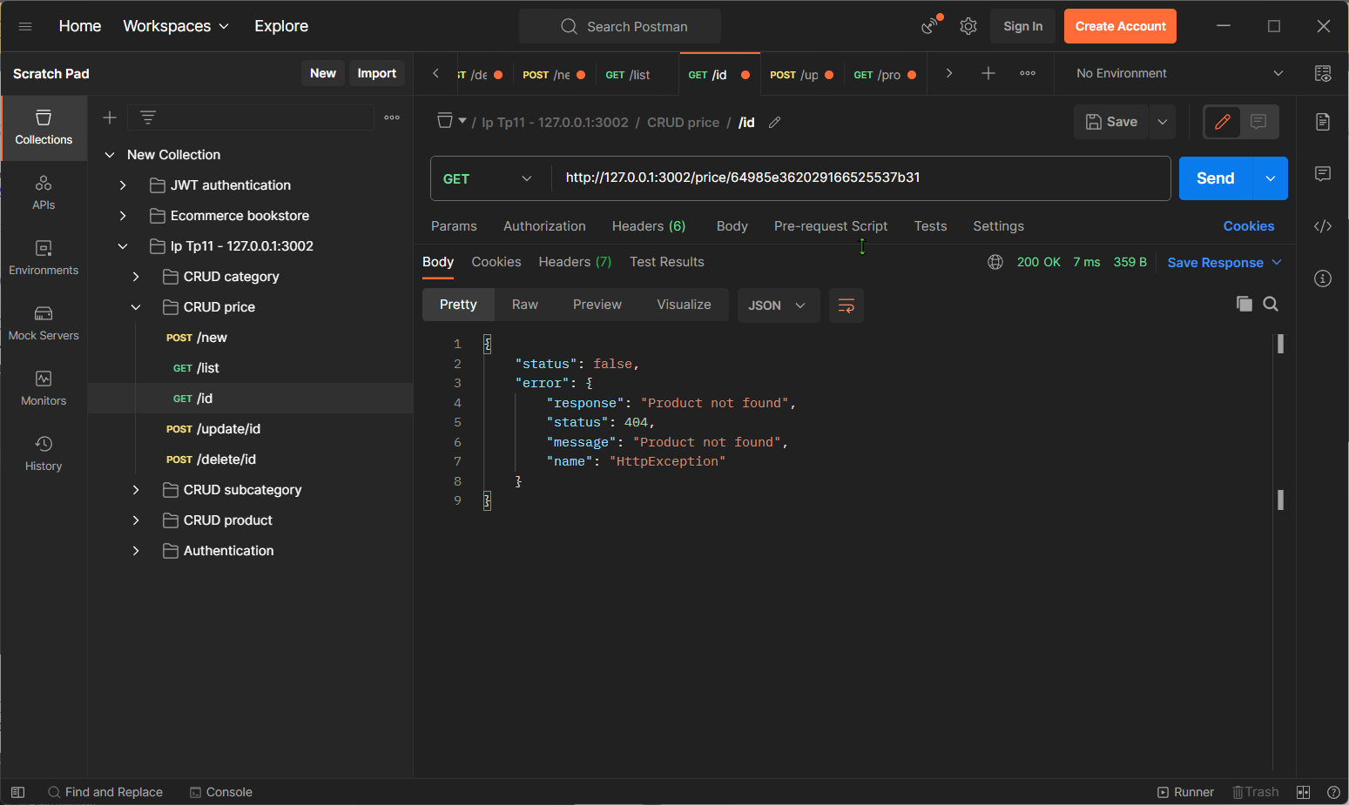

## Edit or Update

Edit a price by its ID. You can update any field you want.

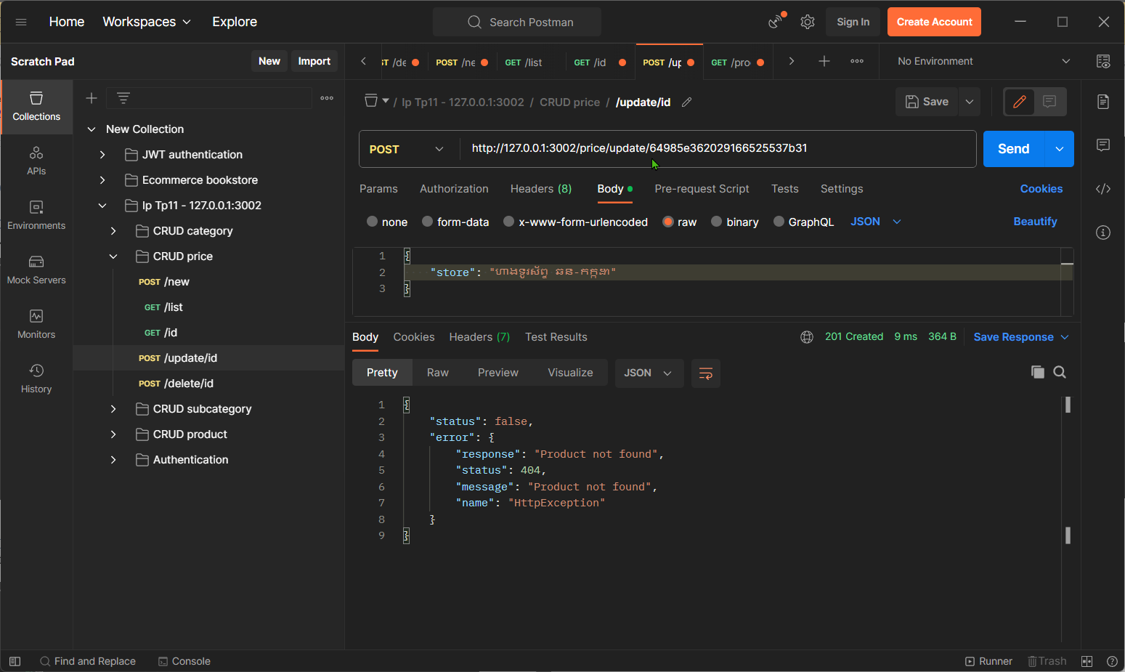

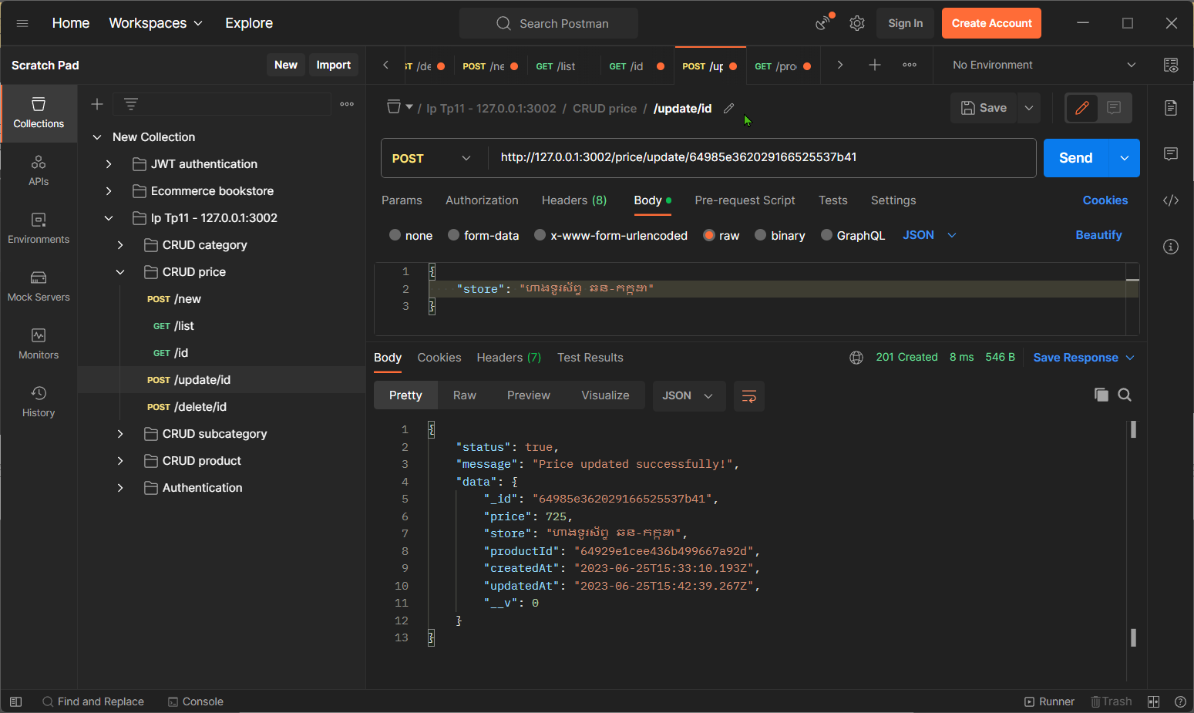

## Delete

Delete the price by its ID. If the ID you put cannot find the DB, it will send the not found data for you.

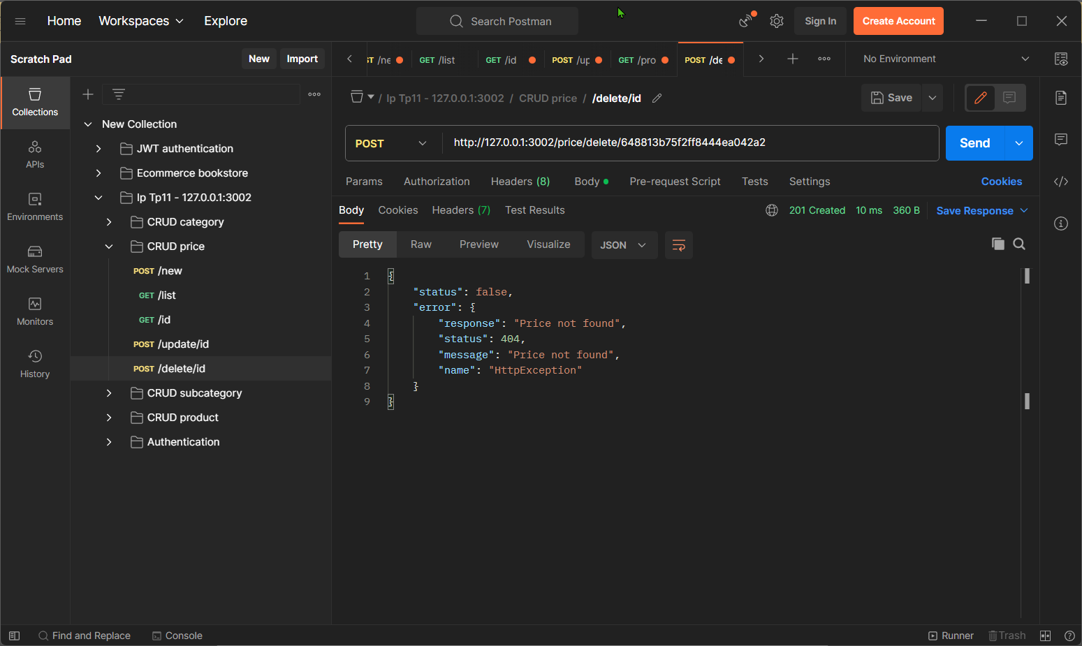

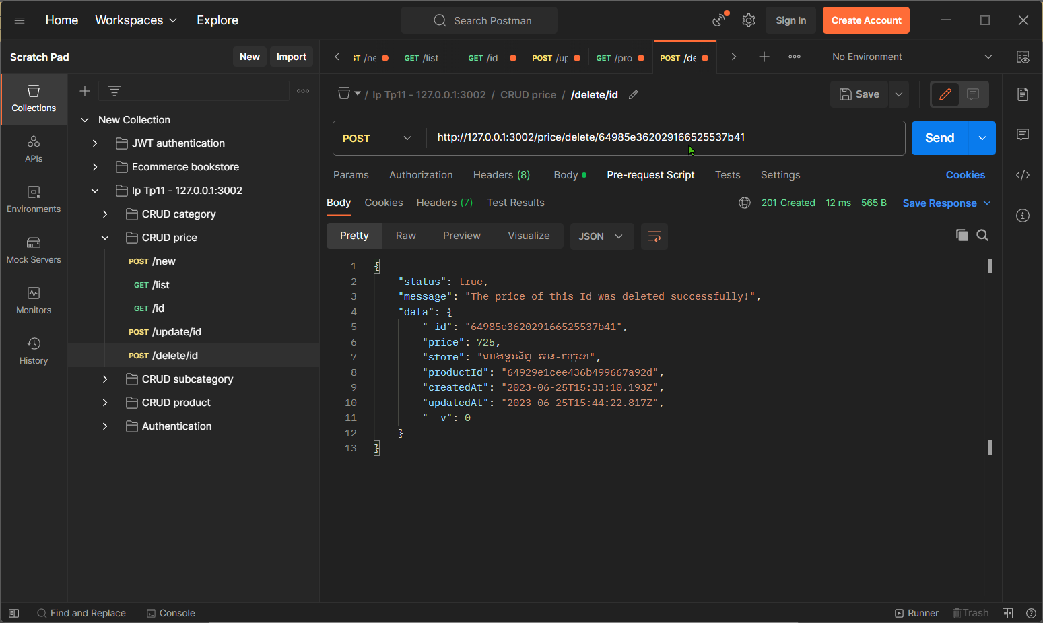

## Get all price of a product

You can find all the prices of a product by input the productId.

