Github Account:

<https://github.com/ChhornKakada/IntenetProgramming/tree/tp9>

## Register

## Validation register

When registration user, the username must be difference from the existing username.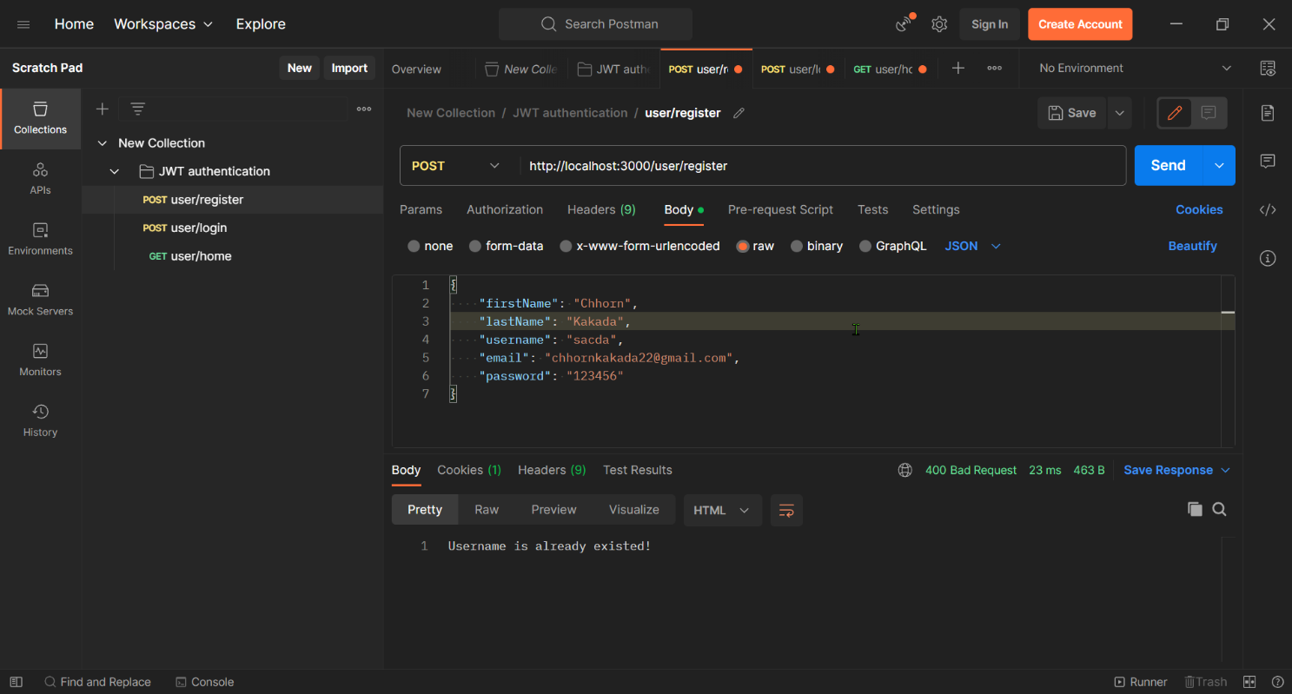

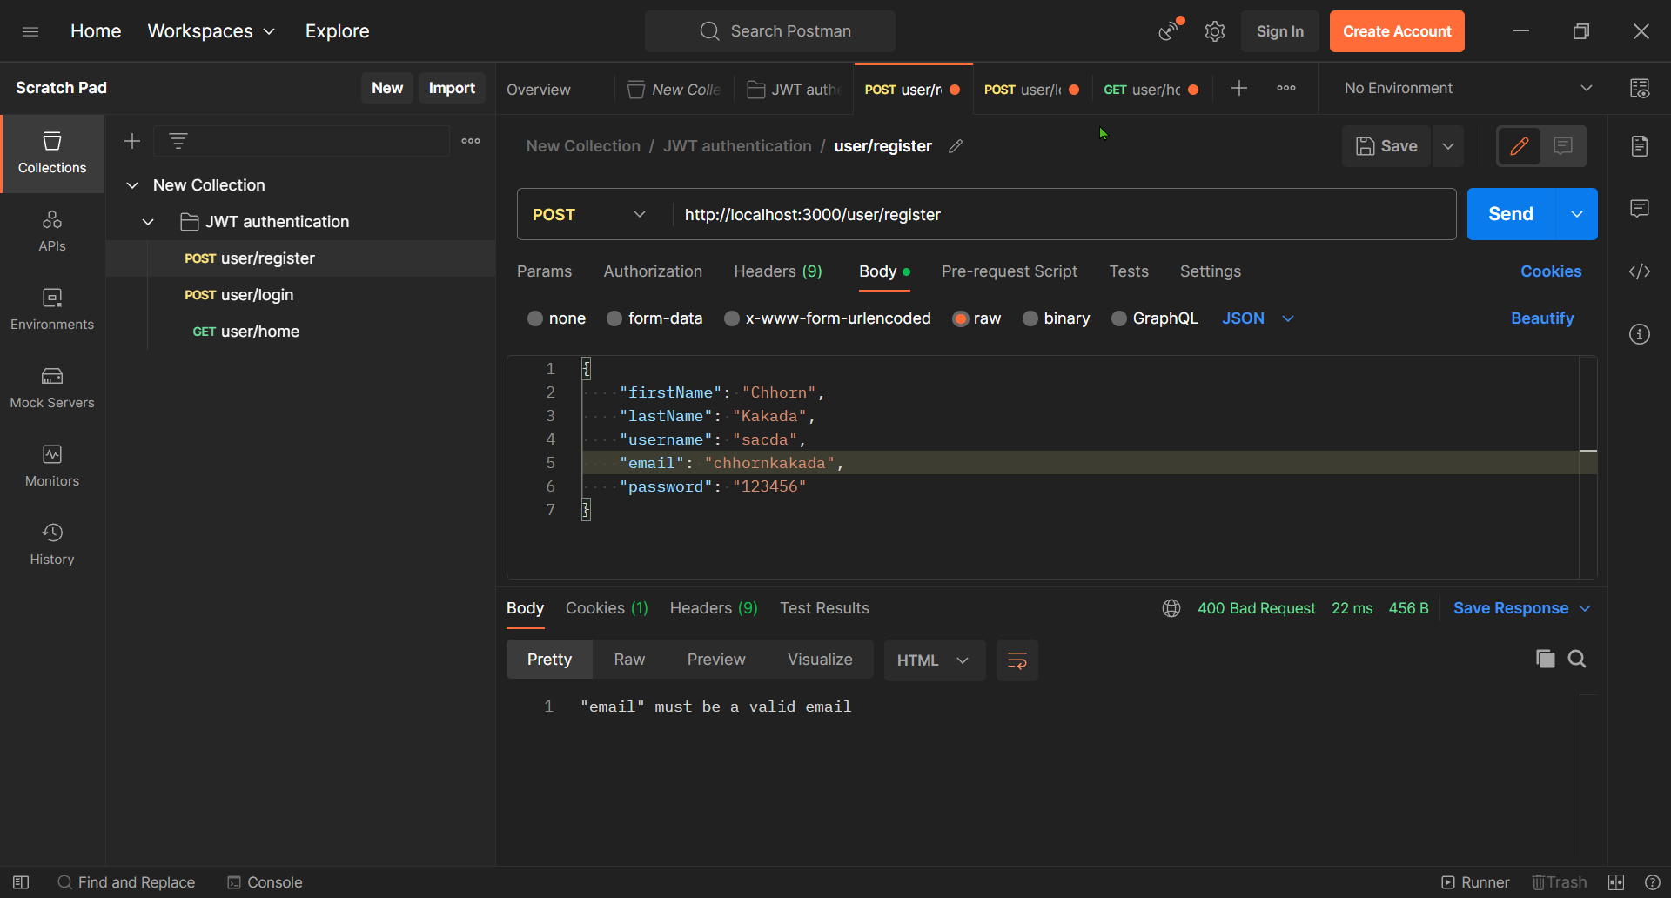

## Login

When the user login successfully. The API return the token back.

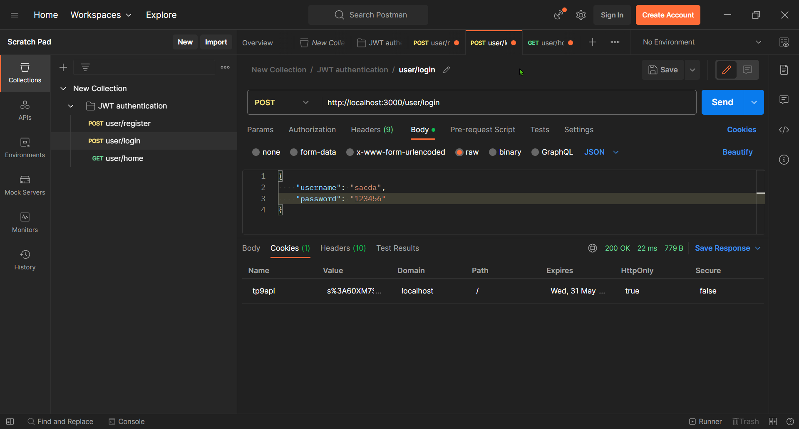

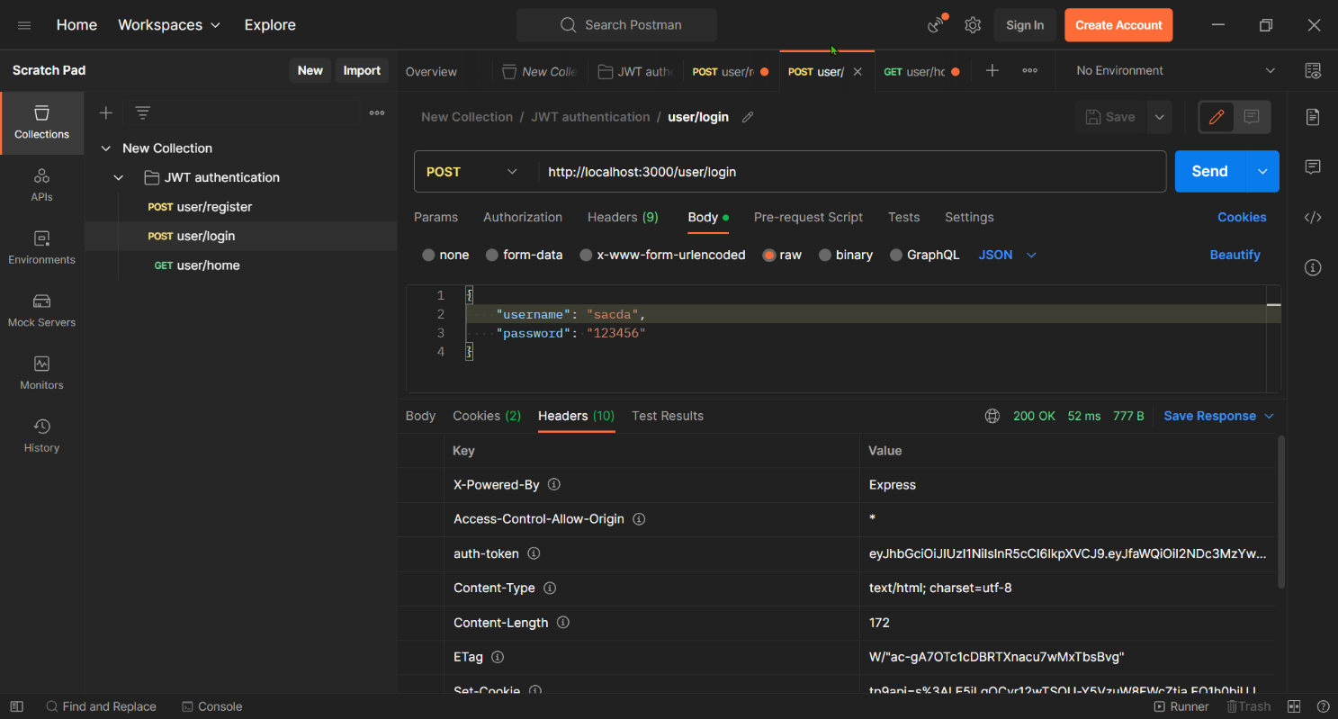

## Home

If the user no yet login, they can go to route /home.

