github: <https://github.com/ChhornKakada/IntenetProgramming/tree/tp7>

## ex1. Activity Suggestion

## ex2. List/Viewer

## ex3. Bookstore

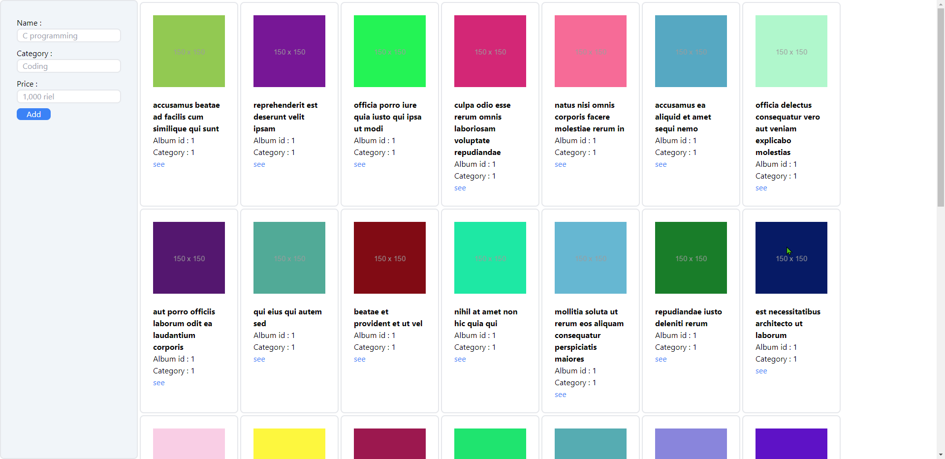

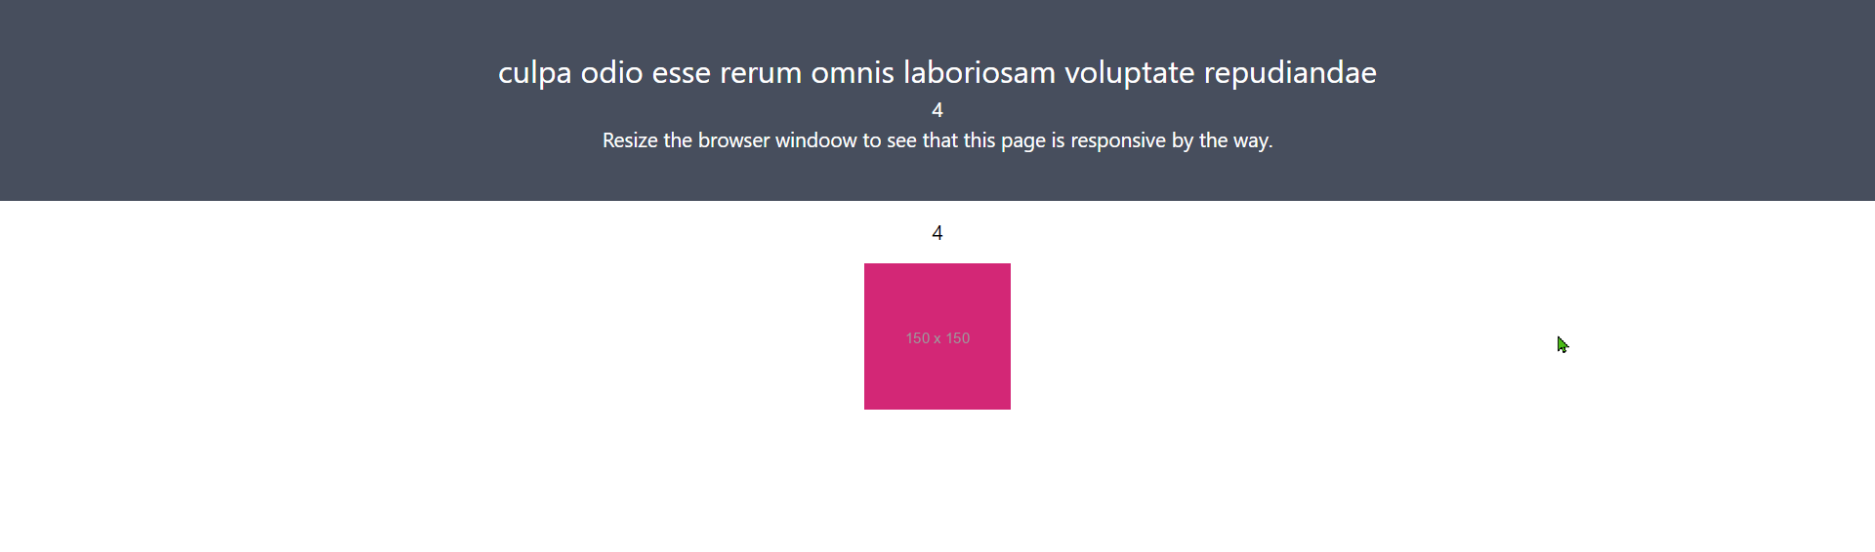

## ex4. Past Time Library with Typescript

