**Part A**

**I**

**A**

**B**

**C**

**D**

**E**

**F**

**G**

**Objective** : Name and decribe each component

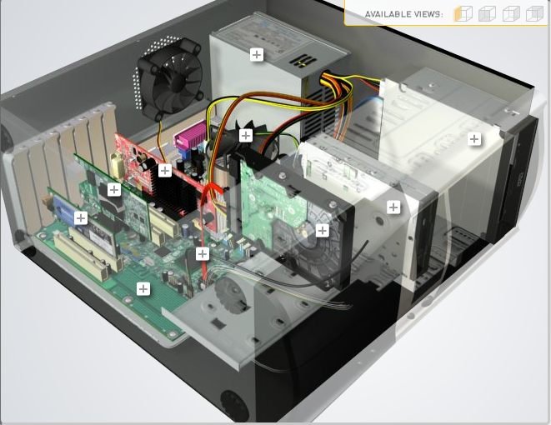

**H**

|  |  |  |
| --- | --- | --- |
| Download [**http://tinyurl.com/CW208-CAG-SIM**](http://tinyurl.com/CW208-CAG-SIM) PC Build Simulator.  Go through steps of building a PC, as you complete the simulation find and describe in detail components A to I. To run simulator first install <http://www.swffileplayer.com/> and open ***RootMovie.swf*** using SWF player. Alternatively install [Macromedia Flashplayer](https://fpdownload.macromedia.com/pub/flashplayer/updaters/32/flashplayer_32_sa.exe) . Ideally use a simulator as listed in class. | | |
| Label | Name each component | Description |
| A | Wireless NIC | Connect Computer to a network |
| B | Video Adapter | Provide video capabilities |
| C | Heat Sink | Forces air through heat sink |
| D | Power Supply | A power supply provides the needed voltage to power the various electronic circuits that make up the PC. |
| E | Optic Drive | Reads digital video disks |
| F | Floppy Disk | Reads and writes memory to floppy disk |
| G | Hard Drive Disk | Reads and writes memory to fixed disk |
| H | SATA Cable | Connect SATA Drives to motherboard |
| I | Motherboard | The main printed circuit board in a computer |

**Part B**

**Objective**

Compare a pre-assembled system and the components that could be assembled to build a comparable system. After completing this practical, you should be able to:

1. Identify the components of a pre-assembled system
2. Locate prices for components needed to assemble a comparable system
3. Compare the cost of a pre-assembled system and a self-assembled system.

If you can’t find exact match for components, find the closest possible substitute. Use the Internet and available computer-related publications as your sources for information. Examples of websites for computer parts [www.komplett.ie](http://www.komplett.ie), [www.dell.ie](http://www.dell.ie), [www.custompc.ie](http://www.custompc.ie) [www.amazon.de](http://www.amazon.de)

MAKE SURE TO INCLUDE VALID LINKS TO WEB REFERENCES

|  |  |  |
| --- | --- | --- |
|  | **Pre-Assembled Computer Package** | **Computer Package**  **Components** |
| **CPU** | AMD Ryzen™ 5 5600X (6-Core, 35MB Total Cache, Max Boost Clock of 4.6GHz) |  |
| **Storage / Memory** | | |
| |  | | --- | |  | | RAM | | Hard Drive | |  | | |  | | --- | |  | | 8GB, 1x8GB, DDR4, 3200MHz, XMP | |  | | 256GB M.2 PCIe NVMe SSD | |  |
| **Input/Output** | | |
| |  | | --- | | Keyboard | | Pointing Device | | Monitor | | Speakers | | Network Adapter | |  | |  | | Alienware 510K Low-profile RGB Mechanical Gaming Keyboard - AW510K (Lunar Light)  Alienware 310M Wireless Gaming Mouse - AW310M  Dell 27 Gaming Monitor | S2721HGF - 69cm(27") Black  Dell Mobile Adapter Speakerphone- MH3021P  RJ-45 Killer E2600 Gigabit Ethernet |  |
| **Bundled Software**  (Including Operating System) | Windows 11 Home, English, Dutch, French, German, Italian |  |
| **Total Cost** | 1,379.00 |  |

**Part C**

**Objective**

You have been asked by a family friend to assist them with a computer purchase. They’re unfamiliar with technology and the terms used and have presented you with two alternatives machine choices. They would like to be able to write word documents, surf internet and play Minecraft © Mojang and Half-Life © Valve Software. They are considering playing Fortnight but are not sure yet, as it depends on machine cost and if they can extract some money from their Bitcoin wallet.

Compare Personal Computer Option A and B in relation to each of the side headings and recommend a system and any alterations.

|  |  |  |
| --- | --- | --- |
|  | Personal Computer  Option A | Personal Computer  Option B |
| CPU | 2.2 GHz Intel Celeron 450 | 3.2 GHz Intel Core i5 |
| Memory |  |  |
| |  | | --- | | Cache | | RAM | | Hard Drive | | CD-ROM/DVD | | |  | | --- | | 512 KB Cache | | 4 GB RAM | | 320 GB Hard Drive | | DVD+/-RW drive | | |  | | --- | | 4 MB Cache | | 8 GB RAM | | 1 TB Hard Drive | | DVD+/-RW drive | |
| Input/Output |  |  |
| |  | | --- | | Keyboard | | Pointing Device | | Screen | | Speakers | | Network Adapter | | |  | | --- | | USB multifunction keyboard | | USB optical mouse | | 20’’ HD flatscreen monitor | | Multimedia Speaker System | | Integrated 10/100/1000 Ethernet | | |  | | --- | | wireless multifunction keyboard | | wireless optical mouse | | 25’’ HD flatscreen monitor | | Dolby Surround Sound Speakers | | Integrated 10/100/1000 Ethernet | |

|  |
| --- |
| **Recommendations** |
|  |

**Your Recommend System**

|  |  |
| --- | --- |
|  | Personal Computer  Recommendation |
| **CPU** |  |
| **Memory** | |
| |  | | --- | |  | | RAM | | Hard Drive | | SSD Drive | | |  | | --- | |  | |  | |  | |  | |
| **Input/Output** | |
| |  | | --- | | Keyboard | | Pointing Device | | Screen | | Speakers | | Network Adapter  GPU | | |  | | --- | |  | |  | |  | |  | |  | |

Hand up this practical report at the end of session and ensure it has been checked

|  |  |  |  |
| --- | --- | --- | --- |
| **Student Name** |  | **Student Number** |  |
| **Date** |  | **Checked** |  |
| **Group** | **A / B** |  |  |