- Homepage
- Header: Logo, search bar, navigation menu, and user actions (e.g., cart, login).
- Banners: Promotional sections for deals (e.g., 11.11 sale, flash sales).
- Categories: Grid of category icons and links
- Featured Products: Carousel or grid of discounted products with prices and images.
- Footer: Links, contact info, and policies, based on the PDF's footer content.
- Styling: Inline CSS for quick setup; in a real project, use SCSS or a framework like Vuetify.
- Item page
- Login/Signup feature
- Cart page
Virtual Scrolling for Large Product Lists
- Technique: Vue Virtual Scroller or custom implementation
- Why Advanced: Handles rendering thousands of products efficiently by only rendering visible items
- Enhancement: Dramatically improves performance for large catalogs
- Learn: DOM manipulation optimization, component lifecycle hooks
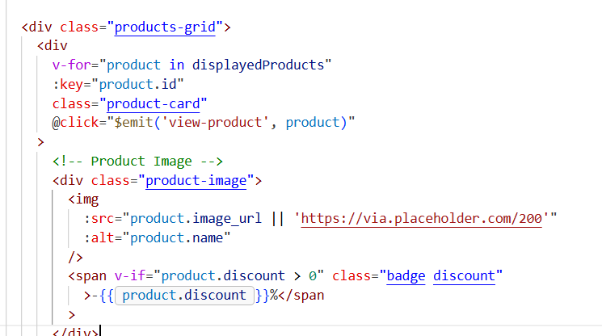
Before: performance check
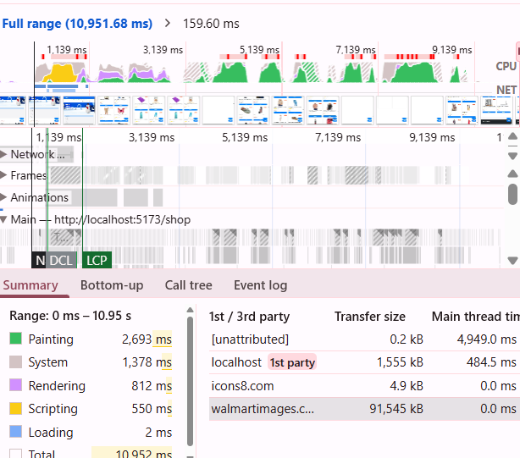

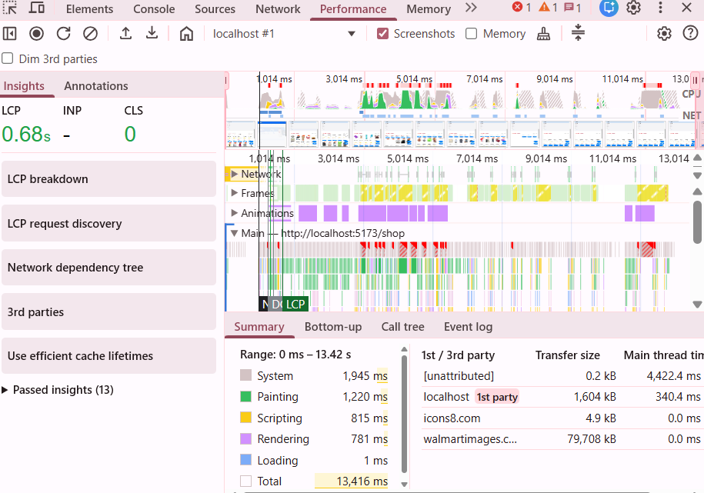
After implementing recycler scroller. The painting time aka the time taken to render pixel on screen is reduced dramatically.
2. Real-time Features with WebSockets
- Technique: Socket.io + Vue 3 Composition API
- Implementation Ideas:
  - Live inventory updates (stock changes in real-time)
  - Live cart synchronization across devices
  - Flash sale countdowns synced across all users
- Why Advanced: Requires understanding of persistent connections, event handling, and reactive state management

