上机随堂作业
–教材
P.39 题 3 (printf组织输出善用转义符P.20)
–上机指导书
实验二，2 (自习完成)
实验二，3 (进制转换)

吴老师，骆学长和孙学长好，以下是我的作业。

–教材
P.39 题 3 (printf组织输出善用转义符P.20)
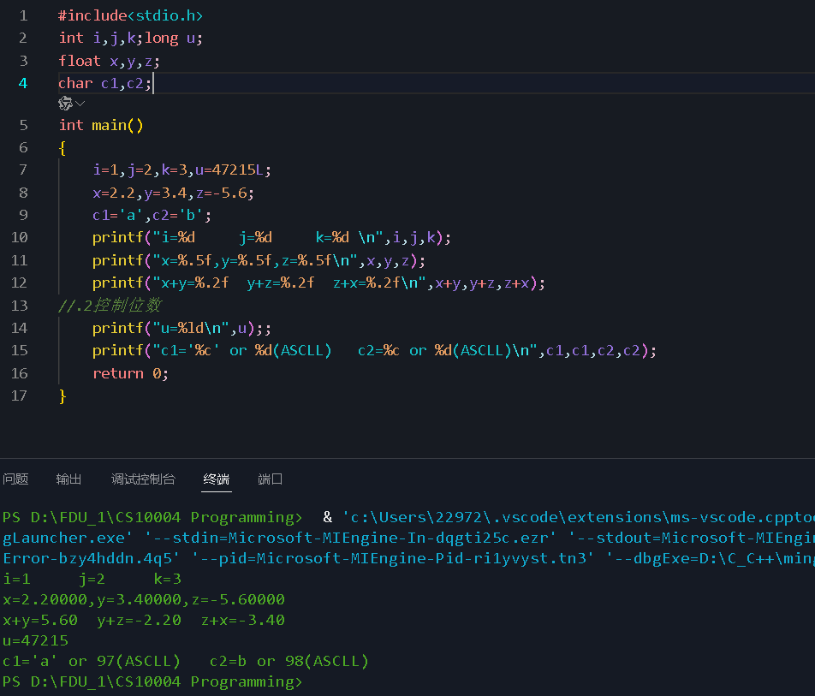
Homework-in-CS10004-Programming-by-yhchi/print float.&char.c at main · Chi-Shan0707/Homework-in-CS10004-Programming-by-yhchi

–上机指导书
实验二，2 (自习完成)
Homework-in-CS10004-Programming-by-yhchi/parameters of printf.c at main · Chi-Shan0707/Homework-in-CS10004-Programming-by-yhchi

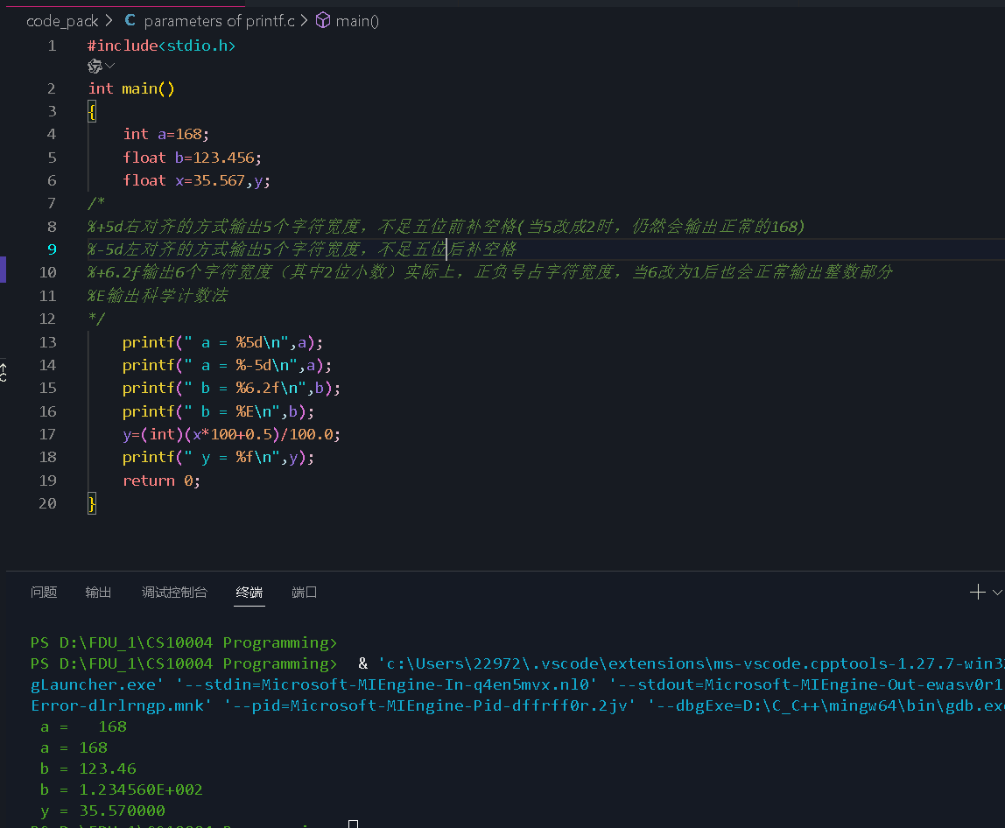

实验二，3 (进制转换)

Homework-in-CS10004-Programming-by-yhchi/Convert the System of Numeration.c at main · Chi-Shan0707/Homework-in-CS10004-Programming-by-yhchi

