吴老师，骆学长和孙学长好，以下是我的作业。

上传课后作业
–教材
P. 185 题 5(编程题，学生成绩管理系统)
要求：1) 结构体成员包括姓名、学号和至少3门自定课程；
2) 能够录入学生信息；
3) 求取某一门指定课程的平均分和某一个学生的总分；
4) 按学号或姓名查找学生的信息并显示；
5) 按指定的若干门课程由高到低显示；
6) 按总分由高到低显示学生信息。
测试样例：信息具体内容自定，作业报告中的截图需完成反映以上各功能，并进行简要的文字对应说明，遗漏或错误不得分。
P.186 题6(编程题，扑克牌游戏)
要求：1) 按题设要求，建立扑克牌的结构类型描述；
2) 随机洗牌函数
3) n人玩牌的发牌程序$n=3,n=4$。
测试样例：作业报告中的截图需完成反映以上各功能。

Chi-Shan0707/Homework-in-CS10004-Programming-by-yhchi
代码仓库↑
1.

先给了一些小的有针对性的输出测试（课程数<3,仅作为 部分测试（也只有这种小测试可以截图）完整的输出内容在最后

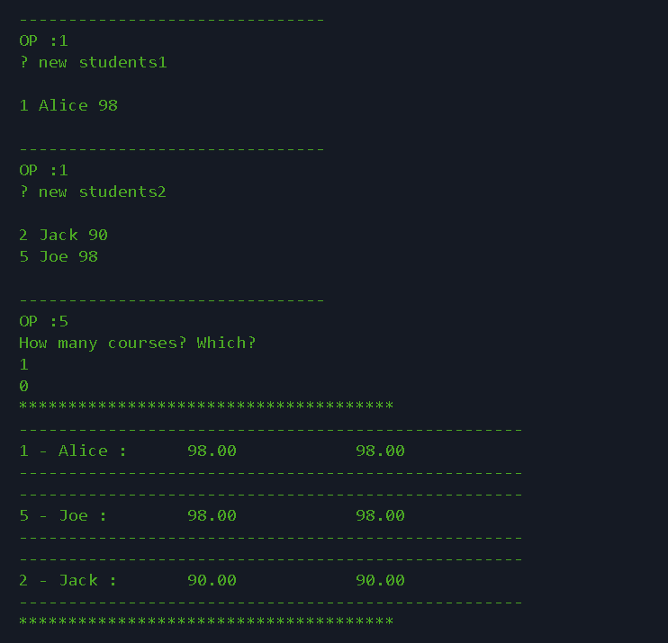
New students 后那个数字是要新增多少个学生

最后一列是总分

这里是展示基本的输入输出
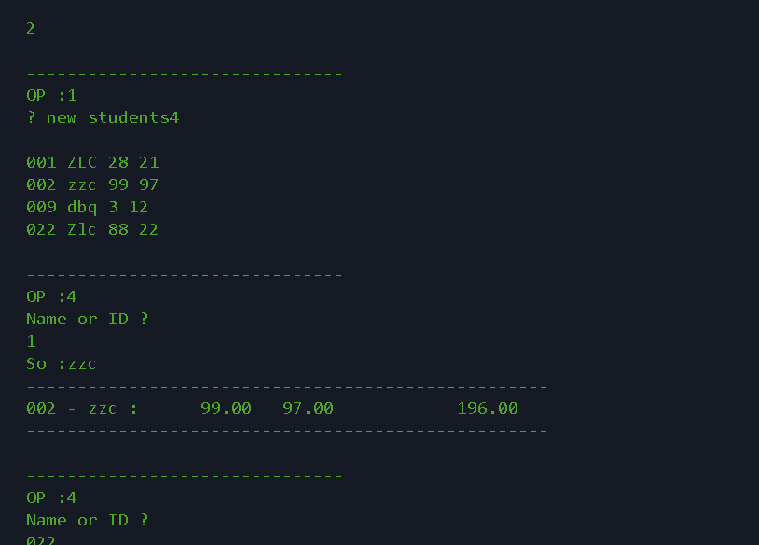
展示了初步 的搜索

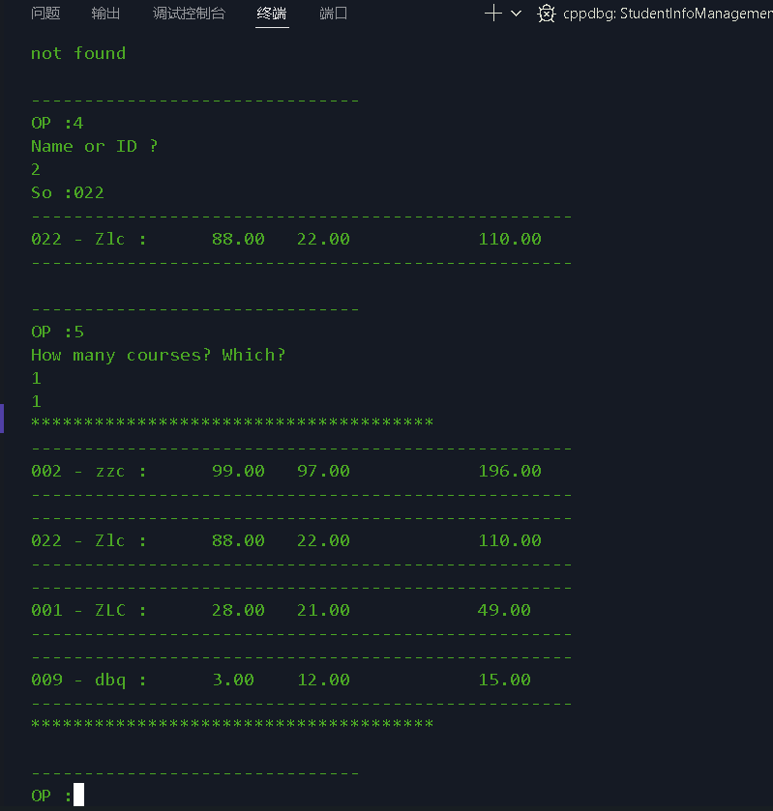
之前是输入姓名
这里输入学号
并且针对第1门课进行排序（我的课程编号从0开始）
#include<stdio.h>
#include<string.h>
#include<stdlib.h>

#define MAX_NUM_OF_ALL 50
//once-and-for-all
struct Student
{
char id[MAX_NUM_OF_ALL];
char name[MAX_NUM_OF_ALL];
float score[MAX_NUM_OF_ALL];
float total;
};
typedef struct Student Student;
void Input_StudentInfo(Student s[],int *pn,const int CourseNum)
{
int n;
printf("? new students");
scanf("%d",&n);
printf("\n");
for(int i=(*pn);i<n+(*pn);i++)
{
s[i].total=0.0f;
scanf("%s",s[i].id);
scanf("%s",s[i].name);
for(int j=0;j<CourseNum;++j)
{
scanf("%f",&s[i].score[j]);
s[i].total+=s[i].score[j];
}
}
//传入指针 进行更改

(*pn)+=n;
}

void print(const Student *p,const int CourseNum)
{
printf("---------------------------------------------------\n");
printf("%s - %s :",p->id,p->name);
for(int j=0;j<CourseNum;j++) printf("\t %.2f",p->score[j]);
printf(" %.2f\n",p->total);
printf("---------------------------------------------------\n");
}

void Query_CourseInfo(const Student s[],const int n,const int CourseNum)
{
int c;
printf("Course ?\n");
scanf("%d",&c);
float sum=0.0f;
for(int i=0;i<n;i++)sum+=s[i].score[c];
printf("sum=%.2f avg=%.2f\n",sum,sum/n);
}

void Query_StudentInfo(const Student s[],const int n,const int CourseNum)
{
printf("The kth input?\n");
int k;scanf("%d",&k);
--k;
print(&s[k],CourseNum);

}

void Find_Student(const Student s[],int n,int CourseNum)
{

int mode;
char key[MAX_NUM_OF_ALL];
printf("Name or ID ?\n");
scanf("%d",&mode);
printf("So :");
scanf("%s",key);
//查学号or查姓名
for(int i=0;i<n;i++)
{
if((mode==2&&strcmp(s[i].id,key)==0)||
(mode==1&&strcmp(s[i].name,key)==0))
{
//字符串比较函数
print(&s[i], CourseNum);
return;
}
}
printf("not found\n");
}

void swap_student(Student *a,Student *b)
{
Student t=*a;
*a=*b;
*b=t;
}

void Print_StudentInfo(const Student s[],int n,int CourseNum)
{
printf("**************************************\n");
for(int i=0;i<n;i++)print(&s[i],CourseNum);
printf("**************************************\n");
}

void Maintain_StudentInfo(Student s[],int n)
{
//如果要按照所有学科排名的话，就手动输入所有学科叭
int k;
int CourseId[MAX_NUM_OF_ALL];
printf("How many courses? Which?\n");
scanf("%d",&k);

for(int i=0;i<k;i++)
{
scanf("%d",&CourseId[i]);
}
for(int i=0;i<n-1;i++)
{
for(int j=0;j<n-1-i;j++)
{
float sumStudentI=0.0f,sumStudentJ=0.0f;
//暴力查看交换条件
for(int t=0;t<k;t++)
{
sumStudentI+=s[j].score[CourseId[t]];

sumStudentJ+=s[j+1].score[CourseId[t]];
}
if(sumStudentI<sumStudentJ)swap_student(&s[j],&s[j+1]);
}
}
}

int main()
{
Student s[MAX_NUM_OF_ALL];
int n=0;
int CourseNum;
int op;
scanf("%d",&CourseNum);
while(1)
{
printf("\n-------------------------------\nOP :");
scanf("%d",&op);
switch(op)
{
case 0:
return 0;
case 1:
Input_StudentInfo(s,&n,CourseNum);
break;
case 2:
Query_CourseInfo(s, n,CourseNum);
break;
case 3:
Query_StudentInfo(s,n,CourseNum);
break;
case 4:
Find_Student(s,n,CourseNum);
break;
case 5:
Maintain_StudentInfo(s,n);
Print_StudentInfo(s,n,CourseNum);
break;
case 6:
Print_StudentInfo(s,n,CourseNum);
break;
default:
break;//只是退出switch
}
}
return 0;
}

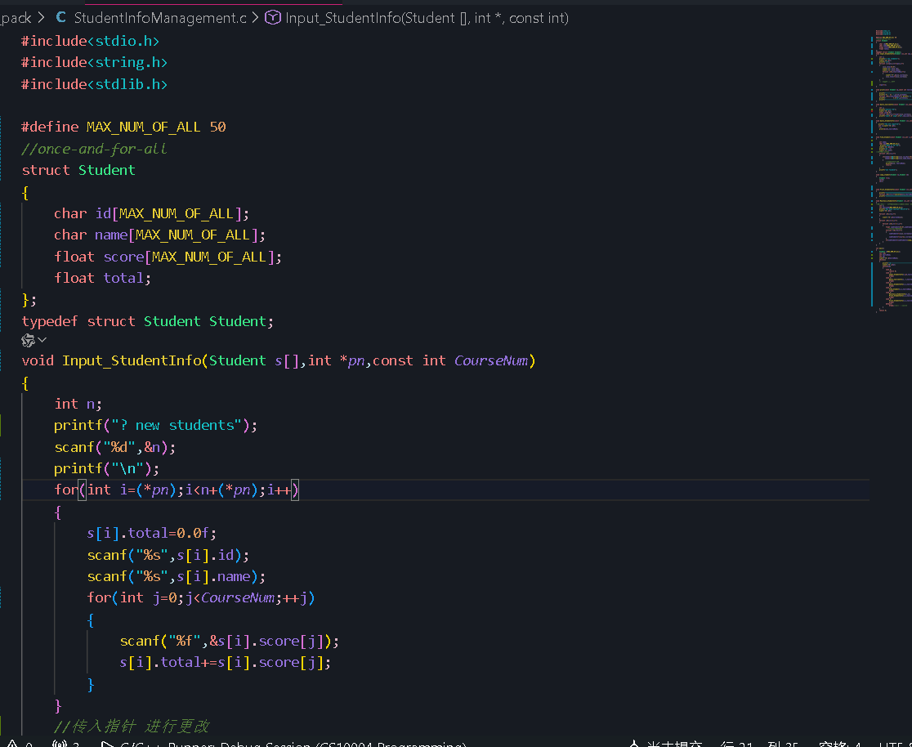

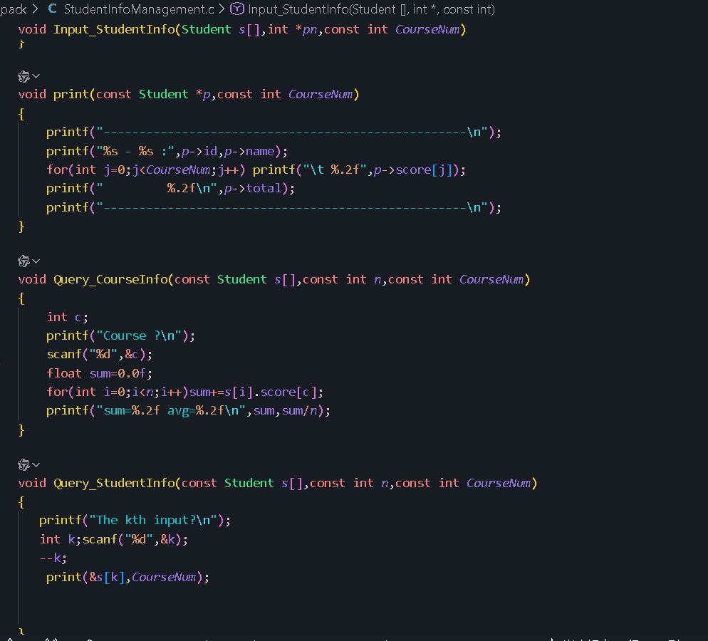

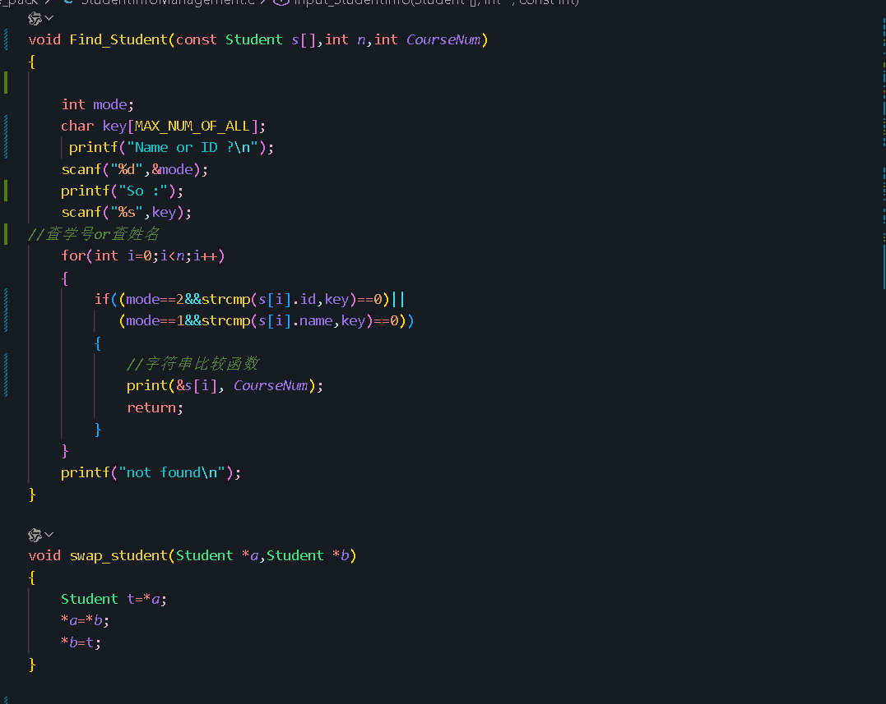

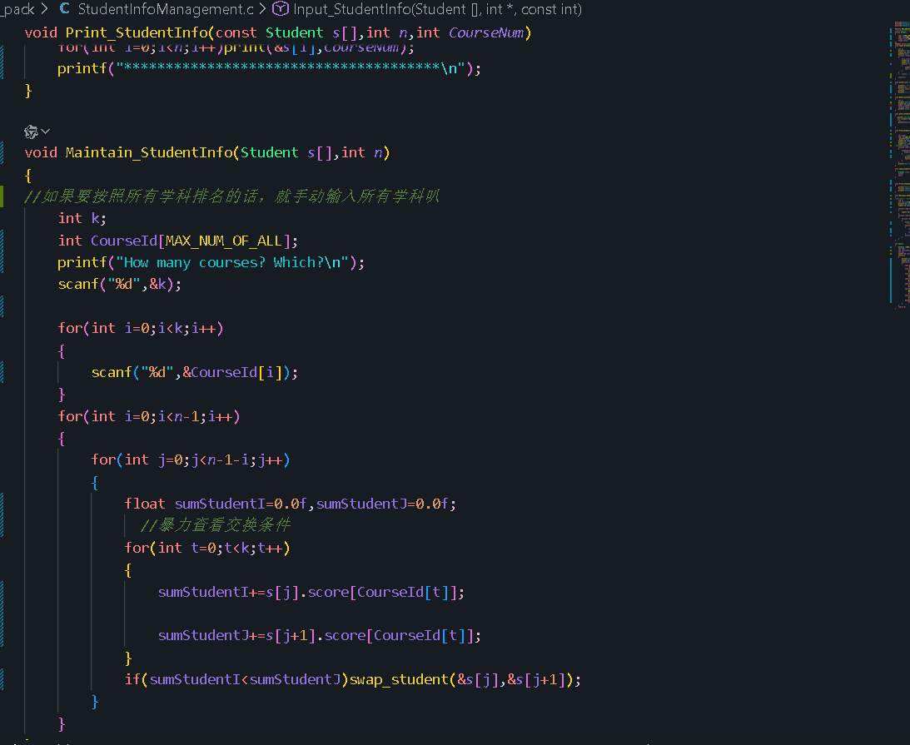

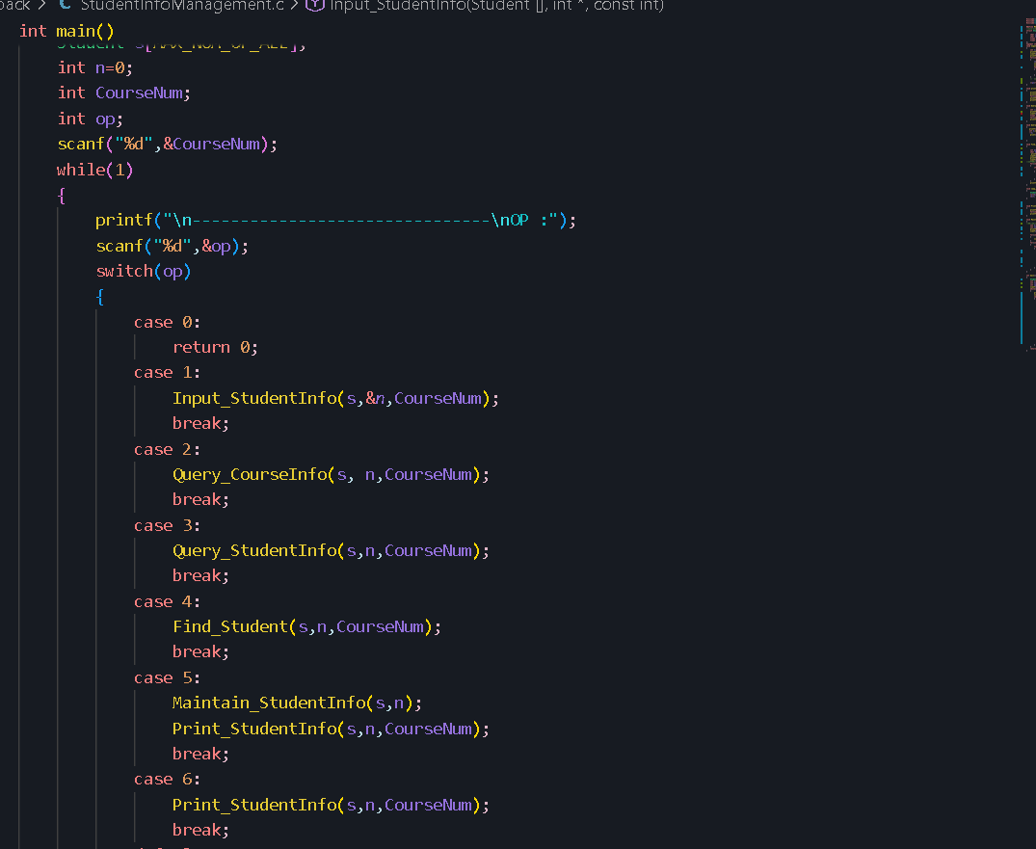

case 0:
return 0;
case 1:
Input_StudentInfo(s,&n,CourseNum);
break;
case 2:
Query_CourseInfo(s, n,CourseNum);
break;
case 3:
Query_StudentInfo(s,n,CourseNum);
break;
case 4:
Find_Student(s,n,CourseNum);
break;
case 5:
Maintain_StudentInfo(s,n);
Print_StudentInfo(s,n,CourseNum);
break;
case 6:
Print_StudentInfo(s,n,CourseNum);
break;
default:
break;//只是退出switch

一个完整且系统的例子
注
3表示课程数量
Newstudent 后输入了6表示输入学生数

3

-------------------------------
OP :1
? new students6

003 jack 100 99 97
023 Pete 88 87 100
034 Sun 90 90 90
100 wiki 100 22 9
101 jason 100 100 100
102 ice 96 78 34

-------------------------------
OP :2
Course ?
2
sum=430.00 avg=71.67

-------------------------------
OP :3
The kth input?
5
---------------------------------------------------
101 - jason : 100.00 100.00 100.00 300.00
---------------------------------------------------

-------------------------------
OP :4
Name or ID ?
1
So :jason
---------------------------------------------------
101 - jason : 100.00 100.00 100.00 300.00
---------------------------------------------------

-------------------------------
OP :4
Name or ID ?
2
So :023
---------------------------------------------------
023 - Pete : 88.00 87.00 100.00 275.00
---------------------------------------------------

-------------------------------
OP :5
How many courses? Which?
3
0 1 2
**************************************
---------------------------------------------------
101 - jason : 100.00 100.00 100.00 300.00
---------------------------------------------------
---------------------------------------------------
003 - jack : 100.00 99.00 97.00 296.00
---------------------------------------------------
---------------------------------------------------
023 - Pete : 88.00 87.00 100.00 275.00
---------------------------------------------------
---------------------------------------------------
034 - Sun : 90.00 90.00 90.00 270.00
---------------------------------------------------
---------------------------------------------------
102 - ice : 96.00 78.00 34.00 208.00
---------------------------------------------------
---------------------------------------------------
100 - wiki : 100.00 22.00 9.00 131.00
---------------------------------------------------
**************************************

-------------------------------
OP :5
How many courses? Which?
2
2 1
**************************************
---------------------------------------------------
101 - jason : 100.00 100.00 100.00 300.00
---------------------------------------------------
---------------------------------------------------
003 - jack : 100.00 99.00 97.00 296.00
---------------------------------------------------
---------------------------------------------------
023 - Pete : 88.00 87.00 100.00 275.00
---------------------------------------------------
---------------------------------------------------
034 - Sun : 90.00 90.00 90.00 270.00
---------------------------------------------------
---------------------------------------------------
102 - ice : 96.00 78.00 34.00 208.00
---------------------------------------------------
---------------------------------------------------
100 - wiki : 100.00 22.00 9.00 131.00
---------------------------------------------------
**************************************

-------------------------------
OP :5
How many courses? Which?
2
注 这里输入2表示关键课程数量
再输入课程编号（从0开始）
0 1
**************************************
---------------------------------------------------
101 - jason : 100.00 100.00 100.00 300.00
---------------------------------------------------
---------------------------------------------------
003 - jack : 100.00 99.00 97.00 296.00
---------------------------------------------------
---------------------------------------------------
034 - Sun : 90.00 90.00 90.00 270.00
---------------------------------------------------
---------------------------------------------------
023 - Pete : 88.00 87.00 100.00 275.00
---------------------------------------------------
---------------------------------------------------
102 - ice : 96.00 78.00 34.00 208.00
---------------------------------------------------
---------------------------------------------------
100 - wiki : 100.00 22.00 9.00 131.00
---------------------------------------------------
**************************************

-------------------------------
OP :6
**************************************
---------------------------------------------------
101 - jason : 100.00 100.00 100.00 300.00
---------------------------------------------------
---------------------------------------------------
003 - jack : 100.00 99.00 97.00 296.00
---------------------------------------------------
---------------------------------------------------
034 - Sun : 90.00 90.00 90.00 270.00
---------------------------------------------------
---------------------------------------------------
023 - Pete : 88.00 87.00 100.00 275.00
---------------------------------------------------
---------------------------------------------------
102 - ice : 96.00 78.00 34.00 208.00
---------------------------------------------------
---------------------------------------------------
100 - wiki : 100.00 22.00 9.00 131.00
---------------------------------------------------
**************************************

3人每人17张
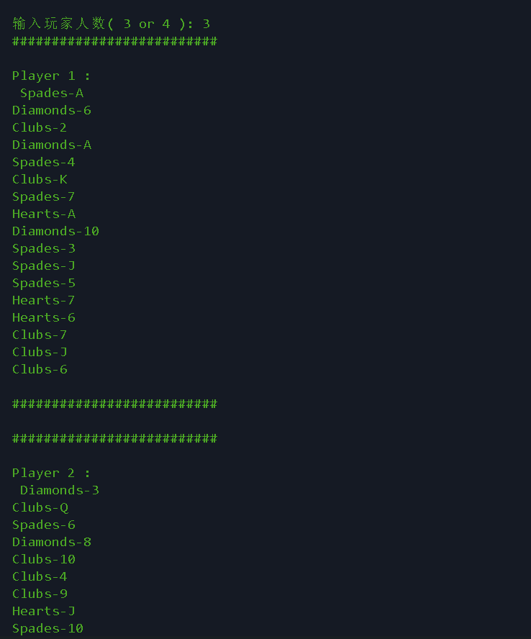
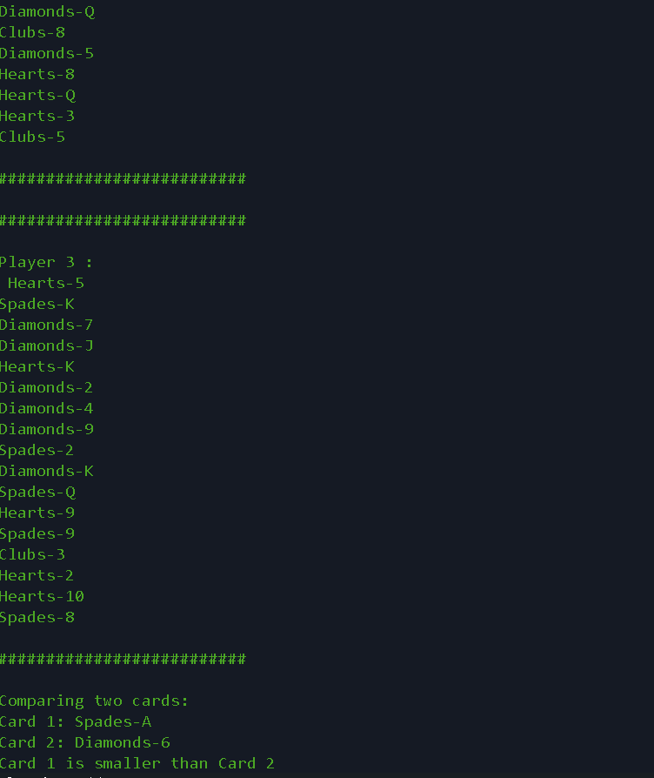

输入玩家人数( 3 or 4 ): 4
##########################
Player 1 :
Hearts-A
Spades-7
Hearts-K
Diamonds-10
Spades-3
Diamonds-6
Diamonds-A
Spades-Q
Hearts-J
Clubs-K
Hearts-5
Clubs-9
Spades-K
##########################
##########################
Player 2 :
Diamonds-J
Clubs-10
Diamonds-8
Hearts-6
Hearts-3
Clubs-3
Diamonds-Q
Spades-10
Diamonds-9
Hearts-9
Hearts-4
Clubs-2
Clubs-5
##########################
##########################
Player 3 :
Hearts-Q
Diamonds-3
Hearts-8
Hearts-2
Spades-5
Hearts-7
Clubs-7
Clubs-A
Spades-8
Hearts-10
Clubs-6
Spades-9
Spades-2
##########################
##########################
Player 4 :
Clubs-J
Spades-6
Clubs-4
Spades-4
Diamonds-K
Spades-J
Diamonds-4
Clubs-8
Diamonds-2
Diamonds-7
Spades-A
Clubs-Q
Diamonds-5
##########################
Comparing two cards:
Card 1: Hearts-A
Card 2: Spades-7
Card 1 is smaller than Card 2

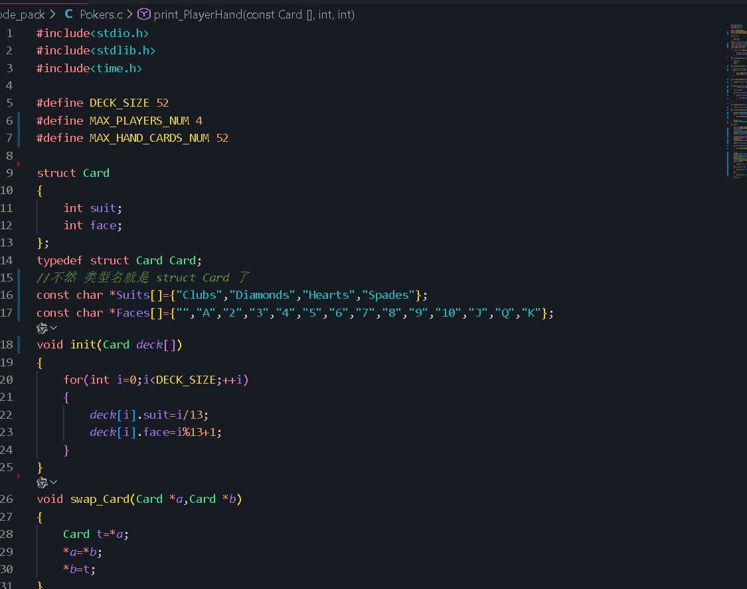
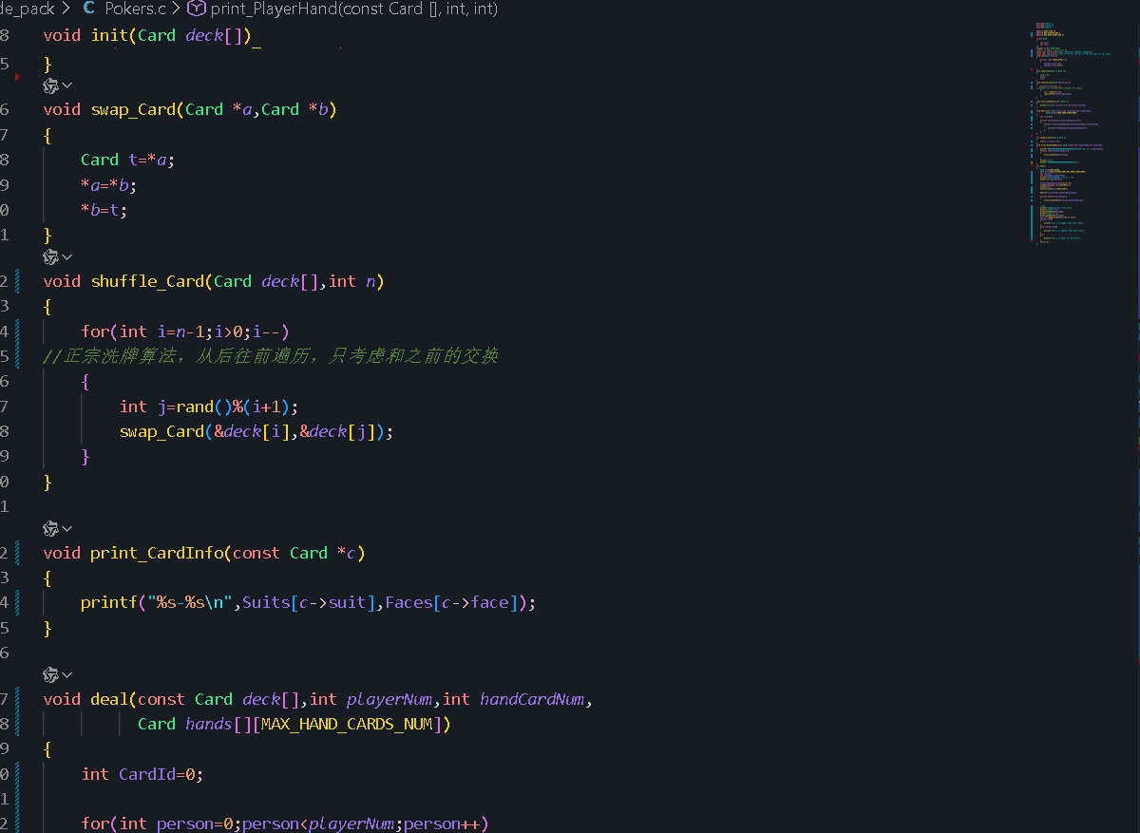

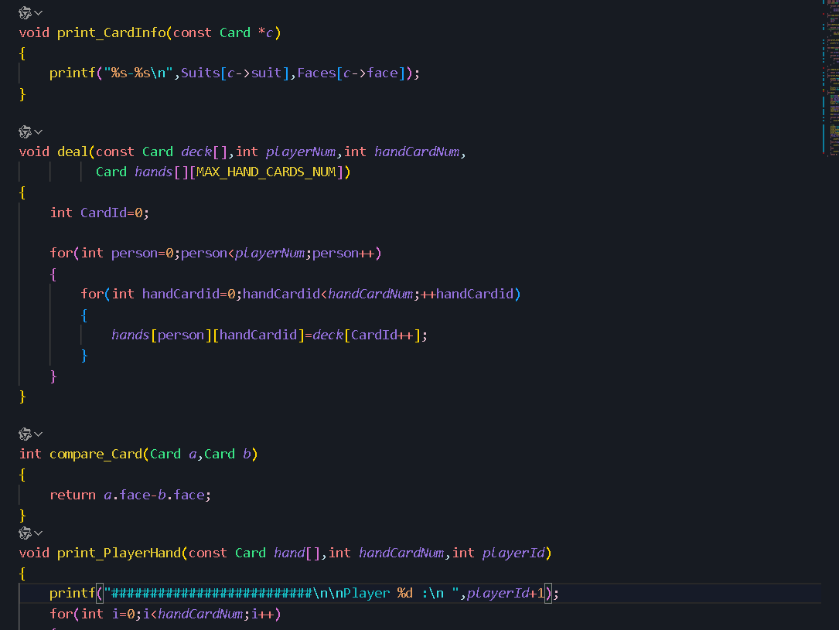
通过计数器去取洗好的牌堆里的牌
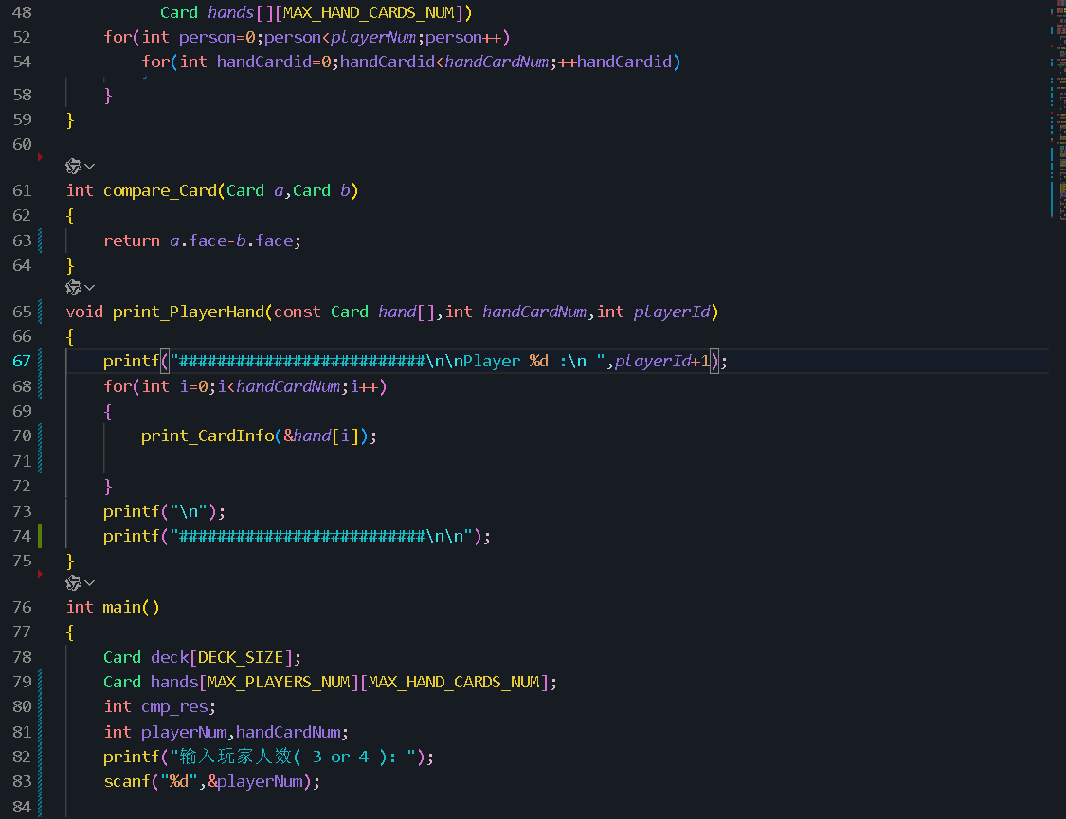

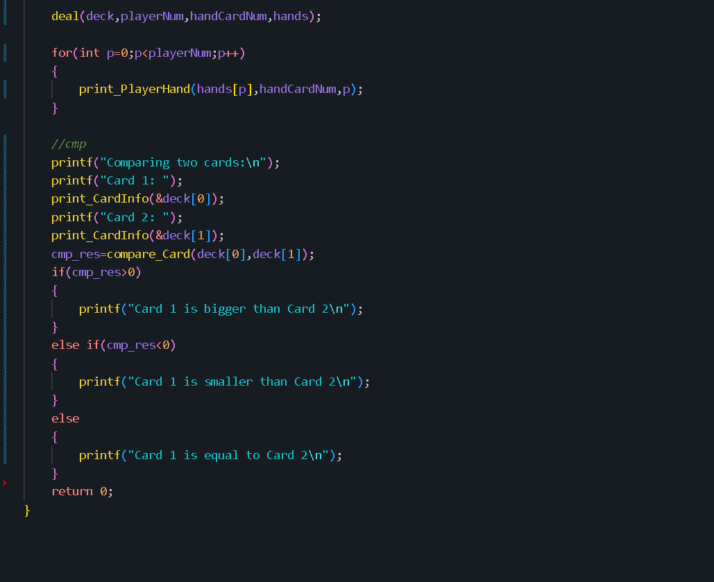
这里稍微选两张比个大小

