¦¸SQL Server 7.0ª
SQL Server 7.0(¥¤ÂºSQL Server)¥¥¦¸¦Windows 98/95©NT¤¡¥¤Åµª¨¤²¥ª¦¸¹µ¡
¦¸«ª·³°§
µÅ»¨ | ¥½¬µÅª»¨¡

 | 硬體設備 |  | 需要的規格
 | CPU |  | 586以上CPU
 | 記憶體 |  | 至少32 MB, 建議64MB以上
 | 硬碟 |  | 完整安裝：210 MB 左右的剩餘空間  典型安裝：185MB 左右的剩餘空間  最小安裝：80 MB 左右的剩餘空間
 | 光碟機 |  | 讀取SQL Server光碟用
³Å»¨ |  | ¦¨¬³Å»¨¡

 | 作業系統 |  | 必須先安裝的軟體
 | Windows 95 |  | DCOM95、IE 4.01以上版本(含Service Pack 1)
 | Windows 98 |  | 無
 | Windows NT 4.0 |  | NT Service Pack 4、IE 4.01以上版本(含Service Pack 1)
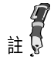 |  | ¥¤©»¤³Å¡±³¥¥¦SQL Serverª¥º¤§¨¡¨¤IE 4.01 (Service Pack 1)¬¦©x86\Other\IE4¥¿©¤ª ¡NT Service Pack 4¤¤ª«¥¥¥SQL Server²«¥¸¤ª¥¤¤¥º¨¦¸¡
SQL Server ªª¥
½©¸¦¸ª³Å³¦¸¤¤«¡§¦¨¬¬¤¦ª§·¨²¥¥¦¸¤»ª¥ªSQL Server¡

您的作業系統 | 可以安裝的SQL Server版本
Windows 95、98、 及  NT Workstation 4.0 | Desktop Edition
NT Server 4.0 | Standard Edition
¦¸«ªª·¨¶
1. ¦±°¦¸µ¦«¡½°¥¥±¨¥À¥µ¦Ã³¡§«¦¸®¥¯·¥²¦¤¹ª°®¡
¹-1 | 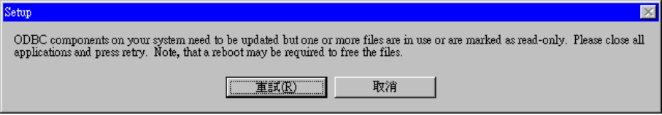
¥¥¡¦¨À¥µ¦³Ã³«¥¶·¶¾¡SQL Server¤¯¶¦¦¸¡¦ª¦NT¤¦¸¡º¥¯°±¤¥ªService¡Â³¦»¡Ã±©¦µ¦¡Ã±¤¥ªService¡·¶¾¡µ«¤¦¸SQL Server¡
2. ·§±¥º¤©¤«¡¨²³±·¦°°¦¦¸µ¦¡¦ª±ª¨²¨¦¦°°¦ª¸¡¥¯¬¥º¾ª¦°°¦¿¶³¨®¤¡±¥¥±¡À®Áº¡¤°¦¥º¤¤ª¨±°¦¸¡
¦Windows 98¤¦¸SQL Server
¦Windows 98¤¦¸SQL Serverª¨Æ³Â³¡¦¬³¦ª¦³¬¤¸¤«¦ª¤¡¨Æ¦¤¡
1. ¦¸µ¦±°¤«·¥À´±ª¨²¡³¹À´«¡±µ·¬¨SQL Serverª¦¸°©µ¡¿¾  ¶¤²¤µ¡¦Â¿Database Server -- Desktop Edition¡
¹-2 | 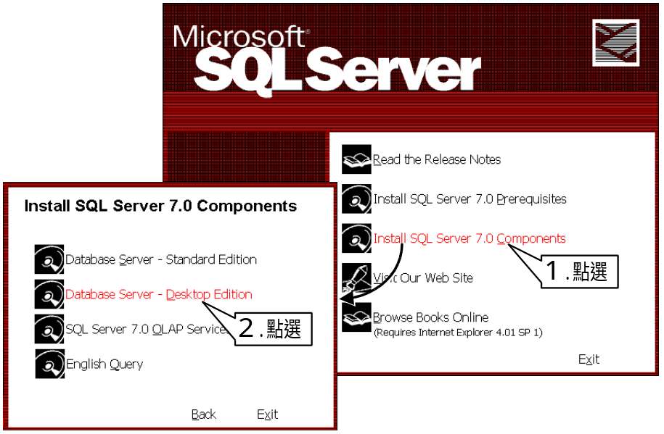
2. ±µ¬Åªµ¤ªÅÁ©¡¨¥ª¸®µ¡³¤«¤¡Next >¡¶¡¶¤¡Setup Type¡(¦¸¼¦¿¶)µ¡±µ±¥¥ª±¿¾¡Typical¡(¨«¦¸)ª¦¸¤¦¡±¤¨¨²´·¤ªÀ§¦¸¨©¡µª«Ä±±¥¦¤¦¸¤¦§¥¡
3. ¦ª±·±¥¡¦¦¸¡¡«¹µ¦¤¡¿¨¡Custom¡¡µ««¤¡Next >¡¶¡
4. ±¤¨Å¥ª¬Åªµ¤ªÅÁ©¡¨¥ª¸®µ¡½³¤«¤¡Next >¡¶ª¨¥²¡Select Components¡(¿¾¤¥)µ¡±µ©¤±¶¡¥¥¬¨¦¶µ¤¨(Development Tools)¤½¨µ¦½(Code Samples)¤¶¤¥¡½¤§¨¤»¨¤¿¡

 | 元件(Components) |  | 子元件(Sub-Components)
 | Development Tools |  | Headers and Libraries
 |  |  | Backup/Restore API
 |  |  | Debugger Interface
 | Code Samples |  | 豐富的範例程式碼
¹-3 |  | 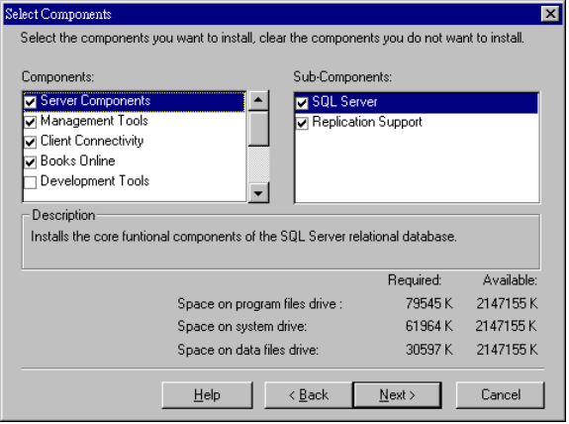
5. ±µ¬¡Character Set¡(¦¤¶)ª¿¶¡¥©µ¦·¦°°´±§·¨²©¥ª»¨¡©¥¤¥§§¡ª±«¤¡Next >¡§¥¡
¹-4 | 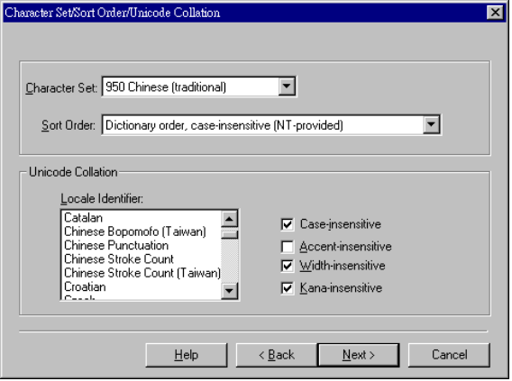
6. ±µ¬º¸³°¨©ª¿¶¡°«±ª°°º¸¤¦NetwareªServer¦¥¥¶»¥¦¨¸®®¡¤»¤¿ ¡§«¤¼«¤¡Next >¡§¥¡
¹-5 | 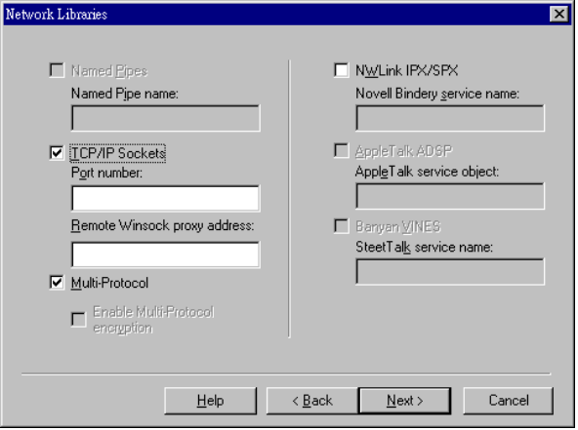
7. «¤¡Next >¡¶«¶©½»À®¨±ª¨²¡µ¦¸µ¦§§¤³¦ª¦¸°§«¡«¡Finish¡¶¦¨¦¸°©µ¡¦«¡Exit¡¶Â¶§¥¡
¦Windows 95¤¦¸SQL Server
¦Windows 95¤¦¸SQL Serverª¨Æ¡¨¹»Windows 98¤¦¤²¡¬²ª³¥¥¬Windows 95¦¦¸¥«¡¥¶¥§· DCOM95¤¦¸IE 4.01 Service Pack 1¡½°¦¤¦¨Æ¡
1. ±°¦¸µ¦«¡Â¿  ·¥²¥¤µ¡¦®¦¿¾  ¦¸DCOM95¡¦¸DCOM95¤«¡¨²·¨±·¶¾¡½·±°¨²¡
¹-6 | 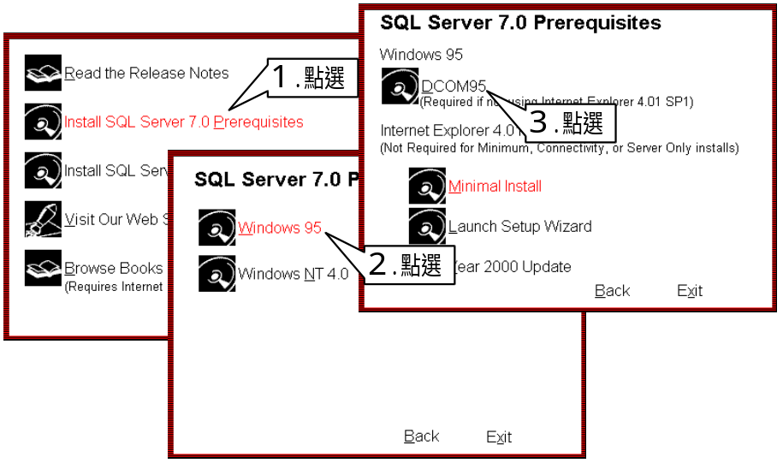
2. ±¤¨¬IE 4.01 SP1ª¦¸¡µª«Ä±¤¨¥SQL Serverª¦¸µ¦¨¦¸IE 4.01 SP1¡¦¬¥·¦¸¤ªªIE 4.01 SP1¡·¦¸¤¤ªªIE 4.01 SP1¡½´¤SQL Server¥¸¤¼¥µ¡Service Pack 4¤¤ª¡ª¥º¡°¦ \Msie401\I386\Ie4Setup.exe¡
3. §¦¥¤°¥¤¥ª¦¸¤«¡±¤¨ª¦¸°§¡Windows 95» Windows 98§¥¬¦¡½°¦¤¡¦Windows 98¤¦¸SQL Server¡ª¨Æ¡§¦SQL Serverª¦¸¡
¦Windows NT¤¦¸SQL Server
¹-7 | 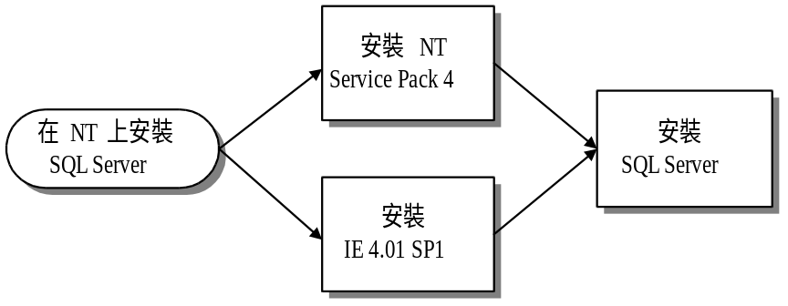
¦Windows NT 4.0¤¦¸SQL Server¤©¥¦¸IE 4.01 SP1¤NT Service Pack 4¡¥¤§¦©¡Service Pack 4¤¤ª¡¥ºª \Msie401\I386\Ie4Setup.exe(IE 4.01 SP1) ¤ \Sp4i386.exe(NT Service Pack 4)¡¦¸IE 4.01 SP1¤NT Service Pack 4 ¤«¡±¤¨¬SQL Serverª¦¸¡
1. ±°SQL Serverª¦¸µ¦¡¥Â¿ ¶¤²¤µ¡¦Â¿ ¡
2. ±µ·¥²¦¤¹ªµ¡Å±¿¾¬¦¸¨»ºª¹¸¤Á¬¦¸¦¥«©¥ª³³¹¸¤¡½¨±¹»±§¾§¡¦³§°³¬¦¸¨¥¦ºª¹¸¡µ««¤¡Next >¡¶¡
¹-8 | 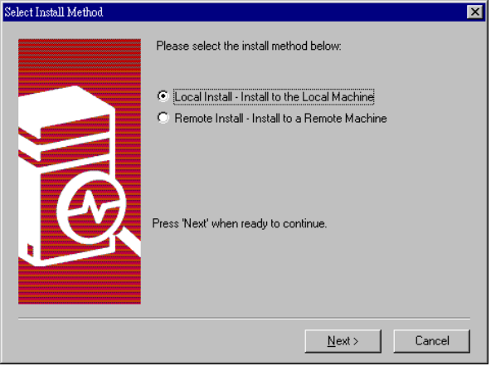
3. ±µ¬Åªµ¤ªÅÁ©¡¨¥ª¸®µ¡³¤«¤¡Next >¡¶¡¶¤¦¸¼¦¿¶µ¡ª±¿¾¨«¦¸(Typical)¡¥¨²À§§¦¸§¥¡±¤¥¥°¦²¤¸Ã©¦¦¸ª»©¡¿¾¦¦¸¡
½§±½°°¨
¹-9 | 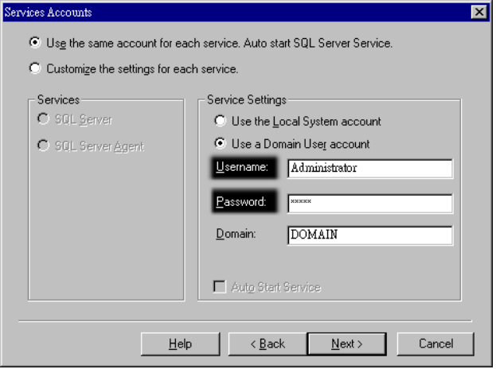
¦¦¸ª¹µ¤¡·¥²¥¤µ±¿¤UserName(¨¥ª¦º)¤Password(±½)¡¿¤¤«¡½°¥§¥°°¨¡§«±¨¶¤¤SQL Server¡´¥¶·¦¸¤¡
¨¥Åª³©
¹-10 | 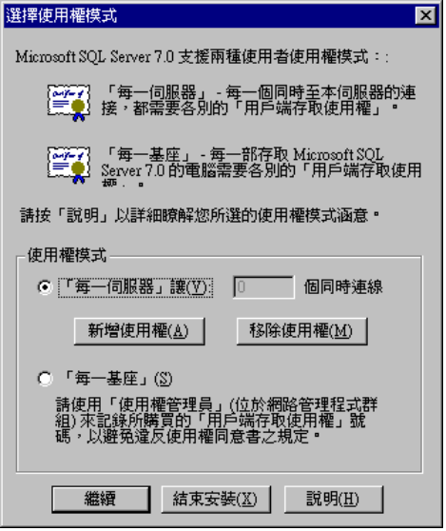
¦NT¤¦¸SQL Server¥¤¤¸¯®ªµ¬¨¥Åª³©¡¦¤¹¡¦¦½¨±©Á¶ª±Åªª¶¦³©¡¦¥¤µ¤¡¤¸¥¤°´ª¦¤¦©¡¨¤¦ª¾¡»¡¨¤°®¡ª®§¡
¨¤¦ª¾  vs. ¨¤°® | ©¿¨¤¦ª¾ª±Å¼¬«¦¤®¶¥¥³¤¸³¦ª¾ª¤§¯¼¶¡¦ª¿¾¦¤¼¦¡À¸¥¦º¦¤®¶³¦·¦¦¤¤³½¡Á¨¨»¡A¤¥¦80¦¤(¨¤¦¤³¤§¯)¡¦¦¤®¶·³½ª¤¼«¥¦30¤¡¨»A¤¥´¥¥¥Á¶30¥±Å¡
¦ª¬¨¤°®¡«¬«·¤§¯ª¼¶¨º¡¦¼¥A¤¥¬¨¡°³©Äª80³¤§¯³¥¥³½¡¨»´¥¶Á¶80¥±Å¡¥Å¤¤¡¿¾¨¤°®ª³½¼¤¸¦º¡¦¨¹¤¤©¡¥A¤¥¬¨¡°³¦3³NT¦¸¤SQL Server¡¨»±Å¼À¸¬30*3 = 90¥¡¦¦¨³¦ª¤¸¦§¡ºµº¸ª³¼¤¦¨ªªª¦©¡¨µ©½¡
±¥SQL Server¤¬Ã¤¨
¦¸SQL Server¤«¡¨§¿¨¡¶©¡¤¨¦ -> ¡µ¦¶¡ -> ¡Microsoft SQL Server 7.0¡¡¥¬¨SQL Server©«¥ªµ¦¶¡¦¤¹¡
¹-11 | 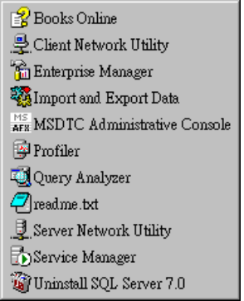
¦¦µª¥¤²³¬±¥ª´µ¦¶¡
 Books Online¡SQL Serverª½¤»©¤¥¡
 Enterprise Manager¡SQL Server©´¨ª¸®®¾§À¹¡
 Import and Export Data¡¥¥¨¶¥/¶¤Access¡Visual Foxpro¡Excel¡dbf¡¤¦À¡µ¦º¸®À®¡
 Service Manager¡¥¨±°¡¼°¡¤°¤SQL Serverªª°¡
Service Manager
¹-12 | 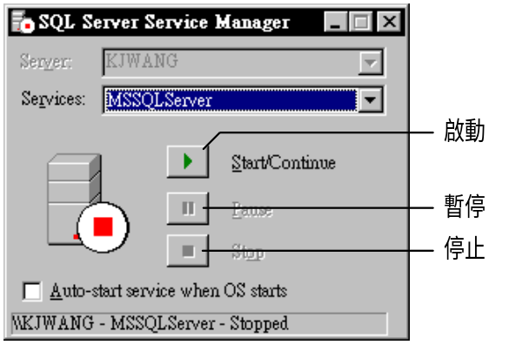
¨¥SQL Server¤«¡¤©±°¥¡¦®µª¤·§¤³¥¨¡µ¨³±SQL Server¤¦¥®¡¤¤Ä²º¤¯¡
Enterprise Manager
±°SQL Server¨¥°¦Enterprise Manager¤«¡¨§®¶¸®®ªµº¨ "Databases" ¬¤¡§¥¥¬¨SQL Server 7.0¤¶©·«¥´¸®®¡¦¤¹¡
¹-13 | 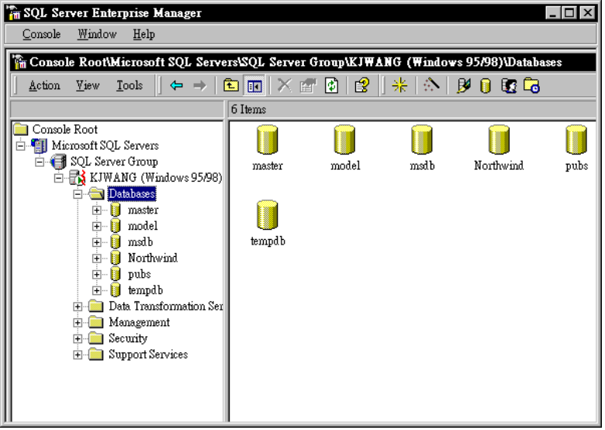
¨¤Northwind¤pubs¬SQL Server´¨µ§½²ª¸®®¡½¸µ®¶Northwind¸®®¡¦¤¹¡
¹-14 | 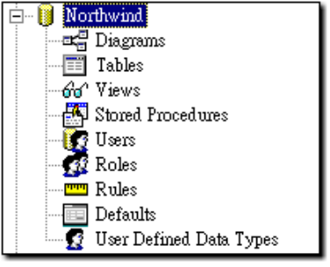
¨¤»VB¸®®µ¦³¦Ãªª¥¦Diagrams¡Tables¡Views¡¤Stored Procedures¡¤¤¸µª±¦¶¤¨ª»©¡
15-2 »ÃSQL Serverª¥ª¥
©ÄEnterprise Managerª¤²¡§¥¥¦Northwind¸®®©¤¬¨Diagrams¡Tables¡Views¡¤Stored Proceduresµª¥¡¥¤Åµª¥¨»©³¨ª¥ª·¸¤¥³¡
Table¡¸®ª
¦Northwind¸®®©¤¿¨Tables¡±µ§¥¥¦Enterprise Manager¥Ãªµ®¬¨¤¨ª®¡¦¤¹¡
¹-15 | 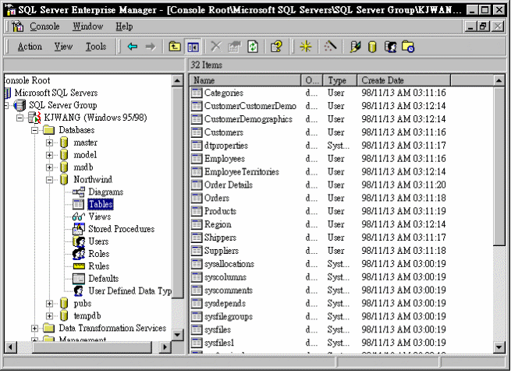
¸mdb¸®®ª¸®ª¤¼¡SQL Serverª¸®ª¤¬¨¸®®¤¤³ª¸®À¦ª¥¡
View¡Àµª
Àµª(View)¦¨¦¤¡»mdb¸®®SelectÃ«ªQueryDefª¥«¹¡³¬§¥Select«¥¨º¦¥¤¡Å¿¸®ª¡¡½¿¨Northwind©¤ªViews¡µ«¦¥·¹¥¶«¤¥Ãµ®ª¥¤Àµª(¨¦ "Alphabetical list of products")¡³«¿¨Design View¡§¥¬¨¸Àµªª³µµ¡
¹-16 | 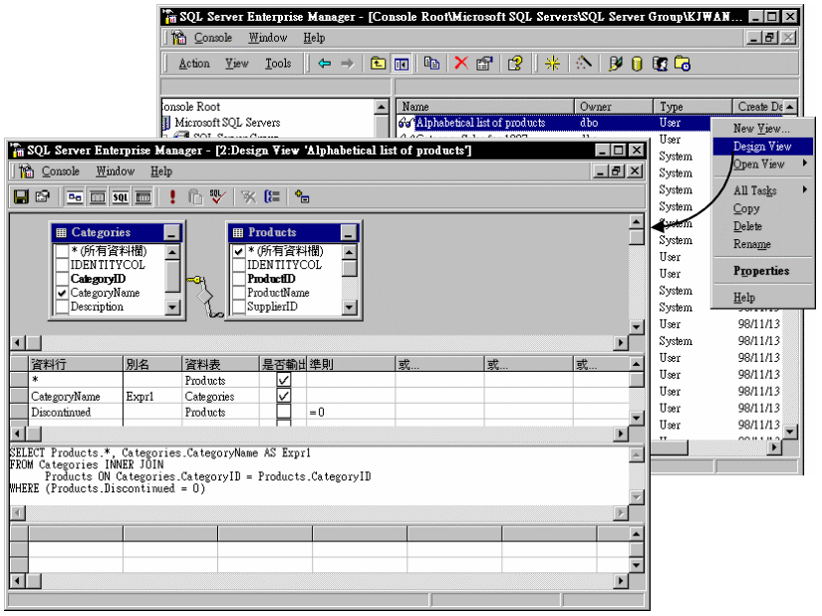
Àµªª³µµ¬°¨À¸¤¥¡¥ª¥ª´¸²11³©¤²ªSQL Builder§¥¬¦¡¥¬µª¥¶´¿±ª¬§¥SQL Builder©«¥ªSelect«¥·³À¦¦Commandª¥¡¦¬¥Select«¥©º¦ªÀµª¨¨¦«»¸®ª¤¸¹¡±¨§¦VBµ¦¤¨¥Àµª®¡¤¥¥±¨µ¬¤Select«¥¡¦±¨µ¬¤¸®ª¡
Relationships¡¸®ªÃ³¹
¹-17 | 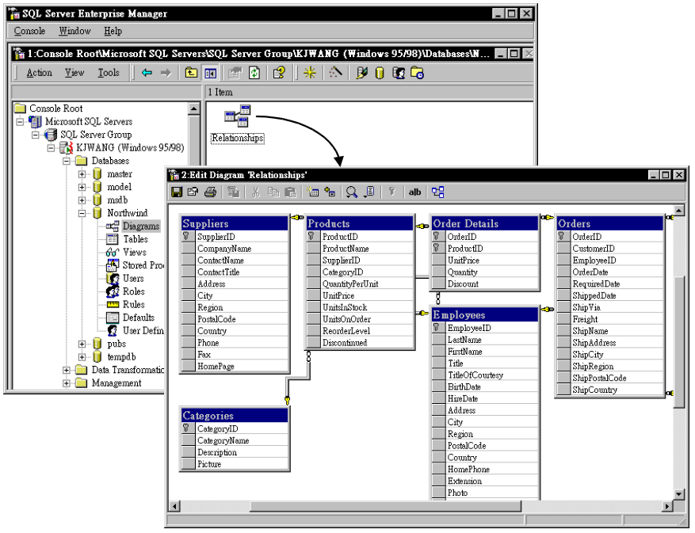
¿¨Northwind©¤ªDiagrams¡¦¿¨¥Ãµ®ªRelationships¡µª·Å¥Northwind¸®®¤¤©¦¸®ª¤¶ªÃ³©¡
§´¸¦²12³§¥Data Environment«¥¹¸®ª¤¶ªÃ³©¡§¨¥ª¸®®¬SQL Server¡¨¥¤¸§¥¤¹ªµµ¨«¥¸®ªªÃ³©¡«±¨¨¥Data Environment®¡¥¿¨¤¥¦¨¨¦Ã³©ª¸®ª¡«¸®ª¤¶ªÃ³¹´·¦°¥²¦Data EnvironmentªSQL Builderµµ¤¡¤¥·«¥¡¨¥SQL Server¤«Ã³©ª¥¤¦³¬¨°¦®¯À©¨¥Data Environment©«¥ªÃ³©¡
Stored Procedure¡¹¦µ§
¹-18 | 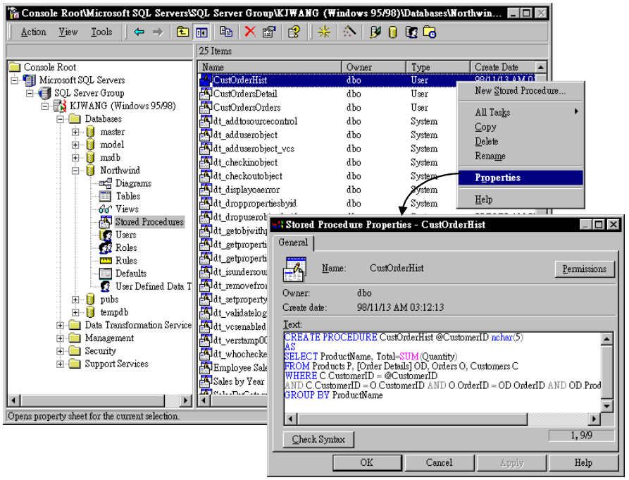
Stored Procedure(¹¦µ§)¦¨¦¤¥¥¸Ä¦À¦©¸®®¤¤ªSQL«¥¡¤¹¥¤¦ÂÃ¦µ¦»¨ª¡µ§¡¡¬³º¬¹¦µ§¡
¦¤¹¡½¿¨Northwind©¤ªStored Procedures¡µ«¦¥·¹«¤¥Ãµ®ª¥¤¹¦µ§(¨¦ "CustOrderHist")¡³«¿¨Properties¡§¥¬¨¸¹¦µ§ª¤®¡

