DevSecOps Blue-Green Deployment
Swiggy-Clone Application on AWS ECS
Project Proof Document
GitHub | AWS CodePipeline | AWS CodeBuild | AWS CodeDeploy
Amazon ECS | Amazon ECR | SonarQube | Trivy (Aqua Security)
Application Load Balancer | AWS Parameter Store | IAM | Docker
Region: ap-south-1 (Mumbai) | Date: May 16, 2026 | Total Proofs: 10 Screenshots

Architecture Diagram
Complete system architecture — all tools and how they connect on AWS
This diagram shows the full DevSecOps architecture for the Swiggy-clone project. The Developer pushes code to GitHub which triggers CodePipeline. CodePipeline orchestrates the Build stage (CodeBuild) and Deploy stage (CodeDeploy). CodeBuild runs SonarQube and Trivy security scans, builds the Docker image, and pushes it to Amazon ECR. CodeDeploy pulls the image from ECR and performs Blue-Green deployment on ECS. The Application Load Balancer routes all user traffic between Blue and Green environments. AWS Parameter Store securely holds all credentials. Five IAM roles provide least-privilege access to each service.
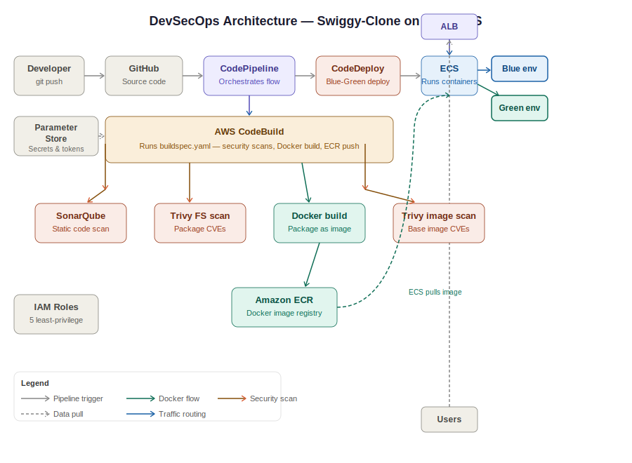
Architecture diagram — Developer to GitHub to CodePipeline to CodeBuild (security scans) to ECR to CodeDeploy to ECS to ALB to Users

CI/CD Pipeline — How It Works
Step-by-step flow from git push to live deployment
This diagram shows exactly what happens inside the pipeline from the moment a developer pushes code to the moment the new version is live. Step 1: Developer pushes to GitHub. Step 2: CodePipeline triggers and pulls the code. Step 3: CodeBuild runs the full build — SonarQube static scan, Trivy filesystem scan, Docker image build, Trivy image scan. If any scan fails the pipeline stops. Step 4: Passing image is pushed to Amazon ECR. Step 5: CodeDeploy deploys to Green environment, runs health checks, and shifts ALB traffic from Blue to Green. Step 6: New version is live with zero downtime. If health checks fail, CodeDeploy automatically rolls back to Blue.
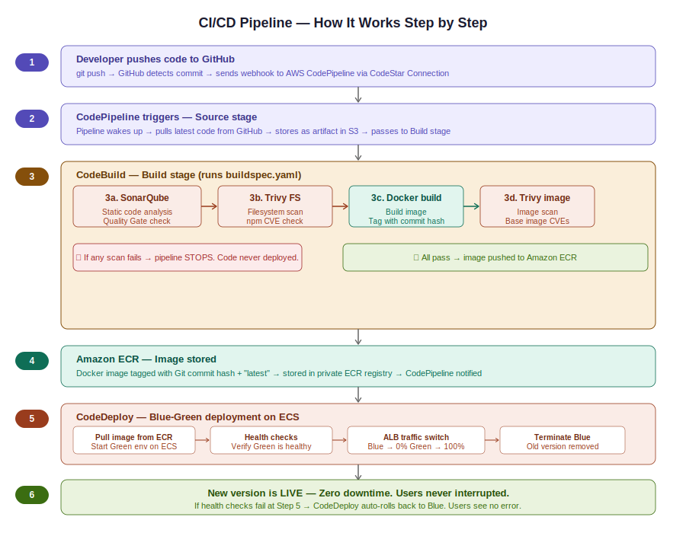
CI/CD pipeline — 6 stages from git push to live Blue-Green deployment with automatic rollback on failure

Proof 1 — IAM Roles — Security Foundation
All 5 project-specific IAM roles created in ap-south-1
This screenshot shows the AWS Identity and Access Management (IAM) console filtered by "swiggy", displaying all 5 service roles created exclusively for this project. Each role follows the principle of least privilege — granted only the minimum permissions required for its specific service.
The 5 roles are: swiggy-codebuild-role (AWS CodeBuild), swiggy-codedeploy-role (AWS CodeDeploy), swiggy-codepipeline-role (AWS CodePipeline), swiggy-ecs-task-execution-role (ECS Tasks), and swiggy-sonarqube-ec2-role (EC2). All roles were active 9 hours ago confirming they were used in the pipeline run.
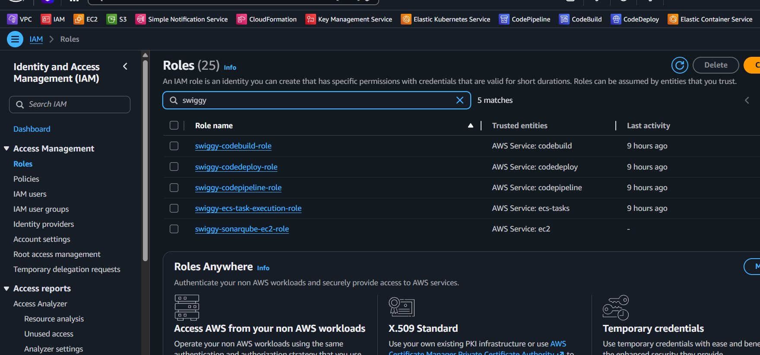
Fig 1 — IAM Roles console filtered by swiggy showing all 5 project roles with their trusted entities

Proof 2 — SonarQube — Code Quality Gate Passed
swiggy-clone project analysis showing 0 bugs and 0 vulnerabilities
This screenshot shows the SonarQube Projects dashboard displaying the swiggy-clone project with a green Passed Quality Gate status. The analysis was completed 10 hours ago and covers approximately 1,000 lines of JavaScript code.
The scan results show: 0 Bugs (A rating), 0 Vulnerabilities (A rating), 0 Code Smells (A rating). If this scan had failed, CodeBuild would have stopped and the code would never have been deployed.
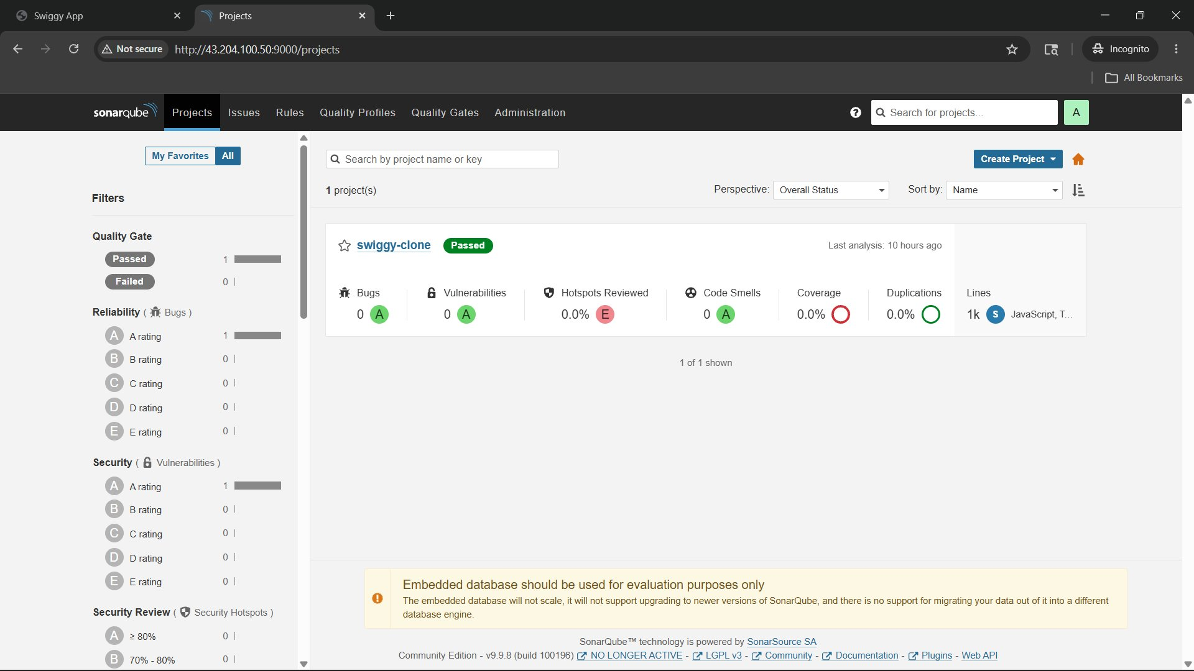
Fig 2 — SonarQube dashboard showing swiggy-clone Quality Gate: Passed with 0 bugs, 0 vulnerabilities, A rating

Proof 3 — SonarQube Analysis — CodeBuild Execution Logs
SonarQube scanner running inside AWS CodeBuild pipeline
This screenshot shows the AWS CodeBuild logs at the exact moment the SonarQube scanner was executed. Line 459 shows the sonar-scanner command being run with the project key, host URL, and authentication token — all retrieved securely from AWS Parameter Store at runtime.
The logs confirm: Scanner version 3.1.0.1141, SonarQube Server version 9.9.8 connected, project key swiggy-clone analysed, and auto-configuration with AWS CodeBuild CI detected. The analysis ran inside a temporary CodeBuild container with no manual intervention.
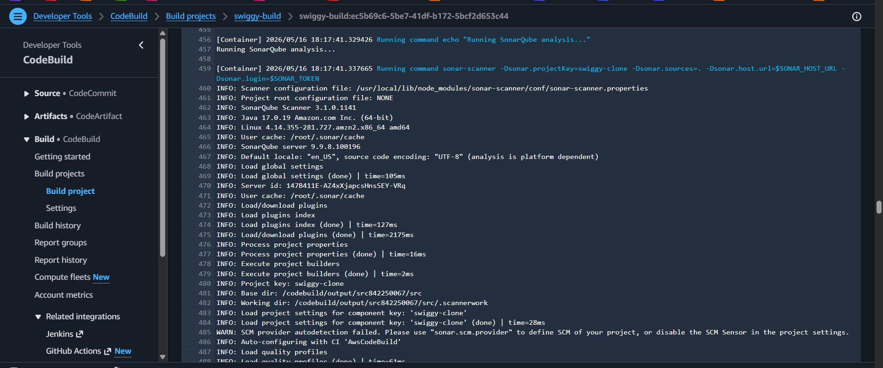
Fig 3 — CodeBuild logs showing SonarQube scanner execution connecting to server v9.9.8 with project key swiggy-clone

Proof 4 — CodePipeline — Full Pipeline Success (Version 2.0)
All 3 stages succeeded for commit: Added something to App.js
This screenshot shows the AWS CodePipeline swiggy-pipeline with all 3 stages showing green success indicators. The pipeline was triggered automatically by a GitHub commit with the message Added something to App.js — commit hash df910743. All stages share the same execution ID confirming this is a single end-to-end automated run.
Stage 1 Source: GitHub via GitHub App detected the commit and pulled the code. Stage 2 Build: AWS CodeBuild ran security scans, built the Docker image, and pushed it to ECR. Stage 3 Deploy: AWS CodeDeploy performed the Blue-Green deployment on ECS.
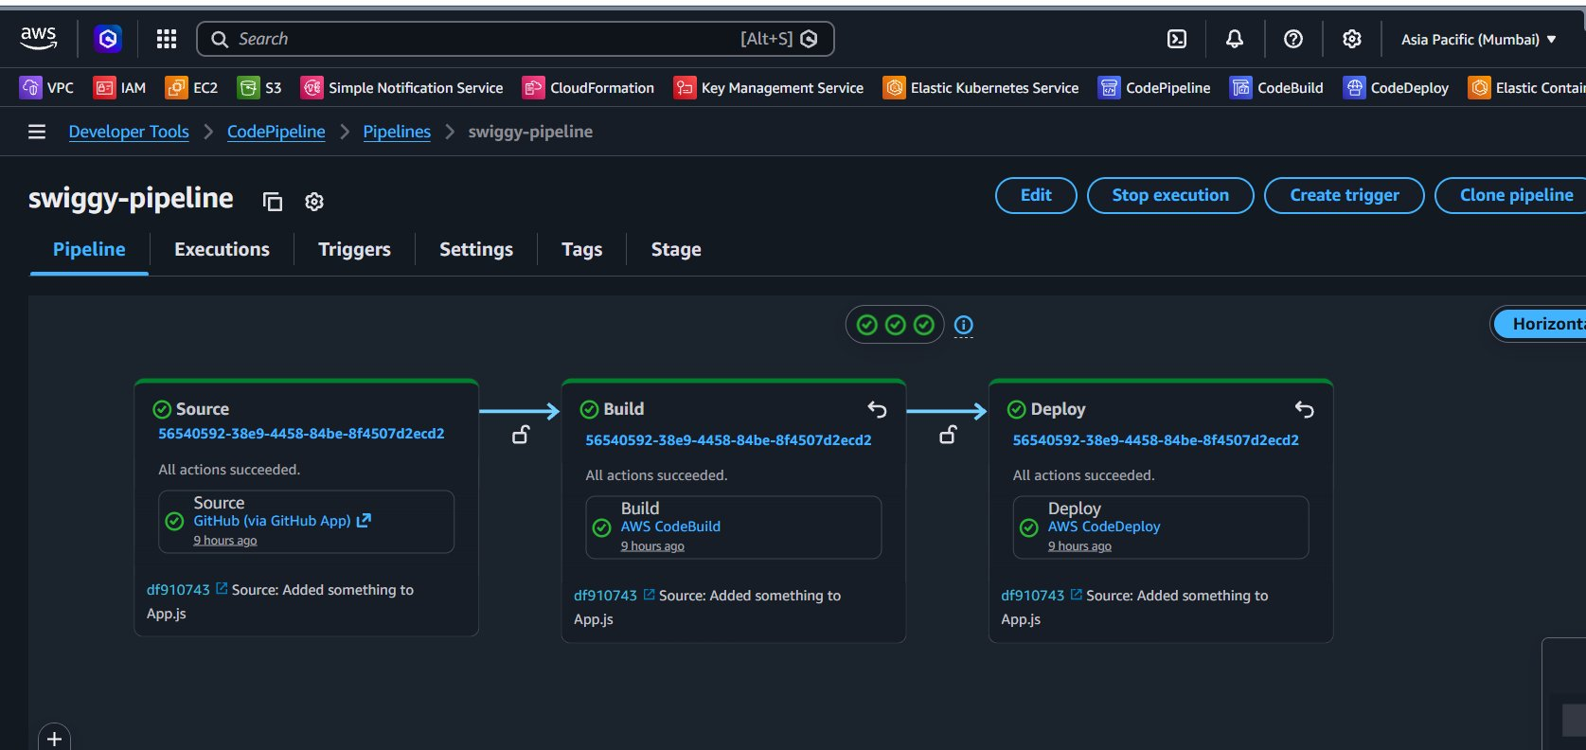
Fig 4 — CodePipeline swiggy-pipeline showing Source, Build, Deploy all succeeded for commit df910743

Proof 5 — Trivy Scan 1 — Filesystem Security Scan
Trivy scanning project dependencies for CVEs before Docker build
This screenshot shows AWS CodeBuild logs for the first Trivy security scan — the filesystem scan. This runs against the raw project source code before the Docker image is built. Trivy downloads its vulnerability database (93.06 MB) and scans all project dependencies.
The scan confirmed: Vulnerability scanning enabled, Secret scanning enabled to detect hardcoded credentials, npm package scanning detected 1 language-specific file (package.json). Results saved to trivyfilescan.txt as a pipeline artifact.
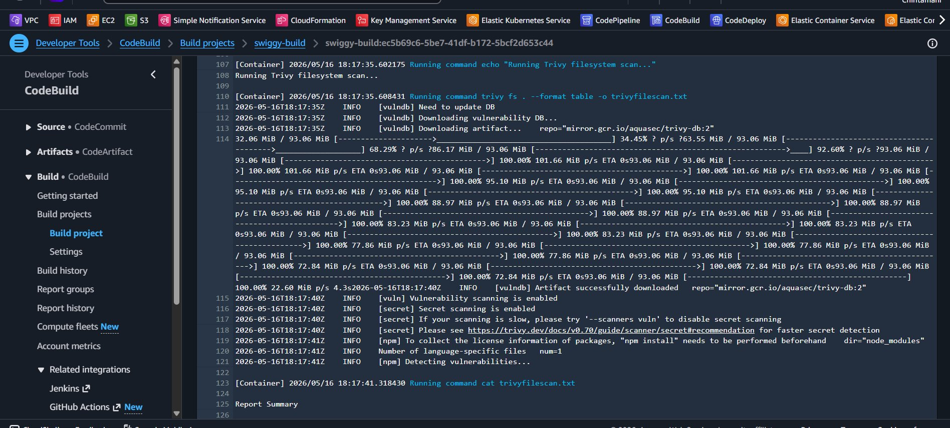
Fig 5 — CodeBuild logs showing Trivy filesystem scan downloading vulnerability DB and scanning npm dependencies

Proof 6 — Trivy Scan 2 — Docker Image Security Scan
14 MEDIUM CVEs found in Alpine 3.23.4 base image layer
This screenshot shows the second Trivy scan — the Docker image scan — against the built image swiggy-clone:df91074. Trivy detected the OS as Alpine version 3.23.4 and scanned 72 packages.
Results: UNKNOWN 0, LOW 0, MEDIUM 14, HIGH 0, CRITICAL 0. These vulnerabilities are in the Alpine base image layer, not the application code. This is why two separate Trivy scans are required — one for code, one for the container runtime.
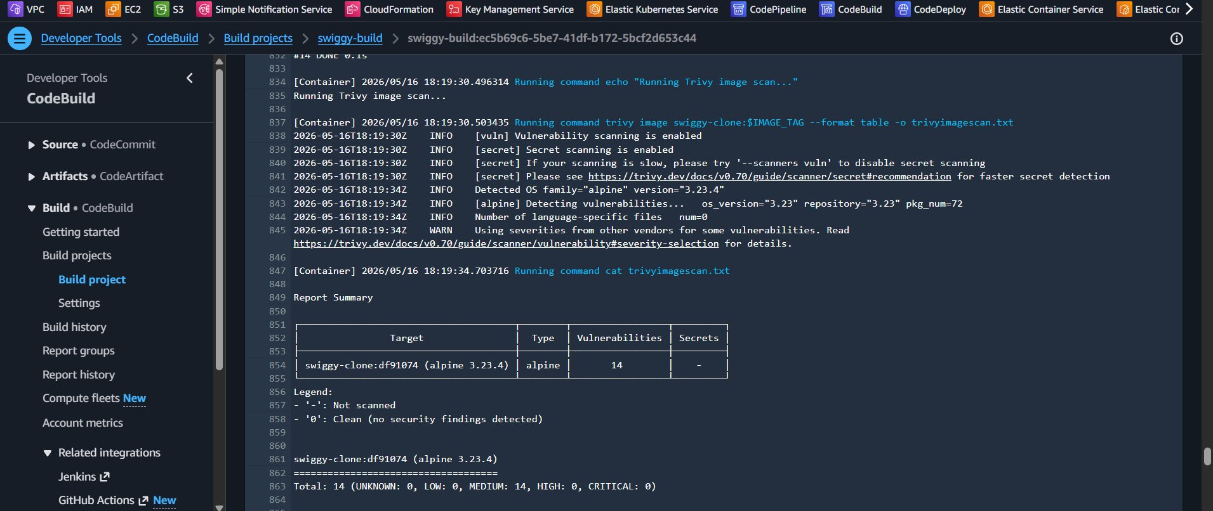
Fig 6 — Trivy image scan: 14 MEDIUM CVEs in alpine 3.23.4 base image, 0 HIGH, 0 CRITICAL

Proof 7 — Live Application — Version 1 (Blue Environment)
Swiggy-clone app running on ALB before code change
This screenshot shows the Swiggy-clone application running live on the AWS Application Load Balancer. This is Version 1 — the Blue environment. No orange banner is visible, confirming this is the original version before any code changes.
The application displays food categories, offers, and restaurant listings — a fully functional Swiggy-like food delivery interface deployed as a containerised React application on Amazon ECS.
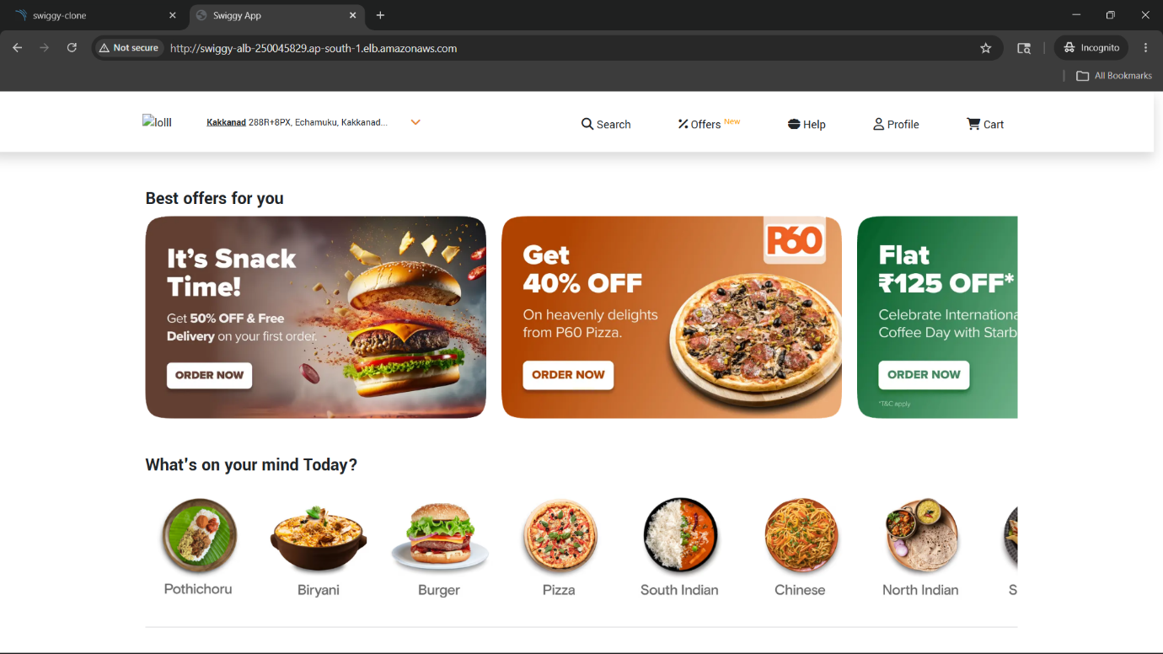
Fig 7 — Swiggy-clone Version 1 (Blue) live at ALB URL — original version serving users before pipeline run

Proof 8 — Live Application — Version 2 (Green Environment)
App updated with Version 2.0 banner after Blue-Green deployment
This screenshot shows the same ALB URL after the pipeline completed successfully. The orange banner Version 2.0 — Deployed via Blue-Green DevSecOps Pipeline on AWS ECS confirms the new version is live. The identical ALB URL proves users experienced no URL change or downtime.
This version was deployed automatically by the pipeline triggered by commit df910743. CodeBuild built a new Docker image, pushed it to ECR, CodeDeploy deployed to Green, ran health checks, and the ALB shifted 100% traffic from Blue to Green.
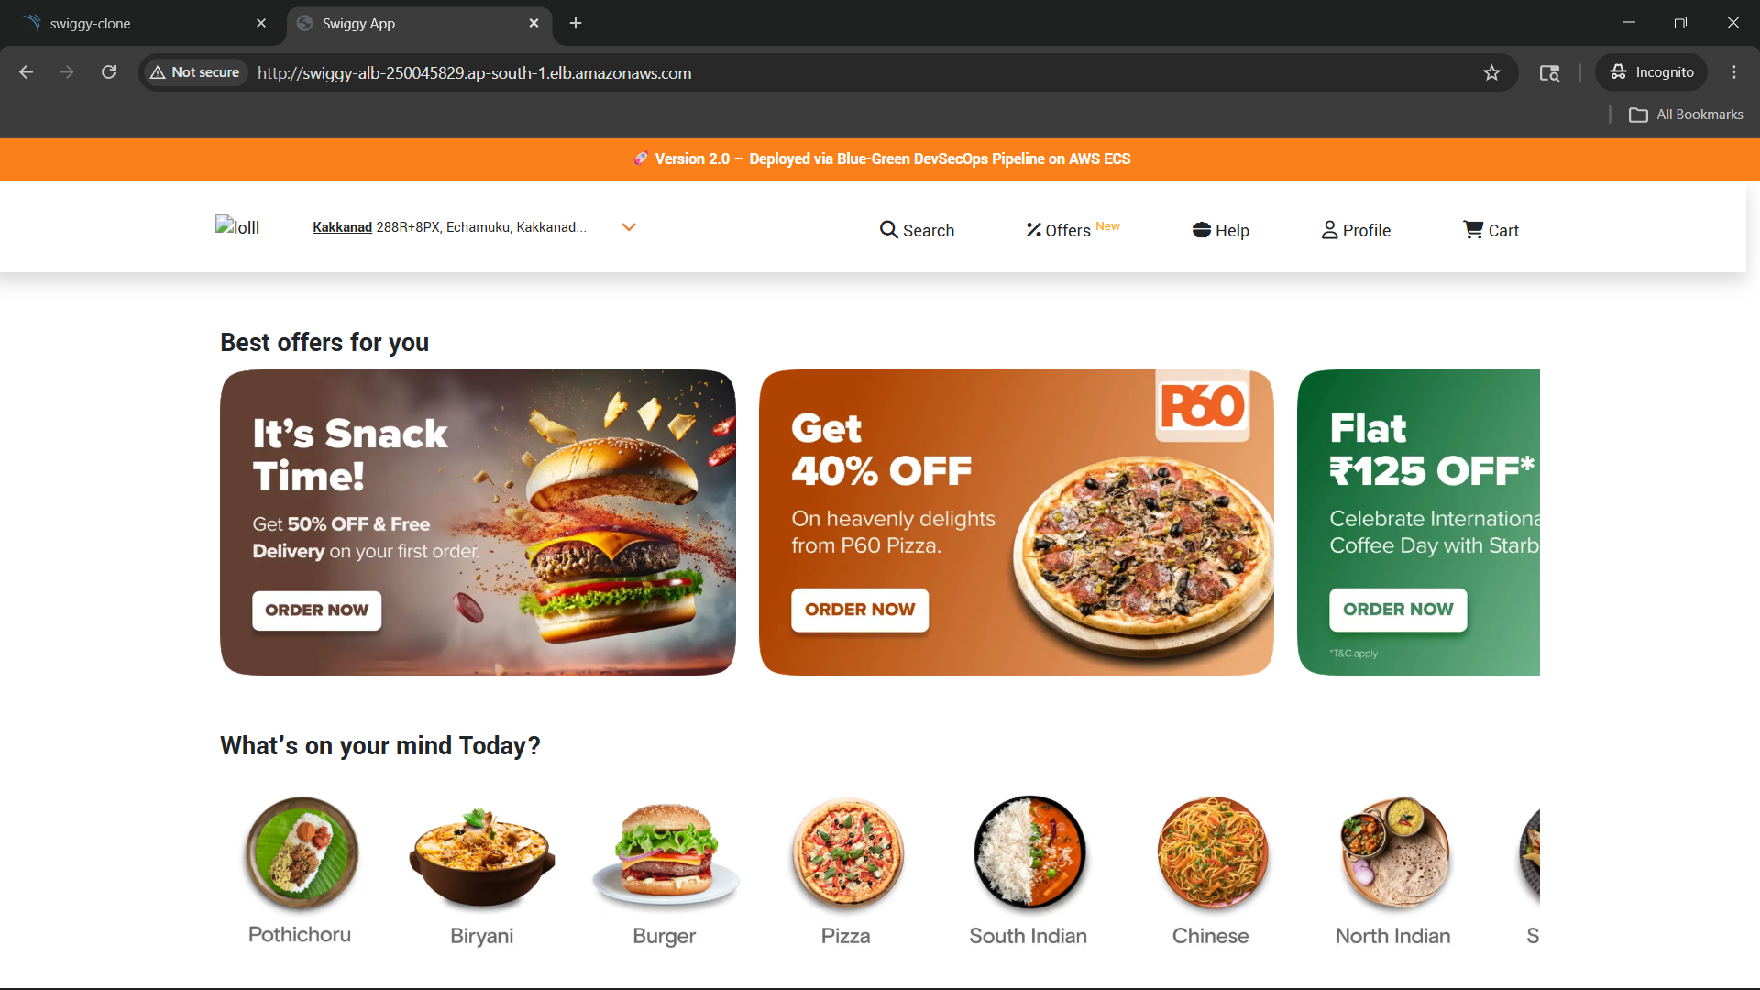
Fig 8 — Swiggy-clone Version 2.0 (Green) at same ALB URL — orange banner confirms successful Blue-Green deployment

Proof 9 — CodeDeploy — Deployment History with Rollbacks
4 deployments showing Blue/Green strategy including automatic rollbacks
This screenshot shows the AWS CodeDeploy deployment history. All 4 deployments are of type Blue/green on Amazon ECS. There are 2 successful deployments (d-E2AX7EECI and d-ZATIZVCCI) and 2 failed deployments (d-TC45H3DCI and d-5SUYKHDCI).
The 2 failed deployments demonstrate automatic rollback. When CodeDeploy detected a configuration mismatch, it kept traffic on Blue and never completed the switch to Green. Users experienced zero downtime during these failed attempts.
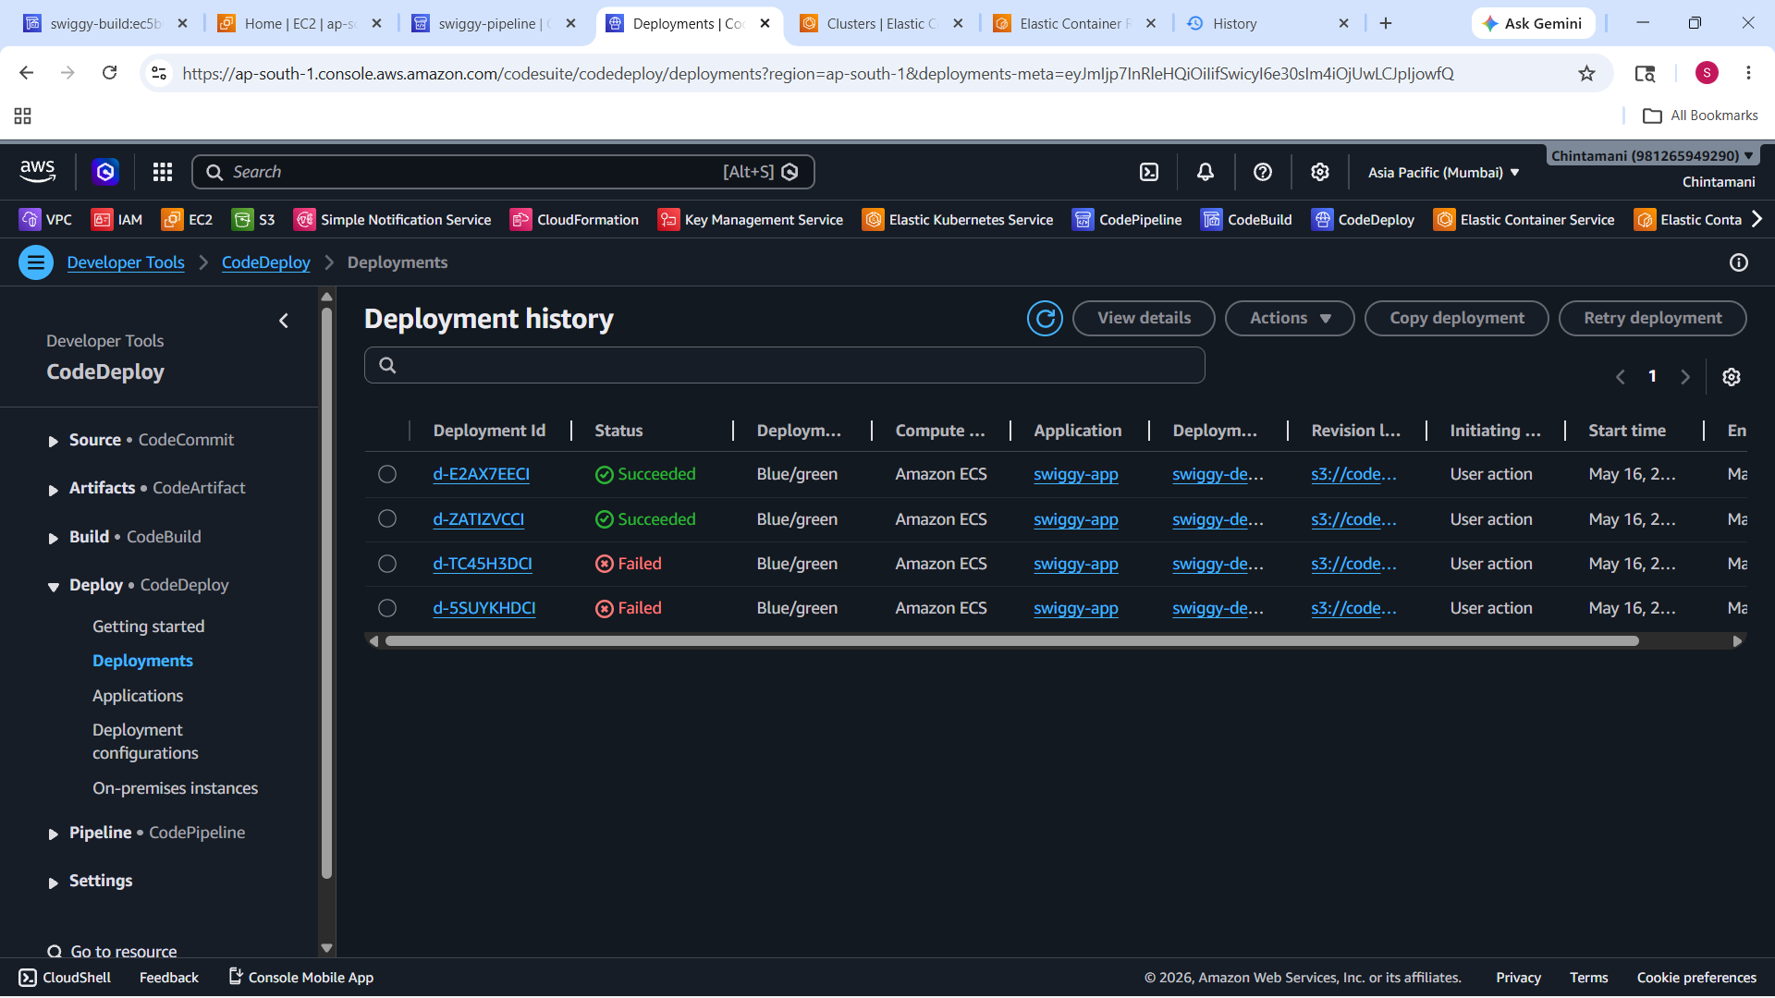
Fig 9 — CodeDeploy history: 2 successful Blue/Green deployments and 2 auto-rolled-back failed attempts on Amazon ECS

Proof 10 — CodeDeploy — 100% Traffic Shifted to Green
Deployment d-E2AX7EECI showing complete Blue-to-Green traffic switch
This screenshot shows the detailed view of the most recent successful deployment. All 5 steps completed: Deploy replacement task set, Test traffic route setup, Reroute production traffic (100% shifted), Wait, and Terminate original task set.
The Traffic shifting panel shows Original (Blue) at 0% and Replacement (Green) at 100%. This transition happened automatically with no manual intervention and zero downtime for end users.
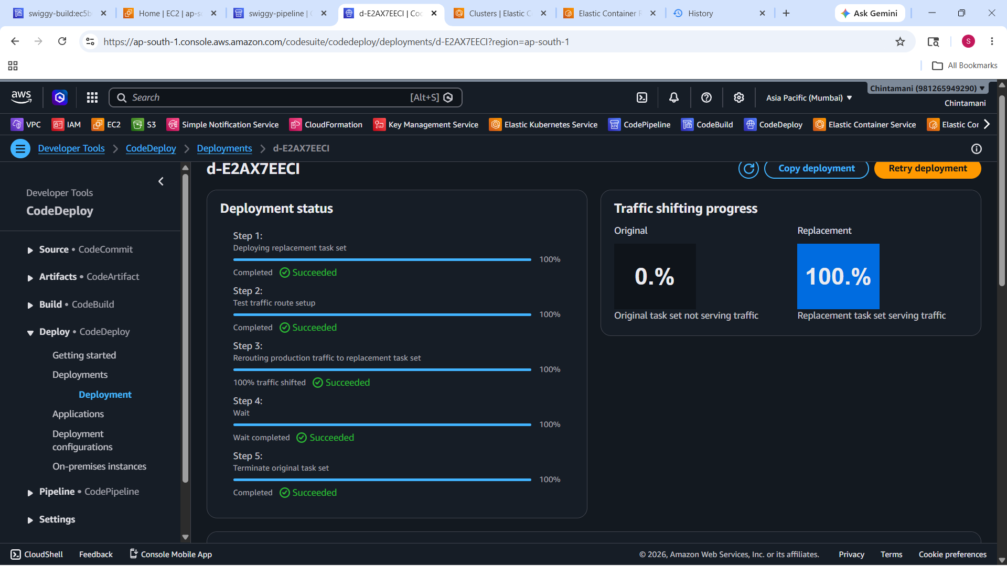
Fig 10 — CodeDeploy d-E2AX7EECI: Original (Blue) 0% traffic, Replacement (Green) 100% — full switch complete

Project Summary
This document proves the complete implementation of a DevSecOps CI/CD pipeline with Blue-Green deployment on AWS. The following capabilities were built, tested, and verified:
Security (DevSecOps)
- SonarQube static code analysis with Quality Gate enforcement — 0 bugs, 0 vulnerabilities detected
- Trivy filesystem scan — npm dependency CVE detection with secret scanning enabled
- Trivy image scan — 14 MEDIUM CVEs detected in Alpine base image, 0 HIGH, 0 CRITICAL
- All credentials stored in AWS Parameter Store — never hardcoded in source code
CI/CD Automation
- GitHub push automatically triggers CodePipeline via CodeStar Connection
- CodeBuild runs full security scan and Docker build pipeline via buildspec.yaml
- Docker image tagged per Git commit hash and pushed to Amazon ECR automatically
- CodeDeploy performs Blue-Green deployment on ECS with ALB traffic management
Reliability
- Zero downtime deployment — users experienced no interruption during version switch
- Automatic rollback — 2 failed deployments kept Blue environment live with no user impact
- Health check enforcement — Green environment verified healthy before traffic switch
- 5 IAM roles created following principle of least privilege
Live Application URL
http://swiggy-alb-250045829.ap-south-1.elb.amazonaws.com
AWS Region: ap-south-1 (Mumbai) | ECR: 981265949290.dkr.ecr.ap-south-1.amazonaws.com/swiggy-clone

