1. There are different interpretations of artificial intelligence in different contexts. Please elaborate on the artificial intelligence in your eyes.

Artificial intelligence is the simulation of human intelligence processes by machines, especially computer systems. It can make a decision

2. Artificial intelligence, machine learning and deep learning are three concepts often mentioned together. What is the relationship between them? What are the similarities and differences between the three terms?

Artificial intelligence, machine learning and deep learning. The three terms are often used interchangeably, but they do not quite refer to the same things.

Here is an illustration designed to help us understand the fundamental differences between artificial intelligence, machine learning, and deep learning.

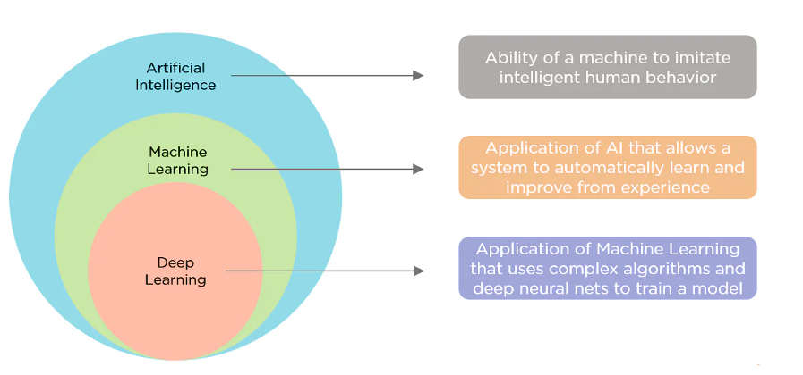

3. After reading the artificial intelligence application scenarios in this chapter, please describe in detail a field of AI application and its scenarios in real life based on your own life experience.

The most advanced form of applications of artificial intelligence in the real-world are being implemented in homes, and are becoming smarter every day. Various devices like smart locks, smart switches, ect., are increasingly becoming compatible with various devices, and the application of smart homes is becoming more accessible to the general population every day.

The past few years have witnessed many smart devices that can now learn your behavior patterns and help you save money by saving energy, suggesting steps that can potentially save your time and resources, and implementing cost-optimized operations. These devices help you with a smarter way of living.

Thermostats and building management systems can help automate building heating and cooling, for instance. In effect, they learn and can predict when to turn your boiler on or off for optimal comfort, whilst factoring in outside weather conditions as well.

4. Which chip is for deep neural networks and Ascend AI processors. Please brief these four major modules.

**Logic Architecture of Ascend AI Processor Software Stack**

L3 application enabling layer: It is an application-level encapsulation layer that provides different processing algorithms for specific application fields. L3 provides various fields with computing and processing engines. It can directly use the framework scheduling capability provided by L2 to generate corresponding NNs and implement specific engine functions.

- Generic engine: provides the generic neural network inference capability.

- Computer vision engine: encapsulates video or image processing algorithms.

- Language and text engine: encapsulates basic processing algorithms for voice and text data.

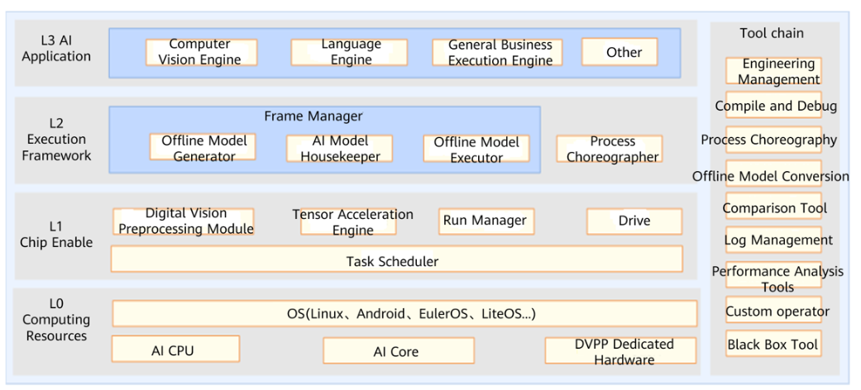

The software stack of the Ascend AI chip consists of four layers and an auxiliary toolchain. The four layers are the application enabling layer (L3), execution framework layer (L2), chip enabling layer (L1), and computing resource layer (L0). The toolchain provides auxiliary capabilities such as program development, compilation and commissioning, application process orchestration, log management, and profiling. The functions of the main components depend on each other in the software stack. They carry data flows, computing flows, and control flows.

L2 execution framework layer: encapsulates the framework calling capability and offline model generation capability. After the application algorithm is developed and encapsulated into an engine at L3, L2 calls the appropriate deep learning framework, such as Caffe or TensorFlow, based on the features of the algorithm to obtain the neural network of the corresponding function, and generates an offline model through the framework manager. After L2 converts the original neural network model into an offline model that can be executed on Ascend AI chips, the offline model executor (OME) transfers the offline model to Layer 1 for task allocation.

L1 chip enabling layer: bridges the offline model to Ascend AI chips. L1 accelerates the offline model for different computing tasks via libraries. Nearest to the bottom-layer computing resources, L1 outputs operator-layer tasks to the hardware.

L0 computing resource layer: provides computing resources and executes specific computing tasks. It is the hardware computing basis of the Ascend AI chip.

**Neural Network Software Flow of Ascend AI Processors**

The neural network software flow of Ascend AI processors is a bridge between the deep learning framework and Ascend AI chips. It realizes and executes a neural network application and integrates the following functional modules.

Process orchestrator: implements the neural network on Ascend AI chips, coordinates the whole process of effecting the neural network, and controls the loading and execution of offline models.

Digital vision pre-processing (DVPP) module: performs data processing and cleaning before input to meet format requirements for computing.

Tensor boosting engine (TBE): functions as a neural network operator factory that provides powerful computing operators for neural network models.

Framework manager: builds an original neural network model into a form supported by Ascend AI chips, and integrates the new model into Ascend AI chips to ensure efficient running of the neural network.

Runtime manager: provides various resource management paths for task delivery and allocation of the neural network.

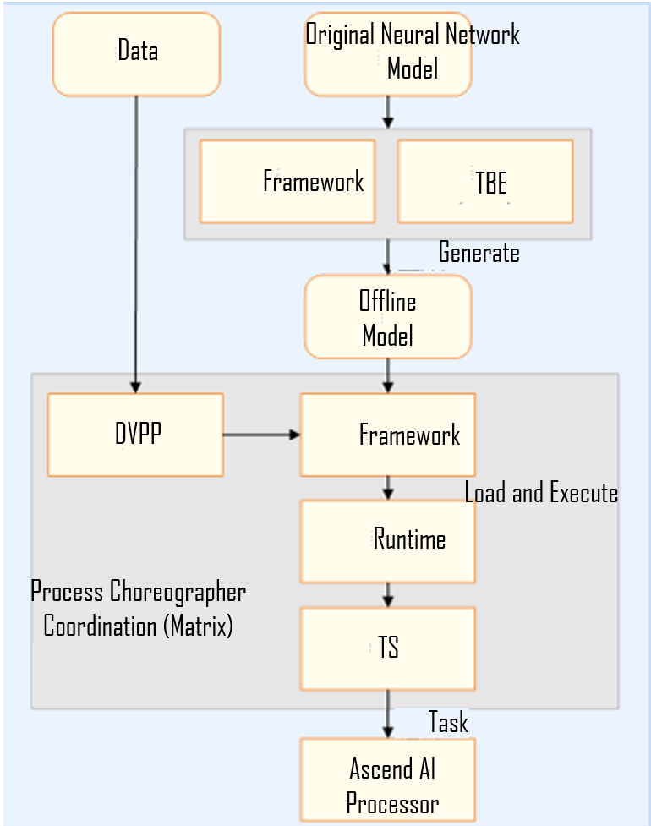

5. Based on your current knowledge and understanding, please elaborate on the development trends of artificial intelligence in the future in your view.

AI will impact every industry in the future, replacing humans in most jobs. But can't dominate people.