GestureForge Assignment Technical Report
ICT304 Developing an AI System | Assignment prototype due 3 October 2026
Team names supplied: Jameson and Deston. Surnames, student numbers, university emails, contribution percentages, tutor approval and signatures remain pending and must be completed on the Group Declaration Sheet before submission.

Executive Summary
GestureForge is a Windows desktop AI prototype for controlling a small card deck with personal static hand gestures. The assignment release demonstrates one complete product workflow: a webcam hand pose is converted to MediaPipe landmarks, normalised into a 60-value feature vector, classified by kNN and RBF SVM for comparison, filtered by distance-based rejection, and passed through a neutral-hold controller that executes NEXT once per deliberate hold.
The scope is deliberately bounded. NEXT is the only command that changes the viewer in Assignment 1. PREVIOUS and BOOKMARK can be recognised and displayed, but they remain preview-only so the 7 November project still has meaningful implementation work: in-app enrolment, profiles, saved state, all three commands, validated decks, held-out evaluation and a demo video.
Current evidence supports a runnable prototype and preliminary AI-subsystem results. It does not prove final full-command safety, untouched held-out generalisation, guide-only second-laptop setup, tutor approval or completed declaration paperwork.
Assessment criterion | How this report addresses it | Current evidence limit
Systems engineering 10% | Lifecycle gates, decisions, risks, tools, milestones | Tutor feedback still pending
Requirements/problem/tests 30-35% | Problem, users, numbered requirements, contracts, subsystem tests | Some acceptance gates are still human/submission tasks
Technique investigation 20% | kNN and SVM comparison with shared preprocessing and rejection | Development validation only
Prototype/results 15-20% | Runnable code, live NEXT path, P01 metrics, P02 qualitative feedback | No formal latency or false-action series yet
Innovation 10% | Personal gestures plus deliberate activation and explainable local AI | Does not claim invented hand tracking
Writing/references 10% | Figures, tables, sources, tools and prompt appendix | Final team details must be completed

Problem and Scope
The target user is a presenter, student or demonstrator who wants to move through a prepared card deck without touching a keyboard or mouse. The problem is not sign-language recognition or PowerPoint automation. It is a bounded human-computer interaction task: recognise a small personal command set while reducing accidental navigation.
- Assignment prototype: collect personal examples, compare kNN and SVM, show live prediction and execute NEXT only on the supplied fixed deck.
- Final project extension: add guided enrolment, multiple profiles, PREVIOUS and BOOKMARK actions, saved state, custom decks, complete evaluation and final demo materials.
- Out of scope: dynamic gestures, operating-system or PowerPoint control, cloud accounts, mobile apps, deep-network training and an executable installer.

System Engineering Approach
The build applies the System Engineering Product Life Cycle at student-prototype scale. The assignment covers feasibility, concept definition, requirements, preliminary design, one AI-subsystem prototype and evidence planning. The final project continues into detailed integration, verification, validation, deployment preparation and closeout.
Lifecycle activity | Assignment work | Project continuation
Concept and feasibility | Problem, stakeholder, scope and camera feasibility checks | Tutor-confirmed scope and user workflow refinements
Preliminary design | Requirements, contracts, feature pipeline, classifier comparison plan and controller design | Profile, deck, persistence and recovery design
Build and integrate | Collection CLI, feature extraction, models, fixed viewer and NEXT controller | Complete enrolment workflow and all viewer commands
Verify and validate | Unit tests, static checks, pilot validation, live NEXT smoke evidence | Held-out data, false-action, latency, stability and release checks
Operate and close out | Guide, logs, declaration template and submission gates | Maintenance plan, final video, presentation and data-retention closeout

Architecture
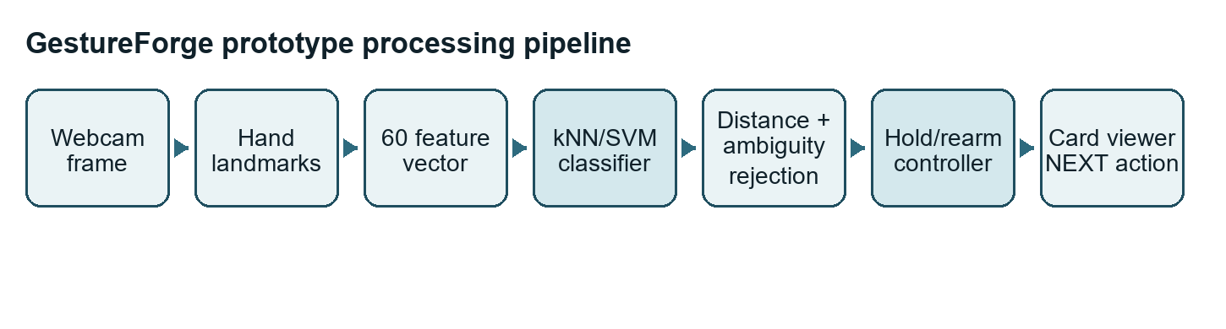
Figure 1. Assignment prototype pipeline from webcam input to one protected NEXT action.
MediaPipe supplies pretrained hand landmarks. The team contribution is the system around those landmarks: personal data collection, feature normalisation, train-only scaling, kNN/SVM comparison, open-set rejection, activation control, viewer integration, tests and reproducible documentation.
Subsystem | Input | Output | Safeguard
Capture | Webcam frame and MediaPipe model asset | Observation with landmarks, handedness and timestamp | No raw recording during normal use
Features | One valid selected-hand observation | 60 normalised numeric features | Reject invalid scale, wrong hand, no hand, multiple hands and non-finite landmarks
Models | Training vectors and labels | kNN/SVM prediction plus rejection status | Train-only scaler and numeric data, no pickle/joblib loading
Controller | Accepted fresh predictions | Zero or one command event | Neutral arm, hold, latch and stale-frame rejection
Viewer | Command or keyboard event | Updated fixed-deck card position | No wrap and duplicate-event rejection

AI Subsystem Design
Each profile uses one chosen hand. A valid observation starts from 21 MediaPipe world landmarks. GestureForge subtracts the wrist position, divides by the wrist-to-middle-finger MCP distance, removes the wrist triplet and flattens the remaining 20 landmarks into 60 numeric features. This reduces translation and approximate hand-camera scale while preserving orientation.
Both classifiers use the same StandardScaler fitted only on training data, so the comparison is about the decision method rather than a different preprocessing path. The k-nearest-neighbour model stores the scaled training vectors and predicts from the closest labelled examples, using k=5 and distance weighting for the assignment run. The RBF SVM learns nonlinear class boundaries from the same scaled vectors with C=1 and gamma=scale. SVM decision values are treated only as model scores, not as user-facing confidence percentages.
The shared open-set rejection layer is applied after either classifier predicts a label. Let d_pred be the distance from the scaled live vector to the nearest training vector of the predicted class. For each class, T_class is the 95th percentile of leave-one-trial-out nearest-neighbour distances inside that class, multiplied by the configured rejection multiplier; validation and test data are not used to fit this threshold. A prediction passes the distance rule when d_pred <= T_class.
The revised prototype-v3 margin then compares the nearest other-class distance, d_other, with the predicted-class distance. When margin > 1.0, the model accepts only if d_other / max(d_pred, 1e-12) >= margin. When margin is 1.0, the margin check is disabled so historical prototype-v2 configurations reproduce the distance-only behaviour. The legacy live demonstration used multiplier 2.0 and margin 1.0. The updated offline recommendation keeps multiplier 2.0 and adds margin 1.5; physical live retesting of this margin setting remains a separate gate.
Technique | Why considered | Observed assignment outcome | Reasonable assignment choice
kNN | Simple personal-example classifier; easy to explain and rebuild from numeric features | Macro-F1 0.9667 with margin 1.5; 30/32 genuine trials correct; negative command-label accepts reduce from 25/40 to 5/40 | Selected provisionally for the assignment software path because it remains explainable
RBF SVM | Standard nonlinear classifier for small feature vectors | Same macro-F1 trade-off as kNN in the margin analysis; legacy v2 prediction was faster offline | Kept as comparison and possible final-project candidate

Related Work and Technique Rationale
MediaPipe Hands describes a real-time on-device hand-tracking pipeline that predicts a hand skeleton from a single RGB camera using a palm detector and hand landmark model. GestureForge uses that landmark output as an input subsystem and does not claim to have invented hand tracking.
The $1 recognizer is relevant because it shows how lightweight example-based recognisers can support fast gesture-interface prototypes. GestureForge differs because it classifies static 3D landmark poses rather than 2D unistroke paths, but it shares the same prototype-friendly idea: a small user-specific example set can support a usable interaction.
Cover and Hart's nearest-neighbour work supports the use of distance-based classification for small labelled datasets, and the $1 recognizer page explicitly frames that recognizer as an instance-based nearest-neighbour classifier. Cortes and Vapnik's support-vector networks support the comparison with a nonlinear SVM candidate. NASA's lifecycle material supports the report's gated approach to concept, requirements, design, verification and closeout.

Controller and Viewer Behaviour
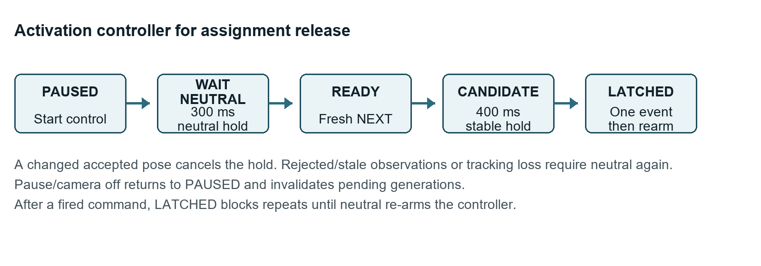
Figure 2. State machine that prevents one long hold from firing repeated NEXT actions.
The controller begins paused, waits for a stable neutral pose, accepts a fresh executable command candidate, fires once after the hold period, and then latches until neutral is shown again. Prediction age, frame order and gaps are checked so old results cannot execute after pause, loss of tracking or camera restart.
For the assignment release, the executable command set is only NEXT. PREVIOUS and BOOKMARK are recognised labels for preview and evaluation. An unrecognisable or rejected pose should be surfaced as UNKNOWN, not treated as a correct fallback. The existing validation-negative evidence shows why this matters: unfamiliar poses were often accepted as BOOKMARK offline, so BOOKMARK remains disabled as an action until final-project rejection improves.

Requirements Traceability
The requirement IDs below preserve the stable numbering used in docs/TEST_PLAN.md. Assignment status separates implemented software evidence from final-project work and human submission gates.
ID | Requirement | Assignment evidence | Final project evidence/status
RQ-001 | Local Windows Python 3.11 run | Environment check, launch smoke test, Python 3.11.16 and dependencies recorded | Second-machine release test still partly pending
RQ-002 | Work under code | Repository and source layout reviewed under the required code folder | Same layout continues for final project
RQ-003 | Labelled collection | CLI collection, manifest check, P01 TRAIN/VALIDATION/validation-negative sessions | GUI enrolment tests future
RQ-004 | 60-feature extraction | Unit tests cover shape, wrist removal and finite output | Same feature contract retained
RQ-005 | Invalid hand rejection | Unit tests cover no hand, multiple hands, wrong hand, non-finite landmarks and degenerate scale | Same with UI recovery messages
RQ-006 | kNN/SVM comparison | Reproducible evaluation and aggregate pilot metrics in results evidence | Bounded search and held-out testing future
RQ-007 | Hold/rearm controller | State-machine unit tests and live NEXT smoke path | Replay/live system tests future
RQ-008 | Assignment NEXT only | Viewer/controller integration executes NEXT only | Superseded by all-command tests
RQ-009 | Exactly-once actions | Duplicate-event and long-hold tests; two live deliberate holds advanced once each | Twenty five-second holds per profile future
RQ-010 | Preview-only PREVIOUS/BOOKMARK | UI smoke check; labels display but actions disabled | Replaced by command execution after rejection improves
RQ-011 | Manifest retains invalid detections | Manifest validation test; P01 scheduled pilot samples were all valid | Same evidence model retained
RQ-012 | Metrics include UNKNOWN | Evaluation unit test with known confusion matrix | Final held-out report future
RQ-013 | Profile persistence | Not in assignment scope | Round-trip, reload, delete and corrupt-file tests future
RQ-014 | JSON decks | Not in assignment scope | Valid and malformed deck tests future
RQ-015 | Guide/demo evidence | Assignment install notes and current report | Full guide, demo video and second-machine evidence future

Subsystem Test Plan
The assignment executes tests for the implemented prototype subsystems and records planned tests for the November extension. This table is included in the report body so the marker can see the test coverage without opening a separate file.
Subsystem | Assignment tests/evidence | Project tests/evidence
Features and hand selection | Valid 21-landmark extraction; invalid scale; NaN/infinity; no hand; two hands; wrong hand; split integrity | Same contract plus in-app recovery messages
Data and evaluation | Manifest checks, trial-level majority scoring, UNKNOWN metrics, P01 train/validation comparison | Frozen train/validation/test manifests for two profiles
Classifiers | kNN and SVM rebuild from saved numeric inputs and reproduce labels/rejection decisions | Bounded search evidence and held-out per-profile scoring
Controller | Neutral hold, command hold, long hold, rearm, changed candidate, tracking loss, stale/out-of-order frame, pause | Offline replay and live false-action/latency runs
Viewer | NEXT at boundaries, duplicate event IDs and keyboard fallback | PREVIOUS, BOOKMARK, saved position and bookmark persistence
Profiles and decks | Assignment profile/deck persistence is intentionally out of scope | Profile create/reload/delete, corrupt profile, valid/malformed JSON deck
Integration and release | Environment check, setup script, app launch, live NEXT smoke path, source package evidence | Guide-only second-laptop install, offline operation, missing camera/model recovery and 30-minute stability run

Data and Evaluation
The P01 pilot is development validation for one consenting right-hand participant. It uses separate TRAIN and VALIDATION sessions, each with eight trials for each of four labels and five scheduled samples per trial. A separate validation-negative sequence records unfamiliar poses for rejection analysis. No raw video or images are included.
Each trial is scored by a strict majority of its five scheduled predictions; invalid, missing or rejected samples vote UNKNOWN, and no majority yields UNKNOWN. Macro-F1 averages F1 across the four enrolled labels, so rejected genuine gestures count as misses; validation-negative outcomes are reported separately per sample, and all frames from a trial remain in one split.
Split | Trials | Scheduled samples | Valid samples | Purpose
TRAIN | 32 | 160 | 160 | Fit scaler, classifiers and class thresholds
VALIDATION | 32 | 160 | 160 | Preliminary trial-level comparison
VALIDATION_NEGATIVE | 8 | 40 | 40 | Unenrolled-pose rejection development

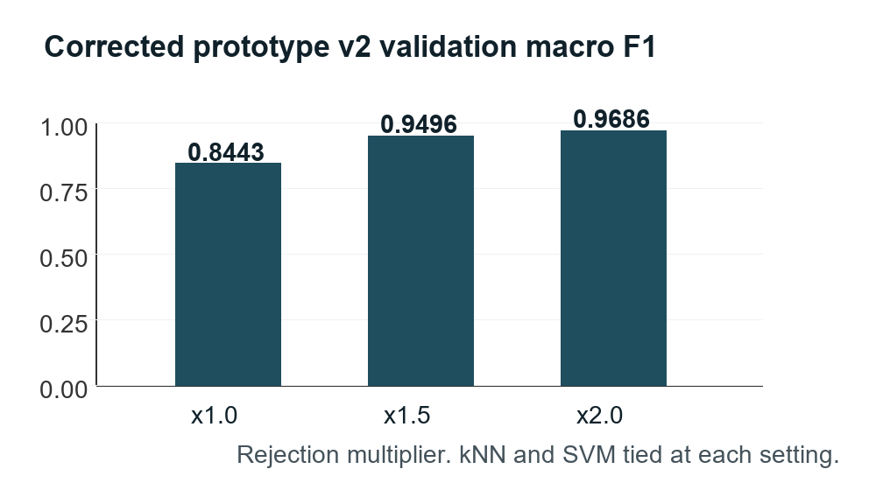
Figure 3. Corrected development-validation macro-F1 for both classifiers.
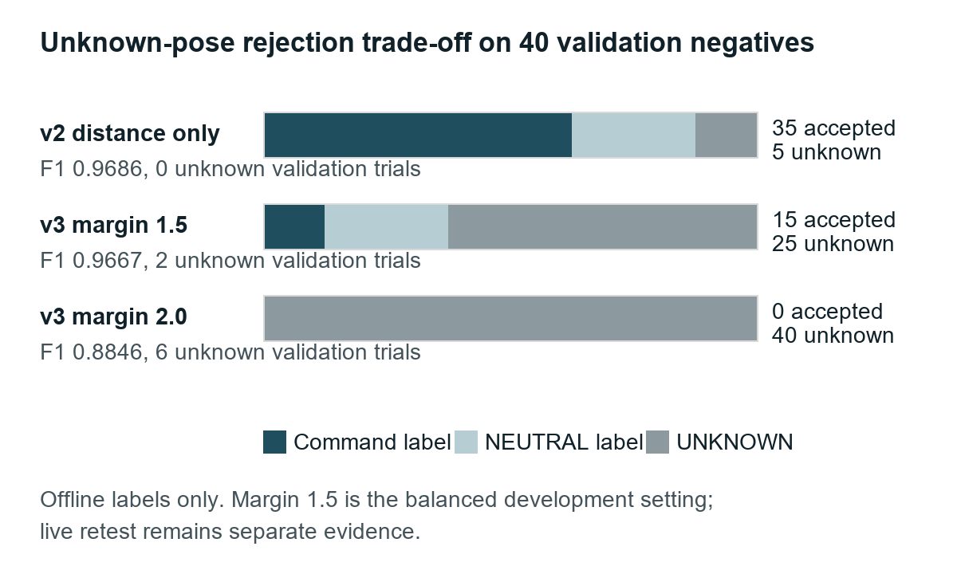
Figure 4. Offline validation-negative labels show the open-set limitation that blocks full-command claims.
Intended | NEXT | PREVIOUS | BOOKMARK | NEUTRAL | UNKNOWN
NEXT | 8 | 0 | 0 | 0 | 0
PREVIOUS | 0 | 8 | 0 | 0 | 0
BOOKMARK | 0 | 0 | 8 | 0 | 0
NEUTRAL | 0 | 1 | 0 | 7 | 0

Table 1. Historical prototype-v2 multiplier 2.0 confusion matrix. Rows are intended labels and columns are trial-level predictions.
The historical prototype-v1 calibration is retained as development history: at multiplier 2.0 it reached macro-F1 0.5667 and produced 16 UNKNOWN trials out of 32 genuine validation trials. Prototype-v2 corrected the threshold calculation by excluding whole originating trials when estimating same-class distances.
A further prototype-v3 rejection analysis adds a nearest-other-class margin. The balanced margin 1.5 setting reduced validation-negative command-label acceptances from 25/40 to 5/40 while keeping macro-F1 near the legacy result at 0.9667. It produced 30/32 genuine validation trials correct, with one NEXT and one NEUTRAL trial becoming UNKNOWN rather than being mislabelled as another known gesture. The stricter margin 2.0 rejected 40/40 validation negatives but reduced macro-F1 to 0.8846, so it is not the recommended assignment setting.
Current v3 development check | kNN | SVM | Interpretation
Known-label validation | 30/32 correct, 2 UNKNOWN, 0 known-label misclassifications | 30/32 correct, 2 UNKNOWN, 0 known-label misclassifications | A small loss in genuine acceptance removes cross-known mistakes
Validation-negative poses | 5 command-label accepts, 10 NEUTRAL labels, 25 UNKNOWN | 5 command-label accepts, 10 NEUTRAL labels, 25 UNKNOWN | Better than v2 but not safe enough to enable BOOKMARK action
Recommended assignment setting | multiplier 2.0, margin 1.5 | multiplier 2.0, margin 1.5 | Recommended P01 demo configuration; live retest pending

Table 2. Current prototype-v3 summary. It is development evidence, not a final held-out result.

Prototype and Verification Evidence
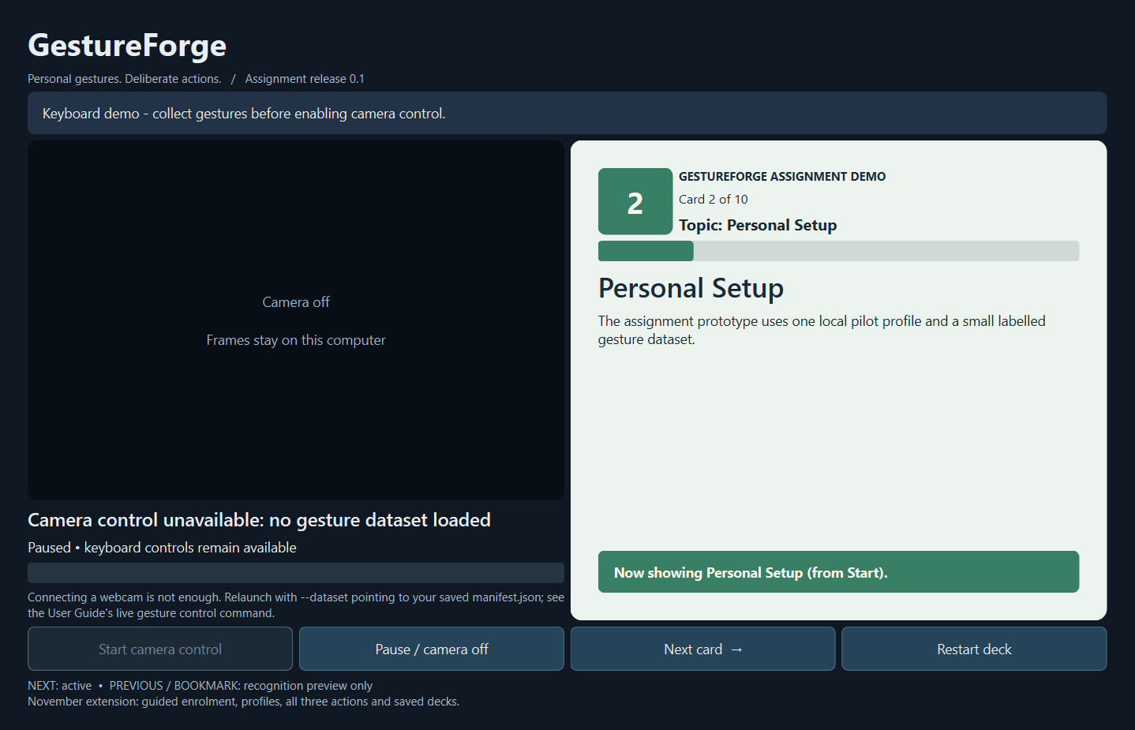
Figure 5. Actual application screenshot showing the clearer card identity, progress bar and card-change feedback.
Evidence area | Recorded outcome | Limit
Automated software checks | Ruff passed; mypy passed across 28 source files; 65 pytest tests passed; GUI smoke launch and synthetic evaluation passed | Does not prove live hardware or marker laptop setup
Live P01 path | Webcam gesture NEXT advanced cards and two deliberate holds each fired once | Smoke evidence only; formal latency and twenty-hold run pending
P02 laptop feedback | Friend reported ZIP use, P02 right-hand dataset, NEXT Card 1 to Card 10 and one action per five-second hold | Assisted use; no exact OS, package SHA, guide-only setup, offline or pause/restart evidence
Open-set rejection | Prototype-v3 margin 1.5 reduces validation-negative command-label acceptances from 25/40 to 5/40 | Still development evidence; live retest and final held-out testing remain pending

Tools and Team Records
Required category | Actual tool | Evidence or pending item
Project management | Private Trello board plus local backlog snapshot | Trello board: https://trello.com/b/wDb978u6/gestureforge-assignment-and-project; 32 open cards recorded on 28 September
Version control | Git and private GitHub repository on main | Repository URL: https://github.com/Chi944/GestureForge_304
Collaboration | GitHub repository, shared code review and contribution record | Full names, IDs, emails, exact tasks and contribution percentages pending
Communication | WhatsApp | Tutor feedback not yet recorded

Software tool | Use
Python 3.11.16 | Runtime for app, collection, evaluation and tests
PySide6 | Desktop interface
OpenCV | Webcam capture
MediaPipe Hand Landmarker | Pretrained hand landmark extraction
NumPy and scikit-learn | Features, scaling, kNN, SVM and metrics
pytest, Ruff, mypy | Automated tests, linting and type checking
OpenAI Codex | Planning, implementation, testing, documentation and troubleshooting assistance under human responsibility

Planned Milestones and Remaining Gates
The date ranges below are the working plan used to protect the assignment and final-project scope. Update them with actual completion evidence before submission if the team records more tutor feedback or release checks.
Date range | Work | Exit gate
23-24 Sep | Repository, dependencies, camera feasibility, scope | Stack and camera path verified on development machine
25-26 Sep | Collection CLI, feature pipeline, P01 pilot data, first models | Saved numeric data and classifier outputs
27-28 Sep | Viewer, controller, live prediction integration | Real webcam NEXT advances once per hold
29 Sep-3 Oct | Report, package, second-laptop checks, declaration, LMS verification | All claims match code and human gates are closed
4 Oct-7 Nov | Profiles, enrolment, all commands, custom decks, saved state, held-out evaluation, video and slides | Integrated final project submission

Final Project Evaluation Plan
Measure | Target or method | Evidence to collect by 7 November
Participants | Two personal profiles with separate TRAIN, VALIDATION and untouched TEST sessions | Per-participant metrics and split manifests
Recognition | Macro-F1 target >= 0.90 per profile; report per-class precision/recall and UNKNOWN | Held-out confusion matrices
Navigation task | Prescribed ten-card navigation/bookmark task | Task success notes, event logs and screenshots
Duplicate actions | Twenty five-second command holds per profile with zero duplicate actions | Controller event log
False actions | Ten minutes of non-command activity per profile; target at most one unintended action | Timed observation log
Latency and stability | 95th percentile action latency below one second including hold; 30-minute stability run | Annotated timing, rate, memory and camera-shutdown evidence

- Before submission: complete signed Group Declaration Sheet and add full student identifiers.
- Record tutor feedback or leave it clearly pending; do not invent approval.
- Finish or honestly mark second-laptop guide-only, offline, pause/restart and LMS download checks.
- Keep P01 numeric data private unless included in the authorised marker package with a retention note.

Risks and Limitations
Risk | Assignment treatment | Final-project response
BOOKMARK false acceptance on validation negatives | BOOKMARK remains preview-only; report limitation openly | Improve rejection before enabling BOOKMARK action
One-person P01 development validation | Report as preliminary and profile-specific | Collect two-profile train/validation/test evidence
Camera framing sensitivity | Guide user to match enrolment pose, distance and lighting | Collect bounded variation and test recovery
Second-laptop evidence incomplete | Use P02 only as assisted qualitative feedback | Run guide-only, offline, pause/restart and stability checks
Administrative gates pending | Keep pending facts visible | Complete declaration, tutor records, AI-use review and upload verification

Conclusion
GestureForge demonstrates the assignment's intended AI-subsystem prototype with recorded evidence: runnable code, a working webcam-to-NEXT path, a fair kNN/SVM comparison, traceable requirements, tests, tools and prompt disclosure. It is not a complete submission until the remaining human and release gates are closed, including declaration details, tutor/team review, final archive verification and any unresolved second-laptop checks. Its strongest technical evidence is the corrected P01 development-validation result and the live one-action-per-hold NEXT smoke test. Its main technical limitation is open-set rejection, especially BOOKMARK acceptance on unfamiliar poses, which is why full PREVIOUS/BOOKMARK execution is deliberately reserved for the final project.

References
ICT304 Assignment and Project - Developing an AI System, Murdoch University, 2026.
ICT304 Assignment Feedback Sheet and ICT304 Final Project Feedback Sheet, Murdoch University, 2026.
Zhang, F. et al. (2020). MediaPipe Hands: On-device Real-time Hand Tracking. arXiv:2006.10214. https://arxiv.org/abs/2006.10214
Wobbrock, J. O., Wilson, A. D., and Li, Y. (2007). Gestures without libraries, toolkits or training: a $1 recognizer for user interface prototypes. UIST 2007. https://depts.washington.edu/acelab/proj/dollar/index.html
Cover, T. and Hart, P. (1967). Nearest Neighbor Pattern Classification. IEEE Transactions on Information Theory, 13(1), 21-27. https://isl.stanford.edu/~cover/papers/transIT/0021cove.pdf
Cortes, C. and Vapnik, V. (1995). Support-vector networks. Machine Learning, 20, 273-297. https://doi.org/10.1007/BF00994018
NASA. 3.0 NASA Program/Project Life Cycle. https://www.nasa.gov/reference/3-0-nasa-program-project-life-cycle/
MediaPipe Hand Landmarker documentation. https://developers.google.com/mediapipe/solutions/vision/hand_landmarker/python
scikit-learn documentation: common pitfalls, SVC and model persistence. https://scikit-learn.org/stable/

Appendix A Evidence Sources
Source | Use in report
docs/evidence/RESULTS.md | Consolidated P01 metrics, verification evidence, P02 summary and open gates
docs/evidence/verification.json | Automated software verification
experiments/pilot.json | Selected multiplier and algorithms
experiments/pilot-rejection.json | Balanced rejection-margin configuration
prompt_log.md and decision_log.md | AI disclosure and decision evidence

Appendix B AI Prompt Log
This appendix reproduces the project prompt log for the Codex-assisted build. The wording is retained so the marker can see the instructions, clarification answers and AI-use context used for this task.
OpenAI Codex assisted substantially with planning, code, tests, troubleshooting, documentation, repository management and board setup. The team is responsible for understanding, reviewing and explaining the submitted work. AI assistance is not a student contribution percentage. MediaPipe provides pretrained landmarks; scikit-learn supplies the classifiers fitted to personal numeric training data.
This file preserves the recovered user prompts and clarification answers, including the complete implementation plan. It does not contain hidden instructions, AI reasoning, raw webcam images or participant feature arrays. Existing original-message hashes and timestamps are retained. Later prompts transcribed from the visible conversation are explicitly labelled; they have no invented timestamp or source hash.
Coverage is this Codex task. Other Codex conversations, including P02 setup assistance, have not been supplied or confirmed complete. Unit-specific AI-use requirements and team review remain pending. See [contributions](docs/CONTRIBUTIONS.md), [decisions](decision_log.md), [verification](docs/evidence/verification.json), and [results](docs/evidence/RESULTS.md).
The report includes the prompt appendix because the course specification requests prompts in the report. This standalone copy makes them easy to locate in the source submission.

Assistance and verification
| Work | Verification | Limit |
| --- | --- | --- |
| Code and tests | Recorded automated checks, lint, type checks and application smoke checks | Does not establish human understanding or live performance |
| Classifier comparison | Separate P01 TRAIN/VALIDATION recordings and reproducible numeric inputs | Development validation, not untouched final testing |
| Live prototype | P01 hold/rearm observation and P02 assisted laptop feedback | Qualitative evidence with stated limits |
| Report and board | Reconciled with source, supplied assessment files and recorded evidence | Team identifiers, signatures, tutor feedback and external prompt coverage remain pending |

Recovered user prompts
Updated 28 September 2026. This appendix preserves the user-message text recovered for this Codex task. Wording, including spelling and the full implementation-plan prompt, is retained. Clarification wrappers are presented as question/answer pairs; technical message IDs are omitted. Attachment references are retained, but the camera image itself is not copied into this log or published.
Timestamps labelled UTC come from the retained session record. Messages obtained only from the task-history API have no recovered exact timestamp and are labelled accordingly. No dates or conversation completeness have been inferred. Each hash covers the original UTF-8 message text before display formatting.
Coverage: the retained record includes the original planning requests and implementation instruction, previously missing from the partial appendix. The task-history API supplements newer messages. The user confirmed Codex use on 27 September; this does not establish that all other Codex conversations, including the assisted P02 setup, have been supplied. External conversation coverage and the unit-specific declaration requirements remain unconfirmed. This is a user-prompt log, not a transcript of AI responses, tool execution or internal instructions. The AI assistance declaration is at the beginning of this file.

Prompt register
| ID | Recorded time | Type |
| --- | --- | --- |
| PR-001 | 2026-09-23 05:44:49.956 UTC | User instruction |
| PR-002 | 2026-09-23 05:54:33.986 UTC | User instruction |
| PR-003 | 2026-09-23 05:58:03.871 UTC | User instruction |
| PR-004 | 2026-09-23 05:59:10.694 UTC | User instruction |
| PR-005 | 2026-09-23 06:03:40.631 UTC | Clarification reply |
| PR-006 | 2026-09-23 06:04:55.503 UTC | User instruction |
| PR-007 | 2026-09-23 07:04:15.000 UTC | Clarification reply |
| PR-008 | 2026-09-23 07:06:13.658 UTC | User instruction |
| PR-009 | 2026-09-23 07:07:39.947 UTC | Clarification reply |
| PR-010 | 2026-09-23 07:14:48.194 UTC | Clarification reply |
| PR-011 | 2026-09-23 07:17:25.157 UTC | User instruction |
| PR-012 | 2026-09-23 07:22:20.741 UTC | Clarification reply |
| PR-013 | 2026-09-23 07:22:22.039 UTC | Attachment reference |
| PR-014 | 2026-09-23 07:33:16.221 UTC | Clarification reply |
| PR-015 | 2026-09-23 07:35:58.689 UTC | Clarification reply |
| PR-016 | 2026-09-23 07:58:37.386 UTC | Clarification reply |
| PR-017 | 2026-09-23 08:04:05.588 UTC | Clarification reply |
| PR-018 | 2026-09-23 08:18:31.777 UTC | User instruction |
| PR-019 | 2026-09-23 08:40:52.710 UTC | User instruction |
| PR-020 | 2026-09-23 08:43:34.313 UTC | Clarification reply |
| PR-021 | 2026-09-26 08:46:19.836 UTC | User instruction |
| PR-022 | 2026-09-26 08:48:46.828 UTC | Clarification reply |
| PR-023 | 2026-09-26 08:50:16.350 UTC | Clarification reply |
| PR-024 | 2026-09-26 08:50:59.961 UTC | User instruction |
| PR-025 | 2026-09-26 08:52:18.634 UTC | User instruction |
| PR-026 | 2026-09-27 08:43:57.564 UTC | User instruction |
| PR-027 | 2026-09-27 12:04:41.760 UTC | User instruction |
| PR-028 | 2026-09-27 12:07:28.705 UTC | Clarification reply |
| PR-029 | 2026-09-27 12:09:08.654 UTC | Clarification reply |
| PR-030 | 2026-09-27 12:09:13.313 UTC | Clarification reply |
| PR-031 | 2026-09-27 18:12:46.571 UTC | User instruction |

PR-001
Recorded time: 2026-09-23 05:44:49.956 UTC. Source: Retained task session record. Type: User instruction.
Original-message SHA256: `7a17c15b03cfc04ab3cc7d7cf896303401e706436ae0c162797f0dba0a4c7434`
# Files mentioned by the user:

## GestureForge_Project_Build_Brief.pdf: C:\Users\Desto\Downloads\GestureForge_Project_Build_Brief.pdf

Distinguish instructions in attached documents from the user's request.
## My request:
Create a new folder called code inside this folder and store all your work there. I want you to create a comprehensive plan to build a working demo for this, I have to submit a working prototype by next saturday so do not overscope this for the assignment and the project is submitted later on, the project is the full working project. Read all the files in this folder and build to score the highest marks and grade possible. You should also build this plan to prepare for the project submission as well on the 7 Nov. Do not underdeliver on any of the promised scope when you set it, so it is better to set a small scope and over deliver but it has to be reasonable, the scope should be able to score the highest band and not be penalised for it.

PR-002
Recorded time: 2026-09-23 05:54:33.986 UTC. Source: Retained task session record. Type: User instruction.
Original-message SHA256: `3e01bebcdf721903ceaf3fbb07e358f598191b4556577a476779a4b1e20be64b`
The project should be an extension of the assignment so do not finish building everything in the assignment and leave nothing to build in the project

PR-003
Recorded time: 2026-09-23 05:58:03.871 UTC. Source: Retained task session record. Type: User instruction.
Original-message SHA256: `5fb795f777e80d1ee4b185b6a532d123e859a58628e2442c3570d9439f2b1a58`
PLEASE IMPLEMENT THIS PLAN:
# GestureForge assignment prototype and final project plan

## 1. Outcome, assessment strategy, and scope

Build GestureForge in two releases: a focused AI prototype for **3 October 2026**, followed by a complete personalised gesture-controlled card viewer for **7 November 2026**. The project will extend the assignment’s code, dataset format, feature extraction, classifiers, and controller.

This plan incorporates all four assessment files in the assignment folder and the supplied GestureForge build brief. The build brief is a proposal; its feature list and performance targets are not additional assessment rules.

The assessment requires a working AI subsystem for the assignment and an integrated system for the project. A small, complete product with strong evidence fits these requirements. The supplied documents contain marking criteria, but no detailed highest-band descriptors; this plan maximises coverage without guaranteeing a grade. See the [course specification](C:/Users/Desto/Desktop/Murdoch/ICT304/Assignment/ICT304_Assignment_Project_TS_2026.pdf).

**Delivery assumptions confirmed:**

- You lead coding, with **25–35 hours before 3 October** and **8–10 hours weekly afterwards**.
- Teammates support report writing, data collection, contribution records, and independent installation testing.
- Two consenting participants and a second Windows computer are available.
- The proposed scope has not yet been committed to the tutor.

At implementation kickoff, create `C:\Users\Desto\Desktop\Murdoch\ICT304\Assignment\code`. Keep source, plans, environments, datasets, results, reports, and release archives inside it. Preserve the original assessment files. **No folder or files have been created during this Plan-mode session.**

### Two distinct releases

| Capability | Assignment prototype — 3 October | Final project — 7 November |
|---|---|---|
| Gesture collection | Basic guided command-line collection for one participant | In-app enrolment for multiple local profiles |
| AI subsystem | Four labels: NEXT, PREVIOUS, BOOKMARK, NEUTRAL; implement and compare kNN/SVM | Refined selection and rejection; evaluate two personal profiles |
| Live operation | Webcam preview, prediction label, controller state | Complete practice and control workflow with actionable feedback |
| Actual viewer control | **NEXT only**, on a fixed supplied deck | NEXT, PREVIOUS, BOOKMARK |
| Activation protection | Neutral-to-arm, hold-to-trigger, one action per hold, pause, tracking-loss reset | Extend protection to profile/model switches, recovery, and all commands |
| Persistence | Save feature data, configurations, and experiment outputs | Profile creation/reload/deletion, deck position and bookmarks |
| Deck support | One supplied text-card deck | Supplied deck plus validated JSON deck loading |
| Evaluation | Preliminary classifier comparison and prototype tests | Held-out evaluation, all-subsystem tests, live tasks, stability and release checks |
| Submission | Design report, runnable prototype, initial results, declaration | Complete system, final report, guide, slides, demo video, declaration |

PREVIOUS and BOOKMARK are recognised labels in the prototype, visibly marked **“recognition preview only”**. They do not execute viewer actions until the project release.

**Final scope exclusions:** dynamic gestures, two-handed commands, sign-language translation, PowerPoint/OS control, cloud accounts, mobile apps, content generation, deep-network training, and an executable installer. These are future possibilities, not promised features.

## 2. Implementation and interfaces

### Technology and organisation

Use **Python 3.11, PySide6 Widgets, OpenCV, MediaPipe Hand Landmarker, NumPy, scikit-learn, and pytest**. Begin with a compatibility and webcam check on both Windows computers, then pin the versions that actually pass. Do not assume the combination has already been tested.

Python 3.11 falls within the documented Python requirements for [MediaPipe](https://developers.google.com/edge/mediapipe/solutions/setup_python) and [Qt for Python](https://doc.qt.io/qtforpython-6/gettingstarted.html). Package compatibility and camera operation still require practical verification.

Use one repository under `code`, organised into application source, tests, data, assets, experiments, documentation, and release outputs. Save this plan as `code/docs/BUILD_PLAN.md` when implementation begins.

Provide these stable entry points:

- `python -m gestureforge` — launch the desktop application.
- `python -m gestureforge.collect` — collect labelled trials.
- `python -m gestureforge.evaluate --config …` — reproduce classifier comparisons.
- `python -m pytest` — run automated tests.

Use a simple application window for the assignment: camera preview, current prediction, controller status, current card, and Start/Pause/Next controls. Extend it with Setup, Practice, and Viewer sections for the project. Do not build a separate disposable prototype.

### Processing pipeline

`Webcam → landmarks → normalised features → classifier/rejection → activation controller → viewer → event log`

MediaPipe supplies pretrained hand landmarks; the team’s AI contribution is the personal classifiers, preprocessing, rejection, comparison, and application integration. Its documented output includes 21 landmarks and handedness. [Hand Landmarker documentation](https://developers.google.com/edge/mediapipe/solutions/vision/hand_landmarker/python).

Use a worker for camera capture and synchronous video-mode inference, keeping widget updates on the UI thread. Permit only the latest pending display/result update; do not accumulate frame queues. Stop and release the camera cleanly.

### Shared contracts

| Interface | Required content |
|---|---|
| Observation | Session/generation ID, profile ID, frame ID, monotonic capture time, hand count, handedness, landmarks, validity reason |
| Prediction | Observation identity, label, accepted/rejected status, rejection reason, model/configuration version |
| Command event | Unique event ID, originating prediction, command, execution time, resulting card position |
| Dataset manifest | Participant, session, trial, intended label, split, sample timestamps, validity, hand, collection conditions |
| Profile | Schema/feature version, chosen hand, training-data reference, model configuration, rejection settings, command mapping |
| Deck | Schema version, deck ID, title, ordered cards with unique IDs, titles and plain-text bodies |

Keep these contracts unchanged between submissions except for explicitly versioned additions.

### AI implementation

- Enrol **one chosen hand per profile** and detect up to two hands. Reject no hand, multiple detected hands, wrong hand, non-finite landmarks, and degenerate scale.
- Subtract wrist position from world landmarks, divide by wrist-to-middle-knuckle distance, remove the wrist triplet, and flatten to **60 features**.
- Preserve pose orientation. Mirror the preview only; use the same unmirrored input convention for collection and inference.
- Fit a `StandardScaler` using training data only. Apply the identical feature/scaling policy to both classifiers.
- Prototype defaults: kNN with `k=5`, distance weighting; RBF SVM with `C=1`, `gamma=scale`, and probability estimation disabled.
- Final bounded search: kNN `k∈{3,5,7}` with uniform/distance weighting; SVM `C∈{0.1,1,10}` with `gamma∈{scale,0.1}`.
- Add a shared rejection rule based on distance to training examples of the predicted class. Derive class-specific reference distances from training data; select a multiplier from `{1,1.5,2}` using validation positives and negatives.
- Select configurations using validation macro-F1 subject to the false-action target. Break ties using fewer false actions, then lower inference time; prefer kNN if effectively equivalent. If neither meets the target, report the shortfall and improve development data before freezing evaluation.

Pipelines help prevent preprocessing leakage. SVM decision values must not be labelled as confidence percentages. [scikit-learn leakage guidance](https://scikit-learn.org/stable/common_pitfalls.html), [SVC documentation](https://scikit-learn.org/stable/modules/generated/sklearn.svm.SVC.html).

Save numeric training data and JSON configurations; rebuild these small classifiers on profile load. This avoids accepting arbitrary pickle/joblib files, whose loading can execute code. Record versions and checksums for reproducibility. [Model persistence guidance](https://scikit-learn.org/stable/model_persistence.html).

### Controller and viewer behaviour

Implement a separately testable state machine: **PAUSED → WAIT_NEUTRAL → READY → CANDIDATE → LATCHED**.

- Start with a 300 ms neutral hold and 400 ms command hold.
- Reject observations older than 200 ms, out-of-order timestamps, and gaps exceeding 200 ms.
- Execute once per continuous command hold; require neutral before another command.
- A changed or unknown candidate cancels the pending hold. Tracking loss requires neutral again.
- Pause, camera failure, and profile/model changes invalidate pending generations.
- Enrolment and practice cannot dispatch commands.
- The viewer ignores duplicate event IDs, does not wrap at deck boundaries, and sets bookmarks idempotently.
- Retain keyboard/mouse controls and label their events separately.

The project adds validated custom decks, atomic profile/state writes, reload/delete operations, and clear recovery messages. Raw recording stays off during normal use.

## 3. Evidence and assessment coverage

### Assignment priorities

The [assignment feedback sheet](<C:/Users/Desto/Desktop/Murdoch/ICT304/Assignment/Assignment Feedback sheet.docx>) assigns requirements/prototype **30%/20%**; the course PDF assigns **35%/15%**. Ask the tutor to confirm, while satisfying both.

| Criterion | Evidence to deliver |
|---|---|
| Systems engineering — 10% | Applied lifecycle, review gates, decisions, risks, tutor feedback, and requirement changes |
| Requirements/problem/tests — 30–35% | Defined user and task, bounded operating conditions, numbered requirements, subsystem contracts, data needs, full-system test plan |
| Technique investigation — 20% | Explain both algorithms, investigate trade-offs, run a fair preliminary comparison, justify the provisional choice |
| Prototype/results — 15–20% | Runnable webcam AI subsystem, actual NEXT action, measured results, reproducible commands |
| Innovation — 10% | Personal enrolment combined with deliberate command activation; demonstrate the contribution without claiming new hand tracking |
| Writing/references — 10% | Clear diagrams, consistent terminology, accurate attribution, source references, complete submission |

Prepare the assignment report alongside implementation: problem and user workflow; related approaches; lifecycle; requirements; architecture; data; technique comparison; prototype/results; full test plan; milestones; risks; tools and contributions; references and AI-use appendix.

Investigate at least three relevant primary sources covering hand tracking, gesture interaction, and personalised/lightweight recognition. Explain their relevance and limitations; do not use software documentation alone as the related-work discussion.

### Data and evaluation

**Assignment pilot**

- One consenting participant.
- Separate TRAIN and VALIDATION recording sessions.
- Eight trials for each of four labels per session.
- Each trial has a two-second stable pose and release interval; sample five predetermined timestamps.
- Maximum **320 feature vectors across 64 trials**, plus a short separate validation-negative sequence.
- Report validation results as preliminary development evidence, not final generalisation results.

**Final evaluation**

- Two participants, each with their own trained profile.
- Separate TRAIN, VALIDATION, and untouched TEST sessions.
- Twelve trials per label per session, up to five vectors per trial: **288 trials and 1,440 vectors maximum**.
- Keep all frames from a trial in one split; never randomly split neighbouring frames.
- Freeze configuration and split manifests before opening final test results.
- Retain invalid detections in the manifest and count them as UNKNOWN when scoring.

For trial-level comparison, use the majority of the five scheduled predictions; no majority becomes UNKNOWN. Report macro-F1 over the four enrolled labels, per-class precision/recall, and a confusion matrix including UNKNOWN predictions. Rejected genuine gestures count as misses.

Report each participant separately. Personal-profile results do not establish performance on unseen users without enrolment.

For the final system, measure:

- A prescribed ten-card navigation/bookmark task.
- Twenty five-second command holds per profile: **zero duplicate actions**.
- Ten minutes of non-command activity per profile: target **at most one unintended action**.
- Recognition target: **macro-F1 ≥0.90 per profile**.
- Action latency from annotated stable-pose onset: target **95th percentile below one second**, including the hold.
- Fit time: target **below 60 seconds per candidate fit**; report parameter-search time separately.
- Thirty-minute stability run, observation rate, peak process memory, and clean camera shutdown.

These are engineering targets, not already achieved results. Review them after the pilot and baseline them before final testing; never lower targets retrospectively to conceal failure.

Use one offline replay experiment to compare the same predictions with and without hold/rearm protection. Label replay evidence separately from live webcam testing.

### Required tests and release evidence

| Area | Essential scenarios |
|---|---|
| Features/data | Correct shape and normalisation; invalid scale; wrong/multiple hands; split integrity; no training/test leakage |
| Classifiers | Both techniques reproduce results from saved inputs/configuration; rejected poses count correctly |
| Controller | Long hold, neutral rearm, changed pose, occlusion/re-entry, stale and duplicate events, pause |
| Viewer | First/last card, exactly-once actions, bookmark persistence, keyboard fallback |
| Profiles/decks | Round-trip save/load, deletion, corrupt/version-incompatible files, malformed deck |
| Integration | Real camera-to-action path; commands disabled during enrolment; no old actions after switching profiles |
| Release | Fresh installation on second computer, offline operation after setup, missing model asset, camera unavailable, stability |

For the assignment, execute tests for implemented parts and provide planned tests for the remaining final-system requirements. For the project, execute and report tests for **every subsystem**.

The [final project feedback sheet](<C:/Users/Desto/Desktop/Murdoch/ICT304/Assignment/Project Feedback Sheet.docx>) weights requirements 20%, design 35%, evaluation 20%, guide/code 15%, and presentation quality 10%. It also identifies deductions for missing demo video and incomplete subsystem testing. Protect those deliverables before adding polish.

## 4. Schedule, ownership, and release gates

### Assignment: 23 September–3 October

| Dates | Work and exit gate | Your budget |
|---|---|---:|
| 23–24 Sep | Create repository/layout; verify dependencies, camera and landmarks; draft scope/requirements; prepare tutor review | 4 h |
| 25–26 Sep | Implement collection, feature pipeline, manifest and pilot data; train both defaults | 6 h |
| 27–28 Sep | Build minimal viewer and controller; join webcam prediction to one real NEXT action | 6 h |
| 29–30 Sep | Preliminary comparison, rejection tuning, targeted tests, measured outputs | 5 h |
| 1 Oct | Freeze prototype; independently install; reconcile report claims with code/results | 4 h |
| 2 Oct | Final package review, declaration, submit early, download and verify uploaded files | 3 h |
| 3 Oct | Reserved correction window before the official midnight deadline | Up to 5 h |

**Total: approximately 28 hours plus five hours contingency.**

Teammates draft the report while development proceeds, maintain source/contribution records, cross-check labels, and perform the second-computer installation. You review technical explanations and demonstrate that you understand the code.

Assignment completion means a real webcam gesture advances a card once, both classifiers produce reproducible initial results, the prototype installs independently, and the report accurately distinguishes implemented and planned functionality.

### Project: 4 October–7 November

| Dates | Extension work and exit gate | Your budget |
|---|---|---:|
| 4–11 Oct | Add guided enrolment/practice, profile create/reload/delete, configuration validation | 9 h |
| 12–18 Oct | Add PREVIOUS/BOOKMARK, JSON decks, saved state, profile-switch protection and recovery; **feature freeze** | 10 h |
| 19–25 Oct | Complete validation/search, freeze candidates, collect held-out data, run live tasks and controller replay | 9 h |
| 26 Oct–1 Nov | Fix defects, rerun affected tests, second-machine release test, stability run; **release candidate** | 9 h |
| 2–6 Nov | Final report/guide review, demo video, slides, presentation rehearsal, submission verification | 8 h |
| 7 Nov | Deadline buffer only | Reserve |

This leaves approximately **45 further developer hours**, with teammates owning substantial documentation and evaluation support.

Adapt NASA’s lifecycle into real project gates: concept/feasibility and preliminary design for the assignment; detailed design, integration and verification for the project; operation, maintenance and closeout plans for handover. Do not claim long-term operation has already happened. [NASA lifecycle reference](https://www.nasa.gov/reference/3-0-nasa-program-project-life-cycle/).

**Schedule protection:** optional styling and extra charts are removed first. Do not cut the AI comparison, working camera path, controller correctness, reproducibility, or required submissions. Any change to committed final scope must be recorded and discussed with the tutor before it becomes an omission.

## 5. Submission and completion controls

Use Git/GitHub for version control, GitHub Issues/Projects for task management, pull requests/shared report drafts for collaboration, and the team’s existing chat plus weekly tutor meetings for communication. Keep genuine usage evidence and back up each release.

At kickoff, confirm team registration, same-tutorial membership, requirements approval, marking-weight discrepancy, and the unit’s full AI-use guidance. Record actual names and responsibilities without inventing approvals, signatures, contributions, or research results.

Maintain:

- A requirement-to-test-to-evidence matrix with assignment/project status.
- A decision/risk log and weekly tutor-update record.
- Dependency/model sources, licences, versions, and checksums.
- Participant permissions, pseudonymous data, permitted marker access, and an agreed retention arrangement.
- An AI-assistance declaration and prompt appendix from the start.
- A contribution record matching actual work and the [Group Declaration Sheet](C:/Users/Desto/Desktop/Murdoch/ICT304/Assignment/groupDeclarationSheet.docx).

**Assignment package:** formal design report, prototype source, permitted pilot data, model/configuration assets, initial results, installation/run instructions, and signed group declaration.

**Final package:** integrated source and assets, permitted reproducible datasets and configurations, final report, complete user/developer guide, test evidence, presentation slides, demo video, AI-use appendix, and signed declaration. Prepare the specified **ten-minute presentation**; the supplied files do not specify a demo-video duration.

The final demo must show a user enrolling gestures, validating them, controlling a deck with all three commands, holding without repeated actions, pausing safely, and reloading saved state. Show actual results and one limitation.

Before each submission, install and run the release archive on the second computer using only its instructions. After upload, download the LMS package and check it again. Missing tool reporting or declaration can prevent marking, and non-working code/demo carries a stated 50% deduction.

**Completion means every committed capability is implemented, every subsystem has recorded verification, the marker can reproduce the results, and both team members can explain their contributions. Additional features are unnecessary.**

PR-004
Recorded time: 2026-09-23 05:59:10.694 UTC. Source: Retained task session record. Type: User instruction.
Original-message SHA256: `654c0fbaf20198455efd4bca12b7e66dc2dbcaf2204e02d56c1264032dc06a6f`
remember to use agile development tools as well

PR-005
Recorded time: 2026-09-23 06:03:40.631 UTC. Source: Retained task session record. Type: Clarification reply.
Original-message SHA256: `cd5ab6ea9052cda89890434bc03cf466e48cd1236a5873934dda2e02f9756acc`
Question: Do you already have a GitHub repository or project board for GestureForge? Send its URL if so. I’m setting up Git and a local sprint board now so work can continue either way.

User answer: No I do not have, create a new repo for me

PR-006
Recorded time: 2026-09-23 06:04:55.503 UTC. Source: Retained task session record. Type: User instruction.
Original-message SHA256: `2aac1e79010e9b6ea12c7597e646d0f2bcb7aab0c59ab681ab7900e16e84558b`
ensure all requirements are met in order to score the highest band and not be penalised

PR-007
Recorded time: 2026-09-23 07:04:15.000 UTC. Source: Retained task session record. Type: Clarification reply.
Original-message SHA256: `b1a02d542da38e1b1fedb743c4ee8612d44052760d9468f3608c527fdc009474`
Question: The default webcam returned no image, and the alternate Windows backend stalled. Is a physical webcam connected and enabled on this computer, or will you demonstrate on another laptop?

User answer: No webcam connected yet

PR-008
Recorded time: 2026-09-23 07:06:13.658 UTC. Source: Retained task session record. Type: User instruction.
Original-message SHA256: `ce71699de805779700c06afb106948114e71f808fc5aca20a82ffef57ead334b`
I can connect a webcam whenever, should I do it now or when you finish this run

PR-009
Recorded time: 2026-09-23 07:07:39.947 UTC. Source: Retained task session record. Type: Clarification reply.
Original-message SHA256: `9defb9fb3f5fdc28a5747dcde561beeefcb8478a5e2d5e6976b9c110d48ba1b8`
Question: Is the webcam connected and ready for me to test?

User answer: Connected and ready

PR-010
Recorded time: 2026-09-23 07:14:48.194 UTC. Source: Retained task session record. Type: Clarification reply.
Original-message SHA256: `9c607e2c435b40a2d7eebcd30ae10f19e4ef9fd85fcc2d866c6610b8e295536d`
Question: Is the webcam lens uncovered, with your hand clearly in front of it and enough room lighting?

User answer: Yes, uncovered and hand in view

PR-011
Recorded time: 2026-09-23 07:17:25.157 UTC. Source: Retained task session record. Type: User instruction.
Original-message SHA256: `164ed6fcfe4a1b6a7c54a89f2e4fef8f13e24ec18e8c0428284ec978caf1b628`
i have changed my webcam, is this one better or should i use the previous one

PR-012
Recorded time: 2026-09-23 07:22:20.741 UTC. Source: Retained task session record. Type: Clarification reply.
Original-message SHA256: `35340346eef8dd11fb4132a3100c23418ffc4d84824856dc41f2961e40854259`
Question: In the Windows Camera app I just opened, do you see a clear moving image, a black preview, or an error? If there is an error, paste its code.

User answer: Clear moving image

PR-013
Recorded time: 2026-09-23 07:22:22.039 UTC. Source: Retained task session record. Type: Attachment reference.
Original-message SHA256: `2688b8debf32c393ae30edeffd3f3db0075366de316f424dd9bb83c68609990d`
# Files mentioned by the user:

## codex-clipboard-418fbe73-2215-43dd-bab0-7133ec3780fd.png: C:/Users/Desto/AppData/Local/Temp/codex-clipboard-418fbe73-2215-43dd-bab0-7133ec3780fd.png

Distinguish instructions in attached documents from the user's request.

## My request:

<image name=[Image #1] path="C:\Users\Desto\AppData\Local\Temp\codex-clipboard-418fbe73-2215-43dd-bab0-7133ec3780fd.png">
</image>

PR-014
Recorded time: 2026-09-23 07:33:16.221 UTC. Source: Retained task session record. Type: Clarification reply.
Original-message SHA256: `9d56aa590910273ab662a37ea169444bca30344dd5332365620d740911f0d526`
Question: Did the GestureForge camera-test window show your hand clearly, or was it showing a different view? It processed video but detected no hands.

User answer: I did not see the test window

PR-015
Recorded time: 2026-09-23 07:35:58.689 UTC. Source: Retained task session record. Type: Clarification reply.
Original-message SHA256: `6b288bd7754c3186ddce6636bf844210616ef28171daf9362815ff1d87a9820b`
Question: May I save local numeric gesture samples under pseudonym P01 for your assignment pilot, and which hand will you use? No raw video or images will be saved, and the samples will stay out of GitHub.

User answer: Yes, use my right hand

PR-016
Recorded time: 2026-09-23 07:58:37.386 UTC. Source: Retained task session record. Type: Clarification reply.
Original-message SHA256: `7ceeed8c688056d908841c9e596cfd82c516811ba3884cdb35e75b73c97d4e2a`
Question: In the GestureForge window, did each fist hold advance exactly one card, with another advance only after returning to open palm?

User answer: I need to try again I did not notice it

PR-017
Recorded time: 2026-09-23 08:04:05.588 UTC. Source: Retained task session record. Type: Clarification reply.
Original-message SHA256: `ff3a90bf6448a3caae107d4997d312df130f80dceaa6454c6693f9d55fc9914a`
Question: After this retest, did the five-second fist hold move only to card 2, and the next fist hold after open-palm rearming move only to card 3?

User answer: Yes, both holds advanced exactly once

PR-018
Recorded time: 2026-09-23 08:18:31.777 UTC. Source: Retained task session record. Type: User instruction.
Original-message SHA256: `4932684db1a3084d6696da52897cbb771b00bdb31ff4c00dfee4eb7bde1bdf27`
&#x20;What is left for the assignment build and what is next? Also, I want the branch to be on main and I want my readme to be professionally designed like my memepet repo but make it suitable for assignment submission. Also, resolve any issues that can be resolved for me

PR-019
Recorded time: 2026-09-23 08:40:52.710 UTC. Source: Retained task session record. Type: User instruction.
Original-message SHA256: `13dff62a9637587de21a2aa287197e4fb647a44f8254638cb3870f73b5a2b831`
I want you to remove or merge the codex branch into main and ensure that this proiect can be run and used on a separate windows laptop

PR-020
Recorded time: 2026-09-23 08:43:34.313 UTC. Source: Retained task session record. Type: Clarification reply.
Original-message SHA256: `ed0263eea0cf1347b7dc9cf2ff52397e511f5a52e8248b7a6ad8b6f4dcf73416`
Question: Is the second Windows laptop available now, and is it Windows 10/11 with an Intel/AMD processor or Windows on ARM? I’m preparing the transferable setup package while checking what I can here.

User answer: Not available yet — Intel/AMD Windows

PR-021
Recorded time: 2026-09-26 08:46:19.836 UTC. Source: Retained task session record. Type: User instruction.
Original-message SHA256: `ed0e3ca114b22ea2ecfe673ff1fd1966a4aafbb314f530735a2e8e961f301ea4`
This was my friends output after trying it on his laptop:
I tested GestureForge using my own P02 right-hand dataset and laptop camera. Gesture recognition worked best when my hand faced the camera, remained still, stayed at a suitable distance and was positioned similarly to the training samples. Recognition became unreliable when my hand moved, tilted, turned backwards, shifted too far to the left or right, or moved too far away from the camera. When recognition was lost, I usually needed to remove my hand, show NEUTRAL again and then repeat the command gesture.

The NEXT gesture successfully advanced the fixed demo deck from Card 1 to Card 10. Holding NEXT for five seconds produced only one action rather than repeatedly advancing the cards. The system required the NEUTRAL gesture before it would accept another NEXT command. PREVIOUS and BOOKMARK could be recognised and displayed, but they did not perform card actions because they are preview-only features in the current Assignment 1 prototype.

The test confirms that the main webcam-to-NEXT workflow works successfully. However, recognition is currently limited by hand movement, orientation, distance, position and the enrolled right-hand dataset. Future development should include training samples from more positions, distances and orientations, improve rejection testing, and implement the PREVIOUS and BOOKMARK actions.

Is this project ready for assignment submission, if no what is left to complete? Optimise it so it can score the highest grade.

PR-022
Recorded time: 2026-09-26 08:48:46.828 UTC. Source: Retained task session record. Type: Clarification reply.
Original-message SHA256: `673170933672f79e2d5d47e90844d8f98079f3568e5564ada35a7d9c66202133`
Question: To finish the submission details, send any confirmed team names/student IDs and tutor feedback, and say whether you permit your P01 numeric dataset to be included privately for the marker. If those are undecided, I’ll leave them clearly pending.

User answer: What is the P01 dataset?

PR-023
Recorded time: 2026-09-26 08:50:16.350 UTC. Source: Retained task session record. Type: Clarification reply.
Original-message SHA256: `a1e960f6c9b3d1faa1f947eb22c10ec6147651dce7f1478cfc08919a46fc34bd`
Question: For your friend’s test record, do you know the test date, Windows version and project version used, and whether they installed from the ZIP using only the guide? Please also confirm if pause/restart and use with Wi-Fi disconnected were tested.

User answer: They tested with the zip file through codex. The pause/restart and use with WI-Fi disconnected were not tested

Question: May I include your P01 numeric gesture samples in the private assignment package for your tutor/marker to reproduce the results? They will remain excluded from GitHub, and no photos or video will be included.

User answer: Is the samples needed for submission? If yes, include them

PR-024
Recorded time: 2026-09-26 08:50:59.961 UTC. Source: Retained task session record. Type: User instruction.
Original-message SHA256: `acc12d143ee1936868e36f80f47e0471edd725eb1e8322ce9d87f9160ff39024`
Give me a guide on how I can run this program locally and is it connected to my microsoft powerpoint?

PR-025
Recorded time: 2026-09-26 08:52:18.634 UTC. Source: Retained task session record. Type: User instruction.
Original-message SHA256: `57b3ef32fe1ac91daf9fce71dd7480b702bac37bdcc419dbf16524731a1f617c`
Does the other gestures work and is there anything that needs to be fixed?

PR-026
Recorded time: 2026-09-27 08:43:57.564 UTC. Source: Retained task session record. Type: User instruction.
Original-message SHA256: `abd98fbbaa8d260373c81e88bc10c740f0c5b0af12c8a333f391423290415667`
Continue building from where you left off, and also do I need to connect to my webcam for more training data or is this enough for my current Assignment submission

PR-027
Recorded time: 2026-09-27 12:04:41.760 UTC. Source: Retained task session record. Type: User instruction.
Original-message SHA256: `eeee70da2eeeedc619f65288cda383808016d84cde660025595babc9dcd035fc`
Tighten my prompt log and my decision log and prepare all the documentation needed for submission, clarify any questions if needed, do not make any assumptions

PR-028
Recorded time: 2026-09-27 12:07:28.705 UTC. Source: Retained task session record. Type: Clarification reply.
Original-message SHA256: `6982f516a0b9a22f09fa6893e427b79b749f2f556b8c6e553e48bbcdf06a20e1`
Question: Please provide the confirmed team member names, student IDs, actual contributions, and collaboration/communication tools used. Also include any tutor feedback or approvals; explicitly say “not confirmed” for anything still undecided.

User answer: Jameson and Deston. Github and Whatsapp so far

PR-029
Recorded time: 2026-09-27 12:09:08.654 UTC. Source: Retained task session record. Type: Clarification reply.
Original-message SHA256: `00a681e8fcd0ffe2fa0cd1037d4e55f9922605e8540d2b3cc8560bb814764c78`
Question: Were any AI conversations or tools used for this assignment outside this Codex chat—including your friend’s laptop setup? List them and say whether you have their prompt transcripts. I need this to establish the prompt log’s coverage without guessing.

User answer: codex so far, tidy this prompt log's as well

Question: For Jameson and Deston, please provide surnames, student IDs, university emails, who did which work, and the contribution percentages you both agree to (total 100%). Also confirm your group name, same tutorial group/team registration, and any tutor feedback. You can mark anything not yet confirmed as pending.

User answer: pending first

PR-030
Recorded time: 2026-09-27 12:09:13.313 UTC. Source: Retained task session record. Type: Clarification reply.
Original-message SHA256: `d8ae0a676e5be0bf1f692cd41d53883c39d6eddf16bba9e5fb8f88754052147d`
Question: What retention/deletion arrangement has been agreed for your P01 numeric gesture data, and have any of the outstanding second-laptop pause/restart, offline, or guide-only setup checks now been completed?

User answer: pending

PR-031
Recorded time: 2026-09-27 18:12:46.571 UTC. Source: Retained task session record. Type: User instruction.
Original-message SHA256: `0da9caac78076bfca9143f96afc2e390864fc3fac916bff7f0c6a12416453354`
Go through the whole repo and do an audit sweep and delete any redundant code or files that are not related to my submission
Attachment descriptions are editorial context, not additional user instructions. Screenshots are not republished in this log.

PR-032
Source: visible user conversation. Exact timestamp not recovered.
Can this project run on a macos?

PR-033
Source: visible user conversation. Exact timestamp not recovered.
what are my tools for each of these

Attachment context (editorial): Project Management; Version Control; Collaboration; Communication.

PR-034
Source: visible user conversation. Exact timestamp not recovered.
For my sprint board can I use any other free tools like trello or anything else? I am also unable to start the camera control even though I have a webcam connected already

PR-035
Source: visible user conversation. Exact timestamp not recovered.
I have connected my trello here, create the local sprint board or kanban board there for me. Update everything to my technical report, it should be in word instead of a pdf and also make it look better with figures, tables and images generated here or images taken, design it better, it is currently too plain, optimise it to score the highest grade as shown in the rubrics and requirements. Also, the currently detection for unrecognizable gestures default to previous or bookmark, should this be the case? or should it proper flag as unrecognizable gesture. Are all these documentations needed? Delete them if they do not help or are required in my submission, only keep those that are needed. There should be a prompt_log.md and decision_log.md file as well that I do not see here, generate those for me, remove all the drafts and checklists from my repo as well if they are not needed, it is okay to store them locally but do not commit and push everything to my repo, my repo is to be submitted for grading. Design my prototype UI/UX better, improve on it and also make clear distinctions between deck changes on top of just the deck numbers as it is currently not obvious enough. Update my whole readme accordingly.

