Subject: PRF192- PFC
Workshop 03

Name : Huỳnh Chí Bảo
Student ID : SE161257

Objectives:
- Practicing skills at analyzing and implementing programs using user-defined functions.
- Making familiar with some basic algorithms

Grading 10 programs, 1 mark/program

Program 1:

Objectives | Practice implementing simple functions
Related knowledge | Definition: A prime is positive integer that is greater than 1 and it is the multiple of 1 and itself only.  Theorem: The integer n is a prime if and only if n>1 and it can not be divided by all integers from 2 to ⎣ square root of n⎦ .  Use the library math.h to get the function sqrt(double) for getting the square root of a positive number.
Problem | Write a C that will accept a positive integer n, n>=2 then print out primes between 2 and n.
Analysis  Nouns:  positive integer  🡪 int n | Suggested algorithm (logical order of verbs)  Begin  Do {  Accept n;  }  While ( n<2);  For ( i=2 to n )  If (i is a prime ) Print out i; 🡪 Function int prime (int i)  End
Algorithm for checking whether an integer is a prime or not | int prime( int n ) {  int m = sqrt(n); /* m: square root of n */  int i; /* variable having value from 2 to m */  if (n<2) return 0; /* Condition 1 is not satisfied */  for ( i=2; i<=m; i++) /* checking the second condition */  if (n%i==0) return 0 ; /* n is divided by i 🡪 n is not a prime */  return 1; /* n is a prime */  }

Code :
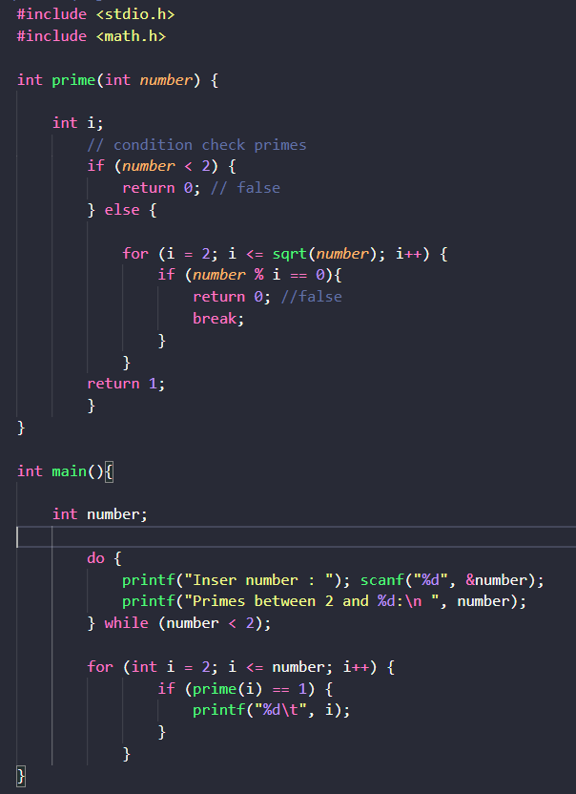
Output :
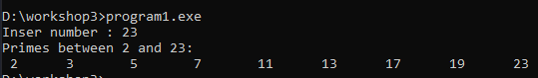

Program 2:

Objectives | Practice implementing simple functions
Related knowledge | Leap year (y): (y%400==0 || ( y%4==0 && y%100!=0))
Problem | Write a C program that will accept data of a day then print out whether they are valid or not.
Analysis  Data of a day  - int d, m, y | Suggested algorithm (logical order of verbs)  Begin  Accept d, m, y  If (valid(d,m,y)) print out “valid date”  Else print out “invalid date”  End
Algorithm for checking whether a date is valid or not | int validDate ( int d, int m, int y) {  int maxd = 31; /*max day of months 1, 3, 5, 7, 8, 10, 12 */  /* basic checking */  if ( d<1 || d>31 || m<1 || m>12) return 0;  /* update maxd of a month */  if ( m==4 || m==6 || m==9 || m=11) maxd=30;  else if (m==2) {  /* leap year? */  if ( y%400==0 || ( y%4==0 && y%100!=0) maxd=29;  else maxd=28;  }  return d<=maxd;  }

Code :
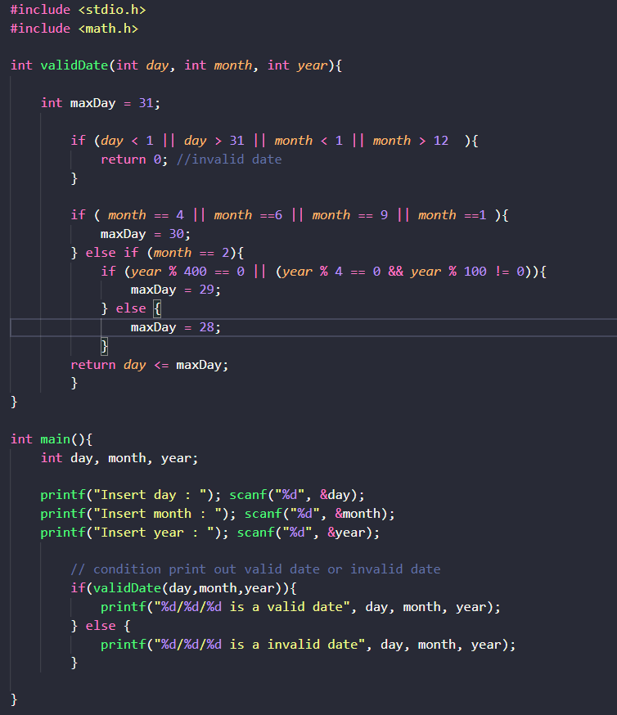

Output :

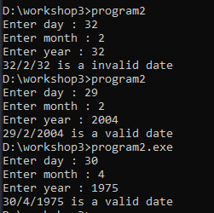
Program 3:

Objectives | Practice implementing simple functions
Related knowledge | A point p is in a circle if the distance from the center to p is less than the radius.
Problem | Write a C program that will accept a point and a circle having the center is (0,0) then print out the relative position of this point with the circle.
Analysis  Nouns:  A point 🡪 double x,y  A circle 🡪 double r  Relative position  - int result  - -1: (x,y) is out of the circle  - 0: (x,y) is on the circle  - 1: (x,y) is in the circle | Suggested algorithm (logical order of verbs)  Begin  Accept x, y;  Do {  Accept r;  }  While(r<0);  result = getRelPos(x,y,r);  if (result ==1) Print out “The point is in the circle”;  else if (result==0) Print out “The point is on the circle”;  else Print out “The point is out of the circle”;  End
Algorithm for  getting relative position of a point with a circle | int getRelPos ( double x, double y, double r) {  double d2=x*x + y*y; /* d²= x²+ y² */  double r2= r*r; /* r²*/  if (d2<r2) return 1 ; /* d²<r² 🡪the point is in the circle */  else if (d2==r2) return 0 ; /* d²=r² 🡪the point is on the circle */  return -1 ; /* d² > r² 🡪the point is out of the circle */  }

Code :
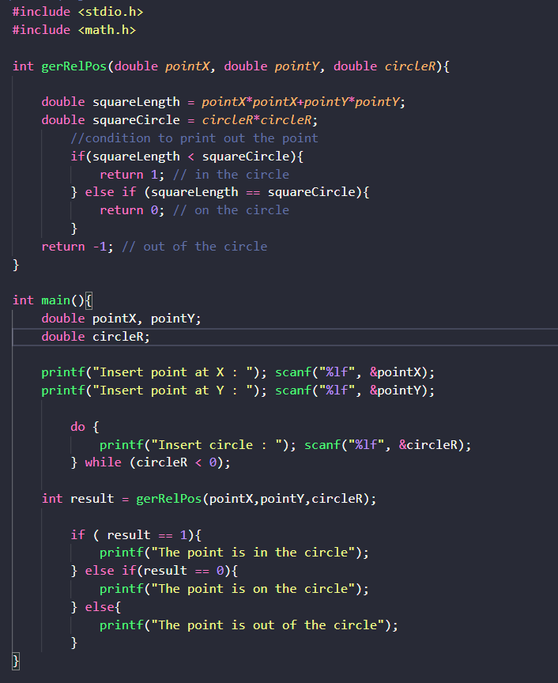

Output :
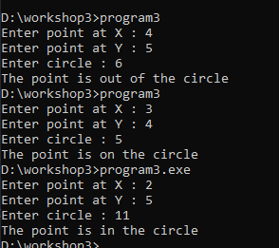
Program 4:

Objectives | Practice implementing simple functions
Related knowledge | n! = 1*2*3*…*n
Problem | Write a C program that will accept a positive integer then print out its factorial.
Analysis  A positive integer  - int n | Suggested algorithm (logical order of verbs)  Begin  Do {  Accept n;  }  While (n<0);  Print out factorial(n);  End.
Algorithm for  Computing factorial of an integer | double factorial ( int n) {  double p=1;  int i;  for (i=2; i<=n; i++) p *= i;  return p;  }

Code :
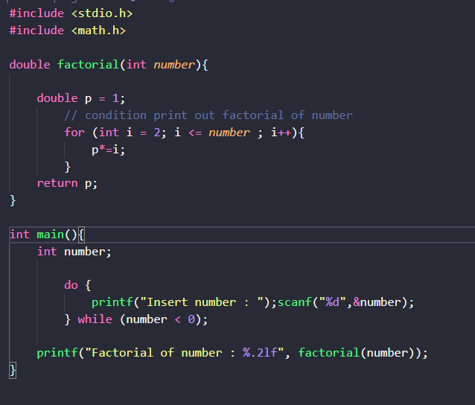

Output :
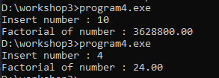

Program 5:

Objectives | Practice implementing simple functions
Related knowledge | Fibonacci sequence: 1 1 2 3 5 8 13 21 34 …  Two first numbers: 1  Others: Its value is the sum of 2 previous numbers
Problem | Write a C program that will print out the value at the n^{th} position in Fibonacci sequence.
Analysis  A position  - int n | Suggested algorithm (logical order of verbs)  Begin  Do {  Accept n;  }  While (n<1);  Print out fibo(n);  End.
Algorithm for  Computing the n^{th} value of the Fibonacci sequence | double fibo ( int n) {  int t1=1, t2=1, f=1, i ;  for ( i= 3, i<=n; i++) {  f= t1 + t2;  t1= t2;  t2=f;  }  return f;  }

How to compute the nth value of the Fibonacci sequence

Position 1 | 2 | 3 | 4 | 5 | 6 | 7 | 8 | 9 | 10
1 | 1 | 2 | 3 | 5 | 8 | 13 | 21 | 34 | 55
T1 | T2 | F
 | T1 | T2 | F
 |  | T1 | T2 | F
 |  |  | T1 | T2 | F
 |  |  |  | T1 | T2 | F
 |  |  |  |  | T1 | T2 | F
 |  |  |  |  |  | T1 | T2 | F | …

Code :
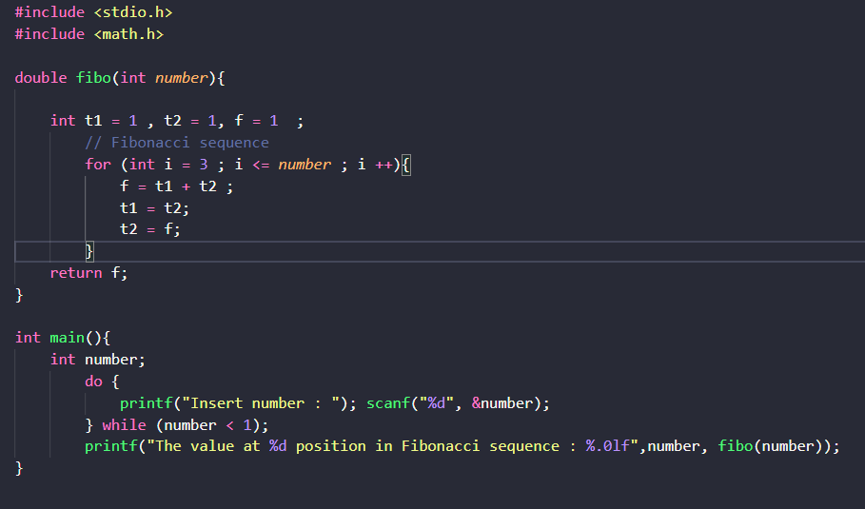
Output :
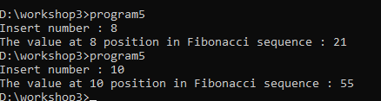

Program 6:

Objectives | Practice implementing simple functions
Related knowledge
Problem | Write a C program that will accept a positive integer then print out whether it is an element of the Fibonacci sequence or not.
Analysis  An integer 🡪 int n | Suggested algorithm (logical order of verbs)  Begin  Do {  Accept n;  }  While (n<1);  If ( isFibonacci(n)==1) Print out “It is a Fibonacci element.”;  Else print out “It is not a Fibonacci element.”  End
Algorithm for  Checking whether an integer is a element of the Fibonacci sequence or not | int isFibonacci (int n)  { int t1=1, t2=1, f=1;  if (n==1) return 1; /* n belongs to the Fibonacci sequence*/  while (f<n) /* Find out the Fibo number f to n */  { f= t1 + t2;  t1=t2;  t2=f;  }  return n==f; /* if n==f 🡪 n is Fibo element 🡪 return 1 */  }
Code :
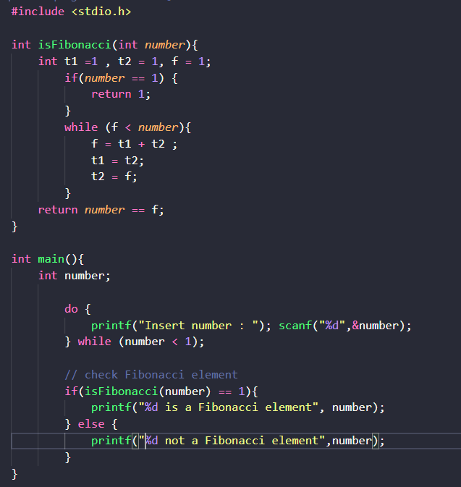
Output :

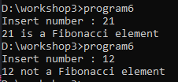

Program 7:

Objectives | Practice implementing simple functions
Related knowledge | Getting the rightmost digit of the integer n: n%10
Problem | Write a C program that will carry out some times. In each time, a nonnegative integer is accepted then print out the sum of its decimal digits. The program will terminate when its value of accepted number is negative.
Analysis  Sum 🡪 int S=0  Accepted integer  - int n | Suggested algorithm (logical order of verbs)  Begin  Do  { Accept n;  If (n>=0)  { S = sumDigits(n);  Print out S;  }  }  While (n>=0);  End
Algorithm for  Computing sum of digits of a nonnegative integer | int sumDigits (int n)  { int sum=0; /* initialize sum of digits */  Do  { int remainder = n%10 ; /* Get a digit at unit position */  n = n/10;  sum += remainder;  }  while (n>0);  return sum;  }

Code :
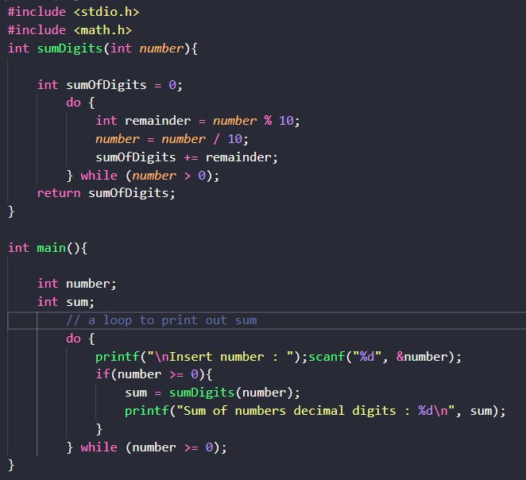

Output :

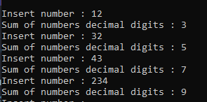

Program 8:

Objectives | Practice implementing simple functions
Related knowledge | Making a real number from its integral part and its fraction (its fraction must be positive).  Example : 32 25 🡺 32.25  25 🡺 0.25 🡺 32+0.25= 32.25  Example -51 139 🡺 -51.139  139 🡺 0.139 🡺 -51- 0.139= -51.139  double makeDouble(int ipart, int fraction)  { double d_f= fraction;  while (d_f >=1) d_f = d_f/10; /* create the fraction <1 */  if (ipart<0) return ipart – d_f; /* case -51 – 0.139 */  return ipart + d_f ; /* case 32 + 0.25 */  }
Problem | Write a C program that will accept the integral part and fraction of a real number then print out the this real number.
Analysis  Integral part  - int ipart  Fraction  - int fraction  Real number  - double value | Suggested algorithm (logical order of verbs)  Begin  Accept ipart;  Do  { Accept fraction;  }  While fraction<0;  value= makeDouble(ipart,fraction);  Print out value;  End

Code:
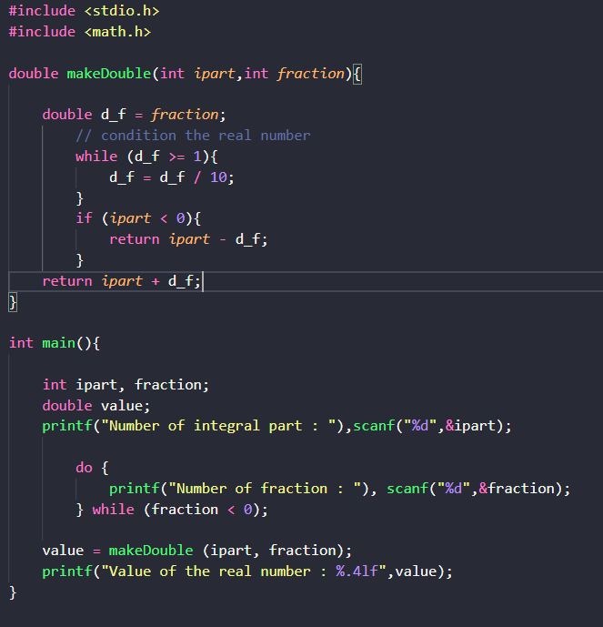

Output :
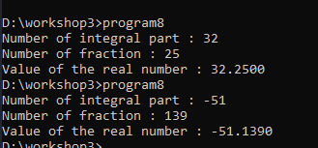
Program 9:

Objectives | Practice implementing simple functions
Related knowledge | Find out the greatest common divisor (gcd) and least common multiple (lcm) of two positive integers:  Find out gcd of a and b  a b a b  14 21 13 8  14 7 5 8  7 7 5 3  2 3  2 1  1 1  int gcd( int a, int b)  { while ( a != b )  if a>b then a -=b;  else b -= a;  return a;  }  int Icm ( int a, int b)  { return a*b/ gcd(a,b);  }
Problem | Write a C program that will accept two positive integers then print out their greatest common divisor and least common multiple.
Analysis  Two integers  - int a, b  gcd 🡪 int d  lcm 🡪 int m | Suggested algorithm (logical order of verbs)  Begin  Do  { Accept a, b;  }  While ( a<=0 OR b <=0);  d = gcd(a,b);  m = lcm (a.b);  Print out d;  Print out m;  End

Code :
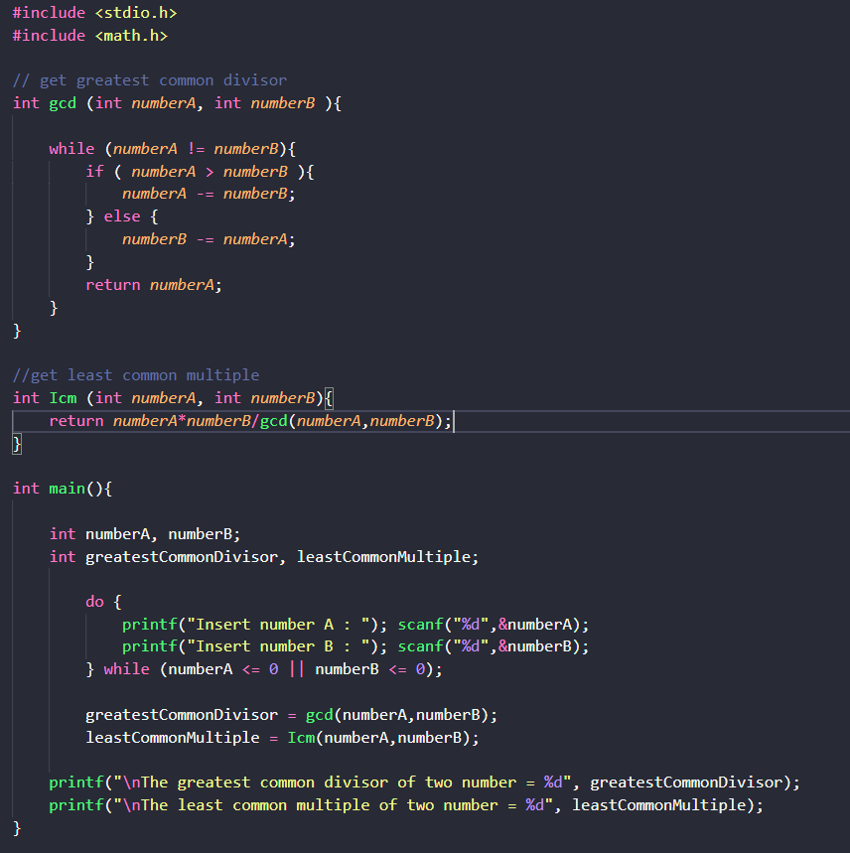

Output :
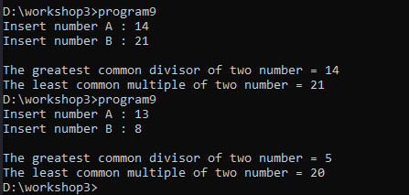

Program 10:

Objectives | Practice implementing simple functions
Related knowledge | Print out the minimum and the maximum digits of a nonnegative integer integer  Example: n= 10293 🡺 Print out 9, 0  void printMinMaxDigits( int n)  { int digit; /* Variable for extracting 1 digit */  int min, max ; /* Result variables */  digit = n% 10; /* get the first rightmost digit: 3 */  n=n/10; /* 1029, the remainder needs to proceed after*/  min=max=remainder; /* initialize results */  while (n>0)  { digit = n%10; /* Get the next digit */  n=n/10;  if (min > remainder) min=remainder; /* update results */  if (max < remainder) max=remainder;  }  Print out min, max;  }
Problem | Write a C program that will accept a non-negative integer then print out its minimum and maximum digits.
Analysis  Noun:  A integer  - int n | Suggested algorithm (logical order of verbs)  Begin  Do  { Accept n;  printMinMaxDigits(n);  }  While (n<0);  End

Code :
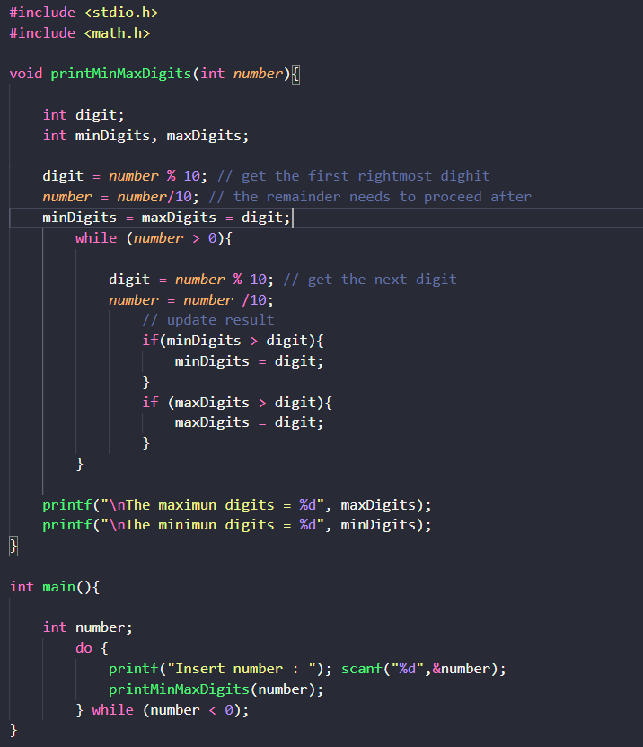

Output :
