Subject: PRF192- PFC
Workshop 04
Name : Huỳnh Chí Bảo
Student ID : SE161257
Objectives:
- Managing data using pointers
- Developing programs using simple menus

Part 1: Use notebook

Exercise 1 (1 mark) : Explain outputs:

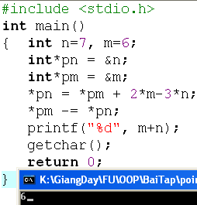

- Explain:
+ line 4 : *pn get pointer address of n
+ line 5 : *pm get pointer address of m
+ line 6 : *pn = 6 + 2*6-3*7 = -3 = &n
+ line 7 : *pm = 6 + 3 = 9 = &m
=> output : m + n = 9 - 3 = 6

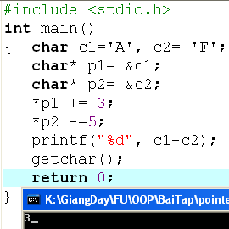

- Explain:
+ *p1 = *p1 +3 => c1 = c1 + 3 = A + 3 = D
+ *p2 = *p2 + 5 => c2 = c2 -5 = F - 5 = A
+ c1 - c2 = D - A = 68 - 65 = 3
=> Output = 3
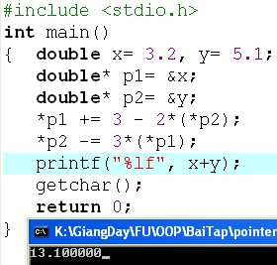
Explain :
+ *p1 = *p1 + 3 - 2 * (*p2 ) => x = x + 3 - 2*y = 3,2 + 3 - 2*5.1 = -4
+ *p2 = *p2 - 3*(*p1) => y = y - 3 * x = 5.1 - 3 * (-4) = 17.1
=> output = x + y = -4 + 17.1 = 13.10000

Exercise 2: (1 marks) What are outputs

Output : 8

value of m : 171
value of n : 29
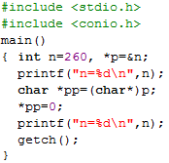
Output : 256

Exercise 3: (2 marks) Walkthroughs

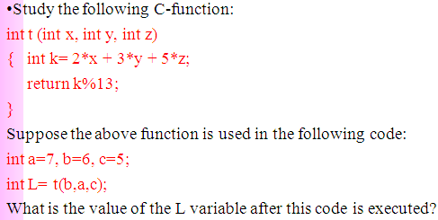
Value of L = 6

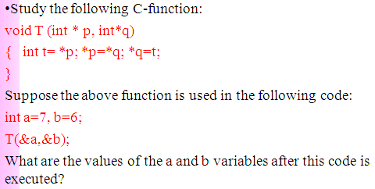
Value : a = 6, b =7
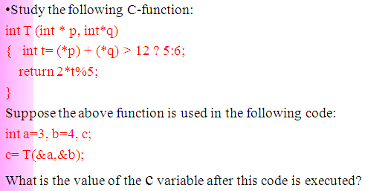
Value C = 2

Part 2: Develop a program using simple menu

Program 1(3 marks):

Objectives | Practice implementing a program with simple menu.
Related knowledge | None
Problem | Write a C program that will execute repetitively using a simple menu as following:  - Process primes  - Print min, max digit in an integer;  - Quit  Select an operation:  - When user selects the option 1, the program will accept a positive integral number and print out a message about whether the input number is a prime or not.  - When user selects the option 2, the program will accept a positive integral number and print out the minimum and maximum digit in this number.  - The program will terminate when user selects the option 3.
Analysis | Nouns:  - positive integral number 🡪 int n  - A number represents a choice of user 🡪 int choice;  Functions:  int prime( int n) 🡪 see above  void printMinMaxDigits( int n) 🡪 see above
Suggested algorithm (logical order of verbs) | Begin  Do /* Print out the menu and get user choice*/  { Print out “1- Process primes\n”;  Print out “2- Print min, max digit in an integer \n”;  Print out “3- Quit\n”;  Print out “Select an operation:”;  switch(choice)  { case 1: do  { Input n;  }  while(n<0);  If ( prime(n)==1) Print “ It is a prime\n”;  Else Print “ It is not a prime\n”;  break;  case 2: do  { Input n;  }  while(n<0);  printMinMaxDigits( int n) ;  break;  }  }  while ( choice >0 & choice<3);  End

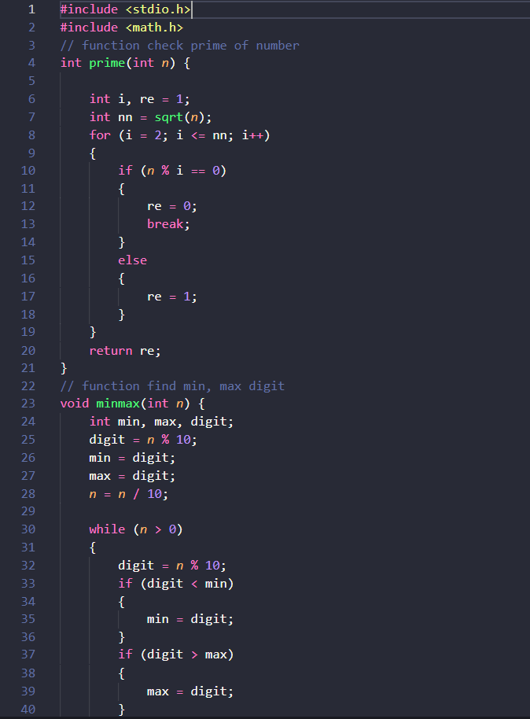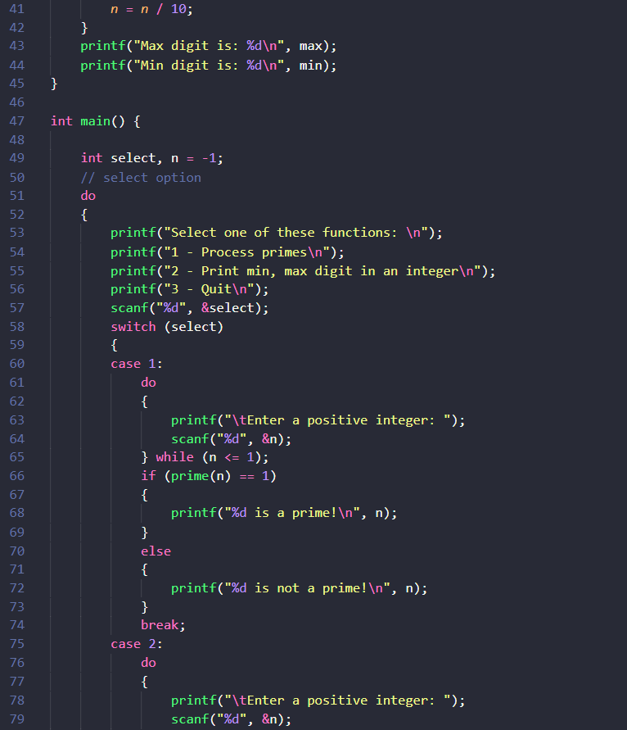
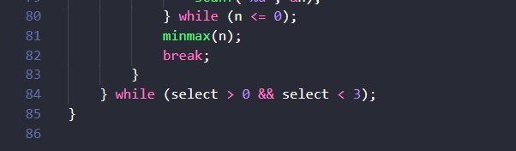

Program 2(3 marks): ( refer to the workshop 2 for algorithms)

Write a C program that will execute repetitively using a simple menu as following:

1-Fibonacci sequence
2-Check a date
3-Quit
Choose an operation:

1- When the option 1 is selected, the program will accept a positive integral number, called as n, then the first n Fibonacci numbers will be printed out
2- When the option 2 is selected, the program will accept a date then the program will tell that whether this data is valid or not.
3- If the option 3 is selected, the program quits

More Programs

You can pick 2 or 3 functions in the workshop 2, associate them to a new program.

