Subject: PRF192- PFC
Workshop 05
Name : Huỳnh Chí Bảo
ID : SE161257

Objectives: Use functions in the library math.h for getting an integer at random and stdio.h for formatting output

Grading: 4 problem, marks: 2, 2, 3, 3
Problem 1. Dice Throws ( 2 marks)
You are required to develop a program that will throw two dice until the top faces of the two dice total to a specified number.
The output from your program looks something like:
Dice Thrower
============
Total sought : 11
Result of throw 1 : 1 + 3
Result of throw 2 : 4 + 4
Result of throw 3 : 6 + 2
Result of throw 4 : 5 + 6
You got your total in 4 throws!
Algorithm should be as the following
/* Get a random integer between min and max randomly */
int intRandom(int min, int max)
{ /* Refer to the lecture to get algorithm for this task */
}
main()
Variable : int total, x,y, count
do
{ Accept total;
}
while (total<2 || total >12);
count =1;
do
{ x= intRandom(2,6);
y= intRandom(2,6);
Print out (“Result of throw %d “ %d + %d\n”, count, x, y)
count++;
}
while (x+y != total);

Code :
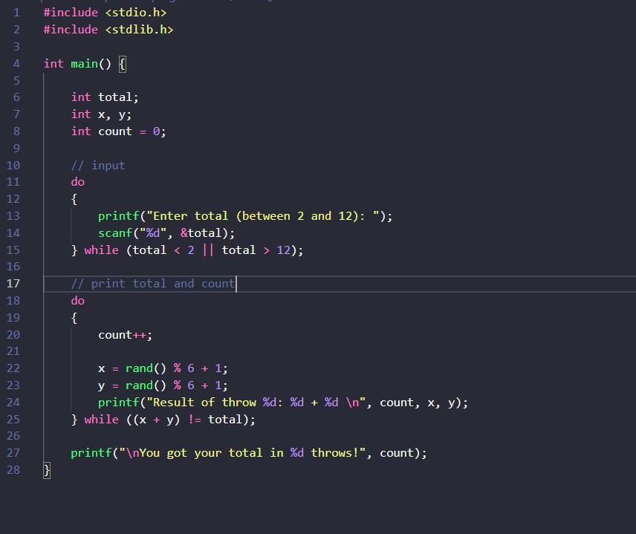

Problem 2. Ball Lottery ( 2 marks)
A basket contains ten balls.
Balls are numbered from 1 to 10.
User gets a pair of balls and he/she hopes that sum of numbers is equal to a known expected total.
This problem is the same with the previous problem but the total is between 2 to 20.

The output from your program looks something like:
Ball Lottery
============
Total sought : 11
Result of picks 1 and 2 : 1 + 3
Result of picks 3 and 4 : 4 + 5
Result of picks 5 and 6 : 6 + 3
Result of picks 7 and 8 : 5 + 6
You got your total in 8 picks!

The algorithm for this program is similar to those in the previous problem
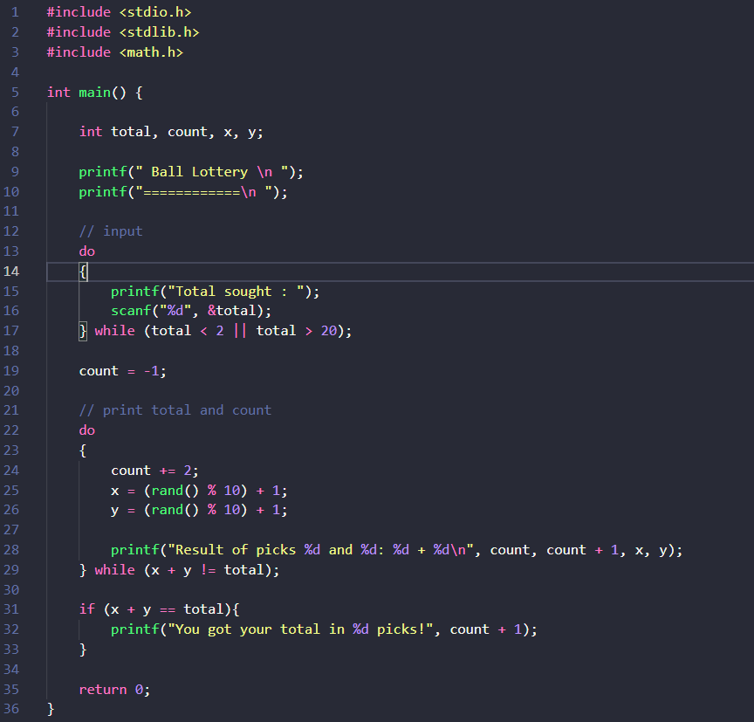
Problem 3. Program using menu ( 3 marks)
Write a C program using the following simple menu:
1- Processing date data
2- Character data
3- Quit
Choose an operation:
- When user chooses 1: User will enter values of date, month, year then the program will announce whether this date is valid or not.
- -When user chooses 2: User will enter two characters, then the program will print out ASCII codes of characters between them using descending order. Examples: Input: ca
Output:
c: 99, 63h
b: 98, 62h
a: 97, 61h
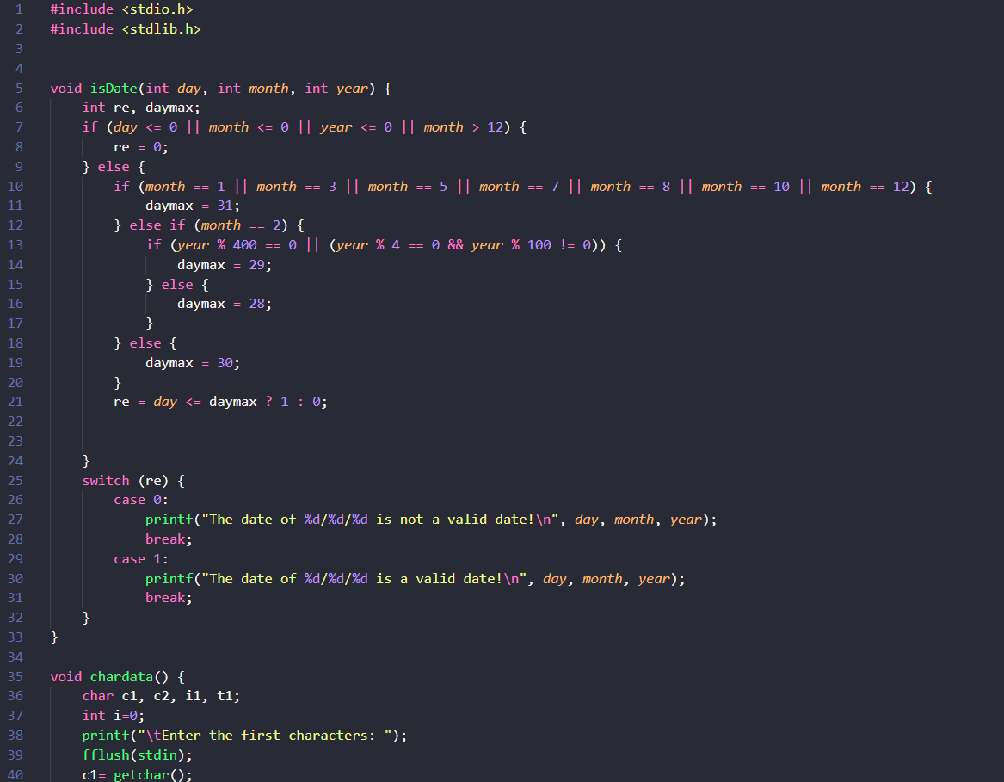
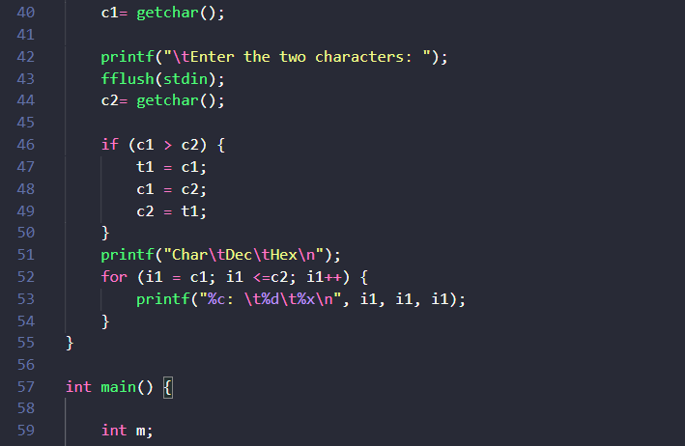
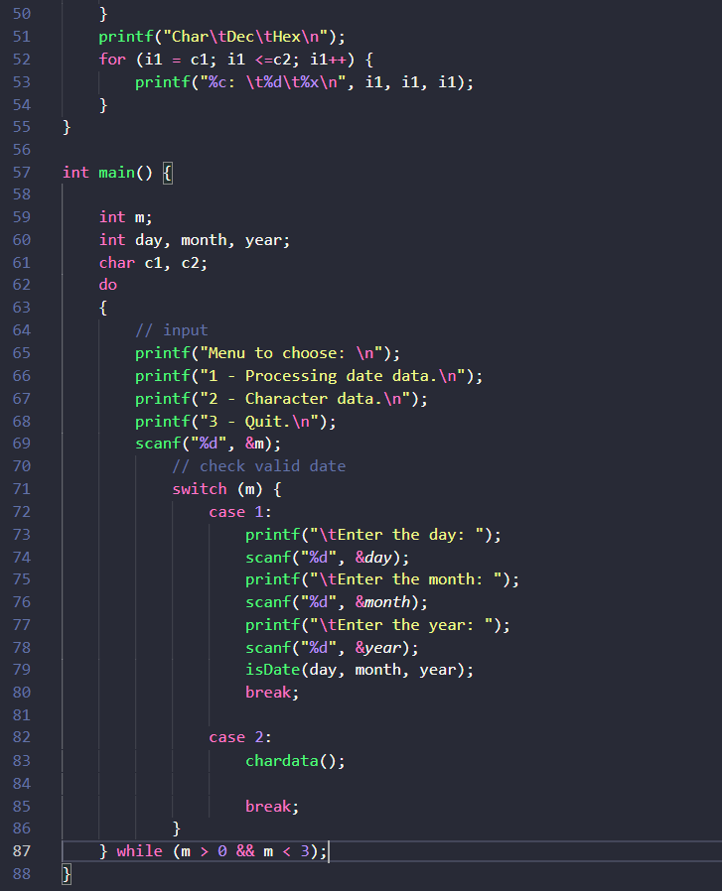
Problem 4. Program using menu ( 3 marks)
Write a C program using the following simple menu:
1- Quadratic equation ( phương trình bậc 2)
2- Bank deposit problem
3- Quit
Choose an operation:
- When user chooses 1: User will enter values describing a quadratic equation then the program will print out its solution if it exists.
- When user chooses 2: User will enter his/her deposit ( a positive number), yearly rate ( a positive number but less than or equal to 0.1), number of years ( positive integer), then the program will print out his/her amount after this duration.

Validations
- Deposit, d >0
- Yearly rate, r: > 0.0 to <1.0
- Number of year, n>0
- Amount at the n(th) year: P = d(1+r)^{n} , Use the function pow(x,y) in Math.h for x^{y}

