Subject: PRF192- PFC
Workshop 06
Huỳnh Chí Bảo
SE161257
Objectives: Managing arrays

Sample: Canadian SIN (Social Insurance Number)

SIN: 193 456 787 | check digit is 7 add first set of alternates to themselves
9 4 6 8 9 4 6 8 18 8 12 16
add the digits of each sum 1+8+8+1+2+1+6 = 27 (T1)
add the other alternates 1+3+5+7 = 16 (T2)
total = T1+T2 = 27+16=43
Next highest integer multiple of 10 T3= 50 (50>43).
Difference T3-total = 50-43= 7 Matches the check digit, therefore this SIN is valid

SIN: 193456787
N0 | N1 | N2 | N3 | N4 | N5 | N6 | N7 | N8 | N9
 | 1 | 9 | 3 | 4 | 5 | 6 | 7 | 8 | 7
 | 9 | 4 | 6 | 8 | 9 | 4 | 6 | 8 | 18 | 8 | 12 | 16
C0 | C1 | C2 | C3 | C4 | C5 | C6 | C7 | C8 | C9 | C10 | C11 | C12

Algorithm for checking whether a number is a Canadian SIN or not

Use the array N, 10 elements, N[0] is not used
Use the array C, 12 elements, C[0] is not used
From n, computing N[i]:
From N, computing C[i]:
Compute
T1= C₉/10 + C₉%10 + C₁₀/10 + C₁₀%10 + C₁₁/10 + C₁₁%10 + C₁₂/10 + C₁₂%10
T2= N₁ + N₃ + N₅ + N₇;
Total= T1+T2
T3= (Total/10+1) *10; ( Total=43 🡪 T3 = (4+1)*10
If (T3-Total == N9) return “Valid”
else return “Invalid”
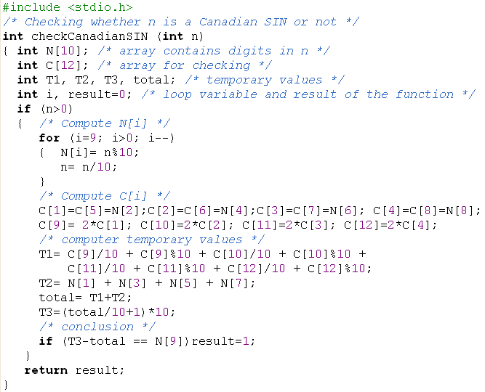
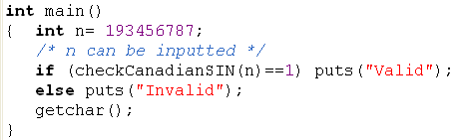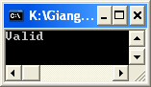

Refer to the sample above, write the following problem.

Problem 1 (4 marks)

An ISBN consists of exactly 10 digits. The rightmost digit is the check digit. The check digit is validated modulo 11.
- multiply each digit from the first to the ninth by a weight from 10 to 2 respectively (the first digit by 10, the second by 9,..., the ninth by 2).
- the sum of the products plus the check digit should be divisible without remainder by 11.
- if there is a remainder, the whole number is not a valid ISBN.
Consider the following example:
ISBN 0003194876 | check digit is 6 add first set of alternates to themselves
0 0 0 3 1 9 4 8 7 10 9 8 7 6 5 4 3 2 0 0 0 21 6 45 16 24 14 = 126
add check digit 6 total 132 divide by 11 12 remainder 0 Therefore this ISBN is valid.

I1 | I2 | I3 | I4 | I5 | I6 | I7 | I8 | I9 | I10
0 | 0 | 0 | 3 | 1 | 9 | 4 | 8 | 7 | 6
C1 | C2 | C3 | C4 | C5 | C6 | C7 | C8 | C9
0*10=0 | 0*9=0 | 0*8=0 | 3*7=21 | 1*6=6 | 9*5=45 | 4*4=16 | 8*3=24 | 7*2=14

T= C1+ C2+C3+C4+C5+C6+C7+C8+C9 + I10; (T=132)
If (T%11==0) print out “Valid” else print out “Invalid”

Write a program that will accept a number (>=1 000 000 000) then show whether the number is an ISBN or not.

ISBN Validator ============== ISBN (0 to quit): 0003194876
This is a valid ISBN.
ISBN (0 to quit): 0003194875
This is not a valid ISBN. ISBN (0 to quit): 0
Have a Nice Day!

CODE:
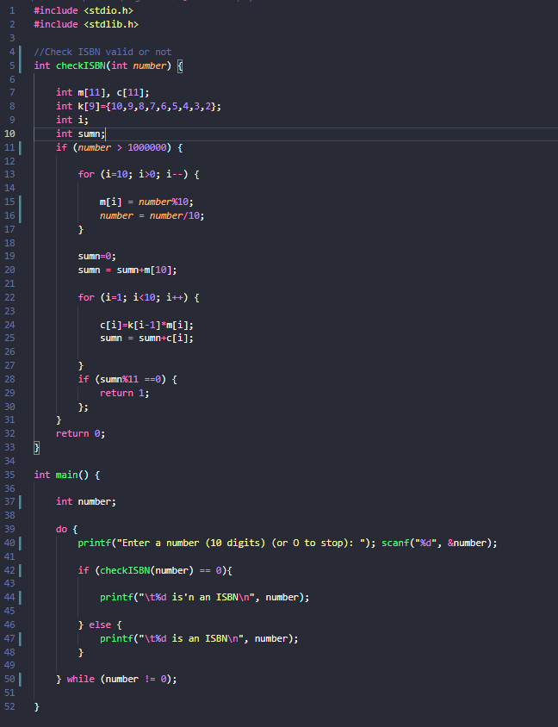

Problem 2 (6 marks)

Develop a C-program that helps user managing an 1-D array of real numbers(maximum of 100 elements), with initial number of elements is 0, using the following simple menu:
1- Add a value
2- Search a value
3- Print out the array
4- Print out values in a range
5- Print out the array in ascending order
Others- Quit

- When the option 1 is selected, user will enters a value then it is added to the array
- When the option 2 is selected, user will enters a value then number of it’s existences will be printed out.
- When the option 3 is selected, values in the array will be printed out.
- When the option 4 is chosen, user will enter 2 values, minVal and maxVal, the values in array which are between minVal and maxVal are printed out (minVal <=value<=maxVal)
- When the option 5 is chosen, values in array will be printed out in ascending order but their position are preserved. ( sorting based their pointers only)

Code :

