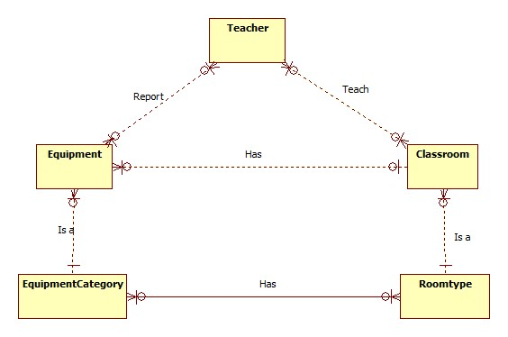

|  |  |
| --- | --- |
| Data dictionary | |
| Entity Name | **Description** |
| Teacher | Entity describes a user with role teacher in system |
| Equipement | Contain the equipment information. |
| Classroom | Contain the classroom information. |
| EquipmentCategory | Contain the equipment category information. |
| Roomtype | Contain the room type information. |