* + 1. **System Scheduler Process**
       1. **Definition**

System scheduler is a main component of ECRM system. All the report will be checked by scheduler and give recommend for staff easy to make decision.

* + - 1. **Define Problems**

In web application:

* We need system schedule run every day at 06:30 and 12:15 to check status of room and change room if needed.
* We need system schedule run every day at 00:00 to check schedule in system.
* We need system schedule run every day at 06:00 to update equipment using time.
* We need system schedule run each 5 minutes to receive report from teacher and change room if needed.
  + - 1. **Solution**

We create schedule task by Spring Scheduler, it will run on the same server with web application and access to database server to check status, find available room to do change if need. It will run at specific time that administrator has defined.

The checking process is described as follow:

* + - * 1. Scheduler change room every day

1. Get all classroom have damaged level is more than 50%
2. Get all schedule in each classroom
3. Get list of available classrooms for current classroom
4. Get classroom which current classroom had been changed to. If it has, check if this classroom is existed in list of available classrooms.
5. Check current day time and change room.
6. Notify and send SMS for teacher.
   * + - 1. Scheduler get report
7. Get new report
8. Check damaged level of classroom (**Refer to …)**
9. Get all schedule in classroom
10. Get list of available classrooms for current classroom
11. Get classroom which current classroom had been changed to. If it has, check if this classroom is existed in list of available classrooms.
12. Check current day time and change room.
13. Update report.
14. Notify and send SMS for teacher.
    * + - 1. Scheduler update equipment using time
15. Get all classroom
16. Get schedule for each classroom the last day.
17. Get all managed equipment in each classroom
18. Time remain of each equipment equals using time subtracts total teaching duration today. If time remain equals 0, set equipment is damaged, evaluate is “Không sử dụng được” and update classroom’s damaged level (**refer to …**) which equipment is belong to.
19. Notify and send SMS for staff if equipment time equals 0 or smaller than “expiredTime” field in table “SystemConfiguration”.
    * + - 1. Scheduler check schedule
20. Get the nearest day of all schedule in database
21. Notify and send SMS for staff.
    * + 1. **Flow Chart**
           1. Scheduler change room everyday

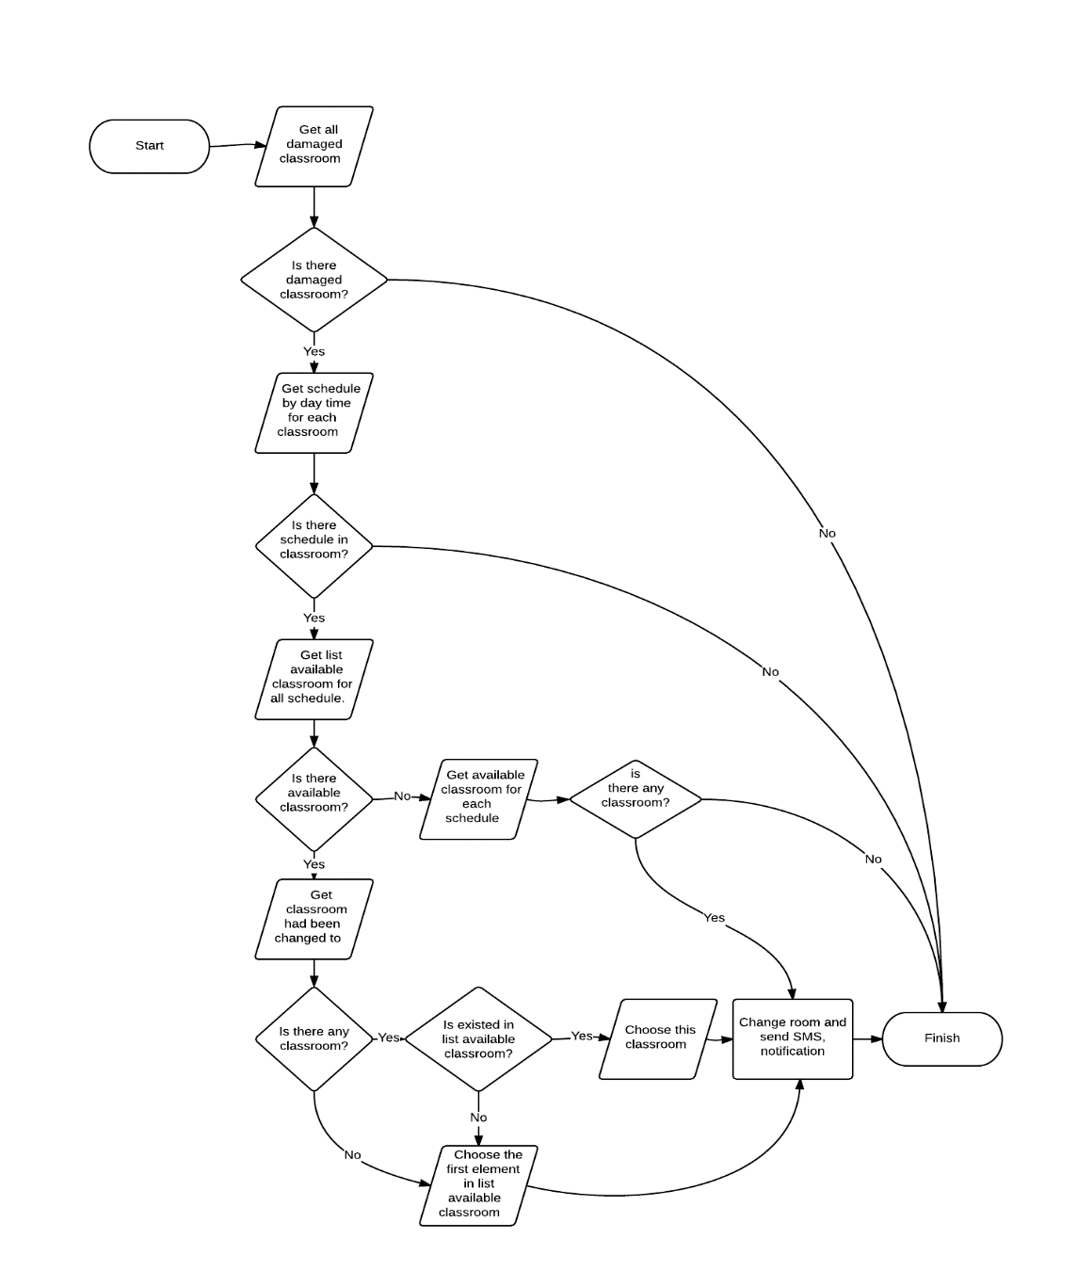

* + - * 1. Scheduler get report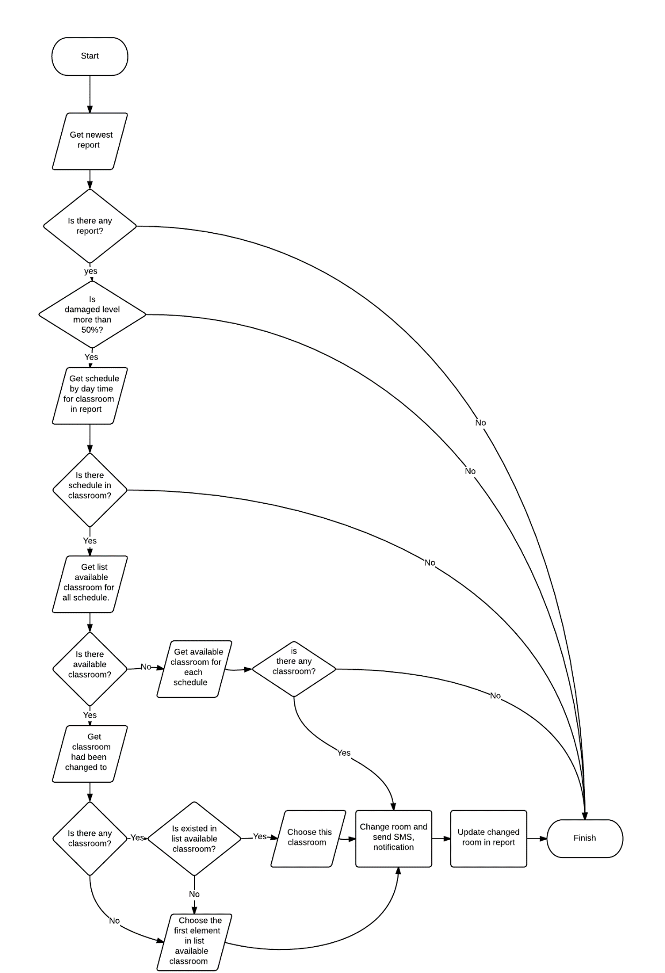
        2. Scheduler update equipment using time

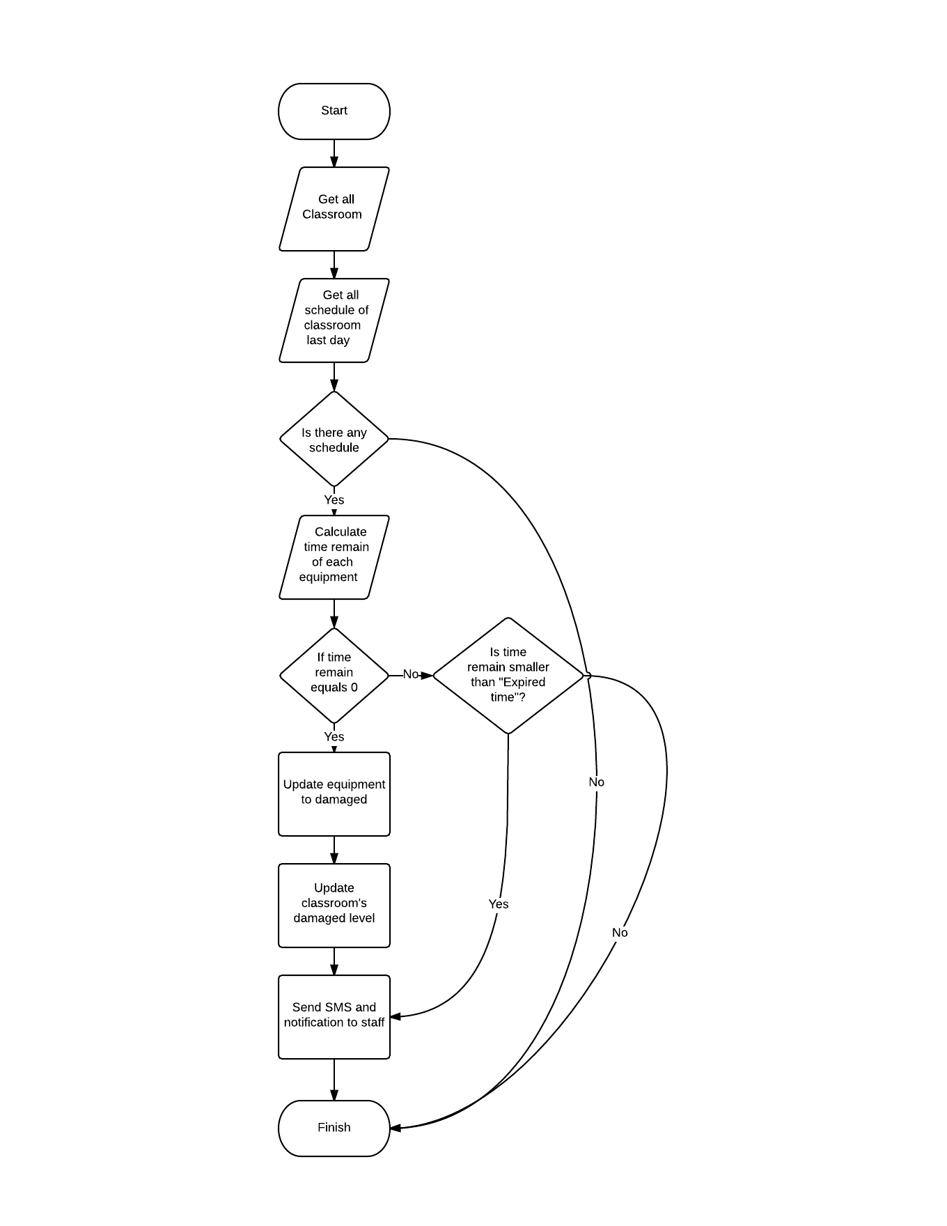

* + - * 1. Scheduler check schedule in database

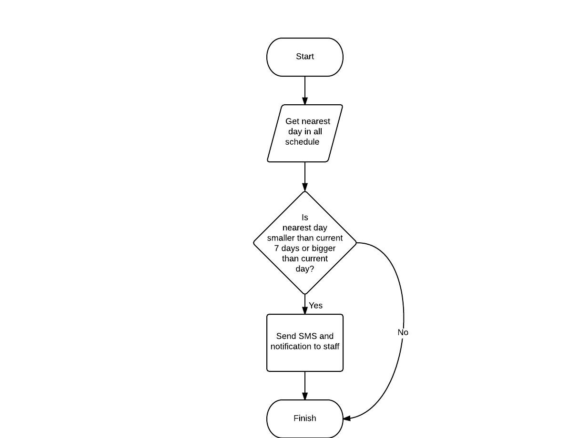

* + 1. **Suggest available classroom**
       1. **Definition**

Suggest available classroom is a function of web application and mobile application to give a list of available and similar classroom with current classroom.

* + - 1. **Define Problems**

In web and mobile application, every time staff or system do change room, finding a classroom that meet criteria about availability, nearest with current classroom.

* + - 1. **Solution**

1. Get all undamaged classroom.
2. Get all schedule in current classroom.
3. Compare each schedule with all schedule in list undamaged classroom. If one classroom has one schedule has the same scheduleConfigId, we will ignore that classroom. The result is list of available classroom.

Table schedule configuration

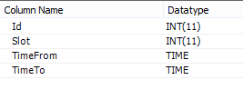

1. We will get list of list available classroom and then compare them. The result we will get is list of common classroom.
2. We sort list of classroom by criteria nearest distance with current classroom. For example: we have list {202, 303, 201, 301, 402, 101, 503} and current classroom is 205, the result is: {202, 201, 301, 303, 101, 402, 503}.
3. Finally, we will sort the list by criteria similar with current room type of classroom. The most similar will appear firstly, the least similar will appear lastly.
   * 1. **Damaged statistic**
        1. **Definition**

Damaged statistic is a function of web application and mobile application to a number describes the damaged level of classroom.

* + - 1. **Define Problems**

In web and mobile application, every time teacher report classroom, staff has to check the damage of this classroom and do change room. We have to find solution to check damaged level automatically.

* + - 1. **Solution**

1. Get classroom.
2. Get list of damaged equipment.
3. Get room type of classroom.
4. Get equipment’s **evaluation** in report and equipment **priority** in room type.
5. Get damaged level in table “SystemConfiguration” in database based on evaluation and priority of each equipment. Example: evaluation of equipment is “Không thế sử dụng được” and priority is “Cao”, we will get field “UserHigh_PriorityHigh” with damaged level equal 50 in table “SystemConfiguration”.
6. Damaged level of classroom equals total equipment’s damaged level.

**Example:**

Teacher A reports classroom B with projector, air conditioning and two tables. Teacher A evaluates “High” for projector, “High” for air conditioning and “High” for table. Meanwhile, in classroom B, the priority of projector is “High”, air conditioning is “Medium”. So the damaged level will be: (**UserHigh-PriorityHigh**)+ (**UserHigh-PriorityMedium**) + (**TableHigh**)*2 = 50 + 30 + 5*2 = 90.

* + - 1. Flow chart

