* 1. **Component Diagram**

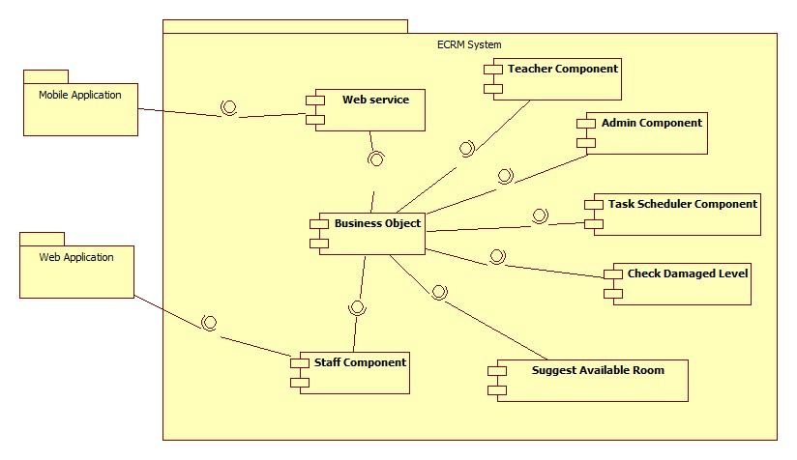

Figure 42: Component Diagram

|  |  |
| --- | --- |
| Component Dictionary: Describes components | |
| Web Application | Web application package: View, Controller. |
| Mobile Application | Mobile application package. |
| Web Service | Include all web API controllers of the system. Include all web API controllers of the system |
| Staff Component | Component to handle staff activities in the system. |
| Teacher Component | Component to handle teacher activities in the system. |
| Admin Component | Component to handle administrator activities in the system |
| Business Objects | Handle business operations for every component. |
| Suggest Available Room | Business logic for suggest room processing. |
| Check Damaged Level | Business logic for checking damaged level processing. |
| Task Scheduler Component | Component to handle task scheduler activities in the system. |