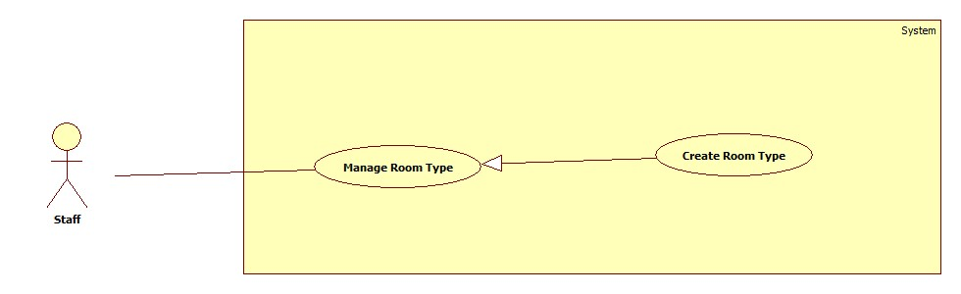

<Staff> Create Room Type

**Use case specification**

|  |  |  |  |
| --- | --- | --- | --- |
| **USE CASE – ECRM005** | |  |  |
| **Use Case No.** | ECRM005 | **Use Case Version** | 2.0 |
| **Use Case Name** | Create Room Type |  |  |
| **Author** | Tang Viet Hung |  |  |
| **Date** | 05/21/2015 | **Priority** | Normal |
| **Actor:** Staff | |  |  |
| **Summary:** This use case allows staff to create new room type.  **Goal:** Create room type to the system.  **Triggers:** Staff sends request “Tạo Loại Phòng” in “Loại Phòng” page.  **Preconditions:**   * User login as staff role.   **Post Conditions:**   * **Success:** New room type will be created and show successful message. * **Fail:** Unsuccessful message will be shown.   **Main Success Scenario:**   |  |  |  | | --- | --- | --- | | Step | Actor Action | System Response | | 1 | Staff clicks on “Phòng Học” and then clicks on tab “Loại phòng”. | System navigates to “Kiểu Phòng” page. Page includes:   * Table with columns: * Loại phòng * Số chỗ ngồi * Quản lý * Xem: command. * Xóa: command * Tạo loại phòng: command | | 2 | Staff sends “Tạo loại phòng” request. | System open pop-up to “Tạo loại phòng”. Pop-up includes:   * Tên loại phòng: free text input, max length: 20, required. * List of equipments: check box * Số dãy bàn: value list. * Số hàng: value list. * Số ghế: value list. * Xem trước: command. * Thoát: command.   [Alternative 1] | | 3 | Staff sends “Xem trước” request. | System will show:   * Classroom map. * Tạo mẫu: command. * Quay lại: command.   [Alternative 2] | | 4 | Staff sends “Tạo mẫu” request.  [Exception 1] | System show successful message: “Tạo loại phòng thành công!” and navigate to “Kiểu Phòng” page. |     **Alternative Scenario:**     |  |  |  | | --- | --- | --- | | No | Actor Action | System Respnse | | 1 | Staff sends “Thoát” request. | System closes pop-up. | | 2 | Staff send request “Quay lại”. | Re-open previous pop-up. |   **Exceptions:**   |  |  |  | | --- | --- | --- | | No | Actor Action | System Response | | 1 | “Tên loại phòng” is empty. | Show error message: “Tên loại phòng không được bỏ trống!” | | 2 | “Tên loại phòng” is existed. | Show confirm message: “Tên loại phòng đã tồn tại, bạn có muốn cập nhật?” |   **Relationships:** N/A  **Business Rules:**   * List of equipment is loaded from database in EquipmentCategory table. * If staff create new room type with existed room type name, system will update the room type with that room type name. * Each room type is created with list of equipment quantity that are presented the equipment in that room type. If staff didn’t choose any equipment, the room type wouldn’t have any equipment. | | | |

Create room type sequence

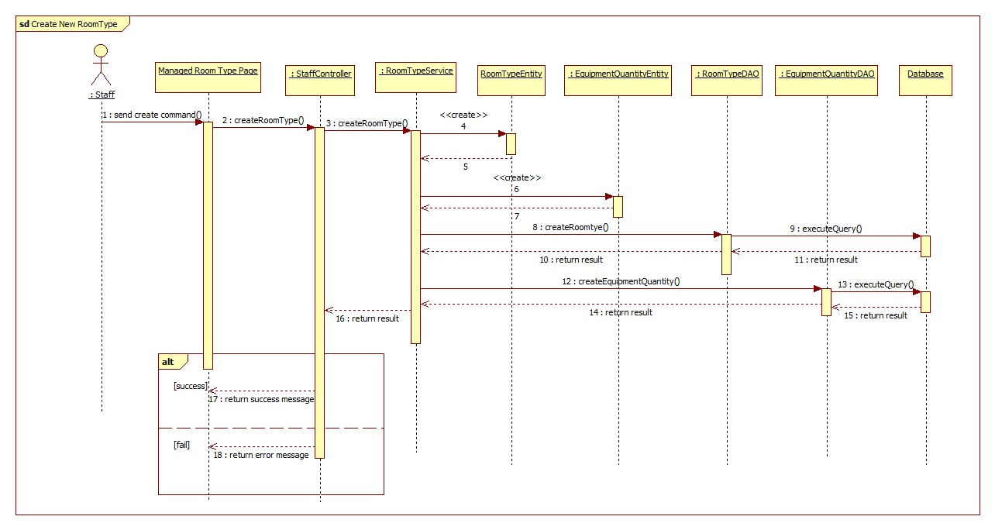

<Staff> Update Room Type

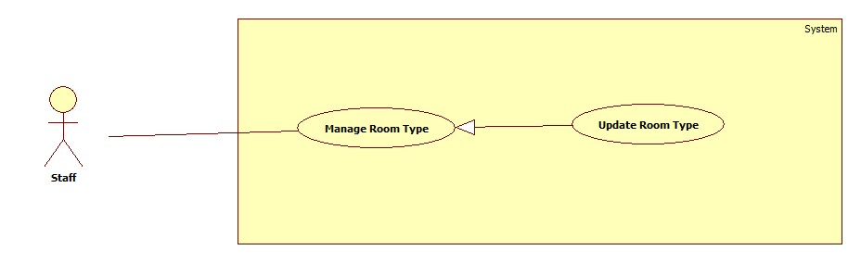

Figure 11: <Staff> Update Room Type

|  |  |  |  |
| --- | --- | --- | --- |
| **USE CASE – ECRM005** | |  |  |
| **Use Case No.** | ECRM005 | **Use Case Version** | 2.0 |
| **Use Case Name** | Update Room Type |  |  |
| **Author** | Tang Viet Hung |  |  |
| **Date** | 05/21/2015 | **Priority** | Normal |
| **Actor:** Staff | |  |  |
| **Summary:** This use case allows staff to update room type.  **Goal:** Update room type to the system.  **Triggers:** Staff sends request “Cập nhật” in “Loại Phòng” page.  **Preconditions:**   * User login as staff role.   **Post Conditions:**   * **Success:** Room type will be updated and show successful message. * **Fail:** Unsuccessful message will be shown.   **Main Success Scenario:**   |  |  |  | | --- | --- | --- | | Step | Actor Action | System Response | | 1 | Staff clicks on “Phòng Học” and then clicks on tab “Loại phòng”. | System navigates to “Kiểu Phòng” page. Page includes:   * Table with columns: * Loại phòng * Số chỗ ngồi * Quản lý * Xem: command. * Xóa: command * Tạo loại phòng: command | | 2 | Staff sends “Xem” command. | System open pop-up includes:   * Tên loại phòng: label. * Classroom map. * Chỉnh sửa: command. * Thoát: command.   [Alternative 1] | | 3 | Staff sends “Chỉnh sửa” request. | System open pop-up includes:   * Tên loại phòng: free text input, max length: 20, required. * List of equipments: check box * Số dãy bàn: value list. * Số hàng: value list. * Số ghế: value list. * Xem trước: command. * Thoát: command.   [Alternative 2] | | 4 | Staff sends “Xem trước” request. | System will show:   * Classroom map. * Tạo mẫu: command. * Quay lại: command.   [Alternative 3] | | 5 | Staff sends “Cập nhật” request.  [Exception 1] | System show successful message: “Cập nhật loại phòng thành công!” and navigate to “Kiểu Phòng” page. |     **Alternative Scenario:**     |  |  |  | | --- | --- | --- | | No | Actor Action | System Response | | 1 | Staff sends “Thoát” request. | System closes pop-up. | | 2 | Staff sends “Thoát” request. | System closes pop-up. | | 3 | Staff send request “Quay lại”. | Re-open previous pop-up. |   **Exceptions:**   |  |  |  | | --- | --- | --- | | No | Actor Action | System Response | | 1 | “Tên loại phòng” is empty. | Show error message: “Tên loại phòng không được bỏ trống!” | | 2 | “Tên loại phòng” is existed. | Show confirm message: “Tên loại phòng đã tồn tại, bạn có muốn cập nhật?” |   **Relationships:** N/A  **Business Rules:**   * List of equipment is loaded from database in EquipmentCategory table. * If staff update new room type with existed room type name, system will update the room type with that room type name. * All the old equipment quantity in the updated room type will be deleted. In the other hand, the new equipment quantity will be created. * If there are any classroom is using the updated room type, all the equipment in that classroom will be removed. Staff has to add new equipment into that classroom by sending “Cập nhật thiết bị” command. | | | |

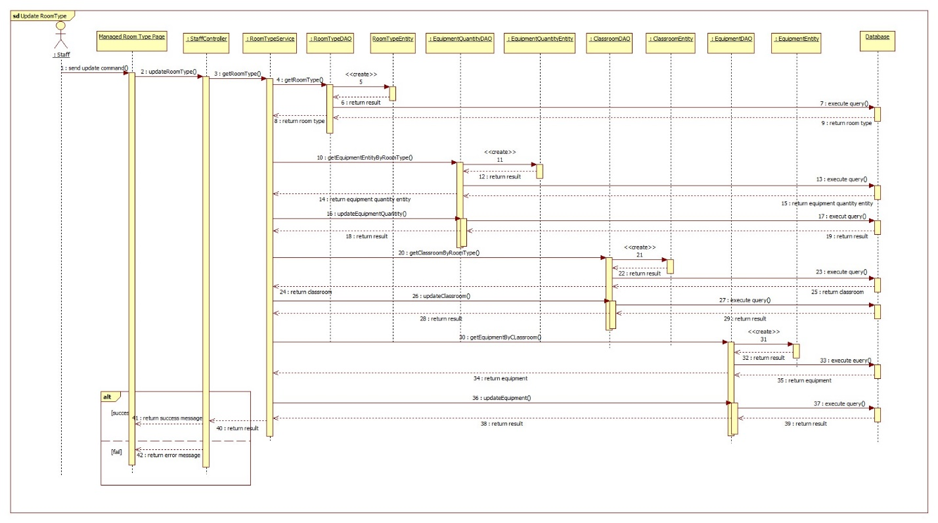

<Staff> Remove Room Type

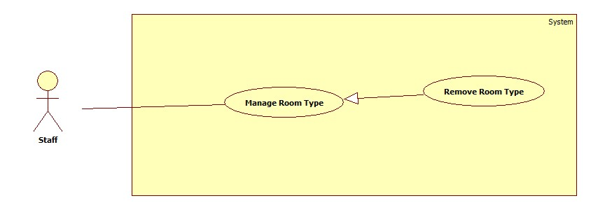

|  |  |  |  |
| --- | --- | --- | --- |
| **USE CASE – ECRM005** | |  |  |
| **Use Case No.** | ECRM005 | **Use Case Version** | 2.0 |
| **Use Case Name** | Remove Room Type |  |  |
| **Author** | Tang Viet Hung |  |  |
| **Date** | 05/21/2015 | **Priority** | Normal |
| **Actor:** Staff | |  |  |
| **Summary:** This use case allows staff to remove room type.  **Goal:** Update room type to the system.  **Triggers:** Staff sends request “Xóa” in “Loại Phòng” page.  **Preconditions:**   * User login as staff role.   **Post Conditions:**   * **Success:** Room type will be removed and show successful message. * **Fail:** Unsuccessful message will be shown.   **Main Success Scenario:**   |  |  |  | | --- | --- | --- | | Step | Actor Action | System Response | | 1 | Staff clicks on “Phòng Học” and then clicks on tab “Loại phòng”. | System navigates to “Kiểu Phòng” page. Page includes:   * Table with columns: * Loại phòng * Số chỗ ngồi * Quản lý * Xem: command. * Xóa: command * Tạo loại phòng: command | | 2 | Staff sends “Xóa” command.  [Exception 1] | System show successful message: “Xóa loại phòng thành công!” and navigate to “Kiểu Phòng” page. |     **Alternative Scenario:**  **Exceptions:**   |  |  |  | | --- | --- | --- | | No | Actor Action | System Response | | 1 | There is at least one classroom is using this room type. | Show error message: “Không thể xóa loại phòng này! Bạn phải gỡ ra khỏi phòng học trước!” |   **Relationships:** N/A  **Business Rules:**   * List of equipment is loaded from database in EquipmentCategory table. * Staff can only delete one room type when there is no classroom is using this room type. | | | |

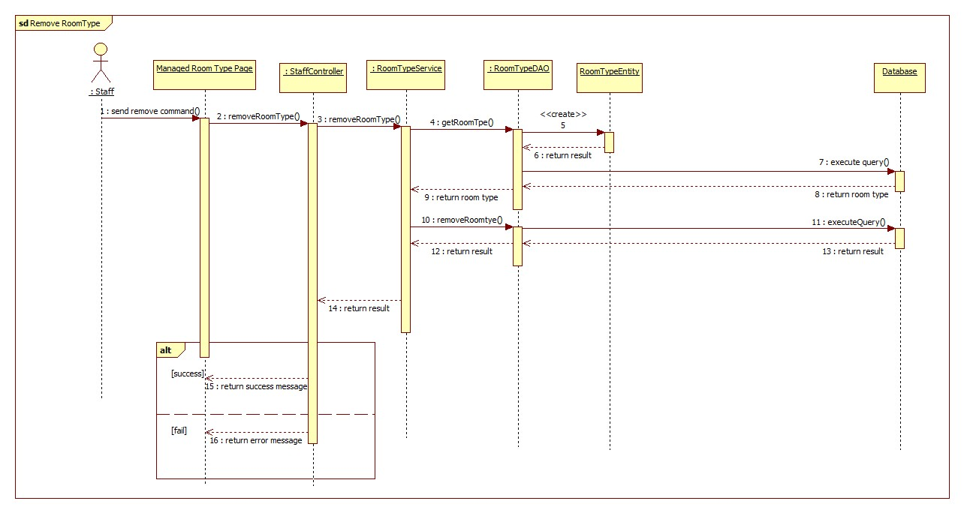

<Staff> Create Classroom

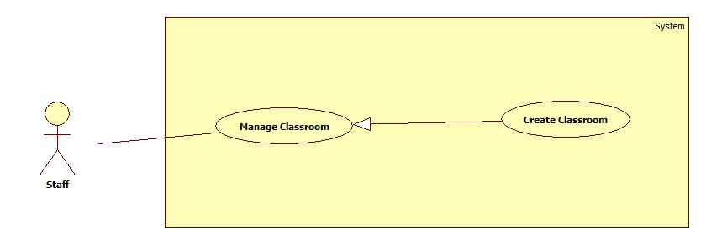

|  |  |  |  |
| --- | --- | --- | --- |
| **USE CASE – ECRM008** | |  |  |
| **Use Case No.** | ECRM008 | **Use Case Version** | 2.0 |
| **Use Case Name** | Create Classroom |  |  |
| **Author** | Tang Viet Hung |  |  |
| **Date** | 05/21/2015 | **Priority** | Normal |
| **Actor:**   * Staff | |  |  |
| **Summary:**   * This use case allows staff to create new classroom (applied for web application)   **Goal:** Add new classroom to system.  **Triggers:** Staff sends request “Thêm Lớp Học” in classroom management page.  **Preconditions:**   * User must login into the system with staff role.   **Post Conditions:**   * **Success:** New classroom will be added to database. Success message will be shown. * **Fail:** Error message will be shown.   **Main Success Scenario:**   |  |  |  | | --- | --- | --- | | Step | Actor Action | System Response | | 1 | Staff sends request “Tạo phòng học” in tab “Phòng học” in manage page. | System shows pop-up with information:   * Số phòng: free text input, min length: 1, max length: 4, numeric required. * Chọn: command. * Tạo phòng: command * Thoát: command   [Alternative 1] | | 2 | Staff fills necessary information into the form. |  | | 3 | Staff sends “Chọn” request. | System shows pop-up includes:   * Loại phòng: list of values (Loại 30 chỗ, loại 25 chỗ…). * Classroom map. * Chọn: command. * Thoát command.   [Alternative 2] | | 4 | Staff sends “Chọn” request and then sends “Tạo phòng” request. | Classroom is added to database, success message “Thêm mới lớp học thành công” is shown.  System is navigation to “Classroom Management Page”.  [Exception 1,2,3] |     **Alternative Scenario:**   |  |  |  | | --- | --- | --- | | No | Actor Action | System Response | | 1 | Staff click “Thoát” | System navigation to “Classroom Management Page” | | 2 | Staff click “Thoát” | System navigation to “Classroom Management Page” |   **Exceptions:**   |  |  |  | | --- | --- | --- | | No | Cause | System Response | | 1 | “Số phòng” field is empty | Error message “Số phòng không được để trống!” is shown. | | 2 | “Số phòng” is not numeric type. | Error message “Số phòng không hợp lệ!”. | | 3 | “Số phòng” field is duplicated in database | Confirm message “Bạn có muốn cập nhật cho phòng này!” is shown. | | 4 | Staff didn’t choose any room type and then send “Tạo phòng” request. | Error message “Phải chọn loại phòng!” is shown. |   **Relationships:** N/A  **Business Rules:**   * Each classroom will have only 1 type. * The new classroom is created don’t have any equipment in it. There are “Cập nhật thiết bị” command to insert equipment into the classroom. | | | |

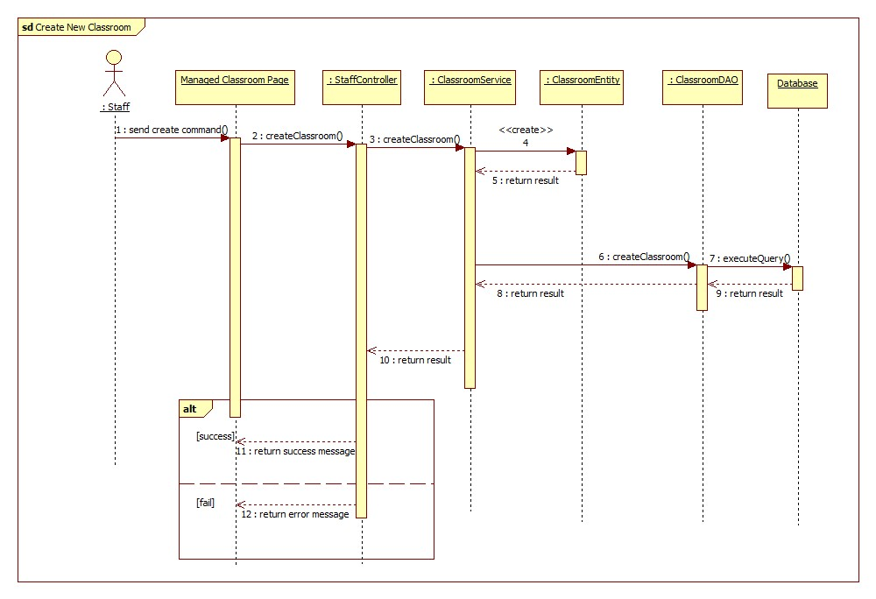

<Staff> Update Classroom

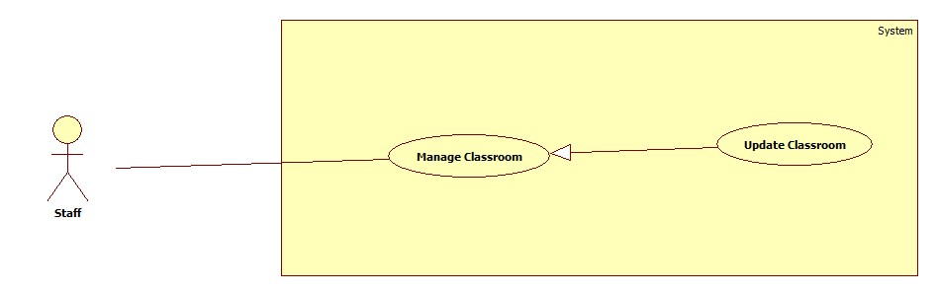

|  |  |  |  |
| --- | --- | --- | --- |
| **USE CASE – ECRM008** | |  |  |
| **Use Case No.** | ECRM008 | **Use Case Version** | 2.0 |
| **Use Case Name** | Update Classroom |  |  |
| **Author** | Tang Viet Hung |  |  |
| **Date** | 05/21/2015 | **Priority** | Normal |
| **Actor:**   * Staff | |  |  |
| **Summary:**   * This use case allows staff to update existed classroom (applied for web application)   **Goal:** Update existed classroom to system.  **Triggers:** Staff sends request “Cập nhật” in classroom management page.  **Preconditions:**   * User must login into the system with staff role. * Classroom must be existed in system   **Post Conditions:**   * **Success:** Classroom will be updated to database. Success message will be shown. * **Fail:** Error message will be shown.   **Main Success Scenario:**   |  |  |  | | --- | --- | --- | | Step | Actor Action | System Response | | 1 | Staff sends request “Xem sơ đồ” in tab “Phòng học” in manage page. | System shows pop-up with information:   * “Sơ đồ phòng”: title. * Classroom map. * Chỉnh sửa: command. * Thoát: command.   [Alternative 1] | | 2 | Staff sends “Chỉnh sửa” request. | System shows pop-up with information:   * Số phòng: free text input, min length: 1, max length: 4, numeric required. * Chọn: command. * Tạo phòng: command * Thoát: command   [Alternative 2] | | 2 | Staff fills necessary information into the form. |  | | 3 | Staff sends “Chọn” request. | System shows pop-up includes:   * Loại phòng: list of values (Loại 30 chỗ, loại 25 chỗ…). * Classroom map. * Chọn: command. * Thoát command.   [Alternative 2] | | 3 | Staff sends “Chọn” request and then sends “Cập nhật” request. | Classroom is added to database, success message “Cập nhật lớp học thành công” is shown.  System is navigation to “Classroom Management Page”.  [Exception 1,2,3] |     **Alternative Scenario:**   |  |  |  | | --- | --- | --- | | No | Actor Action | System Response | | 1 | Staff clicks “Thoát” | System navigation to “Classroom Management Page” | | 2 | Staff clicks “Thoát” | System navigation to “Classroom Management Page” | | 3 | Staff clicks “Thoát” | System navigation to “Classroom Management Page” |   **Exceptions:**   |  |  |  | | --- | --- | --- | | No | Cause | System Response | | 1 | “Số phòng” field is empty | Error message “Số phòng không được để trống!” is shown. | | 2 | “Số phòng” is not numeric type. | Error message “Số phòng không hợp lệ!”. | | 3 | “Số phòng” field is duplicated in database | Confirm message “Bạn có muốn cập nhật cho phòng này!” is shown. | | 4 | Staff didn’t choose any room type and then send “Cập nhật” request. | Error message “Phải chọn loại phòng!” is shown. |   **Relationships:** N/A  **Business Rules:**   * Each classroom will have only 1 type. * All the equipment in the updated classroom will be removed out of it. There are “Cập nhật thiết bị” command to insert equipment into the classroom. | | | |

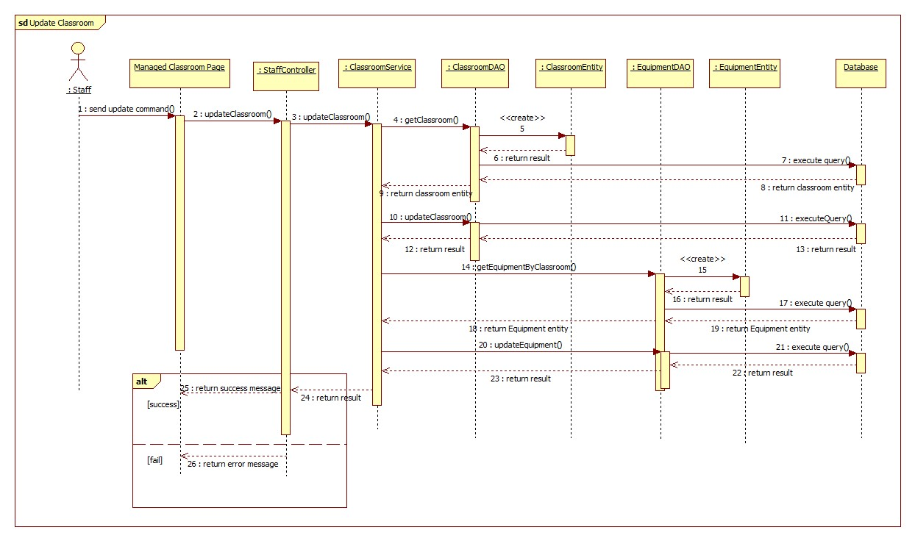

<Staff> Remove Classroom

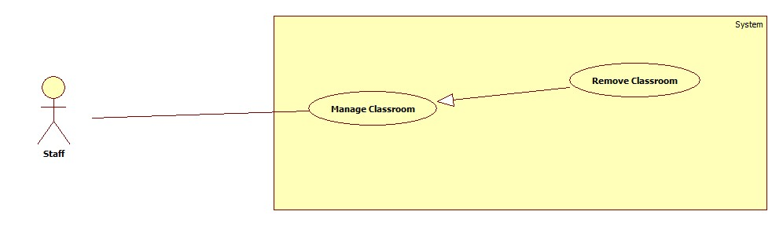

|  |  |  |  |
| --- | --- | --- | --- |
| **USE CASE – ECRM008** | |  |  |
| **Use Case No.** | ECRM008 | **Use Case Version** | 2.0 |
| **Use Case Name** | Remove Classroom |  |  |
| **Author** | Tang Viet Hung |  |  |
| **Date** | 05/21/2015 | **Priority** | Normal |
| **Actor:**   * Staff | |  |  |
| **Summary:**   * This use case allows staff to remove existed classroom (applied for web application)   **Goal:** Remove existed classroom to system.  **Triggers:** Staff sends request “Xóa” in classroom management page.  **Preconditions:**   * User must login into the system with staff role. * Classroom must be existed in system   **Post Conditions:**   * **Success:** Classroom will be removed from system. Success message will be shown. * **Fail:** Error message will be shown.   **Main Success Scenario:**   |  |  |  | | --- | --- | --- | | Step | Actor Action | System Response | | 1 | Staff sends request “Xóa” in tab “Phòng học” in manage page. | System shows confirm box:   * Bạn có muốn xóa phòng học: message. * Xóa: command. * Thoát: command.   [Alternative 1] | | 2 | Staff sends “Xóa” request. | System shows successful message: “Phòng học được xóa thành công!” |     **Alternative Scenario:**   |  |  |  | | --- | --- | --- | | No | Actor Action | System Response | | 1 | Staff clicks “Thoát” | System navigation to “Classroom Management Page” |   **Exceptions:**  **Relationships:** N/A  **Business Rules:**   * All the equipment in the classroom that is deleted will be removed out of this classroom. | | | |



<Staff> Create Equipment Category

|  |  |  |  |
| --- | --- | --- | --- |
| **USE CASE – ECRM008** | |  |  |
| **Use Case No.** | ECRM008 | **Use Case Version** | 2.0 |
| **Use Case Name** | Create Equipment |  |  |
| **Author** | Tang Viet Hung |  |  |
| **Date** | 05/21/2015 | **Priority** | Normal |
| **Actor:**   * Staff | |  |  |
| **Summary:**   * This use case allows staff to create new equipment (applied for web application)   **Goal:** Add new equipment to system.  **Triggers:** Staff sends request “Tạo thiết bị” in equipment management page.  **Preconditions:**   * User must login into the system with staff role.   **Post Conditions:**   * **Success:** New equipment will be added to database. Success message will be shown. * **Fail:** Error message will be shown.   **Main Success Scenario:**   |  |  |  | | --- | --- | --- | | Step | Actor Action | System Response | | 1 | Staff sends request “Tạo equipment” in tab “Thiết bị” in manage equipment page. | System shows pop-up with information:   * Loại thiết bị: list of value (Máy chiếu, máy lạnh…). * Tên thiết bị: free text input, min length 1, max length 30, required. * Số seri: free text input, min length 1, max length 30, required. * Thời gian sử dụng: free text input, min length 1, max length 5, numeric required. * Tạo: command * Thoát: command   [Alternative 1] | | 2 | Staff fills necessary information into the form. |  | | 3 | Staff sends “Tạo” request. | System shows successful message “Thiết bị đã được tạo thành công!”. |     **Alternative Scenario:**   |  |  |  | | --- | --- | --- | | No | Actor Action | System Response | | 1 | Staff click “Thoát” | System closes current pop-up. |   **Exceptions:**   |  |  |  | | --- | --- | --- | | No | Cause | System Response | | 1 | “Tên thiết bị” field is empty | Error message “Tên thiết bị không được để trống!” is shown. | | 2 | “Số seri” field is empty | Error message “Số seri không được để trống!” | | 3 | “Thời gian sử dụng” field is empty. | Error message “Thời gian sử dụng không được để trống!” | | 2 | “Thời gian sử dụng” is not numeric type. | Error message “Số phòng không hợp lệ!”. | | 3 | “Số seri” field is duplicated in database | Confirm message “Số seri đã tồn tại” is shown. |   **Relationships:** N/A  **Business Rules:**   * “Loại thiết bị” field is loaded from “equipment category”. * Each equipment has only one equipment category. * “Thời gian sử dụng” field can be 0. “Thời gian sử dụng” and “Thời gian còn lại” is only equal every time the equipment is created or updated. | | | |

