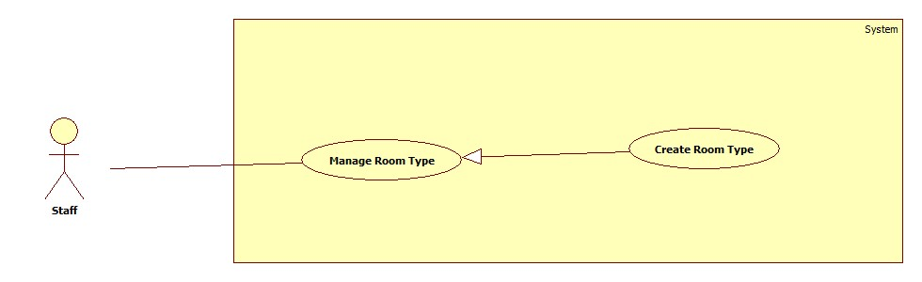

<Staff> Create Room Type

**Use case specification**

|  |  |  |  |
| --- | --- | --- | --- |
| **USE CASE – ECRM005** | |  |  |
| **Use Case No.** | ECRM005 | **Use Case Version** | 2.0 |
| **Use Case Name** | Create Room Type |  |  |
| **Author** | Tang Viet Hung |  |  |
| **Date** | 05/21/2015 | **Priority** | Normal |
| **Actor:** Staff | |  |  |
| **Summary:** This use case allows staff to create new room type.  **Goal:** Create room type to the system.  **Triggers:** Staff sends request “Tạo Loại Phòng” in “Loại Phòng” page.  **Preconditions:**   * User must login into the system with staff role.   **Post Conditions:**   * **Success:** New room type will be created and show successful message. * **Fail:** Unsuccessful message will be shown.   **Main Success Scenario:**   |  |  |  | | --- | --- | --- | | Step | Actor Action | System Response | | 1 | Staff clicks on “Phòng Học” and then clicks on tab “Loại phòng”. | System navigates to “Kiểu Phòng” page. Page includes:   * Table with columns: * Loại phòng * Số chỗ ngồi * Quản lý * Xem: command. * Xóa: command * Tạo loại phòng: command | | 2 | Staff sends “Tạo loại phòng” request.  [Alternative 1] | System open pop-up to “Tạo loại phòng”. Pop-up includes:   * Tên loại phòng: free text input, max length: 20, required. * List of equipments: check box * Số dãy bàn: value list. * Số hàng: value list. * Số ghế: value list. * Xem trước: command. * Thoát: command. | | 3 | Staff sends “Xem trước” request.  [Alternative 2] | System will show:   * Classroom map. * Tạo mẫu: command. * Quay lại: command. | | 4 | Staff sends “Tạo mẫu” request. | System show successful message: “Tạo loại phòng thành công!” and navigate to “Kiểu Phòng” page.  [Exception 1] |     **Alternative Scenario:**     |  |  |  | | --- | --- | --- | | No | Actor Action | System Respnse | | 1 | Staff sends “Thoát” request. | System closes pop-up. | | 2 | Staff send request “Quay lại”. | Re-open previous pop-up. |   **Exceptions:**   |  |  |  | | --- | --- | --- | | No | Actor Action | System Response | | 1 | “Tên loại phòng” is empty. | Show error message: “Tên loại phòng không được bỏ trống!” | | 2 | “Tên loại phòng” is existed. | Show confirm message: “Tên loại phòng đã tồn tại, bạn có muốn cập nhật?” |   **Relationships:** N/A  **Business Rules:**   * List of equipment is loaded from database in EquipmentCategory table. * If staff create new room type with existed room type name, system will update the room type with that room type name. * Each room type is created with list of equipment quantity that are presented the equipment in that room type. If staff didn’t choose any equipment, the room type wouldn’t have any equipment and classroom using the room type will have no equipment inside. | | | |

Create room type sequence

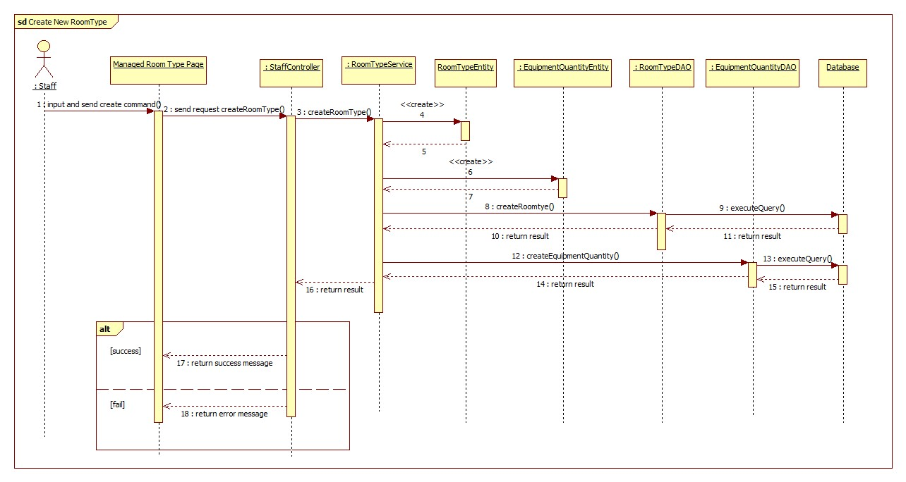

<Staff> Update Room Type

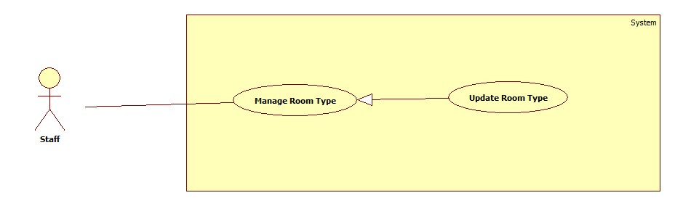

Figure 11: <Staff> Update Room Type

|  |  |  |  |
| --- | --- | --- | --- |
| **USE CASE – ECRM005** | |  |  |
| **Use Case No.** | ECRM005 | **Use Case Version** | 2.0 |
| **Use Case Name** | Update Room Type |  |  |
| **Author** | Tang Viet Hung |  |  |
| **Date** | 05/21/2015 | **Priority** | Normal |
| **Actor:** Staff | |  |  |
| **Summary:** This use case allows staff to update room type.  **Goal:** Update room type to the system.  **Triggers:** Staff sends request “Cập nhật” in “Loại Phòng” page.  **Preconditions:**   * User must login into the system with staff role. * Room type must be existed in database.   **Post Conditions:**   * **Success:** Room type will be updated and show successful message. * **Fail:** Unsuccessful message will be shown.   **Main Success Scenario:**   |  |  |  | | --- | --- | --- | | Step | Actor Action | System Response | | 1 | Staff clicks on “Phòng Học” and then clicks on tab “Loại phòng”. | System navigates to “Kiểu Phòng” page. Page includes:   * Table with columns: * Loại phòng * Số chỗ ngồi * Quản lý * Xem: command. * Xóa: command * Tạo loại phòng: command | | 2 | Staff sends “Xem” command.  [Alternative 1] | System open pop-up includes:   * Tên loại phòng: label. * Classroom map. * Chỉnh sửa: command. * Thoát: command. | | 3 | Staff sends “Chỉnh sửa” request.  [Alternative 2] | System open pop-up includes:   * Tên loại phòng: free text input, max length: 20, required. * List of equipments: check box * Số dãy bàn: value list. * Số hàng: value list. * Số ghế: value list. * Xem trước: command. * Thoát: command. | | 4 | Staff sends “Xem trước” request.  [Alternative 3] | System will show:   * Classroom map. * Tạo mẫu: command. * Quay lại: command. | | 5 | Staff sends “Cập nhật” request. | System show successful message: “Cập nhật loại phòng thành công!” and navigate to “Kiểu Phòng” page.  [Exception 1] |     **Alternative Scenario:**     |  |  |  | | --- | --- | --- | | No | Actor Action | System Response | | 1 | Staff sends “Thoát” request. | System closes pop-up. | | 2 | Staff sends “Thoát” request. | System closes pop-up. | | 3 | Staff send request “Quay lại”. | Re-open previous pop-up. |   **Exceptions:**   |  |  |  | | --- | --- | --- | | No | Actor Action | System Response | | 1 | “Tên loại phòng” is empty. | Show error message: “Tên loại phòng không được bỏ trống!” | | 2 | “Tên loại phòng” is existed. | Show confirm message: “Tên loại phòng đã tồn tại, bạn có muốn cập nhật?” |   **Relationships:** N/A  **Business Rules:**   * List of equipment is loaded from database in EquipmentCategory table. * If staff update new room type with existed room type name, system will update the room type with that room type name. * All the old equipment quantity in the updated room type will be deleted. In the other hand, the new equipment quantity will be created. * If there is any classroom is using the updated room type, all the equipment in that classroom will be removed. Staff has to add new equipment into that classroom by sending “Cập nhật thiết bị” command. | | | |

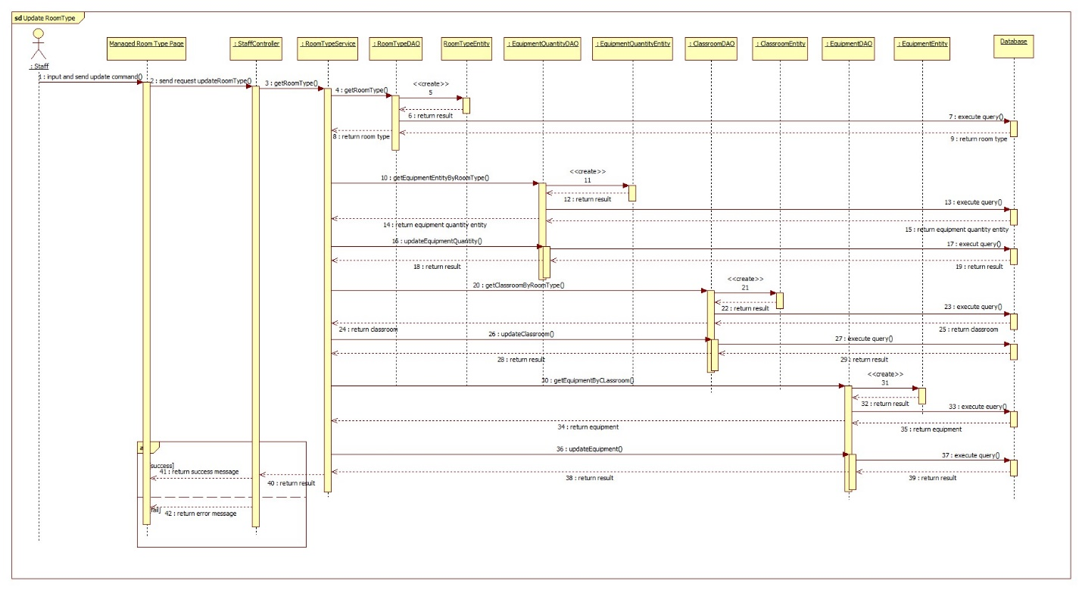

<Staff> Remove Room Type

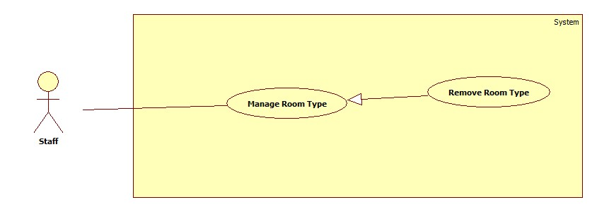

|  |  |  |  |
| --- | --- | --- | --- |
| **USE CASE – ECRM005** | |  |  |
| **Use Case No.** | ECRM005 | **Use Case Version** | 2.0 |
| **Use Case Name** | Remove Room Type |  |  |
| **Author** | Tang Viet Hung |  |  |
| **Date** | 05/21/2015 | **Priority** | Normal |
| **Actor:** Staff | |  |  |
| **Summary:** This use case allows staff to remove room type.  **Goal:** Update room type to the system.  **Triggers:** Staff sends request “Xóa” in “Loại Phòng” page.  **Preconditions:**   * User must login into the system with staff role. * Room type must be existed in database and there are no classroom using this room type.   **Post Conditions:**   * **Success:** Room type will be removed and show successful message. * **Fail:** Unsuccessful message will be shown.   **Main Success Scenario:**   |  |  |  | | --- | --- | --- | | Step | Actor Action | System Response | | 1 | Staff clicks on “Phòng Học” and then clicks on tab “Loại phòng”. | System navigates to “Kiểu Phòng” page. Page includes:   * Table with columns: * Loại phòng * Số chỗ ngồi * Quản lý * Xem: command. * Xóa: command * Tạo loại phòng: command | | 2 | Staff sends “Xóa” command. | System show successful message: “Xóa loại phòng thành công!” and navigate to “Kiểu Phòng” page.  [Exception 1] |     **Alternative Scenario:**  **Exceptions:**   |  |  |  | | --- | --- | --- | | No | Actor Action | System Response | | 1 | There is at least one classroom is using this room type. | Show error message: “Không thể xóa loại phòng này! Bạn phải gỡ ra khỏi phòng học trước!” |   **Relationships:** N/A  **Business Rules:**   * Staff can only delete one room type when there is no classroom is using this room type. If there is any classroom using this room type, these classroom must be updated to another room type or deleted. | | | |

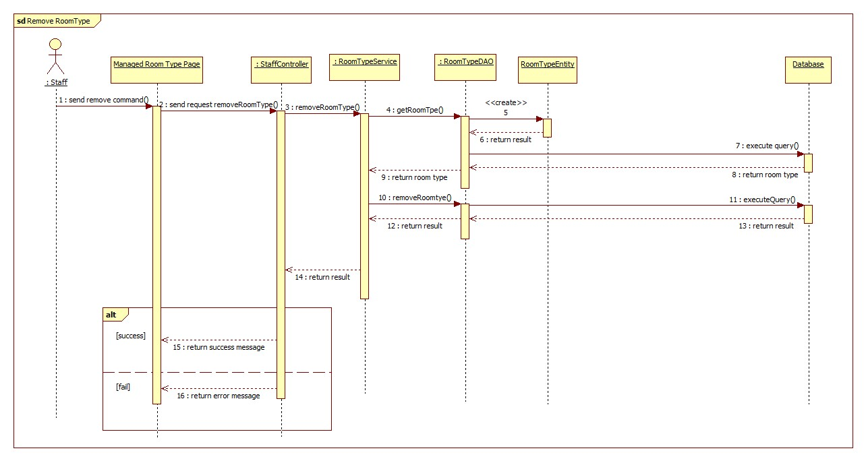

<Staff> Create Classroom

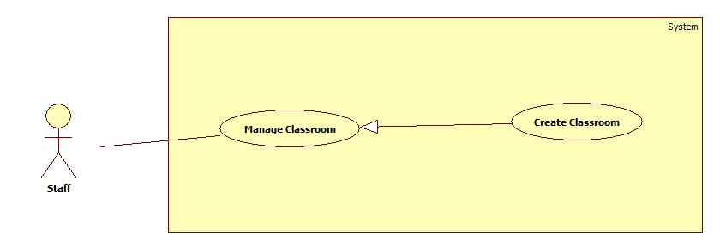

|  |  |  |  |
| --- | --- | --- | --- |
| **USE CASE – ECRM008** | |  |  |
| **Use Case No.** | ECRM008 | **Use Case Version** | 2.0 |
| **Use Case Name** | Create Classroom |  |  |
| **Author** | Tang Viet Hung |  |  |
| **Date** | 05/21/2015 | **Priority** | Normal |
| **Actor:**   * Staff | |  |  |
| **Summary:**   * This use case allows staff to create new classroom (applied for web application)   **Goal:** Add new classroom to system.  **Triggers:** Staff sends request “Thêm Lớp Học” in classroom management page.  **Preconditions:**   * User must login into the system with staff role.   **Post Conditions:**   * **Success:** New classroom will be added to database. Success message will be shown. * **Fail:** Error message will be shown.   **Main Success Scenario:**   |  |  |  | | --- | --- | --- | | Step | Actor Action | System Response | | 1 | Staff sends request “Tạo phòng học” in tab “Phòng học” in manage page.  [Alternative 1] | System shows pop-up with information:   * Số phòng: free text input, min length: 1, max length: 4, numeric required. * Chọn: command. * Tạo phòng: command * Thoát: command | | 2 | Staff fills necessary information into the form. |  | | 3 | Staff sends “Chọn” request.  [Alternative 2] | System shows pop-up includes:   * Loại phòng: list of values (Loại 30 chỗ, loại 25 chỗ…). * Classroom map. * Chọn: command. * Thoát command. | | 4 | Staff sends “Chọn” request and then sends “Tạo phòng” request. | Classroom is added to database, success message “Thêm mới lớp học thành công” is shown.  System is navigation to “Classroom Management Page”.  [Exception 1,2,3] |     **Alternative Scenario:**   |  |  |  | | --- | --- | --- | | No | Actor Action | System Response | | 1 | Staff click “Thoát” | System navigation to “Classroom Management Page” | | 2 | Staff click “Thoát” | System navigation to “Classroom Management Page” |   **Exceptions:**   |  |  |  | | --- | --- | --- | | No | Cause | System Response | | 1 | “Số phòng” field is empty | Error message “Số phòng không được để trống!” is shown. | | 2 | “Số phòng” is not numeric type. | Error message “Số phòng không hợp lệ!”. | | 3 | “Số phòng” field is duplicated in database | Confirm message “Bạn có muốn cập nhật cho phòng này!” is shown. | | 4 | Staff didn’t choose any room type and then send “Tạo phòng” request. | Error message “Phải chọn loại phòng!” is shown. |   **Relationships:** N/A  **Business Rules:**   * Each classroom only has one room type. * The new classroom is created don’t have any equipment in it. There are “Cập nhật thiết bị” command to insert equipment into the classroom. * Classroom without equipment inside cannot be reported. | | | |

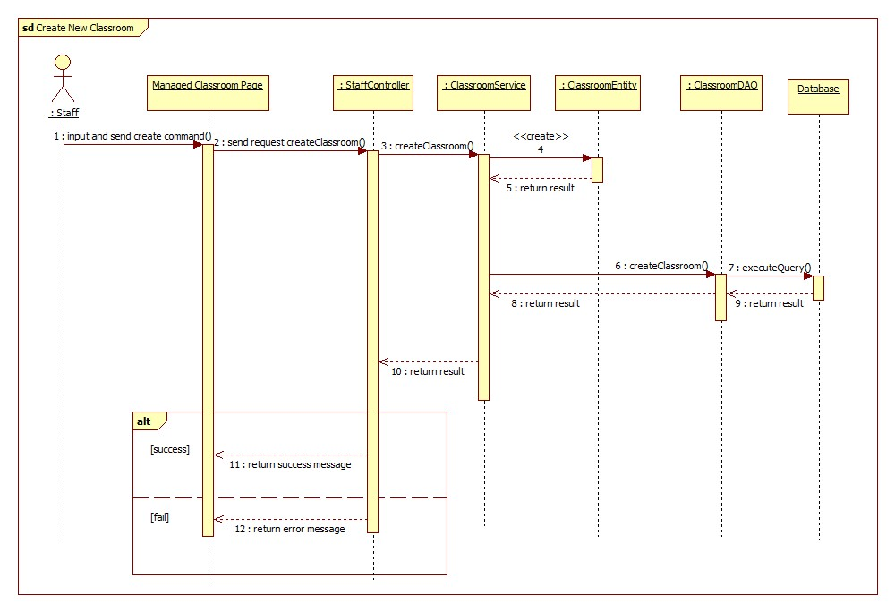

<Staff> Update Classroom

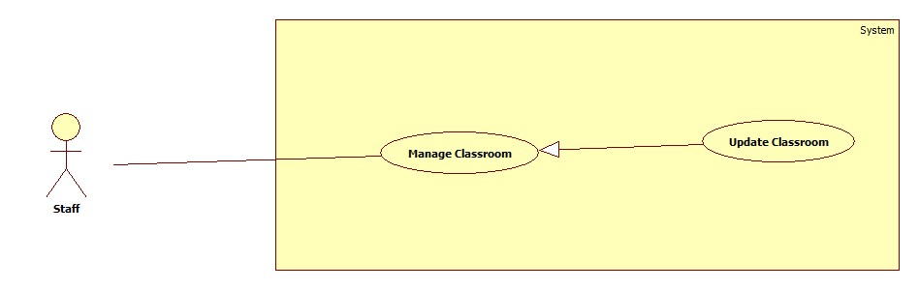

|  |  |  |  |
| --- | --- | --- | --- |
| **USE CASE – ECRM008** | |  |  |
| **Use Case No.** | ECRM008 | **Use Case Version** | 2.0 |
| **Use Case Name** | Update Classroom |  |  |
| **Author** | Tang Viet Hung |  |  |
| **Date** | 05/21/2015 | **Priority** | Normal |
| **Actor:**   * Staff | |  |  |
| **Summary:**   * This use case allows staff to update existed classroom (applied for web application)   **Goal:** Update existed classroom to system.  **Triggers:** Staff sends request “Cập nhật” in classroom management page.  **Preconditions:**   * User must login into the system with staff role. * Classroom must be existed in system   **Post Conditions:**   * **Success:** Classroom will be updated to database. Success message will be shown. * **Fail:** Error message will be shown.   **Main Success Scenario:**   |  |  |  | | --- | --- | --- | | Step | Actor Action | System Response | | 1 | Staff sends request “Xem sơ đồ” in tab “Phòng học” in manage page.  [Alternative 1] | System shows pop-up with information:   * “Sơ đồ phòng”: title. * Classroom map. * Chỉnh sửa: command. * Thoát: command. | | 2 | Staff sends “Chỉnh sửa” request.  [Alternative 2] | System shows pop-up with information:   * Số phòng: free text input, min length: 1, max length: 4, numeric required. * Chọn: command. * Tạo phòng: command * Thoát: command | | 2 | Staff fills necessary information into the form. |  | | 3 | Staff sends “Chọn” request.  [Alternative 3] | System shows pop-up includes:   * Loại phòng: list of values (Loại 30 chỗ, loại 25 chỗ…). * Classroom map. * Chọn: command. * Thoát command. | | 3 | Staff sends “Chọn” request and then sends “Cập nhật” request. | Classroom is added to database, success message “Cập nhật lớp học thành công” is shown.  System is navigation to “Classroom Management Page”.  [Exception 1,2,3] |     **Alternative Scenario:**   |  |  |  | | --- | --- | --- | | No | Actor Action | System Response | | 1 | Staff clicks “Thoát” | System navigation to “Classroom Management Page” | | 2 | Staff clicks “Thoát” | System navigation to “Classroom Management Page” | | 3 | Staff clicks “Thoát” | System navigation to “Classroom Management Page” |   **Exceptions:**   |  |  |  | | --- | --- | --- | | No | Cause | System Response | | 1 | “Số phòng” field is empty | Error message “Số phòng không được để trống!” is shown. | | 2 | “Số phòng” is not numeric type. | Error message “Số phòng không hợp lệ!”. | | 3 | “Số phòng” field is duplicated in database | Confirm message “Bạn có muốn cập nhật cho phòng này!” is shown. | | 4 | Staff didn’t choose any room type and then send “Cập nhật” request. | Error message “Phải chọn loại phòng!” is shown. |   **Relationships:** N/A  **Business Rules:**   * Each classroom only has one room type. * All the equipment in the updated classroom will be removed out of it and updated status to unused equipment. * There are “Cập nhật thiết bị” command to insert equipment into the classroom. | | | |

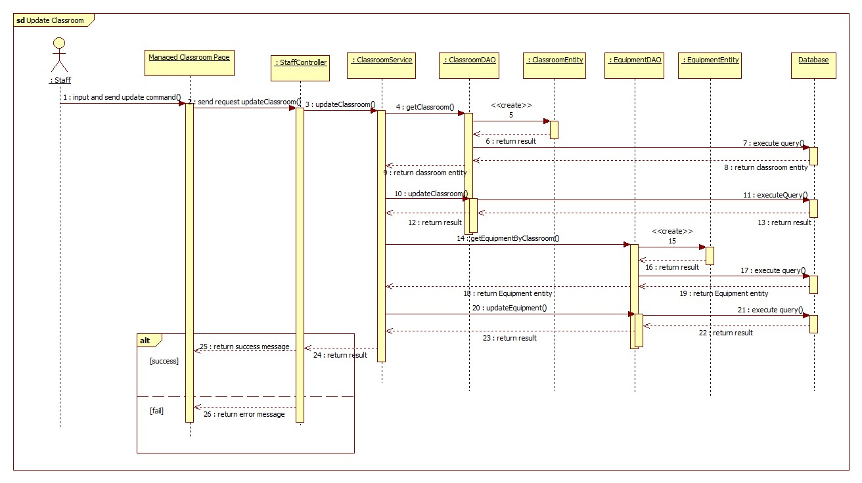

<Staff> Remove Classroom

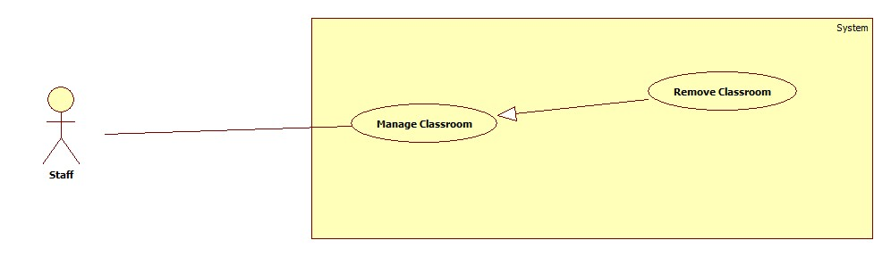

|  |  |  |  |
| --- | --- | --- | --- |
| **USE CASE – ECRM008** | |  |  |
| **Use Case No.** | ECRM008 | **Use Case Version** | 2.0 |
| **Use Case Name** | Remove Classroom |  |  |
| **Author** | Tang Viet Hung |  |  |
| **Date** | 05/21/2015 | **Priority** | Normal |
| **Actor:**   * Staff | |  |  |
| **Summary:**   * This use case allows staff to remove existed classroom (applied for web application)   **Goal:** Remove existed classroom to system.  **Triggers:** Staff sends request “Xóa” in classroom management page.  **Preconditions:**   * User must login into the system with staff role. * Classroom must be existed in system and there are no unresolved report in it.   **Post Conditions:**   * **Success:** Classroom will be removed from system. Success message will be shown. * **Fail:** Error message will be shown.   **Main Success Scenario:**   |  |  |  | | --- | --- | --- | | Step | Actor Action | System Response | | 1 | Staff sends request “Xóa” in tab “Phòng học” in manage page.  [Alternative 1] | System shows confirm box:   * Bạn có muốn xóa phòng học: message. * Xóa: command. * Thoát: command. | | 2 | Staff sends “Xóa” request. | System shows successful message: “Phòng học được xóa thành công!”  [Exption 1] |     **Alternative Scenario:**   |  |  |  | | --- | --- | --- | | No | Actor Action | System Response | | 1 | Staff clicks “Thoát” | System navigation to “Classroom Management Page” |   **Exceptions:**   |  |  |  | | --- | --- | --- | | No | Actor Action | System Response | | 1 | There are unresolved report in this classroom. | Error message “Vẫn còn báo cáo trong phòng này! Vui lòng xóa hoặc khắc phục báo cáo trước khi thực hiện thao tác này!” |   **Relationships:** N/A  **Business Rules:**   * All the equipment in the classroom that is deleted will be removed out of this classroom and updated its status to unused equipment. * Classroom cannot be removed if there are unresolved report in it. These report have to be resolved or rejected before remove classroom. | | | |

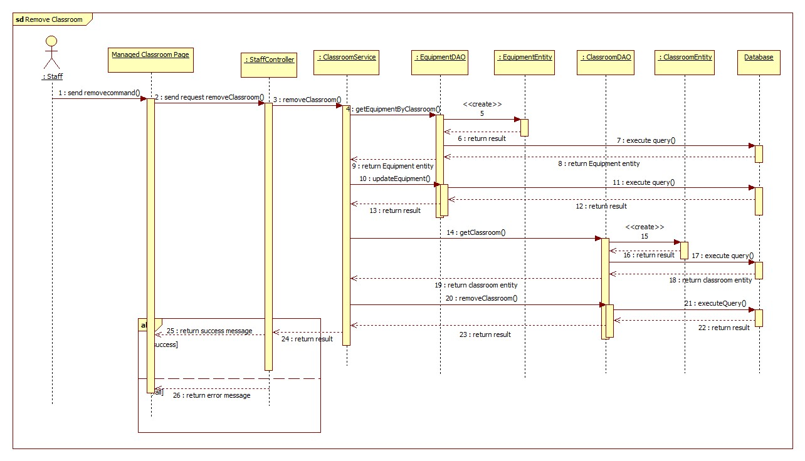

<Staff> Create Equipment

|  |  |  |  |
| --- | --- | --- | --- |
| **USE CASE – ECRM008** | |  |  |
| **Use Case No.** | ECRM008 | **Use Case Version** | 2.0 |
| **Use Case Name** | Create Equipment |  |  |
| **Author** | Tang Viet Hung |  |  |
| **Date** | 05/21/2015 | **Priority** | Normal |
| **Actor:**   * Staff | |  |  |
| **Summary:**   * This use case allows staff to create new equipment (applied for web application)   **Goal:** Add new equipment to system.  **Triggers:** Staff sends request “Tạo thiết bị” in equipment management page.  **Preconditions:**   * User must login into the system with staff role.   **Post Conditions:**   * **Success:** New equipment will be added to database. Success message will be shown. * **Fail:** Error message will be shown.   **Main Success Scenario:**   |  |  |  | | --- | --- | --- | | Step | Actor Action | System Response | | 1 | Staff sends request “Tạo thiết bị” in tab “Thiết bị” in manage equipment page.  [Alternative 1] | System shows pop-up with information:   * Loại thiết bị: list of value (Máy chiếu, máy lạnh…). * Tên thiết bị: free text input, min length 1, max length 30, required. * Số seri: free text input, min length 1, max length 30, required. * Thời gian sử dụng: free text input, min length 1, max length 5, numeric required. * Tạo: command * Thoát: command | | 2 | Staff fills necessary information into the form. |  | | 3 | Staff sends “Tạo” request. | System shows successful message “Thiết bị đã được tạo thành công!”  [Exception 1, 2, 3, 4, 5] |     **Alternative Scenario:**   |  |  |  | | --- | --- | --- | | No | Actor Action | System Response | | 1 | Staff click “Thoát” | System closes current pop-up. |   **Exceptions:**   |  |  |  | | --- | --- | --- | | No | Cause | System Response | | 1 | “Tên thiết bị” field is empty | Error message “Tên thiết bị không được để trống!” is shown. | | 2 | “Số seri” field is empty | Error message “Số seri không được để trống!” | | 3 | “Thời gian sử dụng” field is empty. | Error message “Thời gian sử dụng không được để trống!” | | 4 | “Thời gian sử dụng” is not numeric type. | Error message “Số phòng không hợp lệ!”. | | 5 | “Số seri” field is duplicated in database. | Confirm message “Số seri đã tồn tại” is shown. | | 6 | “Thời gian sử dụng” is smaller than its category’s “Thời gian báo hư” | Error message “Thời gian sử dụng không được nhỏ hơn thời gian báo hư!” |   **Relationships:** N/A  **Business Rules:**   * Staff only create equipment that has equipment category with property “Quản lý” is checked when it was created. * “Loại thiết bị” field is only loaded equipment category with property “isManaged” is true in table equipment category. * Each equipment has only one equipment category. * “Thời gian sử dụng” represents life time of this equipment. * “Thời gian sử dụng” field can be 0. “Thời gian sử dụng” and “Thời gian còn lại” is only equal every time the equipment is created. * Equipment’s “Thời gian sử dụng” must be bigger than its category’s “Thời gian báo hư” | | | |

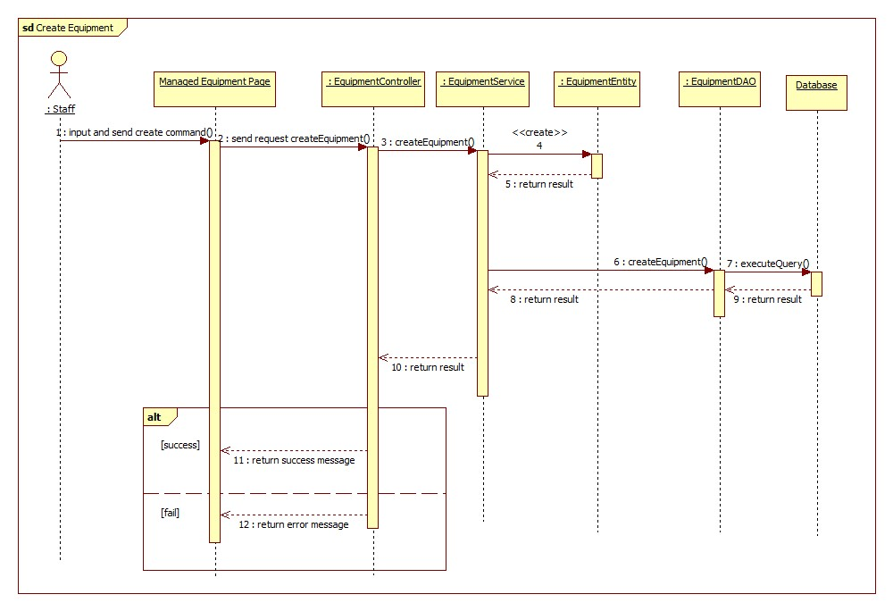

<Staff> Update Equipment

|  |  |  |  |
| --- | --- | --- | --- |
| **USE CASE – ECRM008** | |  |  |
| **Use Case No.** | ECRM008 | **Use Case Version** | 2.0 |
| **Use Case Name** | Update Equipment |  |  |
| **Author** | Tang Viet Hung |  |  |
| **Date** | 05/21/2015 | **Priority** | Normal |
| **Actor:**   * Staff | |  |  |
| **Summary:**   * This use case allows staff to update an existed equipment (applied for web application)   **Goal:** Update an existed equipment to system.  **Triggers:** Staff sends request “Cập nhật” in equipment management page.  **Preconditions:**   * User must login into the system with staff role. * The equipment must be existed in system.   **Post Conditions:**   * **Success:** Equipment will be updated to database. Success message will be shown. * **Fail:** Error message will be shown.   **Main Success Scenario:**   |  |  |  | | --- | --- | --- | | Step | Actor Action | System Response | | 1 | Staff sends request “Cập nhật” in tab “Thiết bị” in manage equipment page.  [Alternative 1] | System shows pop-up with information:   * Loại thiết bị: list of value (Máy chiếu, máy lạnh…). * Tên thiết bị: free text input, min length 1, max length 30, required. * Số seri: free text input, min length 1, max length 30, required. * Thời gian sử dụng: free text input, min length 1, max length 5, numeric required. * Thời gian còn lại: free text input, min length 1, max length 5. * Cập nhật: command * Thoát: command | | 2 | Staff fills necessary information into the form. |  | | 3 | Staff sends “Cập nhật” request. | System shows successful message “Thiết bị đã được tạo thành công!”  [Exception 1, 2, 3, 4, 5, 6, 7, 8] |     **Alternative Scenario:**   |  |  |  | | --- | --- | --- | | No | Actor Action | System Response | | 1 | Staff click “Thoát” | System closes current pop-up. |   **Exceptions:**   |  |  |  | | --- | --- | --- | | No | Cause | System Response | | 1 | “Tên thiết bị” field is empty | Error message “Tên thiết bị không được để trống!” is shown. | | 2 | “Số seri” field is empty | Error message “Số seri không được để trống!” | | 3 | “Thời gian sử dụng” field is empty. | Error message “Thời gian sử dụng không được để trống!” | | 4 | “Thời gian sử dụng” is not numeric type. | Error message “Thời gian sử dụng không hợp lệ!” | | 6 | “Thời gian còn lại” field is empty. | Error message “Thời gian sử dụng không được để trống!” | | 7 | “Thời gian còn lại” is not numeric type. | Error message “Thời gian còn lại không hợp lệ!” | | 8 | “Thời gian còn lại” is bigger than “Thời gian sử dụng”. | Error message “Thời gian còn lại không được lớn hơn thời gian sử dụng!” |   **Relationships:** N/A  **Business Rules:**   * “Loại thiết bị” field is loaded from “equipment category”. * Each equipment has only one equipment category. * “Thời gian sử dụng” presents life time of this equipment. * “Thời gian còn lại” presents using time remain till the expired date of this equipment. * If “Thời gian sử dụng” equals 0, it means this equipment doesn’t have expired time. | | | |

<Staff> Remove Equipment

|  |  |  |  |
| --- | --- | --- | --- |
| **USE CASE – ECRM008** | |  |  |
| **Use Case No.** | ECRM008 | **Use Case Version** | 2.0 |
| **Use Case Name** | Remove Equipment |  |  |
| **Author** | Tang Viet Hung |  |  |
| **Date** | 05/21/2015 | **Priority** | Normal |
| **Actor:**   * Staff | |  |  |
| **Summary:**   * This use case allows staff to delete an existed equipment (applied for web application)   **Goal:** Update an existed equipment to system.  **Triggers:** Staff sends request “Xóa” in equipment management page.  **Preconditions:**   * User must login into the system with staff role. * The equipment must be existed in system.   **Post Conditions:**   * **Success:** Equipment will be delete from database. Success message will be shown. * **Fail:** Error message will be shown.   **Main Success Scenario:**   |  |  |  | | --- | --- | --- | | Step | Actor Action | System Response | | 1 | Staff sends request “Xóa” in tab “Thiết bị” in manage equipment page.  [Alternative 1] | System shows confirm message: “Bạn có muốn xóa thiết bị?” | | 3 | Staff sends request “Xóa”. | System shows successful message “Thiết bị đã được xóa thành công!” |     **Alternative Scenario:**   |  |  |  | | --- | --- | --- | | No | Actor Action | System Response | | 1 | Staff sends request “Xóa” while equipment is using by one classroom. | System show confirm message: “Bạn có muốn gỡ thiết bị ra khỏi phòng?” |   **Exceptions:**  **Relationships:** N/A  **Business Rules:**   * If equipment is using by one classroom, the equipment will not be deleted but removed out of this classroom. If not, equipment will be deleted. * All reports belong to equipment will be deleted. | | | |

<Staff> Map equipment to classroom

|  |  |  |  |  |
| --- | --- | --- | --- | --- |
| **USE CASE – ECRM008** | |  | |  |
| **Use Case No.** | ECRM008 | | **Use Case Version** | 2.0 |
| **Use Case Name** | Map equipment to classroom |  | |  |
| **Author** | Tang Viet Hung |  | |  |
| **Date** | 05/21/2015 | **Priority** | | Normal |
| **Actor:**   * Staff | |  | |  |
| **Summary:**   * This use case allows staff to map equipment into classroom (applied for web application)   **Goal:** Mapping equipment into classroom  **Triggers:** Staff sends request “Cập nhật thiết bị” in classroom management page.  **Preconditions:**   * User must login into the system with staff role. * The needed equipment must be existed in system.   **Post Conditions:**   * **Success:** Equipment will be mapped into classroom and update to database. Success message will be shown. * **Fail:** Error message will be shown.   **Main Success Scenario:**   |  |  |  | | --- | --- | --- | | Step | Actor Action | System Response | | 1 | Staff sends request “Cập nhật thiết bị” in tab “Phòng học” in manage classroom page. | System shows successful message “Cập nhật thiết bị cho phòng học thành công!”  [Exception 1] |     **Alternative Scenario:**  **Exceptions:**   |  |  |  | | --- | --- | --- | | No | Actor Action | System Response | | 1 | Staff sends request “Cập nhật thiết bị” but not enough equipment in database. | System show error message: “Không đủ thiết bị!” |   **Relationships:** N/A  **Business Rules:**   * Each classroom has specific equipment base on their room type. For example: room type 1 has one projector, two air conditioning. Classroom 101 has type 1 so it will has these equipment too. If in database doesn’t have any projector or air conditioning which is not belong to any classroom the mapping action will not be executed until there enough equipment for this classroom. | | | | |

<Staff> Create equipment category

|  |  |  |  |
| --- | --- | --- | --- |
| **USE CASE – ECRM008** | |  |  |
| **Use Case No.** | ECRM008 | **Use Case Version** | 2.0 |
| **Use Case Name** | Create Equipment category |  |  |
| **Author** | Tang Viet Hung |  |  |
| **Date** | 05/21/2015 | **Priority** | Normal |
| **Actor:**   * Staff | |  |  |
| **Summary:**   * This use case allows staff to create new equipment category(applied for web application)   **Goal:** Add new equipment category to system.  **Triggers:** Staff sends request “Tạo loại thiết bị” in equipment management page.  **Preconditions:**   * User must login into the system with staff role.   **Post Conditions:**   * **Success:** New equipment category will be added to database. Success message will be shown. * **Fail:** Error message will be shown.   **Main Success Scenario:**   |  |  |  | | --- | --- | --- | | Step | Actor Action | System Response | | 1 | Staff sends request “Tạo loại thiết bị” in tab “Thiết loại bị” in manage equipment page.  [Alternative 1] | System shows pop-up with information:   * Tên loại: free text input, min length 1, max length 30, required. * Hình ảnh: image file input. * Quản lý: check box. * Thời gian báo hư: free text input, min length 1, max length 3, numeric required disabled. * Tạo: command * Thoát: command | | 2 | Staff fills necessary information into the form.  [Alternative 2] |  | | 3 | Staff sends “Tạo” request. | System shows successful message “Thiết bị đã được tạo thành công!”  [Exception 1, 2, 3, 4] |     **Alternative Scenario:**   |  |  |  | | --- | --- | --- | | No | Actor Action | System Response | | 1 | Staff click “Thoát” | System closes current pop-up. | | 2 | Staff checks “Quản lý”  [Alternative 3] | “Thời gian báo hư” text input will be changed to be enabled. | | 3 | Staff uncheck “Quản lý” | “Thời gian báo hư” text input will be changed to be disabled. |   **Exceptions:**   |  |  |  | | --- | --- | --- | | No | Cause | System Response | | 1 | “Tên loại” field is empty | Error message “Tên loại thiết bị không được để trống!” is shown. | | 2 | “Hình ảnh” field is empty or not image type. | Error message “Hãy chọn tập tin có đuôi là: .jpg, .jpeg, .png, .gif!” | | 3 | “Tên loại” field is duplicated in database | Confirm message “Tên loại đã tồn tại” is shown. | | 4 | “Thời gian báo hư” is empty or not numeric type. | Error message “Thời gian báo hư không hợp lê!” |   **Relationships:** N/A  **Business Rules:**   * If “Quản lý” field is checked, staff can create new equipment has that equipment category. * Equipment has equipment category with “Thời gian báo hư” is bigger than 0 will be changed status to be damaged when “Thời gian còn lại” is smaller than “Thời gian báo hư” and system will notify to staff about it. | | | |

<Staff> Update equipment category

|  |  |  |  |
| --- | --- | --- | --- |
| **USE CASE – ECRM008** | |  |  |
| **Use Case No.** | ECRM008 | **Use Case Version** | 2.0 |
| **Use Case Name** | Update Equipment category |  |  |
| **Author** | Tang Viet Hung |  |  |
| **Date** | 05/21/2015 | **Priority** | Normal |
| **Actor:**   * Staff | |  |  |
| **Summary:**   * This use case allows staff to update an existed equipment category(applied for web application)   **Goal:** Update an existed equipment category to system.  **Triggers:** Staff sends request “Cập nhật” in equipment management page.  **Preconditions:**   * User must login into the system with staff role. * Equipment category must be existed in database.   **Post Conditions:**   * **Success:** Equipment category will be updated to database. Success message will be shown. * **Fail:** Error message will be shown.   **Main Success Scenario:**   |  |  |  | | --- | --- | --- | | Step | Actor Action | System Response | | 1 | Staff sends request “Cập nhật” in tab “Thiết loại bị” in manage equipment page.  [Alternative 1] | System shows pop-up with information:   * Tên loại: free text input, min length 1, max length 30, required. * Hình ảnh: image file input. * Thời gian báo hư: free text input, min length 1, max length 3, numeric required. * Tạo: command * Thoát: command | | 2 | Staff fills necessary information into the form. |  | | 3 | Staff sends “Cập nhật” request. | System shows successful message “Thiết bị đã được cập nhật thành công!”  [Exception 1, 2, 3, 4] |     **Alternative Scenario:**   |  |  |  | | --- | --- | --- | | No | Actor Action | System Response | | 1 | Staff click “Thoát” | System closes current pop-up. |   **Exceptions:**   |  |  |  | | --- | --- | --- | | No | Cause | System Response | | 1 | “Tên loại” field is empty | Error message “Tên loại thiết bị không được để trống!” is shown. | | 2 | “Hình ảnh” field is empty or not image type. | Error message “Hãy chọn tập tin có đuôi là: .jpg, .jpeg, .png, .gif!” is shown. | | 3 | “Thời gian báo hư” is empty or not numeric type. | Error message “Thời gian báo hư không hợp lệ!” is shown. | | 4 | “Tên loại” field is different from current “Tên loại” and duplicated in database | Confirm message “Tên loại đã tồn tại” is shown. |   **Relationships:** N/A  **Business Rules:**   * All equipment have updated equipment category will be updated. * Equipment has equipment category with “Thời gian báo hư” is bigger than 0 will be changed status to be damaged when “Thời gian còn lại” is smaller than “Thời gian báo hư” and system will notify to staff about it. | | | |

<Staff> Remove equipment category

|  |  |  |  |
| --- | --- | --- | --- |
| **USE CASE – ECRM008** | |  |  |
| **Use Case No.** | ECRM008 | **Use Case Version** | 2.0 |
| **Use Case Name** | Remove Equipment category |  |  |
| **Author** | Tang Viet Hung |  |  |
| **Date** | 05/21/2015 | **Priority** | Normal |
| **Actor:**   * Staff | |  |  |
| **Summary:**   * This use case allows staff to remove an existed equipment category(applied for web application)   **Goal:** Remove an existed equipment category to system.  **Triggers:** Staff sends request “Xóa” in equipment management page.  **Preconditions:**   * User must login into the system with staff role. * Equipment category must be existed.   **Post Conditions:**   * **Success:** Equipment category will be remove from database. Success message will be shown. * **Fail:** Error message will be shown.   **Main Success Scenario:**   |  |  |  | | --- | --- | --- | | Step | Actor Action | System Response | | 1 | Staff sends request “Xóa” in tab “Thiết loại bị” in manage equipment page.  [Alternative 1] | System shows confirm message “Bạn có muốn xóa loại thiết bị ra khỏi hệ thống? Điều này sẽ ảnh hưởng tới các thiết bị có loại này!”   * Xóa: command. * Đóng: command. | | 2 | Staff sends “Xóa” request. | System shows successful message “Loại thiết bị đã được xóa thành công!” |     **Alternative Scenario:**   |  |  |  | | --- | --- | --- | | No | Actor Action | System Response | | 1 | Staff click “Thoát” | System closes current confirm message. |   **Exceptions:** N/A  **Relationships:** N/A  **Business Rules:**   * Before equipment category is removed, all equipment have this category will be removed out of classroom and then deleted from database. All report of these equipment will be deleted as well. | | | |

<Staff> Changing room

|  |  |  |  |
| --- | --- | --- | --- |
| **USE CASE – ECRM008** | |  |  |
| **Use Case No.** | ECRM008 | **Use Case Version** | 2.0 |
| **Use Case Name** | Changing room |  |  |
| **Author** | Tang Viet Hung |  |  |
| **Date** | 05/21/2015 | **Priority** | Normal |
| **Actor:**   * Staff | |  |  |
| **Summary:**   * This use case allows staff to change specific classroom to another classroom in system in a certain period time(applied for web application)   **Goal:** Add new equipment category to system.  **Triggers:** Staff sends request “Đổi” in classroom management page.  **Preconditions:**   * User must login into the system with staff role. * Classroom which staff want to change must be existed.   **Post Conditions:**   * **Success:** Change specific classroom to another classroom in system in a certain period time. Success message will be shown. * **Fail:** Error message will be shown.   **Main Success Scenario:**   |  |  |  | | --- | --- | --- | | Step | Actor Action | System Response | | 1 | Staff sends request “Đổi phòng” in tab “Phòng học” in manage equipment page.  [Alternative 1] | System shows pop-up with information:   * Từ ngày: free text input, date type required. * Đến ngày: free text input, date type. * Tìm phòng trống: command * Thoát: command | | 2 | Staff fills necessary information into the form. |  | | 3 | Staff sends “Tìm phòng trống” request.  [Alternative 2] | System shows pop-up with information:   * Phòng trống cho buổi sáng: list of number of classroom. * Phòng trống cho buổi chiều: list of number of classroom. * Đổi: command. * Quay lại: command.   [Exception 1, 2] | | 4 | Staff sends “Đổi” request. | System shows successful message “Đã đổi phòng thành công!”  [Exception 3] |     **Alternative Scenario:**   |  |  |  | | --- | --- | --- | | No | Actor Action | System Response | | 1 | Staff sends “Thoát” command. | System closes current pop-up. | | 2 | Staff sends “Quay lại” command. | System close current pop-up and re-open previous pop-up. |   **Exceptions:**   |  |  |  | | --- | --- | --- | | No | Cause | System Response | | 1 | “Từ ngày” field is empty or not date type. | Error message “Sai kiểu ngày tháng yyyy-mm-dd!” is shown. | | 2 | “Đến ngày” field is not date type. | Error message “Sai kiểu ngày tháng yyyy-mm-dd!” is shown. | | 3 | Staff didn’t choose any value in list “Phòng trống cho buổi sáng” and “Phòng trống cho buổi chiều”. | Error message “Không có gì thay đổi!” is shown. |   **Relationships:** N/A  **Business Rules:**   * Changing room is simply move all schedule in morning classes or noon classes or both of them in current classroom to another classroom that staff choose. * If staff choose the date range when current classroom don’t have any schedule, instead of show list of number classroom, system will show “Không có phòng cho buổi sáng (chiều) hoặc không có lịch dạy!” * If system can’t find any available classroom for morning classes or noon classes or even both of them, system will show “Không có phòng cho buổi sáng (chiều) hoặc không có lịch dạy!” | | | |

<Staff> Mapping schedule by import file

|  |  |  |  |
| --- | --- | --- | --- |
| **USE CASE – ECRM015** | |  |  |
| **Use Case No.** | ECRM015 | **Use Case Version** | 2.0 |
| **Use Case Name** | Mapping schedule by import file |  |  |
| **Author** | Tang Viet Hung |  |  |
| **Date** | 21/05/2015 | **Priority** | Normal |
| **Actor:** Staff | |  |  |
| **Summary:** This use case allows staff to import file schedule.  **Goal:** Import a schedule file.  **Triggers:** Staff sends “Nhập lịch” request on “Xếp Lịch” page.  **Preconditions:**   * User must login into the system with staff role.   **Post Conditions:**   * **Success:** All schedule on file will be imported and save in database and show successful message. * **Fail:** Unsuccessful message will be shown.   **Main Success Scenario:**   |  |  |  | | --- | --- | --- | | Step | Actor Action | System Response | | 1 | Staff sends “Nhập Lịch” request.  [Alternative 1] | System navigates to “Xếp lịch” page. Page includes:   * Tạo mới: command. * Nhập file: command. | | 2 | Staff sends “Nhập file” request. | System shows pop-up includes:   * Bấm vào để tải mẫu: command. * Chọn file excel: command. * Nhập lịch: command. * Thoát: command. | | 3 | Staff sends “Chọn file excel” request and choose schedule excel file from their computer. | System shows the name of schedule file. | | 4 | Staff clicks “Nhập lịch” button. | System shows successful message.  [Exception 1, 2, 3] |     **Alternative Scenario:**   |  |  |  | | --- | --- | --- | | No | Actor Action | System Response | | 1 | Staff sends “Bấm vào để tải mẫu” request. | Staff will get template excel file from server. |   **Exceptions:**   |  |  |  | | --- | --- | --- | | No | Actor Action | System Response | | 1 | Staff import a wrong template excel file. | System shows error message. | | 2 | Teacher name is not existed in database. | Error message “Giáo viên không tồn tại!” is shown. | | 3 | Classroom number is not existed in database. | Error message “Phòng học không tồn tại!” is shown. |   **Relationships:** N/A  **Business Rules:**   * After receiving request, system will check validate the file that got from user. If it’s incorrect template, system will show error. The new schedule will be saved in database. * If staff import one more teacher has more than two schedule in the same class in the same time, system will not save the newest one. * If staff import one teacher has more than two schedule in different class but in the same time, system will not save the newest one. * Every schedule is unique by its schedule configuration, classroom and teacher. | | | |

<Staff> Mapping schedule manually

|  |  |  |  |
| --- | --- | --- | --- |
| **USE CASE – ECRM014** | |  |  |
| **Use Case No.** | ECRM014 | **Use Case Version** | 2.0 |
| **Use Case Name** | Mapping Schedule Manually |  |  |
| **Author** | Tang Viet Hung |  |  |
| **Date** | 21/05/2015 | **Priority** | Normal |
| **Actor:** Staff | |  |  |
| **Summary:** This use case allows staff to import file schedule.  **Goal:** Import a schedule file.  **Triggers:** Staff sends “Tạo” request on “Nhập Lịch” page.  **Preconditions:**   * User must login into the system with staff role.   **Post Conditions:**   * **Success:** Schedule file will be imported and show successful message. * **Fail:** Unsuccessful message will be shown.   **Main Success Scenario:**   |  |  |  | | --- | --- | --- | | Step | Actor Action | System Response | | 1 | Staff sends “Nhập Lịch” request.  [Alternative 1] | System navigates to “Xếp lịch” page. Page includes:   * Tạo mới: command. * Nhập file: command. | | 2 | Staff sends “Tạo mới” request. | System shows pop-up includes:   * Giáo viên: text input, min length: 6, max length: 30, required. * Tiết bắt đầu: list of value (1-7:00:00, 2-8:45:00…) * Số tiết: list of value (1, 2, 3, 4…) * Từ ngày: text input, date type, required. * Đến ngày: text input, date type. * Số lượng học sinh: text input, number type, required. * Tìm phòng trống: command. * Phòng học: free text input or dropdown list, required. * Gửi tin nhắn: check box. * Tạo: command. * Thoát: command.   [Exception 1, 2, 3, 4 ,5, 6, 7, 8] | | 3 | Staff fills all require information and sends “Tạo” request.  [Alternative 1, 2] | System shows successful message. |     **Alternative Scenario:**   |  |  |  | | --- | --- | --- | | No | Actor Action | System Response | | 1 | Staff sends “Tìm phòng trống” request. | System will find available classroom based on information that staff inputted and then change “Phòng học” text input to dropdown list and put list of available classroom to dropdown list.  If staff sends “Tìm phòng trống” again, “Phòng học” will be changed to text input and so on. | | 2 | Staff sends “Thóat” command. | System close current pop-up. |   **Exceptions:**   |  |  |  | | --- | --- | --- | | No | Actor Action | System Response | | 1 | “Giáo viên” field is empty. | System shows error message: “Giáo viên không được bỏ trống!” | | 2 | “Giáo viên” field is not existed in database. | System shows error message: “Giáo viên không tồn tại!” | | 3 | “Số học sinh” field is empty. | System shows error message: “Số học sinh không được bỏ trống!” | | 4 | “Số học sinh” field is not numeric. | System shows error message: “Số học sinh không hợp lệ!” | | 5 | “Từ ngày” text input is empty or not date type. | System shows error message: “Ngày dạy bắt đầu không hợp lệ!” | | 6 | “Đến ngày” text input is not date type. | System shows error message: “Ngày dạy kết thúc” không hợp lệ!” | | 7 | “Từ ngày” field is bigger than “Đến ngày” field. | System shows error message: “Ngày bắt đầu không được nhỏ hơn nagyf kết thúc!” | | 8 | “Phòng học” is empty. | System shows error message: “Phòng học không được bỏ trống!” | | 9 | Staff sends “Tìm phòng trống” but didn’t fill all require field. | System shows error message: “Phải điền đầy đủ thông tin!” |   **Relationships:** N/A  **Business Rules:**   * If check box “Gửi tin nhắn” is checked, system will send SMS to user in “Giáo viên” field. * If in database has one schedule that has the same teacher with the inserted schedule­ but different classroom and in the same time, system will delete the old one and insert the new one with note. * If in database has one schedule that has the same classroom in the same time but different teacher, system will delete the old one and insert the new one with note. * Every schedule is unique by its schedule configuration, classroom and teacher. | | | |

<Staff> Schedule configuration

|  |  |  |  |
| --- | --- | --- | --- |
| **USE CASE – ECRM014** | |  |  |
| **Use Case No.** | ECRM014 | **Use Case Version** | 2.0 |
| **Use Case Name** | Schedule configuration |  |  |
| **Author** | Tang Viet Hung |  |  |
| **Date** | 21/05/2015 | **Priority** | Normal |
| **Actor:** Staff | |  |  |
| **Summary:** This use case allows staff to manage schedule configuration in system.  **Goal:** Import a schedule file.  **Triggers:** Staff sends “Lưu” request on “Tiết học” page.  **Preconditions:**   * User must login into the system with staff role.   **Post Conditions:**   * **Success:** Schedule configuration will be save and show successful message. * **Fail:** Unsuccessful message will be shown.   **Main Success Scenario:**   |  |  |  | | --- | --- | --- | | Step | Actor Action | System Response | | 1 | Staff sends “Tiết học” request.  [Alternative 1] | System navigates to “Cấu hình tiết học” page. Page includes:   * Cập nhật: command. * Số phút mỗi tiết: free text input, numeric, disabled. * List of slot in database. Each slot has:   + Time from: free text input, time type, disabled.  + Time to: free text input, time type, disabled. | | 2 | Staff sends “Cập nhật” request. | System shows pop-up includes:   * Số phút mỗi tiết: free text input, min length 1, max length 3, time type, required. * OK: command. * Thoát: command. | | 3 | Staff fills all require information and sends “OK” request.  [Alternative 1] | System close pop-up and page now includes:   * Xóa tiết: command. * Thêm tiết: command. * Số phút mỗi tiết: free text input, numeric, disabled. * List of slot in database. Each slot has:   + Time from: free text input, time type.  + Time to: free text input, time type, disabled.   * Lưu: command. * Hủy: command.   [Exception 1] | | 4 | Staff fills in “Time from” field and then sends “Lưu” request.  [Alternative 2, 3, 4] | System show successful message.  [Exception 2] |     **Alternative Scenario:**   |  |  |  | | --- | --- | --- | | No | Actor Action | System Response | | 1 | Staff sends “Thoát” request. | System closes current pop-up. | | 2 | Staff sends “Xóa tiết” command. | System will remove the last element of list slot.  [Exception 4] | | 3 | Staff sends “Thêm tiết” command. | System will add new slot to the last element. | | 4 | Staff sends “Hủy” command. | System will reload page. |   **Exceptions:**   |  |  |  | | --- | --- | --- | | No | Actor Action | System Response | | 1 | “Số phút mỗi tiết” field is empty or not numeric type. | System shows error message: “Số phút không hợp lệ!” | | 2 | “Time from” is empty or not time type. | System shows error message: “Kiểu giờ phải là hh:MM:ss!” | | 3 | Staff sends “Xóa tiết” but there are no slot left. | System shows error message: “Không còn tiết nào để xóa!” |   **Relationships:** N/A  **Business Rules:**   * After staff had inputted “Time from” field, “Time to” field will be automatically generated based on “Time from” and value of “Số phút mỗi tiết”. “Time to” is equal “Time to” plus value of “Số phút mỗi tiết”. * Each schedule configuration is unique by “TimeFrom”, “TimeTo” and slot. | | | |