**MINISTRY OF EDUCATION AND TRAINING**

**FPT UNIVERSITY**

Capstone Project Document

Equipment’s Classroom Management

|  |  |
| --- | --- |
| **Group 10** | |
| **Group member** | Trần Vĩnh Quang – SE61078  Tăng Việt Hưng – SE61019  Đoàn Nguyễn Minh Chí – SE60717  Vũ Thế Anh – 60111 (Drop out) |
| **Supervisor** | Kiều Trọng Khánh |
| **Ext. Supervisor** | N/A |
| **Capstone Project Code** | ECRM |

-Ho Chi Minh City, May 11, 2015-

*This page is intentionally left blank*

**

**CAPSTONE PROJECT REGISTER**

Class: Duration time: from 11/05/2015…. To /2015…..

(*) Profession: <Software Engineer> Specialty: <ES> <IS>

x

(*) Kinds of person make registers: Lecturer Students

x

1. Register information for supervisor (if have)

|  |  |  |  |  |
| --- | --- | --- | --- | --- |
|  | **Full name** | **Phone** | **E-Mail** | **Title** |
| Supervisor 1 | Kiều Trọng Khánh |  | khanhkt@fpt.edu.vn | Mr. |

2. Register information for students (if have)

|  |  |  |  |  |  |
| --- | --- | --- | --- | --- | --- |
|  | **Full name** | **Student code** | **Phone** | **E-mail** | **Role in Group** |
| Student 1 |  |  |  |  |  |
| Student 2 |  |  |  |  |  |
| Student 3 |  |  |  |  |  |
| Student 4 |  |  |  |  |  |

3. Register content of Capstone Project

(*) 3.1. Capstone Project name:

English: Equipments' Classroom Management.

Vietnamese: Ứng dụng hỗ trợ quản lý trang thiết bị cho các phòng học

Abbreviation:

- ECRM

- Building the application supports the staff manage the equipment's classroom. The Classroom type is present with position of each equipment. The user can report their damage by checking, then that report is notified to staff. The staff also notify to the reported about the fixing.

- Building the application provides following services

* **Manage Equipment**
* **Notify damage and fixing the equipment**
* **Manage Classroom**

(*) 3.2. Main proposal content (including result and product)

1. Theory and practice (document):

* Student should apply the software development process and the UML
* Software artifacts include User Requirement, Software Requirement Specification, Architecture Design, Detail Design, System Implementation and Testing Document, Installation Guide, sources code, and deployable software packages
* 3 tiers should be applied
* Server side technique:
  + Database design, OOA, OOD, OOP, MVC, Java or .Net technology, …
* Client side technique
  + HTML5, CSS, JavaScript, JQuery, Ajax, Androids …
* Communication technique
  + Exchange information and transfer data in effective in networks, communicating protocol between mobile device, ...
* Research
  + Graphics, ...

1. Program:

* Main functions
* **Manage Equipment**
* Manage the equipment with their position in the classroom
* All the equipment of the specified class room is shown with interactive graphic to particular instructor on his/her account on the website and mobile device
* **Notify damage and fixing the equipments**
* The notify is applied on the website and the mobile device
* **Manage Classroom**

1. Other products:

* The system should be implemented using Web Services
* The system should be implemented with mobile application
* The map of classroom and equipment should be presented with graphics both web and mobiles
* All of management functions of the system must be implemented to support the operating system in best

4. Other comment (propose all relative thing if have)

|  |  |
| --- | --- |
| **Supervisor (If have)**  *(Sign and full name)* | HCM city, date 14/4/2015 …..  **On behalf of Registers**  *(Sign and full name)* |

Table of Contents

**A.** **Software Project Manager Plan** 1

**1.** **Problem Definition** 1

**1.1.** **Name of this Capstone Project** 1

**1.2.** **Problem Abstract** 1

**1.3.** **Project Overview** 1

**2.** **Project Organization** 3

**2.1.** **Software Process Model** 3

**2.2.** **Tool and Techniques** 4

**B.** **Software Requirement Specification** 5

**1.** **User Requirement Specification** 5

**1.1.** **Guest Requirement** 5

**1.2.** **User Requirement** 5

**1.3.** **Staff Requirement** 5

**1.4.** **Administrator Requirement** 6

**1.5.** **Authorize User Requirement** 6

**2.** **System Overview Use Case** 6

**3.** **Conceptual Diagram** 8

**C.** **Software Design Description** 9

**1.** **Design Overview** 9

**2.** **System Architecture Design** 9

**2.1.** **Web Application architecture description** 10

**2.2.** **Mobile Application architecture description** 10

**3.** **Component Diagram** 11

**4.** **Detailed Description** 11

**4.1.** **Class Diagram** 12

**4.2.** **Sequence Diagram** 14

**4.3.** **Activity Diagram** 17

**5.** **Database Design** 23

**5.1.** **Entity Relationship Diagram** 23

**5.2.** **Entity Dictionary** 24

**6.** **Algorithms** 24

**6.1.** **Suggest available classroom** 24

**6.2.** **Damaged Statistic** 25

**6.3.** **System Scheduler Process** 27

**D.** **System Implementation & Testing** 29

**1.** **Database Relationship Diagram** 29

**1.1.** **Physical Diagram** 29

**1.2.** **Data Dictionary** 30

**Figure**

Figure 1: Software Process Model 3

Figure 2: System Overview Usecase 7

Figure 3: Conceptual Diagram 8

Figure 4: System Architecture Design 9

Figure 5: Android Application Architecture 10

Figure 6: Component Diagram 11

Figure 7: Class Diagram 12

Figure 8: <Teacher> Create Report - Sequence Diagram 14

Figure 9: <Staff> Resolve Report - Sequence Diagram 15

Figure 10: <Staff> Change Room - Sequence Diagram 16

Figure 11: <Teacher> Create Report - Activity Diagram 17

Figure 12: <Staff> View Report Information- Activity Diagram 18

Figure 13: <Staff> Resolve Report- Activity Diagram 19

Figure 14: <Staff> Change Room for Report - Interactive Diagram 20

Figure 15: <Staff> Change Room Manual - Interactive Diagram 21

Figure 16: Entity Relationship Diagram 23

Figure 17: Damaged Statistic - Flow Chart 26

Figure 18: Physical Diagram 29

**Table**

Table 1: Conceptual Diagram - Data Dictionary 8

Table 2: Component Dictionary 11

Table 3: Entity Dictionary 24

Table 4: Data Dictionary 33

**Definitions, Acronyms and Abbreviations**

|  |  |
| --- | --- |
| Name | Definitions |
| ECRM | Equipment’s Classroom Management |
| HTTP | Hyper Text Transfer Protocol |
| App | Application |
| API | Application Program Interface |
| SMS | Short Message Service |
| JRE | Java Runtime Environment |

1. **Software Project Manager Plan**
   1. **Problem Definition**
      1. **Name of this Capstone Project**

* **Official Name:** Equipment’s Classroom Management.
* **Vietnamese Name:** Ứng dụng hỗ trợ quản lí trang thiết bị cho các phòng học.
* **Abbreviation:** ECRM.
  + 1. **Problem Abstract**

Reporting damaged equipment in classroom is very important. It affects the quality of teaching badly since it caused wasting time. If we can optimize it, the quality of teaching will be improved. So the ECRM system will provide the platform where people can reduce reporting damaged equipment time, manage equipment and receive suggestions via web site and mobile application.

* + 1. **Project Overview**
       1. **Current Situation**

The ECRM is the system that helps manages equipment in classroom more convenient way. With teacher, they just click (with web app version) or touch (with mobile app version) on the equipment which is damaged and system will notify to the staff immediately. With staff, they can see specific equipment was damaged in which classroom and who reported it. They can also check which classroom is available due to the schedule excel file imported to the system. Staff can read the statistic about equipment in school if they want to.

The system also has restrictions and it comes from the data in schedule excel file. If staff imports incorrect data but match the template, the result will be wrong. One more thing is the system couldn’t check user’s behaviors. So if teacher report wrong position of the damaged equipment, there are no way the system can deal with it.

* + - 1. **The proposed system**

Our system includes three main subsystems: an online website application for teacher and staff, a mobile application for teacher and a mobile application for staff.

* + - * 1. **Website application**
* **Classroom management:**
* Staff can manage classroom of school.
* Staff can apply each classroom with the specific room type.
  + Staff can manage room type of school.
* **Account management:**
  + Admin can manage all account of system.
  + Admin can activate or deactivate specific account.
* **Report management:**
* Staff can receive report about the damaged equipment from teacher.
* Teacher can send report about damaged equipment when they are teaching and after teach in class.
* **Equipment management:**
* Staff can manage equipment.
* Staff can manage equipment category in school.
* Staff can tracking time remain of specific equipment.
* **Tracking schedule:**
* Staff can create manual schedule for teacher or import schedule by excel file.
* Staff can track schedule of all teacher in system.
* Teacher can see schedule in each day.
* **Statistic:**
* Staff can read statistic about the equipment likes life time, current status…
* **Analysis:**
  + System automatically analyzes the damaged level, gives suggestions.
* **Send SMS:**
  + System sends SMS to related peoples.
* **Suggest available classroom:**
  + System find similar available classroom base on some conditional and give suggestion.
    - * 1. **Mobile application for teacher (ECRM Teacher)**
* Teacher sends report about damaged equipment.
* Teacher views the map of room with interactive graphic in their account.
* Teacher views the schedule in current date.
* Teacher receives notification and SMS about changing room if needed.
* Teacher can edit or remove report in a certain time.
  + - * 1. **Mobile application for staff (ECRM Staff)**
* Staff can get notification from damaged equipment which reported by teacher.
* Staff can send notification to teacher about fixing equipment of changing room if needed.
* Staff can send SMS to relative people such as: teacher, security…
* Staff can resolve report when needed.
* Staff can change room manually.
  + - 1. **Boundaries of the System**
* The ECRM is used by teacher and staff, run in laptop, PC and android smart phone.
* Language: Vietnamese.
* The lasted product contain:
* The website application for staff and teacher.
* The android application for staff (ECRM Staff).
* The android application for teacher (ECRM Teacher).
  1. **Project Organization**
     1. **Software Process Model**

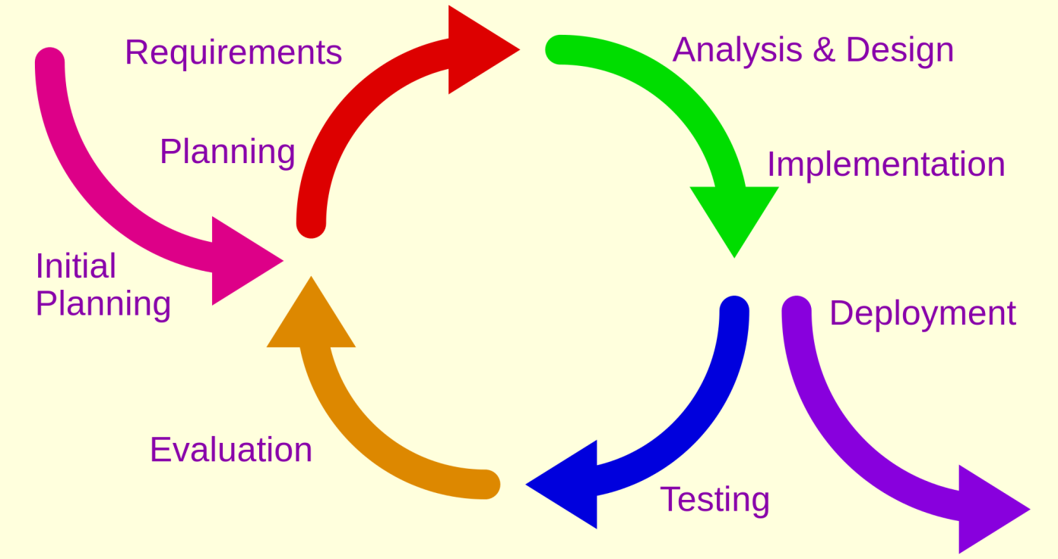

Figure 1: Software Process Model

Source: <http://en.wikipedia.org/wiki/Iterative_and_incremental_development>

The reasons for choose iterative development are:

* Members are active but lack of experience so we need to receive feedback during project evolving.
* We have 14 weeks for this project. So we can defined this is small project. Iterative model is suitable for this project to approaching the user thinking.
* This project does not exist, so we must take the survey to customer to know the equipment management in each school.
* In each phase, members only focus for their function. This will make the result better.
* Customer is more actively involved, get higher priority.
* Requirement changed frequently.
  + 1. **Tool and Techniques**
* Front-end: HTML 5, Bootstrap, CSS3, JavaScript, jQuery.
* Back-end: RESTful Web service, Spring MVC, Hibernate, JSP.
* Web-server: Apache Tomcat 7.0.
* Development Tools: IntelliJ IDEA 14
* Database Management System: MySQL 5.6

1. **Software Requirement Specification**
   1. **User Requirement Specification**
      1. **Guest Requirement**

Guest is a person who does not login to the system. Guest can use some function in the system. These are some functions guest can use:

* Login
  + 1. **User Requirement**

User is guest, who uses his account to login to the system. In this system, we can define user is a teacher. Member can use some additional function, such as:

* View Report History.
* View Room Map.
* Manage Report include
  + Create Report
  + Delete Report
  + Edit Report
    1. **Staff Requirement**

Staff is manager of the system, we can define staff is an equipment manager in school. Staff can use these function:

* Manage Room Type include:
  + Create Room Type.
  + Update Room Type.
  + Remove Room Type.
* Manage Classroom include:
  + Create Classroom.
  + Update Classroom.
  + Remove Classroom.
* Manage Schedule include:
  + Mapping Schedule Import File.
  + Mapping Schedule Manual.
* Statistic.
* Configuration schedule.
* Manage Report include:
  + Resolve Report.
  + Remove Report.
  + Change Room
* Manage Equipment include:
  + Create Equipment.
  + Remove Equipment.
  + Update Equipment.
  + Map equipment to classroom.
* Manage Category include:
  + Create Category.
  + Remove Category.
  + Update Category.
    1. **Administrator Requirement**

Admin is the person who manages the system. Admin is super user can use following functions:

* Manage Account include:
  + Create Account
  + Update Account
  + Activate/Deactivate Account
* Manage configuration
  + 1. **Authorize User Requirement**

Authorize User is the person who login to system include user, staff, administrator. Authorize user can use following functions:

* Logout.
* Change Password.
  1. **System Overview Use Case**

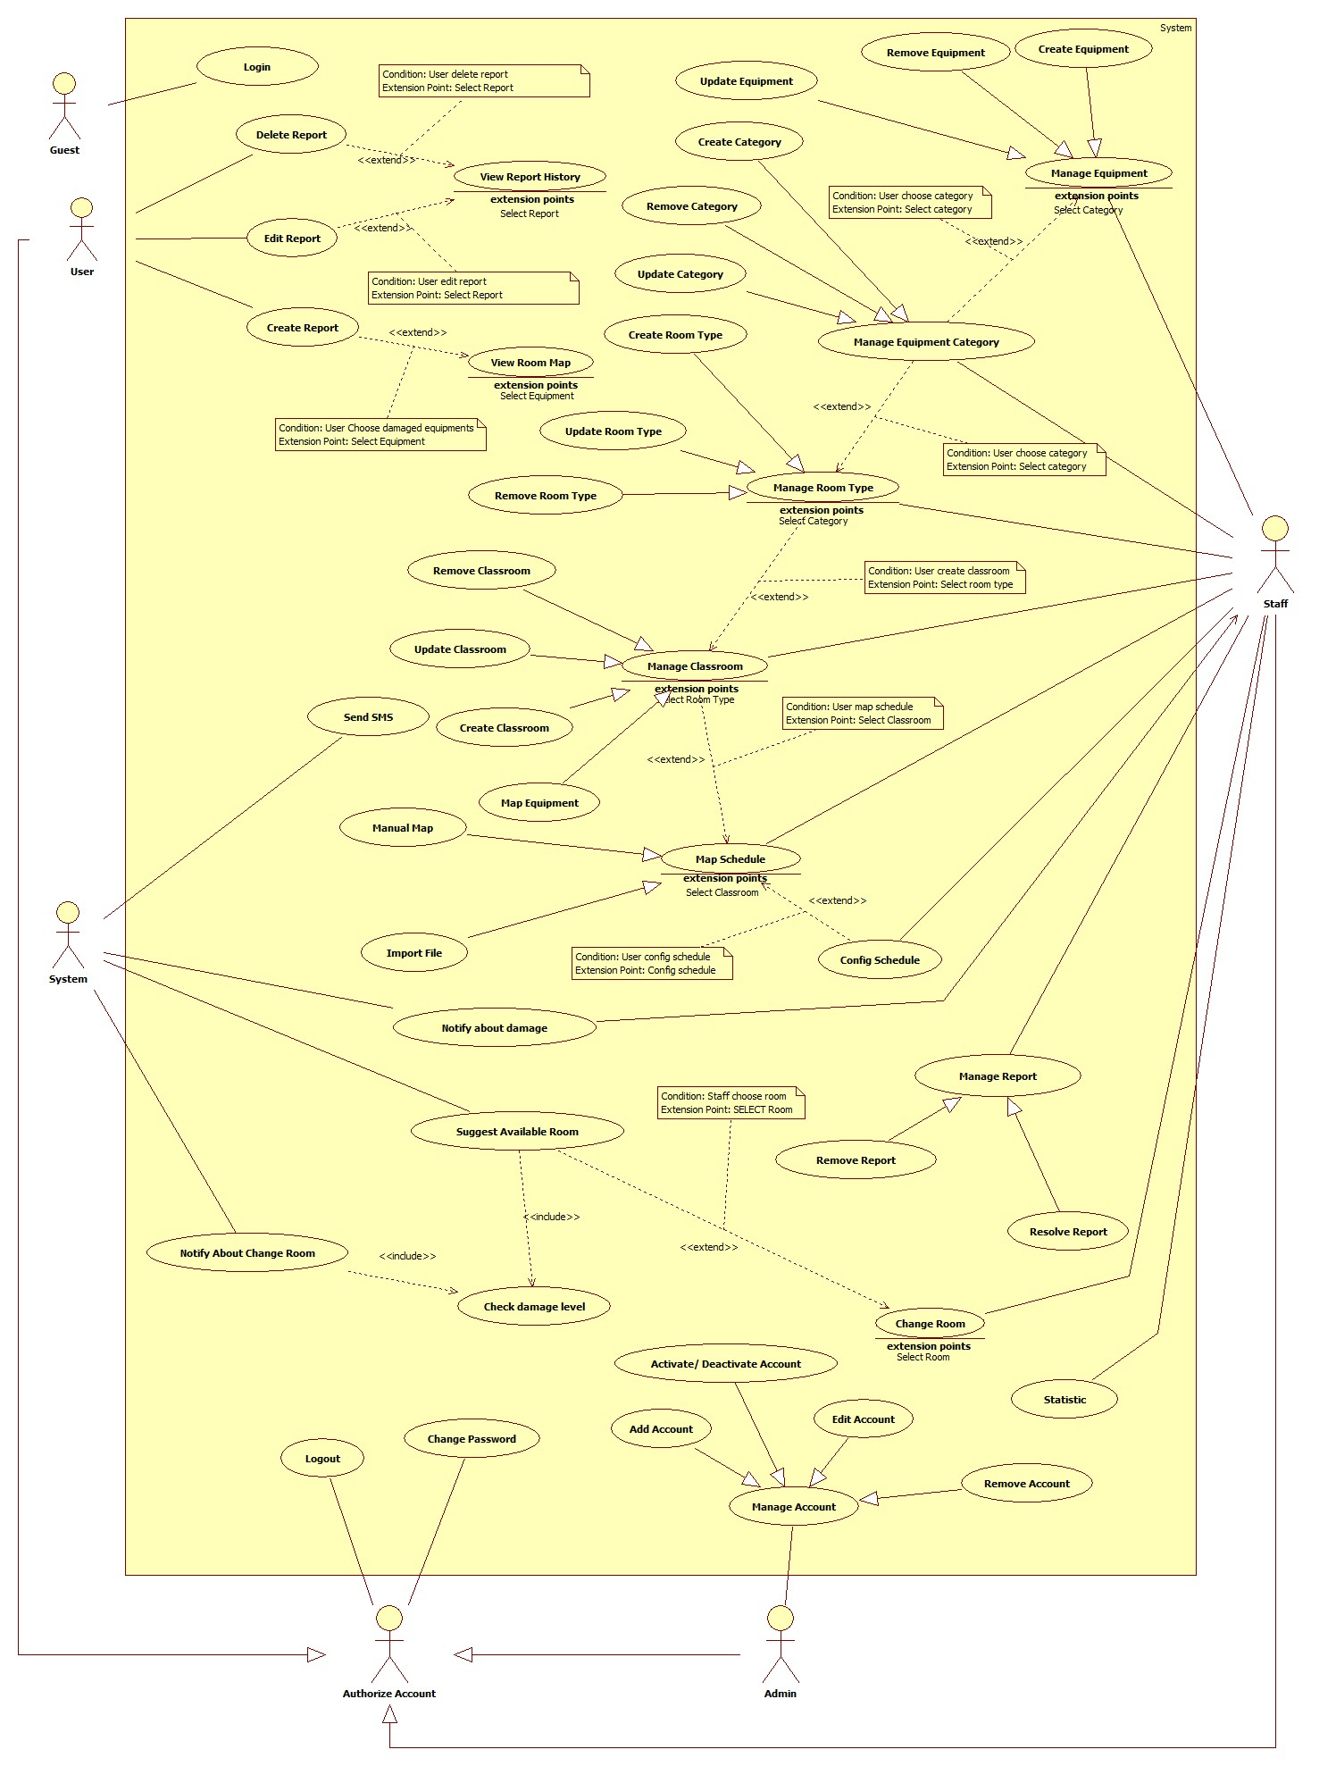

Figure 2: System Overview Usecase

* 1. **Conceptual Diagram**

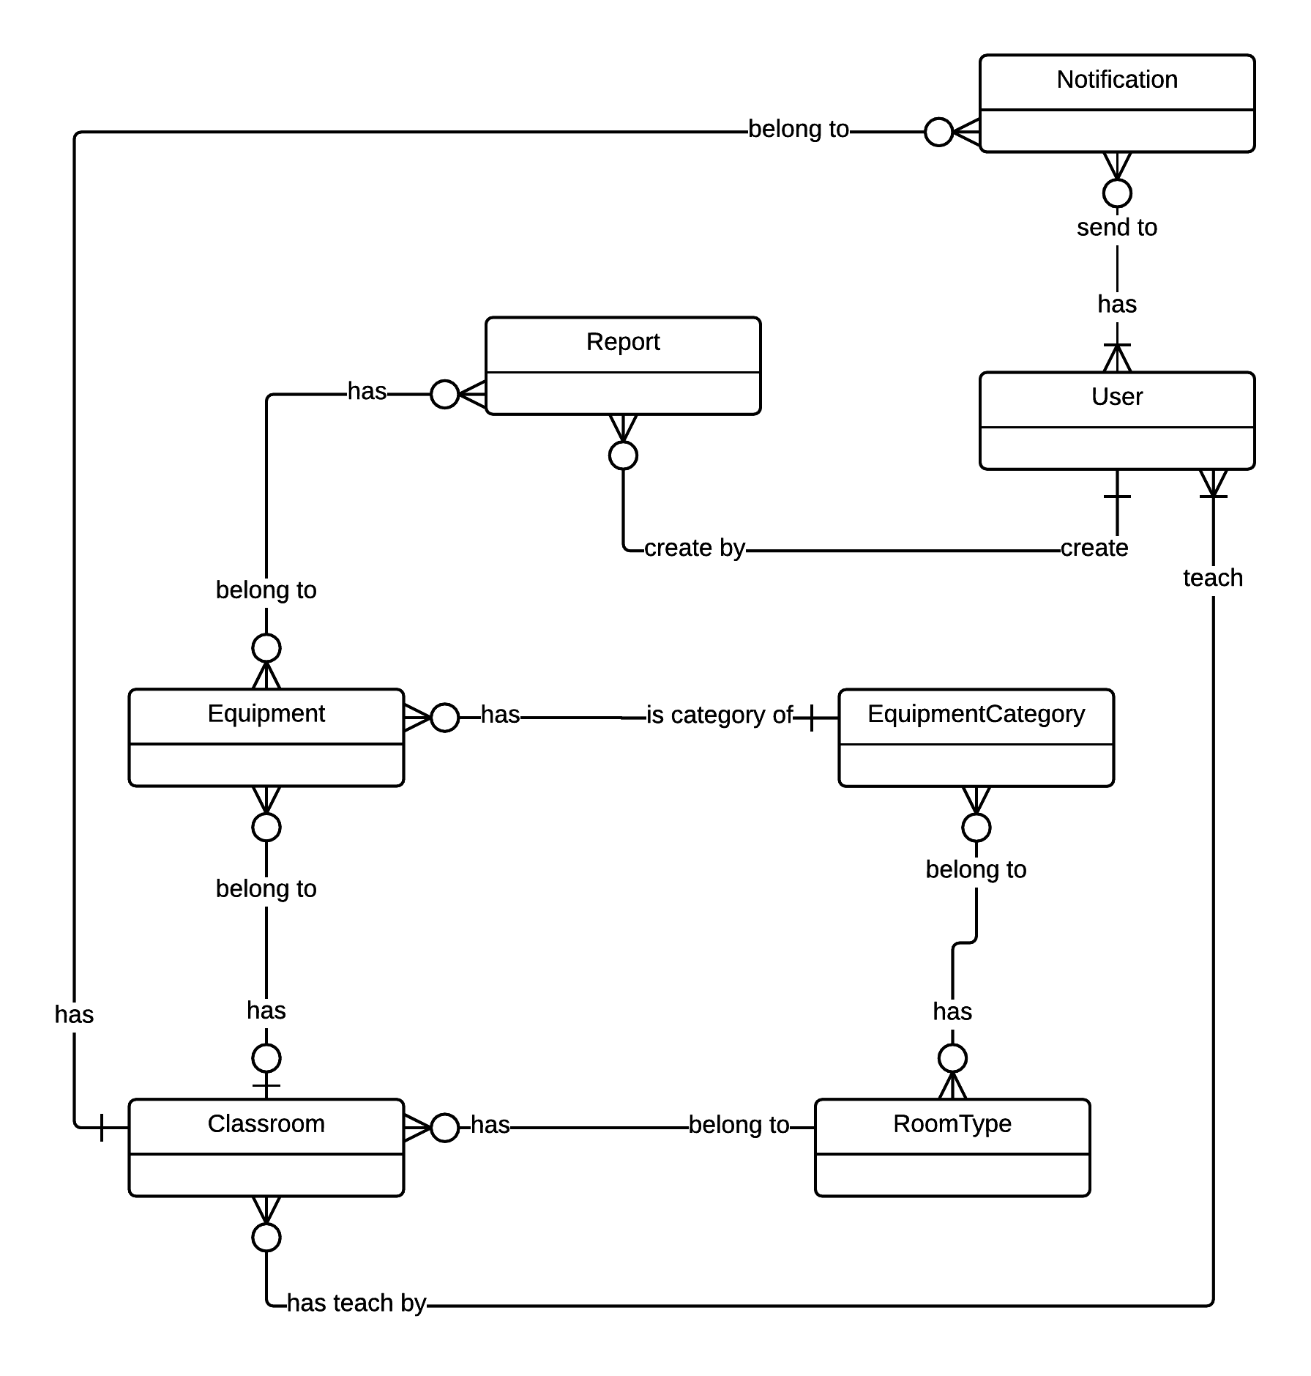

Figure 3: Conceptual Diagram

|  |  |
| --- | --- |
| Data dictionary | |
| Entity Name | **Description** |
| Teacher | Entity describes a teacher in system |
| Equipment | Contain the equipment information. |
| Classroom | Contain the classroom information. |
| EquipmentCategory | Contain the equipment category information. |
| RoomType | Contain the room type information. |
| Report | Contain the report information. |
| Notification | Contain the notification information. |
| Staff | Entity describes a staff in system. |

Table 1: Conceptual Diagram - Data Dictionary

1. **Software Design Description**
   1. **Design Overview**

* This document describes the technical and user interface design of ECRM system. It includes the architectural design, the detailed design of common functions, the business functions and the design of database model.
* The architectural design describes the overall architecture of the system and the architecture of each main component and subsystem.
* The detailed design describes static and dynamic structure for each component and functions. It includes class diagrams, class explanations and sequence diagrams for each use cases.
* The database design describes the relationships between entities and details of each entity.
* Document overview:
  + Section 1: gives an overall overview of this document.
  + Section 2: gives an overall description of the system architecture design.
  + Section 3: gives component diagrams that describe the connection and integration of the system.
  + Section 4: gives the detail design description, which includes class diagram, class explanation, and sequence diagram to details the application functions.
  + Section 5: describe a fully attributed Entity Relationship Diagram
  1. **System Architecture Design**

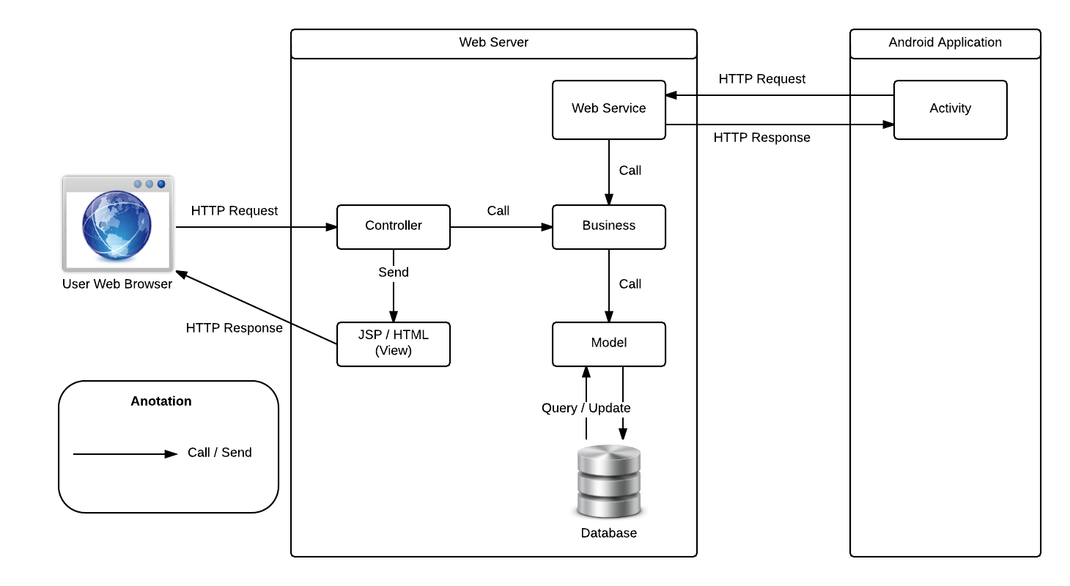

Figure 4: System Architecture Design

* + 1. **Web Application architecture description**

In Web Application, the system is developed under Spring MVC architecture style. We choose this architecture for Web application because of following advantages:

* Web application contains a Web service (public API for mobile app) with MVC architecture we can separate business code with Controller and View so we can use the business code in web service without repeat the code.
* In scope of 3-member team this, MVC architecture makes it easier to split the big project into small modules and make it easier to assign each module for members in our team.

This project follows MVC architecture with following components:

* **Web Service:** is the part of the application that acts like event handler for web and mobile communication via REST method.
* **Controller:** is the part of the application that acts like event handler to handles user interaction. Typically controller read data from a request and calls appropriate Business’s method then selects view to return to user.
* **JSP/HTML (View):** is the part of the application that handles the display of the data. The selection of View is under control of Controller.
* **Business:** is the part of the application that does business processing to solve domain problems.
* **Model:** is the part of the application that acts like a data transfer object between the system and database.
  + 1. **Mobile Application architecture description**

The application is developed as an Android native application. In general, the application architecture conforms to Android architecture.

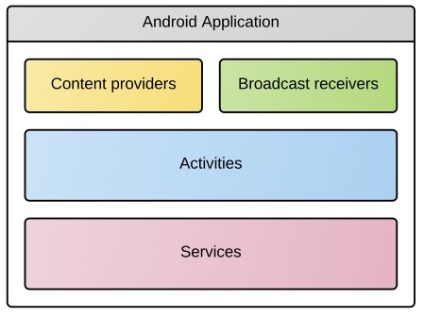

Figure 5: Android Application Architecture

**Reference:** [Android Developer Guide - Application Fundamentals](http://developer.android.com/guide/components/fundamentals.html)

This project follows Android application architecture with following components:

* **Activity** is the basic core of an android application that handles user input, create thread to run asynchronous tasks, send request and receive data from server via web services ...
  1. **Component Diagram**

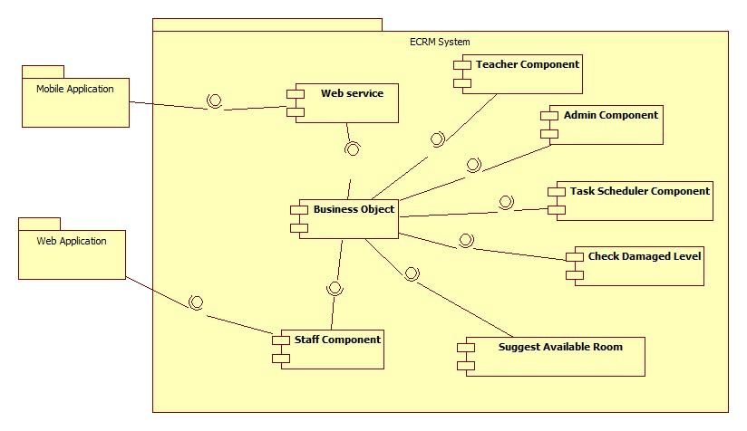

Figure 6: Component Diagram

|  |  |
| --- | --- |
| Component Dictionary: Describes components | |
| Web Application | Web application package: View, Controller. |
| Mobile Application | Mobile application package. |
| Web Service | Include all web API controllers of the system. Include all web API controllers of the system |
| Staff Component | Component to handle staff activities in the system. |
| Teacher Component | Component to handle teacher activities in the system. |
| Admin Component | Component to handle administrator activities in the system |
| Business Objects | Handle business operations for every component. |
| Suggest Available Room | Business logic for suggest room processing. |
| Check Damaged Level | Business logic for checking damaged level processing. |
| Task Scheduler Component | Component to handle task scheduler activities in the system. |

Table 2: Component Dictionary

* 1. **Detailed Description**
     1. **Class Diagram**

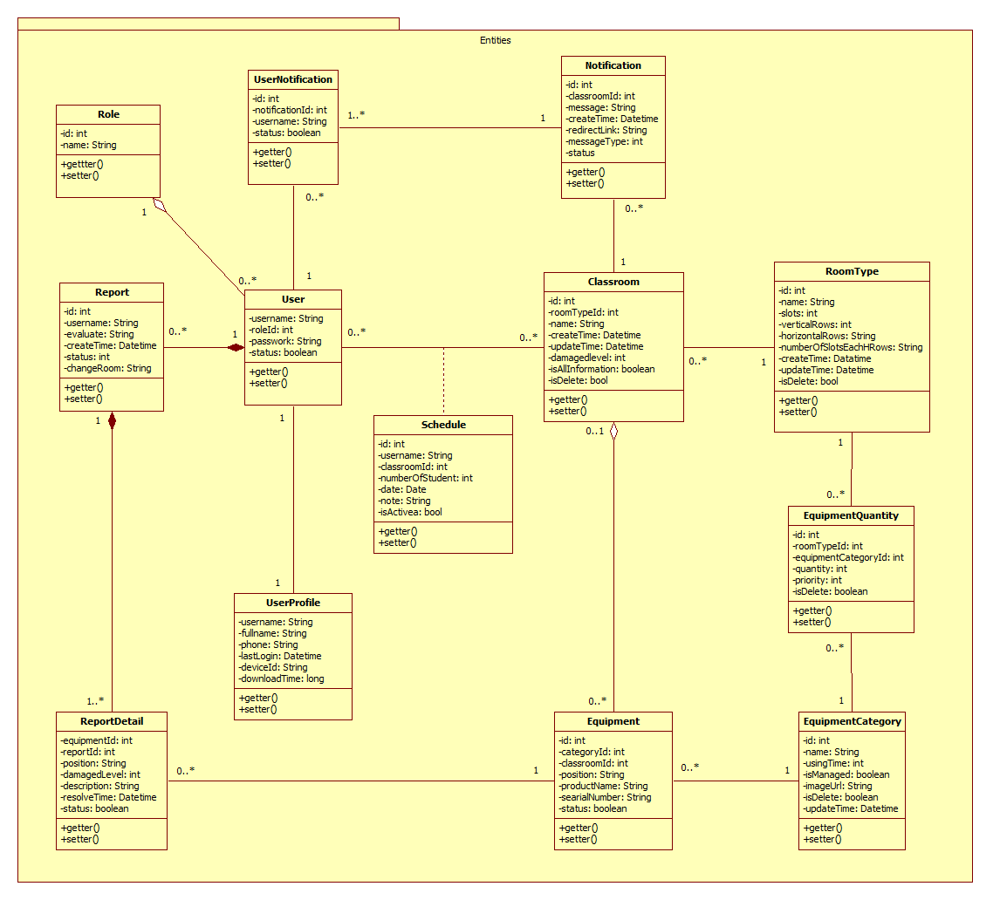

Figure 7: Class Diagram

|  |  |  |
| --- | --- | --- |
| Class dictionary: describe Class | | |
| Class Name | **Mapping column with Conceptual diagram** | **Description** |
| User | User | Contain the user information. |
| Report | Report | Contain the report information. |
| Classroom | Classroom | Contain the classroom information |
| Equipment | Equipment | Contain the equipment information |
| EquipmentCategory | EquipmentCategory | Contain the equipment category information |
| RoomType | Roomtype | Contain the room type information |
| Notification | Notification | Contain the notification information |
| Role | N/A | Not exist in conceptual diagram. But needed in class diagram to contain the role of user |
| UserProfile | N/A | Not exist in conceptual diagram. But needed in class diagram to contain user detail information |
| ReportDetail | N/A | Not exist in conceptual diagram. But needed in class diagram to contain report detail information |
| EquipmentQuantity | N/A | Not exist in conceptual diagram. But needed in class diagram to contain quantity of equipment in each room type. |
| Schedule | N/A | Not exist in conceptual diagram. But needed in class diagram to contain the schedule information. |
| UserNotification | N/A | Not exist in conceptual diagram. But needed in class diagram to contain the notification of user information |

* + 1. **Sequence Diagram**
       1. **<Teacher> Create Report**

**Summary:** This diagram shown how to create report in web application

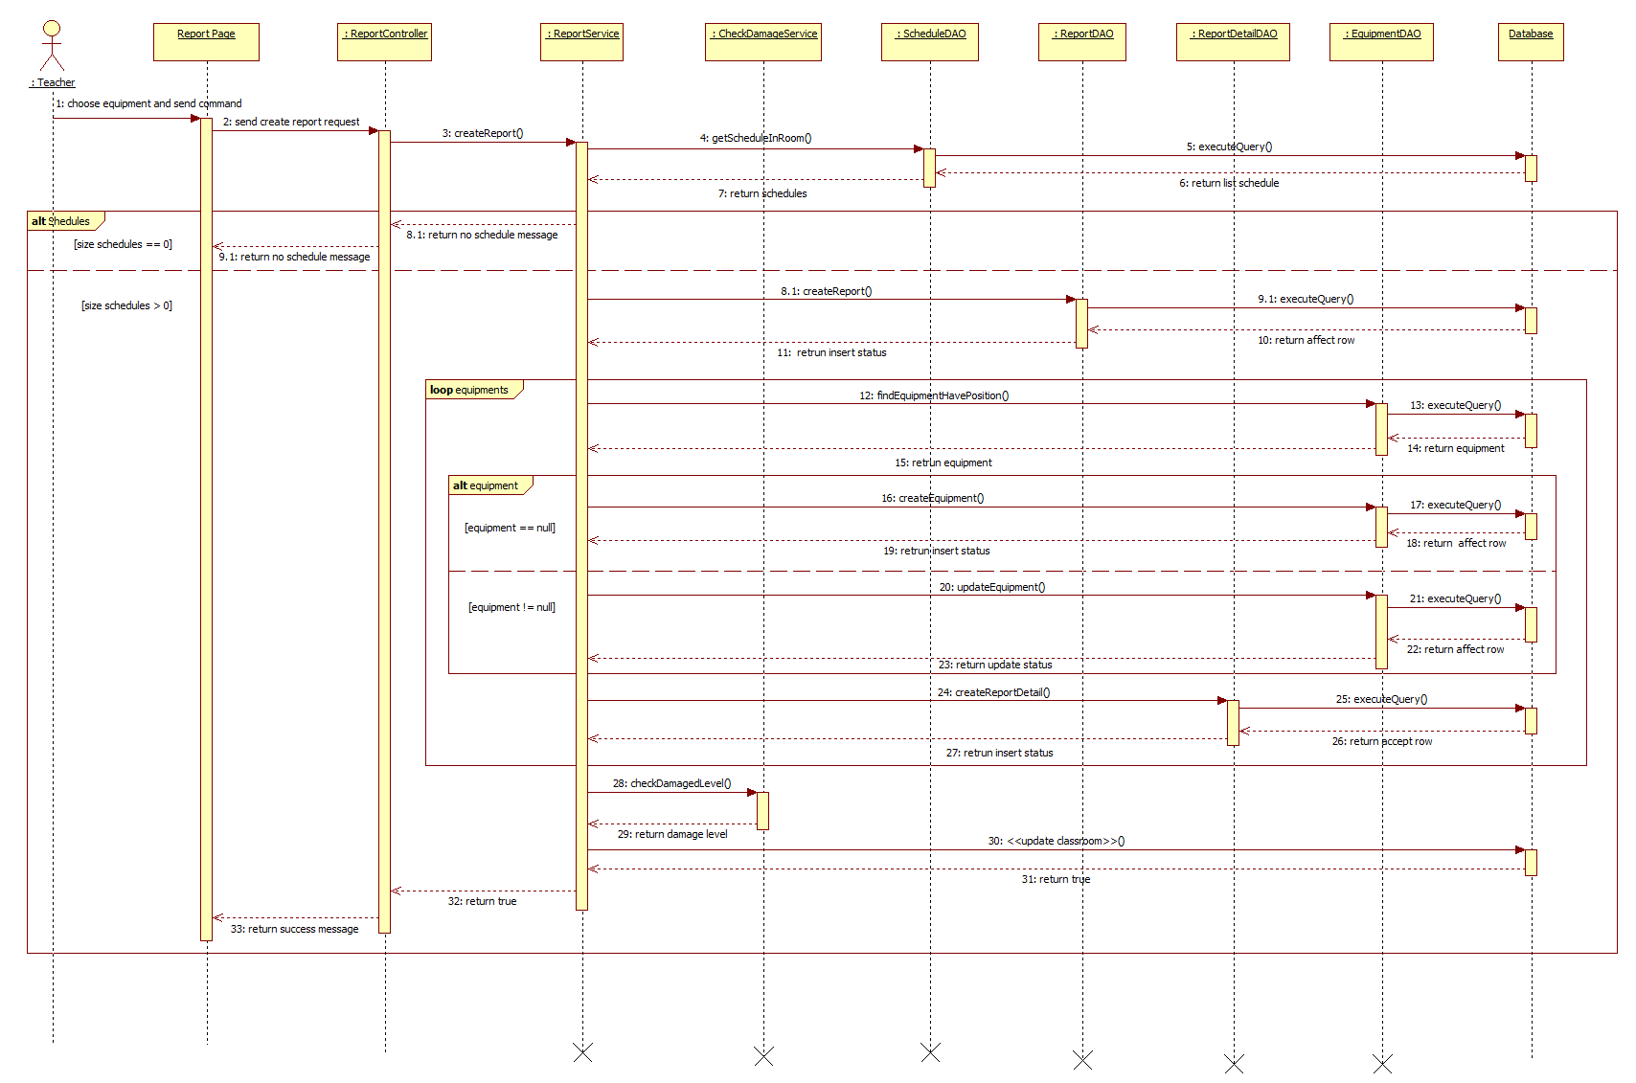

Figure 8: <Teacher> Create Report - Sequence Diagram

* + - 1. **<Staff> Resolve Report**

**Summary:** This diagram show how to resolve report at web application

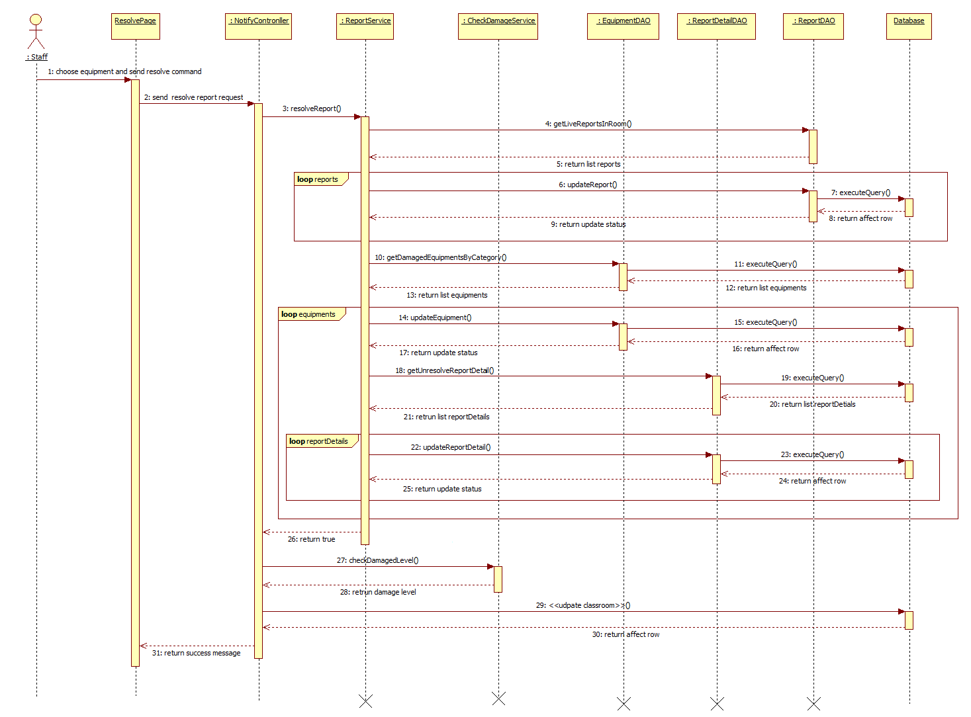

Figure 9: <Staff> Resolve Report - Sequence Diagram

* + - 1. **<Staff> Change Room**

**Summary:** This diagram shows how to change room in web application.

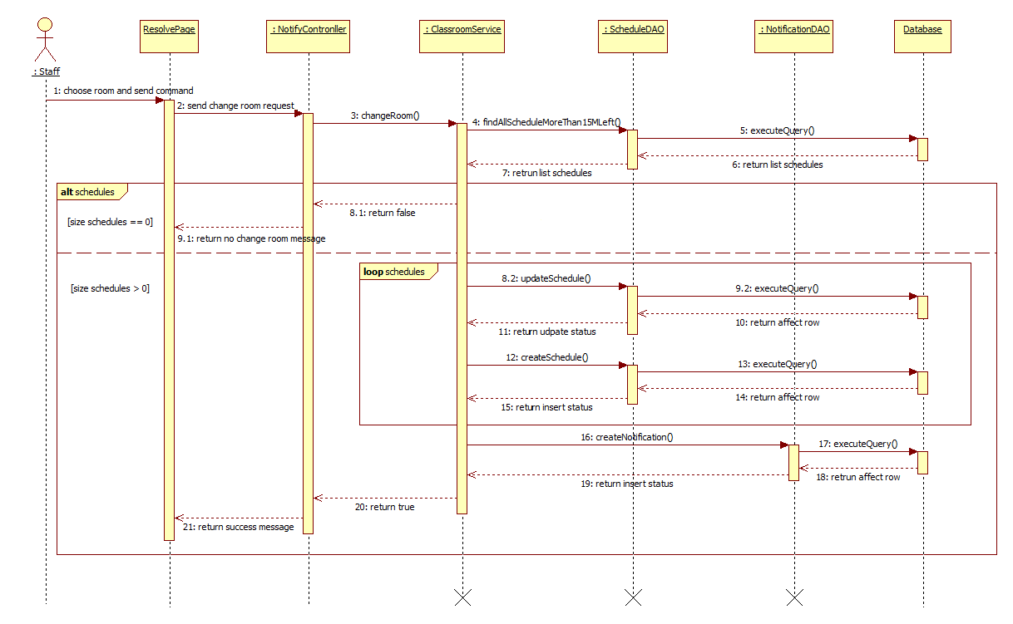

Figure 10: <Staff> Change Room - Sequence Diagram

* + 1. **Activity Diagram**
       1. **<Teacher> Create Report**

**Summary:** This diagram shown how to create report in mobile application

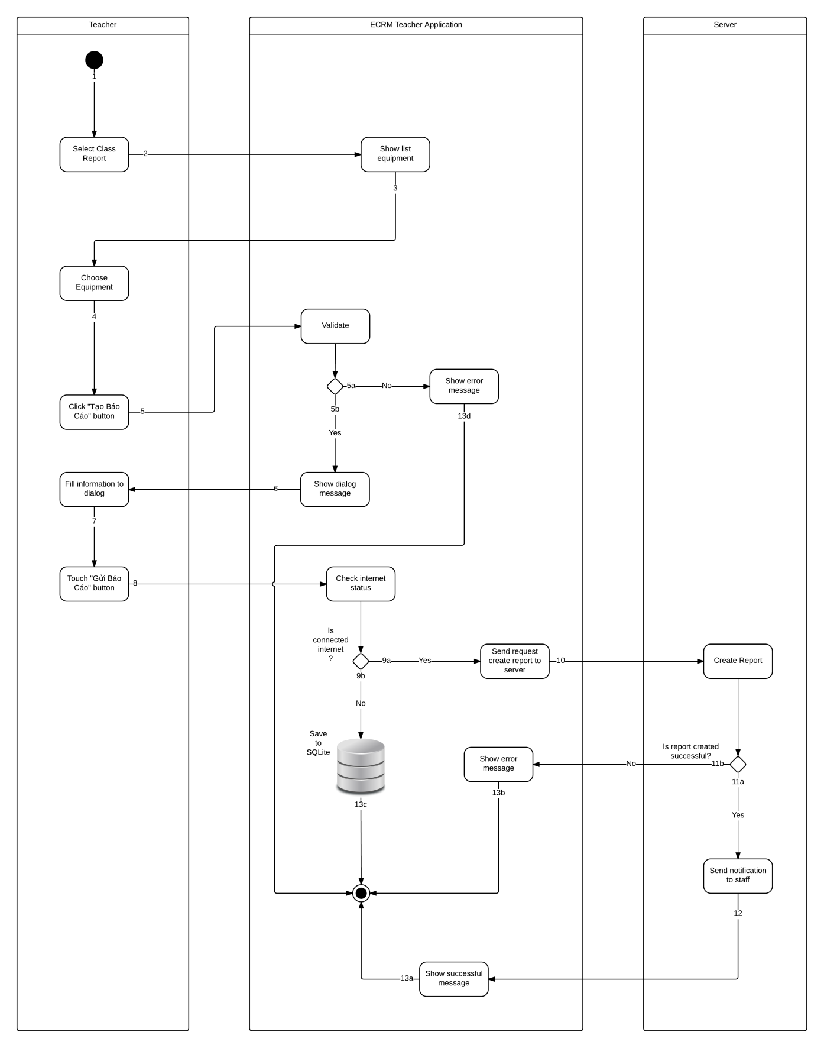

Figure 11: <Teacher> Create Report - Activity Diagram

|  |  |  |
| --- | --- | --- |
| 1. Start | 2. Select Class | 3. Show equipment of class |
| 4. Choose equipment | 5. Touch “Tạo Báo Cáo” button | 6a. Validate failed, show error message. |
| 6b. Validate success, show dialog | 7. Choose evaluate | 8. Touch “Gửi Báo Cáo” button |
| 9a. Connect internet, send request to server | 9b. Disconnect internet, save to local database. | 10. Create report |
| 11a. Create success, send notification to staff | 11b. Create failed, show error message. | 12. Show success message |
| 13a. Finish | 13b. Finish | 13c. Finish |
| 13d. Finish. |  |  |

* + - 1. **<Staff> View Report Information**

**Summary:** This diagram shows how to view detail report in mobile application

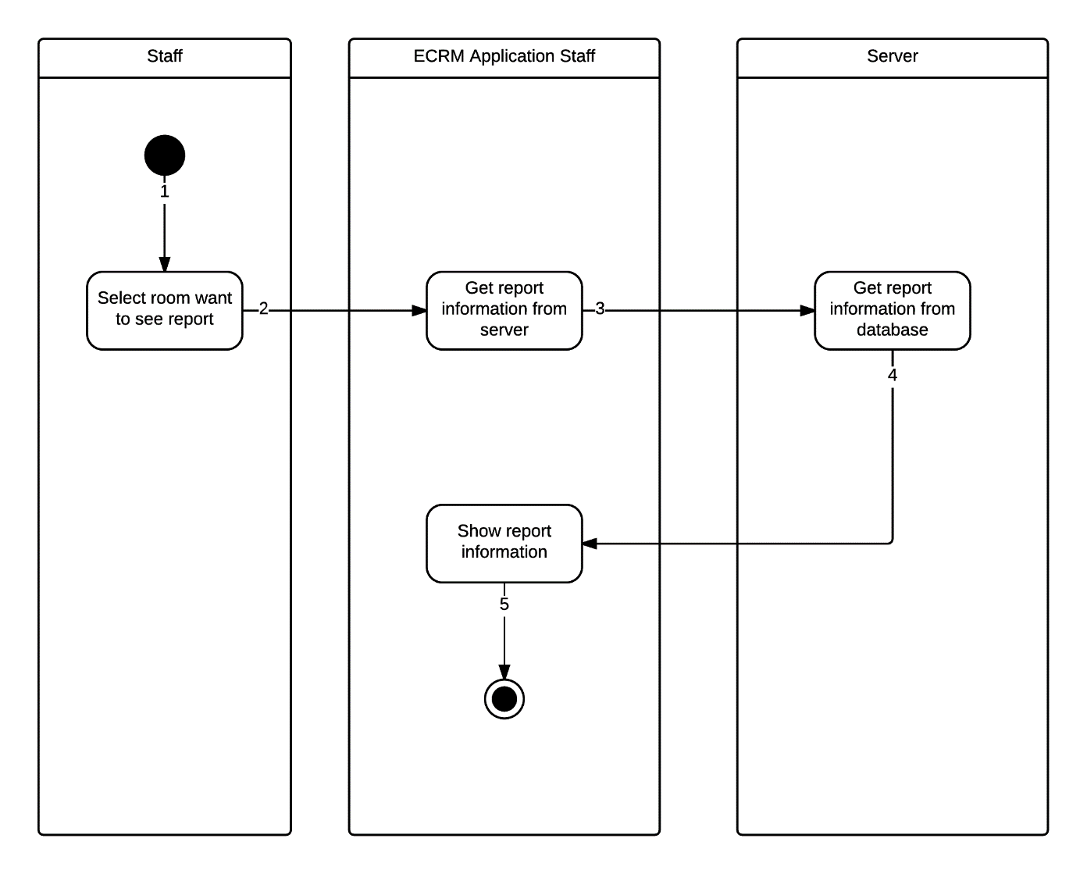

Figure 12: <Staff> View Report Information- Activity Diagram

|  |  |  |
| --- | --- | --- |
| 1. Start | 2. Select room to view report | 3. Send request get report to server |
| 4. Show report detail | 5. Finish. |  |

* + - 1. **<Staff> Resolve Report**

**Summary:** This diagram shown how to resolve report in mobile application

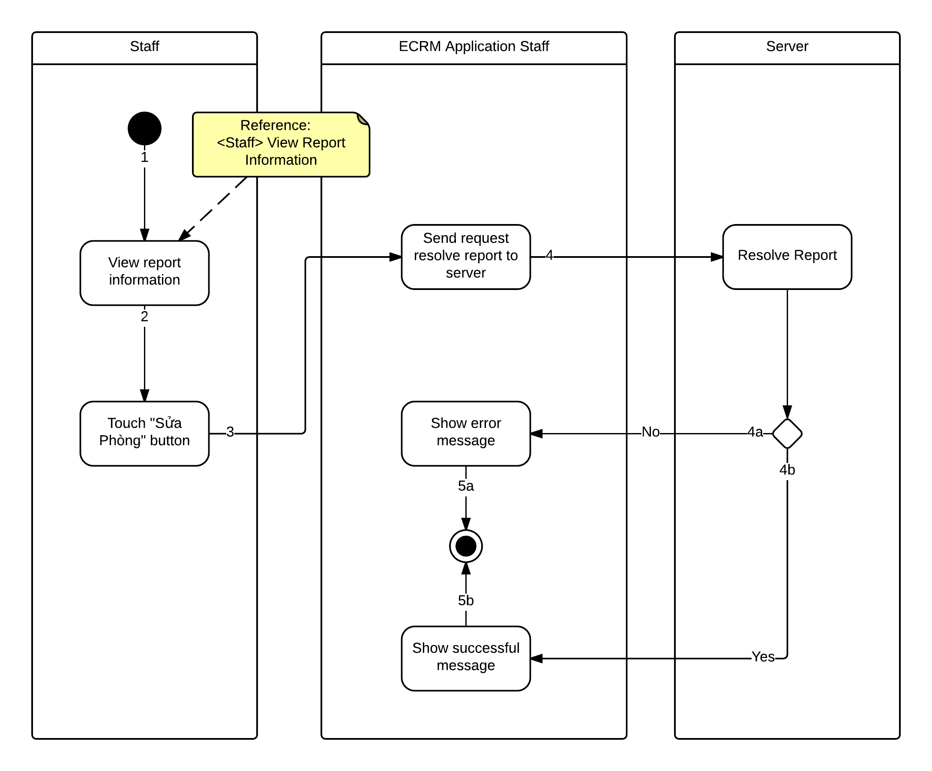

Figure 13: <Staff> Resolve Report- Activity Diagram

|  |  |  |
| --- | --- | --- |
| 1. Start | 2. Touch “Sửa Phòng” button | 3. Send request resolve report |
| 4a. Resolve success, show success message | 4b. Resolve failed, show error message. | 5a. Finish |
| 5b. Finish |  |  |

* + - 1. **<Staff> Change Room**

**Summary:** This diagram shows how to change room in mobile application.

There are two ways for staff to change room in mobile application:

* Change room for report:

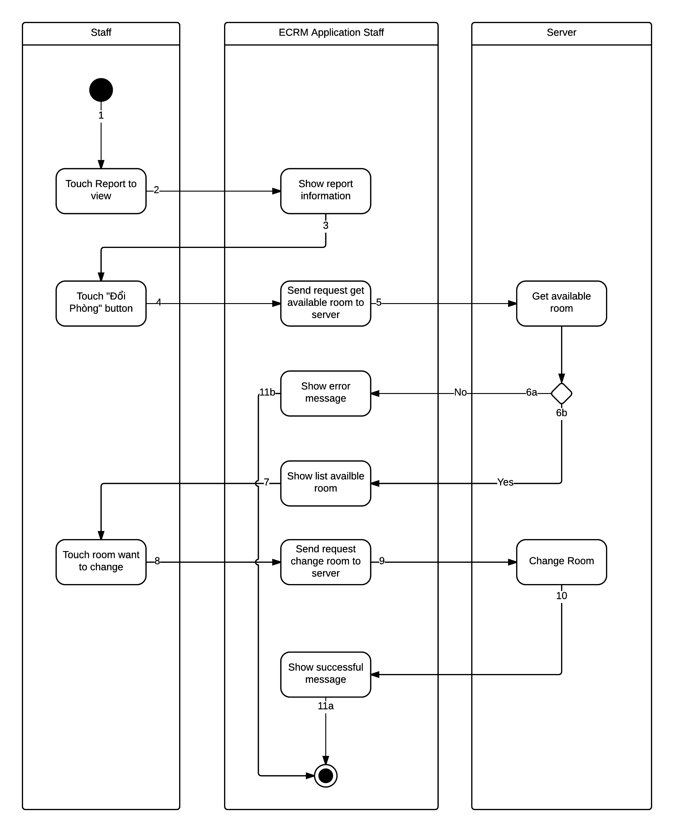

Figure 14: <Staff> Change Room for Report - Interactive Diagram

|  |  |  |
| --- | --- | --- |
| 1. Start | 2. Choose Report | 3. Show report |
| 4. Choose “Đổi phòng” | 5. Get available room from server | 6a. No available room, show error message |
| 6b. Show list available room | 7. Touch room want to change | 8. Send request change room |
| 9. Change room | 10. Change room success, show successful message. | 11a. Finish |
| 11b. Finish. |  |  |

* Change room manual:

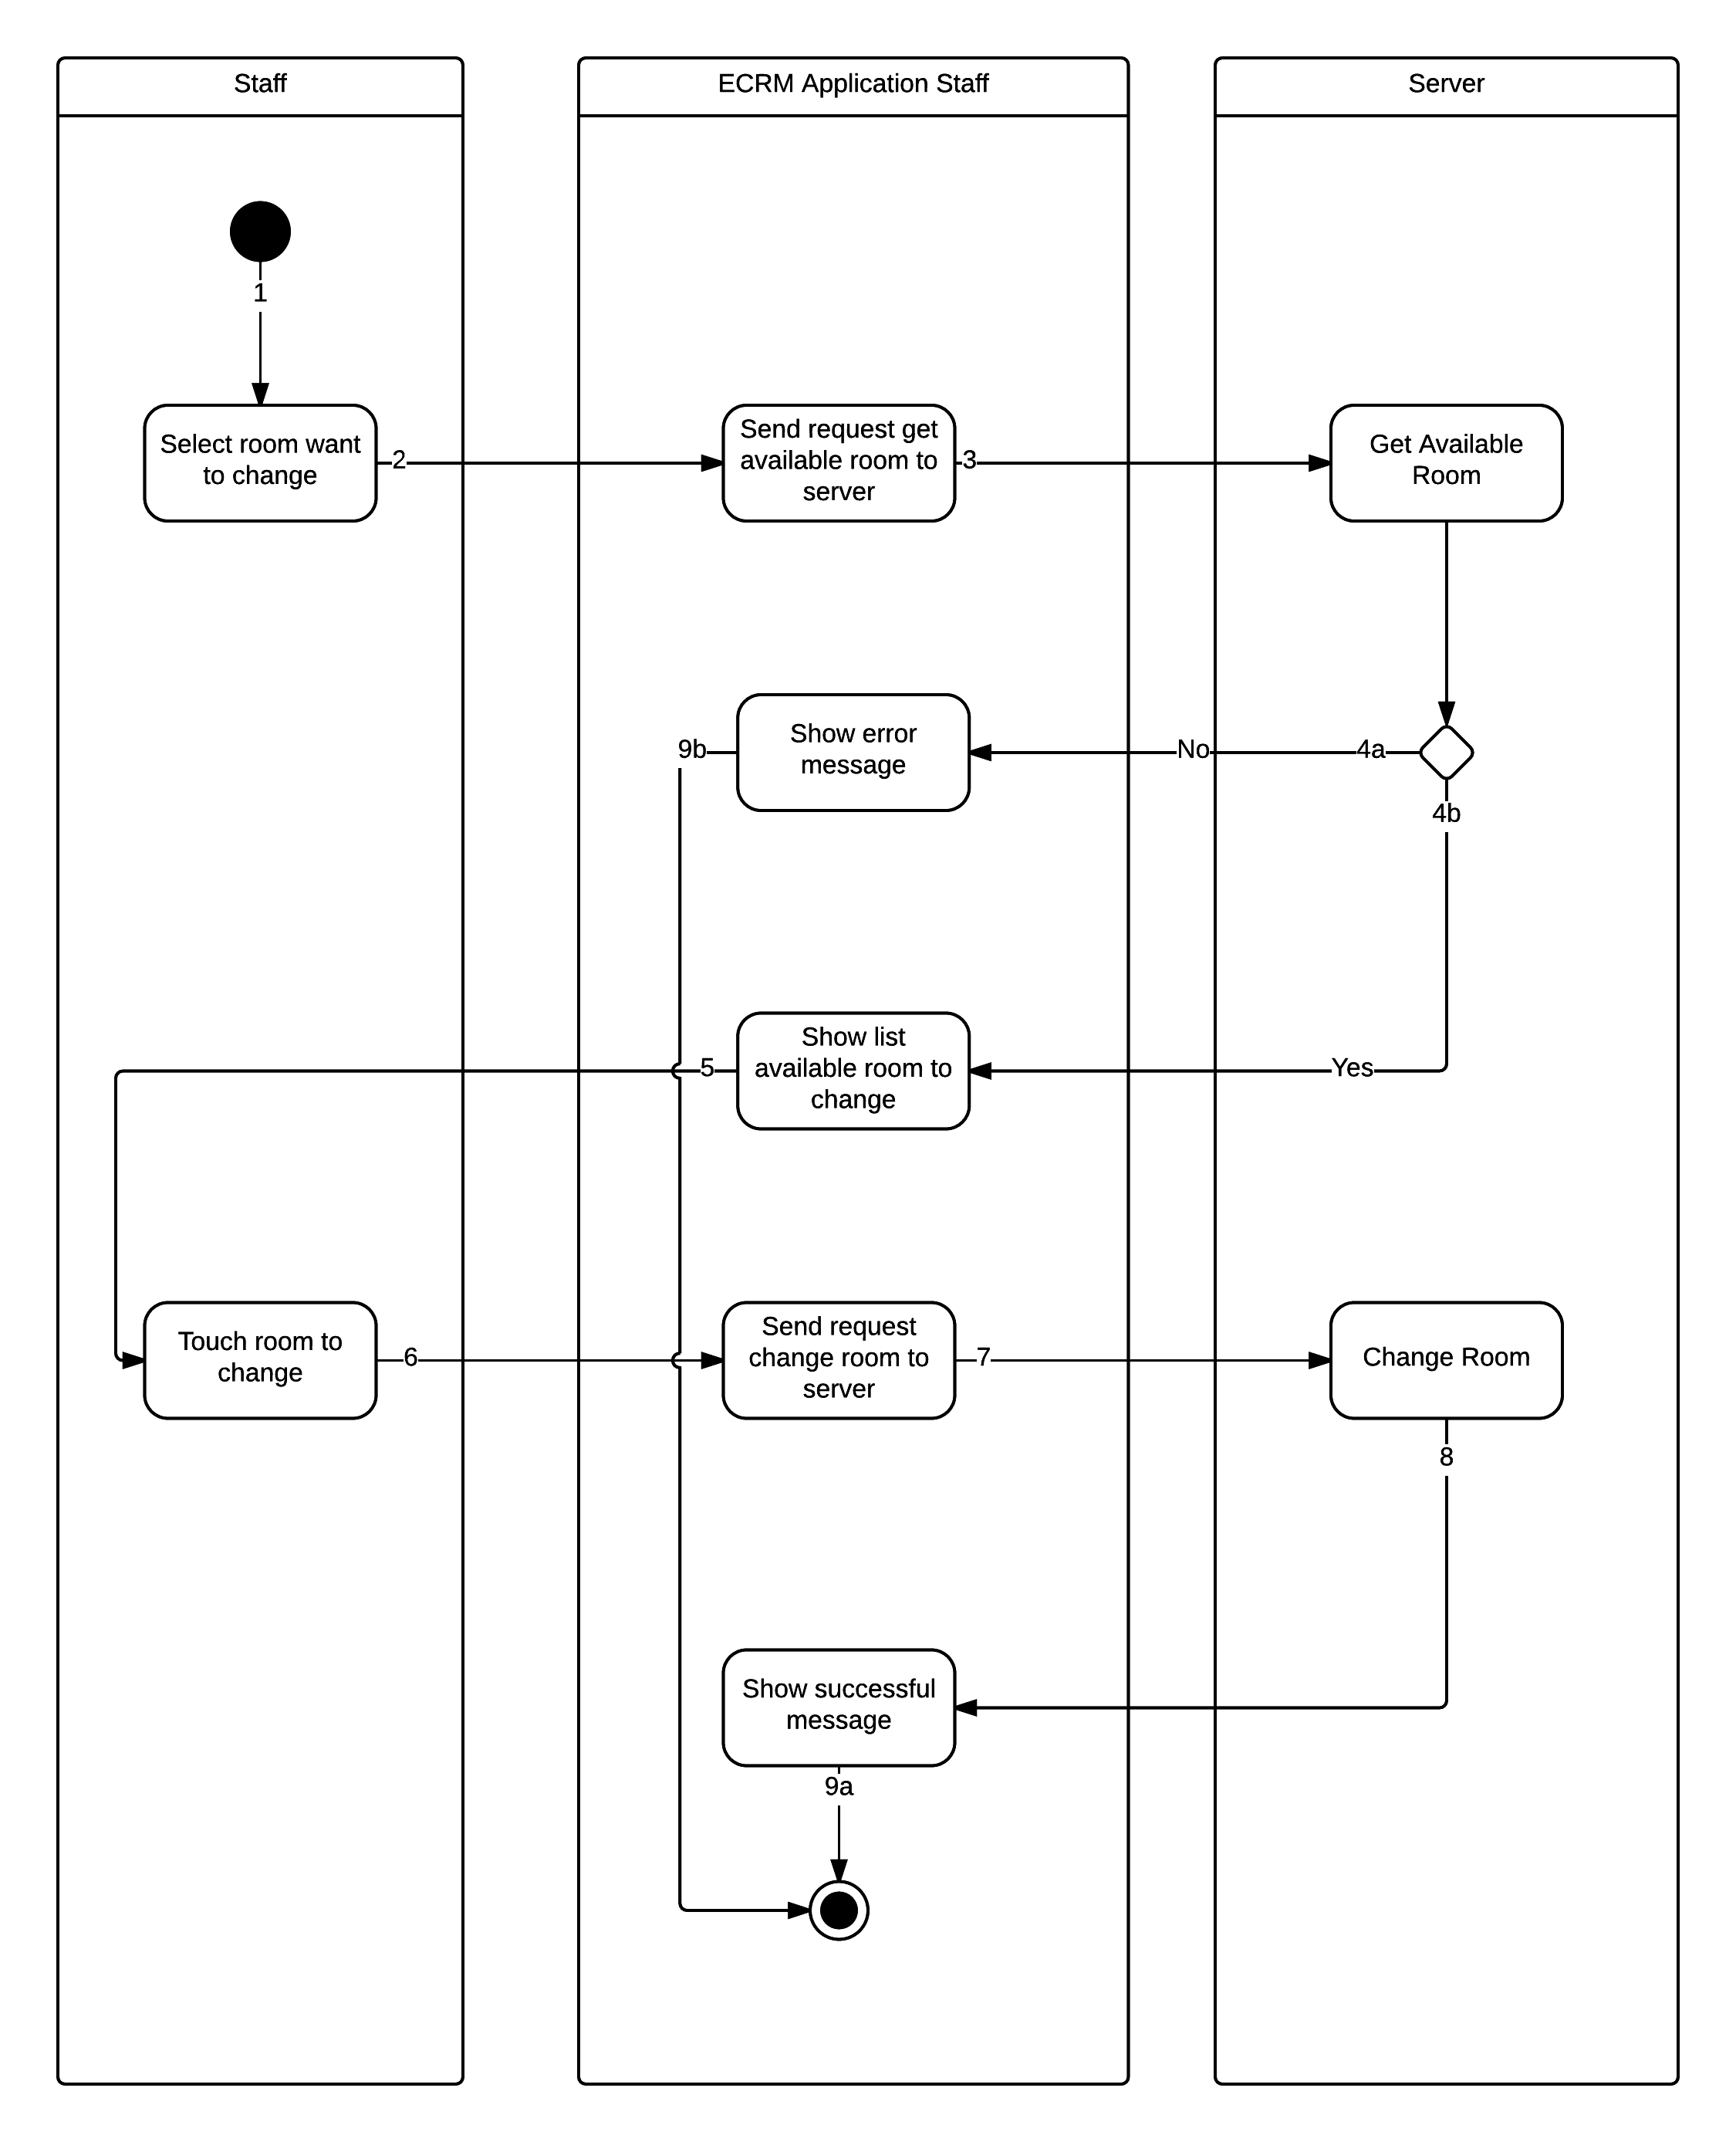

Figure 15: <Staff> Change Room Manual - Interactive Diagram

|  |  |  |
| --- | --- | --- |
| 1. Start | 2. Touch room to change | 3. Send request get available room. |
| 4a. No available room, show error message. | 4b. Show list available room | 5. Touch room change tom |
| 6. Send request change room | 7. Change room | 8. Show success message. |
| 9a. Finish | 9b. Finish. |  |

* 1. **Database Design**
     1. **Entity Relationship Diagram**

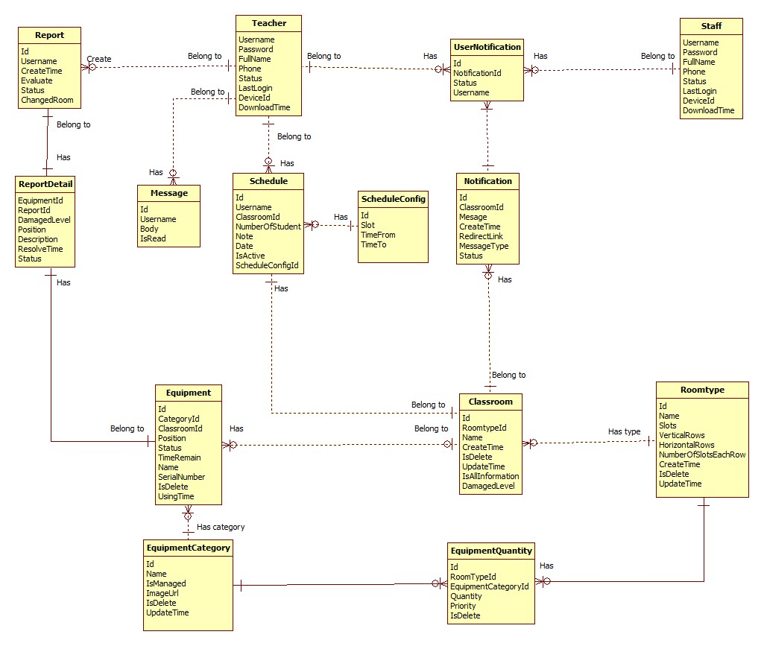

Figure 16: Entity Relationship Diagram

* + 1. **Entity Dictionary**

|  |  |
| --- | --- |
| Data Dictionary | |
| Entity name | **Description** |
| Teacher | Abstract entity describes a user with role teacher in system. |
| Staff | Abstract entity describes a user with role staff in system. |
| UserNotification | Represent a notification sent for user. |
| Notification | Contain the notification information. |
| Message | Represent a message sent by teacher. |
| Schedule | Contain the schedule information. |
| ScheduleConfig | Contain the schedule configuration information |
| Classroom | Contain the classroom information. |
| RoomType | Contain the room type information. |
| EquipmentQuantity | Contain the equipment quantity information. |
| EquipmentCategory | Contain the equipment category information. |
| Equipment | Contain the equipment information. |
| ReportDetail | Contain the report detail information. |
| Report | Contain the report information. |

Table 3: Entity Dictionary

* 1. **Algorithms**
     1. **Suggest available classroom**
        1. **Definition**

Suggest available classroom is a function of web application and mobile application to give a list of available and similar classroom with current classroom.

* + - 1. **Define problems**

In web and mobile application, every time staff or system do change room, finding a classroom that meet criteria about availability, nearest with current classroom.

* + - 1. **Solution**

1. Get all undamaged classroom.
2. Get all schedules in current classroom.
3. Compare each schedule with all schedule in list undamaged classroom. If one classroom has one schedule has the same scheduleConfigId, we will ignore that classroom. The result is list of available classroom.

Table schedule configuration

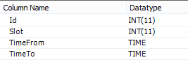

1. We will get list of list available classroom and then compare them. The result we will get is list of common classroom.
2. We sort list of classroom by criteria nearest distance with current classroom. For example: we have list {202, 303, 201, 301, 402, 101, 503} and current classroom is 205, the result is: {202, 201, 301, 303, 101, 402, 503}.
3. Finally, we will sort the list by criteria similar with current room type of classroom. The most similar will appear firstly, the least similar will appear lastly.
   * 1. **Damaged Statistic**
        1. **Definition**

Damaged statistic is a function of web application and mobile application to a number describes the damaged level of classroom.

* + - 1. **Define Problems**

In web and mobile application, every time teacher report classroom, staff has to check the damage of this classroom and do change room. We have to find solution to check damaged level automatically.

* + - 1. **Solution**

1. Get classroom.
2. Get list of damaged equipment.
3. Get room type of classroom.
4. Get equipment’s **evaluation** in report and equipment **priority** in room type.
5. Get damaged level in table “**SystemConfiguration**” in database based on **evaluation** and **priority** of each equipment. Example: **evaluation** of equipment is “**Không thế sử dụng được**” and priority is “**Cao**”, we will get field “**UserHigh_PriorityHigh**” with damaged level equal 50 in table “**SystemConfiguration**”.
6. Damaged level of classroom equals total equipment’s damaged level.

**Example:**

Teacher A reports classroom B with projector, air conditioning and two tables. Teacher A **evaluates** “**High**” for projector, “**High**” for air conditioning and “**High**” for table. Meanwhile, in classroom B, the **priority** of projector is “**High**”, air conditioning is “**Medium**”. So the damaged level will be: (**UserHigh-PriorityHigh**)+ (**UserHigh-PriorityMedium**) + (**TableHigh**)*2 = 50 + 30 + 5*2 = 90.

* + - 1. **Flow chart**

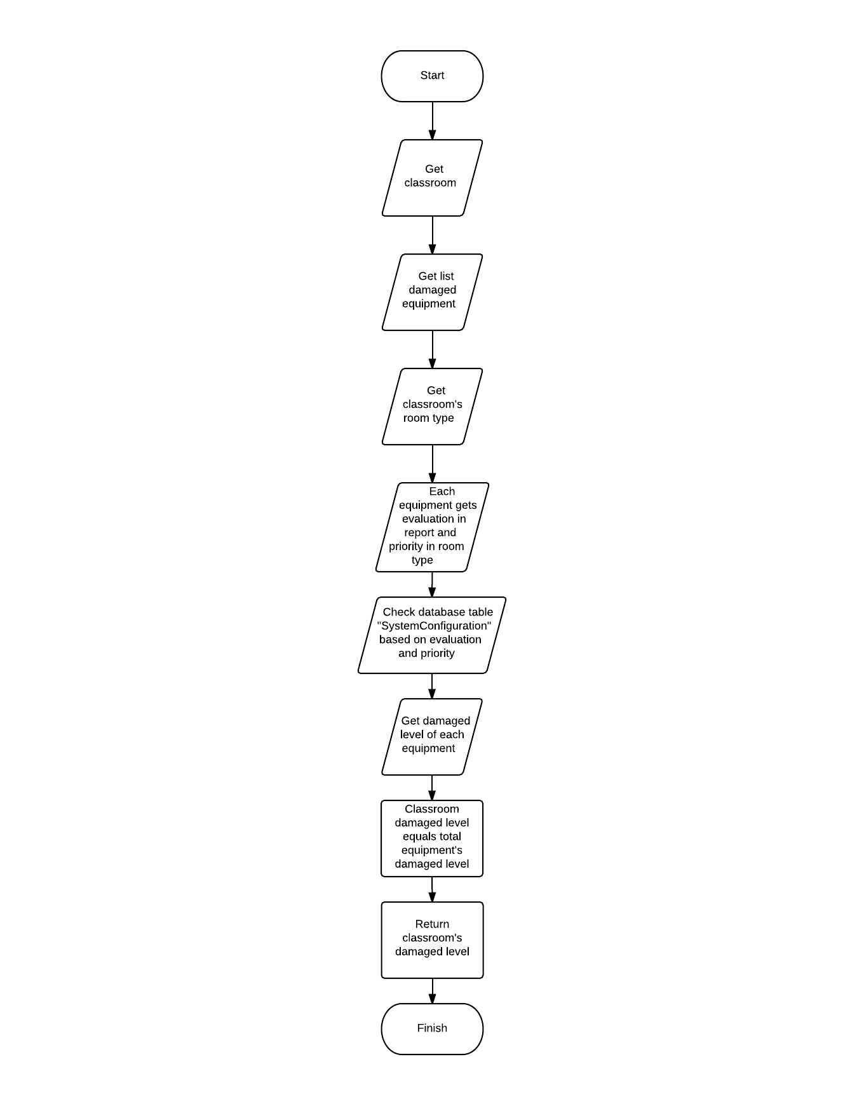

Figure 17: Damaged Statistic - Flow Chart

* + 1. **System Scheduler Process**
       1. **Definition**

System scheduler is a main component of ECRM system. All the report will be checked by scheduler and give recommend for staff easy to make decision.

* + - 1. **Define Problems**

In web application:

* We need system schedule run every day at 06:30 and 12:15 to check status of room and change room if needed.
* We need system schedule run every day at 00:00 to check schedule in system.
* We need system schedule run every day at 06:00 to update equipment using time.
* We need system schedule run each 5 minutes to receive report from teacher and change room if needed.
  + - 1. **Solution**

We create schedule task by Spring Scheduler, it will run on the same server with web application and access to database server to check status, find available room to do change if need. It will run at specific time that administrator has defined.

* + - * 1. **Scheduler change room every day**

The checking process is described as follow:

1. Get all classroom have damaged level is more than 50%
2. Get all schedule in each classroom
3. Get list of available classrooms for current classroom
4. Get classroom which current classroom had been changed to. If it has, check if this classroom is existed in list of available classrooms.
5. Check current day time and change room.
6. Notify and send SMS for teacher.
   * + - 1. **Scheduler get report**

The checking process is describes as follow:

1. Get new report
2. Check damaged level of classroom
3. Get all schedule in each classroom
4. Get list of available classrooms for current classroom
5. Get classroom which current classroom had been changed to. If it has, check if this classroom is existed in list of available classrooms.
6. Check current day time and change room.
7. Update report.
8. Notify and send SMS for teacher.
   * + - 1. **Scheduler update equipment using time**

The checking process is describes as follow:

1. Get all classroom
2. Get schedule for each classroom the last day.
3. Get all managed equipment in each classroom
4. Time remain of each equipment equals using time subtracts total teaching duration today. If time remain equals 0, set equipment is damaged, evaluate is “Không sử dụng được” and update classroom’s damaged level (**refer to …**) which equipment is belong to.
5. Notify and send SMS for staff if equipment time equals 0 or smaller than “expiredTime” field in table “SystemConfiguration”.
   * + - 1. **Scheduler check schedule in system.**

The checking process is describes as follow:

1. Get the nearest day of all schedule in database
2. Notify and send SMS for staff.
3. **System Implementation & Testing**
   1. **Database Relationship Diagram**
      1. **Physical Diagram**

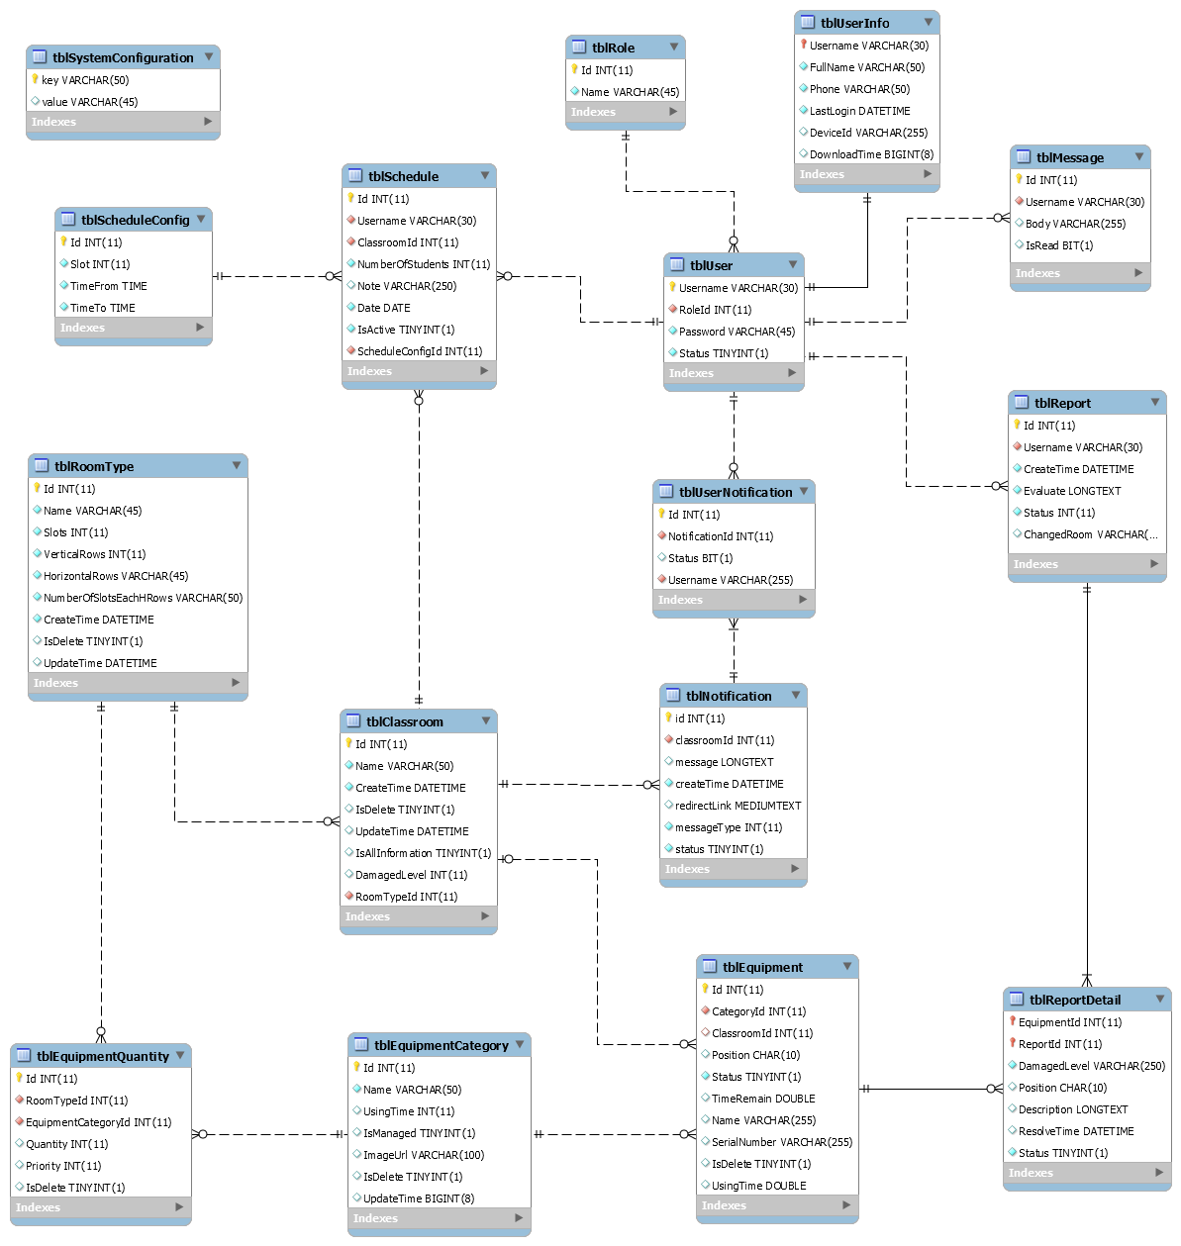

Figure 18: Physical Diagram

* + 1. **Data Dictionary**

|  |  |  |  |  |
| --- | --- | --- | --- | --- |
| Table Name | Attributes | Description | Domain | Null |
| tblUser | Username | Username to login system | VARCHAR(30) | No |
|  | Password | Password of account to login system | VARCHAR(45) | No |
|  | Status | Status of account | TINYINT(1) | No |
|  | RoleId | Role of account | INT(11) | No |
| tblRole | Id | Id of role | INT(11) | No |
|  | Name | Name of role | VARCHAR(45) | No |
| tblUserInfo | Username | Username of account | VARCHAR(30) | No |
|  | FullName | Fullname of account | VARCHAR(50) | No |
|  | Phone | Phone number of account | VARCHAR(50) | No |
|  | LastLogin | Last login of account to system | DATETIME | Yes |
|  | DeviceId | Device ID of account when using mobile application | VARCHAR(255) | Yes |
|  | DownloadTime | Last download time of user when using mobile application | BIGINT(8) | Yes |
| tblMessage | Id | Id of message | INT(11) | No |
|  | Body | Content of message | VARCHAR(255) | No |
|  | IsRead | Status of message | BIT(1) | No |
|  | Username | Username of user send message | VARCHAR (30) | No |
| tblReport | Id | Id of report | INT(11) | No |
|  | Username | Username of account create report | VARCHAR(30) | No |
|  | CreateTime | Time report has created | DATETIME | No |
|  | Evaluate | Evaluate of teacher about this report | LONGTEXT | No |
|  | Status | Status of report | INT(11) | No |
|  | ChangeRoom | Room number has changed | VARCHAR(45) | Yes |
| tblEquipmentCategory | Id | Id of equipment category | INT(11) | No |
|  | Name | Name of equipment category | VARCHAR(50) | No |
|  | UsingTime | Time using of equipment category | INT(11) | Yes |
|  | IsManaged | Check equipment has managed quantity or not | TINYINT(1) | No |
|  | ImageUrl | Link to image of equipment category | VARCHAR(100) | No |
|  | IsDelete | Check equipment is deleted or not | TINYINT(1) | No |
|  | UpdateTime | Time user update information of equipment category | BIGINT(8) | Yes |
| tblEquipment | Id | Id of equipment | INT(11) | No |
|  | CategoryId | Id of equipment category | INT(11) | No |
|  | ClassroomId | Id of classroom has equipment | INT(11) | No |
|  | Position | Position of equipment in classroom | CHAR(10) | No |
|  | Status | Status of equipment | TINYINT(1) | No |
|  | TimeRemain | Time remain of equipment | DOUBLE | No |
|  | Name | Name of equipment | VARCHAR(255) | No |
|  | SerialNumber | Serial Number of equipment | VARCHAR(255) | No |
|  | IsDelete | Check equipment has deleted or not | TINYINT(1) | No |
|  | UsingTime | Time using of equipment | DOUBLE | No |
| tblReportDetail | EquipmentId | Id of equipment has reported | INT(11) | No |
|  | ReportId | Id of report | INT(11) | No |
|  | DamagedLevel | Damage level of equipment | VARCHAR(250) | No |
|  | Position | Position of equipment in classroom | CHAR(10) | No |
|  | Description | Description of equipment | LONGTEXT | Yes |
|  | ResolveTime | Time resolve this equipment | DATETIME | Yes |
|  | Status | Status of this report detail | TINYINT(1) | No |
| tblUserNotification | Id | Id of user notification | INT(11) | No |
|  | NotificationId | Id of notification | INT(11) | No |
|  | Status | Status of notification | BIT(1) | No |
|  | Username | Username of account received this notification | VARCHAR(30) | No |
| tblNotification | Id | Id of notification | INT(11) | No |
|  | ClassroomId | Id of classroom | INT(11) | No |
|  | Message | Content of notification | LONGTEXT | No |
|  | CreateTime | Time notification has been created | DATETIME | No |
|  | RedirectLink | Link will redirect after user click to notification | MEDIUMTEXT | No |
|  | MessageType | Type of message | INT(11) | No |
|  | Status | Status of notification | TINYINT(1) | No |
| tblClassroom | Id | Id of classroom | INT(11) | No |
|  | RoomTypeId | Id of roomtype | INT(11) | No |
|  | Name | Name of classroom | VARCHAR(50) | No |
|  | CreateTime | Time create of classroom | DATETIME | No |
|  | IsDelete | Check classroom has been deleted | TINYINT(1) | No |
|  | UpdateTime | Time update classroom | DATETIME | No |
|  | IsAllInformation | Check classroom has full equipment | TINYINT(1) | No |
|  | DamageLevel | Damage level of classroom | INT(11) | No |
| tblSchedule | Id | Id of schedule | INT(11) | No |
|  | Username | User of schedule | VARCHAR(30) | No |
|  | ClassroomId | Classroom of schedule | INT(11) | No |
|  | NumberOfStudents | Number of student of classroom | INT(11) | No |
|  | Note | Note of schedule | VARCHAR(250) | Yes |
|  | TimeFrom | Time start schedule | TIME | No |
|  | Slots | Total slot of schedule | INT(11) | No |
|  | Date | Date of schedule | DATE | No |
|  | IsActive | Status of schedule | TINYINT(1) | No |
|  | ScheduleConfigId | Config of schedule | INT(11) | No |
| tblScheduleConfig | Id | Id of schedule config | INT(11) | No |
|  | Slot | Slot of schedule config | INT(11) | No |
|  | TimeFrom | Time start of schedule config | TIME | No |
|  | TimeTo | Time end of schedule config | TIME | No |
| tblRoomType | Id | Id of roomtype | INT(11) | No |
|  | Name | Name of roomtype | VARCHAR(100) | No |
|  | Slots | Number of slot of roomtype | INT(11) | No |
|  | VerticalRows |  | INT(11) | No |
|  | HorizontalRows |  | VARCHAR(50) | No |
|  | NoSlotEachHRows |  | VARCHAR(50) | No |
|  | CreateTime | Time create roomtype | DATETIME | No |
|  | IsDelete | Check roomtype has deleted or not | TINYINT(1) | No |
|  | UpdateTime | Time update roomtype | DATETIME | No |
| tblEquipmentQuantity | Id | Id of equipment quantity | INT(11) | No |
|  | RoomTypeId | Room Type Id | INT(11) | No |
|  | EquipmentCategoryId | Id of equipment category | INT(11) | No |
|  | Quantity | Quantity of equipment category in roomtype | INT(11) | No |
|  | Priority | Priority of equipment category | INT(11) | No |
|  | IsDelete | Check equipment category is delete or not | TINYINT(11) | No |
| tblSystemConfig | Key | Key | VARCHAR(50) | No |
|  | Value | Value of key | VARCHAR(50) | No |

Table 4: Data Dictionary