**E. System Implementation & Test**

**1. Introduction**

**1.1. Overview**

This section describes the approach and methodologies used by group to plan, organize and manage the testing of ECRM system. It provides in the detail all necessary information about the implementation and testing procedure of the system included test plans, test cases, test result, test environments, pass/fail criteria and risks estimations as well as a checklist to cover all possible cases.

**1.2. Test Approach**

* Goal: Test all features in the whole ECRM system based on the core flow.
* Method: black-box testing
* Technique: check list

The testing for this project will consists of Integration System test level. Testing the program which was integrated and as a complete system to ensure that the software requirements have been met.

* Integration testing would be performed by all member of team and approved by team leader.
* System testing is focused on assessing the system’s reliability. This process is concerned with finding errors that result from unanticipated interactions between components and component interface problems.

**2. Database Relationship Diagram.**

**2.1. Physical Diagram**

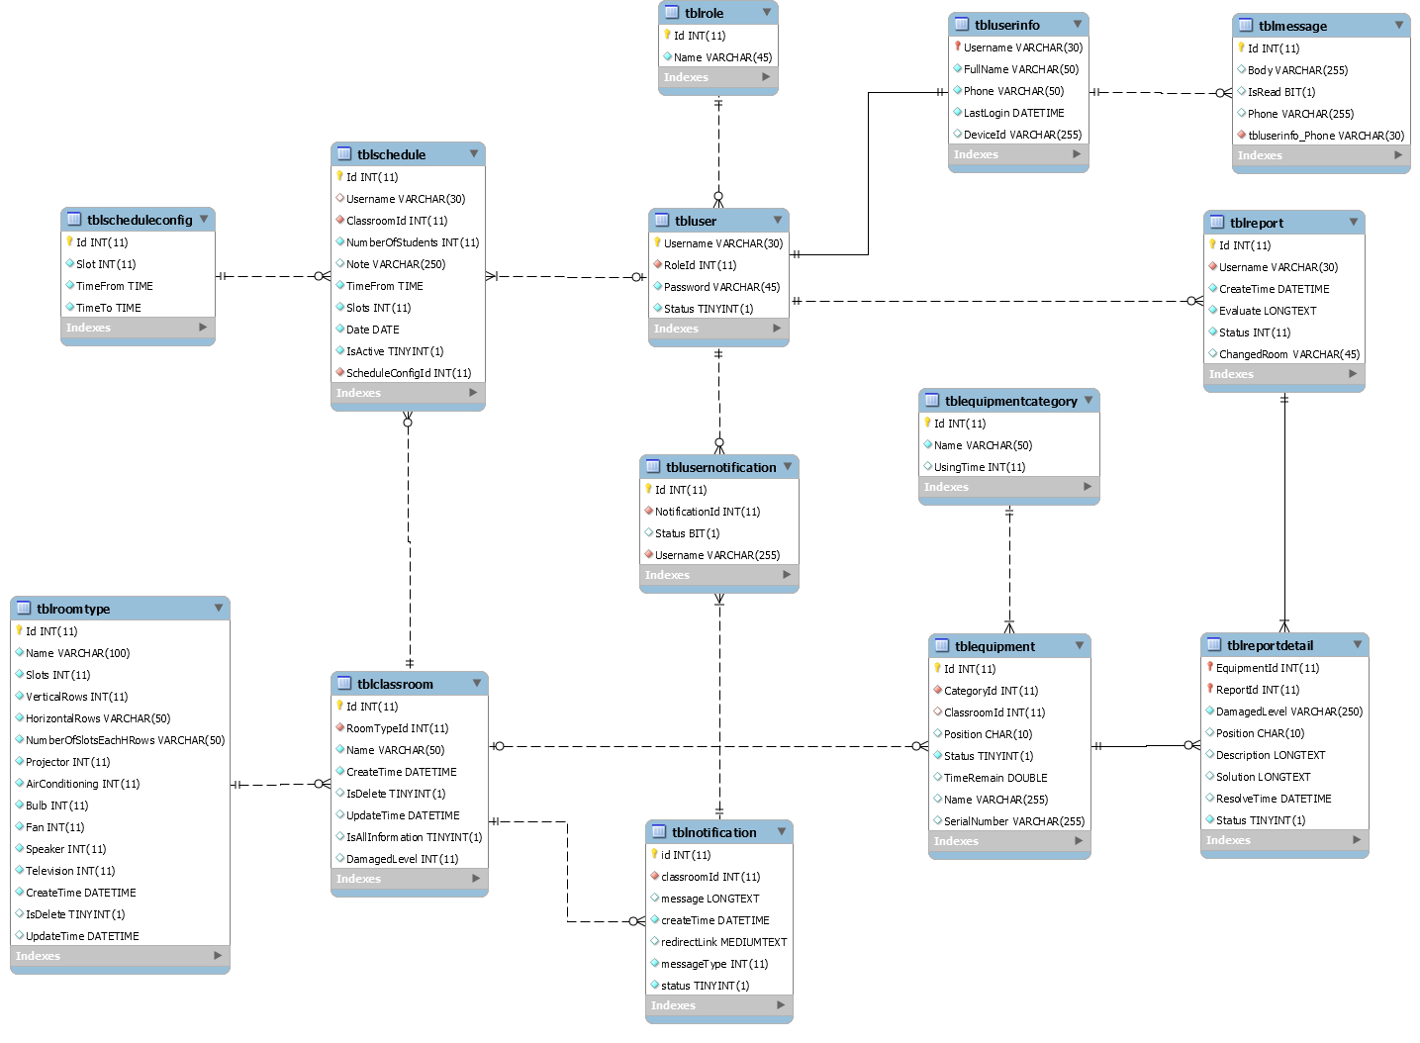

**2.2. Data Dictionary**

|  |  |  |  |  |
| --- | --- | --- | --- | --- |
| Table Name | Attributes | Description | Domain | Null |
| tblUser | Username | Username to login system | VARCHAR(30) | No |
|  | Password | Password of account to login system | VARCHAR(45) | No |
|  | Status | Status of account | TINYINT(1) | No |
|  | RoleId | Role of account | INT(11) | No |
| tblRole | Id | Id of role | INT(11) | No |
|  | Name | Name of role | VARCHAR(45) | No |
| tblUserInfo | Username | Username of account | VARCHAR(30) | No |
|  | FullName | Fullname of account | VARCHAR(50) | No |
|  | Phone | Phone number of account | VARCHAR(50) | No |
|  | LastLogin | Last login of account to system | DATETIME | Yes |
|  | DeviceId | Device ID of account when using mobile application | VARCHAR(255) | Yes |
| tblMessage | Id | Id of message | INT(11) | No |
|  | Body | Content of message | VARCHAR(255) | No |
|  | IsRead | Status of message | BIT(1) | No |
|  | Phone | Phone number send message | VARCHAR (30) | No |
| tblReport | Id | Id of report | INT(11) | No |
|  | Username | Username of account create report | VARCHAR(30) | No |
|  | CreateTime | Time report has created | DATETIME | No |
|  | Evaluate | Evaluate of teacher about this report | LONGTEXT | No |
|  | Status | Status of report | INT(11) | No |
|  | ChangeRoom | Room number has changed | VARCHAR(45) | Yes |
| tblEquipmentCategory | Id | Id of equipment category | INT(11) | No |
|  | Name | Name of equipment category | VARCHAR(50) | No |
|  | UsingTime | Time using of equipment category | INT(11) | Yes |
| tblEquipment | Id | Id of equipment | INT(11) | No |
|  | CategoryId | Id of equipment category | INT(11) | No |
|  | ClassroomId | Id of classroom has equipment | INT(11) | No |
|  | Position | Position of equipment in classroom | CHAR(10) | No |
|  | Status | Status of equipment | TINYINT(1) | No |
|  | TimeRemain | Time remain of equipment | DOUBLE | No |
|  | Name | Name of equipment | VARCHAR(255) | No |
|  | SerialNumber | Serial Number of equipment | VARCHAR(255) | No |
| tblReportDetail | EquipmentId | Id of equipment has reported | INT(11) | No |
|  | ReportId | Id of report | INT(11) | No |
|  | DamagedLevel | Damage level of equipment | VARCHAR(250) | No |
|  | Position | Position of equipment in classroom | CHAR(10) | No |
|  | Description | Description of equipment | LONGTEXT | Yes |
|  | Solution | Solution to resolve equipment | LONGTEXT | Yes |
|  | ResolveTime | Time resolve this equipment | DATETIME | Yes |
|  | Status | Status of this report detail | TINYINT(1) | No |
| tblUserNotification | Id | Id of user notification | INT(11) | No |
|  | NotificationId | Id of notification | INT(11) | No |
|  | Status | Status of notification | BIT(1) | No |
|  | Username | Username of account received this notification | VARCHAR(30) | No |
| tblNotification | Id | Id of notification | INT(11) | No |
|  | ClassroomId | Id of classroom | INT(11) | No |
|  | Message | Content of notification | LONGTEXT | No |
|  | CreateTime | Time notification has been created | DATETIME | No |
|  | RedirectLink | Link will redirect after user click to notification | MEDIUMTEXT | No |
|  | MessageType | Type of message | INT(11) | No |
|  | Status | Status of notification | TINYINT(1) | No |
| tblClassroom | Id | Id of classroom | INT(11) | No |
|  | RoomTypeId | Id of roomtype | INT(11) | No |
|  | Name | Name of classroom | VARCHAR(50) | No |
|  | CreateTime | Time create of classroom | DATETIME | No |
|  | IsDelete | Check classroom has been deleted | TINYINT(1) | No |
|  | UpdateTime | Time update classroom | DATETIME | No |
|  | IsAllInformation | Check classroom has full equipment | TINYINT(1) | No |
|  | DamageLevel | Damage level of classroom | INT(11) | No |
| tblSchedule | Id | Id of schedule | INT(11) | No |
|  | Username | User of schedule | VARCHAR(30) | No |
|  | ClassroomId | Classroom of schedule | INT(11) | No |
|  | NumberOfStudents | Number of student of classroom | INT(11) | No |
|  | Note | Note of schedule | VARCHAR(250) | Yes |
|  | TimeFrom | Time start schedule | TIME | No |
|  | Slots | Total slot of schedule | INT(11) | No |
|  | Date | Date of schedule | DATE | No |
|  | IsActive | Status of schedule | TINYINT(1) | No |
|  | ScheduleConfigId | Config of schedule | INT(11) | No |
| tblScheduleConfig | Id | Id of schedule config | INT(11) | No |
|  | Slot | Slot of schedule config | INT(11) | No |
|  | TimeFrom | Time start of schedule config | TIME | No |
|  | TimeTo | Time end of schedule config | TIME | No |
| tblRoomType | Id | Id of roomtype | INT(11) | No |
|  | Name | Name of roomtype | VARCHAR(100) | No |
|  | Slots | Number of slot of roomtype | INT(11) | No |
|  | VerticalRows |  | INT(11) | No |
|  | HorizontalRows |  | VARCHAR(50) | No |
|  | NoSlotEachHRows |  | VARCHAR(50) | No |
|  | Projector | Check roomtype has projector or not | INT(11) | No |
|  | AirConditioning | Check roomtype has air condition or not | INT(11) | No |
|  | Bulb | Check roomtype has bulb or not | INT(11) | No |
|  | Fan | Check roomtype has fan or no | INT(11) | No |
|  | Speaker | Check roomtype has speaker or not | INT(11) | No |
|  | Television | Check roomtype has television or not | INT(11) | No |
|  | CreateTime | Time create roomtype | DATETIME | No |
|  | IsDelete | Status of roomtype is deleted or not | TINYINT(1) | No |
|  | UpdateTime | Update Time of roomtype | DATETIME | No |

**3. Performance Measures**

**3.1. Web Application Page Load Speed**

**3.1.1. Definition**

This section tests the general page load speed from all the page of the web application

**3.1.2. Test Environment**

Server

* Operating System: Ubuntu 14.04 Server 32 bit
* RAM: 512MB
* Storage: 40GB
* Network: 1Mbps

**3.1.3. Test cases**

Using browser from client side and request each page of web application. Record the page load time using Chrome Dev Tools at client side.

Test pages:

|  |  |
| --- | --- |
| Public | Login Page |
| User | Dashboard |
| Create Report |
| View History Report |
| Staff | Dashboard |
| Schedule Config   * Add new schedule config * Update schedule config * Remove schedule config |
| Schedule   * Search schedule by user in default time. * Search schedule by classroom in default time. * Search between time with all user and classroom * Search between time will specific user and classroom * Search between time with specific user in all classroom. * Search between time with specific classroom with all user. * Import schedule excel file in 1 week of school (about 15KB) * Import manually 1 schedule |
| Statistic |
| Classroom   * Create new classroom * Remove classroom * Edit classroom * List all classroom * Search classroom by class name |
| Roomtype   * Create new roomtype * Remove roomtype * Edit roomtype * List all roomtype * Search roomtype by name |
| Equipment   * List all equipment * Create new equipment * Remove equipment |
|  | Report   * List all report * View report * Resolve report * Remove report |
| Admin | Account   * List all account * Activate/ Deactivate account * Create account * Edit account |

**3.1.4. Test result.**

The test is run 10 times, in each time we go through all the pages listed above and log down the average page load time.

|  |  |  |
| --- | --- | --- |
| Test No. | Average page load time (second) | Execute date |
| 1 | 1.85 | 25 July 2015 |
| 2 | 1.68 | 25 July 2015 |
| 3 | 2.94 | 25 July 2015 |
| 4 | 3.19 | 25 July 2015 |
| 5 | 2.63 | 25 July 2015 |
| 6 | 2.96 | 25 July 2015 |
| 7 | 2.48 | 25 July 2015 |
| 8 | 3.39 | 25 July 2015 |
| 9 | 2.73 | 25 July 2015 |
| 10 | 2.10 | 25 July 2015 |
|  | **Average: 2.59 (seconds)** |  |

**3.2. Mobile Application API load speed**

**3.2.1. Definition**

This section tests the load speed of mobile apps when connection to server through API

**3.2.2. Test environment.**

Server

* Operating System: Ubuntu 14.04 Server 32 bit
* RAM: 512MB
* Storage: 40GB
* Network: 1Mbps

Client:

|  |  |  |
| --- | --- | --- |
| Hardware Requirements | Minimum | Recommended |
| Internet Connection | 512Kbps | Wi-Fi Connection 12MB |
| Operating System | Android 4.0 | Android 4.0 |
| Memory | 128MB of RAM | 1GB of RAM or more |

**3.2.3. Test cases**

Using mobile application to send the entire API request to web server.

List of APIs:

|  |  |  |
| --- | --- | --- |
| No. | API | Description |
| 1 | checkConnection | Check connection to server |
| 2 | login | Login to application |
| 3 | schedule | Get schedule of user |
| 4 | getEquipments | Get equipment of each classroom |
| 5 | createReport | Create new report |
| 6 | getCurrentTime | Get current time of server |
| 7 | getReportByUsername | Get report of user |
| 8 | remove | Remove report |
| 9 | editReport | Edit report |
| 10 | getReportStaff | Get all report of staff |
| 11 | getAvailableRoom | Get available room for change room function |
| 12 | changeRoom | Do change room function when needed |
| 13 | sendNotification | Send notification to user |
| 14 | sendSMS | Send SMS to user |
| 15 | map | Get map of classroom |
| 16 | getAllReport | Get all report |
| 17 | resolve | Resolve report |
| 18 | checkSchedule | Check classroom has user teacher after that slot. |
| 19 | getAllSchedule | Get all schedule of user in week |
| 20 | getClassroom | Get current status of classroom |

**3.2.4. Test result**

The test is run 10 times, each time we run all the test cases listed above and log down the average API response time.

|  |  |  |
| --- | --- | --- |
| Test No. | Average page load time (second) | Execute date |
| 1 | 3.04 | 25 July 2015 |
| 2 | 4.86 | 25 July 2015 |
| 3 | 3.78 | 25 July 2015 |
| 4 | 4.42 | 25 July 2015 |
| 5 | 4.45 | 25 July 2015 |
| 6 | 3.43 | 25 July 2015 |
| 7 | 4.05 | 25 July 2015 |
| 8 | 2.96 | 25 July 2015 |
| 9 | 4.13 | 25 July 2015 |
| 10 | 4.68 | 25 July 2015 |
|  | **Average: 3.98 (seconds)** |  |

**4. Test Plan**

The overall purpose of testing is to ensure ECRM system meets its entire technical, functional and business requirement. The purpose of this document is to describe the overall test plan and strategy for testing the ECRM system. The approach described in this document provides the framework for all testing related to this application. Individual test cases will be written for each version of the application that is released. This document will also be updated as required for each release.

**4.1. Features to be tested**

* Staff: View schedule, resolve report, remove report, change room, import file schedule, import schedule manual.
* User: Create report, edit report and remove report.
* Mobile Application: Create report, edit report, remove report, resolver report and change room.
* System: Automatically check damage and change room.

**4.2. Features not to be tested.**

* Admin: Create account, update account, active/deactivate account.
* Staff: Create classroom, edit classroom, remove classroom, create roomtype, create equipment, edit equipment, edit roomtype, and delete roomtype, config schedule, statistic, search schedule.
* Login, logout, change profile
* View information: list roomtype, list classroom, list report.

**5. System Testing Test Case.**

**5.1. Create Report**

**5.1.1. Create Report by Mobile Application**

|  |  |  |  |  |  |  |  |
| --- | --- | --- | --- | --- | --- | --- | --- |
| **ID** | **Test Case Description** | **Test Case Procedure** | **Expected output** | **Inter-test Case Dependence** | **Result** | **Test Date** | **Note** |
| CRM1 | User with role is teacher report some damaged equipmet in the classroom that he have schedule in, at the time before his schedule start. | 1. User login with account “HoangNT” on date: “21/07/2015” at time: “07:45 am”. 2. User choose classroom “113” with start time at “08:45 am”. | 1. After step 1, show list of classroom that user have schedule in. 2. After step 2, show message:”Bạn không thể báo cáo phòng này”. | N/A | Passed | 26/7/2015 |  |
| CRM2 | User with role is teacher report some damaged equipmet in the classroom that he have schedule in, at the time that schedule has already started for 5 minutes. | 1. User logins with account “HoangNT” on date: “21/07/2015” at time: “08:50 am”. 2. User chooses classroom “113” with start time at “08:45 am”. 3. User chooses “Máy lạnh” and “Máy chiếu” and then chooses “Tiếp tục”. 4. User chooses “Phải đổi phòng” and then chooses “Gửi báo cáo”. | 1. After step 1, show list of classroom that user have schedule in. 2. After step 2, show list equipment of classroom “113”. 3. After step 3, show evaluate damaged box. 4. After step 4, show message “Đã báo cáo thành công”. | N/A | Passed | 26/7/2015 |  |
| CRM3 | User with role is teacher report classroom that he have schedule in, at the time that schedule has already started for 5 minutes. But there are no euipment is choosen. | 1. User logins with account “HoangNT” on date: “21/07/2015” at time: “08:50 am”. 2. User chooses classroom “113” with start time at “08:45 am”. 3. User chooses “Tiếp tục”. | 1. After step 1, show list of classroom that user have schedule in. 2. After step 2, show list equipment of classroom “113”. 3. After step 3, show error message: “Bạn cần chọn 1 thiết bị trước khi báo cáo! ” | N/A | Passed | 26/7/2015 |  |
| CRM4 | User with role is teacher report some damaged equipmet in the classroom that he have schedule in, with no internet access. | 1. User logins with account “HoangNT” on date: “21/07/2015” at time: “08:50 am”. 2. User chooses classroom “113” with start time at “08:45 am”. 3. User chooses “Máy lạnh” and “Máy chiếu” and then chooses “Tiếp tục”. 4. User chooses “Phải đổi phòng” and then chooses “Gửi báo cáo”. | 1. After step 1, show list of classroom that user have schedule in. 2. After step 2, show list equipment of classroom “113”. 3. After step 3, show evaluate damaged box. 4. After step 4, System wil evaluate damaged level of classroom “113” , if it’s more than 50%, show confirm message box “Hệ thống đánh giá phòng hư hại năng! Bạn có muốn gửi tin nhắn đến nhân viên? Việc này sẽ gây tốn phí!”. Otherwise, show message: “Gửi báo cáo thành công!”. | N/A | Passed | 26/7/2015 |  |

**5.1.2. Create Report in Web Application**

|  |  |  |  |  |  |  |  |
| --- | --- | --- | --- | --- | --- | --- | --- |
| **ID** | **Test Case Description** | **Test Case Procedure** | **Expected output** | **Inter-test Case Dependence** | **Result** | **Test Date** | **Note** |
| CRM1 | User with role is teacher report some damaged equipmet in the classroom that he have schedule in, at the time before his schedule start. | 1. User login with account “HoangNT” on date: “21/07/2015” at time: “07:45 am”. 2. User clicks on button “Gửi báo cáo” | 1. After step 2, show message: “Hiện tại bạn không có lịch dạy”. | N/A | Passed | 26/7/2015 |  |
| CRM2 | User with role is teacher report some damaged equipmet in the classroom that he have schedule in, at the time that schedule has already started for 5 minutes. | 1. User logins with account “HoangNT” on date: “21/07/2015” at time: “08:50 am”. 2. User clicks on button “Gửi báo cáo” 3. User chooses classroom “113”. 4. User clicks on “Máy lạnh” and “Máy chiếu” and then clicks on “Gửi báo cáo”. | 1. After step 2, show list of classroom that user have schedule in. 2. After step 3, show list equipment of classroom “113”. 3. After step 4, show message: “Báo cáo đã gửi thành công!”. | N/A | Passed | 26/7/2015 |  |
| CRM3 | User with role is teacher report in the classroom that he have schedule in, at the time that schedule has already started for 5 minutes. But there are no euipment is choosen. | 1. User logins with account “HoangNT” on date: “21/07/2015” at time: “08:50 am”. 2. User clicks on button “Gửi báo cáo” 3. User chooses classroom “113”. 4. User clicks on “Gửi báo cáo”. | 1. After step 2, show list of classroom that user have schedule in. 2. After step 3, show list equipment of classroom “113”. 3. After step 4, show message: “Bạn cần chọn 1 thiết bị trước khi báo cáo! ”. | N/A | Passed | 26/7/2015 |  |