1. **Software User’s Manual**
   1. **Installation Guide**
      1. **Setting up environment at server side**

The following software must be installed into the server machine:

* + - 1. **Hardware requirement**

Personal computers for developing with the minimum configuration:

* Processor: Minimum Core 2 Duo 2.0GHz
* Memory: Minimum 1GB RAM
* Available Disk Space: Minimum 30GB hard disk
* Internet: Minimum speed 10Mbps
  + - 1. **Software requirement**
* Web Server: Apache Tomcat 7.0.55 with JRE 7
* OS: Microsoft Windows Server 2008
* MySQL Server 5.5
  + 1. **Deployment at server side**
       1. **Setup environment variable**

Please go following path: Click **Properties** of **Computer**, then click **Advanced System Setting**, in “**Advanced**” tab select **Environment** **variables**.

* Add variable **JRE_HOME**: Directory path of Java Runtime Environment.

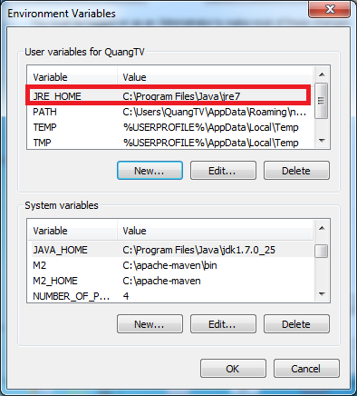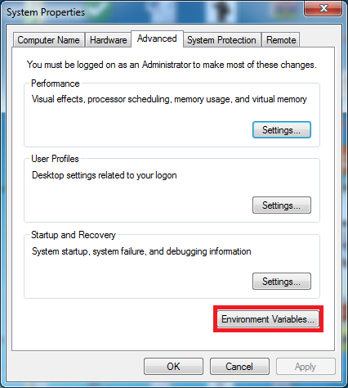

* + - 1. **Prepare deployment package**

Copy the deployment package (**WAR** file) to a folder on the Tomcat server.

* + - 1. **Configure Server before deploy**
* Open MySQL Workbench, connect to server
* Create new schema with name “ECRM”
* Select **Management** tab and choose **Data Import/Restore**
* Choose **Import From Self-Contained File** and enter path to “**ECRM_DATA.sql**”
* Choose **Default Target Schema** is **ECRM**
* Press **Start Import**
  + - 1. **Deploy web application at server**
* Copy the deployment package **ECRM.war** to a folder **webapps** in the directory of Tomcat server. Ex: C:\apache-tomcat-7.0.55\webapps
* Navigate to folder **bin** in the directory of Tomcat server. Then click **startup.bat** file to start the server and wait for server startup.
  + 1. **Setting up environment at client side**
       1. **Setting up for computer**

The client devices need to have one of the following browsers to access the website: Firefox (v30 or above), Google Chrome (v14 or above) browser… enables JavaScript.

* + - 1. **Setting up for Android device**

Change setting to install unknown source **apk files**. To do this, go to **Setting/Security**, tick check box **Unknown sources**.

Copy installation source into device external memory: **ECRM Teacher.apk** or **ECRM Staff.apk**

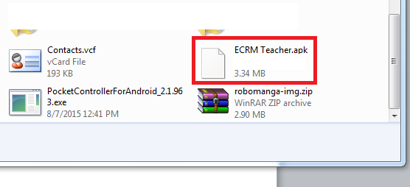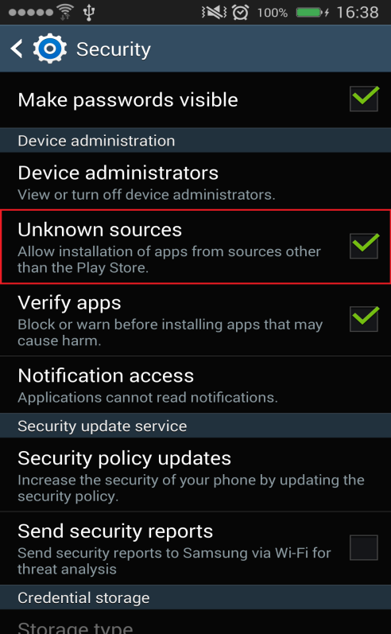

Open Android file explorer, navigate to external memory directory. Click on file to install.

* 1. **User Guide**
     1. **Teacher Guide**
        1. **Mobile Application**
           1. **Create Report**

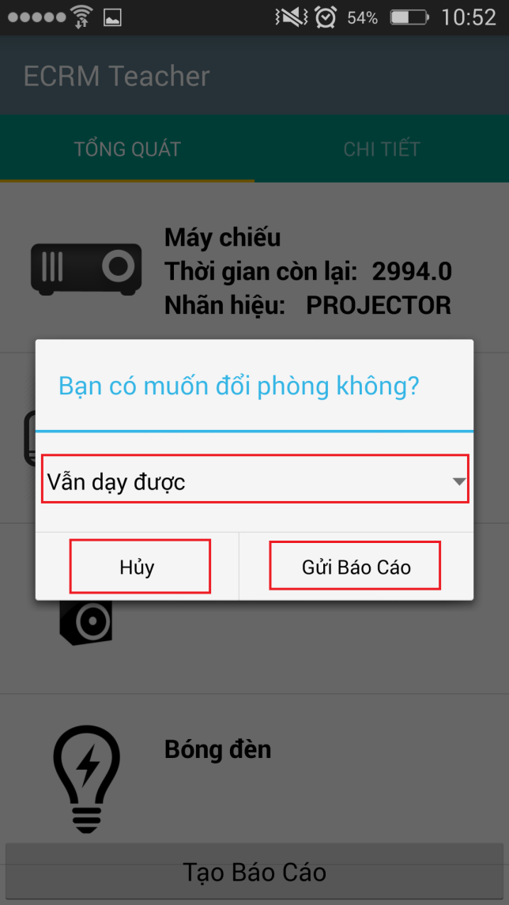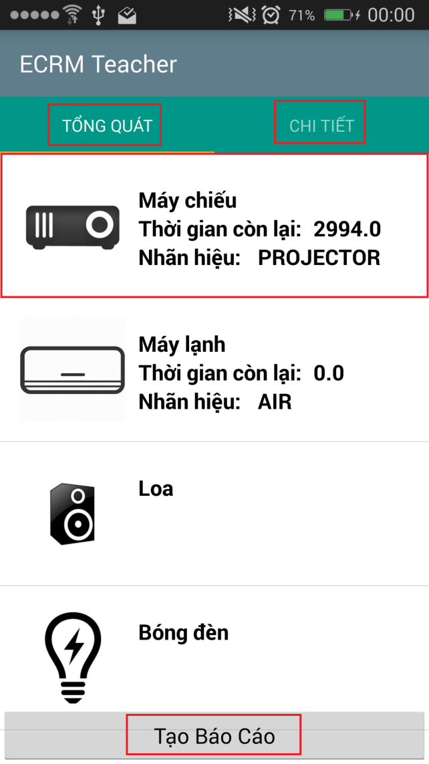

|  |  |
| --- | --- |
| Step | Description |
| 1 | At View Schedule Screen, choose classroom to report |
| 2 | Touch “TỔNG QUÁT” to view list equipment category of classroom |
| 3 | Touch “CHI TIẾT” to view map of classroom |
| 4 | Choose equipmenet show in list to report |
| 5 | Touch “Tạo Báo Cáo” to create report |
| 6 | Evaluate report by choose from spinner value |
| 7 | Touch “Gửi Báo Cáo” to send report to staff |

* + - 1. **Web Application**
         1. **Create Report**

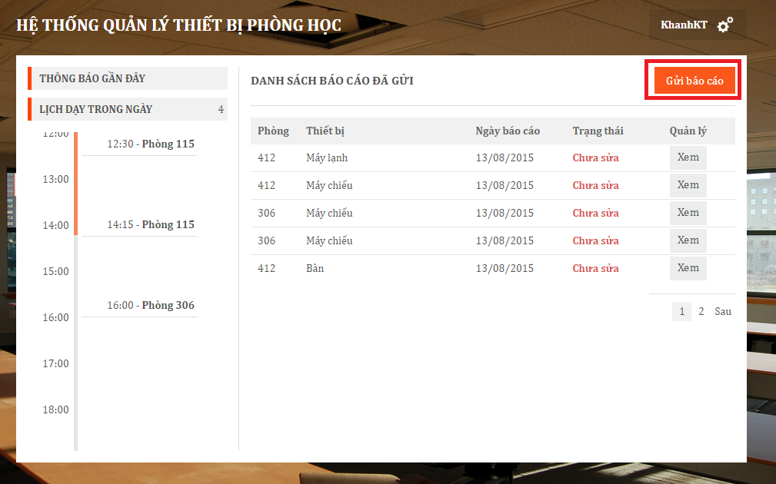

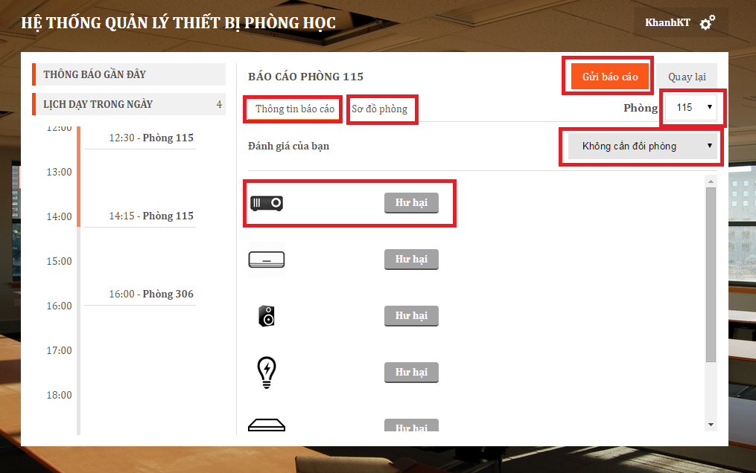

|  |  |
| --- | --- |
| Step | Description |
| 1 | At home page, click “Gửi báo cáo” |
| 2 | Click “Thông tin báo cáo” to view list equipment category of classroom |
| 3 | Click “Sơ đồ phòng” to view map of classroom. |
| 4 | Choose “Phòng” to report specific classroom. |
| 5 | Choose equipmenet show in list to report. |
| 6 | Choose “Đánh giá của bạn” to send teacher’s evaluation about classroom. |
| 7 | Click “Gửi Báo Cáo” to send report. |

* + 1. **Staff Guide**
       1. **Mobile Application**
          1. **Resolve Report**

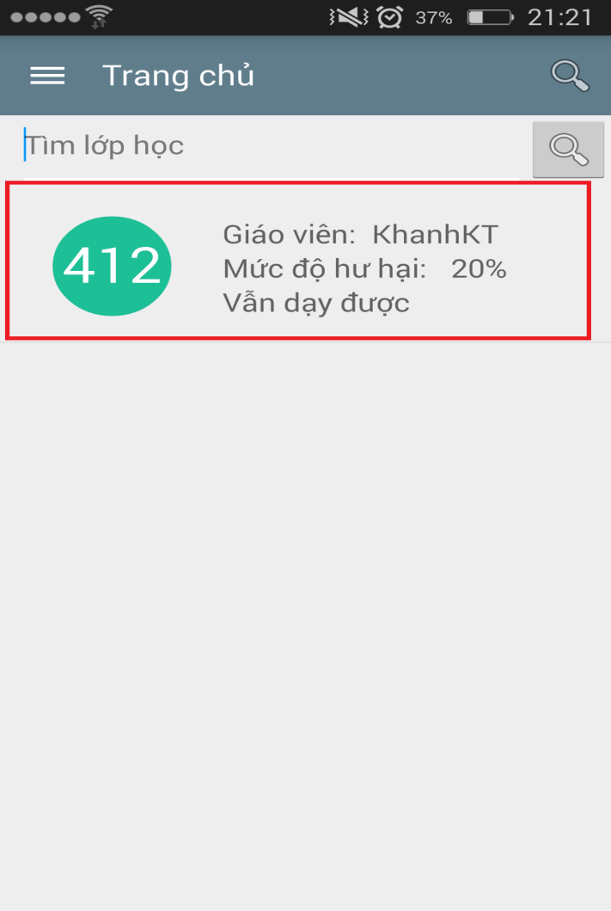

|  |  |
| --- | --- |
| Step | Description |
| 1 | Touch to view detail report |
| 2 | Touch “Khắc phục” to resolve report |
| 3 | Touch “Đổi phòng học” to change room |

* + - * 1. **Change Room**

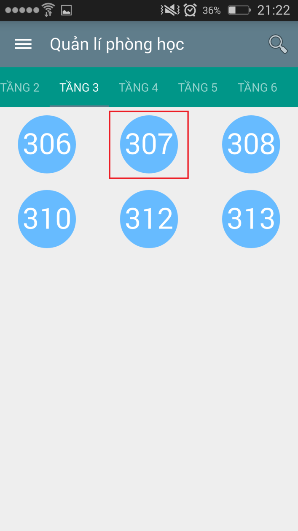

|  |  |
| --- | --- |
| Step | Description |
| 1 | Touch to room name to find available room |
| 2 | Touch “Đổi phòng học” to change room |

* + - 1. **Web Application**
         1. **Resolve Report**

**Resolve All**

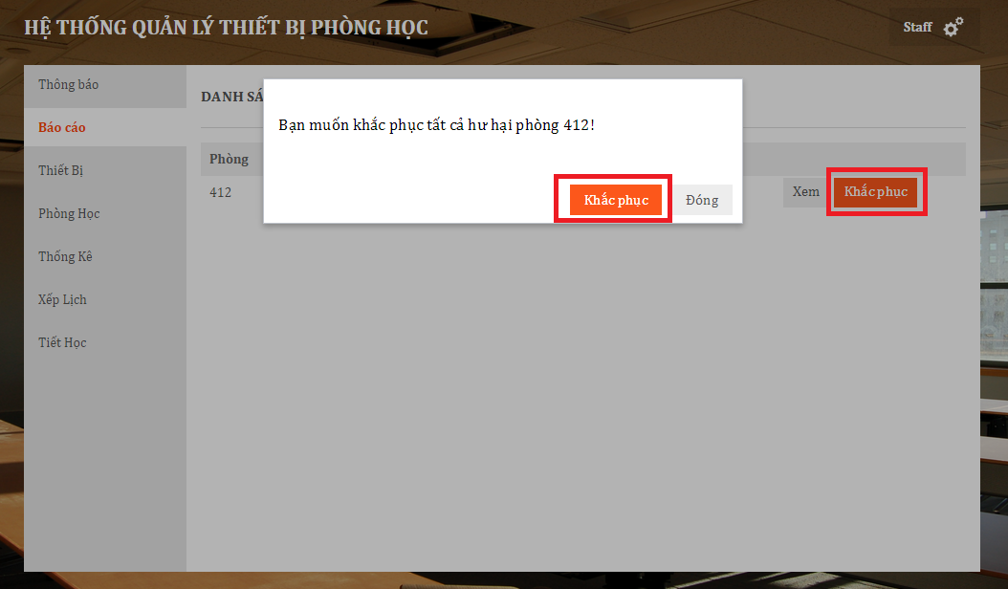

|  |  |
| --- | --- |
| Step | Description |
| 1 | At “Báo cáo”, click “Khắc phục” |
| 2 | Click “Khắc phục” to resovle report. |

**Resolve Detail**

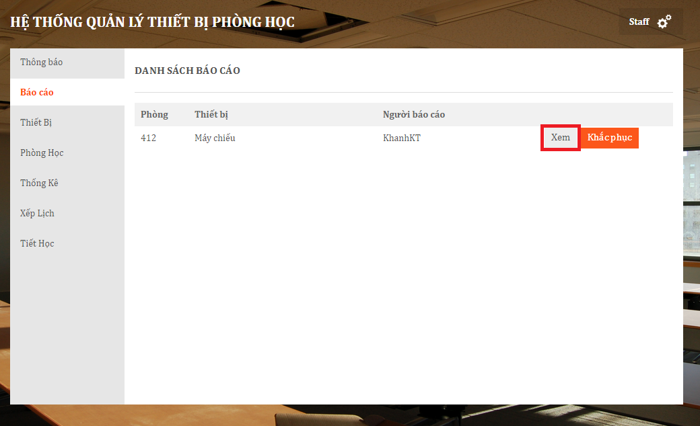

|  |  |
| --- | --- |
| Step | Description |
| 1 | At “Báo cáo” page, click “Xem” |
| 2 | Check equipment and choose serial number. |
| 3 | Click “Khắc phục tất cả” |

* + - * 1. **Create Room Type**

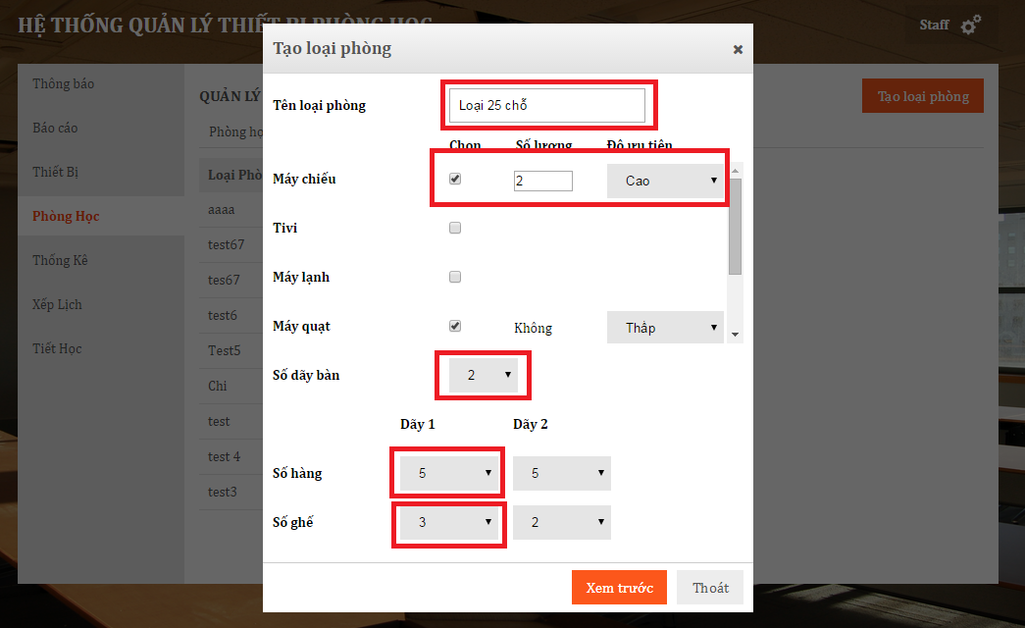

|  |  |
| --- | --- |
| Step | Description |
| 1 | At “Phòng học” page, tab “Loại phòng”, click “Tạo loại phòng” |
| 2 | Input at “Tên loại phòng” |
| 3 | Check equipment, input “Số lượng” and choose “Ưu tiên” |
| 4 | Choose “Dãy bàn”, “Số hàng”, “Số ghế” |
| 5 | Click “Xem mẫu” |
| 6 | Click “Tạo mẫu” |