**<Guest login>**

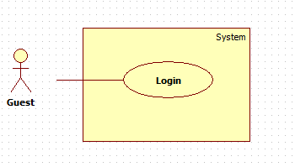

|  |  |  |  |
| --- | --- | --- | --- |
| **USE CASE – ECRM001** | |  |  |
| **Use Case No.** | ECRM001 | **Use Case Version** | 1.0 |
| **Use Case Name** | Login |  |  |
| **Author** | Tang Viet Hung |  |  |
| **Date** | 21/05/2015 | **Priority** | Normal |
| **Actor:** Guest | |  |  |
| **Summary:** This use case allows guest to login.  **Goal:** Authentication and authorization  **Triggers:** Guest click on “Login” button  **Preconditions:**   * N/A   **Post Conditions:**   * **Success:** Guest will be logged in system with their roles. * **Fail:** Unsuccessful message will be shown.   **Main Success Scenario:**   |  |  |  | | --- | --- | --- | | Step | Actor Action | System Response | | 1 | Guest clicks “Login” button. | System navigates to “Login” page.   * Username: textbox, required. * Password: textbox, required. - Login: button | | 2 | Input field. |  | | 3 | Click on “Login” button. | Guest will login system with their roles.  [Exception 1] |     **Alternative Scenario:** N/A    **Exceptions:**   |  |  |  | | --- | --- | --- | | No | Actor Action | System Response | | 1 | Click on “Login” button. | Wrong username or password. Show unsuccessful message: “Sai username hoặc password. Hãy thử lại!”. |     **Relationships:** N/A  **Business Rules:**   * After login successfully, guest will login with their role: user, staff. | | | |

**<Guest logout>**

|  |  |  |  |
| --- | --- | --- | --- |
| **USE CASE – ECRM001** | |  |  |
| **Use Case No.** | ECRM001 | **Use Case Version** | 1.0 |
| **Use Case Name** | Logout |  |  |
| **Author** | Tang Viet Hung |  |  |
| **Date** | 21/05/2015 | **Priority** | Normal |
| **Actor:** Guest | |  |  |
| **Summary:** This use case allows user to logout.  **Goal:** Logout of the system  **Triggers:** User click on “Logout” button  **Preconditions:**   * User have successfully logged in system.   **Post Conditions:**   * **Success:** User will be logged out of system. * **Fail:** Unsuccessful message will be shown.   **Main Success Scenario:**   |  |  |  | | --- | --- | --- | | Step | Actor Action | System Response | | 1 | User clicks “Login” button. | System show dialog: “Bạn có chắc muốn đăng xuất?” | | 2 | User clicks “Yes” button. | System navigates to login screen. |     **Alternative Scenario:**     |  |  |  | | --- | --- | --- | | Step | Actor Action | System Response | | 1 | User clicks “No” button in dialog. | System remains user in current page. |   **Exceptions:** N/A    **Relationships:** N/A  **Business Rules:**   * After login successfully, guest will login with their role: user, staff. | | | |

<**Staff> Manage Account**

**<Staff> Activate/ Deactivate Account**

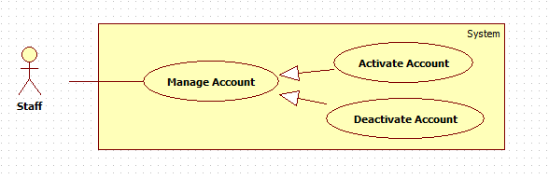

|  |  |  |  |
| --- | --- | --- | --- |
| **USE CASE – ECRM002** | |  |  |
| **Use Case No.** | ECRM002 | **Use Case Version** | 1.0 |
| **Use Case Name** | Activate/ Deactivate Account |  |  |
| **Author** | Tang Viet Hung |  |  |
| **Date** | 21/05/2015 | **Priority** | Normal |
| **Actor:** Staff | |  |  |
| **Summary:** This use case allows staff to activate and deactivate user’s account in system.  **Goal:** Activate and deactivate user’s account  **Triggers:** Staff want to activate or deactivate user’s account.  **Preconditions:**   * User must login with staff role.   **Post Conditions:**   * **Success:** user’s account will be changed its status to Activated or Deactivated and show successful message. * **Fail:** Unsuccessful message will be shown.   **Main Success Scenario:**   |  |  |  | | --- | --- | --- | | Step | Actor Action | System Response | | 1 | Staff focuses on “Account” and clicks “Edit Account” | System navigates to “Manage Account” page.   * Table contains columns:   + - Username.     - Classroom: teacher’s classroom.     - Check box. * Activate: button. * Deactivate: button. | | 2 | Staff checks the checkbox to select account. |  | | 3 | Staff clicks on “Activate” or “Deactivate”. | Update status of account and show successful message: “Cập nhật tài khoản thành công!”  [Exception 1] |     **Alternative Scenario:** N/A    **Exceptions:**     |  |  |  | | --- | --- | --- | | No | Actor Action | System Response | | 1 | Staff didn’t check any check box and then clicks “Activate” or “Deactivate” button | Show error message: “Phải chọn ít nhất một tài khoản!” |   **Relationships:** N/A  **Business Rules:**   * User only can login to the system with activated account. | | | |

**<Staff> Add Account**

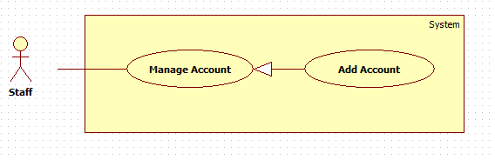

|  |  |  |  |
| --- | --- | --- | --- |
| **USE CASE – ECRM003** | |  |  |
| **Use Case No.** | ECRM003 | **Use Case Version** | 2.0 |
| **Use Case Name** | Add Account |  |  |
| **Author** | Tang Viet Hung |  |  |
| **Date** | 21/05/2015 | **Priority** | Normal |
| **Actor:** Staff | |  |  |
| **Summary:** This use case allows staff to add new account.  **Goal:** Add new account to the system.  **Triggers:** Staff want to add new account.  **Preconditions:**   * User login as staff role.   **Post Conditions:**   * **Success:** New account will be created and show successful message. * **Fail:** Unsuccessful message will be shown.   **Main Success Scenario:**   |  |  |  | | --- | --- | --- | | Step | Actor Action | System Response | | 1 | Staff focuses on “Account” and clicks “Add Account” | System navigates to “Tạo tài khoản” page. Page includes form:   * Username: textbox, min length 6, max length 30, required. * Họ tên: textbox, required. * Số điện thoại: textbox, number type, required. * Chức vụ: dropdown list, required. * Clear: button. * Tạo tài khoản: button | | 2 | Staff enters information and then clicks “Tạo tài khoản” button. | Create new account and show successful message: “Tài khoản được tạo thành công”.[Exception 1, 2, 3, 4] |     **Alternative Scenario:** N/A    **Exceptions:**   |  |  |  | | --- | --- | --- | | No | Actor Action | System Response | | 1 | Length of “username” is not in range. | Show unsuccessful message: “Username bao gồm từ 6 đến 10 ký tự. Xin thử lại!” | | 2 | “Số điện thoại” is empty or characters. | Show unsuccessful message: “Số điện thoại không hợp lệ. Xin thử lại!” | | 3 | “Họ tên” is empty. | Show unsuccessful message: “Họ tên không được bỏ trống. Xin thử lại!” | | 4 | “Username” have been already existed. | Show unsuccessful message: “Username đã tồn tại, vui lòng nhập lại!” |     **Relationships:** N/A  **Business Rules:** Account is created is activated account. | | | |

**<Staff>Create room type**

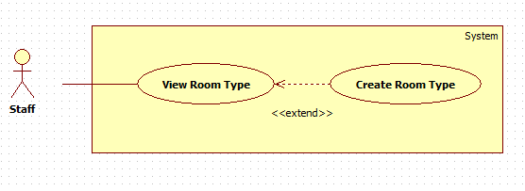

|  |  |  |  |
| --- | --- | --- | --- |
| **USE CASE – ECRM003** | |  |  |
| **Use Case No.** | ECRM003 | **Use Case Version** | 2.0 |
| **Use Case Name** | Create Room Type |  |  |
| **Author** | Tang Viet Hung |  |  |
| **Date** | 21/05/2015 | **Priority** | Normal |
| **Actor:** Staff | |  |  |
| **Summary:** This use case allows staff to create new room type.  **Goal:** Create room type to the system.  **Triggers:** Staff want to create new room type.  **Preconditions:**   * User login as staff role.   **Post Conditions:**   * **Success:** New room type will be created and show successful message. * **Fail:** Unsuccessful message will be shown.   **Main Success Scenario:**   |  |  |  | | --- | --- | --- | | Step | Actor Action | System Response | | 1 | Staff focuses on “Phòng Học” and clicks “Kiểu Phòng”. | System navigates to “Kiểu Phòng” page. Page includes:   * Text box search. * Dropdown list. * Search: button. * Table with columns: * Số kiểu * Số chỗ ngồi * Check box * Xem: button. * Tạo Mới: button.   [Alternative 1, 2] | | 2 | Staff clicks on “Tạo Mới” button. | System navigates to “Tạo Mới Kiểu Phòng” page. Page includes:   * Số kiểu: textbox, disabled. * Máy lạnh: check box. * Máy chiếu: check box. * Tivi: check box. * Quạt: check box. * Loa: check box. * Số lượng dãy dọc: text box, number type, required. * Chấp nhận: button. * Cancel: button.   [Exception 1]  [Alternative 4] | | 3 | Staff inputs two textbox and clicks “Chấp nhận” button. | System will show table with number of column equal with number staff inputted in “Số lượng dãy dọc”. Each column includes:   * Số dãy ngang: text box, number type, required. * Số chỗ ngồi mỗi dãy ngang: text box, number type, required. * Xem: button.   [Exception 2] | | 4 | Staff inputs all fields and click “Xem” button. | System navigates to “Xem Kiểu Phòng” Page. Page includes:   * Classroom map. * Tạo Kiểu Phòng: button. * Cancel: button.   [Alternative 5] | | 5 | Staff clicks on “Tạo Kiểu Phòng” button. | System show successful message: “Tạo kiểu phòng mới thành công!” and navigate to “Kiểu Phòng” page. |     **Alternative Scenario:**     |  |  |  | | --- | --- | --- | | No | Actor Action | System Response | | 1 | Staff inputs to text box search and clicks “Tìm kiếm” button. | Show result in table. | | 2 | Staff clicks “Xem” button. | Navigate to “Xem Kiểu Phòng” page. | | 4 | Staff clicks on “Cancel” button in “Tạo Mới Kiểu Phòng” page. | System navigate to “Kiểu Phòng” page. | | 5 | Staff clicks on “Cancel” button in “Xem Kiểu Phòng” page. | System navigate to “Tạo Mới Kiểu Phòng” page. |   **Exceptions:**   |  |  |  | | --- | --- | --- | | No | Actor Action | System Response | | 1 | “Số lượng dãy dọc” is empty or characters. | Show error message: “Số lượng dãy dọc không hợp lệ!” | | 2 | “Số chỗ ngồi mỗi dãy ngang” is empty or characters. | Show error message: “Số chỗ ngồi mỗi dãy ngang không hợp lệ!” |   **Relationships:** N/A  **Business Rules:** N/A | | | |

**<Staff>Update Room Type**

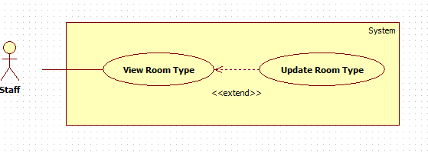

|  |  |  |  |
| --- | --- | --- | --- |
| **USE CASE – ECRM003** | |  |  |
| **Use Case No.** | ECRM003 | **Use Case Version** | 2.0 |
| **Use Case Name** | Update Room Type |  |  |
| **Author** | Tang Viet Hung |  |  |
| **Date** | 21/05/2015 | **Priority** | Normal |
| **Actor:** Staff | |  |  |
| **Summary:** This use case allows staff to update a room type.  **Goal:** Update a specific room type.  **Triggers:** Staff want to update a room type.  **Preconditions:**   * User login as staff role. * Room type existed in database.   **Post Conditions:**   * **Success:** Room type will be updated. * **Fail:** Unsuccessful message will be shown.   **Main Success Scenario:**   |  |  |  | | --- | --- | --- | | Step | Actor Action | System Response | | 1 | Staff focuses on “Phòng Học” and clicks “Kiểu Phòng”. | System navigates to “Kiểu Phòng” page. Page includes:   * Text box search. * Dropdown list. * Search: button. * Table with columns: * Số kiểu * Số chỗ ngồi * Check box * Xem: button. * Tạo Mới: button. * [Alternative 1, 2] | | 2 | Staff clicks “Xem” button. | System navigates to “Xem Kiểu Phòng” page. Page includes:   * Sơ đồ kiểu phòng: map. * Xóa: button. * Chỉnh sửa: button. * Quay về: button.   [Alternative 3, 4] | | 3 | Staff clicks “Chỉnh sửa” button. | System navigates to “Chỉnh Sửa Kiểu Phòng” page. Page includes:   * Số kiểu: textbox, disabled. * Máy lạnh: check box. * Máy chiếu: check box. * Tivi: check box. * Quạt: check box. * Loa: check box. * Số lượng dãy dọc: text box, number type, required. * Chấp nhận: button. * Cancel: button.   [Exception 1]  [Alternative 5] | | 4 | Staff inputs two textbox and clicks “Chấp nhận” button. | System will show table with number of column equal with number staff inputted in “Số lượng dãy dọc”. Each column includes:   * Số dãy ngang: text box, number type, required. * Số chỗ ngồi mỗi dãy ngang: text box, number type, required. * Xem: button.   [Exception 2] | | 4 | Staff inputs all fields and click “Xem” button. | System navigates to “Xem Kiểu Phòng” Page. Page includes:   * Classroom map. * Tạo Kiểu Phòng: button. * Cancel: button. * [Alternative 6] | | 5 | Staff clicks on “Tạo Kiểu Phòng” button. | System show successful message: “Chỉnh sửa kiểu phòng thành công” and navigate to “Kiểu Phòng” page. |     **Alternative Scenario:**   |  |  |  | | --- | --- | --- | | No | Actor Action | System Response | | 1 | Staff inputs to text box search and clicks “Tìm kiếm” button. | Show result in table. | | 2 | Staff clicks “Xem” button. | Navigate to “Xem Kiểu Phòng” page. | | 3 | Staff clicks “Xóa” button. | Show message: “Bạn có chắc muốn xóa kiểu phòng?” | |  | Staff clicks “Quay về” button. | Naviages to “Kiểu Phòng” page. | | 5 | Staff clicks on “Cancel” button in “Chỉnh Sửa Kiểu Phòng” page. | System navigate to “Kiểu Phòng” page. | | 6 | Staff clicks on “Cancel” button in “Xem Kiểu Phòng” page. | System navigate to “Chỉnh Sửa Kiểu Phòng” page. |   **Exceptions:**   |  |  |  | | --- | --- | --- | | No | Actor Action | System Response | | 1 | “Số lượng dãy dọc” is empty or characters. | Show error message: “Số lượng dãy dọc không hợp lệ!” | | 2 | “Số chỗ ngồi mỗi dãy ngang” is empty or characters. | Show error message: “Số chỗ ngồi mỗi dãy ngang không hợp lệ!” |   **Relationships:** N/A  **Business Rules:** N/A | | | |

**<Staff>Delete Room Type**

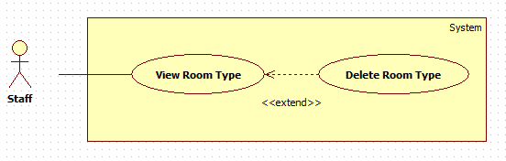

|  |  |  |  |
| --- | --- | --- | --- |
| **USE CASE – ECRM003** | |  |  |
| **Use Case No.** | ECRM003 | **Use Case Version** | 2.0 |
| **Use Case Name** | Delete Room Type |  |  |
| **Author** | Tang Viet Hung |  |  |
| **Date** | 21/05/2015 | **Priority** | Normal |
| **Actor:** Staff | |  |  |
| **Summary:** This use case allows staff to delete a room type.  **Goal:** Delete a specific room type.  **Triggers:** Staff want to delete a room type.  **Preconditions:**   * User login as staff role. * Room type existed in database.   **Post Conditions:**   * **Success:** Room type will be deleted and show successful message. * **Fail:** Unsuccessful message will be shown.   **Main Success Scenario:**   |  |  |  | | --- | --- | --- | | Step | Actor Action | System Response | | 1 | Staff focuses on “Phòng Học” and clicks “Kiểu Phòng”. | System navigates to “Kiểu Phòng” page. Page includes:   * Text box search. * Dropdown list. * Search: button. * Table with columns: * Số kiểu * Số chỗ ngồi * Check box * Xem: button. * Tạo Mới: button. * [Alternative 1, 2] | | 2 | Staff clicks “Xem” button. | System navigates to “Xem Kiểu Phòng” page. Page includes:   * Sơ đồ kiểu phòng: map. * Xóa: button. * Chỉnh sửa: button. * Quay về: button.   [Alternative 3, 4] | | 3 | Staff clicks “Xóa” button. | Show dialog: “Bạn có chắc muốn xóa kiểu phòng?”  [Alternative 5] | | 4 | Staff clicks “Yes” button in dialog. | System shows successful message: “Xóa kiểu phòng thành công” and navigates to “Kiểu Phòng” page. |     **Alternative Scenario:**   |  |  |  | | --- | --- | --- | | No | Actor Action | System Response | | 1 | Staff inputs to text box search and clicks “Tìm kiếm” button. | Show result in table. | | 2 | Staff clicks “Tạo Mới” button. | Navigate to “Tạo Mới Kiểu Phòng” page. | | 3 | Staff clicks “Chỉnh sửa” button. | Navigate to “Chỉnh Sửa Kiểu Phòng” page. | |  | Staff clicks “Quay về” button. | Naviages to “Kiểu Phòng” page. | | 5 | Staff clicks “No” in dialog | System remains in “Xem Kiểu Phòng” Page. |   **Exceptions:** N/A  **Relationships:** N/A  **Business Rules:** N/A | | | |

**<Staff> Import File**

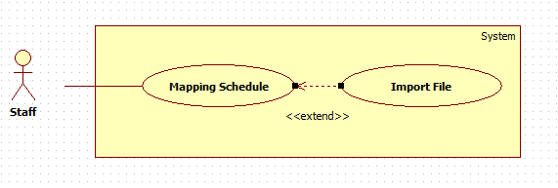

|  |  |  |  |
| --- | --- | --- | --- |
| **USE CASE – ECRM003** | |  |  |
| **Use Case No.** | ECRM003 | **Use Case Version** | 2.0 |
| **Use Case Name** | Import File |  |  |
| **Author** | Tang Viet Hung |  |  |
| **Date** | 21/05/2015 | **Priority** | Normal |
| **Actor:** Staff | |  |  |
| **Summary:** This use case allows staff to import file schedule.  **Goal:** Import a schedule file.  **Triggers:** Staff want to import schedule file.  **Preconditions:**   * User login as staff role.   **Post Conditions:**   * **Success:** Schedule file will be imported and show successful message. * **Fail:** Unsuccessful message will be shown.   **Main Success Scenario:**   |  |  |  | | --- | --- | --- | | Step | Actor Action | System Response | | 1 | Staff focuses on “Lịch” and clicks “Nhập Lịch”. | System navigates to “Nhập Lịch” page. Page includes:   * Tìm: button * Import: button | | 2 | Staff clicks on “Tìm” button and choose schedule excel file from his computer. | System shows the name of schedule file. | | 4 | Staff clicks “Import” button. | System shows successful message.  [Exception 1] |     **Alternative Scenario:** N/A  **Exceptions:**   |  |  |  | | --- | --- | --- | | No | Actor Action | System Response | | 1 | Staff import a wrong template excel file. | System shows error message. |   **Relationships:** N/A  **Business Rules:** N/A | | | |

**<Staff> View Schedule**

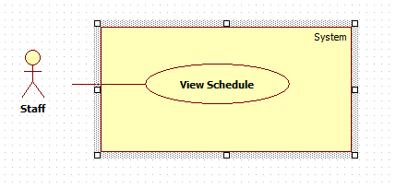

|  |  |  |  |
| --- | --- | --- | --- |
| **USE CASE – ECRM003** | |  |  |
| **Use Case No.** | ECRM003 | **Use Case Version** | 2.0 |
| **Use Case Name** | View Schedule |  |  |
| **Author** | Tang Viet Hung |  |  |
| **Date** | 21/05/2015 | **Priority** | Normal |
| **Actor:** Staff | |  |  |
| **Summary:** This use case allows staff to view schedule.  **Goal:** View schedule.  **Triggers:** Staff want to view schedule.  **Preconditions:**   * User login as staff role.   **Post Conditions:**   * **Success:** Schedule will be showed. * **Fail:** Unsuccessful message will be shown.   **Main Success Scenario:**   |  |  |  | | --- | --- | --- | | Step | Actor Action | System Response | | 1 | Staff focuses on “Lịch” and clicks “Xem Lịch”. | System navigates to “Xem Lịch” page. Page includes:   * Text box search. * Dropdown list * Search: button. * Table includes column:   + - Giáo Viên.     - Phòng học.     - Giờ học.     - Số học sinh.   [Alternative 1] |     **Alternative Scenario:**   |  |  |  | | --- | --- | --- | | No | Actor Action | System Response | | 1 | Staff inputs to text box search and clicks “Tìm kiếm” button. | Show result in table. |   **Exceptions:** N/A  **Relationships:** N/A  **Business Rules:** N/A | | | |