**Danh ba**

**Adapter**

package com.example.b1906314_buichihai_danhba

import android.content.Intent

import android.view.LayoutInflater

import android.view.View

import android.view.ViewGroup

import android.widget.ImageView

import android.widget.TextView

import androidx.recyclerview.widget.RecyclerView

import com.bumptech.glide.Glide

class Adapter(private val dataset: ArrayList<Result>): RecyclerView.Adapter<Adapter.ViewHolder>() {

class ViewHolder(view: View): RecyclerView.ViewHolder(view) {

val tvEmail: TextView

val tvTen: TextView

val tvAddress: TextView

val tvPhone: TextView

val img : ImageView

init {

tvEmail = view.findViewById(R.id.Email_b1906314)

tvTen = view.findViewById(R.id.Name_b1906314)

tvAddress = view.findViewById(R.id.Address_b1906314)

tvPhone = view.findViewById(R.id.Phone_b1906314)

img = view.findViewById(R.id.image1_b1906314)

}

}

override fun onCreateViewHolder(parent: ViewGroup, viewType: Int): ViewHolder {

val view = LayoutInflater.from(parent.context).inflate(R.layout.contact_activity_items, null)

return ViewHolder(view)

}

override fun getItemCount(): Int {

return dataset.size

}

override fun onBindViewHolder(holder: ViewHolder, position: Int) {

holder.tvTen.setText(dataset[position].name.title + ". "+dataset[position].name.first + " " + dataset[position].name.last)

holder.tvEmail.setText(dataset[position].email)

holder.tvPhone.setText(dataset[position].phone)

holder.tvAddress.setText(dataset[position].location.city)

Glide.with(holder.itemView.context).load(dataset[position].picture.thumbnail).circleCrop().into(holder.img)

holder.itemView.setOnClickListener {

val intent = Intent(holder.itemView.context, ContactActivity::class.java)

intent.putExtra("name", dataset[position].name.first)

intent.putExtra("email", dataset[position].email)

intent.putExtra("phone", dataset[position].phone)

intent.putExtra("city", dataset[position].location.city)

intent.putExtra("img", dataset[position].picture.thumbnail)

holder.itemView.context.startActivity(intent)

}

}

}

**Contact_Activity**

package com.example.b1906314_buichihai_danhba

import androidx.appcompat.app.AppCompatActivity

import android.os.Bundle

import com.bumptech.glide.Glide

import com.example.b1906314_buichihai_danhba.databinding.ActivityContactBinding

class ContactActivity : AppCompatActivity() {

lateinit var binding: ActivityContactBinding

override fun onCreate(savedInstanceState: Bundle?) {

super.onCreate(savedInstanceState)

binding = ActivityContactBinding.inflate(layoutInflater)

setContentView(binding.root)

val name = intent.getStringExtra("name")

val email = intent.getStringExtra("email")

val city = intent.getStringExtra("city")

val phone = intent.getStringExtra("phone")

val img = intent.getStringExtra("img")

Glide.with(this).load(img).circleCrop().into(binding.image2B1906314)

binding.tvHotenB1906314.text = name

binding.tvEmailB1906314.text = email

binding.tvAddressB1906314.text = city

binding.tvPhoneB1906314.text = phone

}

}

**Contat_Activiti_item**

Package com.example.b1906314_buichihai_danhba

Import android.app.Activity;

Public class ContactActivity_items extends Activity{

}

**Interface**

package com.example.b1906314_buichihai_danhba

import retrofit2.Call

import retrofit2.http.GET

interface Interface {

@GET("api/?results=10")

fun getQuotes(): Call<ResponesData>

}

**MainActivity**

package com.example.b1906314_buichihai_danhba

import android.os.Bundle

import android.util.Log

import android.view.View

import androidx.appcompat.app.AppCompatActivity

import androidx.recyclerview.widget.LinearLayoutManager

import androidx.recyclerview.widget.RecyclerView

import com.example.b1906314_buichihai_danhba.databinding.ActivityMainBinding

import kotlinx.coroutines.CoroutineScope

import kotlinx.coroutines.Dispatchers

import kotlinx.coroutines.launch

import kotlinx.coroutines.withContext

import retrofit2.Retrofit

import retrofit2.awaitResponse

import retrofit2.converter.gson.GsonConverterFactory

class MainActivity : AppCompatActivity() {

lateinit var binding: ActivityMainBinding

override fun onCreate(savedInstanceState: Bundle?) {

super.onCreate(savedInstanceState)

binding = ActivityMainBinding.inflate(layoutInflater)

setContentView(binding.root)

binding.RVB1906314.layoutManager = LinearLayoutManager(this, RecyclerView.VERTICAL, false)

CoroutineScope(Dispatchers.IO).launch {

getQuotes();

}

}

suspend fun getQuotes() {

val contact = Retrofit.Builder()

.baseUrl("https://randomuser.me/")

.addConverterFactory(GsonConverterFactory.create())

.build().create(Interface::class.java)

val response = contact.getQuotes().awaitResponse()

val data = response.body()!!

Log.i("ctu: size", data.results.size.toString())

withContext(Dispatchers.Main) {

binding.RVB1906314.visibility = View.VISIBLE

var adapter = Adapter(data.results)

binding.RVB1906314.adapter = adapter

}

}

}

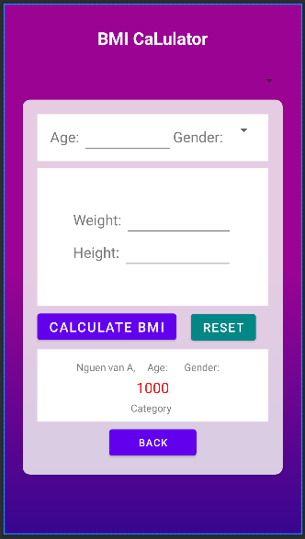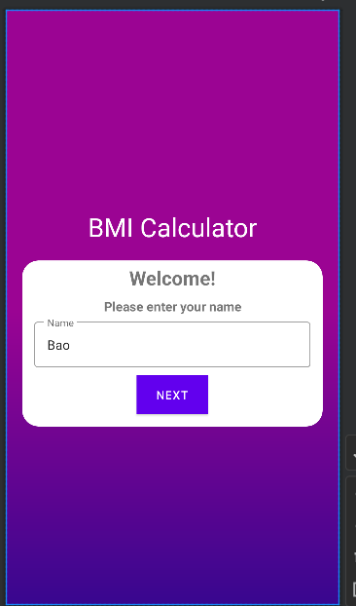---------------------------------------------------------

**BMI Calculatror**

**BMI_Activity**

package com.example.b1906314_buichihai_ktra

import android.R

import android.content.Intent

import androidx.appcompat.app.AppCompatActivity

import android.os.Bundle

import android.view.View

import android.widget.AdapterView

import android.widget.ArrayAdapter

import android.widget.Toast

import com.example.b1906314_buichihai_ktra.databinding.ActivityBmiBinding

import com.example.b1906314_buichihai_ktra.databinding.ActivityMainBinding

import kotlin.math.roundToInt

class BMI_Activity : AppCompatActivity() {

lateinit var binding: ActivityBmiBinding

override fun onCreate(savedInstanceState: Bundle?) {

super.onCreate(savedInstanceState)

binding = ActivityBmiBinding.inflate(layoutInflater)

setContentView(binding.root)

addEvents()

}

private fun addEvents() {

val options =

arrayOf("Weight in Kg & Height in Cm", "Weight in Pounds (lb) & Height in Inch (in)")

val adapter = ArrayAdapter(this, R.layout.simple_spinner_item, options)

adapter.setDropDownViewResource(android.R.layout.simple_spinner_dropdown_item)

binding.SPB1906314.adapter = adapter

binding.SPB1906314.onItemSelectedListener = object : AdapterView.OnItemSelectedListener {

override fun onItemSelected(p0: AdapterView<*>?, p1: View?, position: Int, p3: Long) {

val selected = options[position]

Toast.makeText(this@BMI_Activity, "you selected $selected", Toast.LENGTH_LONG)

.show()

}

override fun onNothingSelected(p0: AdapterView<*>?) {

}

}

val options1 = arrayOf("Male", "Female", "Unknown")

val adapter1 = ArrayAdapter(this, R.layout.simple_spinner_item, options1)

adapter1.setDropDownViewResource(android.R.layout.simple_spinner_dropdown_item)

binding.SpinnerGenderB1906314.adapter = adapter1

binding.SpinnerGenderB1906314.onItemSelectedListener =

object : AdapterView.OnItemSelectedListener {

override fun onItemSelected(

p0: AdapterView<*>?,

p1: View?,

position: Int,

p3: Long

) {

val selected = options1[position]

Toast.makeText(this@BMI_Activity, "you selected $selected", Toast.LENGTH_LONG)

.show()

}

override fun onNothingSelected(p0: AdapterView<*>?) {

}

}

// reset dữ liệu

binding.btnResetB1906314.setOnClickListener {

binding.SPB1906314.setSelection(0)

binding.SpinnerGenderB1906314.setSelection(0)

binding.etAgeB1906314.setText("")

binding.etWeightB1906314.setText("")

binding.etHeightB1906314.setText("")

// binding.tvNameB1906314.setText("")

binding.AgeeB1906314.setText("")

binding.tvGenderB1906314.setText("")

binding.tvResulB1906314.setText("")

binding.tvCategoryB1906314.setText("")

}

binding.btnCalculateBMIB1906314.setOnClickListener {

val age = binding.etAgeB1906314.text.toString()

val gender = binding.SpinnerGenderB1906314.selectedItem.toString()

val position = binding.SPB1906314.selectedItemPosition.toString().toInt()

var weight = binding.etWeightB1906314.text.toString().toInt()

var height = binding.etHeightB1906314.text.toString().toInt()

var kq = 0.2f

binding.AgeeB1906314.setText(age)

binding.tvGenderB1906314.setText(gender)

if (position == 0) {

var temp = height.toDouble() / 100

kq = (weight / (temp * temp)).toFloat()

} else {

kq = 703 * (weight.toFloat()) / (height * height).toFloat()

}

binding.tvResulB1906314.setText(kq.toString())

if (kq < 16) {

binding.tvCategoryB1906314.setText("Severe Thinness")

} else if (kq > 16 && kq <= 17) {

binding.tvCategoryB1906314.setText("Moderate Thinness")

} else if (kq > 17 && kq <= 18.5) {

binding.tvCategoryB1906314.setText("Mild Thinness")

} else if (kq > 18.5 && kq <= 25) {

binding.tvCategoryB1906314.setText("Normal")

} else if (kq > 25 && kq <= 30) {

binding.tvCategoryB1906314.setText("Overweight")

} else if (kq > 30 && kq <= 35) {

binding.tvCategoryB1906314.setText("Obese Class I")

} else if (kq > 35 && kq <= 40) {

binding.tvCategoryB1906314.setText("Obese Class II")

} else if (kq > 40) {

binding.tvCategoryB1906314.setText("Obese Class III")

}

}

// Hiển thị tên

val username = intent.getStringExtra(Constants.USER_NAME)

binding.tvNameB1906314.text = username

// chở về giao diện trước

binding.btnBackB1906314.setOnClickListener {

startActivities(arrayOf(Intent(this, MainActivity::class.java)))

}

}

}

**Main_Activity**

package com.example.b1906314_buichihai_ktra

import android.R

import android.content.Intent

import androidx.appcompat.app.AppCompatActivity

import android.os.Bundle

import android.view.View

import android.widget.AdapterView

import android.widget.ArrayAdapter

import android.widget.Toast

import com.example.b1906314_buichihai_ktra.databinding.ActivityMainBinding

class MainActivity : AppCompatActivity() {

lateinit var binding: ActivityMainBinding

override fun onCreate(savedInstanceState: Bundle?) {

super.onCreate(savedInstanceState)

binding = ActivityMainBinding.inflate(layoutInflater)

setContentView(binding.root)

addEvents()

}

private fun addEvents() {

binding.btnButtonB1906314.setOnClickListener {

if(binding.editNameB1906314.text?.isEmpty() == true){

Toast.makeText(this, "Please enter your name", Toast.LENGTH_LONG).show()

}

else{

val intent = Intent(this, BMI_Activity::class.java)

intent.putExtra("username", binding.editNameB1906314.text?.toString())

startActivity(intent)

}

}

}

}

**Constants**

package com.example.b1906314_buichihai_ktra

object Constants {

const val USER_NAME: String = "username"

}

**Question**

package com.example.b1906314_buichihai_ktra

class Question (

val Weight: Float,

val Height: Float

)

-------------------------------------------------------------------

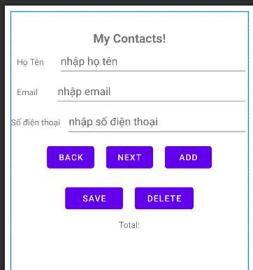**Data**

**Main_Activity**

package com.example.b1906314_bui_chi_hai_ct274

import android.content.ContentValues

import android.database.Cursor

import android.database.sqlite.SQLiteDatabase

import androidx.appcompat.app.AppCompatActivity

import android.os.Bundle

import

com.example.b1906314_bui_chi_hai_ct274.databinding.ActivityMainBinding

class MainActivity : AppCompatActivity() {

lateinit var binding: ActivityMainBinding

lateinit var helper: MyDB

lateinit var db: SQLiteDatabase

lateinit var rs: Cursor

var selectedId = 0

override fun onCreate(savedInstanceState: Bundle?) {

super.onCreate(savedInstanceState)

binding = ActivityMainBinding.inflate(layoutInflater)

setContentView(binding.root)

helper = MyDB(applicationContext)

db = helper.readableDatabase

rs = db.rawQuery("select * from users_b1906314", null)

if (rs.moveToFirst())

updateData()

binding.btnBackB1906314.setOnClickListener {

if (!rs.moveToPrevious())

rs.moveToFirst()

updateData()

}

binding.btnNextB1906314.setOnClickListener {

if (!rs.moveToNext())

rs.moveToFirst()

updateData()

}

binding.btnDeleteB1906314.setOnClickListener {

db.delete("users_b1906314","id=?", arrayOf(selectedId.toString()))

reloadData()

}

binding.btnSaveB1906314.setOnClickListener {

var cv = ContentValues()

cv.put("fullname", binding.edtHoTenB1906314 .text.toString())

cv.put("email", binding.edtEmailB1906314.text.toString())

cv.put("phone", binding.edtSoDTB1906314.text.toString())

db.update("users_b1906314", cv, "id=?", arrayOf(selectedId.toString()))

reloadData()

}

binding.btnAddB1906314.setOnClickListener {

val cv = ContentValues()

cv.put("fullname", binding.edtHoTenB1906314.text.toString())

cv.put("email", binding.edtEmailB1906314.text.toString())

cv.put("phone", binding.edtSoDTB1906314.text.toString())

db.insert("users_b1906314", null, cv)

reloadData()

}

}

private fun reloadData() {

rs = db.rawQuery("select * from users_b1906314", null)

rs.moveToLast()

updateData()

}

private fun updateData() {

selectedId = rs.getString(0).toInt()

binding.edtHoTenB1906314.setText(rs.getString(1))

binding.edtEmailB1906314.setText(rs.getString(2))

binding.edtSoDTB1906314.setText(rs.getString(3))

binding.tvTotalB1906314.setText("Total: ${rs.count} users_b1906314")

}

override fun onDestroy() {

super.onDestroy()

rs.close()

}

}

**MyDatabase**

package com.example.b1906314_bui_chi_hai_ct274

import android.content.Context

import android.database.sqlite.SQLiteDatabase

import android.database.sqlite.SQLiteOpenHelper

class MyDB (context: Context): SQLiteOpenHelper(context, "users_b1906314",null,1) {

override fun onCreate(p0: SQLiteDatabase?) {

p0?.execSQL("create table users_b1906314(id integer primary key autoincrement not null, fullname text, email text, phone text)")

p0?.execSQL("insert into users_b1906314(fullname,email, phone) values ('Bui chi hai','hai@gmail.com', '0987645678')")

p0?.execSQL("insert into users_b1906314(fullname,email, phone) values ('Hai b1906314','b1906314@gmail.com', '0987564321')")

}

override fun onUpgrade(p0: SQLiteDatabase?, p1: Int, p2: Int) {

}

}

----------------------------------------------------------

**Tuan 9**

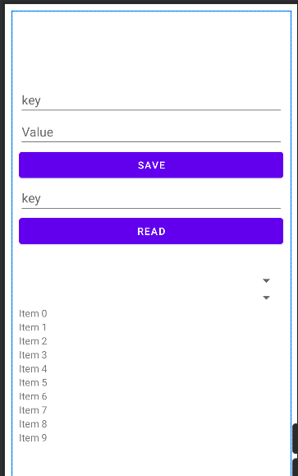

**Main_Activity**

package com.example.b1906314_bt_tuan_9

import android.content.Context

import androidx.appcompat.app.AppCompatActivity

import android.os.Bundle

import android.view.View

import android.widget.AdapterView

import android.widget.ArrayAdapter

import android.widget.Toast

import androidx.datastore.core.DataStore

import androidx.datastore.preferences.core.Preferences

import androidx.datastore.preferences.core.edit

import androidx.datastore.preferences.core.stringPreferencesKey

import androidx.datastore.preferences.preferencesDataStore

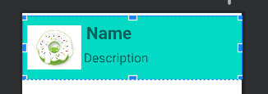import androidx.recyclerview.widget.LinearLayoutManager

import androidx.recyclerview.widget.RecyclerView

import com.example.b1906314_bt_tuan_9.databinding.ActivityMainBinding

import kotlinx.coroutines.CoroutineScope

import kotlinx.coroutines.Dispatchers

import kotlinx.coroutines.flow.Flow

import kotlinx.coroutines.flow.first

import kotlinx.coroutines.flow.map

import kotlinx.coroutines.launch

val Context.dataStore: DataStore<Preferences> by preferencesDataStore(name = "settings")

class MainActivity : AppCompatActivity() {

lateinit var binding: ActivityMainBinding

val items = ArrayList<MyAndroid>()

override fun onCreate(savedInstanceState: Bundle?) {

super.onCreate(savedInstanceState)

binding = ActivityMainBinding.inflate(layoutInflater)

setContentView(binding.root)

addEvents()

binding.rvListItems.layoutManager = LinearLayoutManager(this, RecyclerView.VERTICAL, false)

val adapter = MyAndroidRVAdapter(this, items)

binding.rvListItems.adapter = adapter

}

private fun addEvents() {

binding.myCustomSpinner.adapter = MyAndroidAdater(this, items)

items.add(MyAndroid(1, R.drawable.cupcake, "Cupcake", "Cupcake"))

items.add(MyAndroid(2, R.drawable.donut, "Donut", "Donut"))

items.add(MyAndroid(3, R.drawable.eclairs, "Eclairs", "Eclairs"))

items.add(MyAndroid(4, R.drawable.froyo, "Froyo", "Froyo"))

items.add(MyAndroid(5, R.drawable.gingerbread, "Gingerbread", "Gingerbread"))

items.add(MyAndroid(6, R.drawable.honeycomb, "Honeycomb", "Honeycomb"))

items.add(MyAndroid(7, R.drawable.icecream, "Icecream", "Icecream"))

items.add(MyAndroid(8, R.drawable.jellybean, "Jellybean", "Jellybean"))

val options = arrayOf("Option 1", "Option 2", "Option 3", "Option 4")

val adapter = ArrayAdapter(this, android.R.layout.simple_spinner_item, options)

adapter.setDropDownViewResource(android.R.layout.simple_spinner_dropdown_item)

binding.mySpinner.adapter = adapter

binding.mySpinner.onItemSelectedListener = object :AdapterView.OnItemSelectedListener{

override fun onItemSelected(p0: AdapterView<*>?, p1: View?, position: Int, p3: Long) {

val selected = options[position]

Toast.makeText(this@MainActivity, "you selected $selected", Toast.LENGTH_LONG).show()

}

override fun onNothingSelected(p0: AdapterView<*>?) {

}

}

binding.rvListItems.layoutManager = LinearLayoutManager(this, RecyclerView.VERTICAL, false)

val adapter1 = MyAndroidRVAdapter(this, items)

binding.rvListItems.adapter = adapter1

binding.btnSave.setOnClickListener {

CoroutineScope(Dispatchers.IO).launch {

savePrefs(binding.edtKey.text.toString(), binding.edtValue.text.toString())

}

}

binding.btnRead.setOnClickListener {

CoroutineScope(Dispatchers.IO).launch {

binding.tvReadValue.text = readPrefs(binding.edtReadKey.text.toString())

}

}

}

suspend fun savePrefs(key: String, value: String) {

val _key = stringPreferencesKey(key)

dataStore.edit { settings ->

settings[_key] = value

}

}

suspend fun readPrefs(key: String): String {

val _key = stringPreferencesKey(key)

val _value: Flow<String> = dataStore.data.map { settings ->

settings[_key] ?: "No value"

}

return _value.first().toString()

}

}

**MyAndroid**

package com.example.b1906314_bt_tuan_9

data class MyAndroid(

val id: Int,

val image: Int,

val name: String,

val description: String

)

**MyAndroidAdate**

package com.example.b1906314_bt_tuan_9

import android.content.Context

import android.view.LayoutInflater

import android.view.View

import android.view.ViewGroup

import android.widget.BaseAdapter

import android.widget.ImageView

import android.widget.TextView

class MyAndroidAdater(val context: Context, val items: ArrayList<MyAndroid>) :

BaseAdapter()

{

override fun getCount(): Int {

return items.size

}

override fun getItem(p0: Int): Any? {

return null

}

override fun getItemId(p0: Int): Long {

return 0

}

override fun getView(i: Int, p1: View?, p2: ViewGroup?): View {

val view = LayoutInflater.from(context).inflate(R.layout.spinner_item, null)

val icon = view.findViewById<ImageView>(R.id.iv_spinner)

val name = view.findViewById<TextView>(R.id.tv_spinner)

icon.setImageResource(items[i].image)

name.text = items[i].name

return view

}

}

**MyAndroidRVAdapter**

package com.example.b1906314_bt_tuan_9

import android.content.Context

import android.view.LayoutInflater

import android.view.View

import android.view.ViewGroup

import android.widget.ImageView

import android.widget.TextView

import androidx.recyclerview.widget.RecyclerView

class MyAndroidRVAdapter(val context: Context, val items: ArrayList<MyAndroid>) :

RecyclerView.Adapter<MyAndroidRVAdapter.MyAndroidViewHolder>() {

class MyAndroidViewHolder(val view: View): RecyclerView.ViewHolder(view){

fun binding(item: MyAndroid){

val ivImage = view.findViewById<ImageView>(R.id.rv_iv_image)

val tvName = view.findViewById<TextView>(R.id.rv_tv_name)

val tvDescription = view.findViewById<TextView>(R.id.rv_tv_dec)

ivImage.setImageResource(item.image)

tvName.text = item.name

tvDescription.text = item.description

}

}

override fun onCreateViewHolder(

parent: ViewGroup,

viewType: Int

): MyAndroidRVAdapter.MyAndroidViewHolder {

val view = LayoutInflater.from(parent.context).inflate(R.layout.item, parent, false)

return MyAndroidViewHolder(view)

}

override fun onBindViewHolder(holder: MyAndroidRVAdapter.MyAndroidViewHolder, position: Int) {

holder.binding(items[position])

}

override fun getItemCount(): Int {

return items.size

}

}