James Abreu.

1)

int main() {

int a, b;

cout << "Enter two number: ";

cin >> a >> b;

if (a != b) {

if (a > b) {

cout << a << " is greater than " << b << endl;

}

else cout << b << " is greater than " << a << endl;

}

else cout << a << " and " << b << " are equals." << endl;

return 0;

}

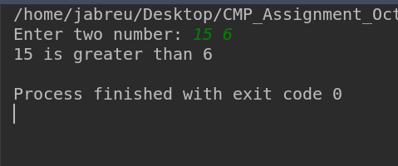

2)

int main() {

int num(0);

cout << "Lets figure out if your number is odd or even." << endl;

cout << "Enter a number: " << endl;

cin >> num;

if (num % 2 == 0){

cout << "The number is even. " << endl;

}else cout << "The number is odd. " << endl;

return 0;

}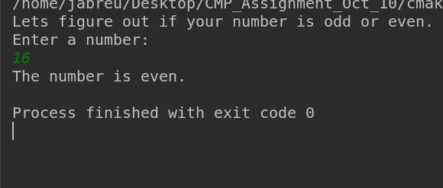

3)

int main() {

int month, day, year;

cout << "\n"

<< "lets see if the current date is magic!. " << endl;

cout << "Enter a month in number: " ;

cin >> month;

cout << "Enter a day: ";

cin >> day;

cout << "Enter the year' last two digits: ";

cin >> year;

if (month <= 12 && day <= 30){

if (month * day == year){

cout << "The date: "

<< month

<< "\\"

<< day

<< "\\"

<< year

<< " is magic." << endl;

}else cout << "The date is not magic. :(" << endl;

}else cout << "You have lied to me. The year and day length is not that long." << endl;

return 0;

}

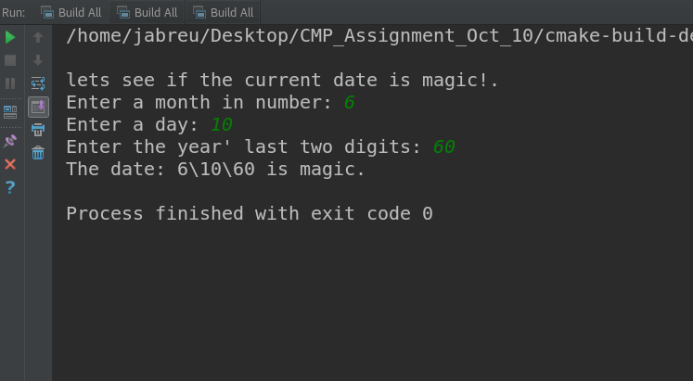

4)

class Rectangle{

private:

float width;

float length;

public:

void set_dimensions(float set_witdh, float set_length){

this->width = set_witdh;

this->length = set_length;

}

float get_dimensions(){

return this->width * this->length;

}

};

int main() {

cout << "Enter the width and length of the first rectangle: ";

float width, length;

cin >> width >> length;

Rectangle rect1{};

rect1.set_dimensions(width, length);

cout << "Enter the dimension of the second rectangle: ";

cin >> width >> length;

Rectangle rect2{};

rect2.set_dimensions(width, length);

if (rect1.get_dimensions() != rect2.get_dimensions()){

if (rect1.get_dimensions() > rect2.get_dimensions()) {

printf("Rectangle 1 is greater than rectangle 2: \n\t A = %.1f", rect1.get_dimension());

}else {

printf("Rectangle 2 is greater than rectangle 1: \n\t A = %.1f", rect2.get_dimension());

}

}else cout << "Both rectangles are equals: Area=" << rect1.get_dimension() << endl;

return 0;

}

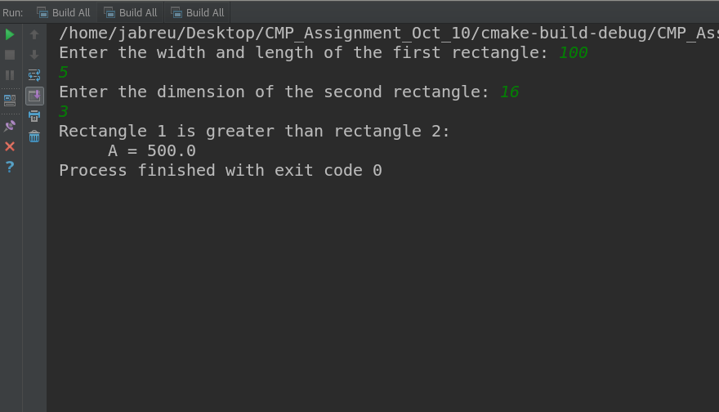

5)

int main() {

cout << "\n" << setw(4) << "BMI Calculator." << endl;

cout << "Please enter you weight in pounds: ";

float weight;

cin >> weight;

cout << "\nNOTE: 1 feet is 12 inches.\nEnter your height in inches: ";

float height;

cin >> height;

float bmi = (weight * 703) / (height * height);

if (bmi >= 18.5f && bmi <= 25){

cout << "Your BMI is "

<< setprecision(2)

<< fixed << bmi

<< ". Your are in optimal shape.";

}

else if (bmi < 18.5f) {

cout << "Your BMI is "

<< setprecision(2)

<< fixed << bmi

<< ". Your are underweight.";}

else if (bmi > 25){ cout << "Your BMI is "

<< setprecision(2)

<< fixed << bmi

<< ". Your are obese.";

}

cout << "\n";

return 0;

}

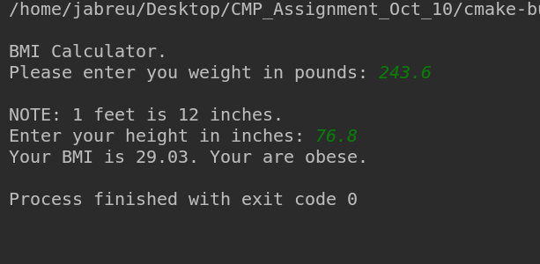

6)

int main() {

string color_choice1, color_choice2;

cout << "We have 3 colors: Red, Blue, Yellow. "

<< endl;

cout << "Enter the name of 2 to mix them. You will get the secondary color: " << endl;

cout << "Enter the first color: ";

getline(cin, color_choice1);

cout << "Enter the second color: ";

getline(cin,color_choice2);

if (color_choice1 == "Red" && color_choice2 == "Yellow") {

cout << "You get: Orange" << endl;

}else if (color_choice1 == "Red"

&& color_choice2 == "Blue") {cout << "You get: Purple" << endl;}

else if (color_choice1 == "Yellow"

&& color_choice2 == "Blue") {cout << "You get: Green" << endl;}

else cout << "The color was not found" << endl;

//Check if the same colors are input twice

if (color_choice1 == "Red" && color_choice2 == "Red") {cout << "Is " << color_choice1 << ". Be creative!" << endl;}

if (color_choice1 == "Yellow" && color_choice2 == "Yellow") {cout << "Is " << color_choice1 << ". Be creative!" << endl;}

if (color_choice1 == "Blue" && color_choice2 == "Blue") {cout << "Is " << color_choice1 << ". Be creative!" << endl;}

return 0;

}

