作业三

- 绘制简单条形图、堆砌条形图、分组条形图，并在同一幅画面中展示。
#导包
install.packages("vcd")
library(vcd)
#1
layout(matrix(c(1, 2, 3), 1, 3, byrow = TRUE))
# 简单条形图
barplot(counts,
main="简单条形图",
xlab="Improvement", ylab="Frequency")
counts <- table(Arthritis$Improved, Arthritis$Treatment)
#堆砌条形图
barplot(counts,
main="堆砌条形图",
xlab="Treatment", ylab="Frequency",
col=c("red", "yellow","green"),
legend=rownames(counts))
#分组条形图
barplot(counts,
main="分组条形图",
xlab="Treatment", ylab="Frequency",
col=c("red", "yellow", "green"),
legend=rownames(counts), beside=TRUE)
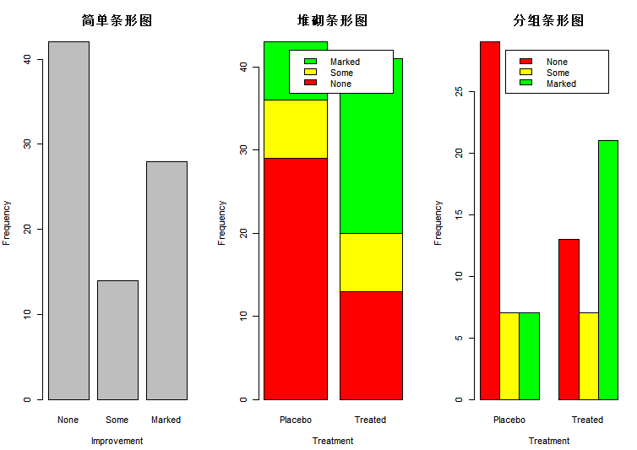

- 绘制一幅直方图， 需要设置颜色、组数、标签以及标题，并叠加轴须图和密度曲线，最后用盒围起来。
#2.绘制一幅直方图， 需要设置颜色、组数、标签以及标题，并叠加轴须图和密度曲线，最后用盒围起来。
layout(matrix(c(1, 1, 2, 2), 2, 2, byrow = TRUE))
x <- mtcars$mpg
#轴须图
hist(x,
freq=FALSE, #freq=FALSE表示根据概率密度
breaks=12,
col="red",
xlab="每加仑英里数",
main="直方图和轴须图")
rug(jitter(mtcars$mpg))#rug在坐标轴上标出元素出现的频数
lines(density(mtcars$mpg), col="blue", lwd=2)
box()
#加密度曲线
h<-hist(x,
breaks=12,
col="yellow",
xlab="每加仑英里数",
main="直方图和密度曲线")
xfit<-seq(min(x),max(x),length=40)
yfit<-dnorm(xfit,mean=mean(x),sd=sd(x))
yfit <- yfit*diff(h$mids[1:2])*length(x) # 频数=频率/组距*组距*总数~密度*组距*总数
lines(xfit, yfit, col="blue", lwd=2)
box()
par(opar)
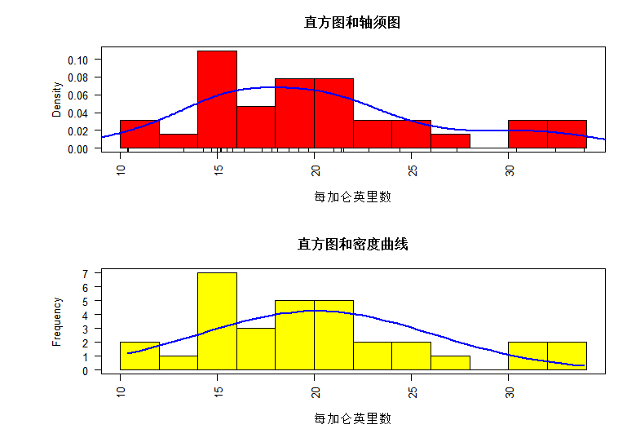

- 绘制一幅可比较的并列箱线图
#并列箱线图
boxplot(mpg ~ cyl, data=mtcars,
main="Car Mileage Data",
xlab="Number of Cylinders",
ylab="Miles Per Gallon")
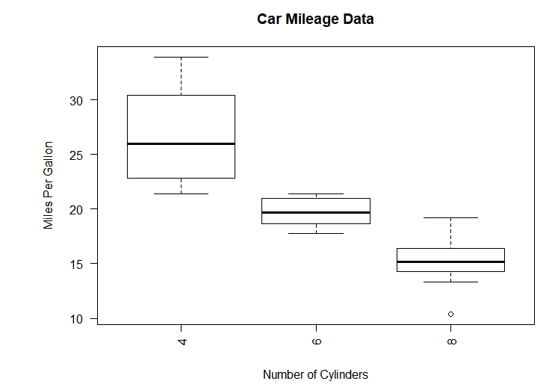

- 对mtcars数据集mpg属性绘制分组点图(按照cyl进行分组)
# 4.对mtcars数据集mpg属性绘制分组点图(按照cyl进行分组)
#分组、排序、着色后的点图
x <- mtcars[order(mtcars$mpg),]
x$cyl <- factor(x$cyl)
x$color[x$cyl==4] <- "red"
x$color[x$cyl==6] <- "blue"
x$color[x$cyl==8] <- "darkgreen"
dotchart(x$mpg,
labels = row.names(x),
cex=.7,
groups = x$cyl,
gcolor = "black",
color = x$color,
pch=19,
main = "Gas Mileage for Car Models\ngrouped by cylinder",
xlab = "Miles Per Gallon")
