DFSO_Business_FRQ
Describing a Scatterplot (DFSO)
Context: Advertising and Sales
A marketing manager at a retail company wants to investigate the relationship between weekly advertising spending and weekly sales revenue. The manager randomly selects 20 weeks from the company’s records and creates the scatterplot below.
Question
Describe the relationship between weekly advertising spending and weekly sales revenue. Be sure to discuss the direction, form, strength, and any unusual features of the relationship.
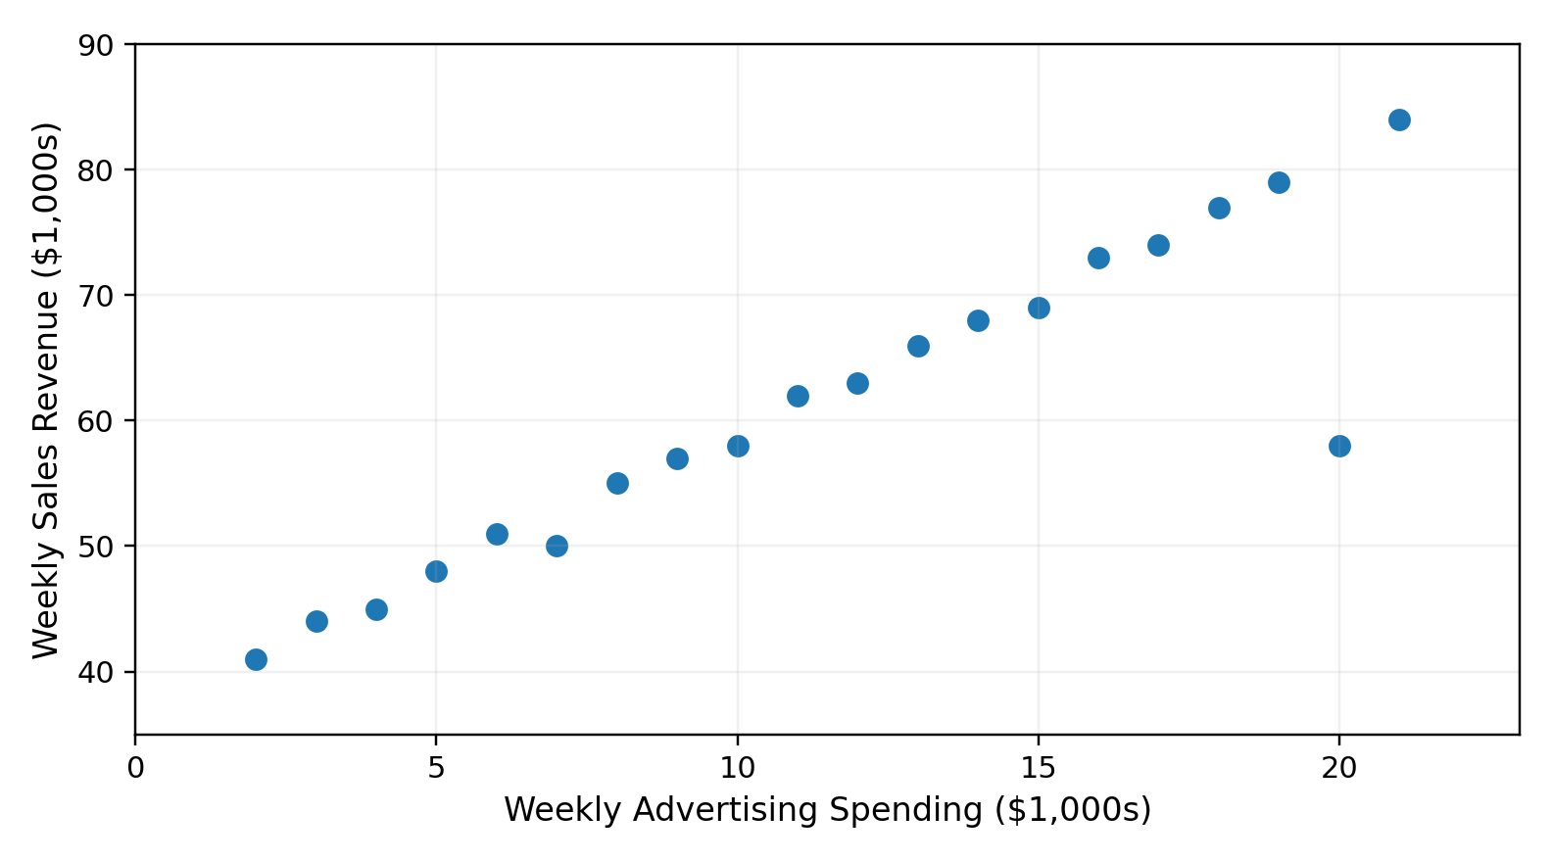
Figure 1. Weekly advertising spending and weekly sales revenue for 20 randomly selected weeks.

