DFSO_Business_FRQ – Practice 2
Describing a Scatterplot (DFSO)
Context: Product Price and Weekly Demand
A manager of an online retail store wants to investigate the relationship between the selling price of a product and the number of units sold per week. The manager records data for 20 comparable products and creates the scatterplot below.
Question
Describe the relationship between product price and weekly units sold. Be sure to discuss the direction, form, strength, and any unusual features of the relationship.
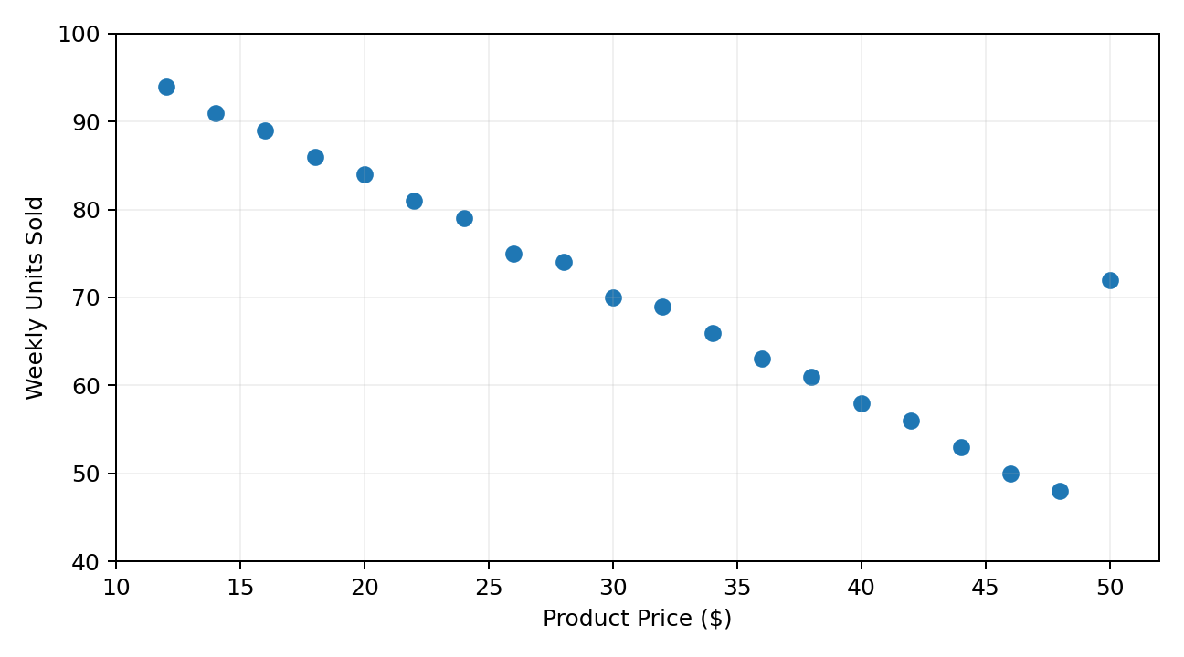
Figure 1. Product price and weekly units sold for 20 comparable products.

